1.1

If=else | while | 2.b

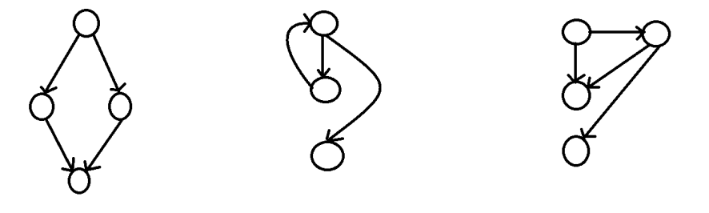

2.

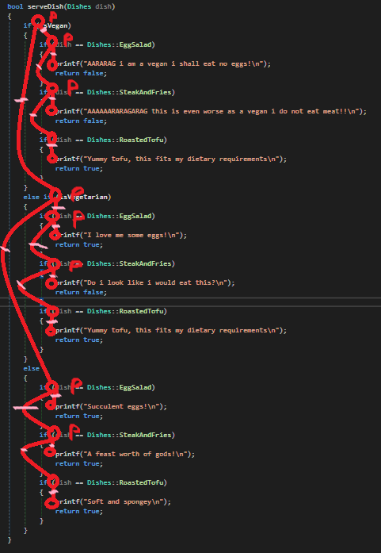

P(C) = 8

E(C) = 19

N(C) = 20

R(C) = 19 – 20 + 2 = -1 + 2 = 1

R(C) = 8 + 1 = 9

Basis paths:

1-2-3

1-2-4-5

1-2-4-6-7

1-8-9-10

1-8-9-11-12

1-8-9-11-13-14

1-8-15-16

1-8-15-17-18

1-8-15-17-19-20

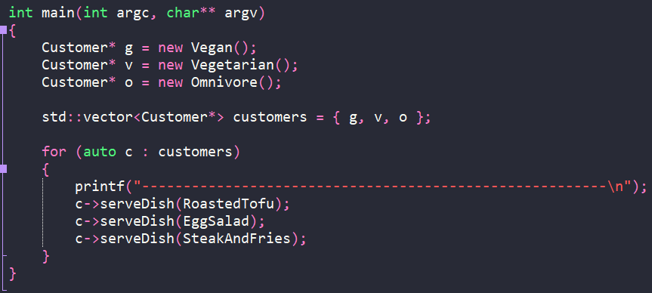

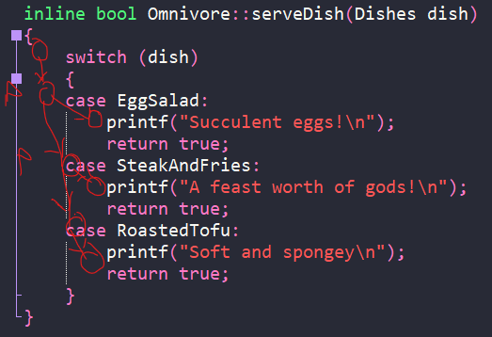

P(C) = 2

E(C) = 6

N(C) = 7

R(C) = 6 – 7 + 2 = -1 + 2 = 1

R(C) = 2 + 1 = 3