Below you can see snippets with the console output of the components.

rrclient output: rrworker output:

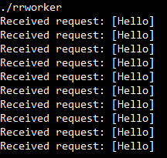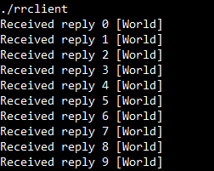

msgqueue output:

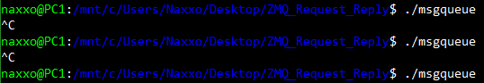

Upon stopping the msgqueue, the exchange of requests/responses is stopped. Upon restarting the queue, the exchange continues from where it was put to a halt. We can see that the communication between the client and the worker seems uninterrupted even after 2 restarts of msgqueue.

We can see how this is achieved by checking the API documentation:

“When the frontend is a ZMQ_ROUTER socket, and the backend is a ZMQ_DEALER socket, the proxy shall act as a shared queue that collects requests from a set of clients and distributes these fairly among a set of services. Requests shall be fair queued from frontend connections and distributed evenly across backend connections. Replies shall automatically return to the client that made the original request.”