

**User manual**

Betting system

Semester project

sBetting System

TABLE OF CONTENTS

1. INTRODUCTION 2

2. Register/Login 3

2.1 Create an account 4

3. Main Window 5

3.1 Events 5

3.2 Virtual ticket 6

3.3 History 7

3.4 Profile 8

3. Administrator window 9

# 1. INTRODUCTION

Thank you for purchasing our advanced betting system.

In the following pages you will find some tips on how to unlock the full potential of the application.

Please follow the guidelines and if you have questions that the following manual does not provide answers to, do not hesitate to contact us.

So you have made the right choice, you have chosen the best betting system. What know? How can you take advantage of its functionality? Do not worry as the answers to your questions are among these pages.

The purpose of the manual is for you to get familiar with the capabilities of the software.

If you have some question about us, feel free to contact us. We are looking forward to your ideas or questions.

# 2. Register/Login

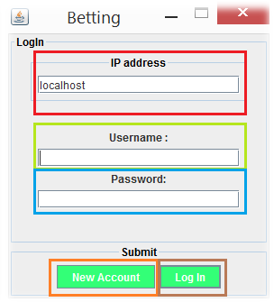

When you run the program the Log In window appears. If you are a new user, the first thing you have to do is to create a new account – click on the “New Account” button. Otherwise, fill the Username and Password fields, click the “Log In” button and enjoy the best betting experience.

**Red-** IP address.

**Green-** Username field.

**Blue-** Password field.

**Orange-** Create an account.

**Brown-** Login.

## 2.1 Create an account

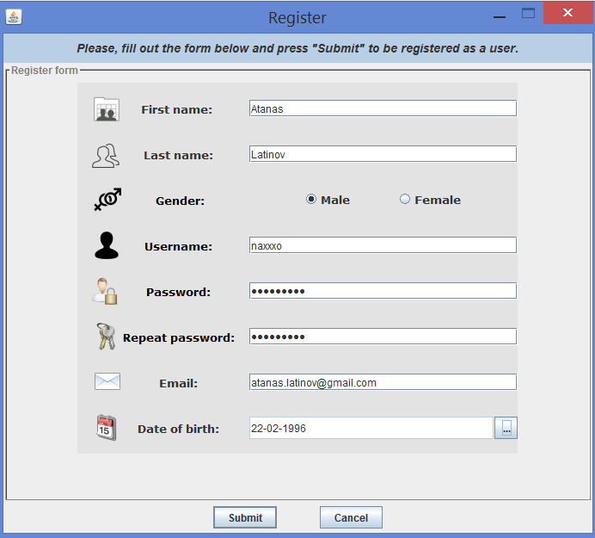

By filling out all the fields, you can easily create an account. When you are done click the “Submit” button and you will be automatically redirected to the main window. Do not worry if you accidentally create your account with wrong information. You can modify it later in the Profile tab in the main page.

# 3. Main Window

## 3.1 Events

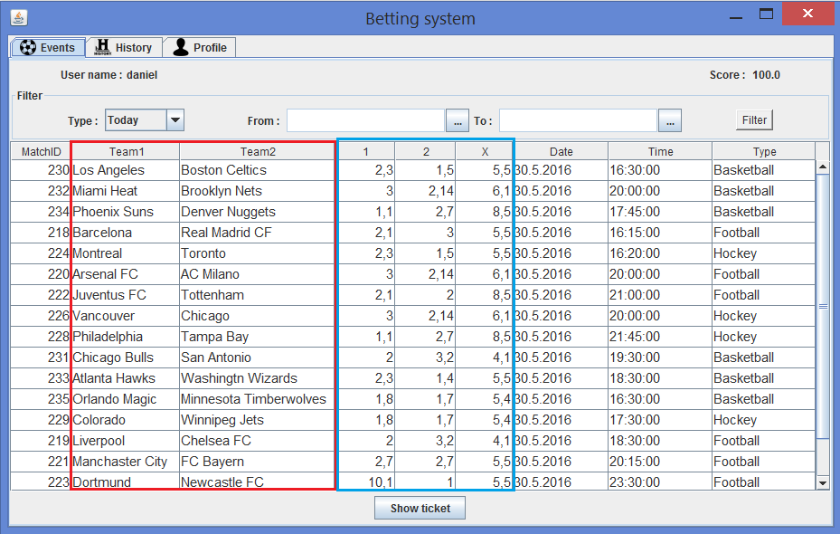

The Main Window is the first thing you can see when you are logged in. Almost every action is executed from this window. You can filter all events based on their types or a selected time period. If you find a match you would like to bet on, just double-click on either a team name or a coefficient from the highlighted columns to indicate your choice and the program will do the rest. The match will be automatically transferred to your virtual ticket.

## 3.2 Virtual ticket

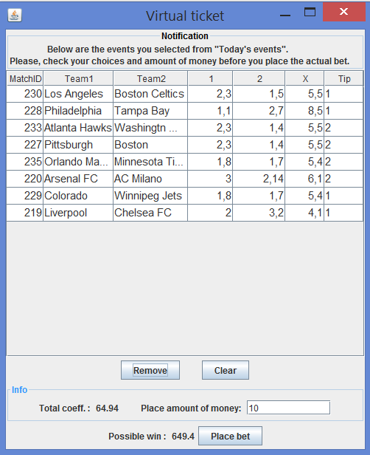

In the virtual ticket you can organize all selected matches. In the lower part of the ticket you can find all the important information about it – the total coefficient of all bets as well as the possible amount of points you could win. When you are done with selecting matches, you can place the amount of money you want to spend and then click on the button “Place bet”. After that, the ticket will be stored in your “History”, where you can see its evaluation as well as all the details about your other tickets.

## 3.3 History

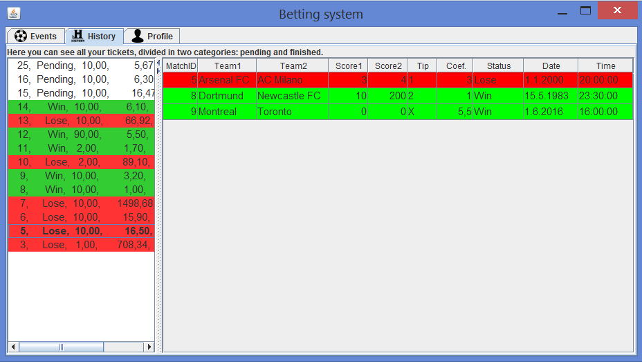

In the History tab, you can see a summary of all tickets you placed as well as a detailed description about each of them. To inspect a ticket, just click on it and the information about it will be presented in the table on the right.

## 3.4 Profile

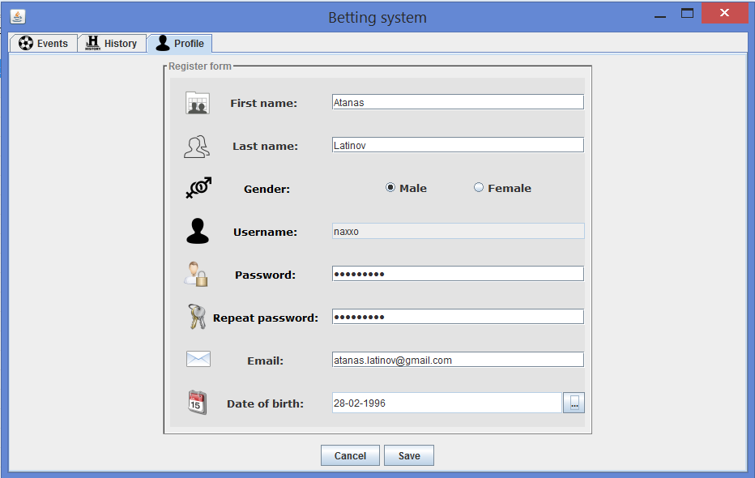

In the Profile tab, you can easily change your profile information, such as your password or email. When you are done with the changes, press the “Save” button and all changes will be saved. If you want to revert the changes, click on the Cancel button.

# 3. Administrator window

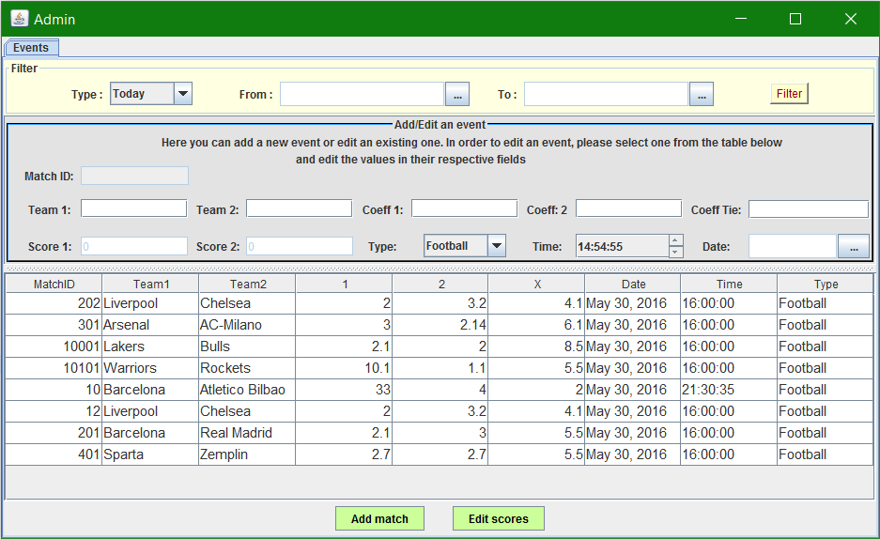 As an admin you can add a completely new event or modify an existing one’s scores, time or date. When you fill all the information necessary for adding a new match, press “Add match”. If you want to edit an already existing one, select one from the table below the Add/edit panel. You can change all of the following: Score for team 1 and/or team2, as well as the time and date of the event.