Advance DevOps

Experiment 5

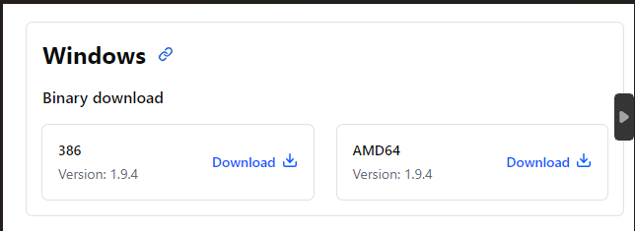Step 1: To install terraform first download the Terraform CLI Utility for Windows from terraform official website [www.terraform.io/downloads.html](http://www.terraform.io/downloads.html)

Step 2: After the zip file is downloaded, we will right click on it and click on extract all files.

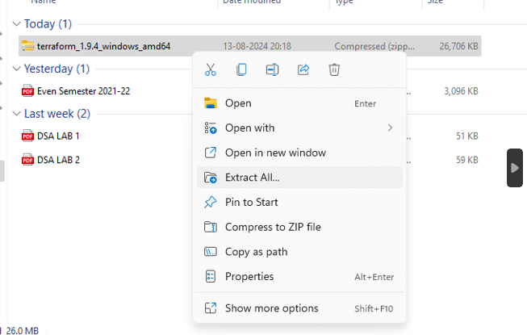

Step 3: Go to advance system settings in settings

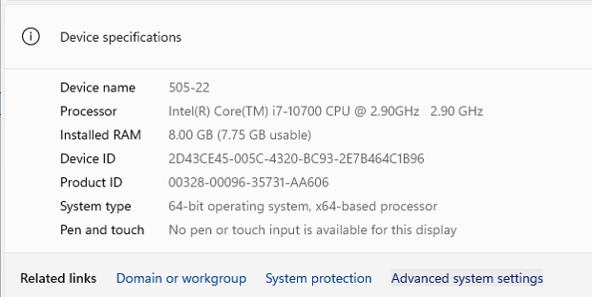

Step 4: In advance settings select environment variables and set the path of Terraform.

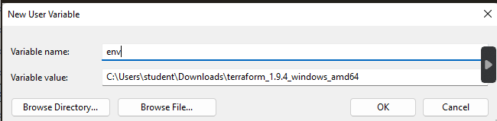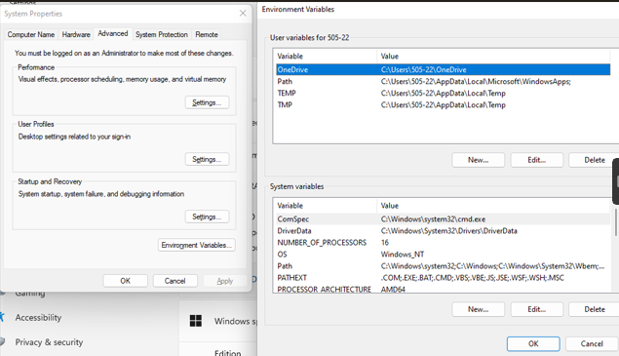

Step 5: In order to check whether terraform was successfully installed we have to run the command “terraform -v” which will give us the version of our terraform and hence terraform has been downloaded correctly.

