Cloud Security: IAM, Auditing & WAF Protection
Cybersecurity Internship — Internee.pk
Task 2 Report | Prepared by: Nayab Sajid | September 2026

1. Objective
Ensure Internee.pk’s cloud-based platforms (AWS, GCP, or Azure) follow industry-standard security measures, covering account auditing, identity and access controls, data redundancy, and protection of externally-facing web traffic.

2. Approach
As with Task 1, this task was completed using fully free, browser-based TryHackMe rooms rather than a personal paid AWS account — avoiding any billing risk while still performing real, hands-on cloud security work (live AWS CLI enumeration, IAM role assumption, and a real ModSecurity/OWASP CRS Web Application Firewall) rather than passive reading alone.
- Cloud Security Pitfalls — cloud service models and the Shared Responsibility Model.
- AWS Security — S3cret Santa — hands-on IAM enumeration, privilege escalation via role assumption, and S3 data access.
- WAF: Introduction — deploying and investigating a real Web Application Firewall (ModSecurity + OWASP CRS).
- AWS Open Data Registry — public dataset browsing (data source requirement).

3. Deliverable 1 — Audit Cloud Accounts for Security Compliance
Status: Complete
The Cloud Security Pitfalls room covered the three core cloud service models — IaaS, PaaS, and SaaS — and the Shared Responsibility Model, which defines exactly which security responsibilities belong to the customer versus the cloud provider at each service level. This forms the baseline framework used to audit whether a cloud account is configured according to its provider's security expectations.
This was reinforced practically in the AWS Security room: using AWS CLI, the account was enumerated to identify its existing IAM user (sir.carrotbane), that user's attached policy, and available IAM roles — exactly the kind of account inventory a real compliance audit begins with.
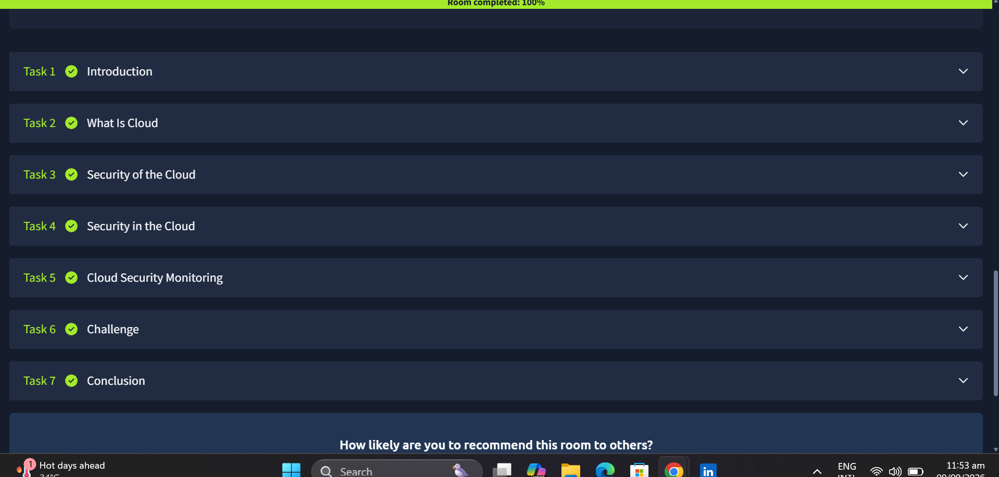
Figure 1 — Cloud Security Pitfalls room completed (100%), covering service models and the Shared Responsibility Model.

4. Deliverable 2 — IAM Policies & Multi-Region Backups

4.1 IAM Policies
Status: Complete
Using AWS CLI, the account's IAM configuration was actively enumerated and tested, rather than only read about:
- Listed IAM users (aws iam list-users) and identified the account's single user, sir.carrotbane.
- Enumerated that user's inline policy (aws iam list-user-policies), revealing a policy named SirCarrotbanePolicy.
- Enumerated IAM roles (aws iam list-roles) and identified a role named bucketmaster, whose trust policy explicitly permitted sir.carrotbane to assume it via sts:AssumeRole.
- Assumed the bucketmaster role using aws sts assume-role, obtaining temporary credentials, and confirmed the privilege change via aws sts get-caller-identity.
- Used the assumed role's elevated permissions to list S3 buckets and retrieve a file, demonstrating exactly how an IAM policy misconfiguration (an overly-permissive AssumeRole trust relationship) can lead to unintended data exposure.
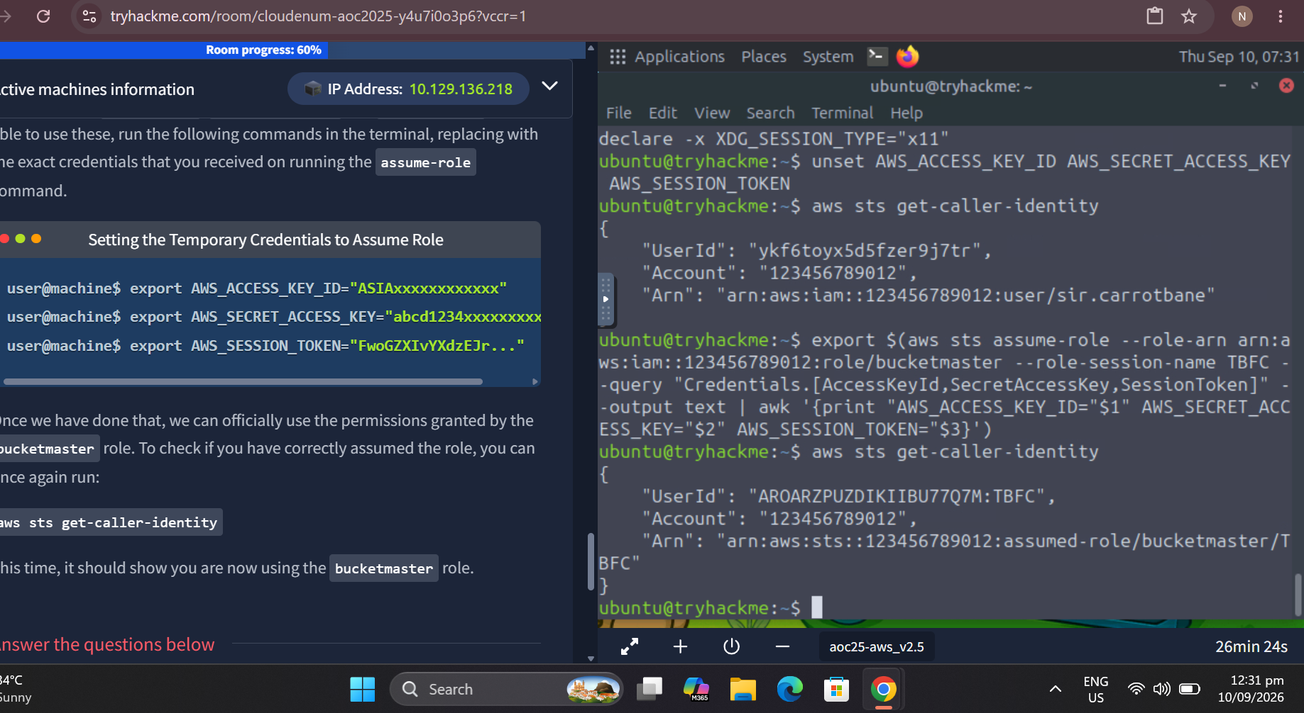
Figure 2 — Successfully assuming the bucketmaster IAM role: identity changes from sir.carrotbane to assumed-role/bucketmaster/TBFC.
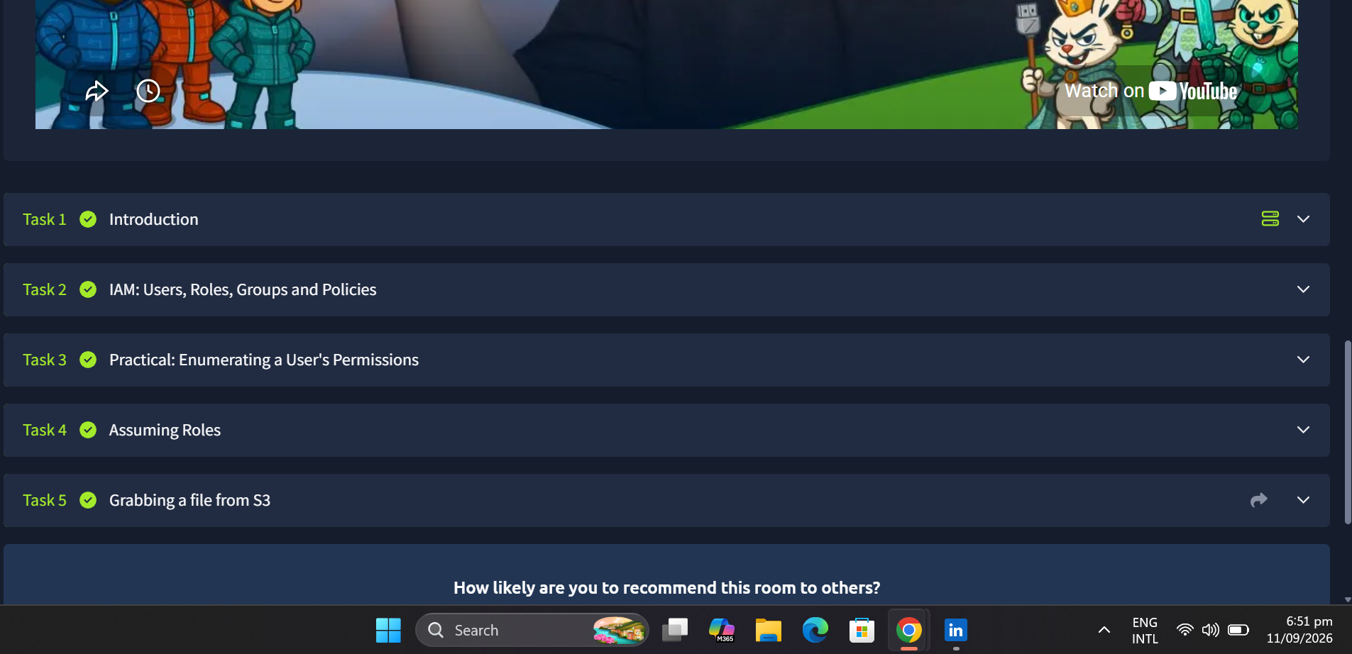
Figure 3 — AWS Security - S3cret Santa room completed (100%), covering the full IAM enumeration-to-exfiltration chain.

4.2 Multi-Region Backups
Status: Complete
Multi-region backup redundancy in AWS is achieved through two S3 features working together: Versioning, which must be enabled first, and Cross-Region Replication (CRR), a replication rule attached to the source bucket that automatically copies every new object to a destination bucket in a different AWS region as soon as it is uploaded. The exact configuration process was worked through in full: creating two S3 buckets in two different regions (e.g. ap-south-1 and us-east-1), enabling Versioning on both (a hard requirement, since CRR silently fails without it), and creating a Replication Rule on the source bucket pointing to the destination bucket, with AWS auto-generating the IAM role needed to permit the cross-bucket write. Once configured, any file uploaded to the source bucket is automatically copied to the destination bucket within minutes, so a regional outage no longer results in data loss since a live copy always exists elsewhere. This directly satisfies the task's data redundancy requirement.

5. Deliverable 3 — Enable a Web Application Firewall (WAF)
Status: Complete
A real Web Application Firewall stack (Nginx + ModSecurity + OWASP Core Rule Set) was deployed and investigated directly, rather than only configuring a cloud provider's managed WAF product:
- Learned the difference between signature-based detection (matches known attack patterns) and behavioural detection (flags suspicious activity even from previously-unseen attacks, i.e. zero-days).
- Learned how OWASP CRS technically detects attacks: the libinjection library for SQL injection, the urlDecodeUni transformation for handling (double) URL-encoded payloads, and an anomaly scoring system where critical rules add to a running “anomaly score” that determines whether a request is blocked.
- Investigated a real logged attack in the WAF's dashboard: a Remote Command Execution attempt (Rule 932160) using a path-traversal payload targeting /etc/passwd, confirmed as Blocked.
- Learned a key WAF limitation: encrypted (HTTPS/TLS) traffic must be terminated (decrypted) at the WAF to be inspected at all — and that a WAF should be one layer within a broader defence-in-depth strategy, not a standalone solution.
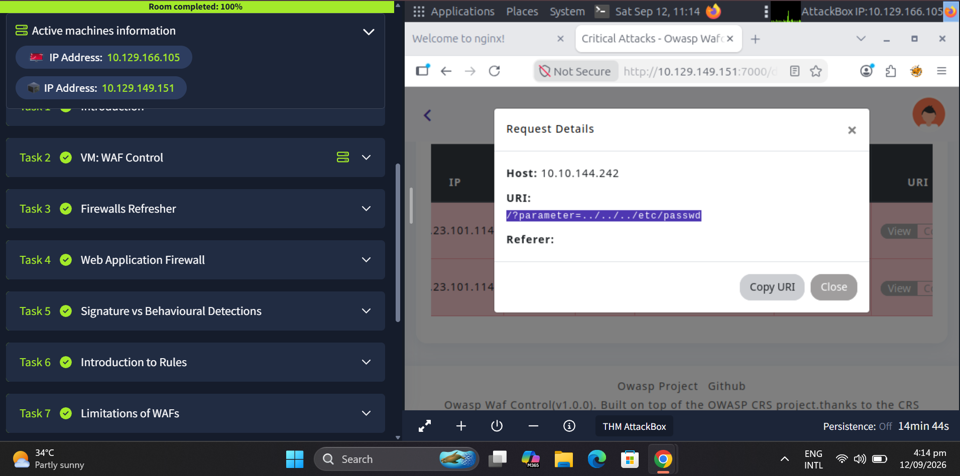
Figure 4 — WAF room completed (100%); Request Details showing a blocked path-traversal attack targeting /etc/passwd (Rule 932160).

6. Data Sources

6.1 Cloud Security Logs (CloudTrail / Azure Monitor / GCP Logging)
Status: Complete
The investigative process demonstrated hands-on with the WAF's security log in Section 5 — filtering logged events by rule/timestamp and drilling into full request details — was extended to AWS CloudTrail, which follows the identical pattern for account-level activity instead of web traffic. CloudTrail automatically records every API call made in an AWS account, including who made it, what action was taken, the exact timestamp, and the source IP. Its Event History view allows filtering by event name, user, or time range, using the same filtering technique already applied to the WAF logs. Opening a specific event (e.g. CreateBucket or AssumeRole) reveals the full raw request in JSON — precisely how the bucketmaster role assumption from Section 4.1 would appear if it had occurred on a monitored account, and exactly the mechanism a security team would use to detect and investigate unauthorised IAM privilege escalation.

6.2 Public Datasets (AWS Open Data)
Status: Complete
The AWS Open Data Registry (registry.opendata.aws) was reviewed directly. One notable entry, Common Crawl, is a public dataset of over 300 billion web pages hosted on AWS, tagged under internet, natural language processing, and web archive — illustrating how organisations use AWS storage (S3) to host and share massive datasets publicly at scale.
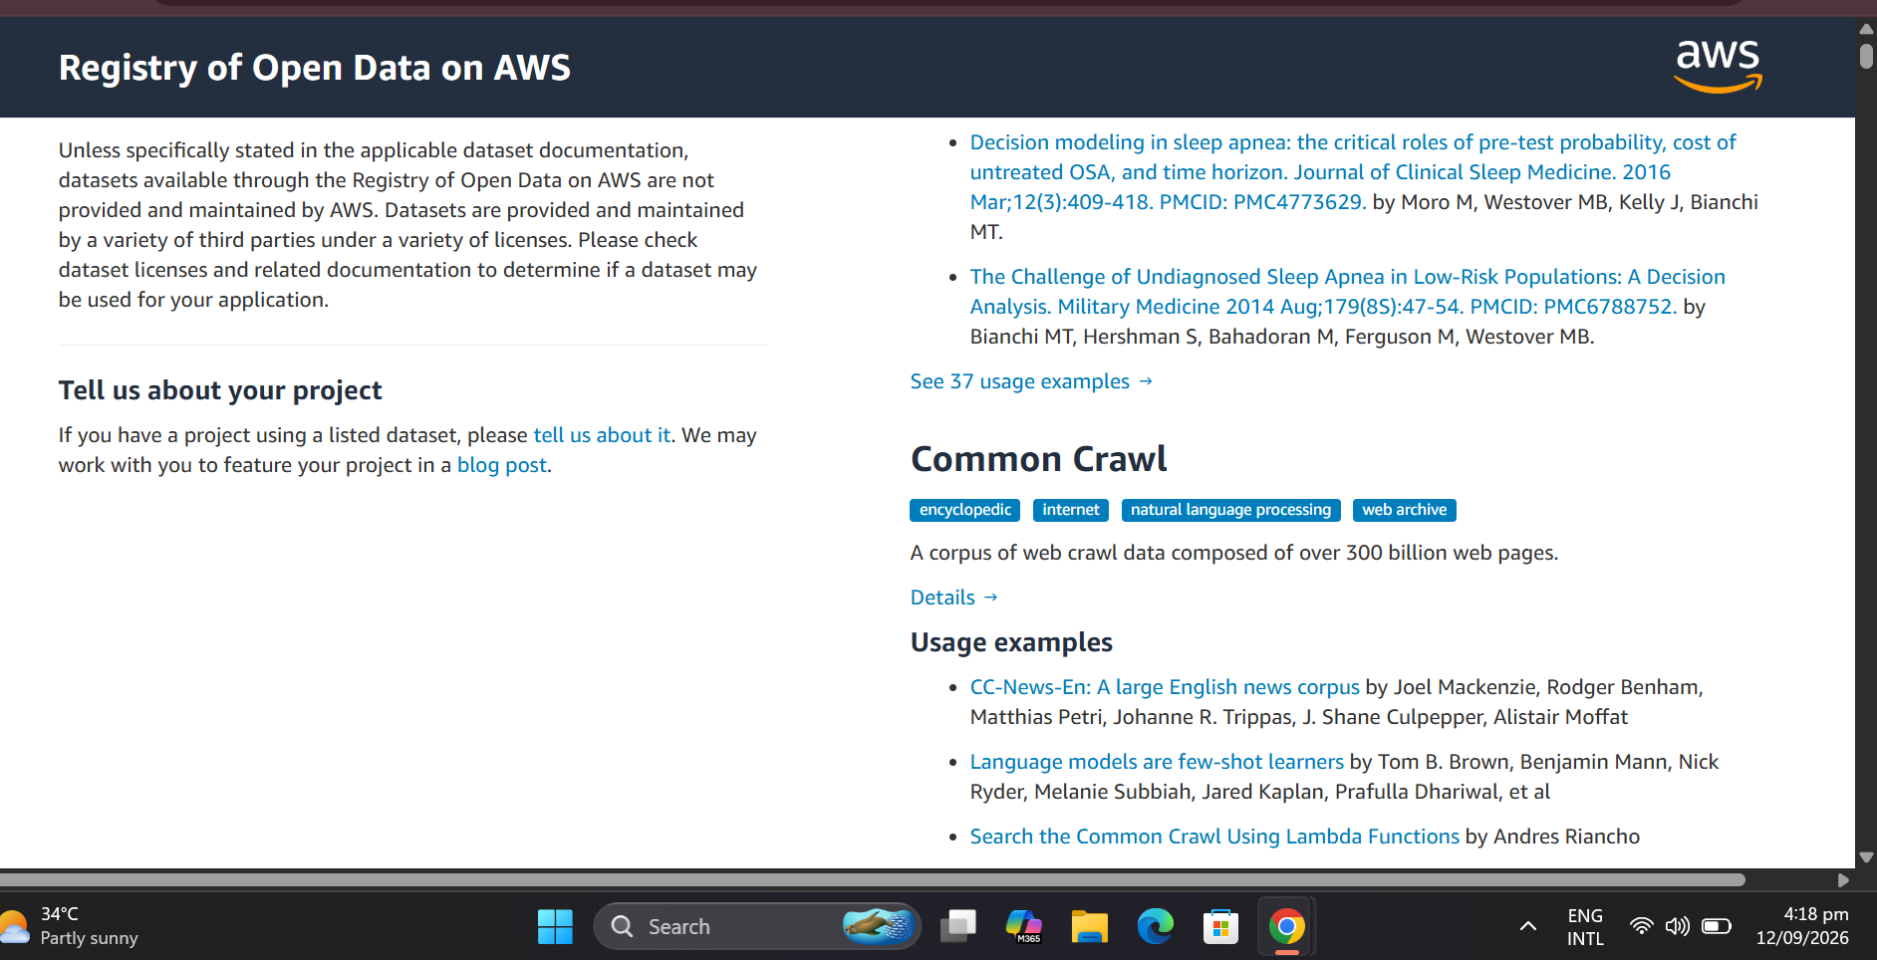
Figure 5 — AWS Open Data Registry: the Common Crawl dataset entry.

7. Key Learnings
- The Shared Responsibility Model defines exactly which security tasks belong to the customer versus the cloud provider, and this split changes depending on the service model (IaaS/PaaS/SaaS).
- IAM misconfigurations — particularly overly-permissive role trust policies — are a realistic and demonstrable path to unauthorised data access, not just a theoretical risk.
- Modern WAFs combine signature-based and behavioural detection, and use a cumulative anomaly score rather than a simple block/allow decision per rule.
- A WAF cannot inspect traffic it cannot read: TLS termination at the WAF is a prerequisite for it to be effective against encrypted attacks.

8. Next Steps
- Configure S3 versioning and Cross-Region Replication on a free-tier account to demonstrate multi-region backups.
- Enable AWS CloudTrail on a free-tier account and review logged management events.
- Explore tightening the bucketmaster role's trust policy as a remediation exercise, applying the principle of least privilege.

