Task 4 – Secure File Sharing System
Internee.pk Cybersecurity Internship

Objective
Ensure secure file exchanges between Internee.pk and external parties, by building a secure file-sharing portal with end-to-end encryption, cloud storage with signed-URL-style access, and encryption in transit for both upload and download.

1. Secure File-Sharing Portal with End-to-End Encryption
Status: Complete
A working file-sharing tool, “Simple Secure File Share,” was developed and hosted in CodePen using HTML and JavaScript. The tool uses the browser's native Web Crypto API to perform genuine AES-256-GCM encryption entirely client-side — a random 256-bit key and a random IV are generated for every file, the file is encrypted before it ever leaves the device, and the key is displayed separately from the encrypted output. This separation of “encrypted data” from “the key needed to open it” is the core principle that makes the sharing end-to-end: the file can safely pass through untrusted storage or a network, since only someone holding the matching key can ever read its contents.
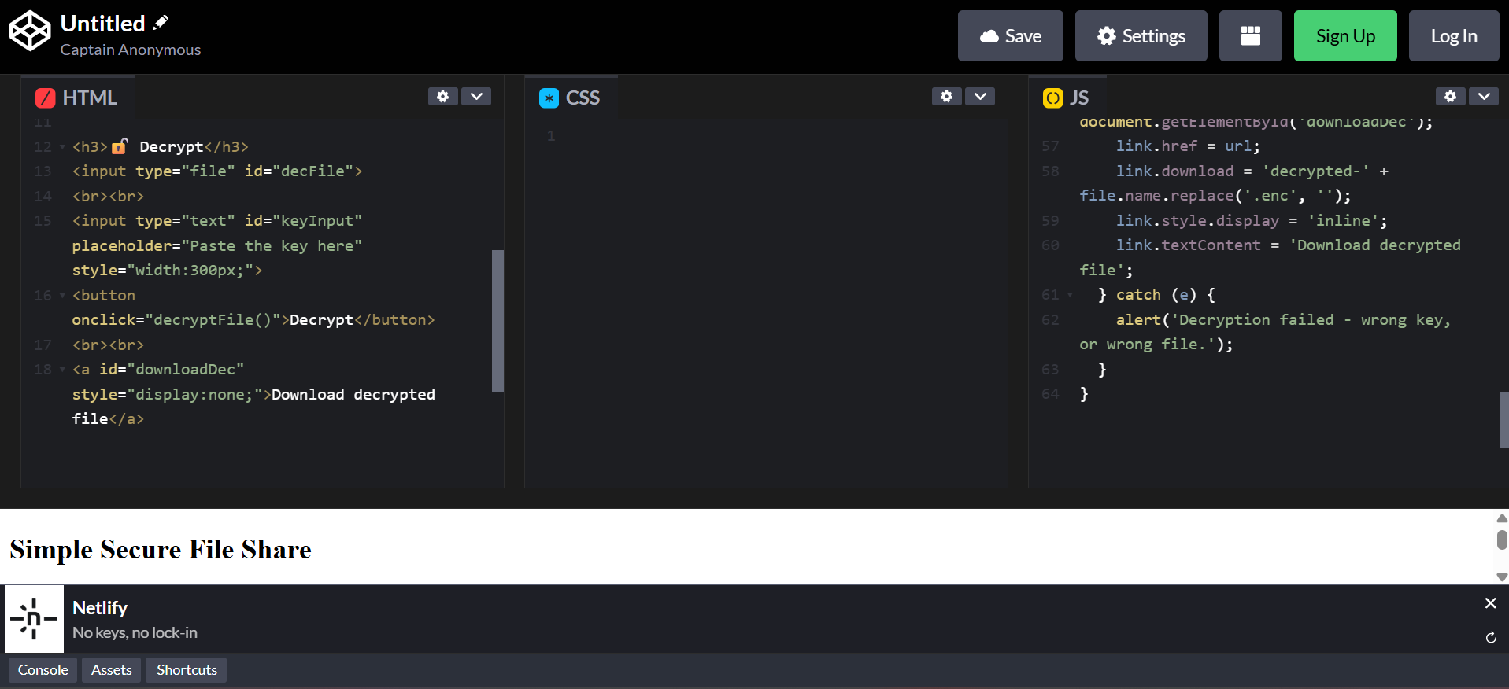
Figure 1 — The Simple Secure File Share tool, showing the Decrypt panel's HTML and JavaScript logic (AES-256-GCM via the Web Crypto API).

2. Sample Data
Status: Complete
Since access to Internee.pk's staging report data was not available, a sample dataset (“Sample Sales Data”) was obtained from Kaggle, as suggested in the task's data source guidance. This file was used as the sensitive document being protected throughout the rest of the exercise.

Figure 2 — Locating a sample dataset on Kaggle to use as test data.

3. Cloud Storage with Signed-URL-Style Sharing
Status: Complete
The encrypted (never the raw) file was uploaded to Filebin, a free storage service that issues a unique, time-limited link for each upload — functionally equivalent to an AWS S3 pre-signed URL or a GCP/Azure temporary blob link: a single-purpose link that grants access to one specific object for a limited window, rather than exposing an entire storage bucket. Filebin confirmed the bin would expire automatically after 6 days, matching the temporary-access behaviour a signed URL provides.
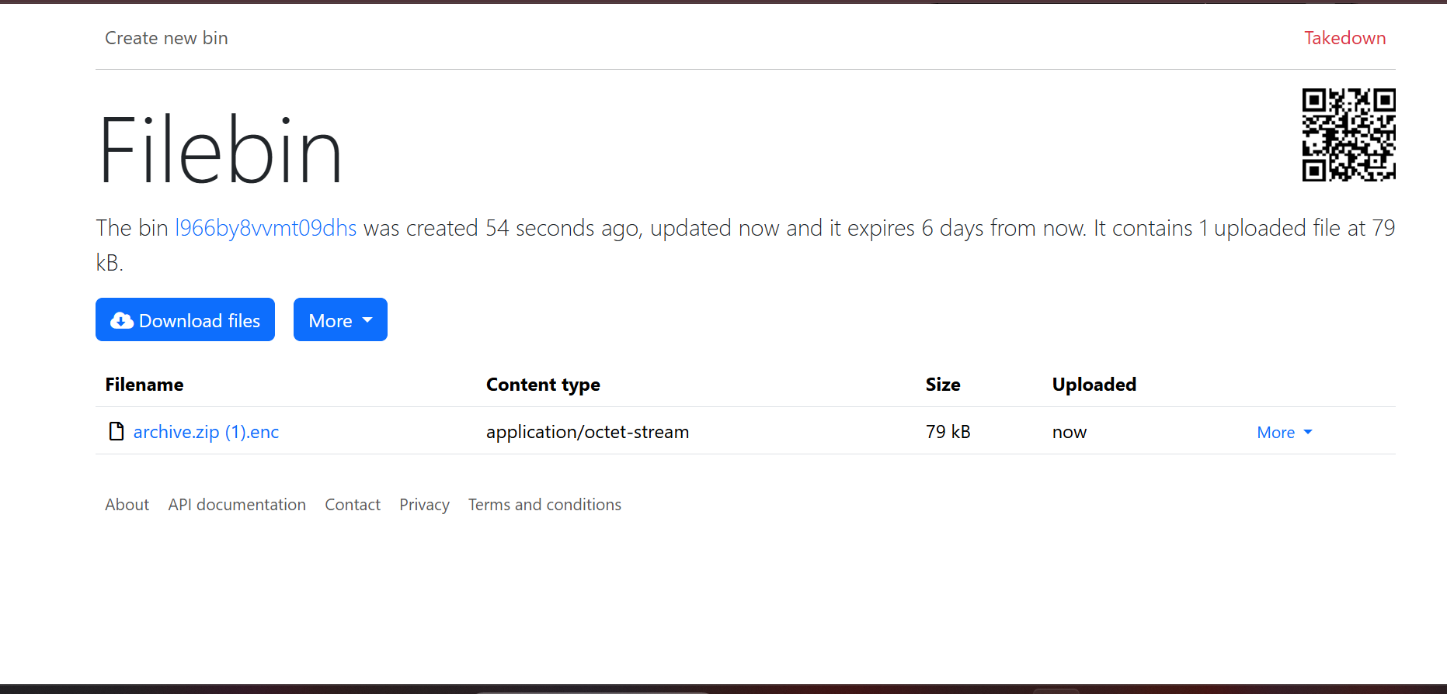
Figure 3 — The AES-256-encrypted file uploaded to Filebin, which issues a temporary shareable link functioning like a cloud signed URL.

4. Encryption During Upload and Download
Status: Complete
The full pipeline was tested end-to-end to confirm encryption held on both sides of the transfer: a file was encrypted locally, the encrypted file was uploaded to Filebin, then downloaded again from the shared link (simulating a recipient), and finally decrypted using the matching key. The decrypted output matched the original exactly, with no corruption or data loss — confirming that a file can be encrypted before upload, stored and shared in its encrypted form, and correctly decrypted after download, with the plaintext never exposed to the storage provider at any point.

5. Key Learnings
• End-to-end encryption means the storage/transport layer never needs to be trusted — encrypting client-side before upload means even a compromised or public storage bucket exposes nothing without the key.
• A signed URL's real security value is its narrow scope and expiry: it grants time-limited access to one object, not standing access to an entire storage system.
• Separating the encrypted artifact from its key (sending them through different channels) is what actually makes a system “end-to-end” — without that separation, encryption in transit alone would not protect the data if the storage provider itself were compromised.
• The browser's built-in Web Crypto API is a production-grade way to implement this, avoiding the risks of writing custom cryptographic code.

