Task 5 – Cyber Incident Response Plan
Internee.pk Cybersecurity Internship

Objective
Prepare Internee.pk to respond quickly and calmly to a cyber incident. This task covers three things: (1) simulating a ransomware attack and investigating it, (2) using the MITRE ATT&CK framework to describe the attacker's behaviour, and (3) writing an incident response plan and a short staff training guide.

1. Ransomware Attack Simulation (REvil Corp Room)
Status: Complete
The attack was simulated in the TryHackMe room "REvil Corp". In the room, a Windows computer belonging to a user named John Coleman was infected with REvil ransomware (also called Sodinokibi or Sodin). The machine's evidence was opened in Mandiant Redline, a free forensic analysis tool, and every room question was answered by finding the evidence in Redline.

1.1 What the evidence showed
What was found | Details | Where in Redline
Encrypted files | Files on the Desktop, Contacts and Downloads folders were renamed with the extension .t48s39la (for example passwords.txt.t48s39la and CreditCardInfo.txt.t48s39la). | File System
Ransom note | A file named t48s39la-readme.txt was dropped in every affected folder. | File System
Lock marker files | Zero-byte files named d60dff40.lock were created in the folders. | File System
Number of renamed files | 48 files were renamed with the .t48s39la extension. | Timeline (Modified + Changed)
Infection file | WinRAR2021.exe in the Downloads folder (164 KB), a fake program that was really the ransomware. MD5: 890a58f200dfff23165df9e1b088e58f. | File System > Full Detailed Information
Fake decryptor | The user later downloaded a "decryptor" (d.e.c.r.yp.tor.exe) from http://decryptor.top/644E7C8EFA02FBB7 hoping to get the files back. It did not work. | Browser URL History; File System
Decryptor MD5 | f617af8c0d276682fdf528bb3e72560b | Full Detailed Information > Details
Wallpaper changed | C:\Users\John Coleman\AppData\Local\Temp\hk8.bmp | Timeline / File System
Infection time | The file changes start at about 19:45 UTC on 2021-08-02. | Timeline

1.2 Screenshots
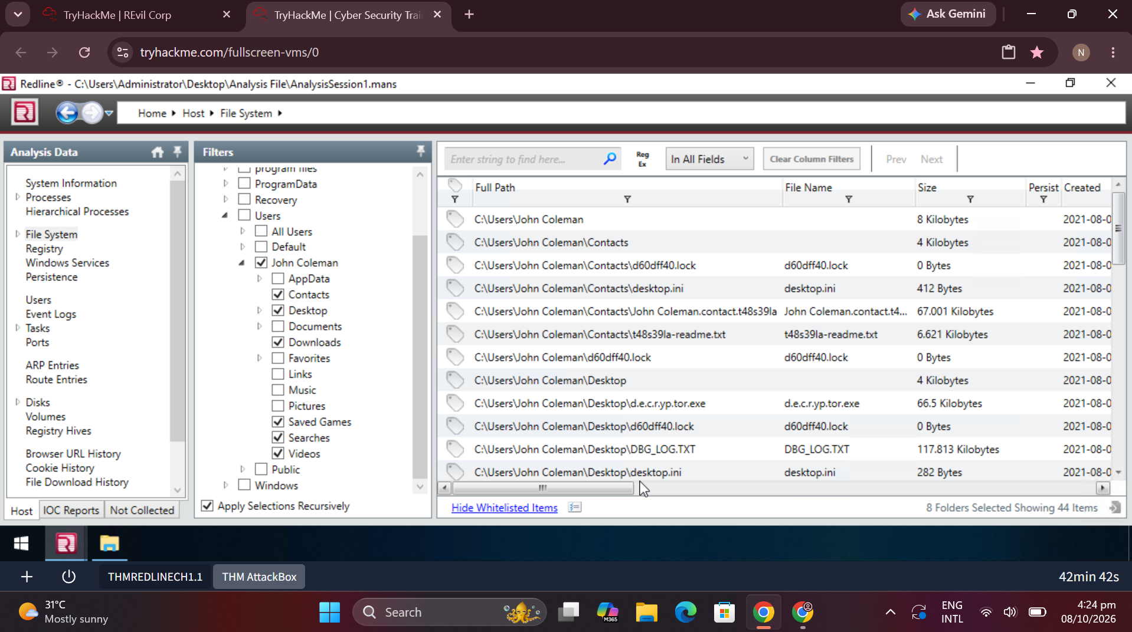
Figure 1 – Redline File System view of John Coleman's folders: .lock files, the ransom note t48s39la-readme.txt and the decryptor file on the Desktop.
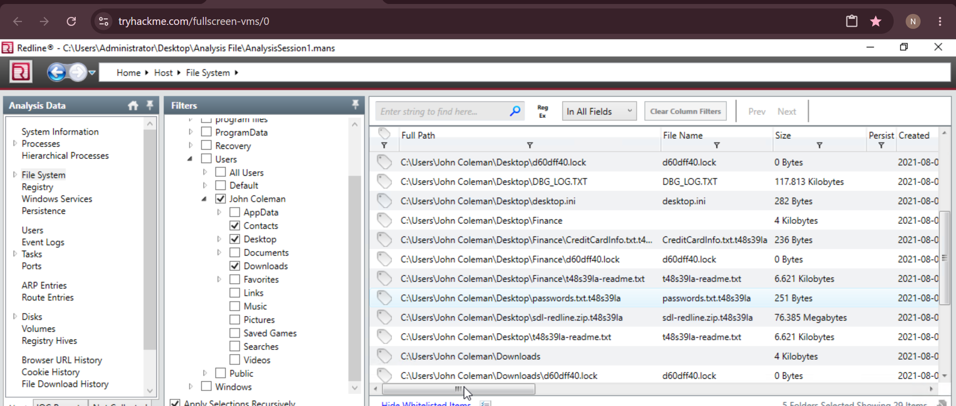
Figure 2 – Sensitive files on the Desktop renamed with the .t48s39la extension (CreditCardInfo, passwords).
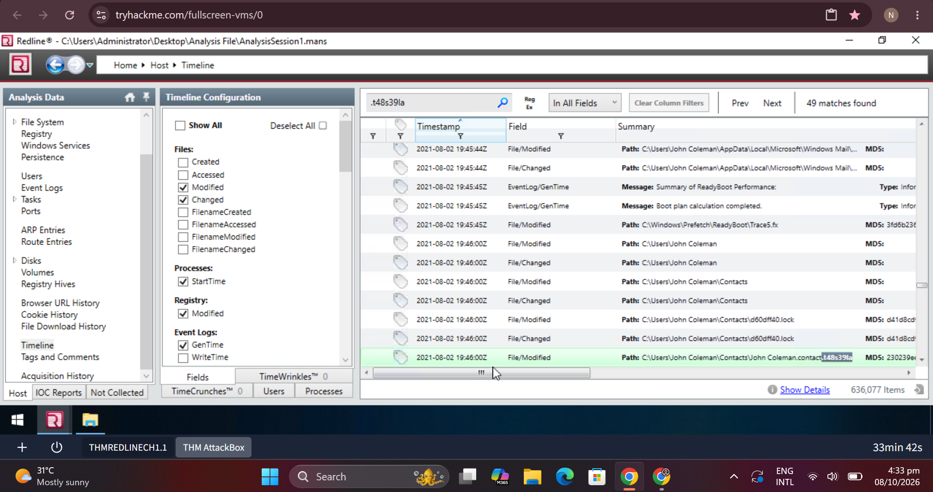
Figure 3 – Redline Timeline filtered for t48s39la: 49 matches, showing when the files were modified.
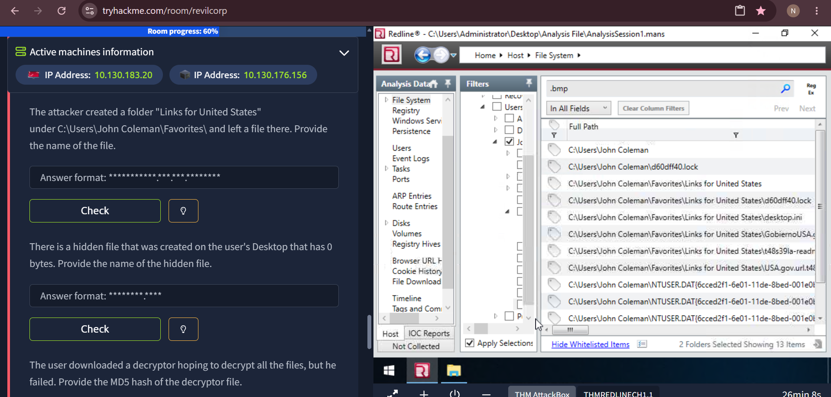
Figure 4 – Redline search showing the folder "Links for United States" in Favorites, where the attacker also left files (.lock and readme files).
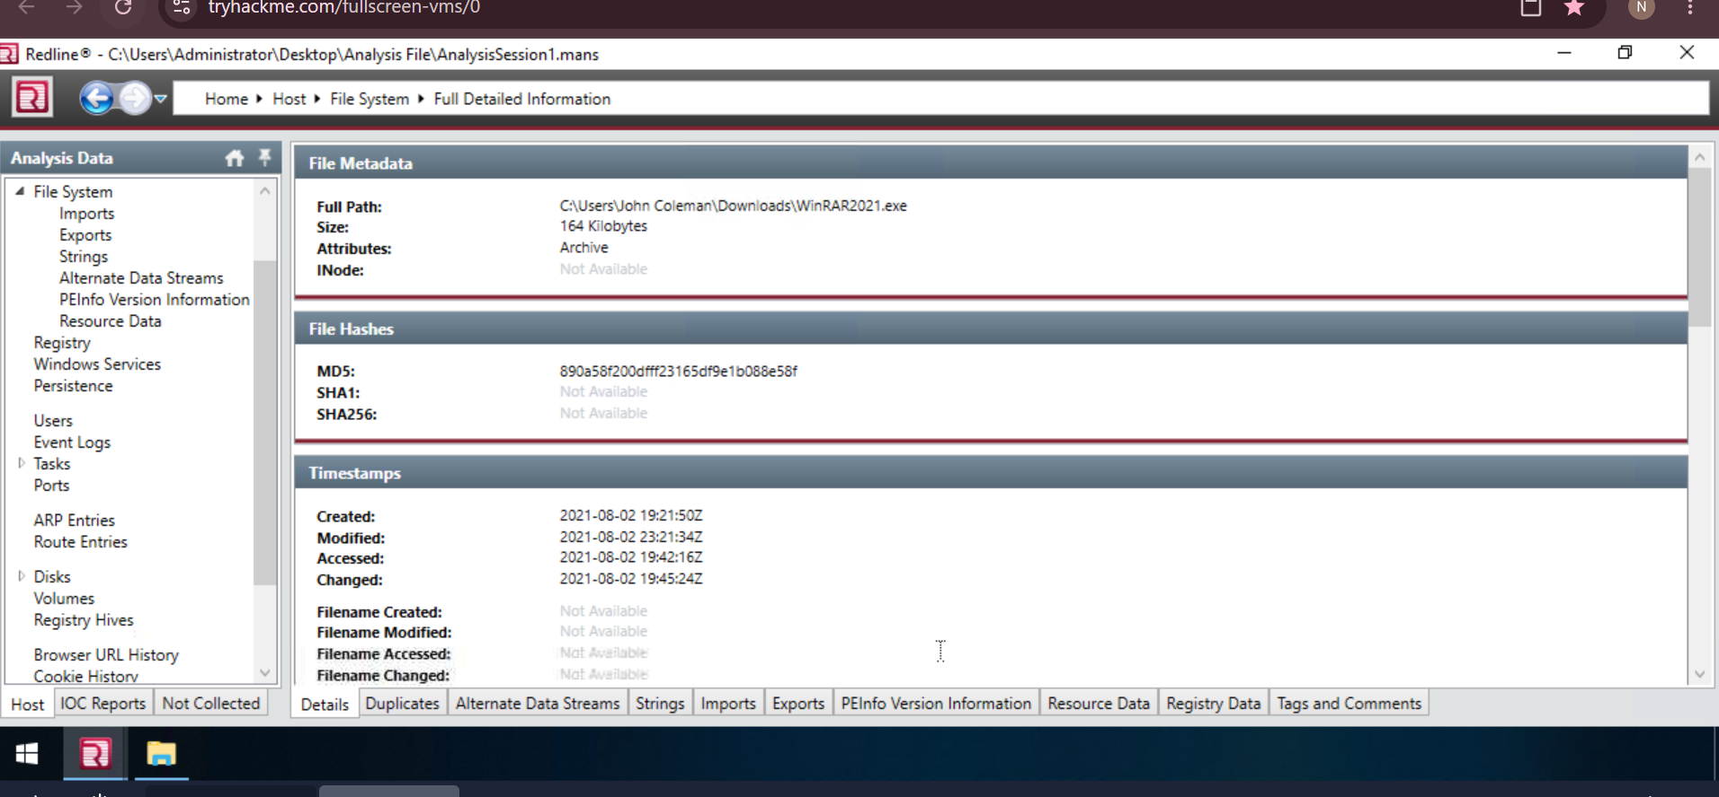
Figure 5 – Details of WinRAR2021.exe, the downloaded file, with its MD5 hash and timestamps.
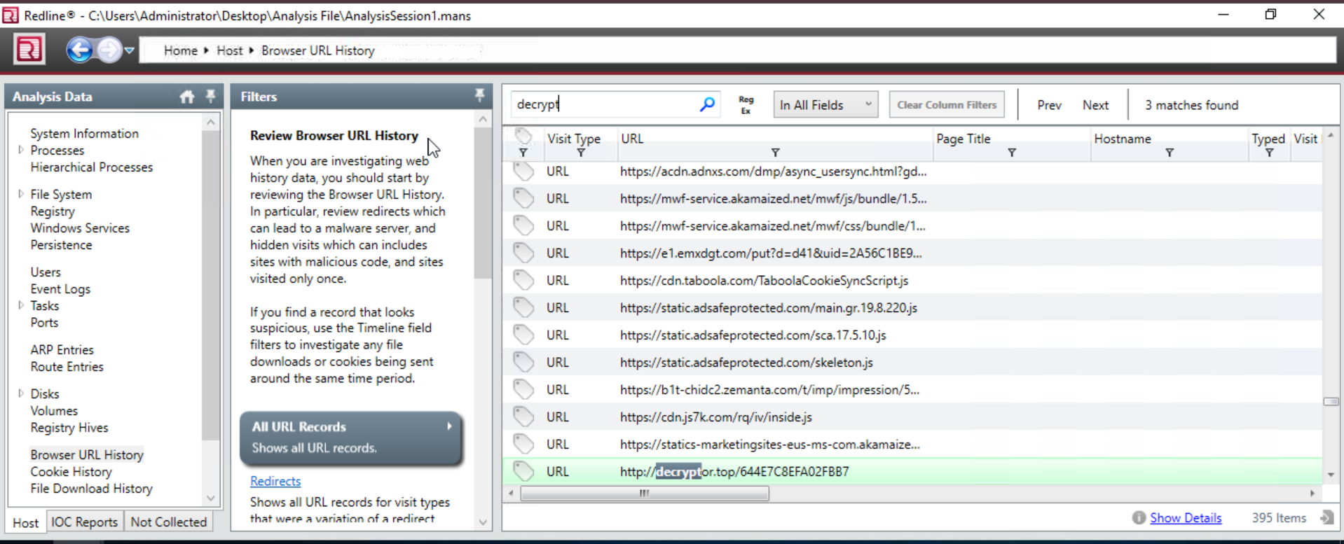
Figure 6 – Browser URL History showing the visit to http://decryptor.top/644E7C8EFA02FBB7.
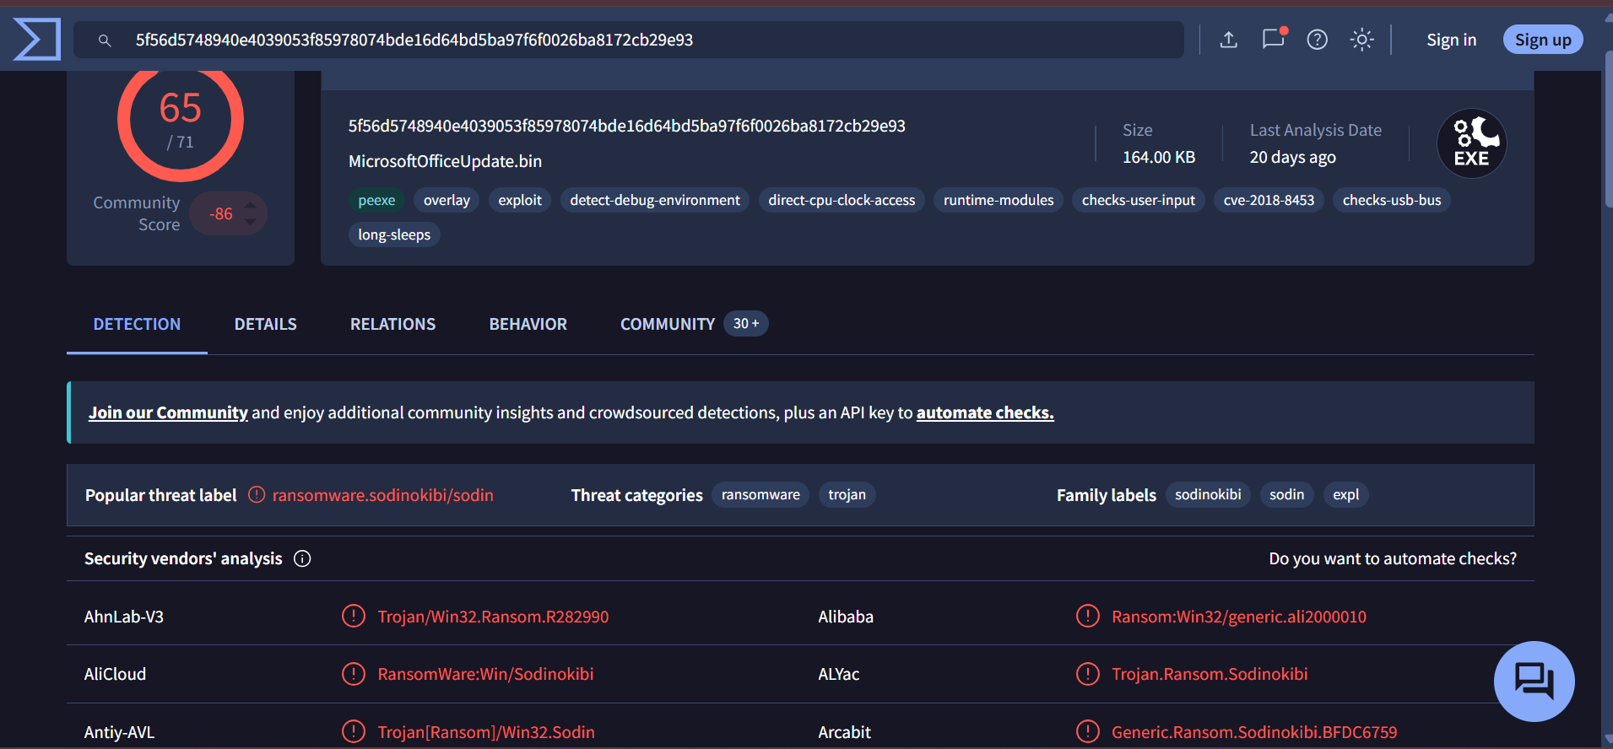
Figure 7 – VirusTotal result for the sample: 65 of 71 vendors flag it, labelled ransomware.sodinokibi/sodin.

2. MITRE ATT&CK Mapping
Status: Complete
MITRE ATT&CK is a public list of the tactics (goals) and techniques (methods) that attackers use. It gives security teams one shared language for describing an attack. The REvil attack was looked up on attack.mitre.org (Figures 8 to 12).
ID | Name | Tactic | How it appears in this case
T1486 | Data Encrypted for Impact | Impact | Files were encrypted and renamed .t48s39la so the user could not open them, then a ransom was demanded. MITRE says: "REvil can encrypt files on victim systems and demands a ransom to decrypt the files."
S0496 | REvil (also Sodin, Sodinokibi) | Software entry | The malware family: a ransomware-as-a-service (RaaS) linked to the GOLD SOUTHFIELD group, Windows platform. VirusTotal also labels the sample sodinokibi / sodin (Figure 7).
T1485 | Data Destruction | Impact | MITRE lists that REvil has the capability to destroy files and folders.
T1059.003 | Command and Scripting Interpreter: Windows Command Shell | Execution | MITRE lists that REvil uses the Windows command shell to delete volume shadow copies and disable recovery, so the victim cannot restore files.
T1189 | Drive-by Compromise | Initial Access | MITRE lists that REvil has infected machines through compromised websites and exploit kits. In this case the infection file WinRAR2021.exe was a fake download.

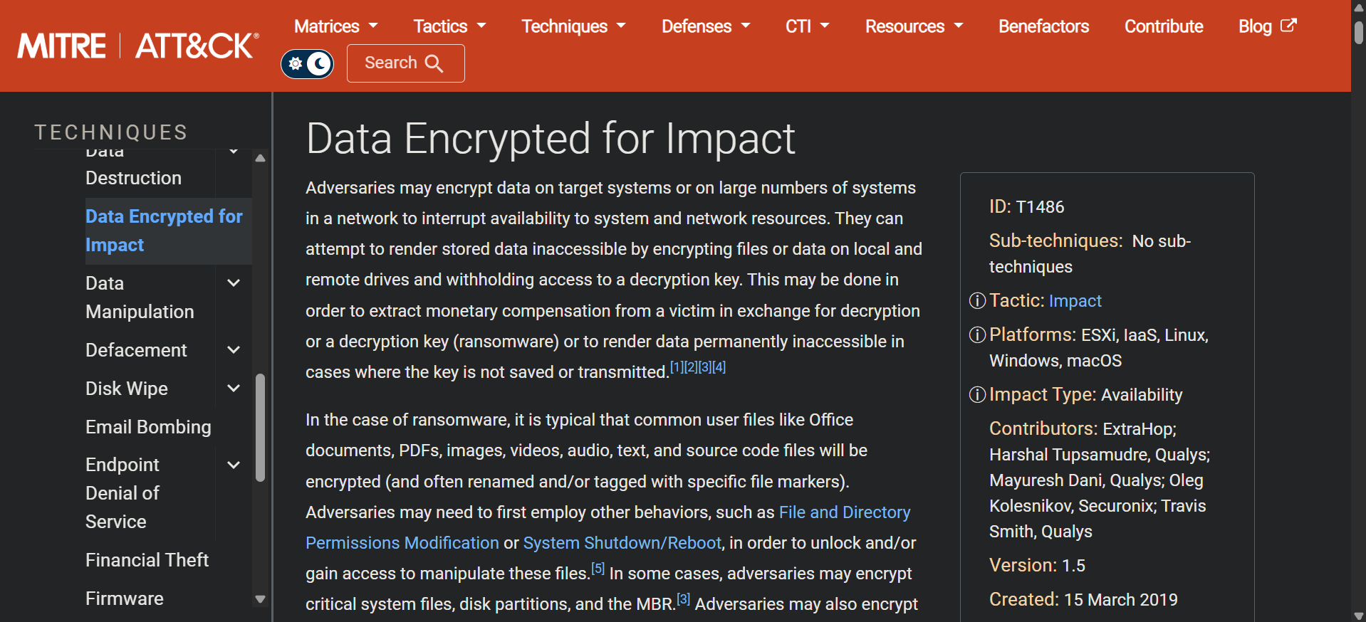
Figure 8 – MITRE ATT&CK technique T1486, Data Encrypted for Impact. Tactic: Impact; platforms: ESXi, IaaS, Linux, Windows, macOS; impact type: Availability.
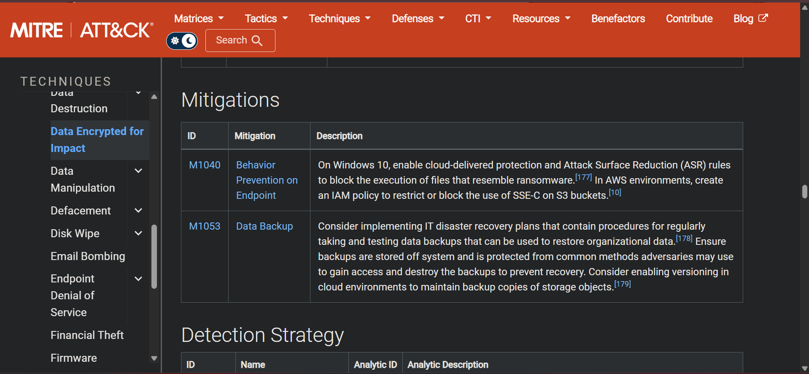
Figure 9 – Mitigations listed for T1486: M1040 Behavior Prevention on Endpoint and M1053 Data Backup.
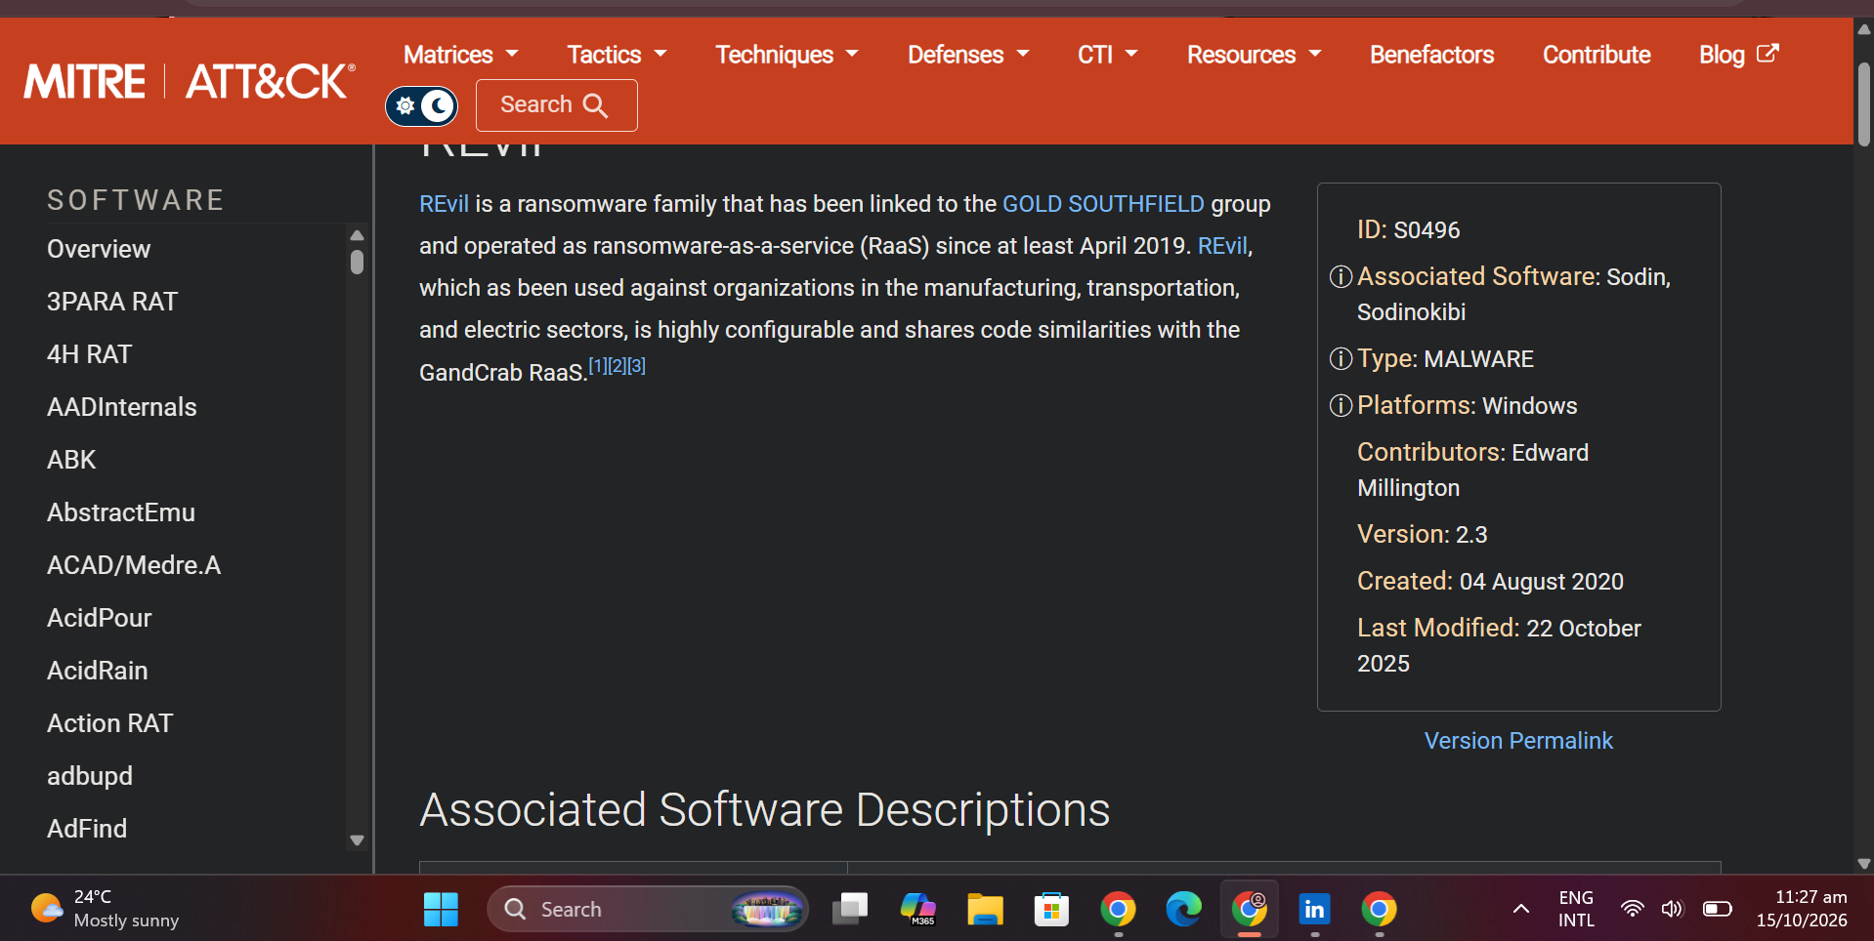
Figure 10 – MITRE software entry S0496 REvil: associated software Sodin and Sodinokibi, type malware, platform Windows.
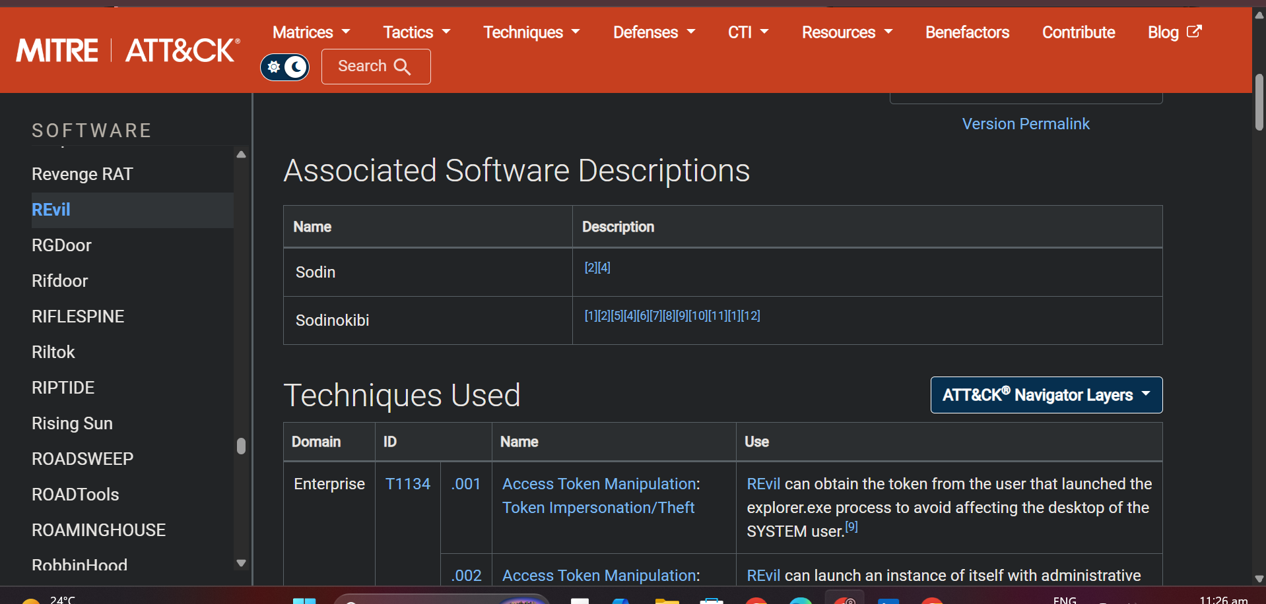
Figure 11 – Associated software descriptions (Sodin, Sodinokibi) and the start of the Techniques Used table for REvil.
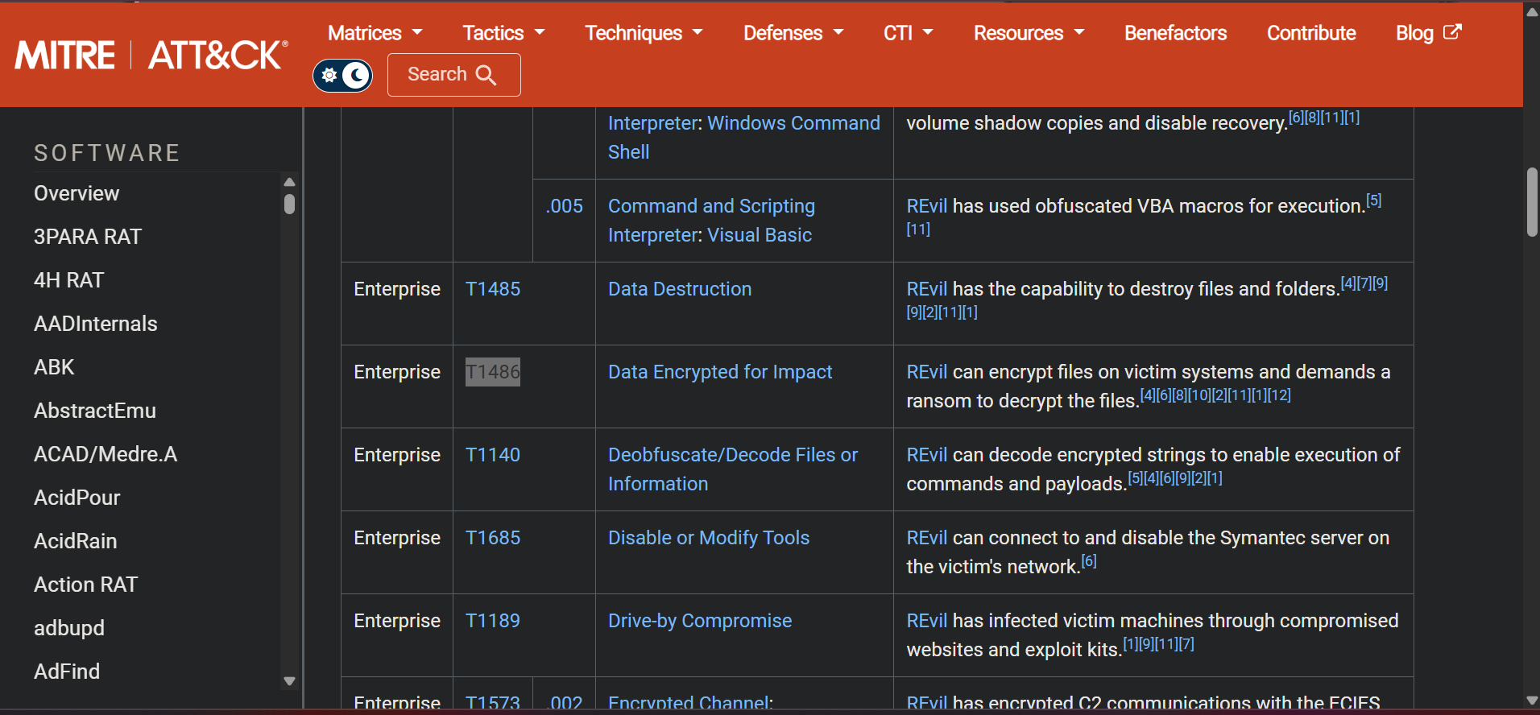
Figure 12 – REvil Techniques Used: T1486 Data Encrypted for Impact, T1485 Data Destruction and T1189 Drive-by Compromise.

3. Incident Response Plan
Status: Complete
This plan follows the six standard phases of incident response. It is written for a small team and uses simple steps that anyone on the team can follow under pressure.

3.1 Roles
Role | Responsibility
Incident Lead | Takes charge, makes decisions, decides how serious the incident is, and keeps a written log.
IT / Security Analyst | Investigates, isolates machines, removes the threat, restores systems.
Communications Lead | Informs management, staff, customers and authorities. Nobody else speaks to outsiders.
Management | Approves big decisions such as shutting down systems or contacting law enforcement.

3.2 Severity levels
Level | Meaning | Example
Low | One user affected, no data lost. | Blocked phishing email.
Medium | One machine infected, contained quickly. | Malware found on one laptop.
High | Several machines or sensitive data affected. | Ransomware encrypting a shared folder.
Critical | Business stopped or data stolen. | Ransomware across the network.

3.3 The six phases
Phase | What we do
1. Preparation | Keep a contact list of the team. Keep offline backups and test restoring them. Keep systems patched. Turn on logging and the endpoint tool (Wazuh). Train staff (Section 4).
2. Detection | Watch for: files with strange extensions (like .t48s39la), ransom notes (readme.txt files), files that suddenly cannot open, antivirus or Wazuh alerts, users reporting a locked screen. Confirm that it is real and give it a severity level. Start the incident log with date, time and who reported it.
3. Containment | Disconnect the infected computer from the network (unplug the cable or turn off Wi-Fi). Do NOT turn it off, so the evidence stays in memory. Disable the user's accounts. Block bad URLs and file hashes. Check other computers for the same signs.
4. Eradication | Find how it got in (for example a fake download). Remove the malware and any leftovers. Reset passwords for affected accounts. Patch the weakness. Check hashes on VirusTotal.
5. Recovery | Rebuild or clean the machine. Restore files from clean offline backups. Test that everything works. Watch the system closely for a few weeks. Do not pay the ransom: there is no guarantee of getting the files back, and it pays the attacker.
6. Lessons learned | Hold a meeting within two weeks. Write what happened, what worked and what did not. Update this plan and the training. Share a short report with management.

3.4 Ransomware playbook (quick checklist)
- Stop: do not click, do not run any "decryptor" from the internet (in this case the fake decryptor did not work).
- Isolate: unplug the machine from the network.
- Report: call the Incident Lead straight away.
- Record: take photos of the screen and the ransom note, write down the time.
- Check: look for the same file extension and ransom note on other machines.
- Recover: restore from clean backups after the threat is removed.
- Review: update the plan after the incident.

3.5 Communication
Staff report to the Incident Lead only. The Incident Lead tells management. The Communications Lead decides what customers and authorities are told and when. Everyone avoids discussing the incident on public channels.

4. Staff Training Guide
Status: Complete
There were no real staff to train in this internship, so a one-page guide was written that could be given to staff or used in a short training session.

How to spot ransomware
- Files suddenly will not open, or their names end in a strange extension.
- A note appears asking for money or telling you to visit a website.
- The desktop wallpaper changes.
- You were just asked to download software from an unofficial website or email link.

Do
- Disconnect from Wi-Fi or unplug the network cable at once.
- Tell the Incident Lead immediately, even if you are not sure.
- Take a photo of the screen.
- Only download software from the official website.

Do not
- Do not turn the computer off or delete anything.
- Do not run a "decryptor" or "fix" tool from the internet.
- Do not pay the ransom.
- Do not hide it: reporting fast saves the company.

Quick test for staff
1) You see files ending in .t48s39la. What do you do first? Answer: disconnect and report. 2) A website offers "WinRAR2021.exe" for free. Do you run it? Answer: no, only use the official site.

5. Case Study – Kaseya VSA Attack (REvil, July 2021)
Status: Complete
The task suggested a "Cybersecurity Breaches" link, but it could not be opened. A well-known public REvil incident was used instead.
In July 2021 the REvil group abused a weakness in Kaseya's VSA remote management software. Because managed service providers use that software to manage their customers, the ransomware was pushed to many businesses at once, a supply-chain attack. REvil asked for a very large ransom in exchange for a single decryptor for all victims.

What this teaches us
- Keep software patched and watch the vendors we depend on.
- Keep offline backups that the attacker cannot reach.
- Limit remote-management tools and monitor them closely.
- Have a plan ready before the incident, because the first hours matter most.

6. Conclusion and Limits
Status: Complete
The ransomware simulation was completed and investigated in Redline, mapped to MITRE ATT&CK (T1486 and S0496), and turned into a six-phase incident response plan and a staff training guide. Limits: the attack was a lab simulation, there was no real staff to train, and the plan is a template that Internee.pk would adjust to its own systems and contacts.
Sources: TryHackMe REvil Corp room; MITRE ATT&CK (attack.mitre.org, T1486 and S0496); VirusTotal; Mandiant Redline.

