

Cloud Computing Project Report

Project 6 – High-Performance Web Hosting Platform

Semester:5B

Submitted To:
Sir Waqas
Group Members:
Nayab Khazin_046
Safa Jahangir_056
Maria Abdul Malik_076

Submission Date: 27-01-2026
Contents
Part 1: Git Repository Setup 3
1.1 Repository Structure 3
1.2 Git Branching Strategy 3
1.3 .gitignore Configuration 4
Part 2: Terraform Infrastructure 6
2.1 Network Module (VPC & Subnets) 6
2.2 Load Balancer EC2 Module 8
2.3 Web EC2 Module 10
Part 3: Environment Configuration 11
3.1 Root Terraform Configuration 11
3.2 Environment-Specific Variables 12
Part 4: Ansible Web Stack & Websites 12
4.1 Dynamic Inventory Configuration 12
4.2 Web Stack Role (Nginx + PHP-FPM) 13
4.3 Load Balancer Nginx Role 15
4.4 Website Deployment & Onboarding 15
Part 5: Monitoring & Customer Onboarding 16
5.1 Monitoring Scripts 16
5.2 Customer Onboarding Documentation 17
Conclusion 17

Part 1: Git Repository Setup

1.1 Repository Structure
The repository was structured according to the project requirements, separating Terraform, Ansible, website content, and documentation. This modular structure improves maintainability and scalability.
- project6_part1_repository_structure.png
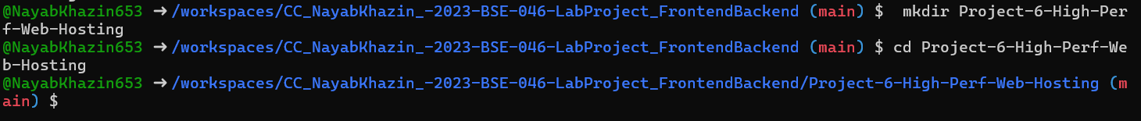
- project6_part1_initial_commit.png
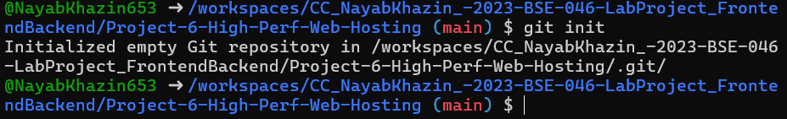

1.2 Git Branching Strategy
A three-level branching strategy was followed:
main: production
staging: pre-production
test: internal testing
Feature branches were merged into test before promotion.
- project6_part1_git_branches.png
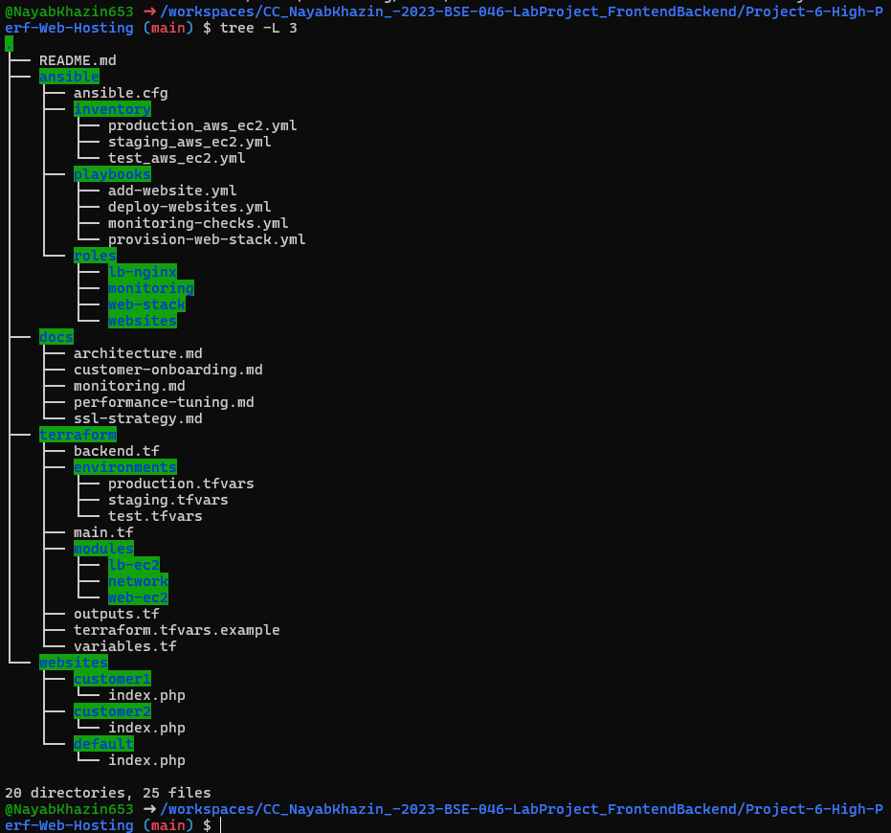

1.3 .gitignore Configuration
.gitignore was configured to prevent Terraform state files, credentials, keys, and temporary files from being committed.
- project6_part1_gitignore_content.png
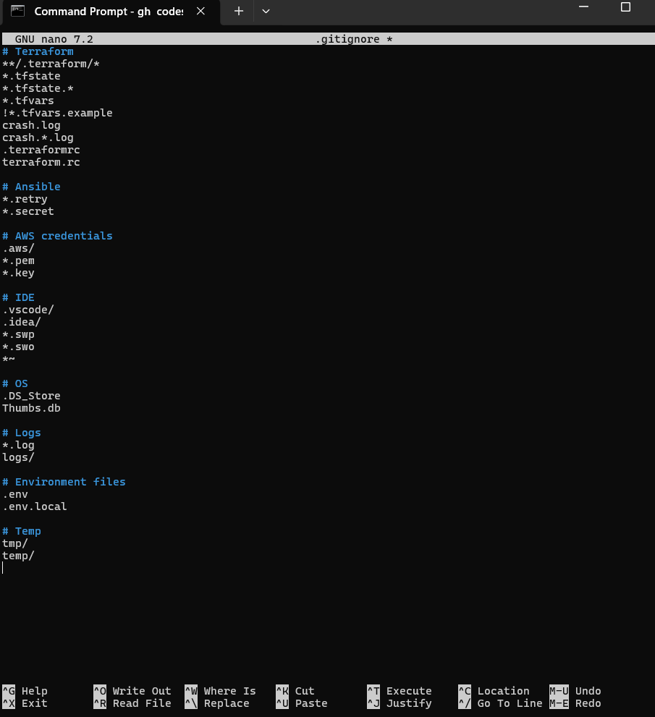
- project6_part1_git_status_clean.png
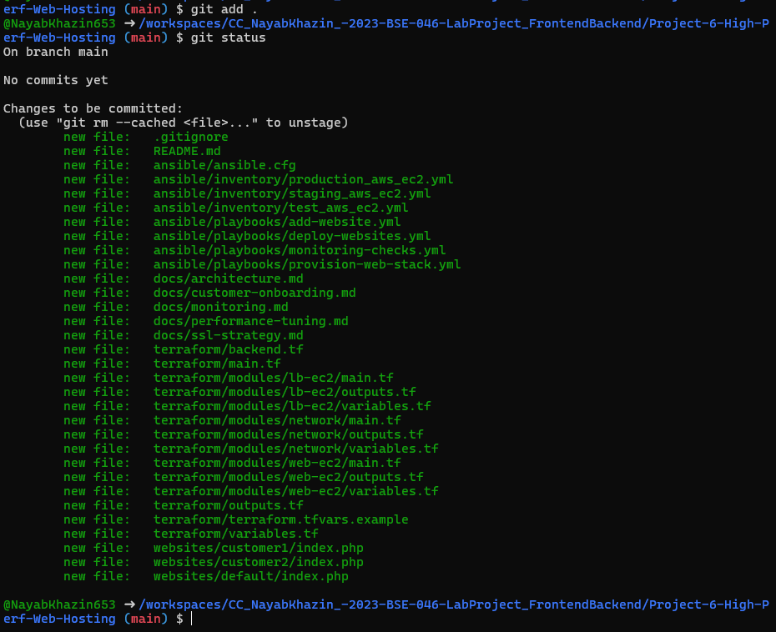

Part 2: Terraform Infrastructure

2.1 Network Module (VPC & Subnets)
Terraform was used to provision a VPC with public and private subnets across two Availability Zones. An Internet Gateway and route tables were configured. A NAT Gateway was used to allow outbound access for private instances.
- project6_part2_network_main.png
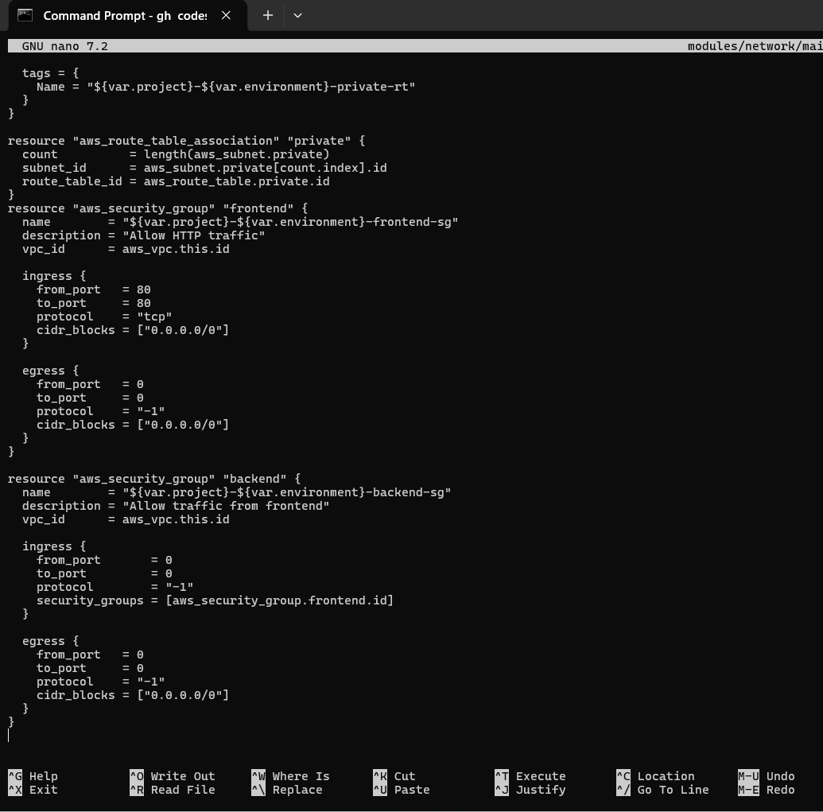
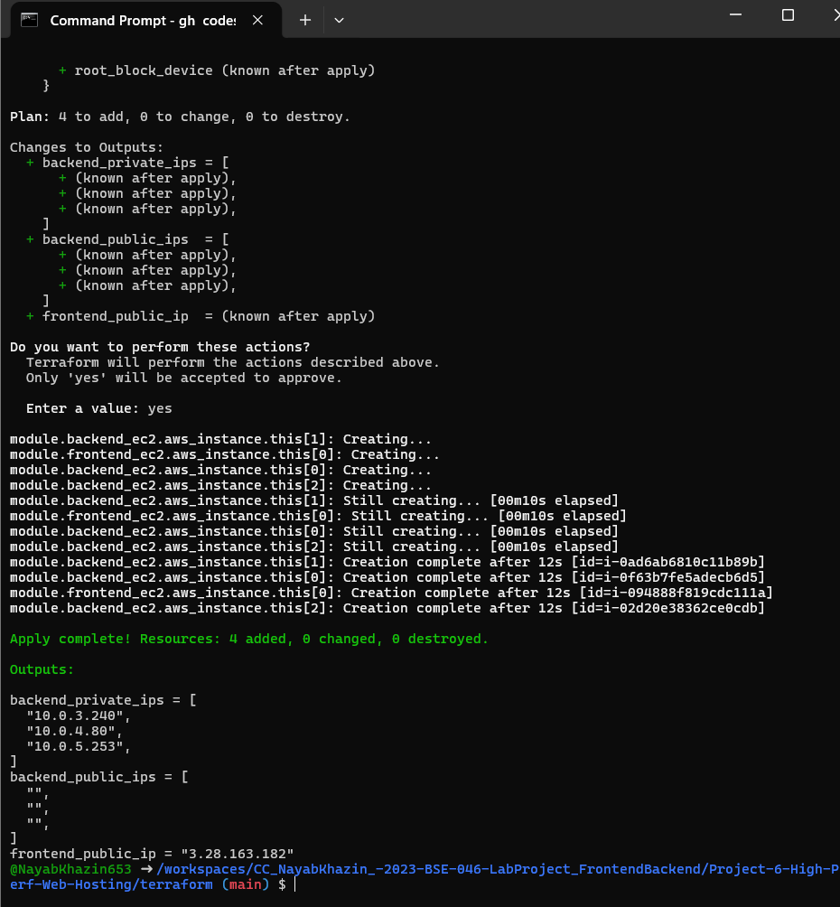
- project6_part2_network_outputs.png
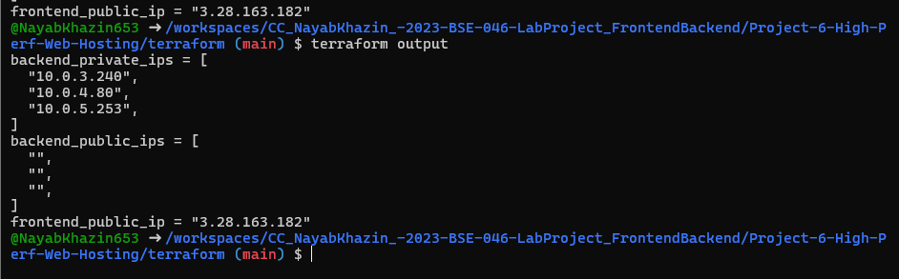

2.2 Load Balancer EC2 Module
Two EC2 instances were provisioned as Nginx-based load balancers in public subnets. Security groups allow HTTP/HTTPS from the internet and SSH from the admin IP.
- project6_part2_lb_ec2_main.png
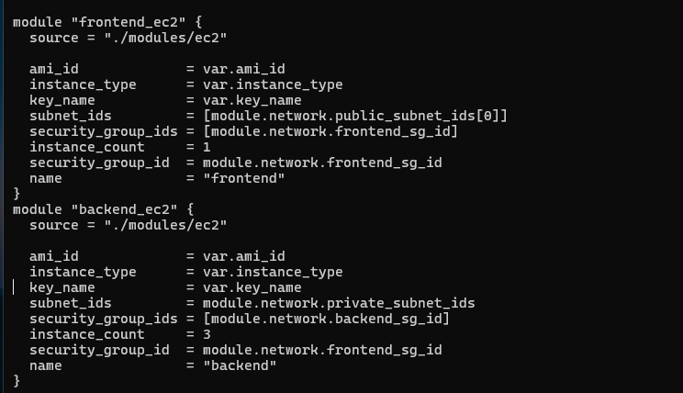
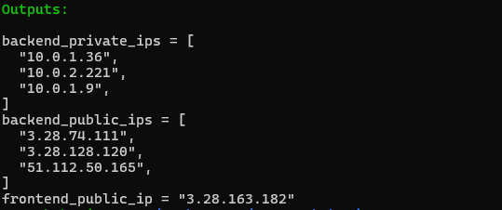
- project6_part2_lb_ec2_outputs.png
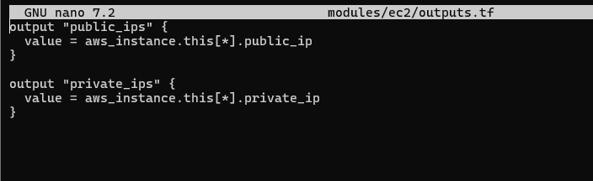
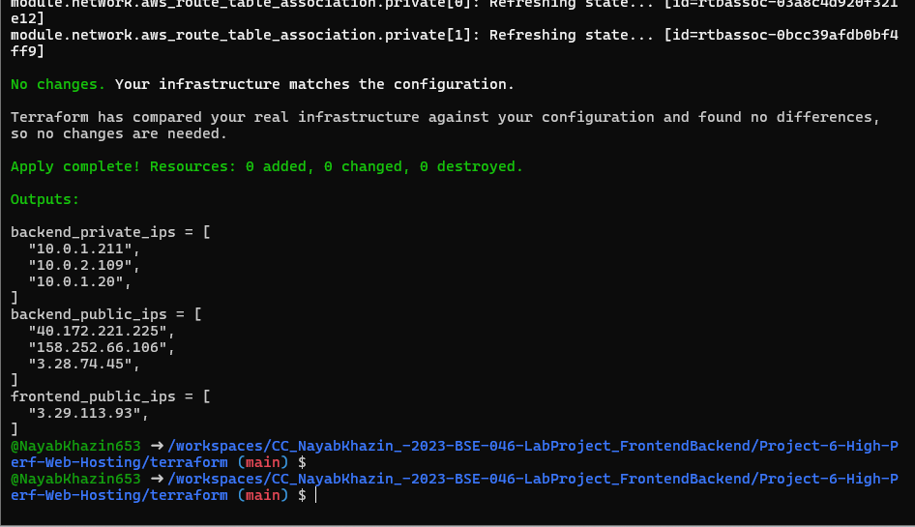

2.3 Web EC2 Module
Web servers were deployed in private subnets across multiple AZs. They accept traffic only from the load balancer security group.
- project6_part2_web_ec2_main.png
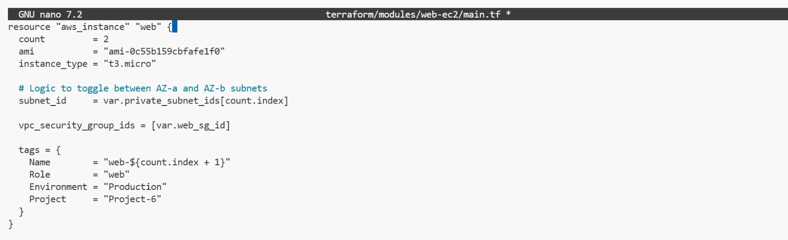
- project6_part2_web_ec2_outputs.png
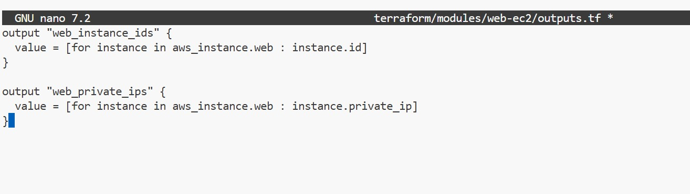

Part 3: Environment Configuration

3.1 Root Terraform Configuration
The root Terraform configuration instantiates all modules and exports outputs such as load balancer public IPs and web server private IPs for Ansible use.
- project6_part3_main_tf.png
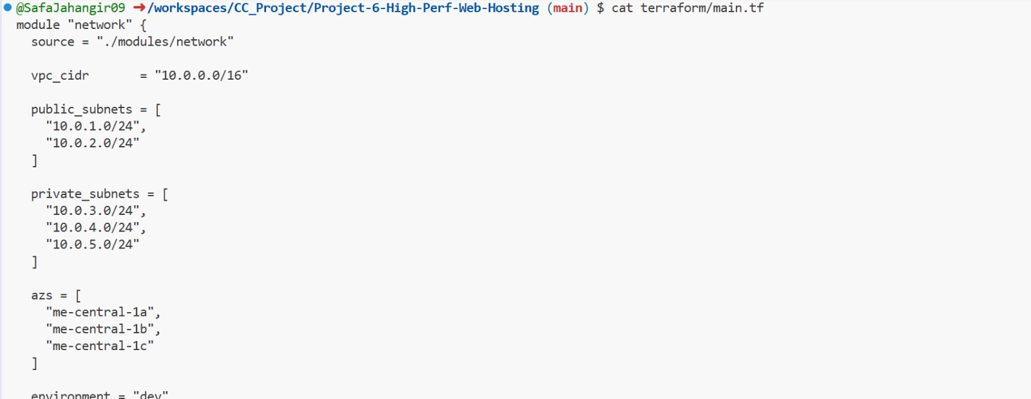
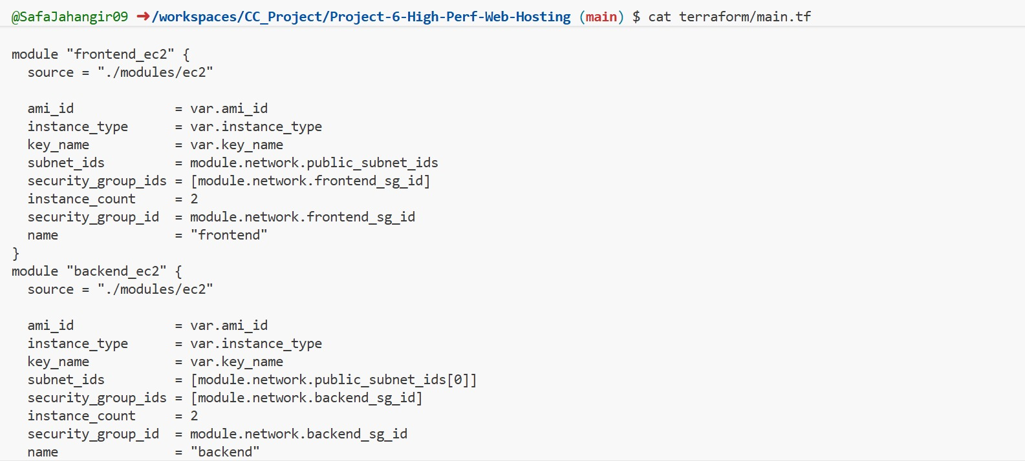
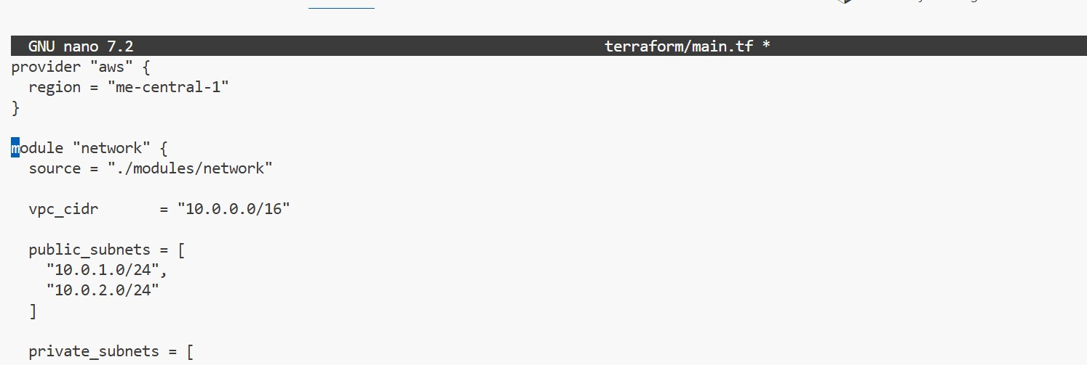
- project6_part3_outputs_tf.png
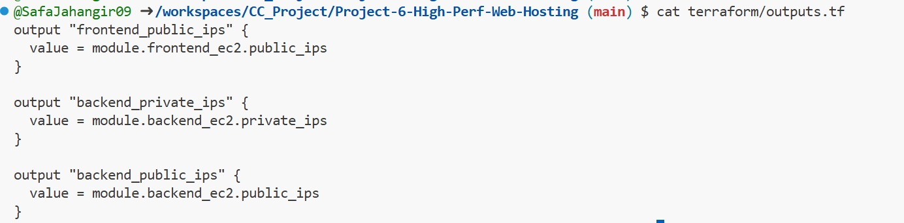

3.2 Environment-Specific Variables
Separate tfvars files were created for test, staging, and production environments. These define instance sizes, counts, and admin IP restrictions.
- project6_part3_test_tfvars.png
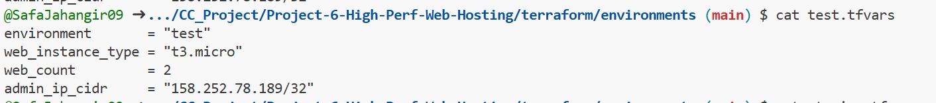
- project6_part3_staging_tfvars.png
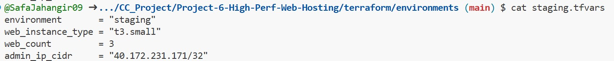
- project6_part3_production_tfvars.png
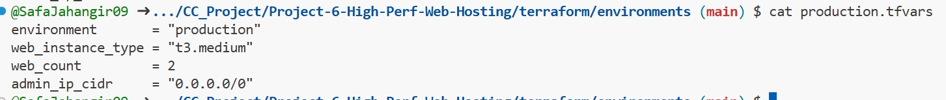
- project6_part3_tfvars_example.png
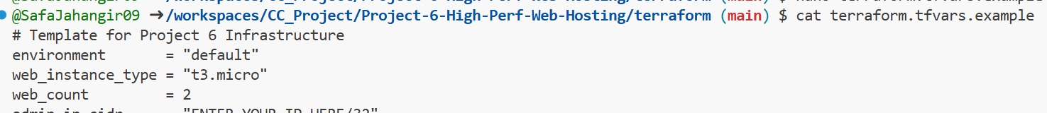

Part 4: Ansible Web Stack & Websites

4.1 Dynamic Inventory Configuration
Ansible uses the aws_ec2 dynamic inventory plugin to automatically discover instances based on tags.
- project6_part4_ansible_inventory_graph.png

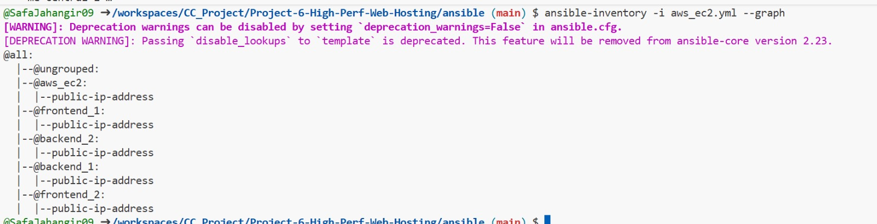
- project6_part4_ansible_cfg.png

4.2 Web Stack Role (Nginx + PHP-FPM)
The web-stack role installs and configures Nginx and PHP-FPM with performance tuning. Multiple customer websites are hosted using Nginx server blocks.
- project6_part4_web_stack_role_main.png
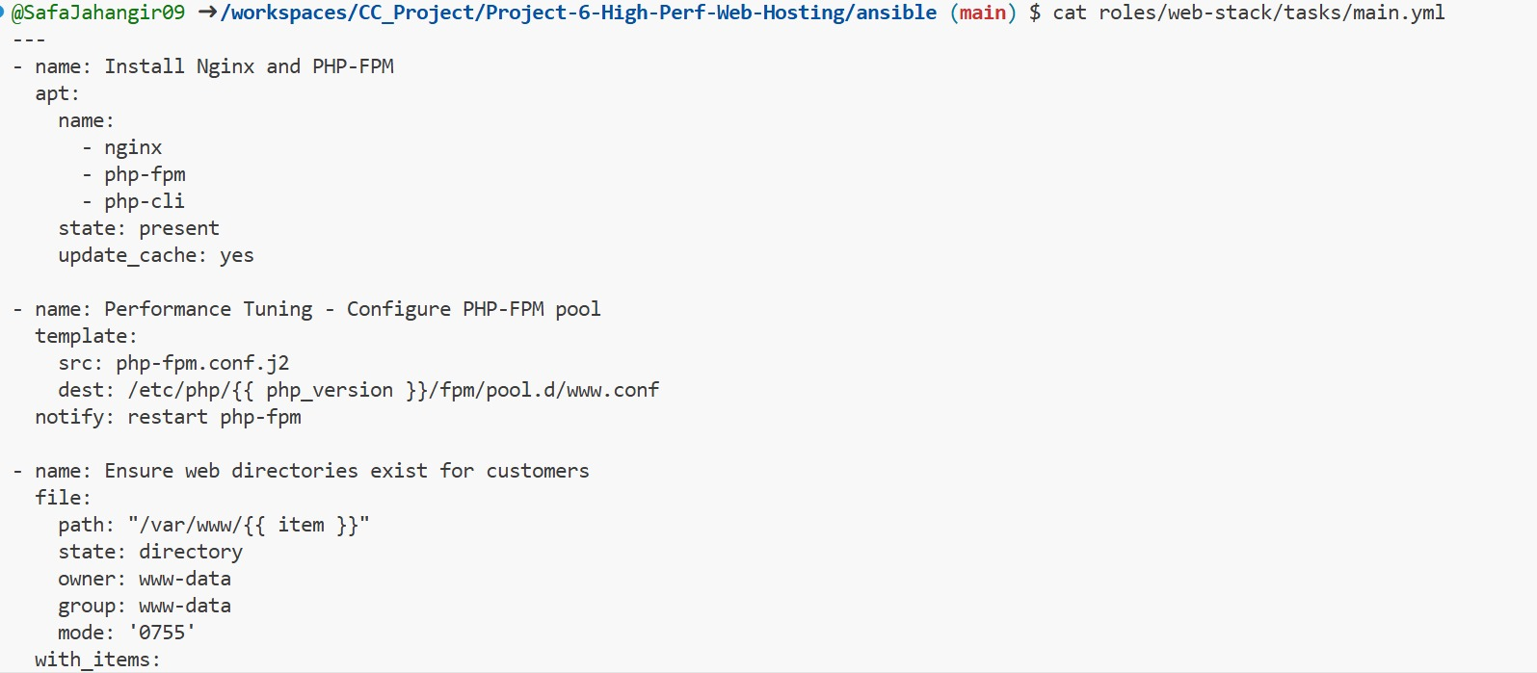
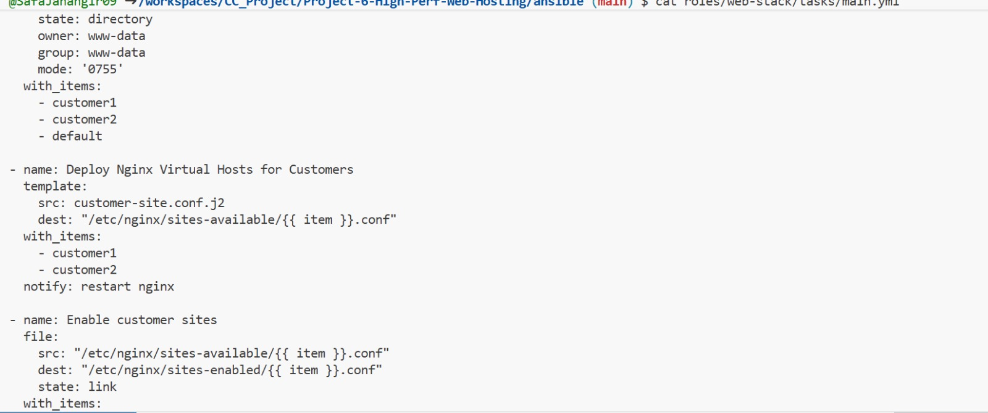

- project6_part4_nginx_server_blocks.png
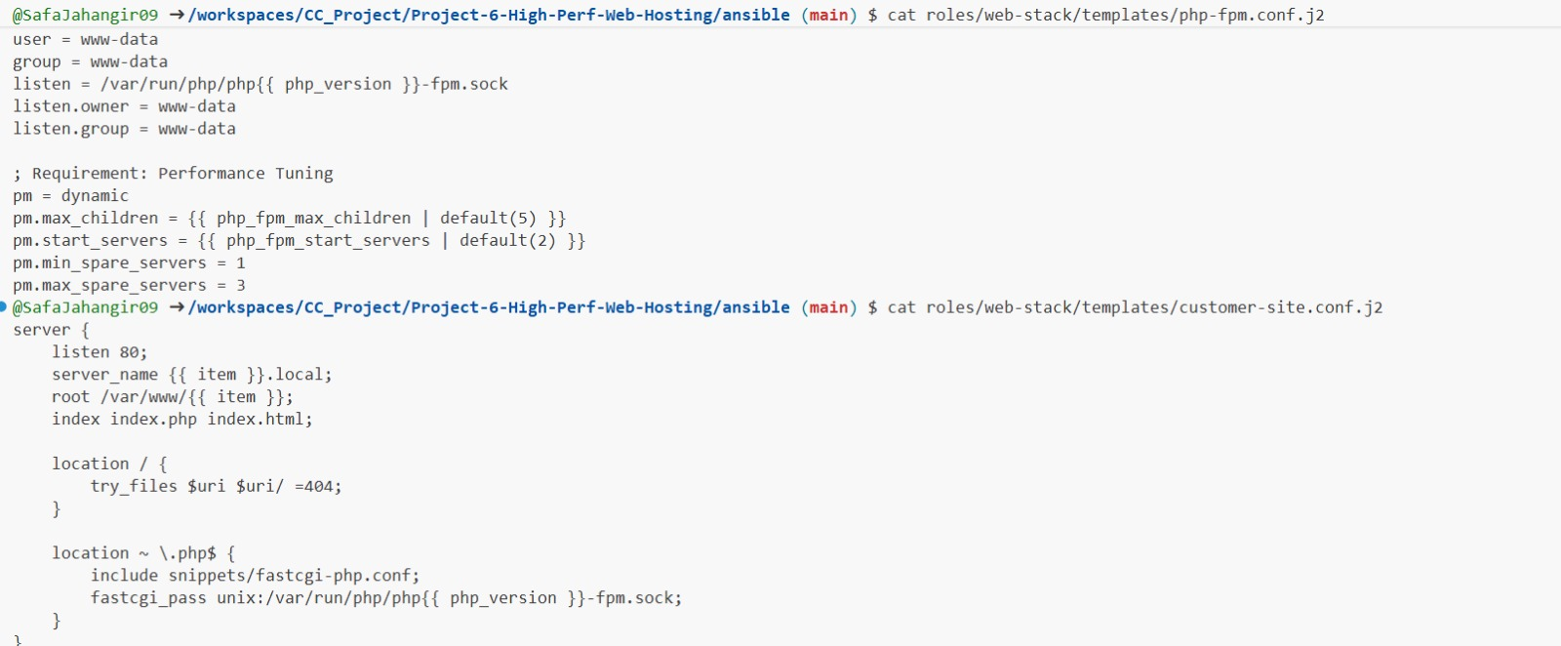

4.3 Load Balancer Nginx Role
The load balancer role configures Nginx as a reverse proxy with SSL termination, caching, and a backup server.
- project6_part4_lb_nginx_conf.png
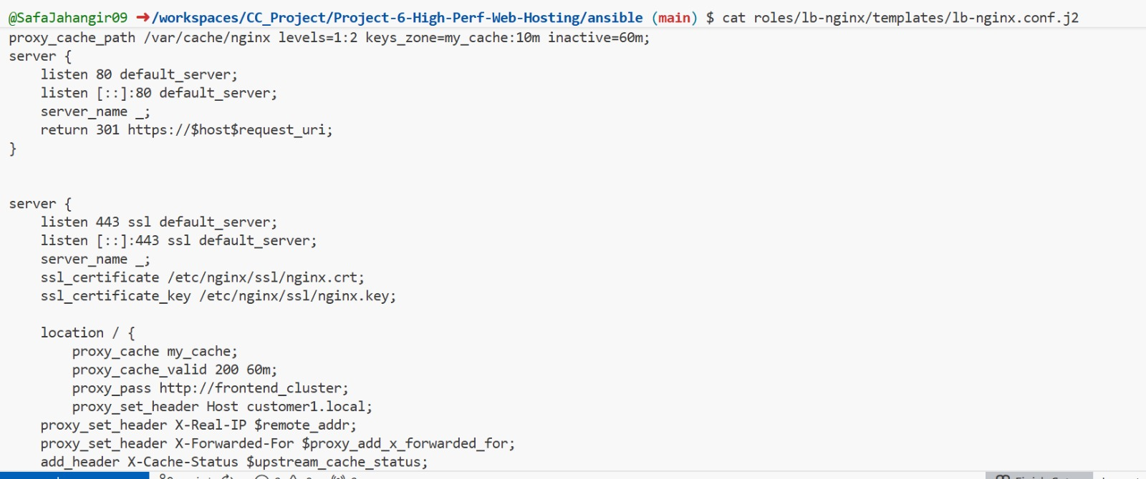
- project6_part4_lb_ssl_certs.png
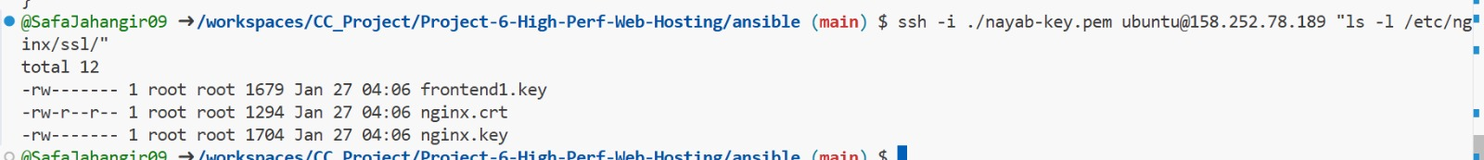

4.4 Website Deployment & Onboarding
Websites are deployed using Ansible playbooks. New customer sites can be added automatically using variables.
- project6_part4_add_website_playbook.png
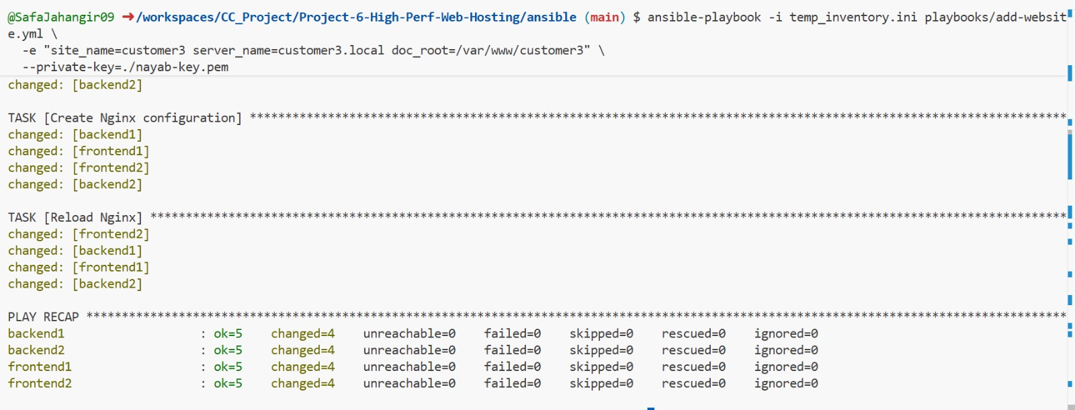

- project6_part4_new_site_added.png

Part 5: Monitoring & Customer Onboarding

5.1 Monitoring Scripts
A bash-based monitoring script checks HTTP status and response time for each site and logs results periodically via cron.
- project6_part5_monitoring_script.png
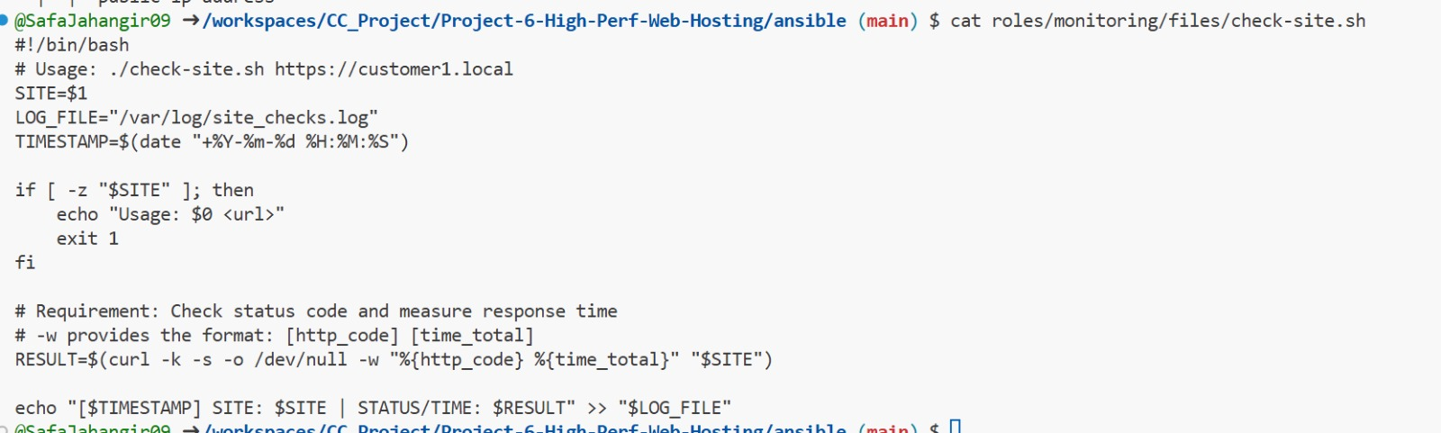
- project6_part5_monitoring_log_output.png
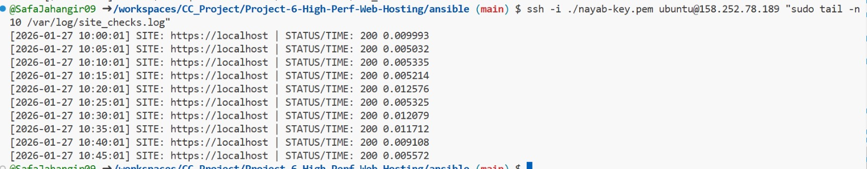

5.2 Customer Onboarding Documentation
The onboarding document explains required inputs, Ansible commands, verification steps, and directory conventions.
- project6_part5_customer_onboarding_doc.png
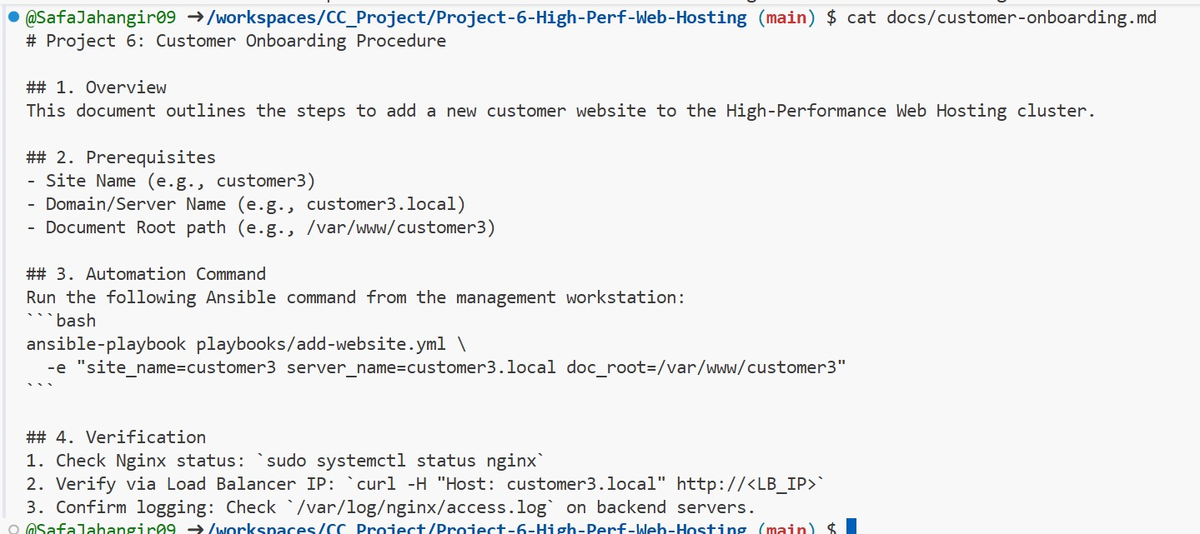

Conclusion
This project demonstrates a production-ready, high-performance web hosting platform using Terraform and Ansible. All requirements were implemented within course scope, including high availability, SSL, caching, automation, and monitoring.

