**Cloud Computing Lab**

**Nayab khazin**

**BSE-V B**

**2023-BSE-046**

**LAB 03**

**Task 1 – Handling Local and Remote Commit Conflicts (Pull vs Pull --rebase)**

* remote_edit.png

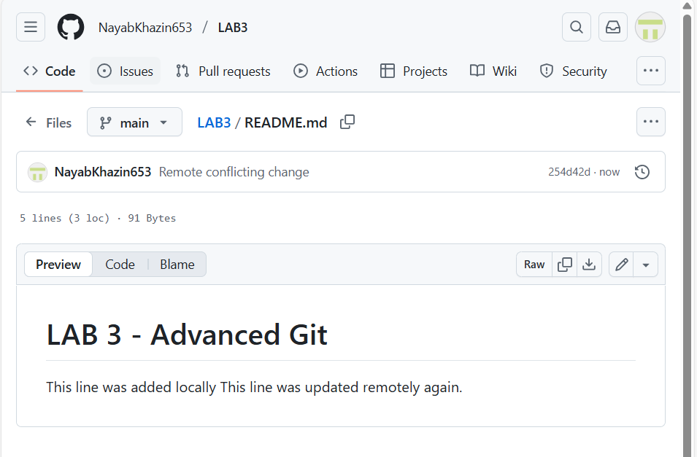

* local_commit.png

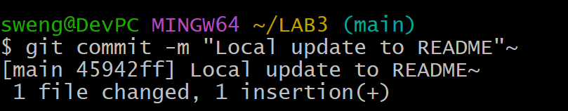

* push_error.png

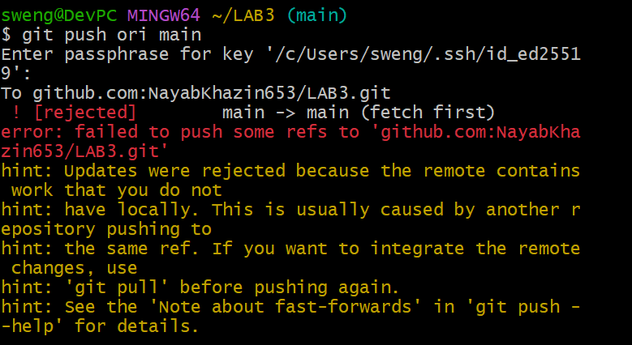

* merge_commit.png

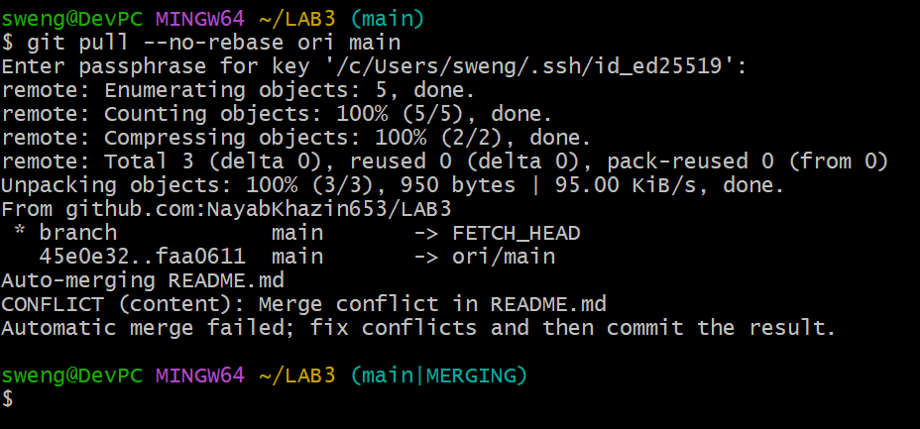

* push_after_merge.png

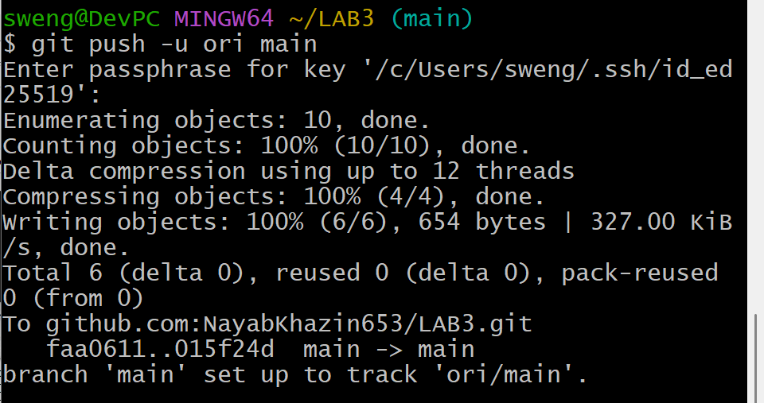

* rebase_pull.png

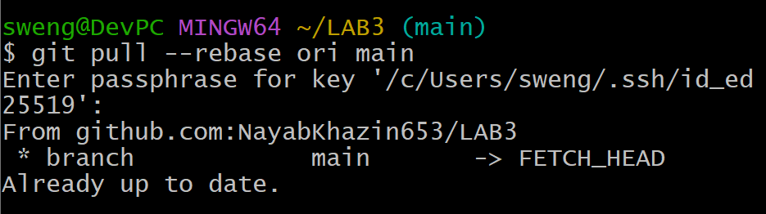

* push_after_rebase.png

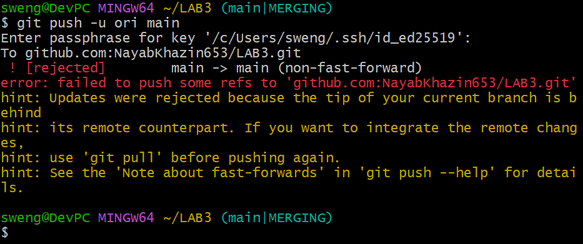

## Task 2 – Creating and Resolving Merge Conflicts Manually

* remote_conflict_edit.png

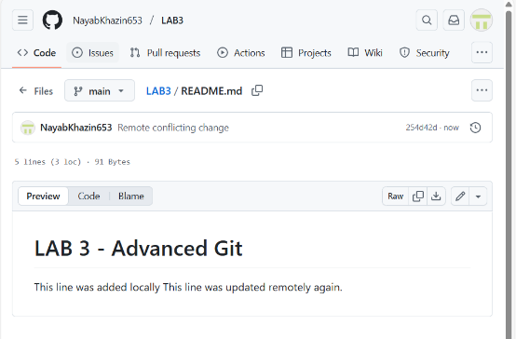

* local_conflict_edit.png

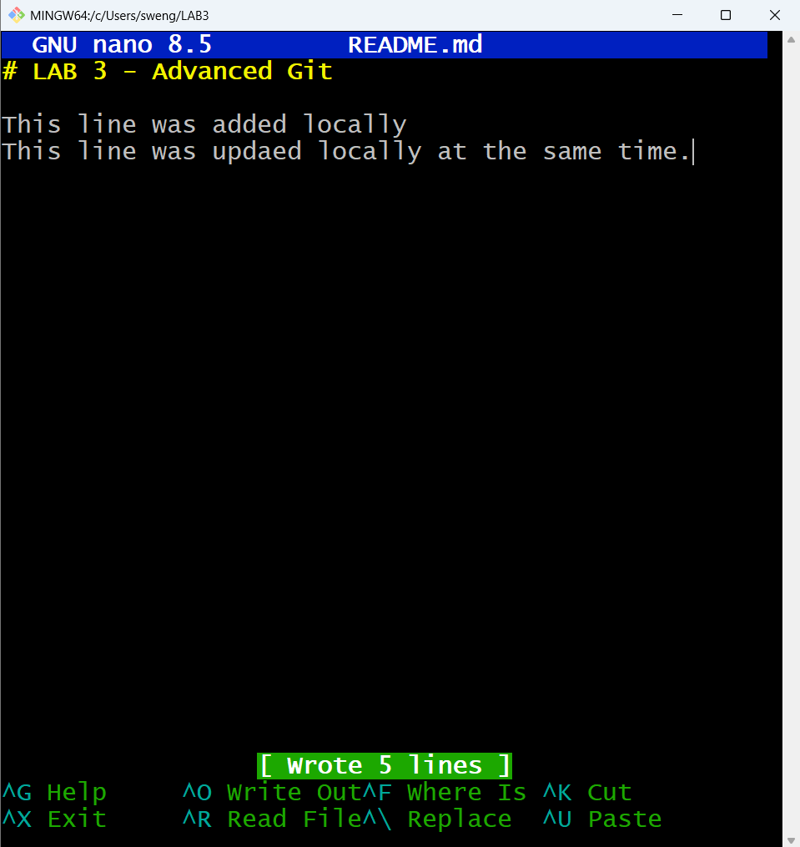

* local_conflict_commit.png

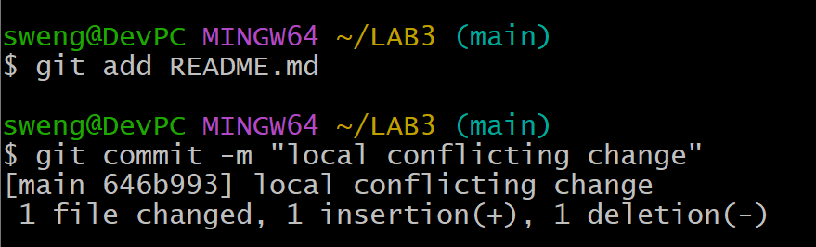

* conflict_push_error.png

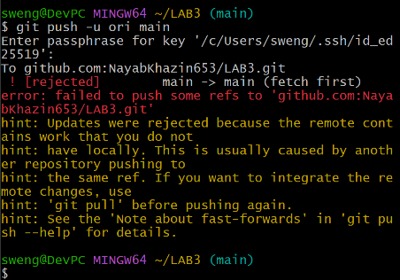

* conflict_message.png

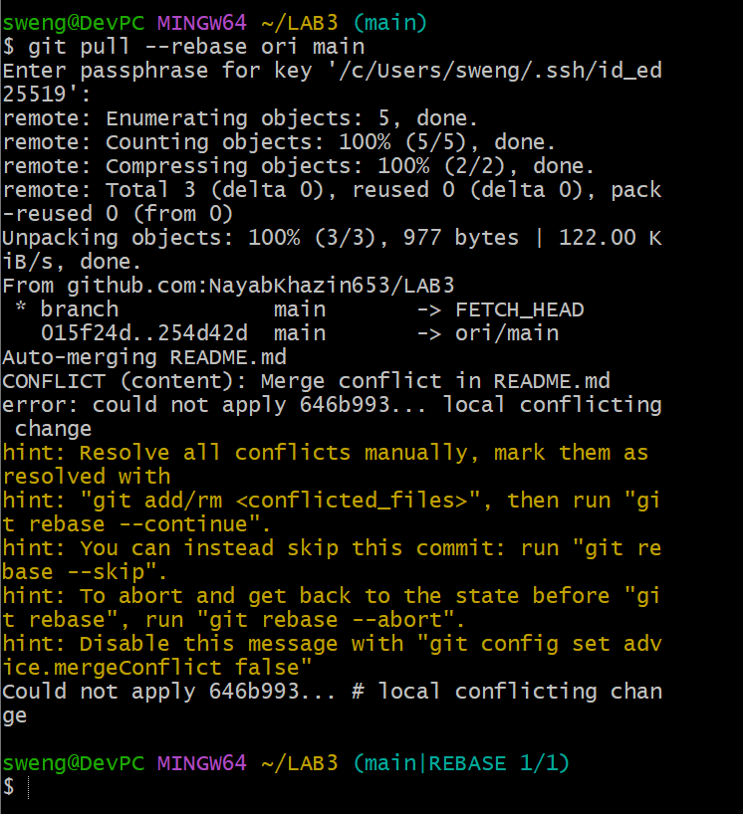

* resolved_readme.png

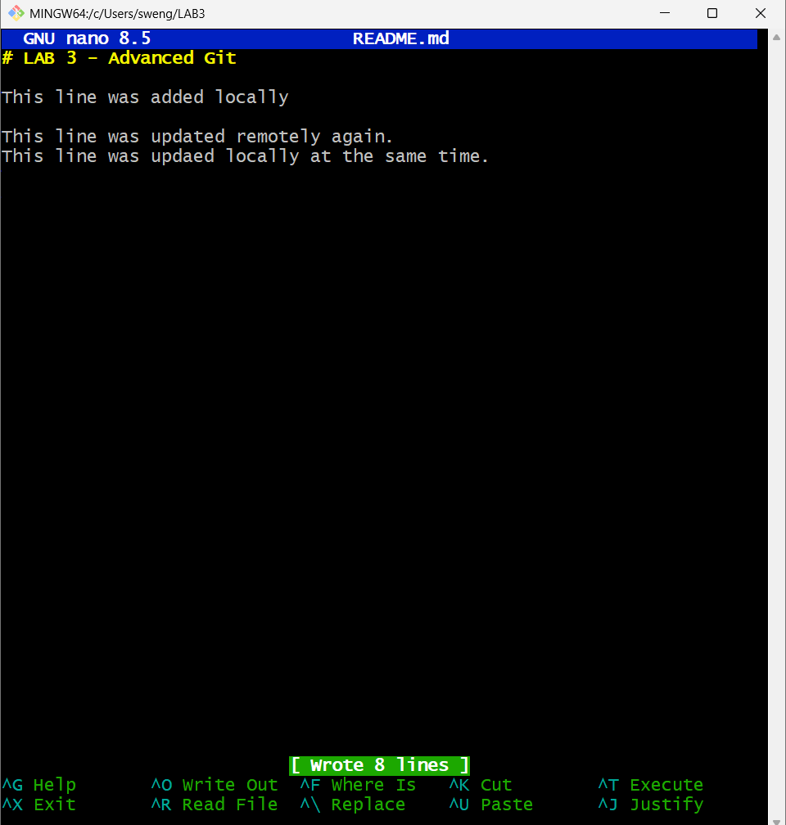

* rebase_continue.png

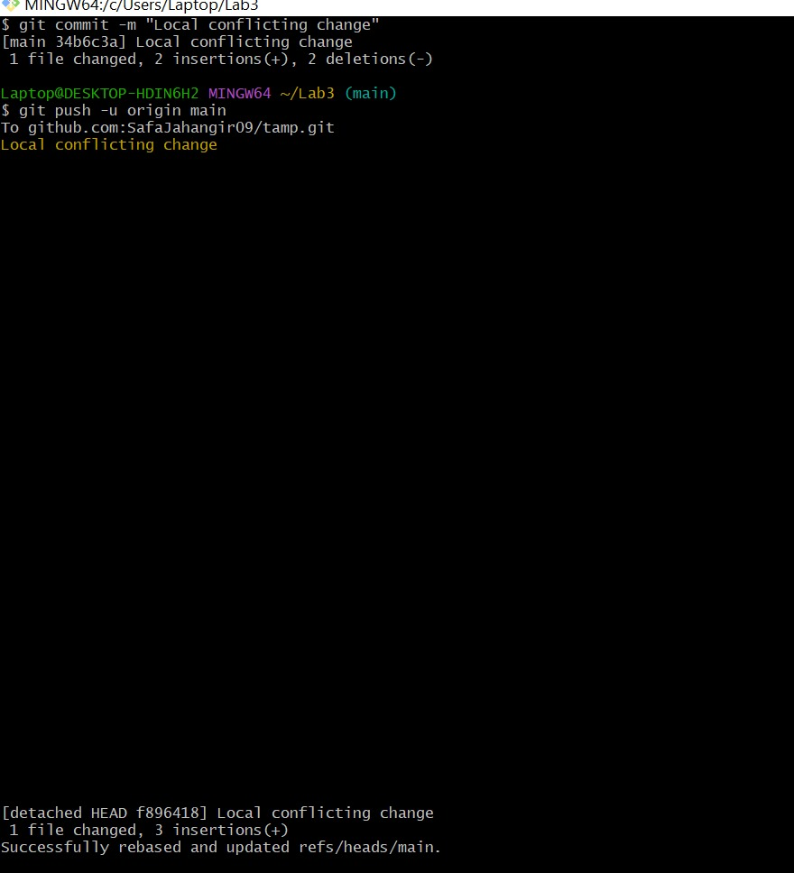

* push_after_resolve.png

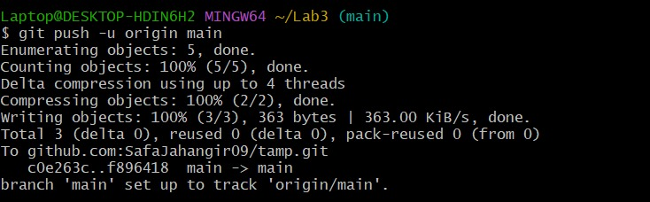

## Task 3 – Managing Ignored Files with .gitignore and Removing Tracked Files

* push_textfiles.png

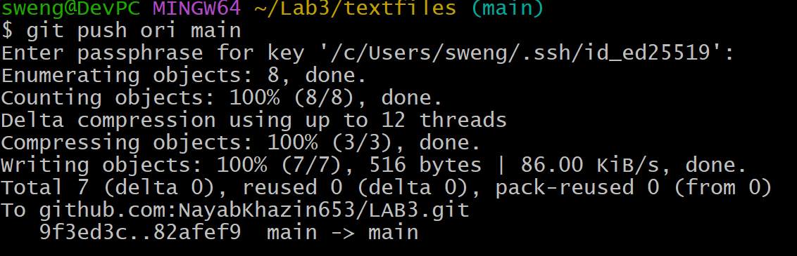

* gitignore_push.png

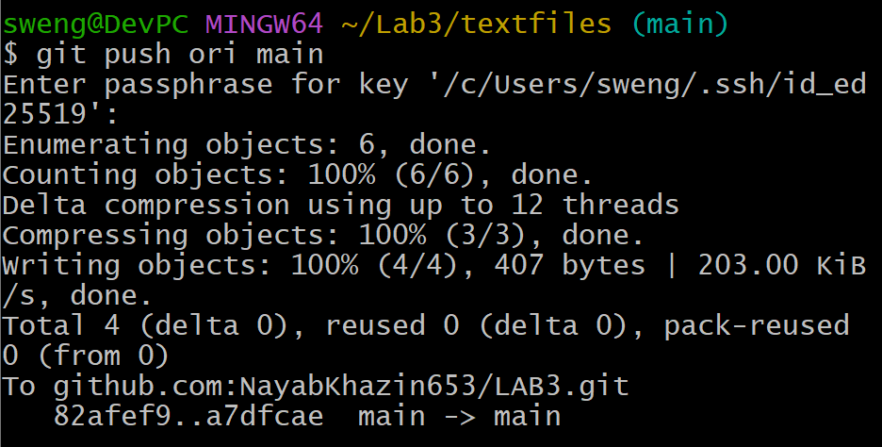

* repo_still_has_textfiles.png

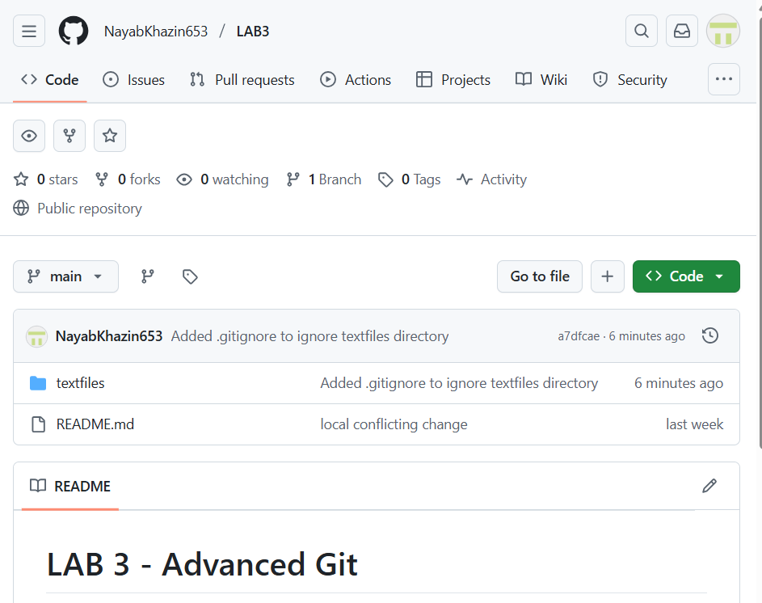

* rm_cached_push.png

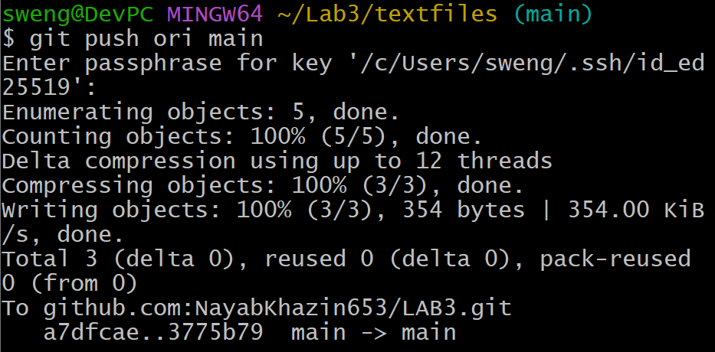

* repo_textfiles_removed.png

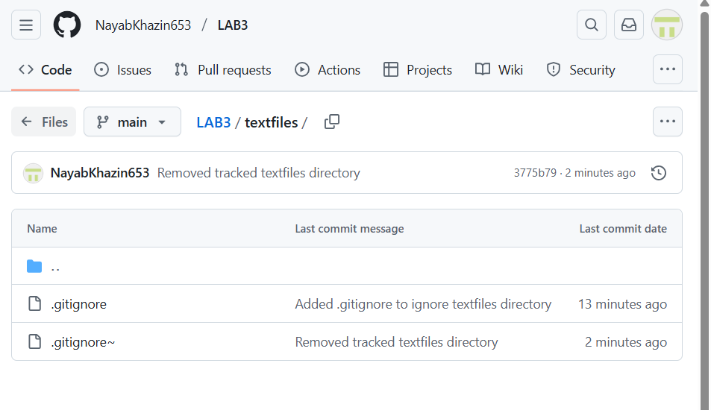

## Task 4 – Create Temporary Changes and Use git stash

* modified_readme.png

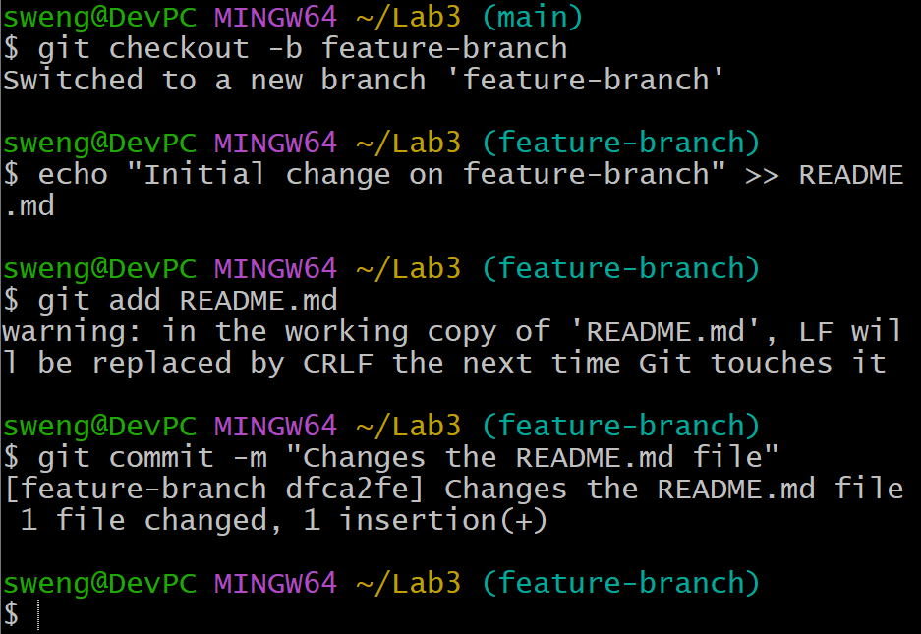

* checkout_error.png

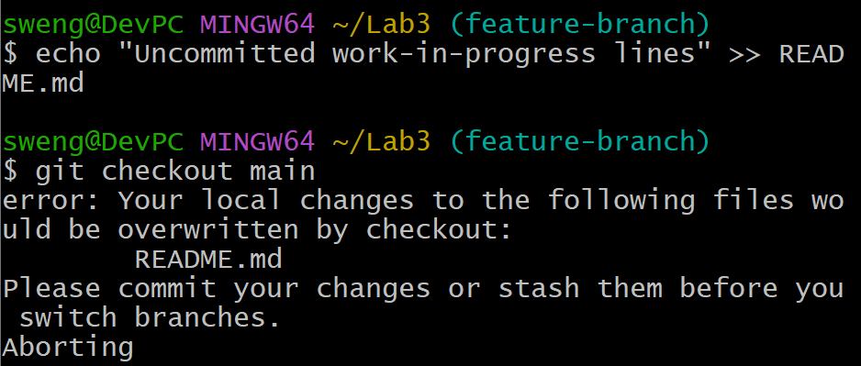

* stash_command.png

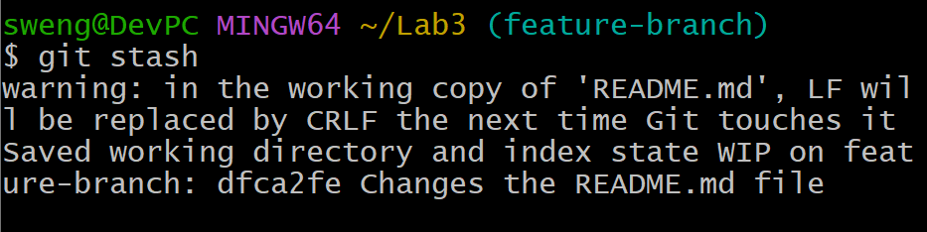

* branch_switched.png

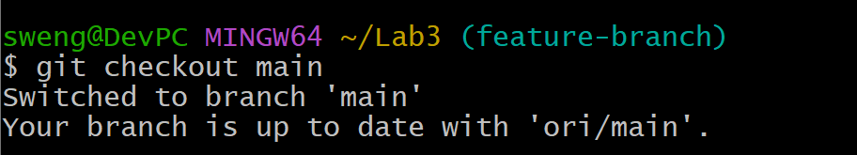

* back_to_feature.png

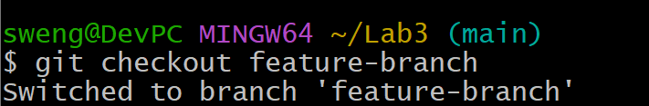

* status_clean.png

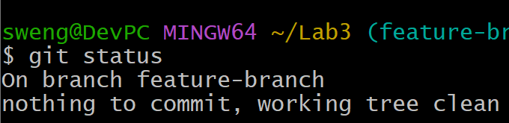

* stash_pop.png

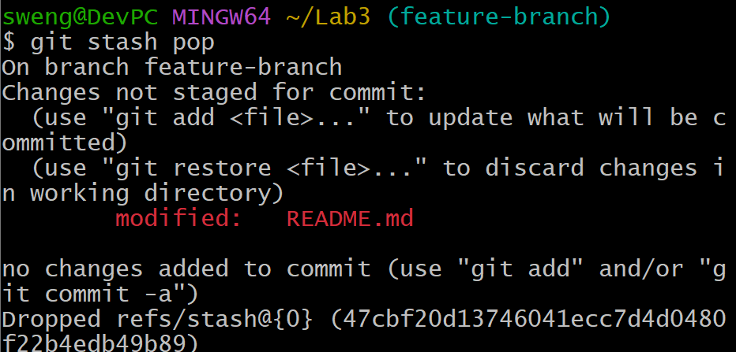

## Task 5 – Checkout a Specific Commit Using git log

* log_before_checkout.png

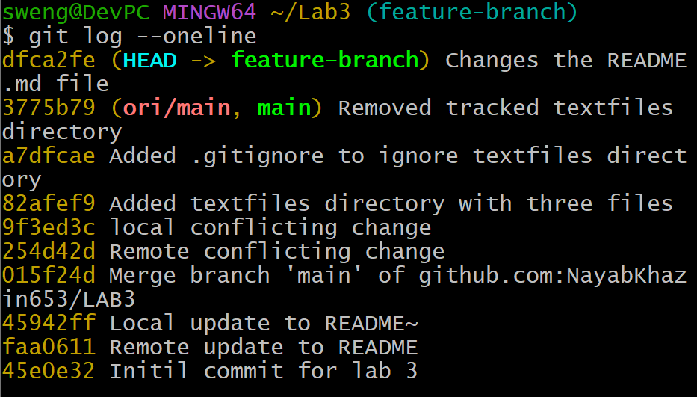

* detached_head.png

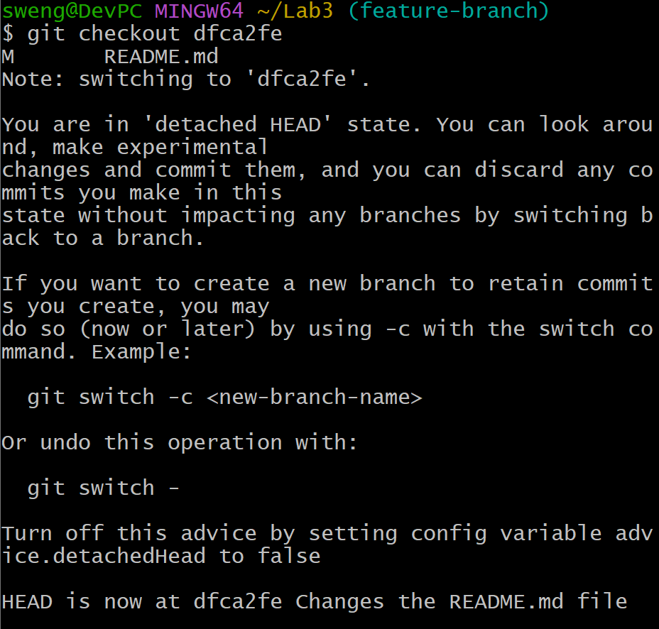

* back_to_main.png

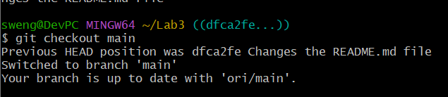

## Task 6 – Resetting Commits (Soft vs Hard Reset) ****(With Verification Steps)****

* first_commit.png

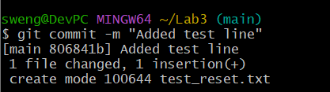

* second_commit.png

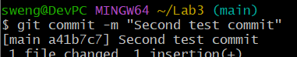

* log_before_reset.png

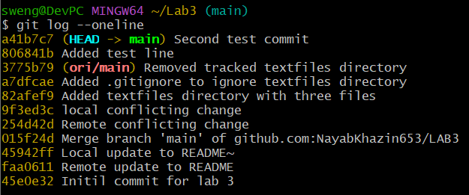

* file_before_reset.png

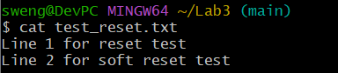

* soft_reset.png



* log_after_soft_reset.png

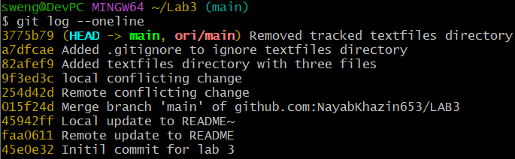

* file_after_soft_reset.png

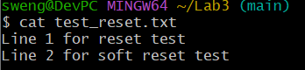

* file_after_hard_reset.png

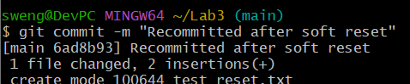

* hard_reset.png

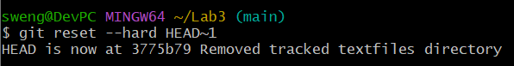

* log_after_hard_reset.png

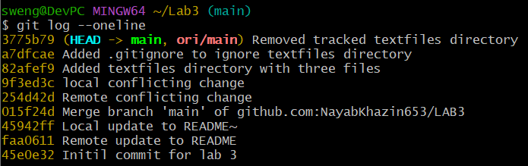

* file_after_hard_reset.png

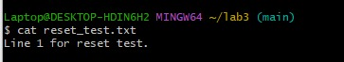

## Task 7 – Amending the Last Commit

* first_amend_commit.png

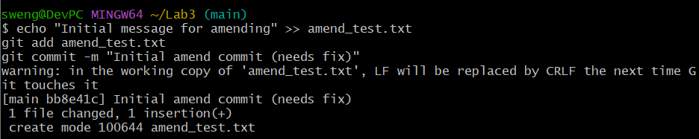

* amend_commit.png

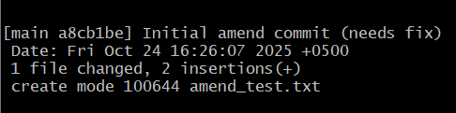

## Task 8 – Reverting a Commit (Safe Undo on Remote Branch)

* commit_temp_file.png

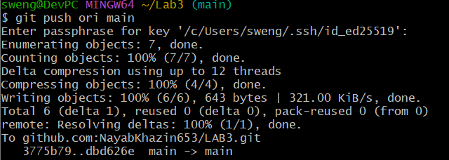

* revert_commit.png

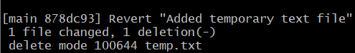

* revert_push.png

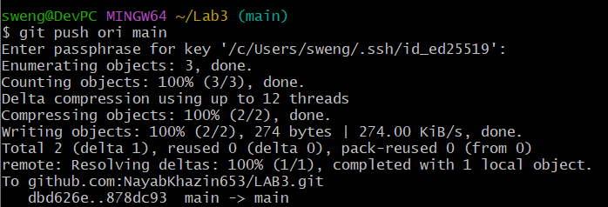

## Task 9 – Force Push (With Caution)

* new_branch.png

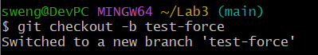

* force_commit.png

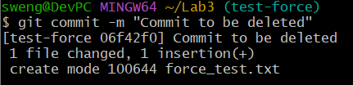

* push_force_branch.png

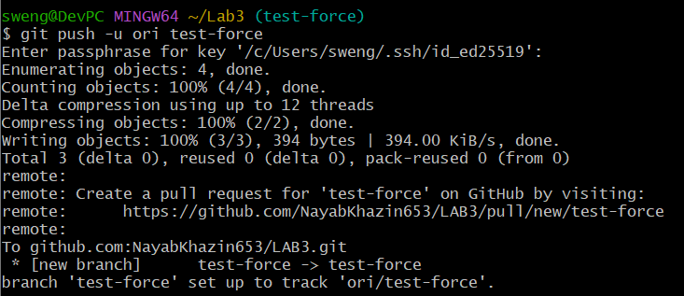

* hard_reset_force.png

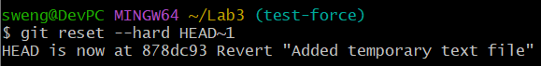

* normal_push.png

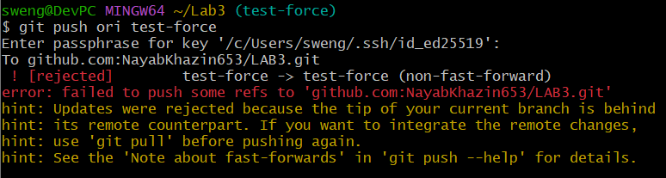

* force_push.png

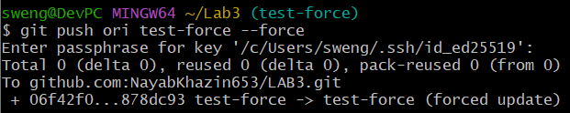

## Task 10 – Running Gitea in GitHub Codespaces via Docker Compose

* forked_gitea.png

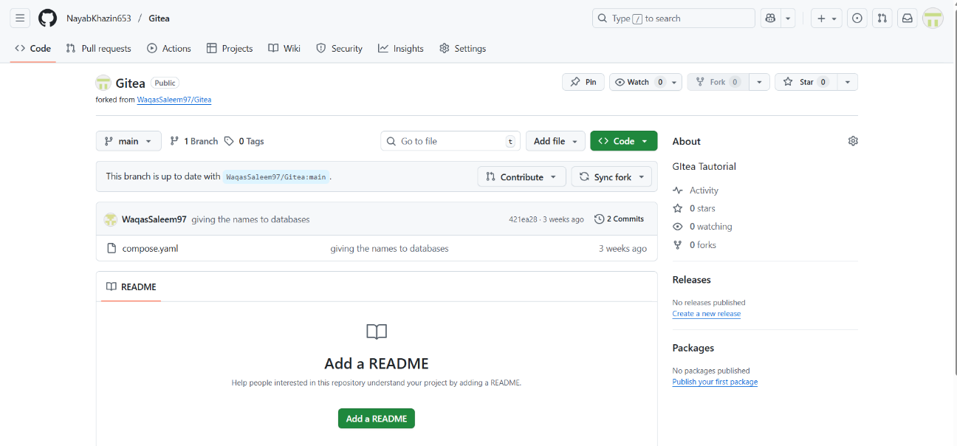

* codespace_loading.png

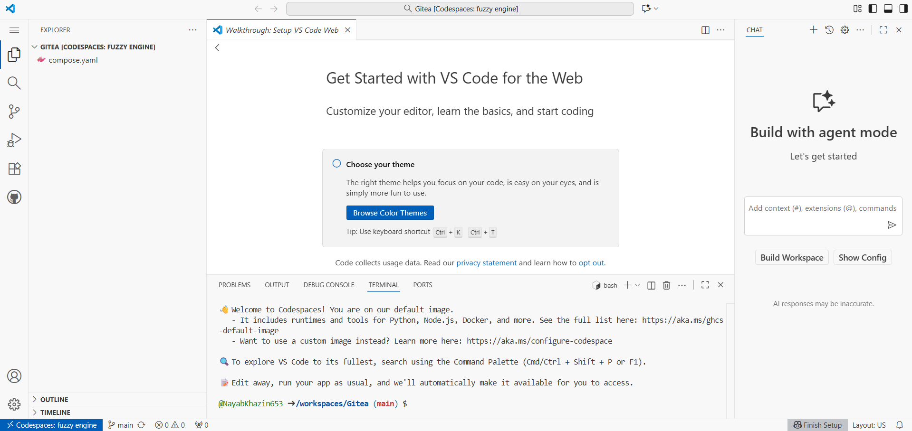

* docker_up.png

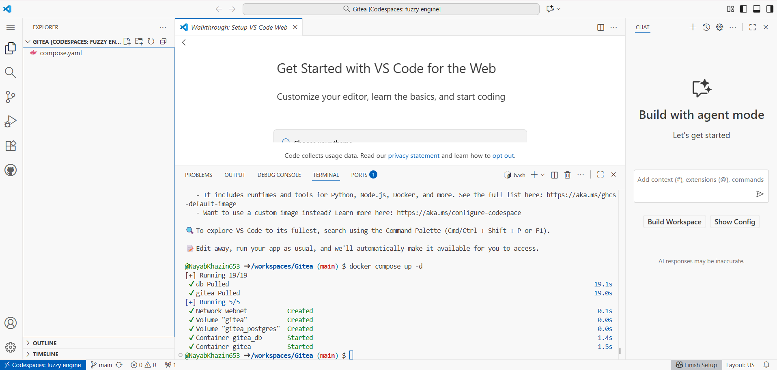

* gitea_install_page.png



* gitea_dashboard.png

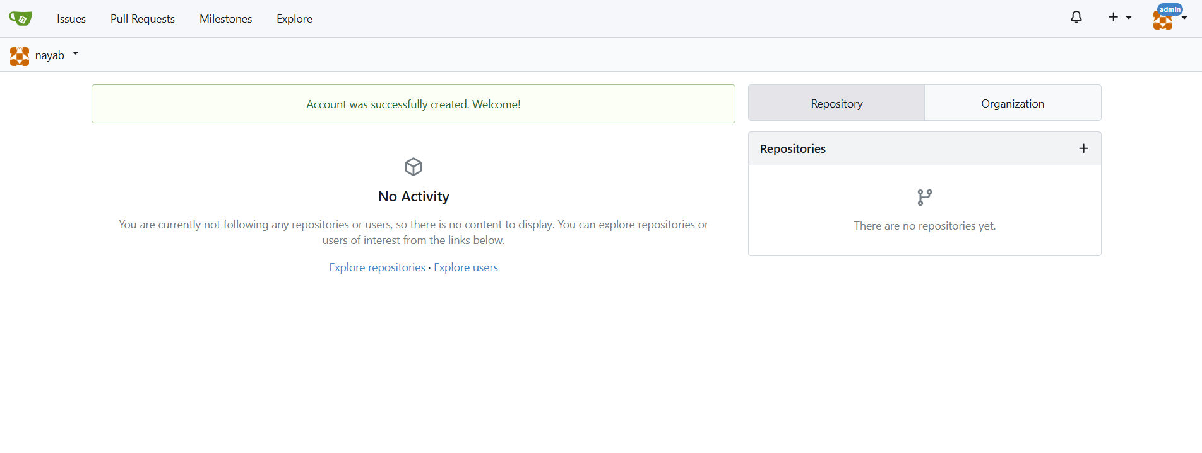

* gitea_new_repo.png

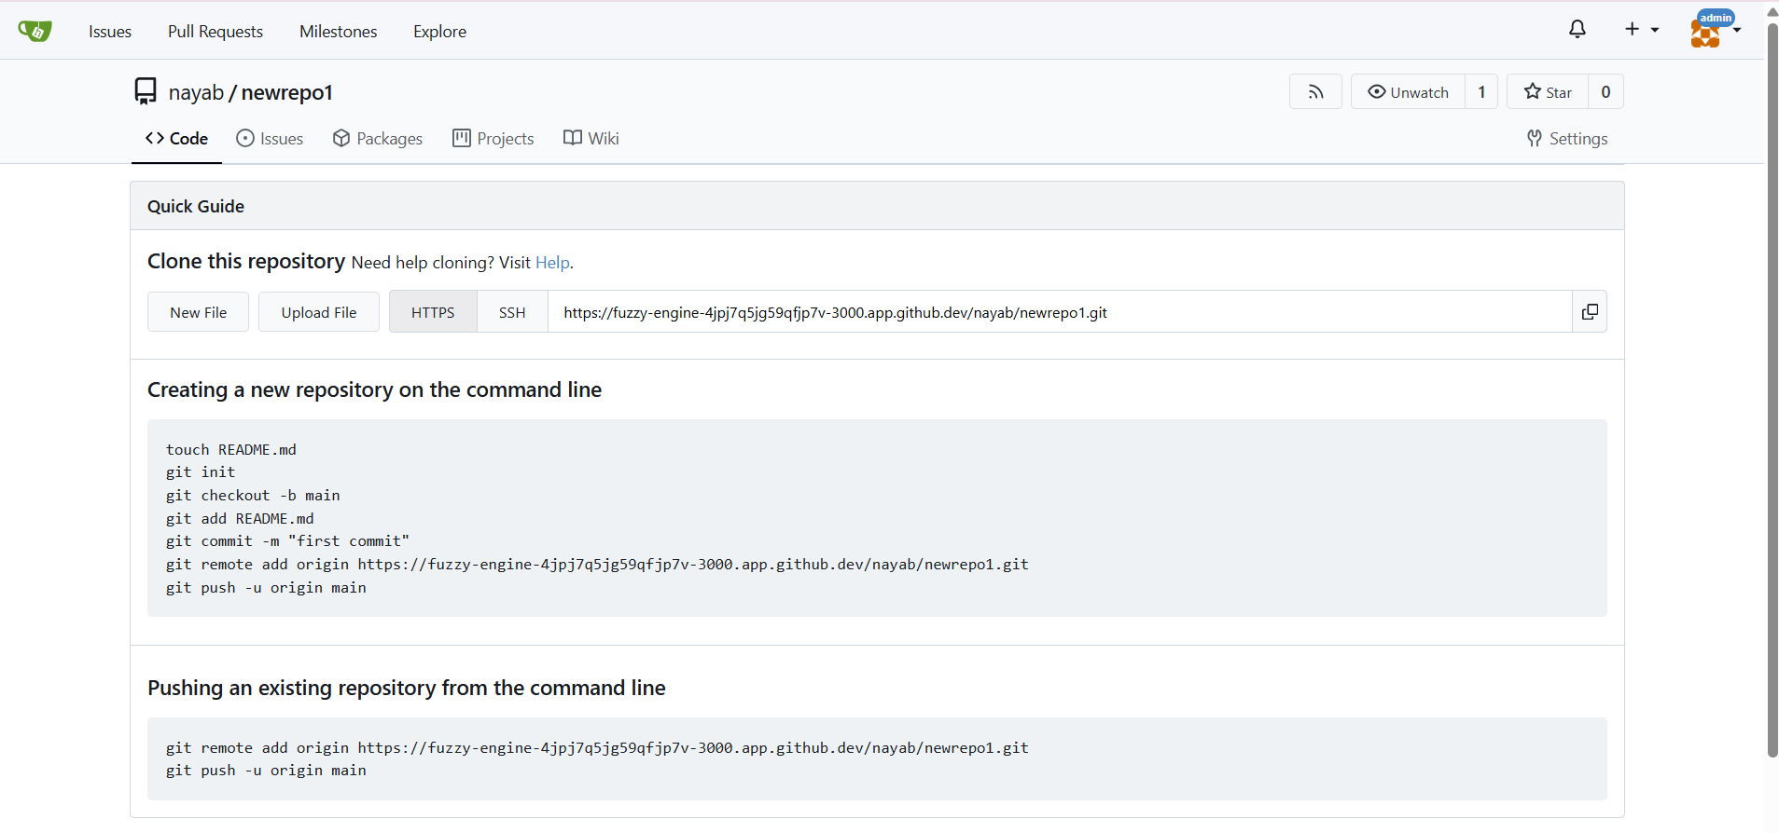

## Task 11 – Creating a GitHub Pages Portfolio Site

* github_pages_repo.png

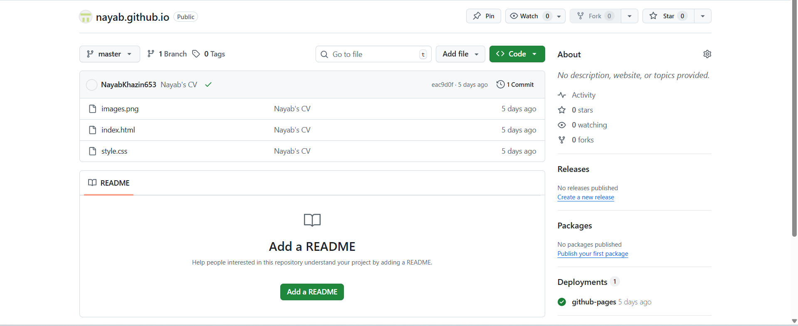

* local_static_site.png

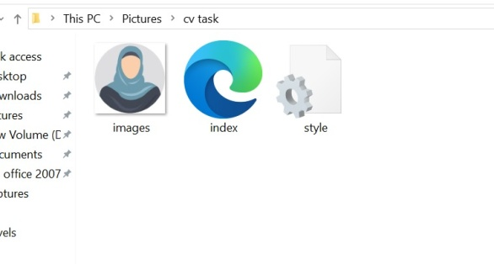

* push_static_site.png

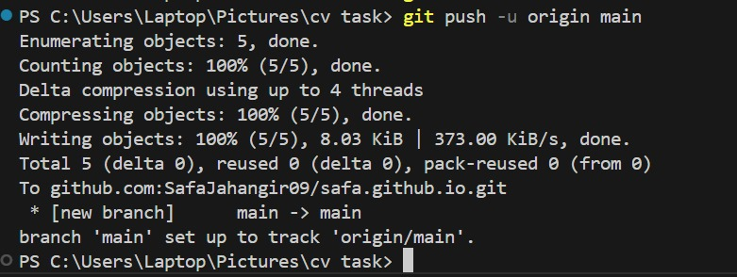

* github_pages_settings.png

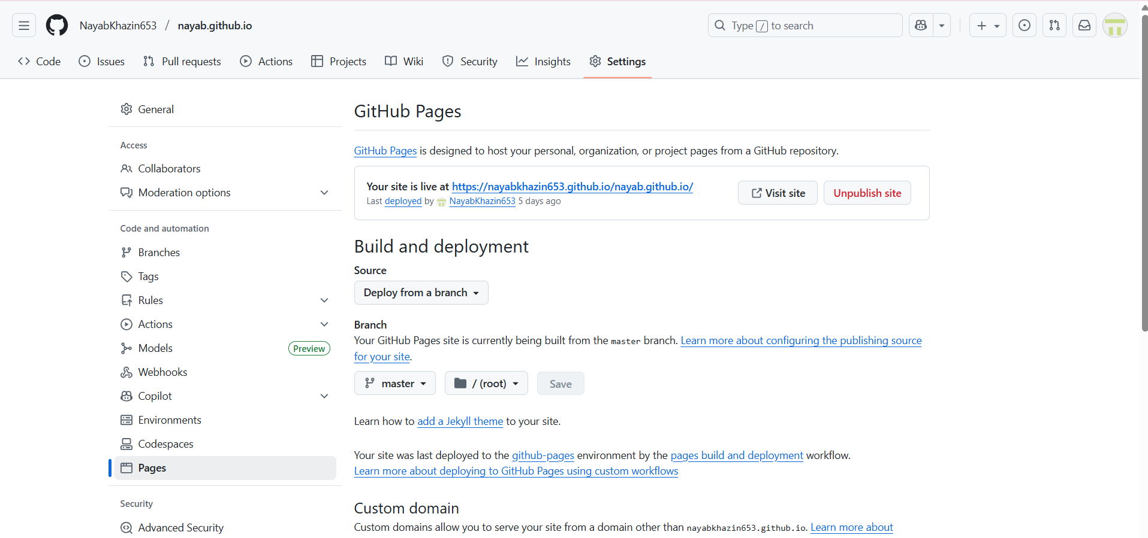

* live_site.png

