**Hyper-V installation.**

In order to install Hyper-V windows, please follow the link below: <https://cloudinfrastructureservices.co.uk/how-to-install-hyper-v-on-windows-10-home/>

**Downloading the CentOS 9 ISO**

In order to get our custom installed on a VHD with Hyper-V, please go ahead and download from <http://mirror.stream.centos.org/9-stream/BaseOS/x86_64/iso/CentOS-Stream-9-latest-x86_64-boot.iso>. We'll need that ISO to load the installer and install it to our VHD. As previously, we'll use [CentOS Stream](https://wiki.centos.org/Manuals/ReleaseNotes/CentOSStream).

**Creating a Virtual Hard Disk (VHD)**

With the ISO downloaded, let's create a virtual hard disk (VHD) on Hyper-V. To do so, open Hyper-V Manager, click **New -> Hard Disk** and choose VHD on the **Choose Disk Format** screen:

](https://1.bp.blogspot.com/-6IL5-9klt7k/XmaatSA7N7I/AAAAAAAACSQ/86yLwiI-YpgrajhwcRJFcQpx548y9qP4gCLcBGAsYHQ/s1600/img-01.jpg)

Next, on **Choose Disk Type**, choose **Fixed size**:

](https://1.bp.blogspot.com/-bEPfbl-sjcU/XmK8Qicyn0I/AAAAAAAACP4/QJOqPNLCHbYk6qh4SvH8DnJU6dnALmaRgCEwYBhgL/s1600/img-02.jpg)

In **Configure Disk**, set the disk size. 6GB was a reasonable size for a simple server and enough space on the home partition:

[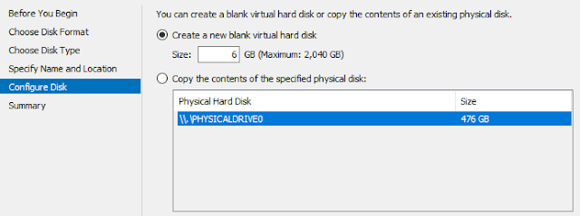](https://1.bp.blogspot.com/-uhMuKV2Hfhc/XmK8QqYijII/AAAAAAAACP4/ruR_LkvDuNUYwhuoNiWnWbR5E4B_Hf45QCEwYBhgL/s1600/img-03.jpg)

**Creating the VM**

The process to create the Hyper-V VM remains the same.

**Configuring Networking**

Make sure that you choose the Default Switch in **Configure Networking**:

](https://1.bp.blogspot.com/-VP5_Nzlq0UY/XmK8RfoCH9I/AAAAAAAACPw/rwVCw1fszs0FSG1_Jc_qN8FM_cz6fo1UACEwYBhgL/s1600/img-04.jpg)

**Connecting the Virtual Hard Disk**

On **Connect Virtual Hard Disk**, we'll choose *Use an existing virtual hard disk* and point it to the one you just created. This is necessary because Hyper-V auto-creates VHDXs by default while Azure requires VHDs:

](https://1.bp.blogspot.com/-RUcVedqA0DU/XmK8R7ZRYuI/AAAAAAAACP0/W1R-nRMP_gw0OUaRuhF3lCLhDDnBk6hpACEwYBhgL/s1600/img-04b.jpg)

To finish up, validate on **Summary** that all looks good and confirm:

](https://1.bp.blogspot.com/-hx7kXfsGPng/XmK8SblUl8I/AAAAAAAACP8/QwbneRxZkLsUXQoXNuBmMCA6Fam2-EDvQCEwYBhgL/s1600/img-05.jpg)

**Specifying the ISO**

The last thing before starting up the VM is to specify the ISO as a DVD drive. That's done on Hyper-V manager by selecting **DVD Drive -> Media**, choosing **Image file** and locating yours on disk:

[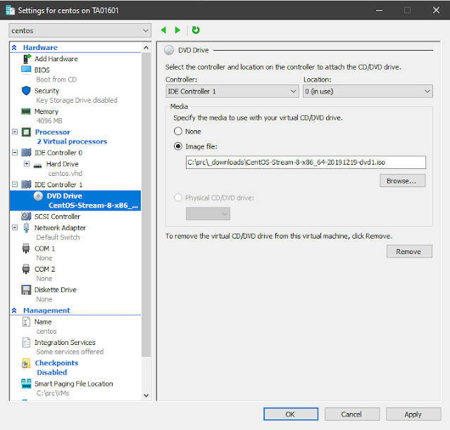](https://1.bp.blogspot.com/-CELUXOB-cQ4/XmK8S37-EeI/AAAAAAAACP8/Kkjpoiv2UxE8feFPfd-cjGsJHsgjy4OhwCEwYBhgL/s1600/img-06.jpg)

**Installing CentOS Stream**

After starting the VM in Hyper-V, you should be prompted with the screen below. Choose **Install CentOS Stream 9-stream**:

**The installer**

After the boot ends, you should be running the installer called [Anaconda](https://en.wikipedia.org/wiki/Anaconda_%28installer%29). Choose your language and click **Continue**:

**Installation Summary**

On Installation Summary, we'll essentially configure **software selection, network**. We'll also need to **setup partitions** on the Installation Destination screen.

**Software selection**

For the software selection, we'll go with **Minimal Install**.   
During installation, click on **Software Selection** and choose **Minimal Install**:

**Disk Partitioning**

Because Azure requires some [special settings](https://docs.microsoft.com/en-us/azure/virtual-machines/linux/create-upload-generic#general-linux-installation-notes) (see requirements above), we'll need to do manual partitioning. But don't be scared, that shouldn't be complicated. We'll divide our disk in three main partitions:

* **/boot, 1.3GiB** - where the boot files will be placed (including the kernel)
* **/, 4.7GiB** - where all the files of the system will be placed (including software, logs, services and libraries)
* **no swap** - we don't need a swap partition as Azure will privision one for us.

Choose your disk and click on Custom:

](https://1.bp.blogspot.com/-NURoq1fG70U/XmK8VmY5GaI/AAAAAAAACPo/UZq5S4SrZK0PgPoseQkiiYfs7Er7NLfzACEwYBhgL/s1600/img-11.jpg)

On the **Manual Partitioning** screen, click on **Standard Partition**:

Add the manual partitions by clicking on the + sign below.

](https://1.bp.blogspot.com/-H0XoYn5CMyw/XmK8WORXYoI/AAAAAAAACPs/0eqkPvahMz0xmFNXgNFXUA1HqdcDfBlUQCEwYBhgL/s1600/img-13.jpg)

 The first to add is **/boot**. Enter 1.3GiB on the popup you see:

And the remainder (4.7G) for /:

Confirm to complete:

[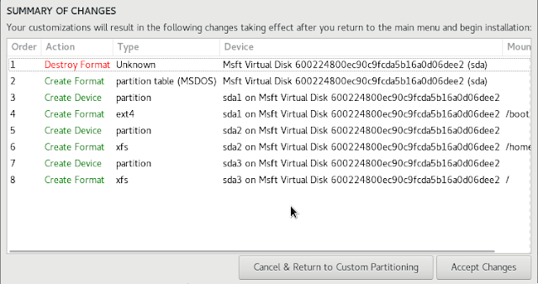](https://1.bp.blogspot.com/-MZxldQH4mFo/XmK8XNY5kWI/AAAAAAAACP8/gFCgrDI3Ym0nNAdEGtQv6jVGkqjO4_5qQCEwYBhgL/s1600/img-17.jpg)

**Networking**

Enable networking as we'll need to install our text editor (and if you wish, update the instance before uploading to Azure):

It's recommended to set a root password and to create an account.

After all the settings are entered, click on Begin Installation to proceed.

**Before the first boot**

Once the installation finishes eject the virtual ISO by going to Hyper-V manager, choosing your **VM -> Settings -> DVD Drive** and set it to *None -> Apply*:

[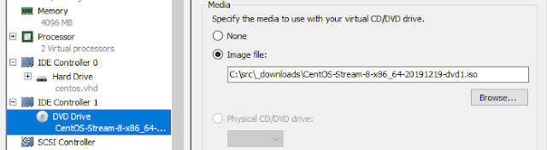](https://1.bp.blogspot.com/-lNdRYwXlydU/XmK8Xm_OWsI/AAAAAAAACP4/7c2Afh6Si80nH2-3-ZMtf8GIEY5Y8oxawCEwYBhgL/s1600/img-19.jpg)

**First Boot**

