**Java String**

In [Java](https://www.javatpoint.com/java-tutorial), string is basically an object that represents sequence of char values. An [array](https://www.javatpoint.com/array-in-java) of characters works same as Java string. For example:

**char**[] ch={'j','a','v','a','t','p','o','i','n','t'};

String s=**new** String(ch);

It is same as

String s=”javatpoint”;

* The java.String.lang class implements Serializable, Comparable and CharSequence [interfaces](https://www.javatpoint.com/interface-in-java).

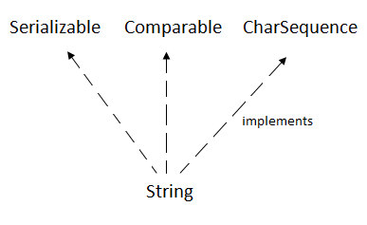

CharSequence Interface

The CharSequence interface is used to represent the sequence of characters. String, [StringBuffer](https://www.javatpoint.com/StringBuffer-class) and [StringBuilder](https://www.javatpoint.com/StringBuilder-class) classes implement it. It means, we can create strings in Java by using these three classes.

**Methods of creating String in java**

* By String literals
* By using new Keyword

### **1) String Literal**

Java String literal is created by using double quotes. For Example:

1. String s="welcome";

Each time you create a string literal, the JVM checks the "string constant pool" first. If the string already exists in the pool, a reference to the pooled instance is returned. If the string doesn't exist in the pool, a new string instance is created and placed in the pool.

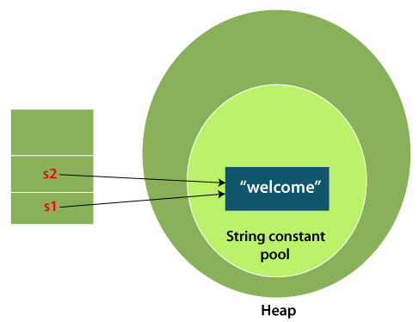

#### **Note: String objects are stored in a special memory area known as the "string constant pool".**

### **2) By new keyword**

1. String s=**new** String("Welcome");//creates two objects and one reference variable

In such case, [JVM](https://www.javatpoint.com/jvm-java-virtual-machine) will create a new string object in normal (non-pool) heap memory, and the literal "Welcome" will be placed in the string constant pool. The variable s will refer to the object in a heap (non-pool).