Shri Ramdeobaba College of Engineering and Management, Nagpur-440013
Department: Information Technology | Course: Internet And Web Programming Lab  Course Code: ITP6002  (VI Semester)
Programme:  B Tech. | Session: 2025-26 (Even Semester) | Date: 13 / Feb / 2026
Roll No:45
Name of Student : Nayan Ghate

AIM : PHP/Node.js and Validate user Credentials

Theory :

Validation of user credentials is the process of verifying whether the username and password entered by a user are correct and authorized. It is an essential part of web application security and is used to allow access only to registered users.
Both PHP and Node.js are server-side technologies used to implement authentication systems in web applications.

Purpose of Credential Validation

- To authenticate users.
- To protect sensitive data.
- To prevent unauthorized access.
- To manage user sessions securely.

How Credential Validation Works
- The user enters a username and password in a login form.
- The form sends the data to the server.
- The server checks the entered data with the records stored in the database.
- If the credentials match:
  - The user is logged in.
  - A session is created.
- If the credentials do not match:
  - An error message is displayed.

Validation in PHP

In PHP:
- User input is collected using $_POST.
- The server connects to a database (like MySQL).
- A query checks if the username and password exist.
- If valid, a session is started using session_start().

Validation in Node.js
In Node.js:
- The Express framework handles requests.
- The server checks user data in a database (like MongoDB or MySQL).
- Passwords are compared using secure libraries like bcrypt.
- If valid, a session or token is generated.

Importance of Security
For better security:
- Passwords should be encrypted or hashed.
- Sessions should be properly managed.
- SQL injection should be prevented using prepared statements.

Website Images :-

- XAMPP

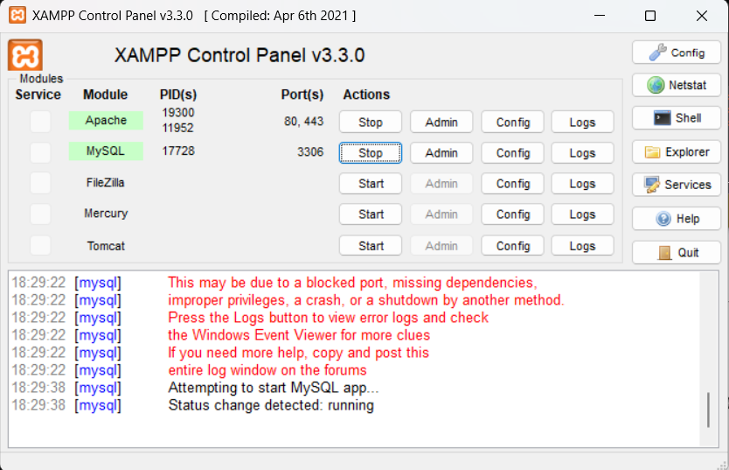

- File Structure

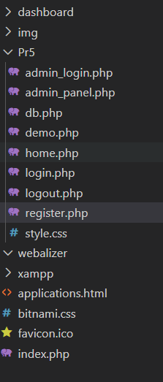

- PHP MyAdmin

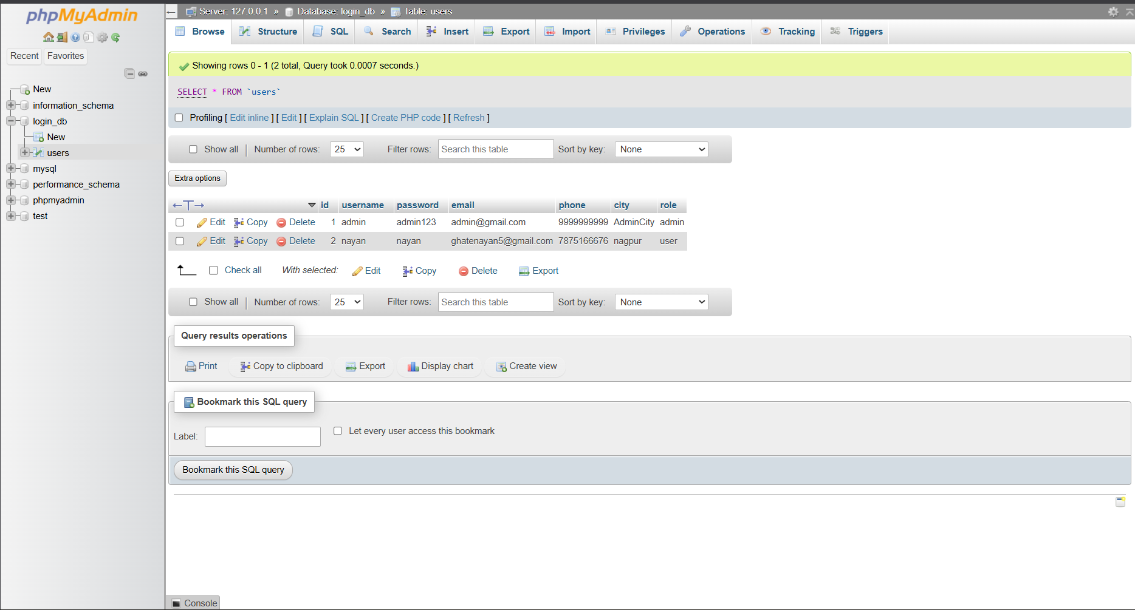

- Basic dashboard

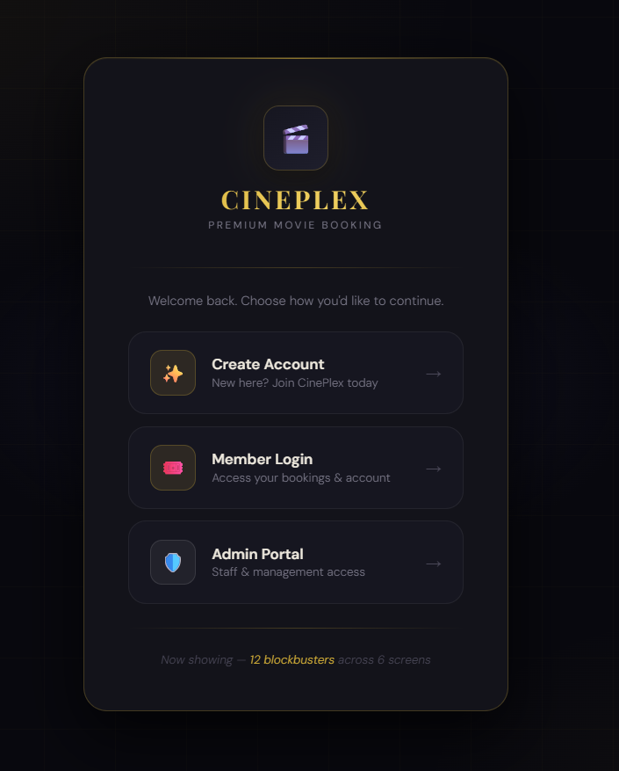

- Create account

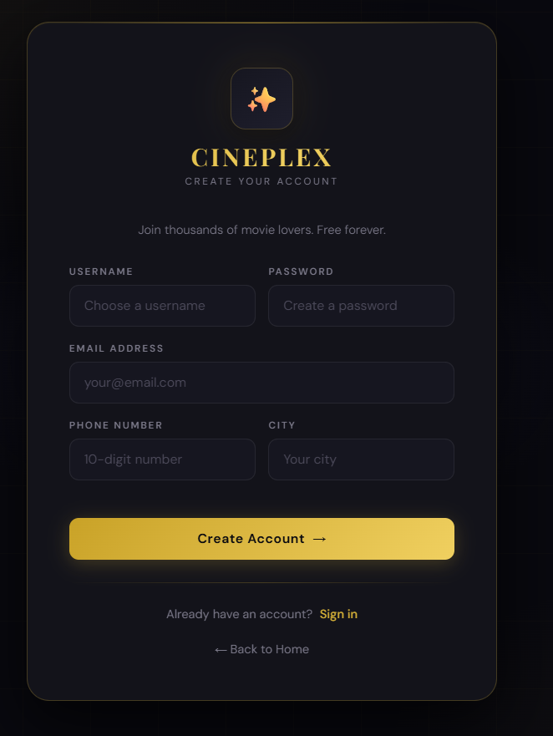

- Successfully create account

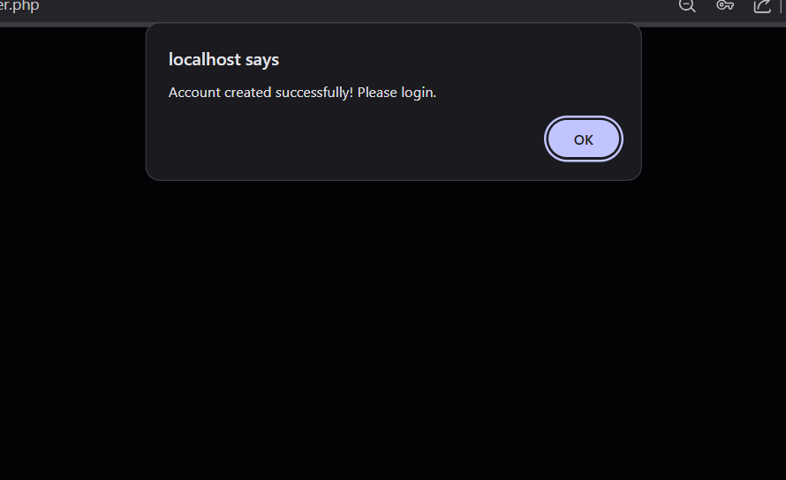

- Login

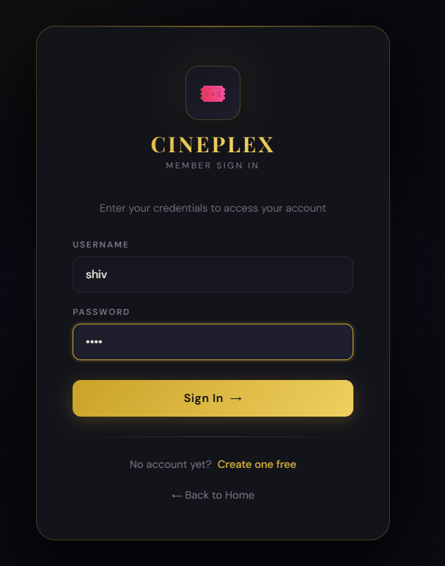

Invalid credentials

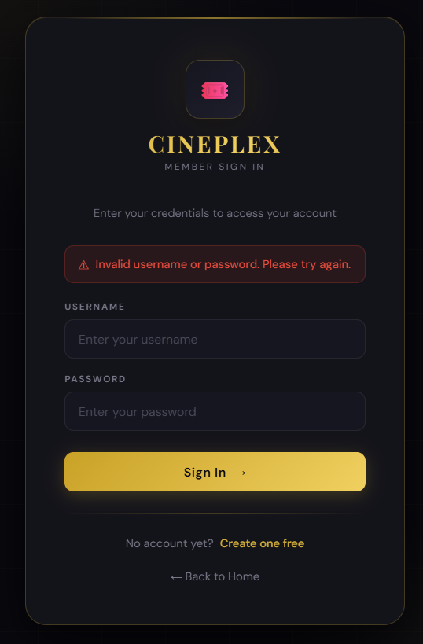

- Basic demo after login



- Admin Login

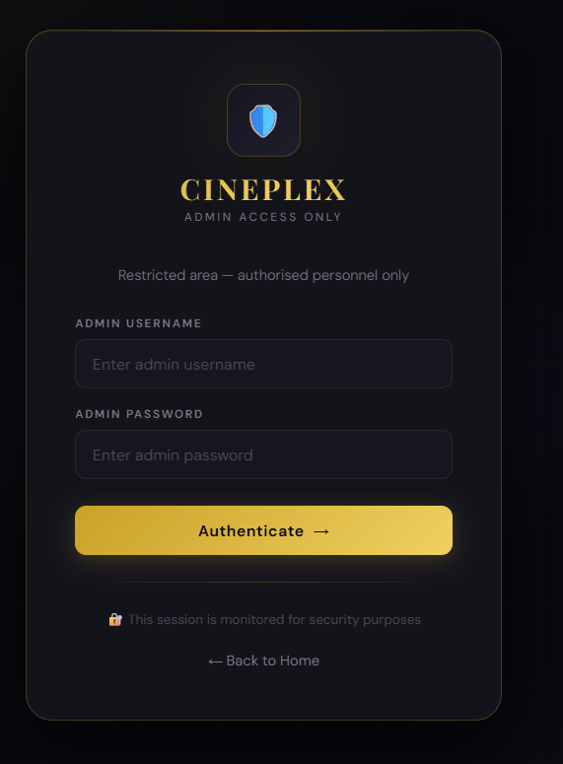

- Admin Dashboard :- it has list of peoples who have create account

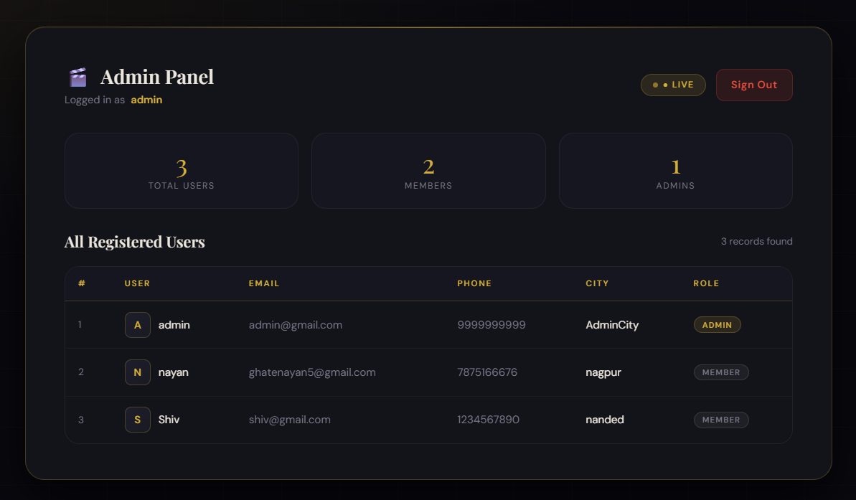

Links :-

Github Link : - https://github.com/Nayan-135/IWP-Practicals/tree/main/Pr5

Conclusion :-

Credential validation is a basic but important feature of web applications. It ensures that only authorized users can access protected resources. PHP and Node.js both provide efficient methods to implement secure user authentication systems.

