Shri Ramdeobaba College of Engineering and Management, Nagpur-440013
Department: Information Technology | Course: Internet And Web Programming Lab  Course Code: ITP6002  (VI Semester)
Programme:  B Tech. | Session: 2025-26 (Even Semester) | Date: 22 / Jan / 2026
Roll No:45
Name of Student : Nayan Ghate

AIM : Create a Responsive layout using Flexbox and Media Queries

Theory :

Responsive Web Design
Responsive Web Design is a technique used to design web pages that automatically adjust their layout and content according to the screen size and device. It improves usability and user experience across different devices.

Flexbox (Flexible Box Layout)

Flexbox is a one-dimensional CSS layout model used to arrange elements in rows or columns. It allows easy alignment, spacing, and resizing of elements within a container.
Key Flexbox Properties:
- display: flex – Enables flexbox layout.
- flex-direction – Defines row or column layout.
- justify-content – Aligns items horizontally.
- align-items – Aligns items vertically.
- flex-wrap – Allows items to move to the next line.
- flex – Controls item size and flexibility.
Flexbox is commonly used for navigation bars, card layouts, image galleries, and page sections.

Media Queries

Media Queries are CSS rules used to apply styles based on screen size, resolution, or device type. They help modify the layout for different devices.
Example:
@media (max-width: 768px) {
.container {
flex-direction: column;
}
}
This changes the layout when the screen width is 768px or smaller.

Working Principle

- On large screens, Flexbox arranges elements horizontally.
- On smaller screens, Media Queries change the layout to vertical.
- Images and content resize automatically to fit the screen.
- The layout remains readable and user-friendly.

Advantages

- Improves user experience on all devices
- Reduces the need for separate mobile websites
- Easy to maintain and modify
- Provides clean and flexible layouts

Image :-

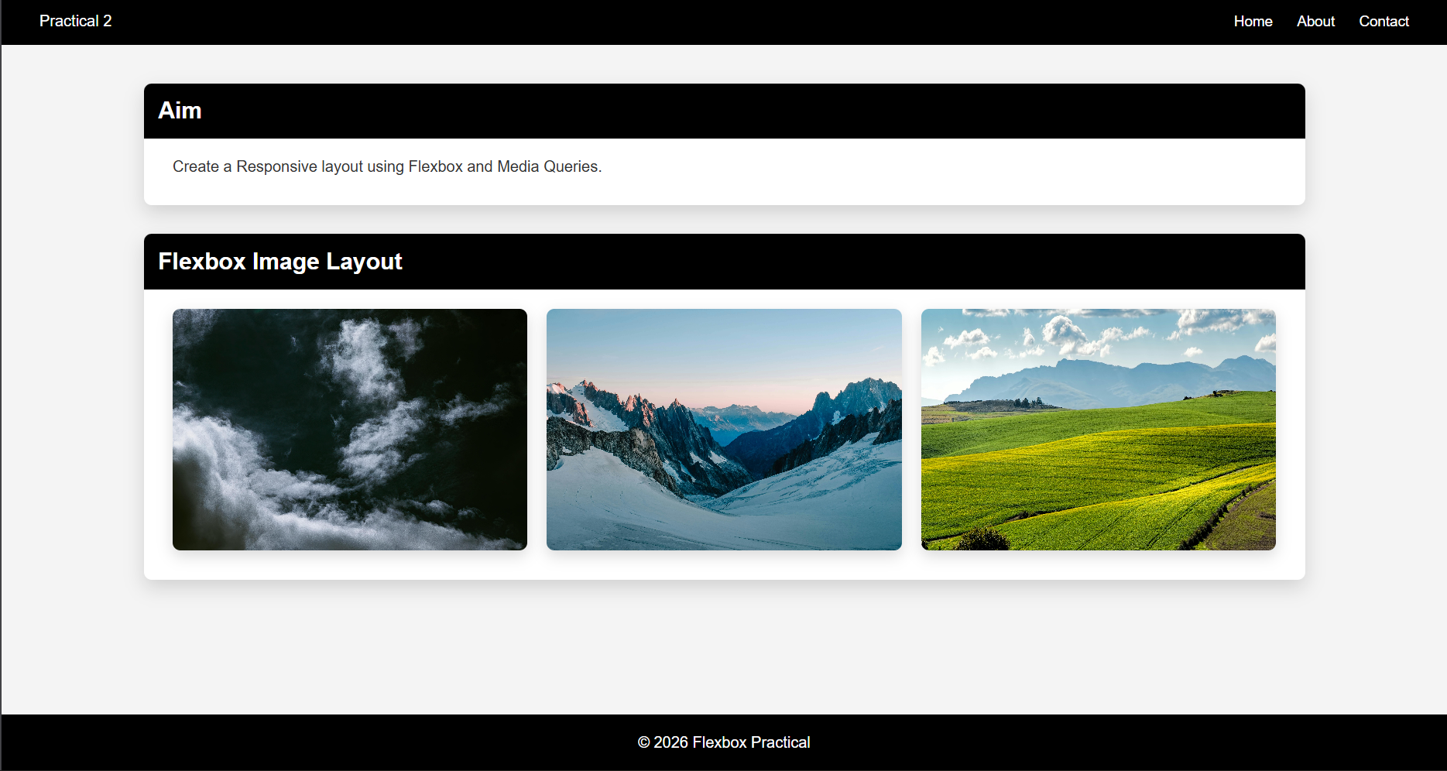

Links :-

Github Link : - https://github.com/Nayan-135/IWP-Practicals/tree/main/Pr2

Conclusion : - By using Flexbox for layout management and Media Queries for screen-based styling, a responsive web design can be created efficiently. This approach ensures that the web page adapts smoothly to different screen sizes and devices.

