Shri Ramdeobaba College of Engineering and Management, Nagpur-440013
Department: Information Technology | Course: Internet And Web Programming Lab  Course Code: ITP6002  (VI Semester)
Programme:  B Tech. | Session: 2025-26 (Even Semester) | Date: 15 / Jan / 2026
Roll No:45
Name of Student : Nayan Ghate

AIM : Create a Collage webpage using HTML5 and CSS and create an alert after submitting form

Theory :

HTML
HTML (HyperText Markup Language) is used to create the structure of web pages such as headings, paragraphs, images, links, and forms.
Example:
<h1>Hello World</h1>
<p>This is a paragraph.</p>

CSS
CSS (Cascading Style Sheets) is used to style HTML elements, such as colors, fonts, layout, and spacing.
Example:
p {
color: blue;
}

Types of CSS

1. Inline CSS

Written inside an HTML element using the style attribute.
Example:
<h1 style="color:red;">Welcome</h1>
Use: Small or quick styling
Drawback: Not reusable

2. Internal CSS

Written inside the <style> tag in the <head> section.
Example:
<style>
h1 { color: green; }
</style>
Use: Single-page websites
Drawback: Not reusable for multiple pages

3. External CSS

Written in a separate .css file and linked to HTML.
Example:
<link rel="stylesheet" href="style.css">
Use: Large and professional websites
Advantage: Reusable and easy to maintain

CSS Priority Order

Inline > Internal > External

Screenshots :

- Basic view of Website
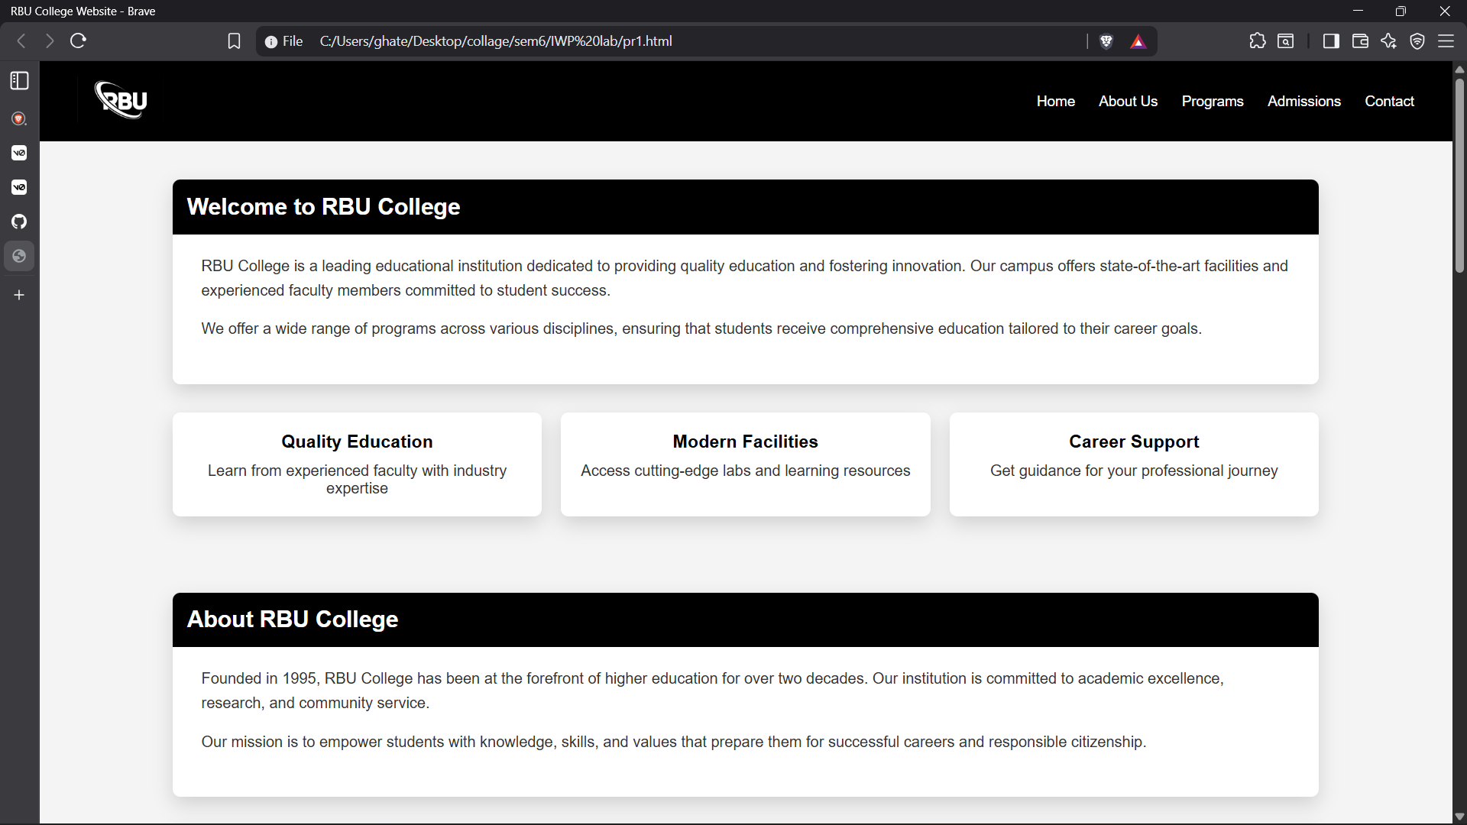

- Form Create

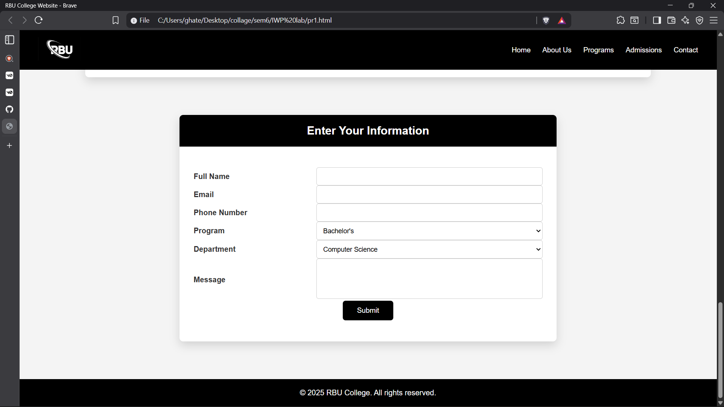

- Alert after submitting form

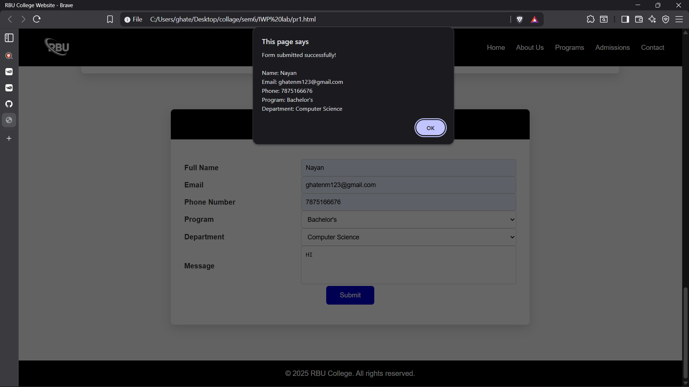

Links :-

Github Link : - https://github.com/Nayan-135/IWP-Practicals
Website Link : - https://scarlet-erna-35.tiiny.site/

Conclusion : - Successfully created a Collage webpage using HTML5 and CSS and create an alert after submitting form

