

Nivestha: Invest Together, Prosper Together

A Project Report
Submitted in fulfilment of the

Requirements for the award of degree of

Bachelor of Science of (Data Science)
By

Nayan Anuj Pandey

Seat no: 3056832

Under the esteemed guidance of

Pragnesh Shah



DEPARTMENT OF DATA SCIENCE

SHREE L. R. TIWARI DEGREE COLLEGE OF ARTS, COMMERCE &
SCIENCE, Mira Road

(Affiliated to University of Mumbai)
THANE, 401107 MAHARASHTRA
2024-25



CERTIFICATE

Department of Bachelor Science of (Data Science)

This is to certify this project report entitled NIVESTHA: Invest Together, Prosper Together, submitted to University of Mumbai, Maharashtra is bonified record of work done by Nayan Anuj Pandey for Academic Year 2024-2025 under the guidance of “Pragnesh Shah” from to .

Date of Evaluation:

Internal Examiner College Stamp
(Guide)

External Examiner Head of the Department

Acknowledgement

I would like to convey my deep appreciation to my Guide
Mr. Pragnesh Shah for his valuable guidance and encouragement in completion of my project work.
I would also like to express my gratitude to our principal Dr. Sanjay Mishra for providing all the required facilities to accomplish my work.
Nayan Anuj Pandey

DECLARATION

I hereby declare that project entitled “Nivestha: Invest Together, Prosper Together” done at Shree L.R. Tiwari Degree college, not been in any case duplicated to submit to any other university for the award of any degree. To the best of my knowledge other than me, no one has submitted to any other university. The project is done in partial fulfilment of requirement for the award of degree of Bachelor of Science of (Data Science) to be submitted as VIth semester project as a part of our curriculum.

Nayan Anuj Pandey

INDEX

Abstract - 09

CHAPTER 1: INTRODUCTION
1.1 Background - 10
1.2 Objectives - 10
1.3 Purpose, Scope, and Applicability - 10
1.3.1 Purpose
1.3.2 Scope
1.3.3 Applicability
1.4 Organisation of Report - 11
1.5 Achievements - 11

CHAPTER 2: SURVEY OF TECHNOLOGIES
2.1 Introduction - 12
2.2 Frontend Technologies - 12
2.3 Backend Technologies - 12
2.4 Database Technologies - 13
2.5 Artificial Intelligence & Machine Learning - 13
2.6 Security and Authentication - 13
2.7 Version Control and Collaboration - 14
2.8 Development Tools - 14
2.9 Conclusion - 14

CHAPTER 3: REQUIREMENTS AND ANALYSIS
3.1 Problem Definition - 15
3.2 Requirements Specification - 15
Functional Requirements
Non-Functional Requirements
3.3 Planning and Scheduling - 16
3.4 Software and Hardware Requirements - 16
3.5 Preliminary Product Description - 17
3.6 Conceptual Models - 17
Use Case Diagram
Data Flow Model
Entity-Relationship Model

CHAPTER 4: SYSTEM DESIGN
4.1 Basic Modules - 18
4.2 Data Design - 18
4.2.1 Schema Design
4.2.2 Data Integrity and Constraints - 19
4.3 Procedural Design - 21
4.3.1 Logic Diagrams
4.3.2 Data Structures
4.3.3 Algorithms Design
4.4 User Interface Design - 22
4.5 Security Issues - 23
4.6 Test Cases Design - 23

CHAPTER 5: IMPLEMENTATION AND TESTING
5.1 Implementation Approach - 24
5.2 Coding Details and Code Efficiency - 24
5.3 Testing Approach - 47
5.3.1 Unit Testing
5.3.2 Integration Testing
5.3.3 Beta Testing
5.4 Modifications and Improvements - 48
5.5 Test Cases - 48

CHAPTER 6: RESULTS AND DISCUSSION
6.1 Test Reports - 49
6.2 User Documentation - 51

CHAPTER 7: CONCLUSION
7.1 Conclusion - 60
7.2 Limitations of the System - 61
7.3 Future Scope of the Project - 61

REFERENCES - 62
List of books, research papers, documentation sources, and online materials used during the project.

GLOSSARY - 63
Definitions of technical terms used throughout the project report.

PLAGARISM REPORT - 65

Abstract
Real estate has always been one of the most reliable and profitable investment areas. Yet, it is only open to a very limited number of people, those with a lot of money and experience, due to the huge capital required and the complicated procedure. That's why Nivestha has been created: a digital solution that makes realty investments easy, affordable, and smart.

Nivestha has come up with a middle-of-the-road plan for shared real estate investment along with money pooling, a concept whereby several investors can jointly own properties of high market value making smaller contributions. This is not only good because it frees investors from the heavy money burden, but it also enables more people to buy stocks in the most expensive assets. The investors get a share of the benefits in the form of rental income and capital gains, hence new ways of creating wealth are opened.

What differentiates Nivestha is the use of AI (artificial intelligence) for the benefit of the customer during the investment process. Some AI models are utilized to predict real estate prices, estimate rental returns, and evaluate the risk. Consequently, the money decision will be highly informed. It is a perfect combination of accessibility and decidability.

The platform also offers standard fintech amenities like the provision of a secure KYC, wallet services, transaction history, and the distribution of rental income. Nivestha, with its user-friendly, up-to-date web-based interface, guarantees a smooth and transparent user experience as well as back-office operations.

Basically, Nivestha merges the power of property, financial technology and artificial intelligence to provide an innovative investment platform that caters to the needs of the future. The initiative is designed to open up markets and facilitate investors' decisions, thereby allowing a fresh wave of investors to take charge while at the same time proving the feasibility of employing cutting-edge technologies in the real estate sector.

Chapter 1: Introduction
1.1 Background
Real estate has historically been one of the most attractive investment options, offering both wealth preservation and appreciation. However, traditional real estate investment is often restricted to wealthy individuals or institutions due to the high capital requirement. This has left a large segment of aspiring investors unable to participate in this lucrative sector.

With the rise of digital platforms and innovative financial technologies, new models such as fractional ownership and investment pooling are gaining popularity. These models allow multiple investors to co-own a property by contributing smaller amounts, enabling them to benefit from rental income and capital appreciation in proportion to their investment.

Nivestha is conceptualized as a digital platform that combines the power of fractional real estate investment with the intelligence of AI-driven predictions. The project envisions making real estate investment more inclusive, transparent, and data-driven.

1.2 Objectives
The primary objectives of Nivestha are:
- To develop a web-based platform that facilitates fractional real estate investment through investment pooling.
- To integrate AI models for property price forecasting, rental yield estimation, and risk assessment.
- To implement a secure authentication and KYC system for verifying investor authenticity.
- To enable a wallet-based system for deposits, withdrawals, and rental income distribution.
- To provide an investor dashboard that displays portfolio, ownership percentage, and AI insights.
- To equip administrators with tools to manage properties, monitor investments, and distribute rental returns.

1.3 Purpose, Scope, and Applicability
1.3.1 Purpose
The purpose of this project is to democratize real estate investment by lowering entry barriers and empowering investors with AI-powered insights. Nivestha aims to create a platform where users can confidently invest smaller amounts in premium properties while enjoying transparency and security.

1.3.2 Scope
- Users: Register, complete KYC, deposit funds, invest in property fractions, and receive proportional rental income.
- Admin: Add and manage property listings, approve users, and handle rent distributions.
- System Features: Secure authentication, wallet management, fractional ownership logic, AI predictions, and detailed transaction history.
- AI Module: Forecast property prices, calculate expected rental yields, and assign risk categories (Low, Medium, High).
The initial scope is to develop a functional MVP hosted locally and ready for cloud deployment. Future scope includes tokenization of property shares using blockchain, advanced AI recommendation systems, and mobile app development.

1.3.3 Applicability
- Academic Relevance: Demonstrates integration of web development, database management, and AI into a single interdisciplinary project.
- Industry Relevance: Provides a blueprint for scalable real estate fintech products that can be extended into startups.
- User Relevance: Makes high-value real estate accessible to common investors by lowering minimum entry requirements.

1.4 Organisation of Report
The report is organized as follows:
- Chapter 1: Introduction – Outlines the background, objectives, scope, applicability, and purpose of the project.
- Chapter 2: Survey of Technologies – Reviews the tools, frameworks, and platforms selected for the development of Nivestha.
- Chapter 3: Requirements and Analysis – Explains the problem definition, requirements specification, planning, scheduling, hardware/software requirements, preliminary product description, and conceptual models.
- Chapter 4: System Design – Provides details on system modules, schema design, data integrity, procedural design (logic diagrams, data structures, algorithms), user interface design, security measures, and test cases.

1.5 Achievements
During the planning and initial development phases, the following achievements have been made:
- Designed a comprehensive database schema covering users, properties, wallets, investments, transactions, rental income, and AI predictions.
- Developed an Entity-Relationship Diagram (ERD) to represent system relationships clearly.
- Prepared a synopsis and abstract aligning academic and industry goals.
- Defined a modular folder structure for frontend and backend development.
- Finalized the brand identity with the name “Nivestha” to establish project uniqueness.
- Identified technology stack (React.js, Node.js, PostgreSQL, AI libraries) and deployment strategies (local-first, cloud-ready).
These achievements lay the foundation for building a robust, scalable, and user-friendly MVP that can later evolve into a production-grade solution.

Chapter 2: Survey and Technologies

2.1 Introduction
The choice of technologies plays a critical role in the development of Nivestha, a fractional real estate investment platform. The system needs to be secure, scalable, user-friendly, and intelligent to ensure investor trust and long-term growth. This chapter surveys the technologies selected for each component of the project—frontend, backend, database, artificial intelligence, security, version control, and development tools—along with their versions and relevance.

2.2 Frontend Technologies
2.2.1 React.js (v18.2.0)
React.js is a modern JavaScript library for building user interfaces. Its component-based architecture makes it easier to reuse UI elements and ensures efficient updates using the Virtual DOM.
- Advantages: High performance, reusable components, rich ecosystem, strong community support.
- Use Case in Nivestha: Powering dashboards, property listings with images, and investor/admin panels.
2.2.2 Tailwind CSS (v3.3.3)
Tailwind CSS is a utility-first CSS framework that accelerates UI development.
- Advantages: Rapid prototyping, responsive design, easily customizable.
- Use Case in Nivestha: Provides a modern, fintech-oriented design with consistent UI components.

2.3 Backend Technologies
2.3.1 Node.js (v18 LTS)
Node.js is a JavaScript runtime environment widely used for building scalable backend systems.
- Advantages: Event-driven, non-blocking I/O, lightweight, scalable for real-time applications.
- Use Case in Nivestha: Handles server requests for authentication, wallet operations, property management, and investment logic.
2.3.2 Express.js (v4.18.2)
Express.js is a minimal web framework built on Node.js.
- Advantages: Simplified routing, middleware support, flexible REST API creation.
- Use Case in Nivestha: Provides backend APIs for user management, admin tools, and AI integration.

2.4 Database Technologies
2.4.1 PostgreSQL (v15.3)
PostgreSQL is an advanced open-source relational database system known for reliability and ACID compliance.
- Advantages: Open-source, secure, advanced query capabilities, strong support for financial transactions.
- Use Case in Nivestha: Stores structured data such as users, roles, properties, property images, wallets, investments, rental income, transactions, and AI predictions.
2.4.2 Schema Design and Integrity
The database schema follows normalization principles to minimize redundancy. Foreign keys, unique constraints, and cascades ensure data integrity across investments, transactions, and wallet operations.

2.5 Artificial Intelligence and Machine Learning
2.5.1 Python (v3.10)
Python is chosen for AI model development due to its simplicity and extensive ML ecosystem.
2.5.2 Libraries
- Scikit-learn (v1.3.0): For regression/classification models in property predictions.
- XGBoost (v1.7.6): Gradient boosting for accurate price forecasting and risk scoring.
- Pandas (v2.0.3): Data processing and analysis.
- NumPy (v1.25.0): Efficient numerical computation.
2.5.3 Use Case in Nivestha
- Predicting property price trends.
- Estimating rental yields.
- Assessing investment risk.

2.6 Security and Authentication
- Password Hashing: Implemented using bcrypt (v5.1.0) for secure credential storage.
- KYC Verification: Ensures authenticity and compliance of investors.
- Role-Based Access Control: Separates privileges for admins and investors.
- Data Protection: Uses encryption protocols to secure financial and personal data.

2.7 Version Control and Collaboration
2.7.1 Git (v2.41.0)
Git is a distributed version control system.
- Advantages: Tracks code changes, supports branching/merging, rollback features.
- Use Case: Maintains history of project development.
2.7.2 GitHub (Latest)
GitHub is a cloud-based Git repository hosting service.
- Advantages: Collaboration via pull requests, issue tracking, CI/CD integration, project backup.
- Use Case: Facilitates collaborative development of Nivestha among team members.

2.8 Development Tools
2.8.1 Visual Studio Code (v1.82.2)
VS Code is the primary IDE used for Nivestha.
- Advantages:
  - Lightweight, cross-platform editor.
  - Built-in support for JavaScript, Python, and PostgreSQL extensions.
  - Git integration for seamless version control.
  - Marketplace with rich extensions (ESLint, Prettier, AI tools).
  - Integrated terminal for running backend and frontend processes.
- Why Preferred: VS Code strikes a balance between performance, flexibility, and developer productivity. It enables smooth development across frontend (React.js), backend (Node.js), and AI modules (Python).
2.8.2 Postman (v10.18.7)
- Advantages: Simple REST API testing, automation support.
- Use Case: Verifying APIs for authentication, wallet transactions, and AI services.

2.9 Conclusion
By adopting a stack of modern, stable, and widely used technologies, Nivestha ensures both academic relevance and industry-grade quality.
- React.js & Tailwind CSS: Modern, responsive UI.
- Node.js & Express.js: Scalable backend for financial and investment operations.
- PostgreSQL: Robust relational database for secure financial transactions.
- Python & ML Libraries: AI-powered predictions to add intelligence to investments.
- GitHub & VS Code: Ensure smooth collaboration and efficient development.
Together, these technologies form a future-proof ecosystem for Nivestha, balancing performance, security, and usability.

Chapter 3: Requirements and Analysis

3.1 Problem Definition
The real estate sector is often seen as a reliable investment, but it remains inaccessible to a large group of potential investors due to the following challenges:
- High Entry Barriers: Traditional property investment requires significant capital, preventing small investors from participating.
- Lack of Transparency: Investors often lack access to detailed insights about property performance, future valuations, and associated risks.
- Fragmented Processes: From KYC verification to fund transfers, existing real estate platforms rely heavily on manual intervention, making them slow and error-prone.
- Limited Decision Support: Traditional investment decisions rely on intuition or market hearsay rather than data-driven analysis.
- Accessibility Issues: Real estate is still dominated by physical transactions, which are time-consuming and geographically restricted.
Nivestha aims to overcome these barriers by providing:
- A fractional investment model to reduce entry costs.
- AI-powered predictions to support informed decisions.
- A digital wallet system for seamless transactions.
- Transparent dashboards to track ownership and rental returns.
- Secure authentication and KYC verification to ensure genuine investors.

3.2 Requirements Specification
3.2.1 Functional Requirements
- User Management: Registration, authentication, KYC verification, and role-based access (Admin/Investor).
- Property Management: Admins can list properties with details (title, location, description, financials, rental yield).
- Property Images: Multiple images per property should be uploaded and displayed to enhance transparency. Images are stored externally (e.g., Firebase Storage), with their URLs saved in the property_images table.
- Investments: Users can invest in properties, and their share allocation is calculated automatically.
- Wallets & Transactions: Every user has a wallet for deposits, withdrawals, and tracking transactions.
- Rental Distribution: Rental income is periodically distributed to investors based on their share percentage.
- AI Predictions: Price forecasting, rental yield estimation, and risk scoring for properties.
- Notifications: Investors receive alerts for important events (investment success, rental credits, withdrawals).
3.2.2 Non-Functional Requirements
- Security: Data encryption, hashed passwords, and secure KYC handling.
- Scalability: Database schema designed to handle thousands of users and properties.
- Reliability: ACID compliance through PostgreSQL for financial integrity.
- Usability: Intuitive web interface with property details and images.
- Maintainability: Modular codebase with proper version control (Git/GitHub).
3.3 Planning and Scheduling
The development of Nivestha is structured into seven phases to ensure systematic progress and timely delivery. Each phase builds upon the previous, ensuring research, implementation, and testing are completed in logical order.
Phase | Description | Timeline
Phase 1: Research & Analysis | Understanding fractional real estate, fintech regulations, and AI applications relevant to property investment pooling. | August – September
Phase 2: Database Design | Designing schema in PostgreSQL, defining tables (users, properties, wallets, investments, etc.), and preparing ER diagrams. | September – October
Phase 3: Backend Development | Building REST APIs in Node.js/Express for user authentication, wallet management, property listings, and investments. | October – November
Phase 4: Frontend Development | Creating React.js frontend with dashboards, property listings (with images), and admin panels. | November – December
Phase 5: AI Module Integration | Training AI models (Python, Scikit-learn, XGBoost) for property price prediction, rental yield estimation, and risk scoring. | December – January
Phase 6: Testing & Quality Assurance | Conducting unit testing, integration testing, and user acceptance testing. Fixing bugs and performance optimization. | January – February
Phase 7: Documentation & Deployment | Finalizing project report, presentation, and deploying the MVP version for demonstration. | February – March

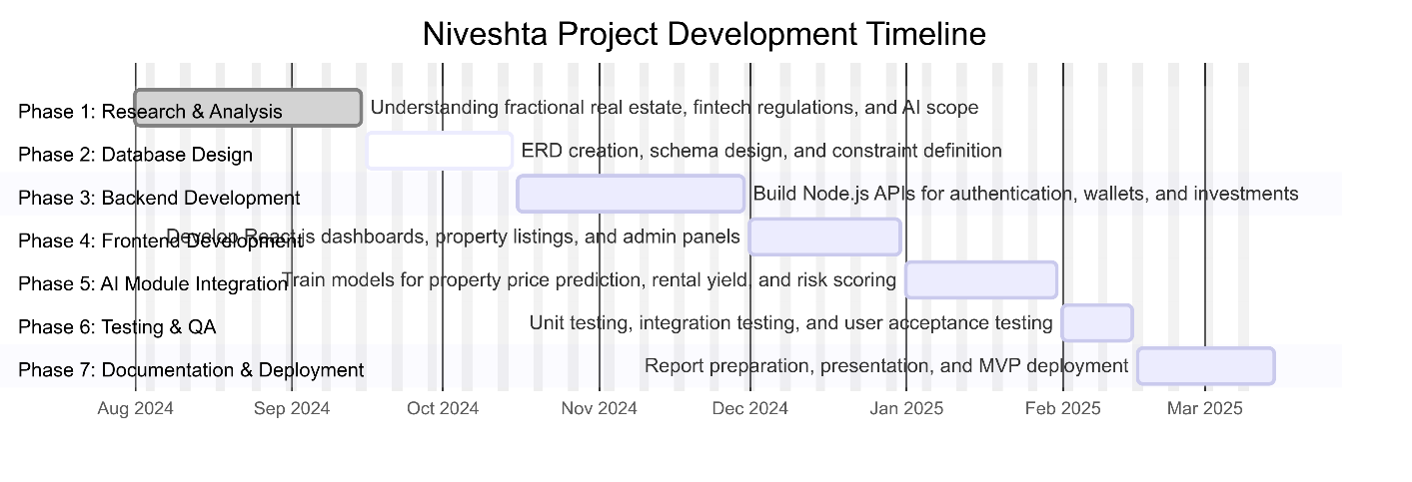

3.4 Software and Hardware Requirements
3.4.1 Software Requirements
- Frontend: React.js, Tailwind CSS
- Backend: Node.js, Express.js
- Database: PostgreSQL
- AI/ML: Python (Scikit-learn, XGBoost, Pandas, NumPy)
- Version Control: Git & GitHub
- Development Tools: Visual Studio Code, Postman (API testing), (optional for containerization)
3.4.2 Hardware Requirements
- Minimum Developer Machine:
  - Processor: Intel i5 or equivalent
  - RAM: 8/16 GB
  - Storage: 256 GB SSD
  - OS: Windows/Linux/Mac

- Minimum User Machine:
  - Processor: Intel i3 or equivalent
  - RAM: 4 GB
  - Storage: 256 GB SSD
  - OS: Windows/Linux/Mac

3.5 Preliminary Product Description
Nivestha is a web-based fractional real estate investment platform. Users register, complete KYC, add funds to their wallet, and invest in fractional property shares. Rental income is distributed automatically based on shareholding.
- For Users: Easy onboarding, transparent dashboards, AI-driven insights, secure transactions.
- For Admins: Efficient property management, user approvals, and rent distribution.
- For the Platform: Scalability for future features like blockchain integration and mobile apps.
This product not only addresses a real-world financial challenge but also acts as an academic demonstration of full-stack + AI integration.

3.6 Conceptual Models
- Use Case Diagram: Shows interactions between Admin (property listing, rent distribution) and User (investment, wallet management).
- Data Flow Diagram (Level 1): Covers registration, property listing with images, investment allocation, rental income distribution, and AI predictions.
- Entity-Relationship Diagram (ERD): Includes 13 tables:
  - Core: users, roles, user_roles, wallets, properties, investments, transactions
  - Rental: rental_distributions, rental_income
  - AI: ai_predictions
  - Enhancements: property_images, notifications, audit_logs

Chapter 4: System Design

4.1 Basic Modules
The system architecture of Nivestha is divided into several interdependent modules:
- User Module: Handles registration, login, authentication, and KYC verification.
- Property Module: Manages property listings, details, shares available, and associated documents/images.
- Investment Module: Enables users to invest in fractional shares and track ownership percentage.
- Wallet Module: Provides deposit, withdrawal, and balance tracking functionalities.
- Transaction Module: Logs all financial activities including investments, deposits, withdrawals, and rental distributions.
- Rental Distribution Module: Calculates and allocates monthly rental income to investors.
- AI Prediction Module: Forecasts property prices, predicts rental yields, and assigns risk scores.
- Admin Module: Allows administrators to manage properties, approve investors, and distribute rental income.

4.2 Data Design
4.2.1 Schema Design
The Nivestha database schema is implemented using PostgreSQL (v15.3) and follows normalization principles to minimize redundancy and ensure data integrity. It consists of 13 interrelated tables supporting core functions such as user management, property listings, investments, transactions, rental distributions, and AI predictions.

Key Tables Summary
Table Name | Purpose | Key Attributes (with Data Types)
Users | Stores investor/admin details and credentials. | user_id (UUID, PK), name (VARCHAR), email (VARCHAR UNIQUE), password_hash (TEXT), kyc_status (BOOLEAN), created_at (TIMESTAMP)
Roles / User_Roles | Defines access levels for users. | role_id (UUID, PK), role_name (VARCHAR), user_id (FK)
Wallets | Maintains wallet balances for users. | wallet_id (UUID, PK), user_id (FK), balance (NUMERIC(15,2))
Properties | Contains property details for investment. | property_id (UUID, PK), title (VARCHAR), location (VARCHAR), total_value (NUMERIC(15,2)), rental_yield (NUMERIC(5,2)), total_shares (INTEGER), available_shares (INTEGER)
Property_Images | Stores image URLs for each property. | image_id (UUID, PK), property_id (FK), image_url (TEXT), uploaded_on (TIMESTAMP)
Investments | Tracks user investments and share ownership. | investment_id (UUID, PK), user_id (FK), property_id (FK), invested_amount (NUMERIC(15,2)), share_count (INTEGER), invested_on (TIMESTAMP)
Transactions | Logs all financial activities. | transaction_id (UUID, PK), user_id (FK), property_id (FK), type (VARCHAR), amount (NUMERIC(15,2)), timestamp (TIMESTAMP)
Rental_Distributions | Records total rental income for properties. | distribution_id (UUID, PK), property_id (FK), total_rent (NUMERIC(15,2)), distribution_date (DATE)
Rental_Income | Stores rental earnings per investor. | rental_income_id (UUID, PK), distribution_id (FK), user_id (FK), investment_id (FK), amount_received (NUMERIC(15,2))
AI_Predictions | Saves predicted property values and risk scores. | prediction_id (UUID, PK), property_id (FK), predicted_price (NUMERIC(15,2)), predicted_yield (NUMERIC(5,2)), risk_score (NUMERIC(5,2))
Notifications | Sends alerts to users. | notification_id (UUID, PK), user_id (FK), message (TEXT), created_on (TIMESTAMP), status (VARCHAR)
Audit_Logs | Tracks system-level user/admin actions. | log_id (UUID, PK), user_id (FK), action (TEXT), log_time (TIMESTAMP)

4.2.2 Data Integrity and Constraints
To maintain consistency and reliability across all modules, the following rules are enforced:
- Primary Keys:
Each table uses a UUID as a unique identifier.
- Foreign Keys:
Establish logical relationships between users, properties, investments, and transactions.
- Check Constraints:
Ensure valid transaction types (deposit, withdrawal, investment, rental_income) and non-negative balances.
- Not Null Constraints:
Enforce mandatory fields like email, investment amount, and property details.
- Referential Integrity:
Cascading updates/deletes maintain consistency across related tables.
- Validation Rules:
  - Email addresses must be unique.
  - Wallet balance cannot be negative.
  - Available shares cannot exceed total shares.

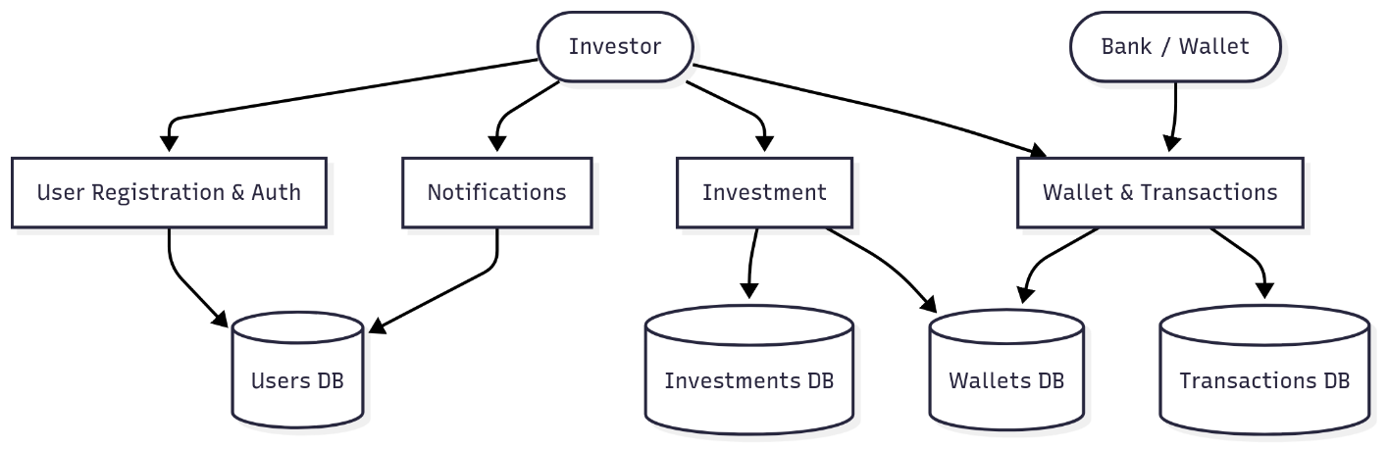
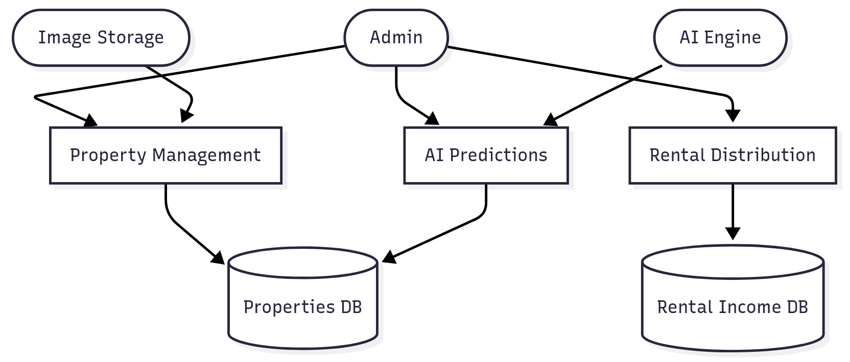
4.3 Procedural Design
4.3.1 Logic Diagrams
Flowcharts and state diagrams depict the logic for core processes in Niveshta.
- User Registration Process:
Input validation → Check if email already exists → Hash password → Save user data → Update KYC status (pending) → Send confirmation message.
- Investment Process:
User selects property → Check wallet balance → Validate available shares → Deduct wallet balance → Allocate shares → Update property availability → Record transaction.
- Rental Distribution Process:
Retrieve monthly rent for property → Calculate investor share percentages → Distribute rental income to wallets → Record rental transactions → Update portfolio dashboard.

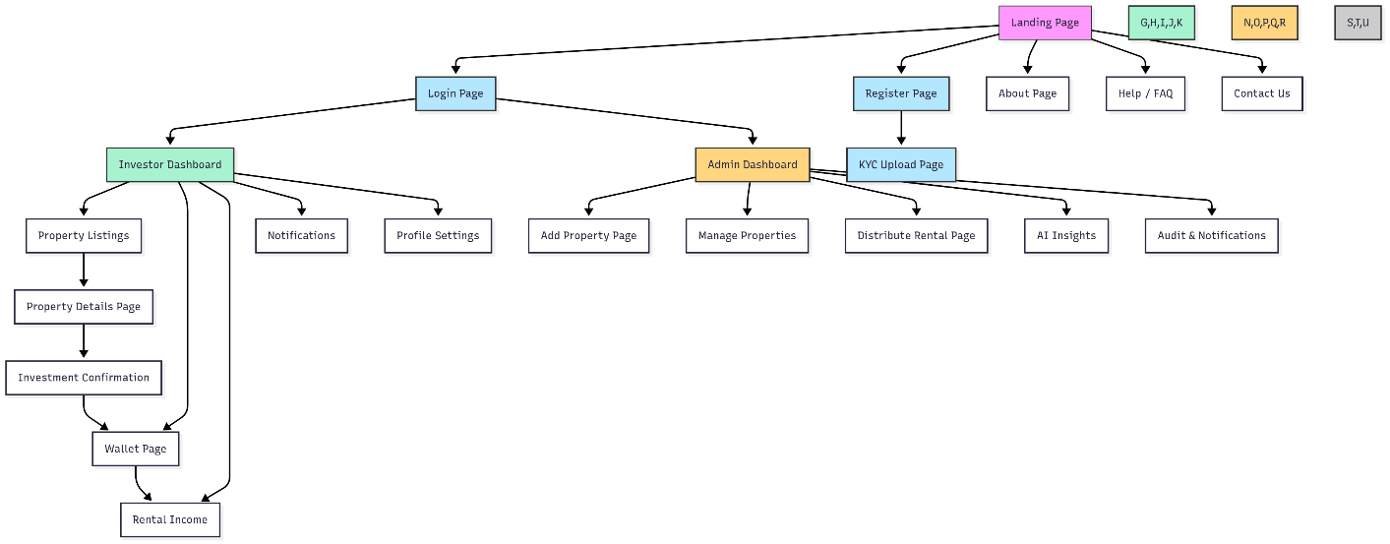

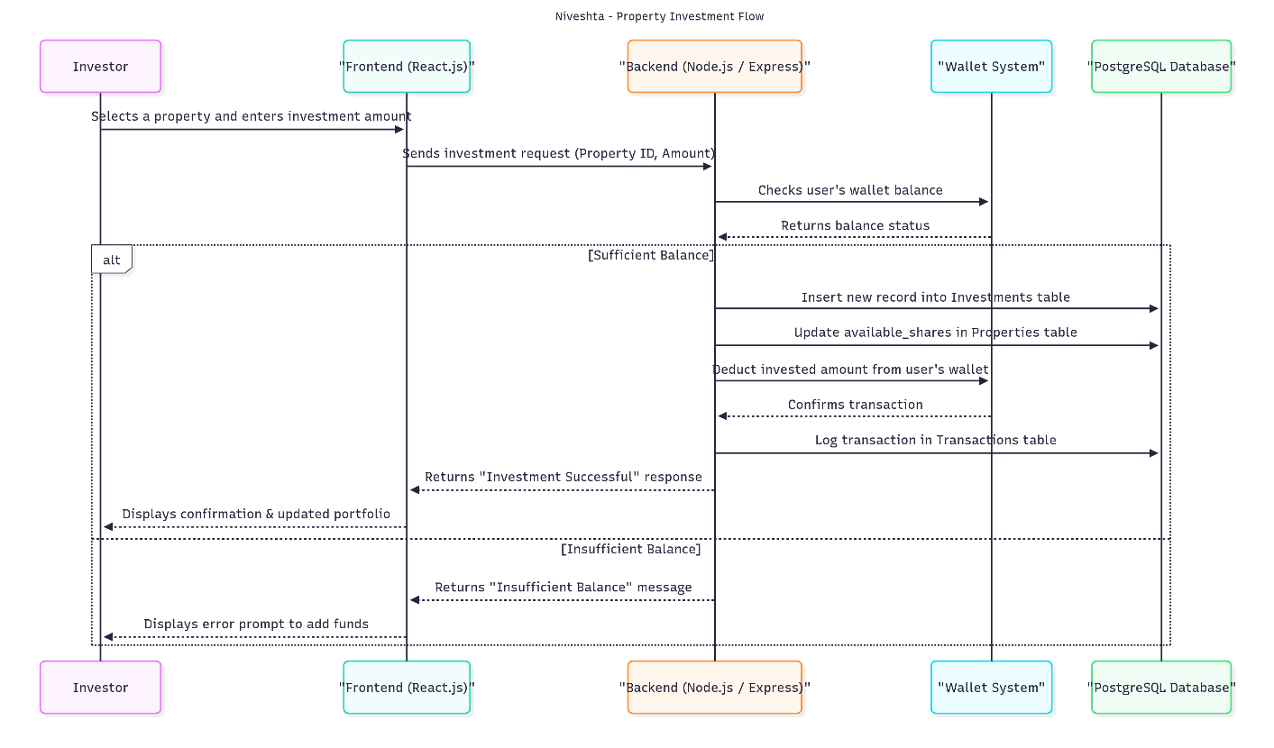

4.3.2 Data Structures
- Arrays/Lists:
Used for ordered collections such as property listings, investment histories, and rental distribution records.
- Dictionaries/Hash Maps:
Used for fast lookups, e.g., mapping user IDs to wallet balances, property IDs to AI predictions.
- Custom Classes/Objects:
  - User: {user_id, name, email, kyc_status, wallet_balance}
  - Property: {property_id, title, value, rental_yield, shares}
  - Investment: {investment_id, user_id, property_id, shares_owned, invested_amount}
  - Transaction: {transaction_id, user_id, type, amount, timestamp}

4.3.3 Algorithms Design
- Investment Validation Algorithm:
  - Check if user’s wallet balance ≥ investment amount.
  - Check if property’s available shares ≥ requested shares.
  - If valid → Deduct balance, allocate shares, update property availability, record transaction.
  - Else → Reject with appropriate message.
- Rental Distribution Algorithm:
  - For each property with rental income:
    - Retrieve total rent for the period.
    - For each investor, calculate share: (investor_shares / total_shares) * total_rent.
    - Credit amount to investor wallet.
    - Log transaction as rental_credit.
- AI Prediction Algorithm (simplified):
  - Input property features (location, value, size, rental yield).
  - Apply trained model (XGBoost/Regression).
  - Output predicted price and risk score (Low/Medium/High).

4.4 User Interface Design
The UI is designed with React.js + Tailwind CSS for responsiveness and a modern fintech look.
- Landing Page: Introduction, features, call-to-action buttons.
- Login/Register: Secure forms with KYC upload.
- User Dashboard: Wallet balance, portfolio summary, AI predictions.
- Property Listings: Grid view of properties with filters.
- Property Details: Investment options, predicted price, risk score.
- Admin Panel: Property management, investor overview, rental distribution.

4.5 Security Issues
- Authentication: Enforced through hashed passwords and session tokens.
- KYC Verification: Ensures genuine investors.
- Authorization: Role-based access control (User vs Admin).
- Data Security: Sensitive user data encrypted in the database.
- Transaction Integrity: PostgreSQL ensures ACID compliance, preventing partial or duplicate transactions.
- Vulnerability Protection: Input validation to avoid SQL injection and XSS attacks.

4.6 Test Case Design
• User Registration: Verify new users are saved, emails are unique.
• Login Authentication: Valid login succeeds, invalid credentials rejected.
• Wallet Transaction: Deposit and withdrawal update balances correctly.
• Investment Allocation: Share count matches invested amount.
• Rental Distribution: Investors receive correct proportional income.
• Property Image Upload: Multiple images are linked to property correctly.
• AI Predictions: Verify predictions are stored in ai_predictions.
• Notifications: Ensure rental credit notifications are sent.

Chapter 5: Implementation & Testing

5.1 Implementation Approach
The implementation phase of the Nivestha platform focuses on transforming the conceptual design and system architecture described in the previous chapters into a functional web-based application. The system follows a full-stack architecture, combining a modern frontend interface, a scalable backend server, and a reliable relational database.
The frontend of the system is developed using React.js and Tailwind CSS, which provide a responsive and component-based user interface. React allows efficient rendering through the Virtual DOM and enables the creation of reusable UI components such as dashboards, property listings, and wallet management panels.
The backend is implemented using Node.js with Express.js, which handles server-side logic, REST API routing, authentication mechanisms, and business logic related to investments, transactions, and rental distribution. Express middleware is used to manage authentication, request validation, and error handling.
The system uses PostgreSQL as the primary database management system. PostgreSQL ensures reliability, strong transaction support, and ACID compliance, which are essential for financial operations such as wallet balance updates and investment allocations.
The implementation architecture follows a three-tier model:
- Presentation Layer – React.js frontend interface interacting with users.
- Application Layer – Node.js and Express.js backend handling business logic.
- Data Layer – PostgreSQL database storing system data such as users, properties, investments, and transactions.
The system workflow operates as follows:
- Users access the platform through the React-based web interface.
- The frontend sends API requests to the backend server.
- The backend processes the request and performs validation.
- Database operations are executed using PostgreSQL queries.
- Results are returned to the frontend and displayed to the user.
This modular architecture ensures that the platform remains scalable, maintainable, and secure for future enhancements.

5.2 Coding Details and Code Efficiency
The Nivestha platform follows a modular coding structure to improve maintainability and readability. Each module of the system is implemented as a separate component or service within the application.
Backend Implementation
The backend server is structured using a layered architecture that separates routes, controllers, and database logic.
Typical backend structure:
- Routes Layer – Defines API endpoints for authentication, property management, investments, and transactions.
- Controller Layer – Handles request processing and business logic.
- Database Layer – Executes PostgreSQL queries and manages database interactions.
Key API endpoints implemented include:
- User registration and login APIs for authentication.
- Property listing APIs to display available investment opportunities.
- Investment APIs that allocate shares based on user investment.
- Wallet APIs for deposits, withdrawals, and balance tracking.
- Rental distribution APIs for distributing rental income among investors.
Each API includes validation checks such as verifying wallet balances, confirming available property shares, and ensuring secure user authentication.
Frontend Implementation
The frontend application is developed using a component-based architecture in React.js. The interface is divided into reusable components such as:
- Navigation bar
- Login and registration forms
- Investor dashboard
- Property listing grid
- Property detail pages
- Wallet management interface
- Admin control panel
Tailwind CSS is used to design a modern and responsive user interface with consistent styling.
Code Efficiency
To ensure optimal performance and efficiency, the following practices are implemented:
- Reusable React components to reduce redundant code.
- Efficient database queries to minimize unnecessary data processing.
- Asynchronous programming in Node.js to handle multiple requests efficiently.
- Proper indexing in PostgreSQL to speed up queries for users, investments, and transactions.
- Error handling mechanisms to prevent application crashes.
These practices help maintain a scalable and responsive application even as the number of users and properties increases.

#Nivestha Website Code:

Routes:
auth.routes.js:

import express from "express";
import {
register,
login
} from "../controllers/auth.controller.js";
import { authenticate } from "../middleware/authMiddleware.js";
const router = express.Router();
router.post("/register", register);
router.post("/login", login);
router.get("/me", authenticate);
export default router;
-------------------------------------------------------------------------------------------------------------------
property.routes.js:

import express from "express";
import authenticate from "../middleware/authenticate.js";
import authorizeRole from "../middleware/authorizeRole.js";
import upload from "../middleware/upload.js";
import {
addProperty,
getAllProperties,
getPropertyDetails
} from "../controllers/property.controller.js";
const router = express.Router();

// PUBLIC
router.get("/", getAllProperties);
router.get("/:id", getPropertyDetails);

// ADMIN ONLY
router.post(
"/",
authenticate,
authorizeRole("ADMIN"),
upload.array("images", 10),
addProperty
);

export default router;
-------------------------------------------------------------------------------------------------------------------
investment.routes.js:

import express from "express";
import authenticate from "../middleware/authenticate.js";
import authorizeRole from "../middleware/authorizeRole.js";
import {
investInProperty,
getMyInvestments

} from "../controllers/investment.controller.js";
const router = express.Router();

router.post(
"/",
authenticate,
authorizeRole("INVESTOR"),
investInProperty
);

router.get(
"/my",
authenticate,
authorizeRole("INVESTOR"),
getMyInvestments
);

export default router;
-------------------------------------------------------------------------------------------------------------------

Frontend Code:

navbar.jsx:

import React from "react";
export default function Navbar(){
const user = JSON.parse(localStorage.getItem("user"));
return(
<div
style={{
height:"60px",
background:"#f1f5f9",
display:"flex",
alignItems:"center",
justifyContent:"flex-end",
padding:"0 30px",
fontWeight:"500"
}}
>
Welcome, {user?.full_name}
</div>
);
}
-------------------------------------------------------------------------------------------------------------------

login.jsx:

import React, { useState } from "react";
import { Link, useNavigate } from "react-router-dom";
import API from "../../services/api";
export default function Login() {
const navigate = useNavigate();
const [email,setEmail] = useState("");
const [password,setPassword] = useState("");

const handleLogin = async (e)=>{
e.preventDefault();
try{
const res = await API.post("/auth/login",{
email,
password
});
// save token
localStorage.setItem("token", res.data.token);
// save user info
localStorage.setItem(
"user",
JSON.stringify(res.data.user)
);
const role = res.data.user.role;
if(role === "ADMIN"){
navigate("/admin/dashboard");
}else{
navigate("/dashboard");
}
}catch(err){
alert(err.response?.data?.message || "Login failed");
}
};
return(
<div className="min-h-screen flex">
{/* Left Side Branding */}
<div className="hidden lg:flex w-1/2 bg-blue-600 text-white items-center justify-center p-12">
<div>
<h1 className="text-4xl font-bold mb-4">
Welcome to Nivestha
</h1>
<p className="text-lg opacity-90">
Invest in premium real estate with fractional ownership.
Grow your wealth securely.
</p>
</div>
</div>

{/* Right Side Form */}
<div className="flex w-full lg:w-1/2 items-center justify-center bg-gray-50">
<form
onSubmit={handleLogin}
className="bg-white p-10 rounded-xl shadow-lg w-full max-w-md"
>
<h2 className="text-2xl font-bold mb-6 text-gray-800">
Login to your account
</h2>
<input
type="email"
placeholder="Email"
className="w-full border p-3 rounded mb-4"
value={email}
onChange={(e)=>setEmail(e.target.value)}
required
/>
<input
type="password"
placeholder="Password"
className="w-full border p-3 rounded mb-6"
value={password}
onChange={(e)=>setPassword(e.target.value)}
required
/>
<button
className="w-full bg-blue-600 text-white p-3 rounded hover:bg-blue-700 transition"
>
Login
</button>
<p className="mt-4 text-sm text-gray-600">
Don't have an account?
<Link
to="/register"
className="text-blue-600 ml-1 font-medium"
>
Register
</Link>
</p>
</form>
</div>
</div>
);}
InvestorDashboard.jsx:

import React, { useEffect, useState } from "react";
import API from "../../services/api";

import {
LineChart,
Line,
XAxis,
YAxis,
Tooltip,
CartesianGrid,
ResponsiveContainer
} from "recharts";

import {
Wallet,
TrendingUp,
Building
} from "lucide-react";
......
.......

/* ===== STYLES ===== */
const dashboardContainer={
display:"flex",
flexDirection:"column",
gap:"30px",
width:"100%"
};
const titleStyle={
fontSize:"26px",
fontWeight:"600"
};
const cardsGrid={
display:"grid",
gridTemplateColumns:"repeat(auto-fit,minmax(250px,1fr))",
gap:"20px"
};
const cardHeader={
display:"flex",
alignItems:"center",
gap:"10px"
};
const labelStyle={
color:"#64748b"
};
const valueStyle={
fontSize:"26px",
fontWeight:"700"
};
const chartCard={
background:"#ffffff",
padding:"25px",
borderRadius:"12px",
boxShadow:"0 4px 12px rgba(0,0,0,0.08)",
width:"100%"
};
const chartTitle={
marginBottom:"15px",
fontWeight:"600"
};
const chartWrapper={
width:"100%",
height:"300px"
};
-------------------------------------------------------------------------------------------------------------------
PropertyDetail.jsx:

import { useEffect, useState } from "react";
import { useParams } from "react-router-dom";
import {
getPropertyById,
predictAI
} from "../../context/ApiClient";
const { id } = useParams();
const [property, setProperty] = useState(null);
const [loading, setLoading] = useState(true);
// AI states
const [aiInsight, setAiInsight] = useState(null);
const [aiLoading, setAiLoading] = useState(false);
const [aiError, setAiError] = useState(null);
.............
.............

<div>
<p className="text-sm text-gray-500">Risk Score</p>
<p
className={`font-bold text-lg ${
aiInsight.risk_score <= 3
? "text-green-600"
: aiInsight.risk_score <= 6
? "text-yellow-600"
: "text-red-600"
}`}
>
{aiInsight.risk_score} / 10
</p>
</div>
</div>
)}
<p className="text-xs text-gray-400 mt-4">
AI predictions are indicative and not guaranteed.
</p>
</div>
-------------------------------------------------------------------------------------------------------------------
PropertyList.jsx:

import {useEffect,useState} from "react";
import ApiClient from "../../context/ApiClient";
export default function PropertyList(){
const [properties,setProperties]=useState([]);
useEffect(()=>{
ApiClient.get("/property")
.then(res=>{
setProperties(res.data.properties);
});
},[]);
return(
<div>
{
properties.map(p=>(
<div key={p.property_id}>
<h3>{p.title}</h3>
<p>{p.location}</p>
<img
src={p.primary_image}
width="200"
/>
</div>
))
}
</div>
);
}

-------------------------------------------------------------------------------------------------------------------
WalletPage.jsx:

import React, { useEffect, useState } from "react";
import API from "../../services/api";
export default function WalletPage() {
const [balance,setBalance] = useState(0);
const [amount,setAmount] = useState("");
const [transactions,setTransactions] = useState([]);
const [stats,setStats] = useState({
total_deposited:0,
total_withdrawn:0,
total_invested:0
});
useEffect(()=>{
loadWallet();
loadTransactions();
loadStats();
},[]);
.............
.............
const transactionsCard={
background:"#fff",
padding:"20px",
borderRadius:"12px",
boxShadow:"0 6px 16px rgba(0,0,0,0.08)"
};
const table={
width:"100%",
borderCollapse:"collapse"
};
const th={
textAlign:"left",
padding:"12px",
borderBottom:"1px solid #e2e8f0",
fontSize:"14px",
color:"#64748b"
};
const td={
padding:"14px",
borderBottom:"1px solid #f1f5f9",
fontSize:"14px"
};
const depositBadge={
background:"#dcfce7",
color:"#15803d",
padding:"4px 8px",
borderRadius:"6px",
fontSize:"12px"
};
const withdrawBadge={
background:"#fee2e2",
color:"#b91c1c",
padding:"4px 8px",
borderRadius:"6px",
fontSize:"12px"
};
const investmentBadge={
background:"#dbeafe",
color:"#1d4ed8",
padding:"4px 8px",
borderRadius:"6px",
fontSize:"12px"
};
-------------------------------------------------------------------------------------------------------------------
AdminDashboard.jsx:

import React,{useEffect,useState} from "react";
import API from "../../services/api";

import {
Users,
Building2,
Wallet,
ArrowLeftRight,
IndianRupee
} from "lucide-react";

export default function AdminDashboard(){
......
......
/* STYLES */

const container={
display:"flex",
flexDirection:"column",
gap:"30px"
};

const title={
fontSize:"24px",
fontWeight:"600"
};

const grid={
display:"grid",
gridTemplateColumns:"repeat(auto-fit,minmax(240px,1fr))",
gap:"25px"
};

const card={
background:"#fff",
padding:"25px",
borderRadius:"12px",
boxShadow:"0 6px 16px rgba(0,0,0,0.08)",
display:"flex",
flexDirection:"column",
gap:"10px"
};
-------------------------------------------------------------------------------------------------------------------

Backend Code :

auth.controller.js
import pool from "../config/db.js";
import bcrypt from "bcryptjs";
import { signToken } from "../utils/jwt.js";

// ===============================
// REGISTER USER
// ===============================
export const register = async (req, res) => {

const { full_name, email, password, phone_number } = req.body;

const client = await pool.connect();

try {

await client.query("BEGIN");

// check existing user
const existingUser = await client.query(
`SELECT user_id FROM users WHERE email=$1`,
[email]
);

if (existingUser.rowCount > 0) {
return res.status(400).json({
message: "User already exists"
});
}
………….
………….
// ===============================
// LOGIN USER
// ===============================
export const login = async (req, res) => {
const { email, password } = req.body;
if (!email || !password) {
return res.status(400).json({
message: "Email and password required"
});
}

try {

const result = await pool.query(
`
SELECT
u.user_id,
u.email,
u.password_hash,
u.full_name,
r.role_name
FROM users u
JOIN user_roles ur ON ur.user_id = u.user_id
JOIN roles r ON r.role_id = ur.role_id
WHERE u.email = $1
`,
[email]
);

if (result.rowCount === 0) {
return res.status(401).json({
message: "Invalid email or password"
});
}
const user = result.rows[0];
const passwordMatch = await bcrypt.compare(
password,
user.password_hash
);
if (!passwordMatch) {
return res.status(401).json({
message: "Invalid email or password"
});
}
const token = signToken({
user_id: user.user_id
});
res.json({
message: "Login successful",
token,
user: {
user_id: user.user_id,
email: user.email,
full_name: user.full_name,
role: user.role_name
}
});
} catch (error) {
res.status(500).json({
message: error.message
});
}
};

property.controller.js:

import pool from "../config/db.js";

/**
* ===============================
* ADMIN: Add new property
* ===============================
*/
export const addProperty = async (req,res)=>{

const {title,location,description,total_value,total_shares} = req.body;
const images = req.file ? [req.file] : [];

if(images.length === 0){
return res.status(400).json({
success:false,
message:"Image required"
});
}

if(!title || !location || !total_value || !total_shares){
return res.status(400).json({
success:false,
message:"All required fields must be provided"
});
}

if(!images || images.length===0){
return res.status(400).json({
success:false,
message:"At least one property image is required"
});
}
………
………
/**
* ===============================
* USER: Property details
* ===============================
*/
export const getPropertyDetails = async (req,res)=>{
const {id} = req.params;
try{
const property = await pool.query(
`
SELECT *,
ROUND(total_value / total_shares,2) AS share_price
FROM properties
WHERE property_id=$1
`,
[id]
);
const images = await pool.query(
`
SELECT image_url,is_primary
FROM property_images
WHERE property_id=$1
ORDER BY is_primary DESC
`,
[id]
);
const imageUrls = images.rows.map(img=>{
let image = img.image_url.replace("/uploads/","");
return{
...img,
image_url:`http://localhost:5000/uploads/${image}`
};
});
res.json({
success:true,
property:{
...property.rows[0],
roi:12,
images:imageUrls
}
});
}
catch(err){
res.status(500).json({
success:false,
message:err.message
});
}
};

investment.controller.js:

import pool from "../config/db.js";
import auditLog from "../utils/auditLog.js";

export const investInProperty = async (req, res) => {
const userId = req.user?.user_id;
const { property_id, shares } = req.body;
if (!userId) {
return res.status(401).json({
success: false,
message: "Unauthorized user"
});
}
if (!property_id || !shares || shares <= 0) {
return res.status(400).json({
success: false,
message: "Invalid input"
});
}
………..
………..
export const getDashboardStats = async (req, res) => {
try {
const userId = req.user.user_id;
const wallet = await pool.query(
`
SELECT COALESCE(NULLIF(balance::text,'NaN')::numeric,0) AS balance
FROM wallets
WHERE user_id=$1
`,
[userId]
);
const investments = await pool.query(
`
SELECT
SUM(amount_invested) as total_invested,
COUNT(*) as properties
FROM investments
WHERE user_id=$1
`,
[userId]
);
const transactions = await pool.query(
`
SELECT
DATE_TRUNC('month', created_at) as month,
SUM(amount) as value
FROM transactions
WHERE user_id=$1
GROUP BY month
ORDER BY month
`,
[userId]
);
res.json({
success:true,
wallet:wallet.rows[0],
investments:investments.rows[0],
growth:transactions.rows
});
} catch(err){
res.status(500).json({
success:false,
message:err.message
});
}
};

AI Module :
Train.py:

import pandas as pd
import joblib
from sklearn.model_selection import train_test_split
from sklearn.preprocessing import LabelEncoder
from xgboost import XGBRegressor

# ===============================
# LOAD DATA
# ===============================
df = pd.read_excel("./data/properties.xlsx")

# -------------------------------
# CLEAN DATA
# -------------------------------

# Remove rows with missing locations
df = df.dropna(subset=["Location"])

# Convert BHK safely
df["BHK"] = df["BHK"].astype(str).str.extract(r'(\d+\.?\d*)')
df["BHK"] = pd.to_numeric(df["BHK"], errors="coerce")

# Fill missing numeric values
df["Sqft"] = df["Sqft"].fillna(df["Sqft"].median())
df["Price Per Sqft"] = df["Price Per Sqft"].fillna(df["Price Per Sqft"].median())
df["Years"] = df["Years"].fillna(0)
df["rental_yield"] = df["rental_yield"].fillna(df["rental_yield"].median())

# -------------------------------
# ENCODE LOCATION
# -------------------------------
le = LabelEncoder()

df["locality_encoded"] = le.fit_transform(df["Location"].astype(str))

# -------------------------------
# FEATURES & TARGETS
# -------------------------------

X = df[["locality_encoded", "Sqft", "BHK", "Price Per Sqft", "Years", "rental_yield"]]

y_price = df["Price"]
y_risk = df["risk_score"]

# -------------------------------
# TRAIN / TEST SPLIT
# -------------------------------

X_train, X_test, y_price_train, y_price_test = train_test_split(
X, y_price, test_size=0.2, random_state=42
)

_, _, y_risk_train, y_risk_test = train_test_split(
X, y_risk, test_size=0.2, random_state=42
)

# -------------------------------
# MODELS
# -------------------------------

price_model = XGBRegressor(
n_estimators=300,
learning_rate=0.08,
max_depth=6,
random_state=42
)

risk_model = XGBRegressor(
n_estimators=200,
learning_rate=0.1,
max_depth=5,
random_state=42
)

# -------------------------------
# TRAIN MODELS
# -------------------------------

price_model.fit(X_train, y_price_train)
risk_model.fit(X_train, y_risk_train)

# -------------------------------
# SAVE MODELS
# -------------------------------

joblib.dump(price_model, "./models/price_model.joblib")
joblib.dump(risk_model, "./models/risk_model.joblib")
joblib.dump(le, "./models/locality_encoder.joblib")

print("🎉 Models trained & saved successfully!")
-------------------------------------------------------------------------------------------------------------------

Predict.py:

from flask import Flask, request, jsonify
import joblib
import numpy as np
import pandas as pd
from pathlib import Path

app = Flask(__name__)

BASE_DIR = Path(__file__).resolve().parent
MODELS_DIR = BASE_DIR / "models"
DATA_PATH = BASE_DIR / "data" / "properties.xlsx"

price_model = joblib.load(MODELS_DIR / "price_model.joblib")
risk_model = joblib.load(MODELS_DIR / "risk_model.joblib")
locality_encoder = joblib.load(MODELS_DIR / "locality_encoder.joblib")

def _build_reference_stats():
default_stats = {
"sqft": 850.0,
"bhk": 2.0,
"price_per_sqft": 30000.0,
"years": 5.0,
"rental_yield": 4.7,
}

if not DATA_PATH.exists():
return {}, default_stats

df = pd.read_excel(DATA_PATH)

df["Location"] = df["Location"].astype(str).str.strip()
df["BHK"] = pd.to_numeric(df["BHK"].astype(str).str.extract(r"(\d+\.?\d*)")[0], errors="coerce")

for c in ["Sqft", "BHK", "Price Per Sqft", "Years", "rental_yield"]:
df[c] = pd.to_numeric(df[c], errors="coerce")

grouped = (
df.dropna(subset=["Location"])
.groupby("Location")[["Sqft", "BHK", "Price Per Sqft", "Years", "rental_yield"]]
.median()
.reset_index()
)

by_location = {}
for _, row in grouped.iterrows():
by_location[row["Location"]] = {
"sqft": float(row["Sqft"]),
"bhk": float(row["BHK"]),
"price_per_sqft": float(row["Price Per Sqft"]),
"years": float(row["Years"]),
"rental_yield": float(row["rental_yield"]),
}

global_med = df[["Sqft", "BHK", "Price Per Sqft", "Years", "rental_yield"]].median(numeric_only=True)
default_stats = {
"sqft": float(global_med.get("Sqft", default_stats["sqft"])),
"bhk": float(global_med.get("BHK", default_stats["bhk"])),
"price_per_sqft": float(global_med.get("Price Per Sqft", default_stats["price_per_sqft"])),
"years": float(global_med.get("Years", default_stats["years"])),
"rental_yield": float(global_med.get("rental_yield", default_stats["rental_yield"])),
}

return by_location, default_stats

LOCATION_STATS, DEFAULT_STATS = _build_reference_stats()

def _clamp(value, min_value, max_value):
return max(min_value, min(value, max_value))

def _safe_float(value, default=0.0):
try:
return float(value)
except (TypeError, ValueError):
return float(default)

def _safe_int(value, default=1):
try:
return int(round(float(value)))
except (TypeError, ValueError):
return int(default)

def _predict_with_derived_features(location, total_price, roi, investment_years):
stats = LOCATION_STATS.get(location, DEFAULT_STATS)

locality_name = location if location in locality_encoder.classes_ else locality_encoder.classes_[0]
locality_encoded = locality_encoder.transform([locality_name])[0]

estimated_sqft = _clamp(total_price / max(stats["price_per_sqft"], 1.0), 250.0, 12000.0)
inferred_ppsf = _clamp(total_price / estimated_sqft, 1000.0, 200000.0)

bhk = _clamp(stats["bhk"], 1.0, 8.0)
years_feature = _clamp(stats["years"], 0.0, 15.0)
rental_yield = _clamp(roi if roi > 0 else stats["rental_yield"], 2.5, 6.5)

features = np.array([[locality_encoded, estimated_sqft, bhk, inferred_ppsf, years_feature, rental_yield]])

base_predicted_price = float(price_model.predict(features)[0])
risk_score = float(risk_model.predict(features)[0])

raw_model_rate = (base_predicted_price / total_price) - 1.0 if total_price > 0 else 0.0
raw_model_rate = _clamp(raw_model_rate, -0.15, 0.25)

roi_rate = rental_yield / 100.0
blended_annual_rate = (0.45 * raw_model_rate) + (0.55 * roi_rate)

blended_annual_rate = max(0.01, blended_annual_rate)

projected_price = total_price * ((1.0 + blended_annual_rate) ** investment_years)

max_ratio = 1.0 + (0.35 * investment_years)
ratio = projected_price / total_price if total_price > 0 else 1.0
if not np.isfinite(projected_price) or ratio > max_ratio:
projected_price = total_price * ((1.0 + roi_rate) ** investment_years)

risk_score = _clamp(risk_score + (0.08 * max(0, investment_years - 1)), 1.0, 10.0)

return projected_price, risk_score, {
"locality_encoded": int(locality_encoded),
"sqft": round(estimated_sqft, 2),
"bhk": round(bhk, 2),
"price_per_sqft": round(inferred_ppsf, 2),
"years_feature": round(years_feature, 2),
"rental_yield": round(rental_yield, 2),
"investment_years": int(investment_years),
"annual_growth_rate": round(blended_annual_rate * 100.0, 2),
}

@app.route("/predict", methods=["POST"])
def predict():
data = request.get_json()

if not data:
return jsonify({"error": "No JSON received"}), 400

location = str(data.get("location", "")).strip()
price = _safe_float(data.get("price"), 0)
roi = _safe_float(data.get("roi"), 0)
investment_years = _safe_int(data.get("investment_years", 1), 1)
investment_years = int(_clamp(investment_years, 1, 30))

if not location or price <= 0:
return jsonify({"error": "location and price are required"}), 400

predicted_price, risk_score, features_used = _predict_with_derived_features(
location,
price,
roi,
investment_years,
)

return jsonify(
{
"predicted_price": round(predicted_price, 2),
"risk_score": round(risk_score, 2),
"investment_years": investment_years,
"features_used": features_used,
}
)

if __name__ == "__main__":
app.run(port=5001, debug=True)

5.3 Testing Approach
Testing is an essential phase of software development to ensure the reliability, security, and correctness of the system. The testing process for the Nivestha platform includes unit testing, integration testing, and beta testing.
5.3.1 Unit Testing
Unit testing focuses on testing individual modules or functions of the system independently.
Examples of unit testing performed include:
- Verifying user registration functionality.
- Checking password hashing during authentication.
- Validating wallet deposit and withdrawal operations.
- Ensuring correct share allocation during property investments.
Each module is tested independently to confirm that it performs its intended function without errors.

5.3.2 Integration Testing
Integration testing ensures that different modules of the system work together correctly.
The following integrations were tested:
- Interaction between frontend and backend APIs.
- Backend communication with the PostgreSQL database.
- Investment processing across the wallet, investment, and transaction modules.
- Rental distribution across investment and wallet modules.
For example, when a user invests in a property, the system verifies wallet balance, updates property share availability, records the investment, and logs the transaction simultaneously. Integration testing confirms that all these processes function together correctly.

5.3.3 Beta Testing
Beta testing involves testing the system in a realistic environment with sample users.
During beta testing, the following aspects were evaluated:
- User interface usability and navigation.
- System performance under multiple requests.
- Accuracy of investment calculations.
- Correct distribution of rental income.
Feedback from beta testing helped identify minor bugs and improve the overall user experience.

5.4 Modifications and Improvements
During the testing phase, several improvements were implemented to enhance system stability and usability.
Some modifications made include:
- Optimizing database queries to improve response time.
- Improving error handling for invalid user inputs.
- Enhancing validation checks for investment transactions.
- Fixing issues related to wallet balance updates.
- Improving the UI responsiveness of the dashboard and property listings.
Additionally, improvements were made to ensure proper synchronization between the frontend and backend, preventing inconsistencies in wallet balances and investment records.
These improvements significantly enhanced the reliability and efficiency of the system.

5.5 Test Cases
To ensure the correctness of the system, multiple test cases were designed and executed. These test cases validate the core functionalities of the Nivestha platform.
Test Case | Input | Expected Output
User Registration | Valid user details | User account created successfully
Login Authentication | Correct email and password | User logged into dashboard
Invalid Login | Incorrect password | Error message displayed
Wallet Deposit | Deposit amount entered | Wallet balance updated
Property Investment | User invests in property | Shares allocated and wallet balance reduced
Rental Distribution | Monthly rent generated | Investors receive proportional income
Property Image Upload | Upload property images | Images displayed with property listing
AI Prediction Storage | AI prediction generated | Data stored in ai_predictions table
Notifications | Rental credited | User receives notification

CHAPTER 6 : RESULTS AND DISCUSSION
6.1 Test Reports
After the implementation phase, the Nivestha platform was tested extensively to evaluate its functionality, reliability, and performance. The testing phase verified that all modules described in the system design—such as user management, property investment, wallet operations, rental distribution, and AI predictions—operate correctly and integrate seamlessly.
The results demonstrate that the system successfully performs the intended operations and provides a stable environment for fractional real estate investment.
User Registration and Authentication
The user registration system allows new investors to create accounts by providing personal details such as name, email address, and password. During registration, the system validates the input data and stores user credentials securely in the database.
Passwords are hashed before storage to ensure security. Once the account is created, users can log in using their registered credentials. The system verifies authentication details and grants access to the investor dashboard upon successful login.
Testing confirmed that:
- New users can register successfully.
- Duplicate email addresses are prevented by unique constraints.
- Invalid login attempts are rejected with appropriate error messages.
- Secure authentication is maintained through encrypted password storage.
These results confirm that the user management module operates correctly and maintains data security.

Property Listing and Management
The property module allows administrators to add new investment properties to the platform. Each property contains essential details such as property title, location, total value, rental yield, total shares, and available shares.
The property listing interface displays investment opportunities to users in a structured grid format. Investors can view detailed information about each property before making investment decisions.
Testing verified that:
- Properties added by administrators are stored correctly in the database.
- Property details and images are displayed correctly in the frontend interface.
- Property share availability updates dynamically when users invest.
This confirms that the property management system successfully provides transparent investment opportunities to users.

Wallet and Transaction System
The wallet system is one of the core components of the platform, enabling users to manage funds for investments. Each user is assigned a digital wallet that records deposits, withdrawals, and investment transactions.
When users deposit funds, the wallet balance increases accordingly. During an investment, the system verifies that the wallet balance is sufficient before deducting the investment amount.
Testing results showed that:
- Wallet balances update accurately during deposits and withdrawals.
- Investment transactions correctly deduct funds from the wallet.
- All financial operations are recorded in the transactions table.
- Wallet balances never become negative due to validation checks.
These results confirm that the wallet and transaction modules operate reliably and maintain financial integrity.

Property Investment Functionality
The investment module allows users to purchase fractional shares in available properties. When an investor selects a property and enters the investment amount, the system performs several validation checks before completing the transaction.
The system verifies:
- The investor’s wallet balance.
- The availability of property shares.
- The correctness of the investment amount.
Once validated, the investment is recorded in the investments table, the wallet balance is updated, and the available property shares are reduced accordingly.
Testing confirmed that:
- Share allocation is calculated correctly.
- Investments are recorded accurately in the database.
- The system prevents investments exceeding available shares.
- Users receive confirmation after successful investment.
This confirms that the fractional ownership mechanism functions correctly within the platform.

Rental Income Distribution
The rental distribution module calculates rental income generated from each property and distributes it among investors according to their ownership percentage.
The system retrieves the total rental income and calculates each investor’s share using the formula:
Investor Share = (Investor Shares / Total Property Shares) × Total Rent
The calculated amount is then credited to the investor’s wallet and recorded in the rental_income table.
Testing results verified that:
- Rental income is distributed accurately based on ownership percentages.
- Investor wallets are credited correctly.
- Transactions are recorded in the database.
- Investors receive notifications when rental income is credited.
This confirms that the rental distribution system operates efficiently and ensures fair income allocation.

AI Prediction Module
The AI prediction module provides insights into property investment opportunities by predicting future property values, rental yields, and risk levels.
Using machine learning models developed in Python, the system processes property data to generate predictions. These predictions are stored in the ai_predictions table and displayed on the investor dashboard.
Testing confirmed that:
- AI predictions are generated successfully.
- Predicted values are stored correctly in the database.
- Users can view AI insights alongside property listings.
These results demonstrate that the AI module enhances decision-making by providing intelligent investment insights.

6.2 User Documentation
The Nivestha platform provides a user-friendly interface designed to simplify the investment process for both investors and administrators. The system allows users to navigate easily between different functionalities such as property browsing, investment tracking, wallet management, and rental income monitoring.
Investor Interface
Investors interact with the system through the following workflow:
- Account Registration
Users begin by creating an account through the registration form. After entering personal information and verifying their credentials, the system creates a secure account and grants access to the platform.
- User Login
After registration, users log in using their email and password. Successful authentication directs them to the investor dashboard.
- Dashboard Overview
The dashboard provides an overview of important information such as:
  - Wallet balance
  - Current investments
  - Rental income received
  - AI investment insights
- Property Exploration
Investors can browse available properties listed on the platform. Each property includes detailed information such as location, total value, expected rental yield, and AI-based predictions.
- Investment Process
Users select a property and enter the investment amount. The system verifies wallet balance and available shares before completing the transaction.
- Investment Confirmation
Once the investment is successful, the user’s ownership share is updated and reflected in the dashboard portfolio.
- Rental Income Tracking
Investors can track rental earnings credited to their wallet through the rental distribution system.
Administrator Interface
Administrators manage the platform using the admin panel, which provides tools to oversee system operations.
Administrative features include:
- Adding new properties to the platform
- Managing property details and images
- Monitoring user investments
- Approving KYC verifications
- Initiating rental income distribution
- Reviewing system transaction logs
The admin panel ensures that platform operations remain transparent and efficient.

Investors UI/UX:

Figure 1 : Register Page
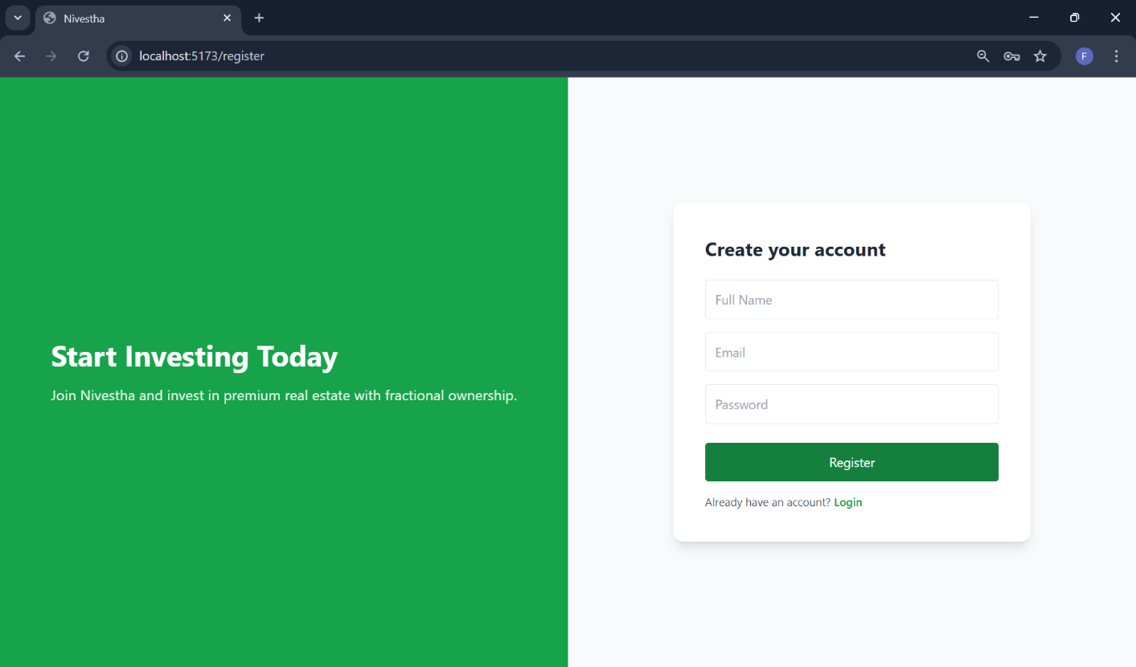
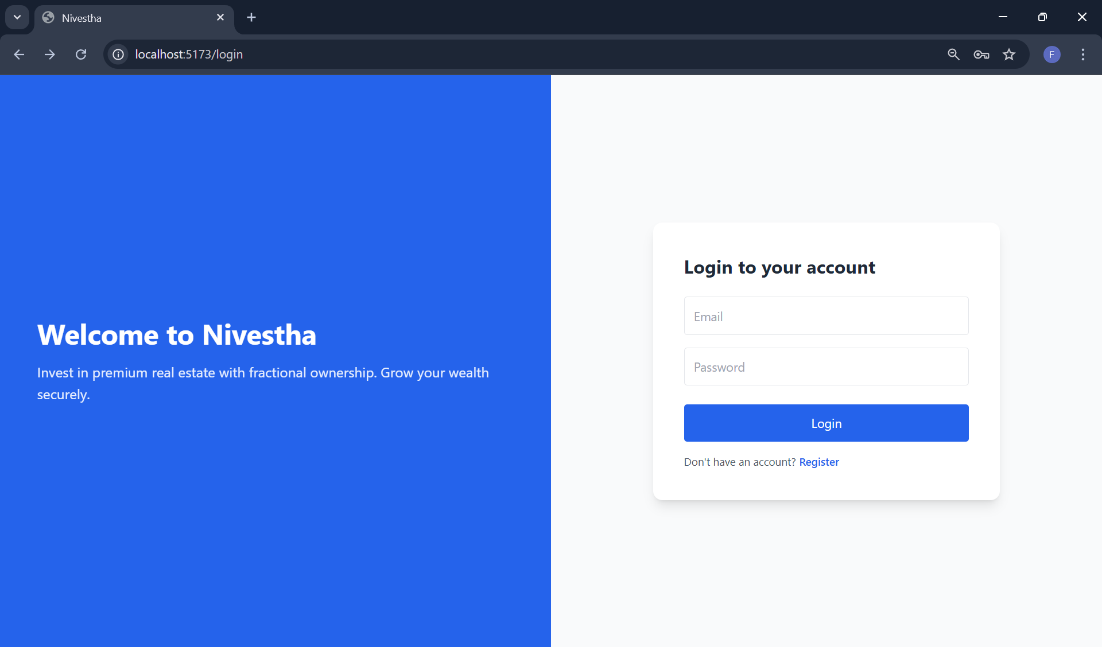
Figure 2 : Login Page
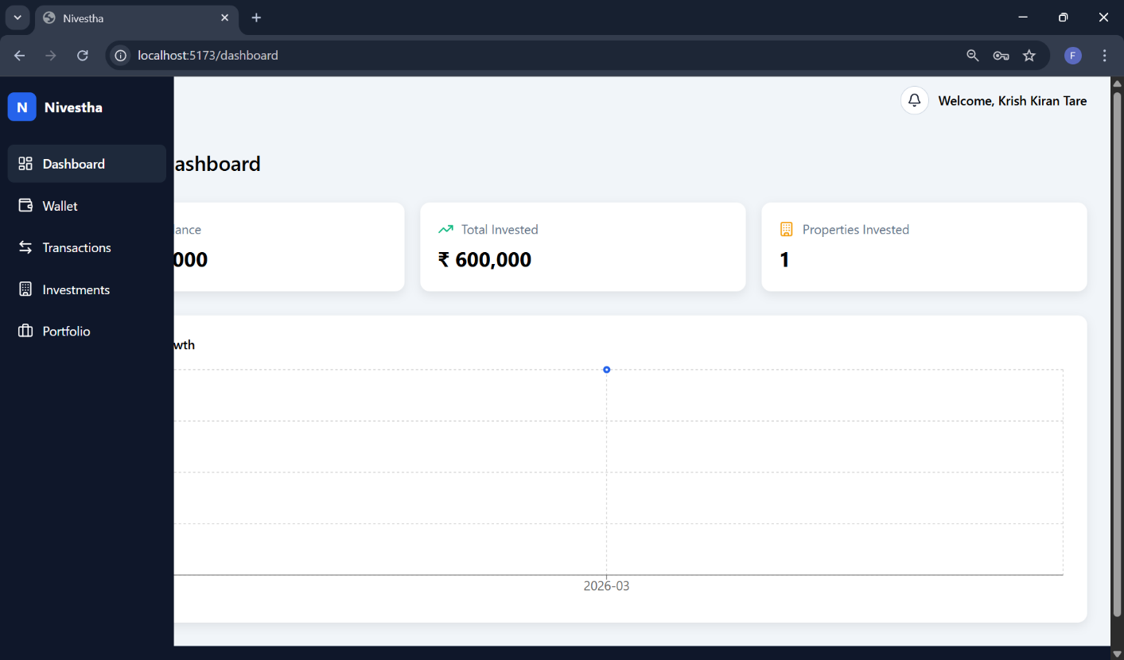

Figure 3 : Dashboard with Sidebar

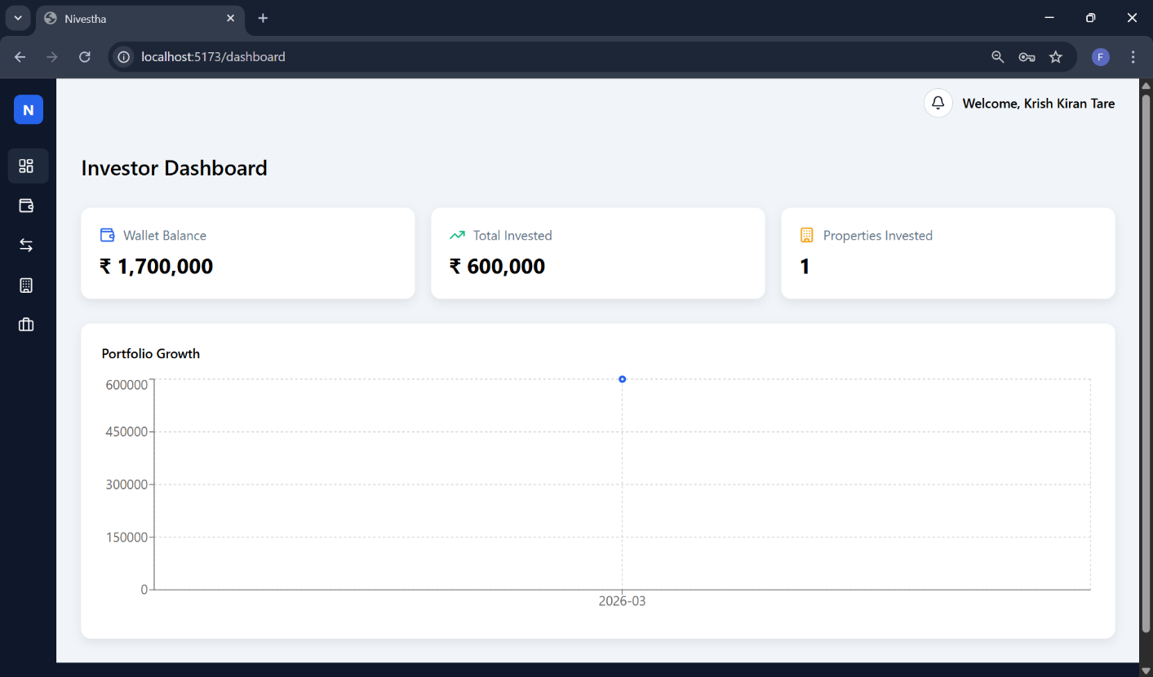
Figure 4 : Investor Dashboard

Figure 5 : Investor Wallet and Recent Transaction Panel
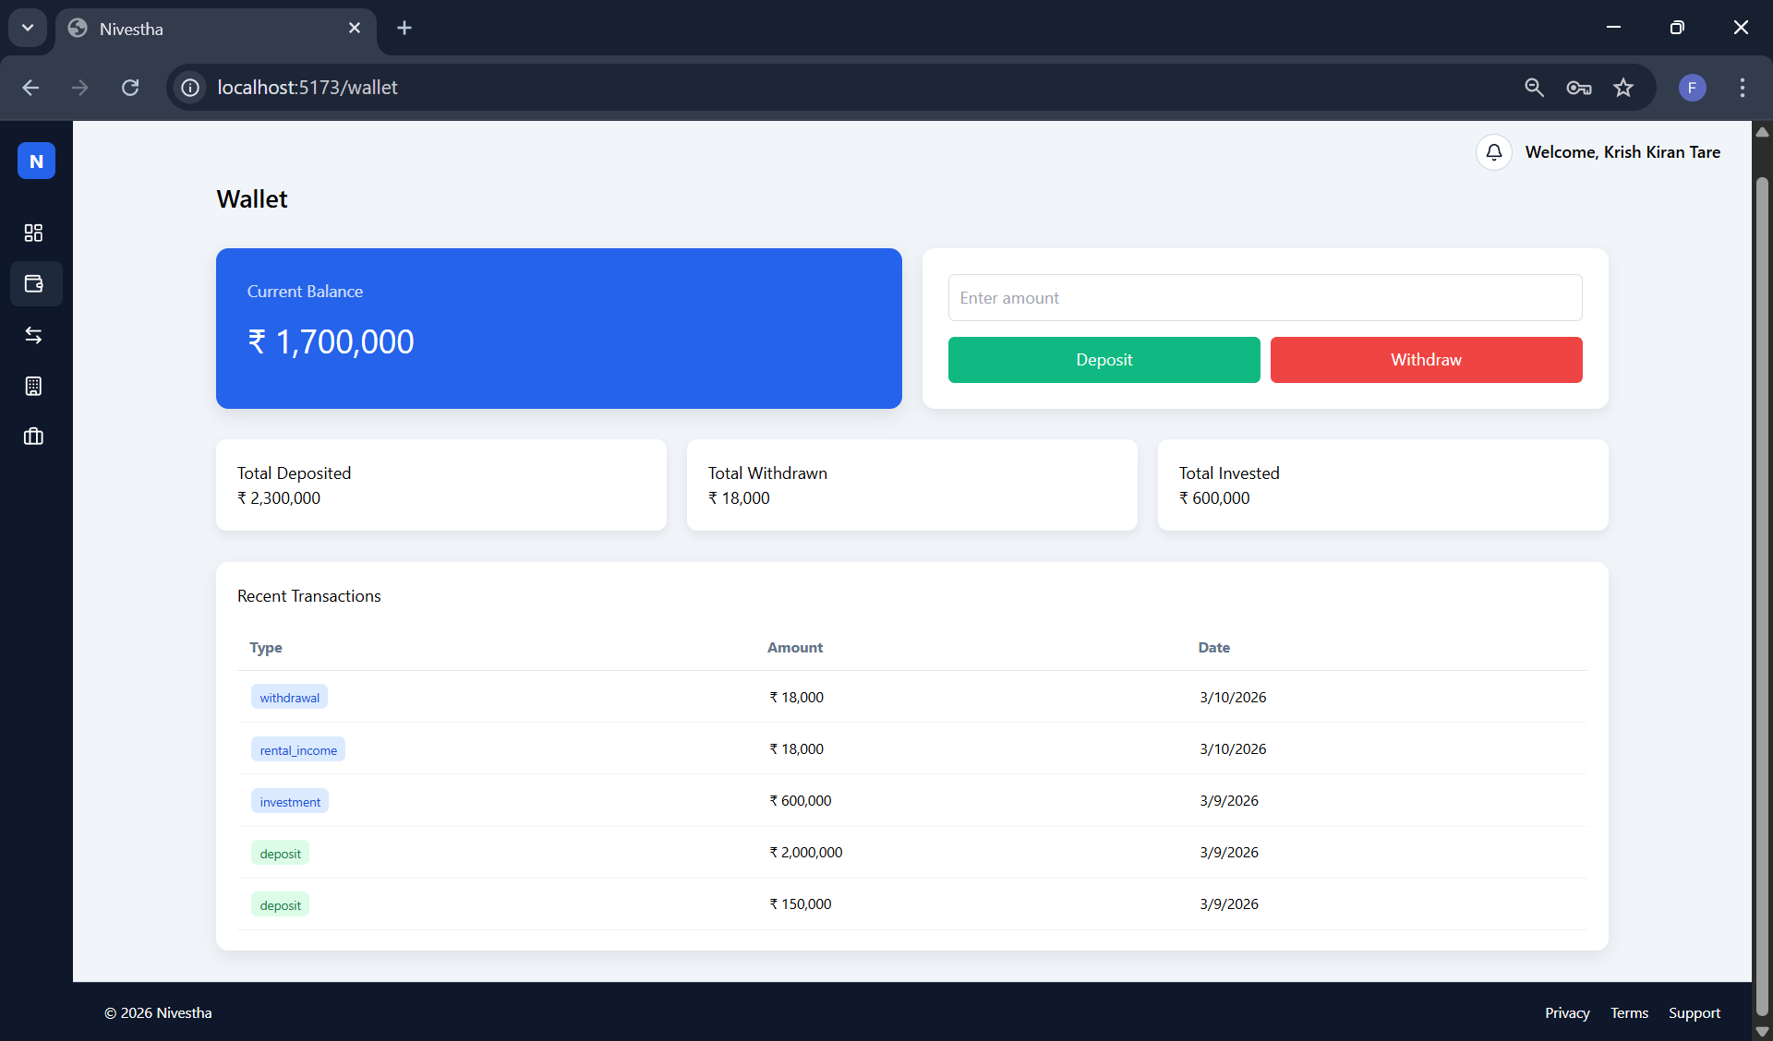

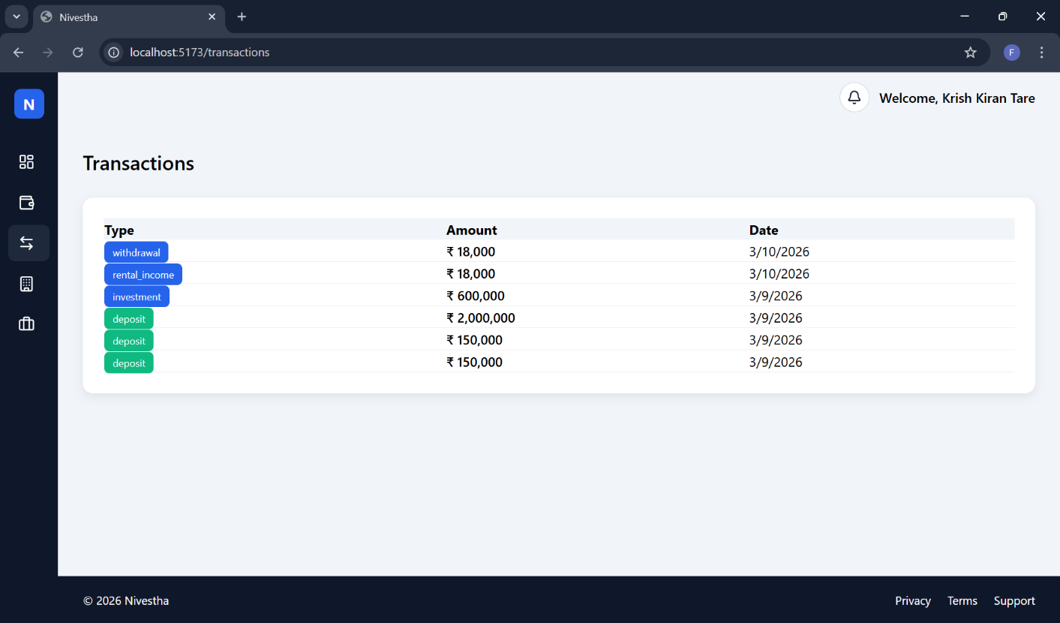
Figure 6 : Investor Transaction Panel
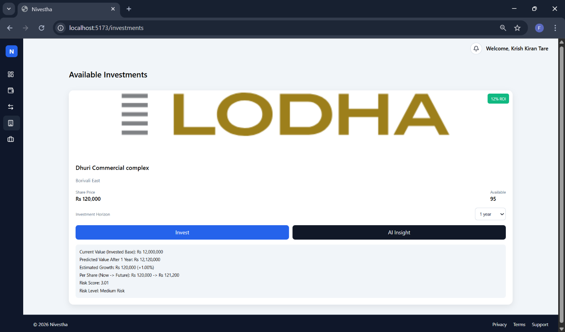

Figure 7 : Investment Panel with Prediction Model System

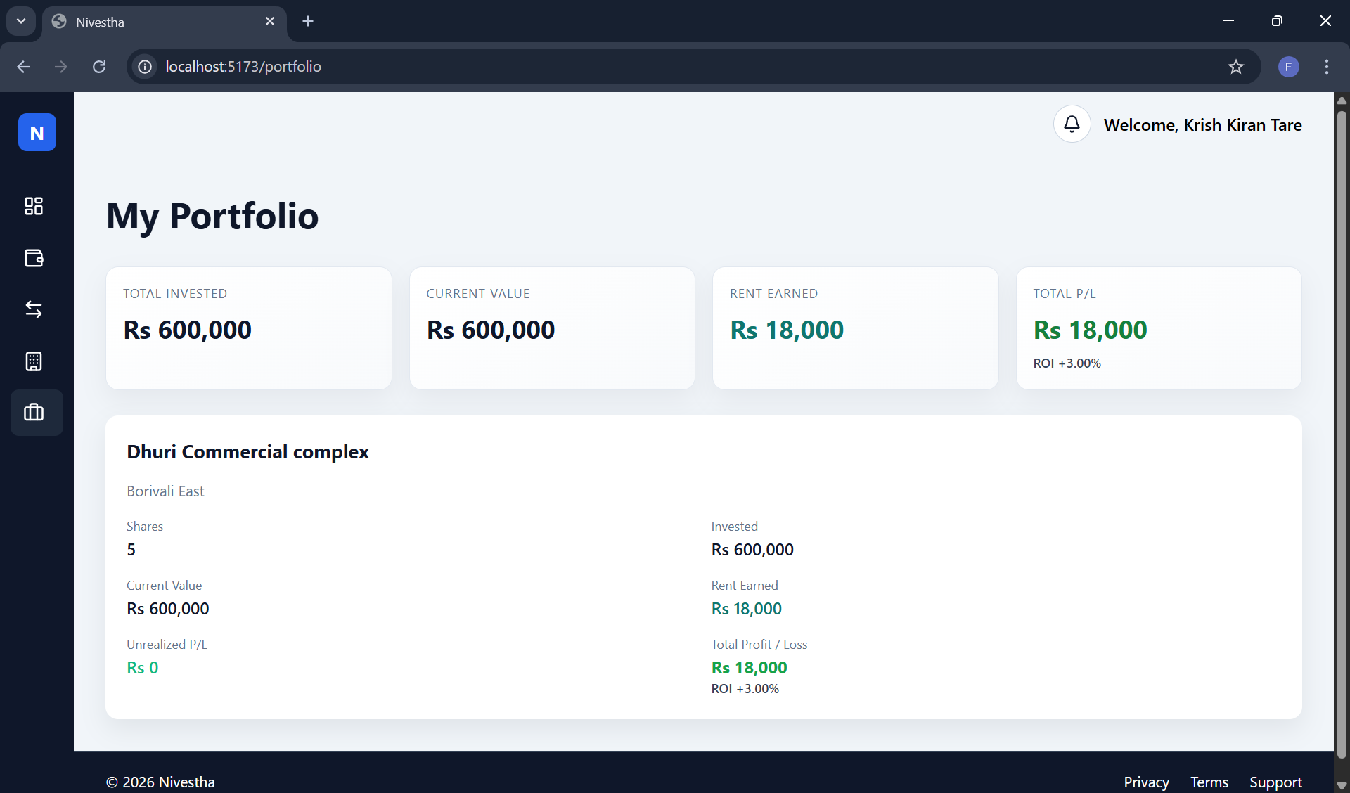
Figure 8 : Portfolio Panel

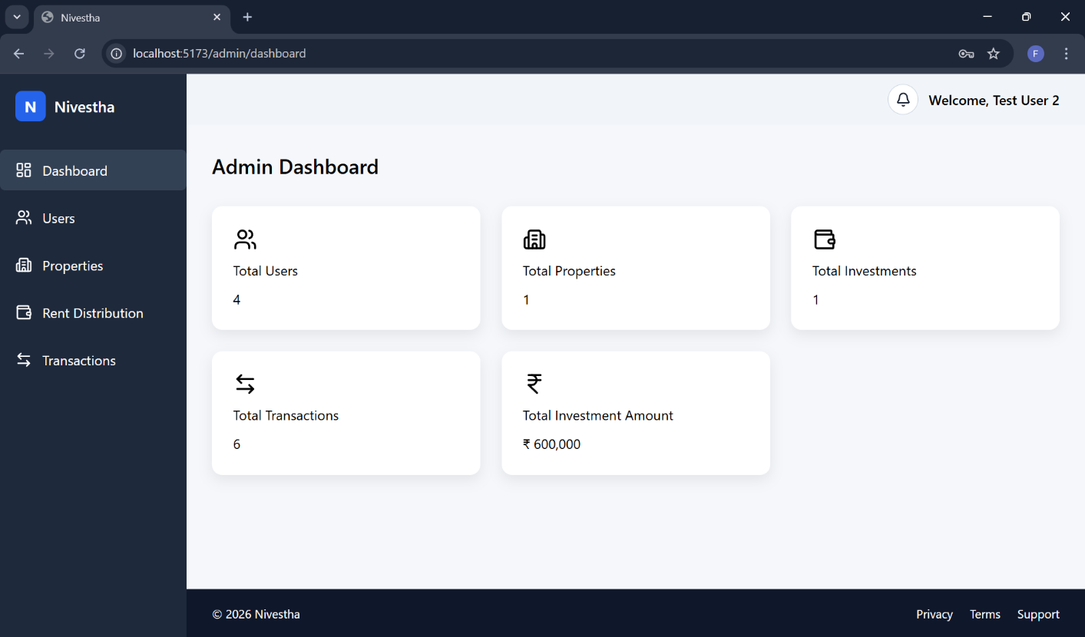
Admin UI/UX:
Figure 1 : Admin Dashboard

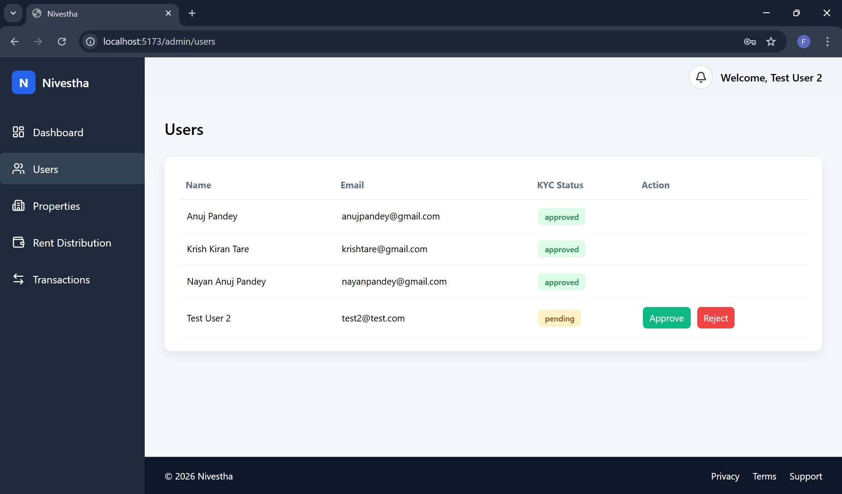
Figure 2 : Users KYC Approval

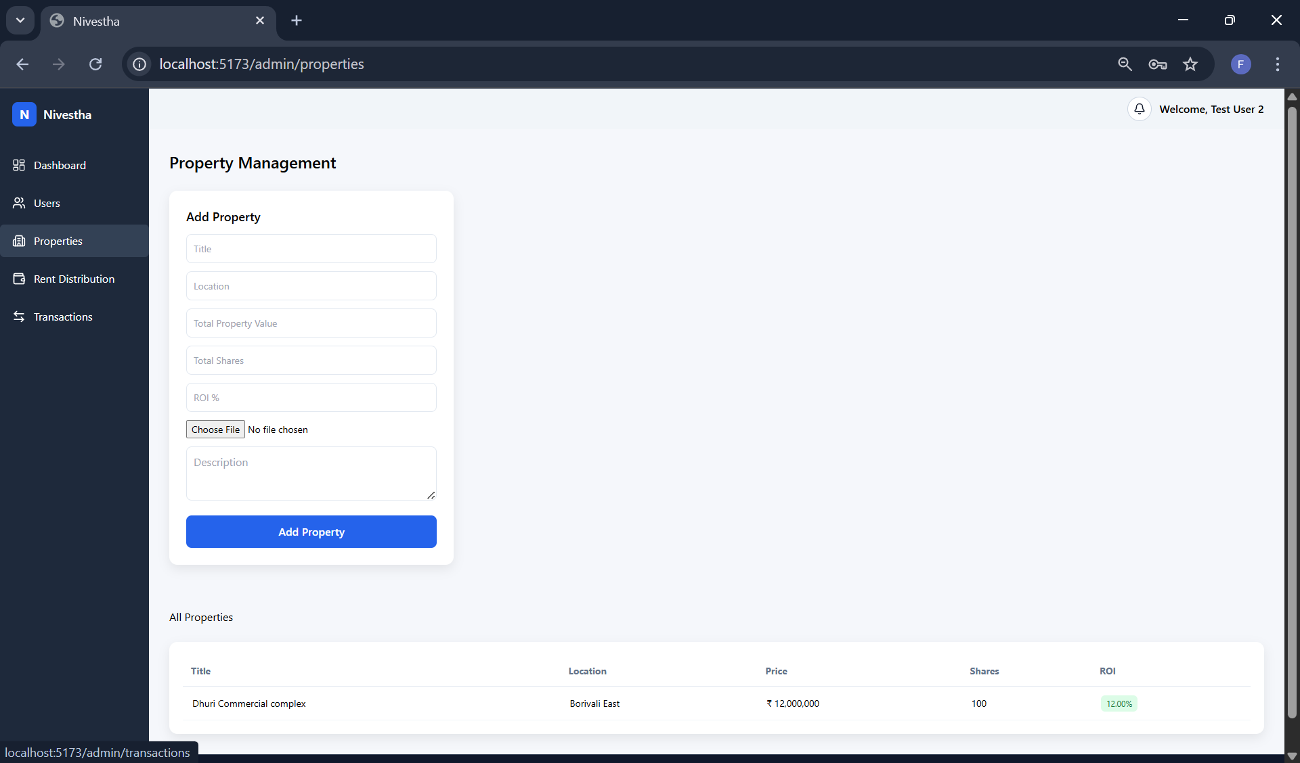
Figure 3 : Properties Management Panel

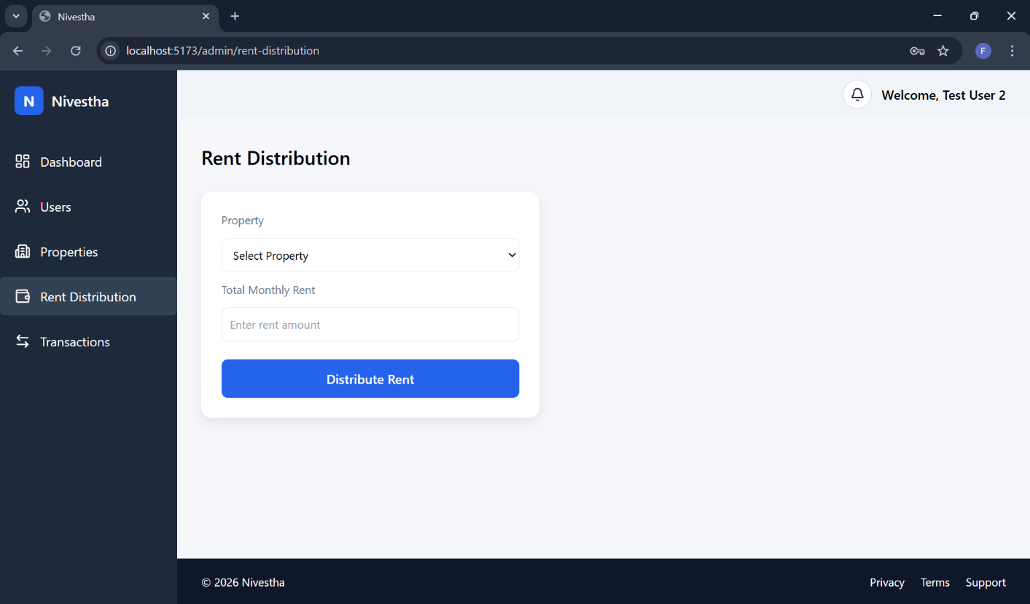
Figure 4 : Users KYC Approval

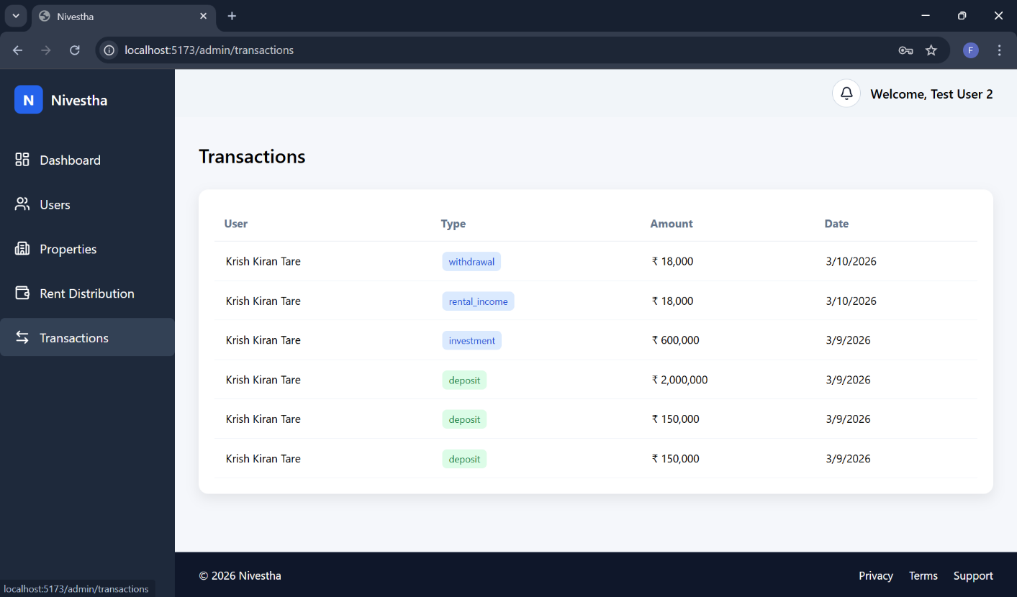
Figure 5 : All Transaction Detail

System Performance Evaluation
The Nivestha system demonstrates strong performance in terms of functionality and responsiveness. The use of modern web technologies such as React.js and Node.js enables efficient communication between the frontend and backend components.
PostgreSQL ensures reliable data storage and maintains transaction integrity for financial operations. The modular system design also allows the platform to scale as more users and properties are added.
The results indicate that the platform successfully achieves its primary goal of enabling fractional real estate investment through a secure, transparent, and intelligent digital platform.

CHAPTER 7 : CONCLUSIONS
7.1 Conclusion
The development of Nivestha: Invest Together, Prosper Together demonstrates how modern web technologies and data-driven decision systems can transform traditional real estate investment into a more accessible and transparent digital platform. The project successfully integrates concepts from full-stack web development, database management, and artificial intelligence to create a unified investment system.
Traditionally, real estate investment has required significant financial capital, making it inaccessible to a large portion of potential investors. Nivestha addresses this challenge by introducing a fractional ownership model, allowing multiple investors to collectively invest in high-value properties with smaller financial contributions. This model lowers the entry barrier and enables wider participation in real estate markets.
The system provides an integrated platform where users can register, verify their identity through KYC procedures, manage digital wallets, and invest in property shares. The implementation of secure authentication mechanisms and role-based access control ensures that both investors and administrators can interact with the platform safely.
One of the distinguishing features of the project is the integration of an AI-based prediction module. This component enhances investment decision-making by forecasting property prices, estimating rental yields, and assigning risk scores. By combining financial technology with machine learning, the platform provides investors with valuable insights that can guide smarter investment strategies.
The project also demonstrates the effective use of modern technologies such as React.js for frontend development, Node.js and Express.js for backend services, PostgreSQL for secure data storage, and Python-based machine learning libraries for predictive analytics. These technologies work together to form a scalable and maintainable architecture capable of supporting complex financial operations.
The successful implementation and testing of modules such as user management, property listing, wallet transactions, investment allocation, and rental distribution confirm that the system performs according to the defined requirements. The testing results demonstrate that the platform maintains data integrity, secure financial transactions, and efficient user interaction.
Overall, the Nivestha platform successfully achieves its objective of building a secure, transparent, and intelligent fractional real estate investment system, showcasing the potential of technology to democratize access to high-value investment opportunities.

7.2 Limitations of the System
Although the Nivestha platform provides a functional prototype for fractional real estate investment, certain limitations exist in the current implementation.
One limitation is that the system currently operates as a prototype or Minimum Viable Product (MVP). While the core features such as investment management, wallet transactions, and rental distribution are implemented, the platform may require additional optimization for handling large-scale production environments.
Another limitation is the reliance on manual administrative operations for certain processes, such as property listing and rental distribution management. In real-world scenarios, these processes may require integration with external financial services and regulatory systems.
The AI prediction module currently relies on limited datasets and simplified models for forecasting property prices and rental yields. More accurate predictions would require access to extensive real estate datasets, historical market trends, and advanced machine learning models.
Additionally, the platform does not currently include direct payment gateway integration. Wallet deposits and withdrawals are simulated within the system rather than connected to real banking or financial services.
Security measures such as authentication and encryption are implemented, but further enhancements such as multi-factor authentication, advanced encryption standards, and blockchain-based ownership verification could improve the system’s security in real-world deployment.
Despite these limitations, the project successfully demonstrates the core concept of a fractional real estate investment platform and provides a strong foundation for future expansion.

7.3 Future Scope of the Project
The Nivestha platform offers several opportunities for future development and enhancement. As technology and financial systems continue to evolve, the platform can be expanded into a more comprehensive and production-ready investment ecosystem.
One potential enhancement is the integration of blockchain technology to tokenize property ownership. Tokenization would allow property shares to be represented as digital tokens, enabling secure and transparent ownership tracking while facilitating secondary market trading.
Another improvement involves integrating secure payment gateways such as UPI, credit cards, and banking APIs. This would allow real-time deposits and withdrawals, making the wallet system more practical for real-world financial transactions.
The AI prediction module can also be improved by incorporating larger datasets and more advanced machine learning algorithms. By analyzing historical market trends, economic indicators, and geographic factors, the system could generate more accurate property valuation and investment risk assessments.
Future versions of the platform could also include personalized investment recommendations, where AI models analyze user preferences and portfolio performance to suggest suitable property investments.
Another significant enhancement would be the development of mobile applications for Android and iOS, allowing users to access the platform conveniently from their smartphones. Mobile accessibility would improve user engagement and expand the reach of the platform.
The system could also support real-time analytics dashboards, enabling administrators and investors to monitor property performance, investment trends, and rental income statistics through data visualization tools.
Finally, the platform could be extended to support global real estate markets, allowing investors to diversify their portfolios across different geographical regions.
Through these enhancements, Nivestha has the potential to evolve from an academic project into a fully functional fintech platform capable of transforming how individuals participate in real estate investment.
REFERENCES
The following references were used during the research, design, and development of the Nivestha platform.
- Hoffer, J. A., George, J. F., & Valacich, J. S. (2002). Modern Systems Analysis and Design (3rd ed.). Pearson Education.
- Lipson, C. (2011). Cite Right: A Quick Guide to Citation Styles. University of Chicago Press.
- React Documentation. (2024). React – A JavaScript library for building user interfaces.
https://react.dev
- Node.js Foundation. (2024). Node.js Official Documentation.
https://nodejs.org
- Express.js Documentation. (2024). Fast, unopinionated, minimalist web framework for Node.js.
https://expressjs.com
- PostgreSQL Global Development Group. (2024). PostgreSQL Documentation.
https://www.postgresql.org/docs/
- Pedregosa, F., et al. (2011). Scikit-learn: Machine Learning in Python. Journal of Machine Learning Research, 12, 2825–2830.
- Chen, T., & Guestrin, C. (2016). XGBoost: A Scalable Tree Boosting System. Proceedings of the 22nd ACM SIGKDD International Conference on Knowledge Discovery and Data Mining.
- GitHub Documentation. (2024). GitHub Developer Guide.
https://docs.github.com

GLOSSARY
This section defines important technical terms used in the project report.
API (Application Programming Interface)
A set of rules that allows different software applications to communicate with each other.
Artificial Intelligence (AI)
Technology that enables computers to perform tasks that normally require human intelligence, such as prediction and decision-making.
Authentication
The process of verifying the identity of a user before granting access to a system.
Authorization
The process of determining what actions an authenticated user is allowed to perform.
Database Schema
The structure that defines how data is organized and stored in a database.
Entity-Relationship Diagram (ERD)
A graphical representation of database entities and their relationships.
Fractional Ownership
An investment model where multiple investors share ownership of a single asset.
Machine Learning
A subset of AI that allows systems to learn patterns from data and make predictions.
REST API
A web service architecture that uses HTTP requests to perform operations on resources.
Wallet System
A digital account used to store and manage financial transactions within the platform.

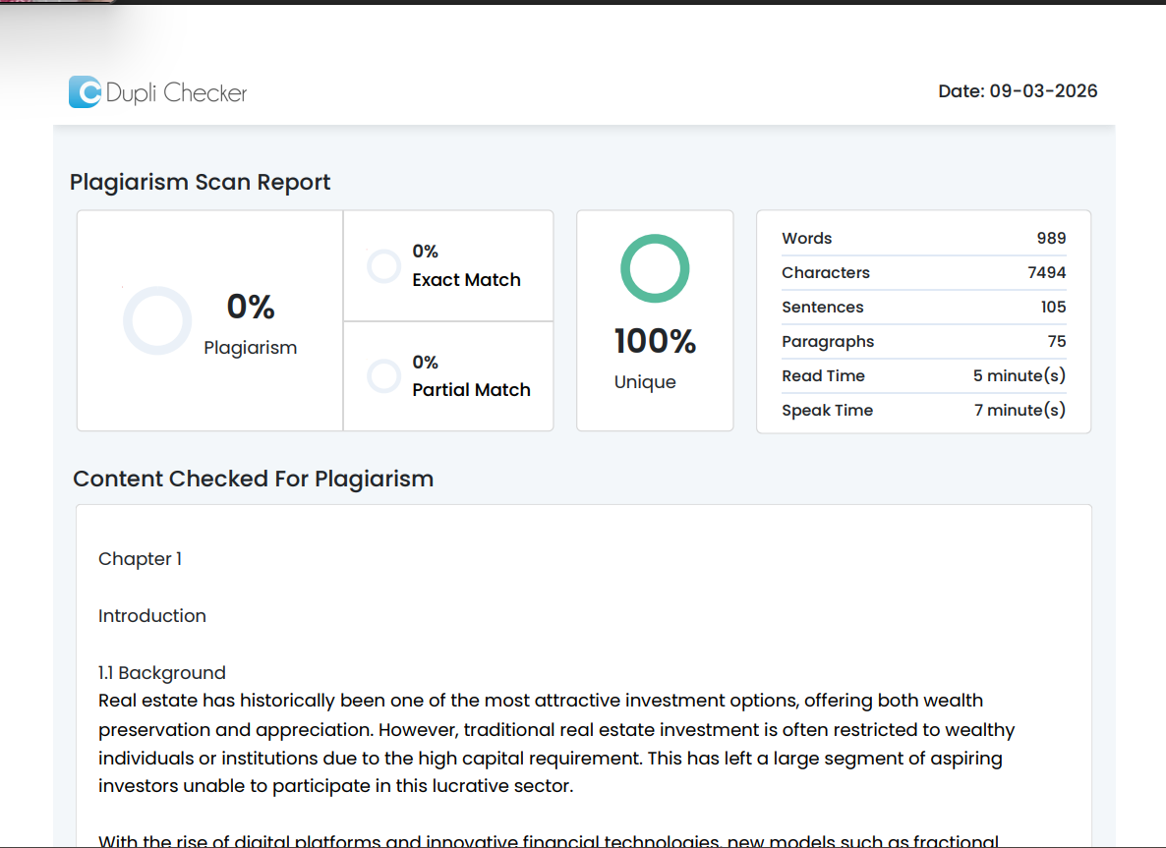
PLAGARISM REPORT
