Assignment 3
Computational Cognitive Science
Nayan Das 18111044
April 4, 2019

Question 1 : Find Normalized Google Distance

Normalized Google distance has been found with the formula -

NGD(a,b) = (max(log of no of webpage for word a, log no of webpage for word b) – log of no of webpage for word a + b)/(log of Total no of webpage – min(log of no of webpage for word a,log of no of webpage for word b))

I have taken Total no of webpage =48000000000 and store the result in result.csv.

Question 2 : Plot human similarity with NGD

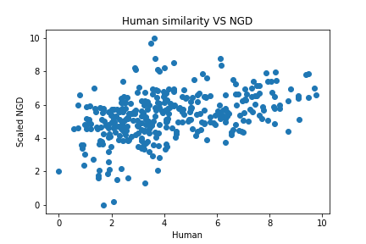

Question 3 : Plot human similarity with word2vec similarity

