

**AMITY SCHOOL OF ENGINEERING & TECHNOLOGY**

**Project Progress Diary**

Multispectral Land Cover Analysis and Change Detection for Assessing Environmental Dynamics

Session: 2023-24

**Name:** Nayan Ranjan Das, Shruti Verma, Utkarsh Chauhan

**Enroll. No:** A2305220148, A2305220034, A2305220103

**Project Group No:** 36

**Project Supervisors:** Dr. Abhishek Singhal

**Department:** Computer Science & Engineering

**AMITY UNIVERSITY UTTAR PRADESH**

**GAUTAM BUDDHA NAGAR**

**Title of project**

Multispectral Land Cover Analysis and Change Detection for Assessing Environmental Dynamics

**Name of Group members:**

1. Shruti Verma
2. Utkarsh Chauhan
3. Nayan Ranjan Das

**Objectives of Project**

The final objective is to train an advanced model capable of accurately detecting changes over time, using change detection algorithms such as Siamese Networks, Recurrent-CNN (Recurrent Temporal Convolutional Neural Networks), and RNN/LSTM (Recurrent Neural Network/Long Short-Term Memory).

**Outcome of Minor Project**

Our study embarked on a thorough exploration of the extensive body of literature surrounding multispectral land cover analysis. This comprehensive literature review delved into a wide array of scholarly works, scrutinizing both contemporary and seminal research endeavors. Our investigation encompassed a meticulous examination of classification and change detection methodologies, encompassing not only the realm of deep learning models but also traditional techniques. The review synthesized and dissected a spectrum of approaches employed in the domain, extracting insights and trends pertaining to the utilization of multispectral data for land cover analysis and the assessment of environmental dynamics. This comprehensive analysis serves as a foundational pillar, providing a nuanced understanding of the evolving landscape within this pivotal field, bridging the gap between cutting-edge deep learning methodologies, and established traditional methods in the realm of land cover analysis and change detection.

**Roles and Responsibilities**

1. **Shruti Verma**

* Modifying and implementing the preprocessing techniques to be used for change detection analysis.

1. **Nayan Ranjan Das**

* Developing and training a hybrid model for change detection analysis

1. **Utkarsh Chauhan**

* Developing a web-based interactive dashboard to visualize the result of research.

**Progress done in Minor Project**

Our research involved an in-depth exploration of the extensive literature on multispectral land cover analysis. Our thorough review covered a broad range of academic studies, examining both recent advancements and key foundational research. We meticulously analyzed various methods for classification and change detection, spanning not just deep learning models but also traditional techniques. This scrutiny allowed us to extract trends and insights concerning the use of multispectral data in understanding land cover and environmental changes. Our comprehensive review forms a crucial foundation, offering a nuanced comprehension of the evolving landscape in this crucial field, uniting state-of-the-art deep learning approaches with well-established traditional methods for land cover analysis and change detection.

**Project Planning**

The upcoming phases will involve training the modified change detection models, developing a hybrid model, and validating model performance. Results from the model will then be used to build an interactive, web-based dashboard to visualise research findings. Continuous testing and optimization will be conducted to ensure the effectiveness of the entire system. The team is committed to delivering a comprehensive and innovative solution to optimize inventory management in the context of defective and deteriorating items.

**Pert Chart**

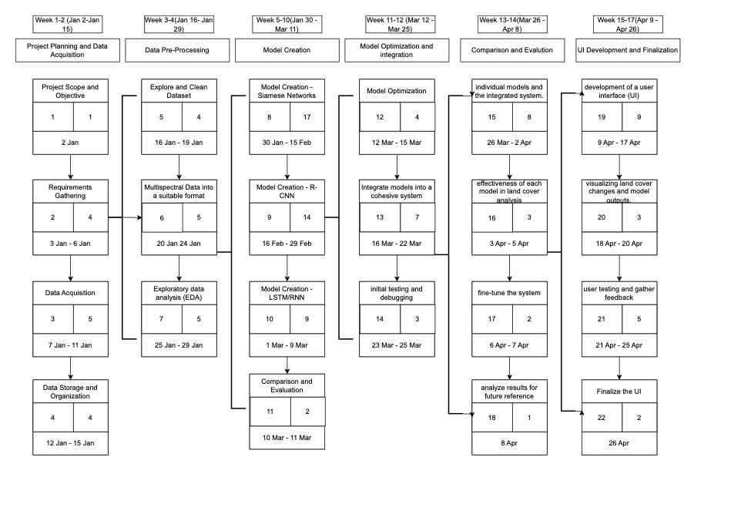

**Milestones targeted:**

|  |  |  |
| --- | --- | --- |
| **S. No.** | **Milestone** | **Tentative Date of Achievement** |
| 1. | Preprocessing verification | 10 Jan 2024 |
| 2. | Model analysis | 14 Jan 2024 |
| 3. | Model Development | 20 Jan 2024 |
| 4. | Validation and verification of model results | 01 Feb 2024 |
| 5. | Integration of results into dashboard | 04 Feb 2024 |
| 6. | Research paper completion | 10 Feb 2024 |

**AMITY SCHOOL OF ENGINEERING & TECHNOLOGY**

**Project Synopsis**

**B. Tech (CSE)**

**Group No.:** 36

**Project Title:** Multispectral Land Cover Analysis and Change Detection for Assessing Environmental Dynamics

**Area:** Machine Learning, Image Processing, Data Analysis

**Academic Session: 2023-24**

**Project Guide:** Dr. Abhishek Singhal

**Details of Project Team:**

|  |  |  |  |
| --- | --- | --- | --- |
| Programme:- | | Year/Semester:- | |
| S. No. | Enrollment No. | Name | Signature |
| 1. | A2305220034 | Shruti Verma |  |
| 2. | A2305220103 | Utkarsh Chauhan |  |
| 3. | A2305220148 | Nayan Ranjan Das |  |

**Project summary (at least 250 words):**

The research project focuses on the development of a hybrid model for change detection analysis in time series land cover data, aiming to identify alterations in physical features such as deforestation and soil degradation. The primary objective will be to train an advanced model capable of accurately detecting changes over time. To achieve this, change detection algorithms such as Siamese Networks, Recurrent-CNN (Recurrent Temporal Convolutional Neural Networks), and RNN/LSTM (Recurrent Neural Network/Long Short-Term Memory) will be used.

Siamese Networks provide a foundation for feature matching, Recurrent-CNN contributes temporal convolutional capabilities, and RNN/LSTM facilitates the modeling of sequential dependencies in the data. The integration of these techniques ensures a holistic approach to change detection, allowing for the identification and characterization of diverse land cover transitions. Additionally, the research introduces improvements in the preprocessing algorithms to further enhance the model's performance in detecting significant changes in physical features.

The outcomes of this research will be presented through a comprehensive dashboard, designed to visually represent the detected land cover changes. The dashboard serves as a user-friendly interface, offering an intuitive visualization of the results generated by the hybrid model and the improved preprocessing algorithms. Through this graphical representation, users can gain insights into the identified changes in physical features such as deforestation and soil degradation over the analyzed time series. The incorporation of a dashboard enhances the accessibility and interpretability of the research findings, making them more readily available to a broader audience, including policymakers, researchers, and environmental practitioners. Through this innovative combination of methodologies, the project aims to contribute to the advancement of change detection analysis in time series land cover data, with potential applications in environmental monitoring and resource management.

**Methodology to be adopted:-**

1. Literature Review:
   1. Review literature on Siamese Networks, Recurrent-CNN, and RNN/LSTM for change detection and preprocessing techniques.
   2. Identify key methodologies and innovations to inform hybrid model development.
2. Preprocessing Enhancement:
   1. Analyze and adapt preprocessing for Siamese Networks, Recurrent-CNN, and RNN/LSTM to optimize for project requirements.
   2. Implement modifications for enhanced accuracy in detecting land cover changes.
3. Model Development:
   1. Integrate Siamese Networks, Recurrent-CNN, and RNN/LSTM into a cohesive hybrid model.
   2. Train and fine-tune the hybrid model with a labeled dataset for change detection.
   3. Implement validation for robustness and generalizability.
4. Model Deployment:
   1. Deploy the hybrid model in the target environment.
   2. Validate performance in a live setting, addressing deployment challenges.
5. Dashboard Development:
   1. Utilize final results to design a web-based dashboard.
   2. Incorporate interactive visualizations and user-friendly features for accessibility and interpretation.
   3. Ensure seamless integration with the hybrid model for real-time updates.

**Resource requirement (Hardware & software etc):-**

Discrete GPU for training deep learning models, Python for framework development, Python modules - tensorflow, pytorch, mlx, numpy for various tasks.

**Justification of the project:-**

The justification for undertaking the project lies in the critical need to address environmental challenges such as deforestation and soil degradation. These issues have far-reaching consequences for ecosystems, biodiversity, and sustainable resource management. Traditional methods of monitoring land cover changes are often labor-intensive and lack the precision required for timely intervention.

The hybrid model proposed in this research leverages advanced machine learning techniques, including Siamese Networks, Recurrent-CNN, and RNN/LSTM, to enhance the accuracy and efficiency of change detection analysis in time series land cover data. By combining these methodologies, the project aims to create a comprehensive and robust approach that can identify and characterize diverse land cover transitions. This is crucial for understanding the dynamics of environmental changes, particularly in regions susceptible to deforestation and soil degradation.

The integration of improved preprocessing algorithms further underscores the project's commitment to enhancing model performance. These enhancements not only contribute to the accuracy of detecting significant changes but also showcase a dedication to refining the entire analytical pipeline. The research's ultimate goal is to provide a reliable tool for environmental monitoring and resource management, facilitating informed decision-making by policymakers, researchers, and environmental practitioners.

The creation of a user-friendly dashboard adds an additional layer of justification, as it ensures the research outcomes are accessible and interpretable to a broader audience. The graphical representation of detected land cover changes allows for intuitive visualization, making the information more readily available for stakeholders who may not have a technical background in machine learning. This democratization of information aligns with the project's overarching aim of contributing to the advancement of change detection analysis in time series land cover data, with tangible applications in addressing pressing environmental issues.

**PERT Chart/Schedule of project completion:-**



**References: Research papers / books / websites etc.:-**

1. *Operational Land Imager* (2021) *NASA*. Available at: https://landsat.gsfc.nasa.gov/satellites/landsat-8/spacecraft-instruments/operational-land-imager/ (Accessed: 17 October 2023).
2. Kavzoglu, Taskin, and Ismail Colkesen. "A kernel functions analysis for support vector machines for land cover classification." *International Journal of Applied Earth Observation and Geoinformation* 11.5 (2009): 352-359.
3. Huang, Chengquan, L. S. Davis, and J. R. G. Townshend. "An assessment of support vector machines for land cover classification." *International Journal of remote sensing* 23.4 (2002): 725-749.
4. Szuster, Brian W., Qi Chen, and Michael Borger. "A comparison of classification techniques to support land cover and land use analysis in tropical coastal zones." *Applied Geography* 31.2 (2011): 525-532.
5. Tarantino, Eufemia, et al. "Comparing the MLC and JavaNNS approaches in classifying multi-temporal LANDSAT satellite imagery over an ephemeral river area." *International Journal of Agricultural and Environmental Information Systems (IJAEIS)* 6.4 (2015): 83-102.
6. Alam, Akhtar, M. Sultan Bhat, and M. Maheen. "Using Landsat satellite data for assessing the land use and land cover change in Kashmir valley." *GeoJournal* 85 (2020): 1529-1543.
7. He, Yecheng, et al. "Land Use/Cover Change Prediction Based on a New Hybrid Logistic-Multicriteria Evaluation-Cellular Automata-Markov Model Taking Hefei, China as an Example." *Land* 12.10 (2023): 1899.
8. Phiri, Darius, and Justin Morgenroth. "Developments in Landsat land cover classification methods: A review." *Remote Sensing* 9.9 (2017): 967.
9. Li, Miao, et al. "A review of remote sensing image classification techniques: The role of spatio-contextual information." *European Journal of Remote Sensing* 47.1 (2014): 389-411.
10. Kadam, Amol, and Vrushali Lokhande. "Land Use Land Cover Analysis: A Case Study of Pune City Using Remote Sensing Data." (2013).
11. Munthali, Maggie G., et al. "Multi-temporal analysis of land use and land cover change detection for dedza district of Malawi using geospatial techniques." (2019).
12. Wulder, Michael A., et al. "Land cover 2.0." *International Journal of Remote Sensing* 39.12 (2018): 4254-4284.
13. Pratama, B. M., D. Gunawan, and R. A. G. Gultom. "Deep learning-based object detection and geographic coordinate estimation system for GeoTiff imagery." *Journal of Physics: Conference Series*. Vol. 1577. No. 1. IOP Publishing, 2020.

Additional material

Cartwright, Hugh, and MARTON. *Artificial neural networks*. Ed. Hugh M. Cartwright. Vol. 1260. Humana Press, 2015.

**Major Project Progress**

**Nayan Ranjan Das**

**Date: 02/01/24**

* Explored viable options deep learning models that can replace traditional methods of change detection.
* Curated the following.
  + Recurrent-CNN
  + Time series models like RNN & LSTM
  + Siamese Network
  + Other RNN/LSTM variants

**Date: 03/01/24**

* Studied basics about Siamese Network and its architecture.
* Explored how Siamese Network accepts and handles data.

**Date: 04/01/24**

* Initialized the Graphics Processing Unit on local device with TensorFlow and PyTorch.
* Studied the loss functions for Siamese network.

**Shruti Verma**

**Date: 02/01/24**

* Explored different techniques for image processing appropriate for LULC data.
* Researched various literature for previously used techniques in this field.

**Date: 03/01/24**

* Studied the data preprocessing processes required for a Siamese Network.
* Implementing initial phases of preprocessing using pair generation from different timestamps.

**Date: 04/01/24**

* Researched alternatives to pair generation technique to compare the efficiency of the process.

**Utkarsh Chauhan**

**Date: 02/01/24**

* Finalized the specific need and requirements for creating a dashboard interface for change detection model backend.

**Date: 03/01/24**

* Explored technical frameworks required.
* Choose a cloud platform (e.g., AWS, Azure, Google Cloud) based on project requirements.

**Date: 04/01/24**

* Explore HTML and CSS interface frameworks appropriate for the project.