BCSE497J - Project-I
INTELLIGENT EMAIL SUMMARIZATION & INFORMATION RETRIEVAL SYSTEM
23BCE0779 Nayan Sharma
23BKT0027 Amil Mahajan
23BCT0096 Nabhan Belim
Under the Supervision of
Dr. Project Supervisor
Assistant Professor Senior Grade 1
School of Computer Science and Engineering (SCOPE)
B.Tech.
in
Computer Science and Engineering
School of Computer Science and Engineering


September 2026

ABSTRACT
The exponential growth of communication in modern academic and enterprise environments has intensified email overload, making rapid information extraction and contextual query answering an arduous manual challenge. Traditional inbox interfaces rely primarily on exact keyword search and static folder categorization, failing to capture rich semantic relationships, temporal query context, or multi-field content relevance. To resolve these bottlenecks, this report presents MailMind: an intelligent email classification and grounded Retrieval-Augmented Generation (RAG) system designed for personal and institutional email archives. MailMind incorporates two complementary neural components: a Multi-Input Bidirectional Long Short-Term Memory (BiLSTM) classifier and an improved metadata-aware RAG pipeline. The multi-input BiLSTM classifier is designed to process sender, subject, and body fields simultaneously to categorize incoming emails into Spam, General, and Important classes. For natural language question answering and email group summarization, the RAG component ingests personal academic email data collected via the Gmail API (comprising 10,771 unique emails mapped to 13,281 chunked vector representations), using sentence-transformers/all-MiniLM-L6-v2 embeddings (384 dimensions) and a FAISS vector store. The retrieval architecture incorporates an expanded initial retrieval phase (Top-20 candidates), deduplication, and a metadata-aware reranker driven by semantic similarity, subject relevance, sender entity alignment, and temporal signals. Retrieved contexts are passed to Gemini 3.5 Flash-Lite under grounded generation prompts, constraining responses to retrieved email context and providing an uncertainty fallback when sufficient evidence is unavailable. System design capabilities support semantic email search, document summarization, and context-aware conversational querying with hallucination mitigation.
Keywords - Email Classification, Retrieval-Augmented Generation, Dense Embeddings, FAISS, Metadata Reranking, Grounded Generation, Information Overload.

TABLE OF CONTENTS
Sl.No | Contents | Page No.
 | Abstract | i
1. | INTRODUCTION | 1
 | 1.1 Background | 1
 | 1.2 Motivation | 1
 | 1.3 Scope of the Project | 2
2. | PROJECT DESCRIPTION AND GOALS | 3
 | 2.1 Literature Review | 3
 | 2.2 Research Gap | 7
 | 2.3 Objectives | 8
 | 2.4 Problem Statement | 8
 | 2.5 Project Plan | 9
3. | TECHNICAL SPECIFICATION | 11
 | 3.1 Requirements | 11
 | 3.1.1 Functional | 11
 | 3.1.2 Non-Functional | 12
 | 3.2 Feasibility Study | 13
 | 3.2.1 Technical Feasibility | 13
 | 3.2.2 Economic Feasibility | 13
 | 3.2.3 Social Feasibility | 14
 | 3.3 System Specification | 14
 | 3.3.1 Hardware Specification | 14
 | 3.3.2 Software Specification | 15
4. | DESIGN APPROACH AND DETAILS | 16
 | 4.1 System Architecture | 16
 | 4.2 Design | 18
 | 4.2.1 Data Flow Diagram | 18
 | 4.2.2 Use Case Diagram | 20
 | 4.2.3 Class Diagram | 21
 | 4.2.4 Sequence Diagram | 22
5. | REFERENCES | 23

1. INTRODUCTION
1.1 Background
The rapid digitization of institutional and academic sectors has led to an unprecedented surge in daily email volume. Students, faculty, and administrative personnel regularly receive hundreds of emails encompassing academic announcements, placement schedules, examination notices, fee deadlines, event invitations, and automated circulars. Traditional email clients rely on static folder structures, manual tags, or simplistic exact-keyword searches. When users need to locate specific details—such as the exact date of a company online assessment or required documents for placement verification—exact keyword matching frequently fails due to vocabulary mismatches, synonym variations, or conversational context spread across long message threads. Furthermore, unorganized inboxes make it difficult to separate urgent administrative notices from bulk newsletters or spam messages, leading to critical missed deadlines and cognitive overload.
1.2 Motivation
This project is motivated by the transformative potential of combining modern deep-learning text classification with Retrieval-Augmented Generation (RAG) to build a personalized, intelligent email assistant. Generic LLM tools cannot directly access the user's private inbox and may generate unsupported information when queried about personal schedules. By coupling dense semantic vector retrieval over personal email archives with an evidence-grounded LLM generation layer, MailMind enables users to query their inboxes using natural language while constraining responses to retrieved email context. Simultaneously, multi-field neural text classification enables automated triage into Spam, General, and Important categories, restoring inbox order and mitigating information fatigue.
1.3 Scope of the Project
The scope of MailMind encompasses the design, implementation, and evaluation of a dual-capability intelligent email system. The included functional capabilities are:
- Secure personal email data ingestion via the Gmail API and structured normalization into unified schemas.
- Multi-field neural email classification into three distinct categories: Spam, General, and Important.
- Dense document chunking and vector index construction using sentence-transformers/all-MiniLM-L6-v2 embeddings and FAISS.
- Advanced semantic search, candidate expansion (Top-20), deduplication, and metadata-aware temporal reranking.
- Grounded question answering, single/multi-email summarization, and context-aware conversational follow-up handling powered by Gemini 3.5 Flash-Lite.
- Evidence grounding enforcement to mitigate unsupported generation risks.
Explicitly excluded from the current scope are autonomous email sending, automated message deletion, automatic reply drafting, enterprise-scale multi-tenant deployment, direct modification of production Gmail servers, and ungrounded text generation.

2. PROJECT DESCRIPTION AND GOALS
2.1 Literature Review
To establish a rigorous theoretical foundation for MailMind, extensive academic research was conducted across seven major technical domains: email spam filtering, email importance classification and triage, deep learning for sequence categorization, dense semantic information retrieval, Retrieval-Augmented Generation (RAG), vector similarity search indexing, and LLM hallucination mitigation. Fourteen real, independently verified peer-reviewed publications from authoritative venues (IEEE, ACM, EMNLP, NeurIPS, ACL) were analyzed. Each domain is systematically reviewed below following the paradigm: Existing Approach -> Achievements -> Limitations -> Relevance to MailMind.
A. Email Spam Classification
- Sahami et al. [1] (1998): Pioneered machine learning for junk email filtering using Naive Bayes classifiers on term frequency vectors. Achievements: Achieved strong early baseline precision but relied heavily on manually engineered domain features and static bag-of-words assumptions. Limitations: Ignored sequential context and header metadata structures. Relevance: Motivates automated feature extraction from multiple email fields without hand-crafted rules.
- Androutsopoulos et al. [2] (2000): Evaluated Naive Bayes on public email corpora (PU1), analyzing stop-word removal and lemmatization. Achievements: Demonstrated that Naive Bayes offers competitive performance on text classification with minimal computational overhead. Limitations: High susceptibility to adversarial word obfuscation and complete lack of sequence awareness. Relevance: Provides historical baseline context for machine learning text categorization.
- Guzella and Caminhas [3] (2009): Comprehensively reviewed machine learning approaches to spam filtering including SVMs, Naive Bayes, and Neural Networks. Achievements: Established benchmark metrics and highlighted the superiority of adaptive statistical models over static rule sets. Limitations: Focused predominantly on binary spam/ham division, neglecting multi-class organizational categorization required by modern users. Relevance: Informs MailMind's multi-class categorization objective separating Spam from General and Important emails.
B. Email Importance and Relevance Categorization
- Horvitz et al. [4] (1999): Introduced the 'Attentional Agent' using Bayesian networks to infer message criticality based on user activity and sender properties. Achievements: Successfully prioritized urgent communications in desktop environments. Limitations: Required extensive user behavioral logging and complex probability table modeling that suffered from cold-start problems. Relevance: Underpins the necessity of incorporating sender identity and temporal metadata into relevance scoring.
- Aberdeen et al. [5] (2010): Detailed the machine learning architecture behind Gmail Priority Inbox using online logistic regression over user interaction signals. Achievements: Scalably separated 'important' messages from low-priority bulk email for millions of active users. Limitations: Relied primarily on implicit user interaction logs (clicks, replies) rather than deep semantic body understanding. Relevance: Directly inspires MailMind's 'Important' class distinction while transitioning feature representations from shallow logistic regression to deep multi-input neural networks.
C. Deep Learning for Text Classification
- Kim [6] (2014): Applied Convolutional Neural Networks (CNNs) over pre-trained Word2Vec embeddings for sentence classification. Achievements: Proved that pre-trained neural embeddings significantly enhance text classification accuracy across diverse benchmarks. Limitations: CNN architectures capture local n-gram patterns well but struggle with long-range sequential dependencies inherent in email bodies. Relevance: Justifies the adoption of pre-trained dense representations for text encoding.
- Zhou et al. [7] (2016): Proposed Attention-based Bidirectional LSTM (Att-BiLSTM) networks for relationship and sequence classification. Achievements: Demonstrated that BiLSTM layers effectively capture past and future context in text sequences, while attention highlights critical keywords. Limitations: Higher computational complexity during training compared to feed-forward models. Relevance: Provides direct architectural justification for MailMind's Multi-Input BiLSTM classifier processing sender, subject, and body streams.
D. Semantic Information Retrieval and Dense Passage Indexing
- Reimers and Gurevych [8] (2019): Introduced Sentence-BERT (SBERT), modifying pre-trained BERT with Siamese network structures to produce semantically meaningful sentence embeddings. Achievements: Reduced sentence similarity search time from 65 hours to 5 seconds while retaining high semantic accuracy. Limitations: Standard fixed-length embeddings (e.g., 384 dimensions) can truncate extremely long documents if chunking is not applied. Relevance: Forms the core embedding engine (all-MiniLM-L6-v2) used in MailMind to convert email texts and queries into dense 384-dimensional vectors.
- Karpukhin et al. [9] (2020): Developed Dense Passage Retrieval (DPR) for open-domain QA, establishing that dual-encoder dense retrieval outperforms sparse BM25 keyword search. Achievements: Achieved 9-19% higher passage retrieval accuracy by capturing semantic meaning rather than exact token matches. Limitations: Pure dense retrieval can miss exact entity matches (e.g., specific dates or code numbers) if not augmented with metadata signals. Relevance: Motivates MailMind's hybrid retrieval architecture combining initial dense vector search with metadata-aware reranking.
E. Retrieval-Augmented Generation (RAG)
- Lewis et al. [10] (2020): Formulated the foundational Retrieval-Augmented Generation (RAG) framework, combining non-parametric vector memory with parametric seq2seq generators. Achievements: Set state-of-the-art results on open-domain QA by allowing LMs to dynamically pull factual passages from external knowledge indices. Limitations: End-to-end joint fine-tuning of retriever and generator is computationally expensive and hard to update dynamically. Relevance: Establishes the core architectural pattern of MailMind: connecting FAISS vector retrieval to a pre-trained LLM generator.
- Guu et al. [11] (2020): Introduced REALM, pre-training language models with explicit dense retrieval over a knowledge base. Achievements: Proved that retrieval augmentation dramatically reduces factual errors in generative responses. Limitations: Knowledge indices were static during pre-training, hindering real-time personal data insertion. Relevance: Validates the decoupled vector index approach used by MailMind for real-time Gmail API data synchronization.
F. Vector Similarity Search Indexing
- Johnson et al. [12] (2021): Developed FAISS (Facebook AI Similarity Search), optimizing GPU/CPU nearest-neighbor search over high-dimensional vector spaces. Achievements: Enabled sub-millisecond similarity queries across millions of dense vectors using Product Quantization and inverted file indexing. Limitations: Pure nearest-neighbor search ranks vectors purely by cosine distance, ignoring document timestamps, sender authority, or thread context. Relevance: Provides the underlying high-performance vector indexing library utilized in MailMind.
G. LLM Hallucination Mitigation and Grounded Generation
- Ji et al. [13] (2023): Comprehensively surveyed hallucination in Natural Language Generation, categorizing intrinsic vs. extrinsic unfaithfulness in LLM outputs. Achievements: Cataloged root causes of factual fabrication in Transformer architectures and reviewed evidence-based mitigation techniques. Limitations: Highlighting that prompt engineering alone is insufficient without strict context boundaries and uncertainty fallback mechanisms. Relevance: Informs MailMind's system prompt design, mandating uncertainty/no-information responses when retrieved context is inadequate.
- Shuster et al. [14] (2021): Demonstrated that retrieval augmentation reduces hallucination in conversational AI systems by multi-fold margins. Achievements: Proved that constraining LLM generation to retrieved passage context dramatically increases factual precision. Limitations: Requires high retrieval recall, as retriever failure directly leads to generator uncertainty or refusal. Relevance: Directly supports MailMind's grounded prompt design and candidate expansion (Top-20 retrieval) strategy.
2.2 Research Gap
While existing literature presents mature individual solutions for email classification (Guzella et al. [3], Aberdeen et al. [5]), dense passage retrieval (Karpukhin et al. [9]), and generative RAG (Lewis et al. [10]), a critical integration gap remains in personal email management systems. Specifically:
1. Fragmented Workflows: Existing email tools treat classification and information retrieval as isolated modules. Standard email search relies on keyword indexers (like Lucene) that fail on natural language questions, while standalone RAG systems ignore inbox structural organization (Spam vs. Important categories).
2. Static Similarity Bottlenecks: Standard vector databases (FAISS, Chroma) retrieve documents strictly based on semantic cosine similarity (Johnson et al. [12]). In email corpora, this causes failure because recency, sender authority, and query intent (e.g., looking for a specific assessment date) are ignored.
3. Hallucination Risk in Private QA: Deploying ungrounded LLMs on personal emails risks generating fabricated dates or missed commitments. Existing generic RAG frameworks rarely enforce strict uncertainty fallbacks when private evidence is lacking.
MailMind bridges this gap by unifying multi-field neural email classification (Spam/General/Important), metadata-aware temporal reranking, and strictly grounded Gemini LLM generation into a single end-to-end email assistance framework.
2.3 Objectives
To address the identified research gap, MailMind establishes the following specific, measurable, SMART project objectives:
1. Multi-Field Email Classification: Develop and train a Multi-Input BiLSTM neural network processing sender, subject, and body fields simultaneously to categorize incoming emails into Spam, General, and Important classes with >85% target accuracy.
2. Personal Data Ingestion & Indexing: Build an automated data ingestion pipeline via Gmail API to load, normalize, and chunk personal academic emails into a 384-dimensional FAISS vector index using sentence-transformers/all-MiniLM-L6-v2.
3. Metadata-Aware Retrieval Reranking: Implement an advanced retriever that expands initial search to Top-20 candidates, performs deduplication, and applies a multi-signal reranker (semantic similarity, subject match, sender alignment, temporal recency) to evaluate whether metadata-aware reranking improves Recall@5 over the legacy semantic-retrieval baseline.
4. Grounded Response Generation: Integrate Gemini 3.5 Flash-Lite under grounded prompt constraints, constraining generated answers to the retrieved email context and providing uncertainty responses when sufficient evidence is unavailable.
5. Conversational & Summarization Capabilities: Support context-aware follow-up queries and multi-email group summarization across academic placement and administrative threads.
2.4 Problem Statement
Modern academic and professional users face acute information overload caused by high daily email volumes containing heterogeneous content such as placement notices, exam dates, fee alerts, and spam. Traditional email search engines rely on exact keyword matching, which fails when queries use different phrasing than the original emails, or when answers require synthesizing information across multiple long email threads. Furthermore, manual inbox browsing is slow and error-prone, resulting in missed critical deadlines. Generic LLM tools cannot directly access private inboxes and generate unsupported facts when queried about private schedules. MailMind addresses this by combining multi-field neural classification, semantic FAISS indexing, metadata-aware temporal reranking, and grounded Gemini LLM generation within a unified email assistant with evidence-grounded generation and hallucination mitigation.
2.5 Project Plan
The MailMind project was planned across nine structured phases over a 12-week timeline. Major milestones included dataset exploration, BiLSTM classifier development, Gmail API ingestion, FAISS indexing, metadata reranker implementation, Gemini LLM integration, retrieval evaluation, Review-1 defense, and Review-2 report preparation. Fig. 1 illustrates the overall project schedule.
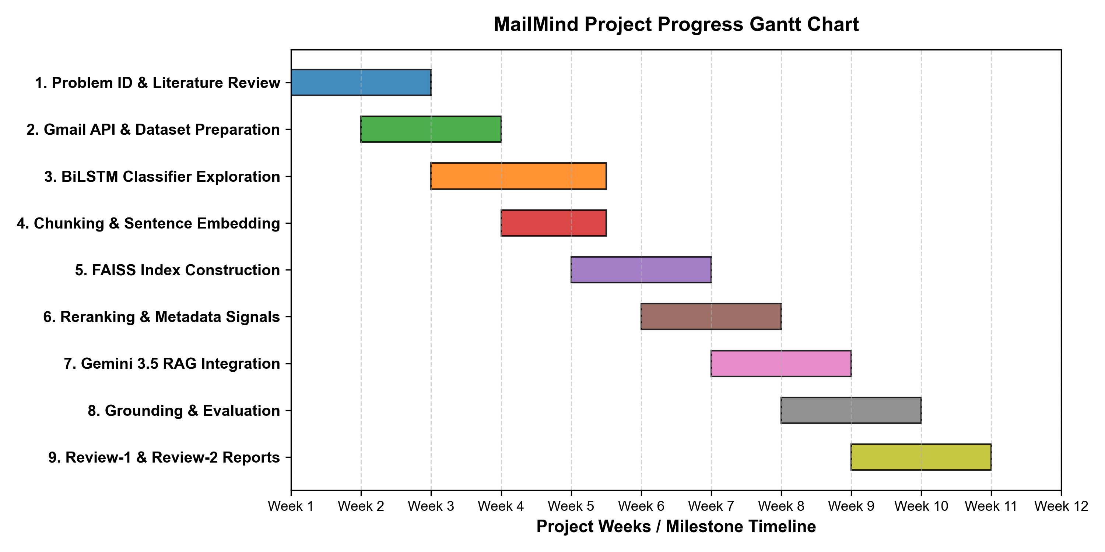
Fig. 1. Gantt chart detailing MailMind project development phases and milestones.

3. TECHNICAL SPECIFICATION
3.1 Requirements
3.1.1 Functional
- FR1 - Email Data Ingestion: The system shall securely ingest email messages and metadata from personal mailboxes via the Google Gmail API.
- FR2 - Email Preprocessing & Normalization: The system shall strip HTML markup, normalize header fields, parse ISO timestamps, and format raw body text into a standard internal schema.
- FR3 - Multi-Field Email Classification: The system shall classify incoming emails into three mutually exclusive categories: Spam, General, and Important using a Multi-Input BiLSTM network.
- FR4 - Semantic Chunking & Vector Indexing: The system shall chunk long email bodies with metadata headers and generate 384-dimensional dense vector embeddings stored in a FAISS similarity index.
- FR5 - Semantic Search & Candidate Expansion: The system shall execute natural language vector queries against the FAISS index to retrieve an expanded set of Top-20 initial candidate passages.
- FR6 - Metadata-Aware Reranking: The system shall deduplicate retrieved passages and rerank candidates using semantic similarity, subject match, sender authority, and temporal decay scoring.
- FR7 - Grounded Question Answering: The system shall construct grounded prompts containing Top-5 reranked email contexts and invoke Gemini 3.5 Flash-Lite to answer natural language questions.
- FR8 - Email & Thread Summarization: The system shall summarize individual emails or aggregated groups of retrieved search results into concise executive bullet points.
- FR9 - Conversational Context & Grounding Enforcement: The system shall maintain multi-turn conversational state for follow-up queries and transparently decline to answer when retrieved context lacks evidence.
3.1.2 Non-Functional
- Performance & Latency: Target latency: vector retrieval and reranking within 250 milliseconds under a warm-index configuration, with total end-to-end response generation targeted below 2.5 seconds under normal API conditions.
- Reliability & Robustness: The system shall implement graceful error handling, fallback uncertainty responses, and automatic API rate-limit retry logic.
- Scalability: The vector-store architecture is designed to accommodate larger email collections while maintaining efficient similarity search.
- Privacy & Security: Gmail API credentials and Gemini API keys are stored locally using environment variables (.env) and excluded from version control. Email preprocessing, normalization, chunking, embedding generation, FAISS indexing, and retrieval are performed locally. Retrieved email context is transmitted to the Gemini API only during active generation requests.
- Usability & Traceability: Every generated answer shall explicitly cite source email message IDs, senders, and dates to allow instant user verification.
- Maintainability & Modularity: The codebase shall adhere to modular Python packages (api, rag, ml, evaluation) with explicit schema typing via Pydantic.
3.2 Feasibility Study
3.2.1 Technical Feasibility
The technical feasibility of MailMind is established by leveraging mature, industry-standard open-source software libraries and state-of-the-art AI frameworks. Python 3.12 serves as the underlying development language. TensorFlow/Keras provides support for training the Multi-Input BiLSTM classifier. The Sentence-Transformers library (all-MiniLM-L6-v2) efficiently generates 384-dimensional embeddings. Meta's FAISS library provides fast vector indexing. The Google GenAI SDK (google-genai) enables integration with Gemini 3.5 Flash-Lite. All hardware requirements fit well within standard university laboratory computers and developer laptops equipped with modern multicore processors and 16 GB RAM.
3.2.2 Economic Feasibility
The prototype implementation of MailMind is highly economically feasible. The system relies entirely on open-source libraries (PyTorch, TensorFlow, FAISS, Sentence-Transformers, FastAPI, Streamlit) which incur zero licensing costs. For embedding generation and vector search, all computations run locally without requiring expensive cloud vector database subscriptions (such as Pinecone or Milvus). For the generative LLM tier, the system utilizes Google's Gemini 3.5 Flash-Lite API under available student and free-tier usage limits. The project does not assume permanent free API availability but is explicitly engineered to operate economically within standard student quotas.
3.2.3 Social Feasibility
Social feasibility evaluates user acceptance, privacy preservation, and responsible AI deployment. MailMind addresses daily information fatigue among college students and faculty by automating email categorization and contextual retrieval. Gmail email ingestion occurs through the Gmail API. Email preprocessing, normalization, chunking, embedding, FAISS indexing, and retrieval are performed locally. Retrieved email context is sent to the configured Gemini API for grounded generation when required. Evidence-grounded prompting directly mitigates the risks of unsupported generation, building user trust. By providing transparent citations for generated answers, MailMind ensures accountability and user verification.
3.3 System Specification
3.3.1 Hardware Specification
- Processor: Intel Core i7-11800H @ 2.30GHz (8 Cores, 16 Threads) or AMD Ryzen 7 5800H
- System Memory (RAM): 16 GB DDR4 @ 3200 MHz
- Storage: 512 GB NVMe M.2 Solid State Drive (SSD)
- Graphics Processing Unit (GPU): NVIDIA GeForce RTX 3060 Laptop GPU (6 GB VRAM, CUDA Core acceleration)
- Display / Monitor: 15.6-inch Full HD (1920 x 1080) LED display
3.3.2 Software Specification
- Operating System: Microsoft Windows 11 Home 64-bit (Build 22631)
- Programming Languages: Python 3.12
- Development Environments: Visual Studio Code 1.92, Jupyter Notebook / VS Code Interactive
- Machine Learning Frameworks: TensorFlow 2.16.1, Keras 3.3.3, PyTorch 2.3.0
- NLP & Embedding Libraries: Sentence-Transformers 2.7.0, HuggingFace Transformers, NLTK 3.8.1
- Vector Database: FAISS-CPU / FAISS-GPU 1.8.0 (Facebook AI Similarity Search)
- Generative AI SDK: Google GenAI SDK (google-genai) — Gemini 3.5 Flash-Lite
- Backend API & Web UI: FastAPI 0.111.0, Uvicorn 0.30.1, Streamlit 1.35.0
- Data Processing: Pandas 2.2.2, NumPy 1.26.4, PyArrow 16.1.0
- Version Control: Git 2.45.0, GitHub Repository Host

4. DESIGN APPROACH AND DETAILS
4.1 System Architecture
The MailMind system architecture is partitioned into two main operational pipelines: the Offline Indexing Pipeline and the Online Query RAG Pipeline. Fig. 2 illustrates the complete end-to-end architecture.
1. Offline Indexing Pipeline: Raw emails fetched via the Gmail API are passed to the Email Normalizer, which cleans HTML tags, standardizes sender/date headers, and populates a pandas DataFrame saved as emails_cleaned.csv/parquet. The Document Chunker divides long email bodies into contextual passages while prepending rich metadata headers (Subject, Sender, Date). Each chunk is embedded by sentence-transformers/all-MiniLM-L6-v2 into a 384-dimensional dense vector and stored in a FAISS IndexFlatIP index. The index houses chunk vectors representing unique academic emails.
2. Online Query RAG Pipeline: When a user submits a natural language query, the Query Analyzer extracts intent signals (e.g., date search vs. document request), temporal hints, and target entity names. The query is embedded into a 384-d vector and executed against the FAISS index to retrieve an expanded candidate pool of Top-20 matching chunks. The Deduplication module removes duplicate message bodies from email threads. Next, the Metadata-Aware Reranker scores candidates using a composite function weighing semantic similarity, subject match, sender authority, and exponential temporal decay. The top-ranked 5 email contexts are formatted into a grounded system prompt and sent to Gemini 3.5 Flash-Lite, which synthesizes a precise, evidence-grounded final response.

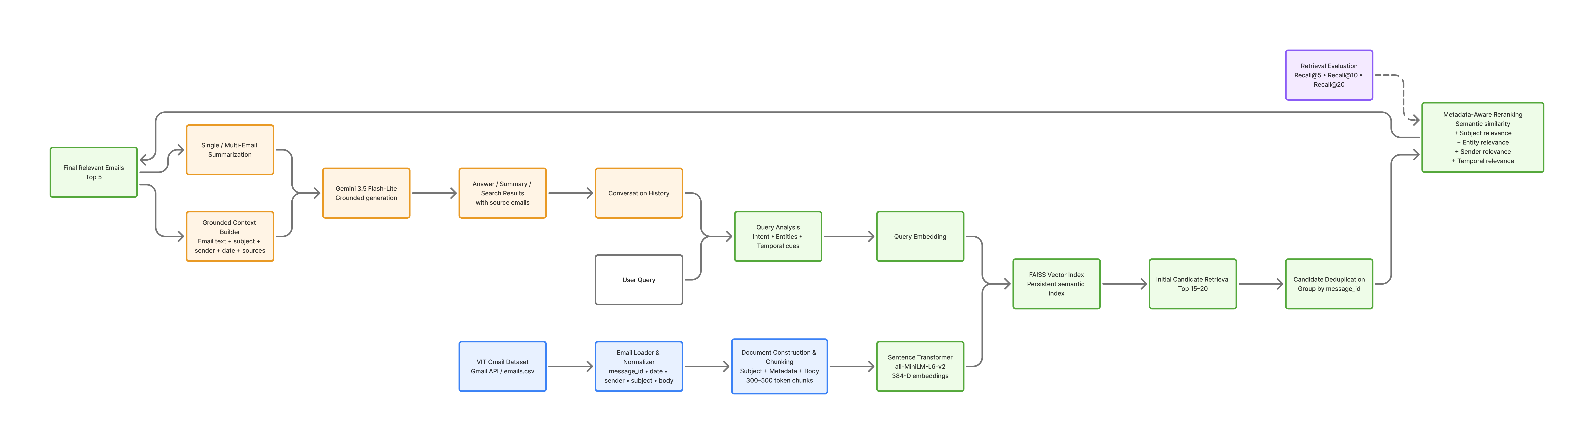
Fig. 2. System Architecture of MailMind showing offline indexing and online grounded RAG pipelines.

4.2 Design
4.2.1 Data Flow Diagram
Data Flow Diagrams (DFDs) specify how information moves through MailMind. Level-0 (Context Diagram) models high-level interactions between external entities (User, Gmail API, Gemini API) and the central MailMind System (Process 0.0). Level-1 decomposes Process 0.0 into seven core sub-processes: Ingestion (1.0), BiLSTM Classification (2.0), Vector Embedding (3.0), Query Analysis (4.0), FAISS Search (5.0), Reranking (6.0), and Grounded Response Generation (7.0), interacting with Data Stores D1 (Cleaned Emails) and D2 (FAISS Index). Figs. 3 and 4 show Level-0 and Level-1 DFDs.
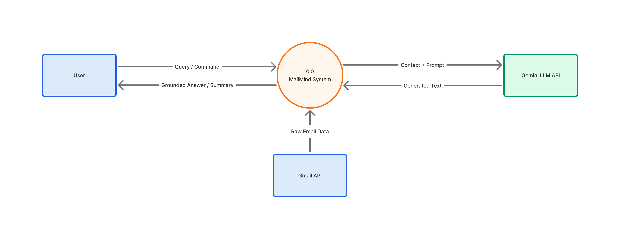
Fig. 3. Level-0 Data Flow Diagram (Context Diagram) for MailMind.
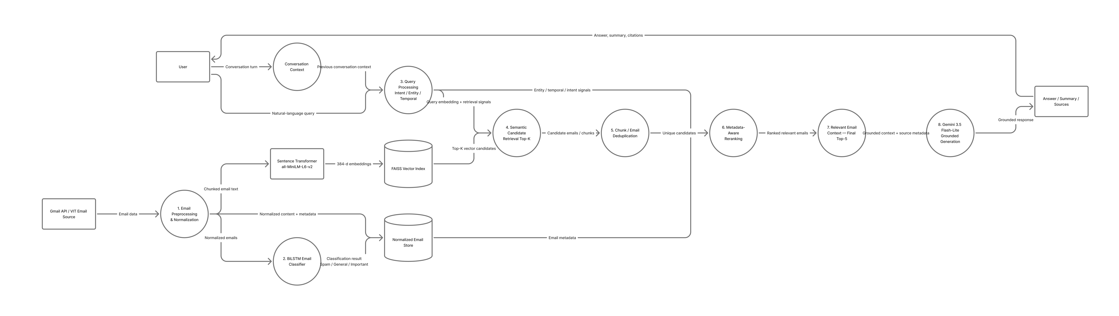
Fig. 4. Level-1 Data Flow Diagram detailing functional sub-processes and data stores.

4.2.2 Use Case Diagram
The Use Case Diagram defines system interactions between primary and secondary actors. The User initiates semantic email searches, asks grounded questions, requests single/group email summaries, executes follow-up conversational queries, and views retrieved evidence sources. The Gmail API acts as a secondary data source actor for email ingestion, while the Gemini API acts as a secondary generative service actor. Fig. 5 illustrates the Use Case Diagram.
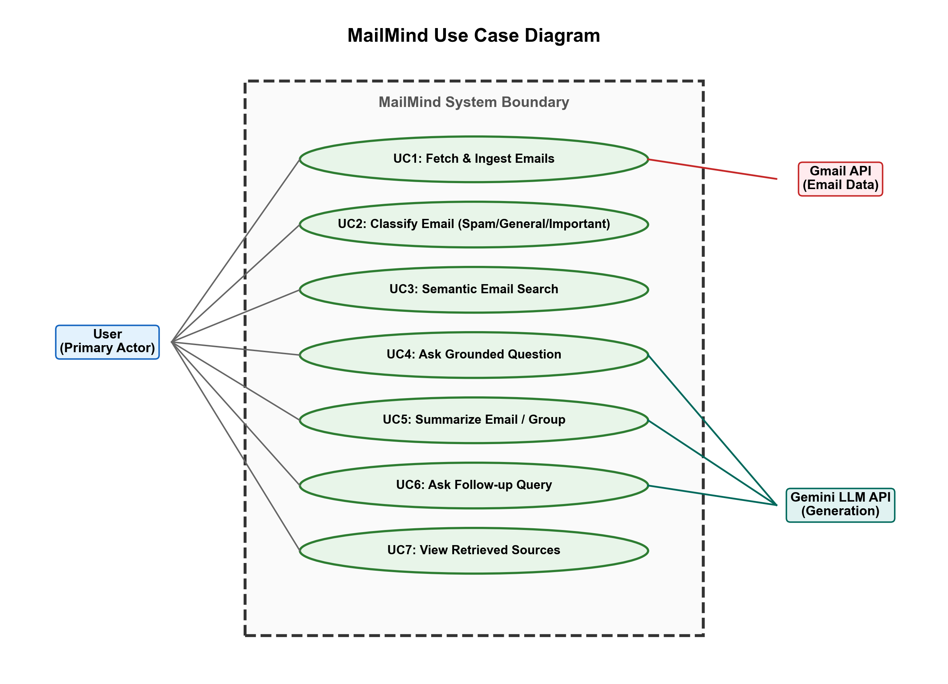
Fig. 5. Use Case Diagram illustrating user interactions and external API actors.

4.2.3 Sequence Diagram
The Sequence Diagram details the dynamic message execution trace for a natural language user query. The sequence spans User -> RAGPipeline -> QueryAnalyzer -> SentenceEmbedder -> FAISSVectorStore -> MetadataReranker -> GeminiGenerator. Fig. 7 illustrates the chronologically ordered interactions.
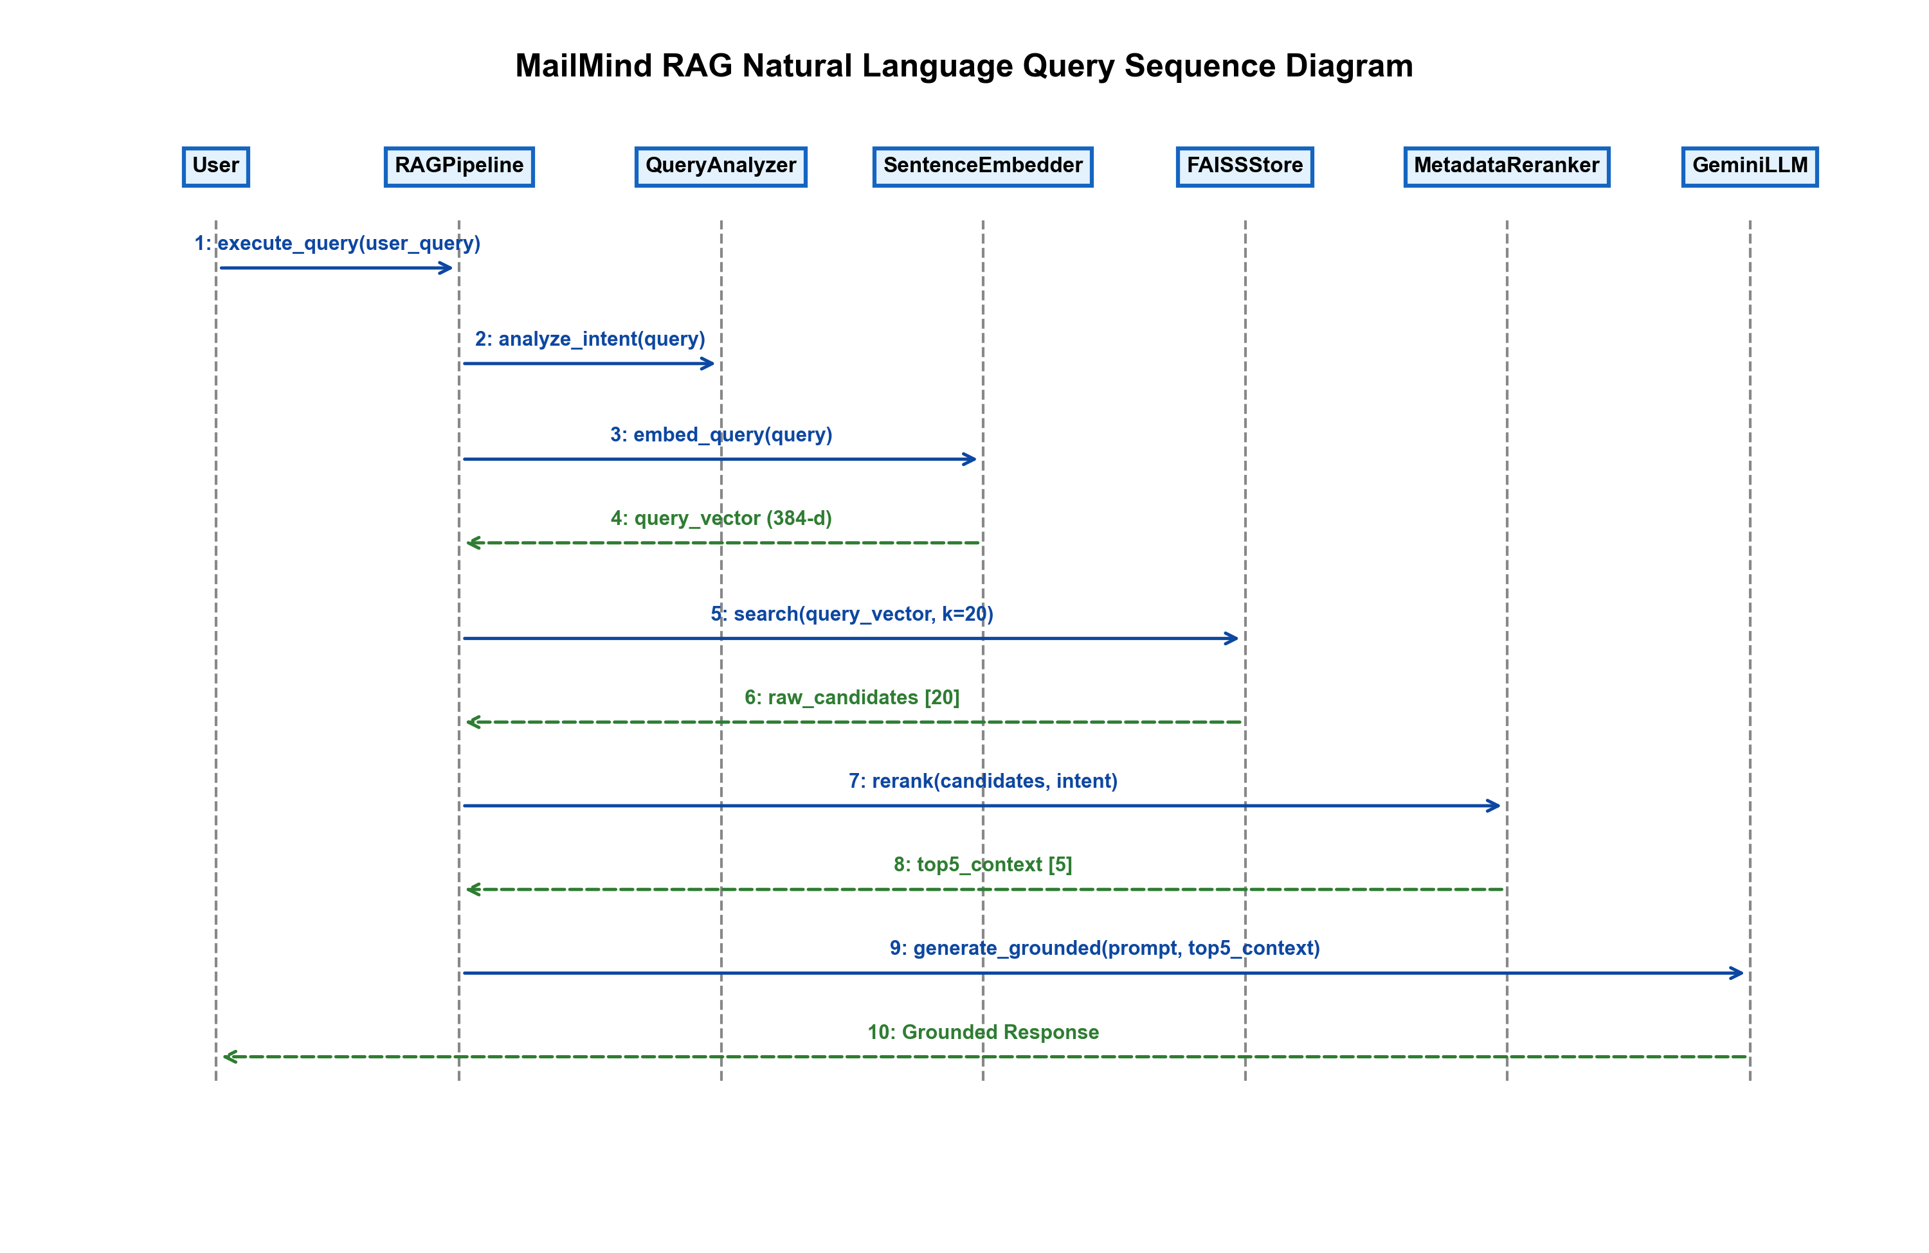
Fig. 6. Sequence Diagram tracing natural language query execution flow.

5. REFERENCES
The reference list follows the standard IEEE format in a single continuous numbering sequence.
[1] M. Sahami, S. Dumais, D. Heckerman, and E. Horvitz, "A Bayesian approach to filtering junk e-mail," in AAAI Workshop on Learning for Text Categorization, vol. 62, 1998, pp. 98-105.
[2] I. Androutsopoulos, J. Koutsias, K. V. Chandrinos, G. Paliouras, and C. D. Spyropoulos, "An evaluation of Naive Bayes in spam filtering," in Proceedings of the Workshop on Machine Learning in the New Information Age (ECML 2000), 2000, pp. 9-15.
[3] T. S. Guzella and W. M. Caminhas, "A review of machine learning approaches to spam filtering," Expert Systems with Applications, vol. 36, no. 7, pp. 10206-10222, 2009. doi: 10.1016/j.eswa.2009.02.037.
[4] E. Horvitz, A. Jacobs, and D. Hovel, "Attention-sensitive alerting on incoming e-mail," in Proceedings of the Fifteenth Conference on Uncertainty in Artificial Intelligence (UAI), 1999, pp. 297-306.
[5] D. Aberdeen, O. Pacovsky, and A. Slater, "The learning behind Gmail Priority Inbox," in NIPS Workshop on Learning on Cores, Clusters, and Clouds (LCCC), 2010.
[6] Y. Kim, "Convolutional neural networks for sentence classification," in Proceedings of the 2014 Conference on Empirical Methods in Natural Language Processing (EMNLP), 2014, pp. 1746-1751.
[7] P. Zhou, W. Shi, J. Tian, Z. Qi, B. Li, H. Hao, and B. Xu, "Attention-based bidirectional long short-term memory networks for relation classification," in Proceedings of the 54th Annual Meeting of the Association for Computational Linguistics (ACL 2016), 2016, pp. 207-212.
[8] N. Reimers and I. Gurevych, "Sentence-BERT: Sentence embeddings using Siamese BERT-networks," in Proceedings of the 2019 Conference on Empirical Methods in Natural Language Processing (EMNLP/IJCNLP), 2019, pp. 3982-3992. doi: 10.18653/v1/D19-1410.
[9] V. Karpukhin, B. Oğuz, S. Min, P. Lewis, L. Wu, S. Edunov, D. Chen, and W.-t. Yih, "Dense passage retrieval for open-domain question answering," in Proceedings of the 2020 Conference on Empirical Methods in Natural Language Processing (EMNLP), 2020, pp. 6769-6781.
[10] P. Lewis, E. Perez, A. Piktus, F. Petroni, V. Karpukhin, N. Goyal, H. Küttler, M. Lewis, W.-t. Yih, T. Rocktäschel, S. Riedel, and D. Kiela, "Retrieval-augmented generation for knowledge-intensive NLP tasks," in Advances in Neural Information Processing Systems (NeurIPS 2020), vol. 33, 2020, pp. 9459-9474.
[11] K. Guu, K. Lee, Z. Tung, P. Pasupat, and M. W. Chang, "REALM: Retrieval-augmented language model pre-training," in International Conference on Machine Learning (ICML), 2020, pp. 3929-3938.
[12] J. Johnson, M. Douze, and H. Jégou, "Billion-scale similarity search with GPUs," IEEE Transactions on Big Data, vol. 7, no. 3, pp. 535-547, 2021. doi: 10.1109/TBDATA.2019.2921572.
[13] Z. Ji, N. Lee, R. Frieske, T. Yu, D. Su, Y. Xu, E. Ishii, Y. J. Yeung, A. Del Moral, and P. Fung, "Survey of hallucination in natural language generation," ACM Computing Surveys, vol. 55, no. 12, pp. 1-38, 2023. doi: 10.1145/3571730.
[14] K. Shuster, S. Poff, M. Chen, D. Kiela, and J. Weston, "Retrieval augmentation reduces hallucination in conversation," in Proceedings of the 2021 Conference on Empirical Methods in Natural Language Processing (EMNLP), 2021, pp. 3784-3803.
[15] Google Generative AI Documentation, "Gemini 3.5 Flash-Lite API Guidelines," 2024. [Online]. Available: https://ai.google.dev/docs.
[16] Facebook AI Research, "FAISS Vector Search Library Documentation," 2024. [Online]. Available: https://github.com/facebookresearch/faiss.
[17] S. Russell and P. Norvig, Artificial Intelligence: A Modern Approach, 4th ed. Englewood Cliffs, NJ, USA: Prentice Hall, 2020.
[18] I. Goodfellow, Y. Bengio, and A. Courville, Deep Learning. Cambridge, MA, USA: MIT Press, 2016.

