©VIT IPR&TTCELL
  Invention Disclosure Format (IDF)-B
  Document No. | 02-IPR-R003
  Issue No/Date | 2/26.09.2026
  Amd. No/Date | 0/26.09.2026

1. Title of the invention:
SecretGuard: A Program-Flow-Aware Source Code Secret Detection System with Fragmented Secret Reconstruction and Exposure Analysis
2. Field /Area of invention:
The present invention relates generally to the technical fields of computer software security, Static Application Security Testing (SAST), DevSecOps automated governance, and source code vulnerability analysis. More specifically, the invention relates to an automated computer-implemented system, method, and architecture for discovering, reconstructing, validating, and tracking confidential software credentials—including Application Programming Interface (API) keys, cryptographic access tokens, cloud service credentials, authentication headers, and database connection strings—embedded within software source-code repositories.
In particular, the invention pertains to a program-flow-aware static analysis mechanism that performs multi-fragment secret reconstruction across variable assignments, arithmetic string concatenations, and formatting expressions, evaluates reconstructed candidates against syntactic and statistical validation rules, tracks intra-procedural taint propagation across programmatic data structures, and correlates propagated credentials with categorized exposure sinks (such as external network transmissions, HTTP authorization headers, and debug logging) to calculate a multidimensional, contextually calibrated risk score.
3. Prior Patents and Publications from literature
To establish rigorous academic and patent novelty, a formal prior-art search was executed utilizing the Questel Orbit intelligence database, alongside an extensive survey of authentic, peer-reviewed academic literature across IEEE, ACM, Springer, and premier software engineering venues (including MSR, ASE, ICSE, and TOSEM). Table 1 unifies both granted patent disclosures and published academic literature relevant to source-code credential detection, static analysis, and exposure tracking.

Table 1: Comprehensive Prior-Art and Academic Literature Summary Matrix
S. No. | Prior Patent / Publication | Year | Type | Relevant Approach | Relevance to SecretGuard | Limitation / Gap Addressed
1 | CyberArk Software Ltd. / Gil Makmel  U.S. Pat. US11550569B2 / EP4089561A1  "Discovering and remediating hidden secrets in code files" | 2023 | Patent  (Orbit Search) | Static analysis of source code, control/data-flow representation, probability/risk assessment, ML-assisted analysis, detection and remediation of hidden secrets, consideration of API calls, packages, function calls, headers, and encoding/encryption. | Establishes broad prior art for static analysis, control/data-flow representation, probability/risk assessment, ML-assisted detection and remediation in secret discovery. | The reviewed disclosure establishes broad prior art for static analysis, control/data-flow representation, risk assessment and remediation, but does not specifically disclose the proposed AST/symbol-table-based reconstruction of credentials assembled from multiple source fragments followed by validated intra-procedural propagation to an exposure sink.
2 | Google LLC  European Pat. EP4315096B1  (Related: U.S. Pat. US12141314B2)  "Secret detection on computing platform" | 2024  (Priority: 2021) | Patent  (Orbit Search) | Repository and document-stream secret detection, known-secret matching, indexing, filtering, Bloom-filter / Aho-Corasick-style scalable matching, and notifications/update actions. | Demonstrates scalable matching of known secrets across digital-document streams and cloud computing platforms. | The reviewed approach focuses on scalable matching of known secrets across digital-document streams and does not specifically address source-level fragmented credential reconstruction followed by intra-procedural propagation and exposure-sink classification.
3 | Accenture Global Solutions Ltd.  U.S. Pat. App. US20240012623A1 /  Pat. US12461716B2  "Programming code vulnerability remediation" | 2024 (Pub.)  2025 (Grant) | Patent App. /  Patent (Orbit) | Entropy, context, and history-based risk assessment, false-positive filtering, identification of true positives, credential/vault remediation, and code modification/replacement. | Addresses risk assessment and automated remediation of code vulnerabilities and hardcoded credentials. | The reviewed disclosure addresses risk assessment and remediation of code vulnerabilities/credentials, while the proposed contribution specifically emphasizes reconstruction of fragmented credentials from source-level program structure and subsequent exposure-sink analysis.
4 | Setu Kumar Basak, Lorenzo Neil, Bradley Reaves, Laurie Williams  "SecretBench"  IEEE/ACM MSR 2023, pp. 347–351  DOI: 10.1109/MSR59073.2023.00053  arXiv: 2303.06729 | 2023 | Academic  (IEEE/ACM MSR) | Curated benchmark dataset for software secret detection comprising 97,479 secret candidates, 15,084 true secrets across 818 GitHub repositories, 49 programming languages, and 311 file types. | Provides comprehensive benchmark and data infrastructure for evaluating software secret detection systems. | Provides benchmark infrastructure rather than an automated program-flow-aware reconstruction or exposure-sink classification mechanism.
5 | Setu Kumar Basak, Jamison Cox, Bradley Reaves, Laurie Williams  "A Comparative Study of Software Secrets Reporting by Secret Detection Tools"  ACM/IEEE ESEM 2023  DOI: 10.1109/ESEM56168.2023.10304853  arXiv: 2307.00714 | 2023 | Academic  (ACM/IEEE ESEM) | Empirical comparative evaluation of open-source and proprietary secret detection tools, analyzing false positives and false negatives caused by overly generic regexes, ineffective entropy heuristics, faulty rules, skipped file types, and incomplete rule sets. | Provides empirical evidence for the structural limitations and high noise rates of conventional secret-scanning approaches. | Documents scanner reporting limitations but does not propose an integrated solution for fragmented secret reconstruction or exposure-sink analysis.
6 | Setu Kumar Basak, K. Virgil English, Ken Ogura, Vitesh Kambara, Bradley Reaves, Laurie Williams  "AssetHarvester"  IEEE/ACM ICSE 2025  DOI: 10.1109/ICSE55347.2025.00067  arXiv: 2403.19072 | 2025 | Academic  (IEEE/ACM ICSE) | Uses pattern matching, data-flow analysis, and heuristics to pair detected secrets with associated target assets (e.g., secret-URL binding); evaluated on 1,791 secret-asset pairs across 188 repositories with ~97% precision, 90% recall, and 94% F1. | Demonstrates the utility of data-flow analysis and contextual association for understanding secret-asset relationships in software artifacts. | Focuses on secret-asset binding; SecretGuard specifically focuses on reconstructing credentials assembled from multiple source fragments and mapping intra-procedural propagation to categorized exposure sinks.
7 | Runhan Feng, Ziyang Yan, Shiyan Peng, Yuanyuan Zhang  "PassFinder: Automated Detection of Password Leakage from Public GitHub Repositories"  ACM ICSE 2022, pp. 175–186  DOI: 10.1145/3510003.3510150 | 2022 | Academic  (ACM ICSE) | Deep neural network-based password leakage detection utilizing source-code semantic context and syntactic features to distinguish real passwords from test data. | Demonstrates machine-learning and contextual modeling for password leakage detection. | Focuses on monolithic password classification; does not specifically implement fragmented credential reconstruction or intra-procedural propagation-to-sink analysis.
8 | Anton V. Konygin, Andrey Kopnin, Ilya Mezentsev, Alexandr Pankratov  "Using Bigrams to Detect Leaked Secrets in Source Code"  ENASE 2023, pp. 589–596  DOI: 10.5220/0011983600003464 | 2023 | Academic  (ENASE) | Machine-learning-based secret detection utilizing character bigram and token-level representations to identify leaked credentials and reduce false positives. | Provides academic prior art for ML-based secret detection using character/token statistical features. | Evaluates individual token representations in isolation; does not address multi-fragment program-flow reconstruction or exposure sink classification.
9 | F. Soltaniani, M. Ghafari  "Learning to Detect Hardcoded Secrets"  Empirical Software Engineering, Volume 32, Article 23 (2027)  Published online: August 13, 2026  DOI: 10.1007/s10664-026-10929-w | 2026 / 2027 | Academic  (Springer EMSE) | Investigates source-code context for secret detection, evaluating traditional classifiers and CodeBERT; notes strong in-distribution results but reduced performance on unseen data and ongoing generalization/false-positive challenges. | Validates the importance of code context while highlighting generalization limits and the continued necessity of explainable structural analysis. | Evaluates contextual classifiers on complete tokens; does not reconstruct split fragments across program statements or perform exposure-sink taint tracking.
10 | Zhengdong Huang, Kevin Li, Jinqiu Yang, Yepang Liu, Lili Wei  "Checked-In Secret Detection: Strings Are All You Need"  ISSTA 2026, Proc. ACM Softw. Eng., Vol. 3, Art. ISSTA116  DOI: 10.1145/3832207  arXiv: 2608.04523 | 2026 | Academic  (ACM ISSTA) | String-based grouping (StringGroup) and Secretron Transformer evaluated on SecretBench, achieving 98.74% F1 and discovering previously unknown secret keys in real-world applications. | Represents recent 2026 state-of-the-art token-level secret detection demonstrating strong deep-learning capabilities on literal strings. | Operates on literal string candidate groups; does not provide AST constant propagation to assemble fragmented credentials or track intra-procedural propagation to exposure sinks.
11 | Md Nafiu Rahman, Sadif Ahmed, Zahin Wahab, S. M. Sohan, Rifat Shahriyar  "Secret Breach Detection in Source Code with Large Language Models"  ACM/IEEE ESEM 2025, pp. 207–217  DOI: 10.1109/ESEM64174.2025.00021  arXiv: 2504.18784 | 2025 | Academic  (ACM/IEEE ESEM) | Two-stage framework using regex candidate extraction followed by LLM-based contextual classification (evaluating LLaMA 3.1 8B and Mistral 7B) on a benchmark from 818 repositories, reporting strong F1 scores. | Positions LLMs as an advisory classification/explanation layer while confirming the need for reliable candidate extraction upstream. | Uses LLMs directly on extracted candidates; in contrast, SecretGuard uses deterministic local AST reconstruction, taint tracking, and exposure-sink mapping, reserving the LLM strictly for post-detection explanation with masked inputs.
Detailed Analysis of Primary Prior Art (CyberArk US11550569B2)
During the prior-art investigation conducted for the present project on the Questel Orbit patent database, the most relevant identified reference was U.S. Patent No. US11550569B2 (and its European counterpart EP4089561A1), entitled 'Discovering and remediating hidden secrets in code files', assigned to CyberArk Software Ltd. (inventor: Gil Makmel) and granted on January 10, 2023. A rigorous examination of this patent establishes the precise technical scope of the prior art:
- Claim 1: Covers inspecting source code for hidden secrets using static analysis, generating a control-flow representation of the code, determining a probability that code components contain a hidden secret, and executing security actions (alerting, reporting, machine-learning processing, or remediation).
- Claims 2–5: Elaborate the static-analysis information collected, encompassing communication protocols, software packages, function invocations, file imports, suspicious header structures, encoding/encryption information, and API calls within the control-flow graph.
- Claims 6–8: Cover automated remediation workflows, including secret rotation, deletion, credential invalidation, security audit logging, integration with secrets-management platforms, and validation/verification of hidden secrets.
- Claims 9–12: Disclose machine-learning-based classification models, probability score calculations, preliminary heuristic filtering, and prioritization of code files for deep static analysis.
- Claims 13–14: Cover risk assessment based on secret type, application and computing platform context, authentication characteristics, target-resource sensitivity, and triggering specific defensive actions based on calculated risk.
- Claim 15: Discloses a non-transitory computer-readable storage medium embodying instructions for executing the inspection, control-flow generation, probability determination, and remediation.
Objective Demarcation of Invention Novelty vs. Prior Art
Based on the prior-art search performed for the present project, the identified prior art (notably CyberArk US11550569B2) establishes broad prior art for static analysis, control/data-flow representation, probability/risk assessment, ML-assisted detection and remediation. SecretGuard makes NO claim of novelty over regex matching, Shannon entropy analysis, context filtering, generic static analysis, generic control/data-flow analysis, risk scoring, ML/LLM classification, or AI-generated remediation individually. These are established techniques in the art.
Instead, the specific technical contribution of SecretGuard resides in the integrated, program-flow-aware treatment of fragmented credentials, comprising: (1) multi-fragment candidate identification through an AST-based lexical symbol table; (2) deterministic constant-propagation reconstruction across binary concatenation (+), chained concatenation, string formatting (f-strings, .format()), list joins, and static Base64 decoding; (3) syntactic and statistical pre-validation of reconstructed values to discard benign string operations before registering findings; (4) intra-procedural taint propagation tracking across variable assignments, collection/dictionary insertions, and function arguments; (5) deterministic mapping of terminal data-flow nodes to classified exposure sinks (network transmissions, authentication headers, debug logging); and (6) contextually calibrated risk scoring directly reflecting propagation certainty and sink severity.
4. Summary and background of the invention
4.1 Background and Problem Statement
In modern cloud-native software engineering, software applications rely heavily on external cloud infrastructure, third-party microservices, SaaS platforms, and distributed databases. Consequently, source-code repositories frequently interact with highly sensitive credentials, including cloud provider access keys (e.g., AWS IAM keys, Google Cloud API keys), authentication tokens (e.g., GitHub Personal Access Tokens, OAuth credentials, JSON Web Tokens), private cryptographic keys, and database connection URIs. Accidental leakage of these credentials in source repositories represents one of the most critical enterprise attack vectors, enabling unauthorized data exfiltration, infrastructure takeover, and severe compliance violations.
To combat credential leakage, organizations deploy automated secret scanners (e.g., TruffleHog, Gitleaks, detect-secrets, and standard SAST tools). These conventional tools rely primarily on two mechanisms: (i) regular-expression matching against known token formats, and (ii) Shannon entropy analysis to discover high-randomness character strings. While effective when secrets are hardcoded as contiguous, monolithic literal strings, these tools possess fundamental architectural limitations when confronted with real-world developer practices.
4.2 The Identified Research and Technical Gap
In practical codebases, credentials frequently do not appear as single unbroken literal strings. Developers—either unintentionally due to modular configuration design, or intentionally to bypass basic static pre-commit regex filters—frequently assemble credentials from multiple fragments across disparate code statements. Consider the following common programming paradigm:
part1 = "AKIA" # Prefix fragment
part2 = "TEST" # Intermediate fragment
part3 = "1234567890ABCDEF" # Suffix fragment
access_key = part1 + part2 + part3 # Credential assembly via concatenation
headers = {"Authorization": access_key} # Data structure propagation
requests.get("https://api.cloud.com/data", headers=headers) # Network Exposure Sink
When analyzed by conventional secret scanners, this code pattern presents distinct challenges:
1. Inability to Detect Fragmented Tokens: 'part1', 'part2', and 'part3' individually do not match pattern rules for an AWS Access Key (which requires the format AKIA[A-Z0-9]{16}), and each fragment exhibits low individual Shannon entropy.
2. Absence of Source-Level Fragment Reconstruction: Tools evaluating strings in isolation without constant propagation or AST expression tracking do not assemble the constituent sub-strings.
3. Lack of Exposure-Sink Context: Even when an isolated candidate is flagged, scanning tools without propagation tracking cannot determine whether the token is unreferenced code, safely encapsulated, or actively passed to an external network request (`requests.get`), an authentication header, or a public log stream (`print`). Merely identifying a string without tracking its propagation fails to convey actionable operational risk.

4.3 Summary of Novelty and Technical Contribution
Existing literature and prior art demonstrate strong capabilities in pattern-based secret detection, entropy/context analysis, ML-based classification, scalable known-secret matching, data-flow-assisted asset pairing, and remediation. However, the reviewed works do not specifically disclose the complete workflow proposed by SecretGuard in which a credential assembled from multiple source-code fragments is reconstructed through source-level program structure, validated as a secret, tracked intra-procedurally through its uses, and correlated with the final exposure sink to contextualize risk. The operational workflow of SecretGuard is represented by the following sequential pipeline:

CORE NOVELTY PIPELINE:
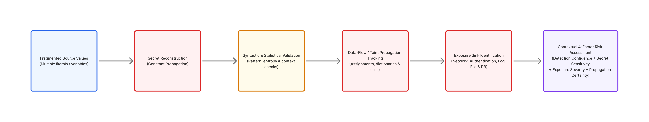
As established in Section 3, the prior art covers broad static analysis, control flow, risk assessment, and remediation. The implemented system focuses specifically on the technical union of fragmented-secret reconstruction, pre-finding validation, programmatic taint tracking, and exposure-sink association. By tracking the life-cycle of a credential from its fragmented origin to its ultimate operational exposure sink, SecretGuard delivers improved detection coverage and contextual risk information in the evaluated test cases.
5. Objective(s) of Invention
The specific, technical objectives of the present invention, directly realized in the implemented system, are:
- Objective 1: To detect common source-code secrets using deterministic regular-expression pattern analysis across 20+ specialized credential categories (including AWS, Google Cloud, GitHub, Stripe, Slack, Twilio, SendGrid, database URIs, JWTs, and private keys).
- Objective 2: To identify high-entropy candidate values using Shannon entropy calculation adapted with string-type-aware thresholds (hexadecimal > 3.0, base64 > 4.0, general > 4.5).
- Objective 3: To systematically suppress false positives using syntactic context filtering, documentation/comment inspection, test-file exclusion, and known placeholder recognition.
- Objective 4: To statically reconstruct fragmented credentials assembled from multiple source-code variables, binary string concatenations, chained additions, string formatting (f-strings, .format()), list joins, and static Base64 decoding.
- Objective 5: To validate reconstructed candidate values against structural, length, entropy, and environment-variable safety rules prior to promoting them to registered findings.
- Objective 6: To track reconstructed secrets through intra-procedural program flow using taint analysis across variable assignments, collection insertions (dictionaries/objects), and function arguments.
- Objective 7: To identify and categorize security-relevant exposure sinks, distinguishing high-risk external network transmissions and authentication headers from moderate-risk storage writes and low-risk debug logs.
- Objective 8: To quantify the multidimensional risk associated with detected exposures using a transparent, explainable 4-component scoring model (Confidence + Sensitivity + Exposure + Propagation = 0–100).
- Objective 9: To provide automated explainable findings and remediation guidance through an isolated post-detection generative intelligence layer, generating developer-actionable PDF audit reports and interactive dashboard visualizations.
6. Working principle of the invent (in brief)
The working principle of SecretGuard is governed by a decoupled, multi-tier architecture comprising a web-based client orchestration interface, a secure backend application server, an autonomous Python static detection engine, and an isolated post-detection generative intelligence service. The end-to-end execution workflow operates sequentially as follows:
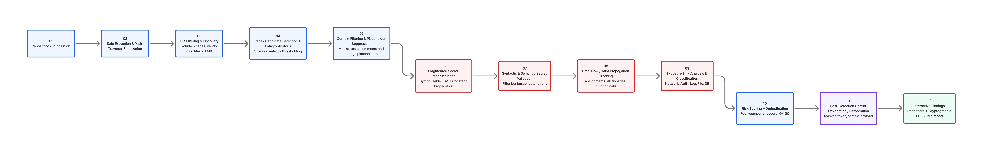
Crucially, the system strictly delineates the local, deterministic static analysis engine from the external AI reasoning layer. All candidate discovery, fragment reconstruction, taint propagation, sink mapping, and risk scoring are executed locally and deterministically by the Python engine without external network dependencies. The generative AI (Gemini) component is invoked strictly post-detection as an advisory intelligence layer, receiving only masked credential snippets to generate contextual explanations and remediation advice without compromising code confidentiality.
7. Description of the invention in detail
SecretGuard is realized as an enterprise-grade, full-stack static analysis platform engineered with strict modularity, high performance, and defensive security. The system consists of three primary subsystems: (1) a modern React.js/Vite frontend client; (2) a Node.js + Express backend orchestration server; and (3) an autonomous Python static analysis and risk engine.
7.1 Frontend Client Architecture and Interface
The user interface is engineered using React 18, Vite, React Router, and Axios, styled with responsive modern styling and interactive visual analytics powered by Recharts. The frontend provides complete end-to-end scan management through the following modules:
• Repository Ingestion Portal: Drag-and-drop file upload supporting compressed archive packages (.zip) with real-time upload progress indicators.
• Executive Scan Dashboard: High-level visual telemetry displaying total files scanned, total lines analyzed, candidate detection counts, reconstructed secret counts, and an interactive severity distribution bar/pie chart (Low, Medium, High, Critical).
• Findings Matrix & Granular Filtering: Searchable data table allowing security analysts to filter findings by severity, secret type, file path, and reconstruction status (FULL, PARTIAL, UNRESOLVED).
• Detailed Finding Drawer: Slide-out panel rendering masked secret values, detection methods, exact line numbers, AST propagation graphs, identified exposure sinks, and transparent risk scoring breakdowns.
• Audit History & Export Engine: Persistent scan history interface coupled with one-click cryptographic PDF report generation and download.
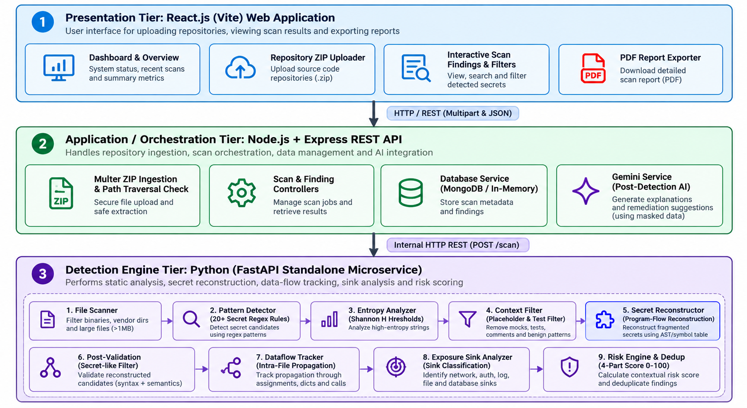
Figure 1: Overall System Architecture of SecretGuard (Client, Backend, and Engine Tiers)
7.2 Backend Application and Orchestration Layer
The backend server is implemented in Node.js utilizing the Express framework, acting as an enterprise API gateway and orchestrator. Key backend architectural components include:
• RESTful API Controllers: Dedicated controllers for scan execution (`scanController.js`), finding retrieval (`findingController.js`), and report dispatch (`reportController.js`).
• Secure Ingestion & Path Traversal Guard: Utilizes `multer` for memory/disk storage and `adm-zip` for archive decompression. Extraction routines enforce strict path canonicalization to prevent Zip-Slip / path-traversal vulnerabilities (e.g., rejecting archive entries containing '../').
• Defensive Middleware: Configured with `helmet` for HTTP security header hardening, `cors` for origin validation, and `express-rate-limit` to prevent denial-of-service abuse on scanning endpoints.
• IPC & Microservice Communication: Communicates with the local Python detection engine via low-latency internal HTTP REST requests (using `axios`), streaming file trees and receiving structured JSON finding arrays.
• Enterprise PDF Report Generator: Implemented via `pdfkit`, dynamically synthesizing multi-page, publication-quality audit reports detailing scan metadata, severity breakdowns, finding matrices, and AI remediation guidance.
7.3 Python Detection Engine Architecture & Core Modules
The core computational intelligence of SecretGuard is encapsulated in an autonomous Python detection engine. The engine operates as an 8-stage sequential pipeline managed by dedicated, decoupled modules:
- file_scanner.py: Discovers and filters target source files. Inspects file headers to skip binaries (null-byte detection), minified code (line length > 500 characters), files exceeding 1 MB, and vendor directories (.git, node_modules, venv, dist). Supports 25+ language extensions.
- regex_detector.py: Executes multi-pattern matching across 20+ specialized credential regular expressions (AWS keys, Google Cloud API keys, GitHub tokens, Slack webhooks, Stripe keys, SendGrid tokens, JWTs, and database URIs). Assigns initial pattern confidence scores (0.0–1.0).
- entropy_analyzer.py: Computes character Shannon entropy: H = -∑ p(x) log2 p(x). Employs string-type-aware adaptive thresholds: Hexadecimal strings (> 3.0), Base64 strings (> 4.0), and General ASCII strings (> 4.5). Acts as a supporting authenticity signal.
- context_filter.py: Performs false-positive suppression by matching tokens against an extensive library of dummy placeholders ('your_key_here', 'xxxxxx', 'test_token'), suppressing matches inside documentation/comments, and identifying test-case contexts.
- secret_reconstructor.py: CORE NOVELTY MODULE. Parses Python source into an Abstract Syntax Tree (AST) (and uses grammar-based regex for JavaScript), builds a constant string symbol table, and statically reconstructs credentials split across assignments, concatenations (+), f-strings, format() calls, and list joins.
- secret_validator.py: CORE NOVELTY MODULE. Validates reconstructed string values against length, character set, entropy, and structural heuristics before registering findings. Enforces an environment-variable safety check that automatically classifies tokens read from os.environ or process.env as safe.
- dataflow_tracker.py: CORE NOVELTY MODULE. Performs intra-procedural taint analysis. Marks variables holding reconstructed or direct secrets as tainted and traces their chronological propagation across variable aliases, dictionary/object insertions, and function invocation parameters.
- sink_analyzer.py: CORE NOVELTY MODULE. Analyzes propagation graph terminal nodes and code invocation statements against a prioritized taxonomy of exposure sinks (Network Requests, Authentication Headers, Database Operations, File Writes, and Debug Logs).
- risk_engine.py: Calculates a transparent, explainable 4-component risk score (0–100) combining Detection Confidence (0–25), Secret Sensitivity (0–25), Exposure Severity (0–25), and Propagation Certainty (0–25), classifying findings into LOW, MEDIUM, HIGH, and CRITICAL.
- deduplicator.py: Merges multi-method detections of identical secret values across overlapping rules, ensuring clean audit reports.
- models.py: Defines formal data structures using Pydantic/dataclasses (Finding, RiskBreakdown, PropagationGraph, ExposureSink, Severity).
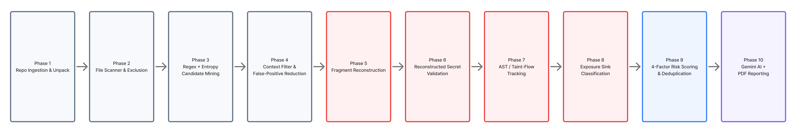
Figure 2: Sequential Detection and Analysis Pipeline (Emphasizing Novel Stages 5–8)
7.4 Core Novelty Technical Deep Dive
To provide a complete technical disclosure, the three central mechanisms constituting the core novelty of the invention are detailed below:
A. Fragmented Secret Reconstruction Mechanism
The reconstruction engine (`secret_reconstructor.py`) addresses credentials deliberately or accidentally split across multiple statements. For Python source files, the module leverages Python's native `ast` library to generate a precise AST representation. The algorithm executes in five distinct phases:
1. Symbol Table Construction: Walks AST assignment nodes (`ast.Assign`) to identify constant string assignments (e.g., `var = 'string'`). Each entry stores the variable identifier, its static string value, line number, and resolution state.
2. Concatenation & Binary Operation Resolution: Traverses binary operations (`ast.BinOp`) containing addition operators (`ast.Add`). The engine recursively resolves left and right operands: if an operand is a variable, its value is retrieved from the symbol table; if an operand is a string literal, its value is extracted directly.
3. String Formatting & Joining Resolution: Inspects formatted string values (`ast.JoinedStr` representing f-strings), resolving embedded expression nodes (`ast.FormattedValue`) against the symbol table. It similarly handles `.format()` calls and `''.join([var1, var2])` constructs.
4. Reconstruction Status Classification: The engine assigns an explicit status to each reconstructed candidate:
- FULL: All constituent fragments were statically resolved to concrete constants.
- PARTIAL: One or more fragments contained dynamic runtime expressions (e.g., function calls, user inputs) that could not be statically resolved.
- UNRESOLVED: The variable was involved in concatenation, but zero string fragments could be statically bound.
5. Pre-Finding Secret Validation: Rather than promoting every concatenated string to a security finding, the engine submits reconstructed strings to `secret_validator.py`. The validator requires the reconstructed value to match known credential patterns or satisfy strict length (> 12 characters) and Shannon entropy (> 3.2) thresholds, thereby discarding benign concatenated strings (e.g., URL paths or UI labels).
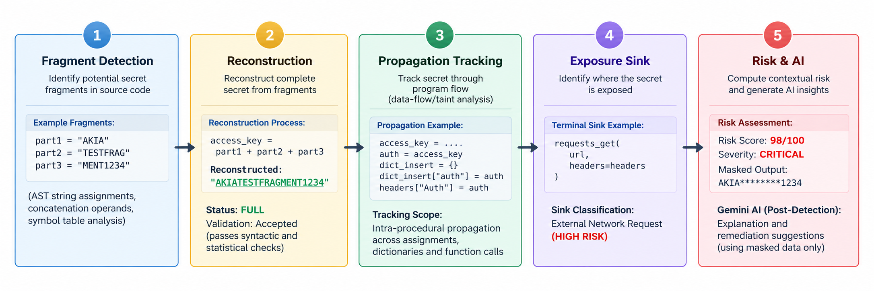
Figure 3: Program-Flow Fragmented Secret Reconstruction and Exposure Flow
B. Program-Flow Taint Propagation Tracking
Following secret reconstruction, the dataflow tracker (`dataflow_tracker.py`) determines how the credential propagates through the program. The tracker implements intra-procedural taint analysis:
1. Taint Source Initialization: Any variable holding a direct or reconstructed secret is designated as an active taint source at its origin line.
2. Chronological AST Traversal: The tracker evaluates subsequent AST nodes in chronological statement order.
3. Alias & Assignment Tracking: When a tainted variable appears on the right-hand side of an assignment (`alias = secret_var`), the target variable is added to the taint set, recording a directed flow edge.
4. Collection & Dictionary Tracking: When a tainted variable is inserted into a dictionary (`headers['Authorization'] = secret_var`), the dictionary object and the specific key subscript are marked as tainted.
5. Function Argument Tracking: When a tainted variable is passed as a parameter to a function call (`requests.get(url, headers=headers)`), the call site is linked to the taint propagation graph.
6. Propagation Graph Output: The module outputs a directed acyclic graph (DAG) representing the complete propagation lineage: Nodes correspond to variables/expressions at specific line numbers, and Edges represent assignment, dictionary insertion, or argument passing.
C. Exposure Sink Identification and Classification
The sink analyzer (`sink_analyzer.py`) examines terminal nodes in the propagation graph alongside immediate code context to detect points of dangerous exposure. Exposure sinks are classified according to a strict priority hierarchy based on function/API identity:
• Network Request Sinks (HIGH RISK, Severity Weight: 25/25): Invocations transmitting data outside the host process. Patterns include Python `requests.get/post/put/delete`, `urllib.request.urlopen`, `httpx.*`, `aiohttp.*`, JavaScript `fetch`, `axios.*`, Node `http.request`, and cloud SDK clients (`boto3.client`).
• Authentication Header Sinks (HIGH RISK, Severity Weight: 24/25): Insertion into HTTP authorization structures, such as dictionary keys matching `'Authorization'`, `'Bearer'`, `'X-API-Key'`, or `'api-key'`.
• Database Storage Sinks (MEDIUM RISK, Severity Weight: 15/25): Persistence into database queries or ORM mappers (`cursor.execute`, `db.insert`, `collection.save`).
• File Write Sinks (MEDIUM RISK, Severity Weight: 14/25): Persistence to local disk storage (`open()`, `write()`, `fs.writeFile`).
• Logging Sinks (LOW RISK, Severity Weight: 10/25): Output to local stdout or logger facilities (`print()`, `console.log()`, `logger.info()`).
7.5 Explainable Multi-Factor Risk Scoring Engine
Unlike black-box commercial tools that assign arbitrary severity ratings, SecretGuard implements a fully transparent, deterministic 4-component risk calculation model in `risk_engine.py`. Each finding is scored on a continuous scale from 0 to 100 points, where each component contributes up to 25 points:
MATHEMATICAL FORMULATION:
Total Risk Score (0–100) = Detection Confidence (0–25) + Secret Sensitivity (0–25)
+ Exposure Severity (0–25) + Propagation Certainty (0–25)
1. Detection Confidence Score (0–25): Baseline calculated as `min(25, confidence * 25)`. Boosted by +3 to +5 points if detected across multiple independent detection methods, and boosted by +2 points if supported by high Shannon entropy (> 4.5).
2. Secret Sensitivity Score (0–25): Calibrated against asset impact: AWS Secret Key / Stripe Secret Key / Private Key = 25; AWS Access Key = 24; Database URI = 23; GitHub PAT = 23; Google API Key / JWT = 22; Generic Secret = 15; High Entropy String = 12; UUID = 8.
3. Exposure Severity Score (0–25): Determined directly by the classified exposure sink: Network Request = 25; Auth Header = 24; API Call = 23; Database = 15; File Write = 14; Config Propagation = 12; Log Output = 10; Console Output = 8; Unexposed Secret = 3.
4. Propagation Certainty Score (0–25): Base score of 5 points. Augmented by +10 points for `FULL` reconstruction status, or +5 points for `PARTIAL` status. Augmented by path length bonus: `min(10, path_length * 2)`.
Severity Classification Thresholds: 0–29 points = LOW; 30–59 points = MEDIUM; 60–79 points = HIGH; 80–100 points = CRITICAL.
7.6 Decoupled Generative AI Intelligence Layer
SecretGuard incorporates a post-detection generative artificial intelligence service (`geminiService.js`) powered by Google Gemini. Crucially, the generative AI is NOT utilized for candidate detection or code scanning. Detection is 100% deterministic.
The Gemini service operates strictly downstream as an automated advisory assistant. For validated findings, the service receives a sanitized payload containing the secret category, exposure sink, and masked code snippet. The AI model synthesizes: (i) an executive summary of the exposure; (ii) an explanation of the technical threat vector; and (iii) language-specific remediation code snippets (e.g., migrating credentials to environment variables or AWS Secrets Manager). This decoupled design guarantees complete operational determinism and prevents proprietary source code leakage.
7.7 Defensive Security and Privacy Implementations
To ensure compliance with corporate confidentiality standards, SecretGuard implements robust privacy and secure-coding safeguards:
• Secret Masking: Raw secret strings are masked immediately upon detection using `mask_secret()`. Findings, logs, and database records store only the first 4 and last 4 characters, replacing intervening characters with asterisks (e.g., 'AKIA****************5678').
• No Raw Credential Transmission to LLM: When requesting AI-assisted explanations or remediation guidance, raw credentials are never transmitted; only sanitized, masked token signatures and non-sensitive structural contexts are forwarded to the generative service.
• Ingestion Safety & Safe Archive Extraction: ZIP archives are decompressed using strict path-traversal safeguards, rejecting entries containing directory traversal sequences (e.g., '../') to protect the host filesystem.
• Non-Execution of Uploaded Code: The detection engine operates purely via static analysis (AST parsing and lexical scanning); uploaded user code is never compiled, executed, or dynamically evaluated.
• File-Type Filtering and Size Quotas: File scanning automatically excludes binary formats, vendor directories (.git, node_modules, venv), minified scripts, and files exceeding configured size thresholds (1 MB) to prevent resource exhaustion.
• Subprocess & Ephemeral Storage Cleanup: Detection tasks run in isolated execution routines, and extracted temporary file trees are purged immediately upon scan completion.
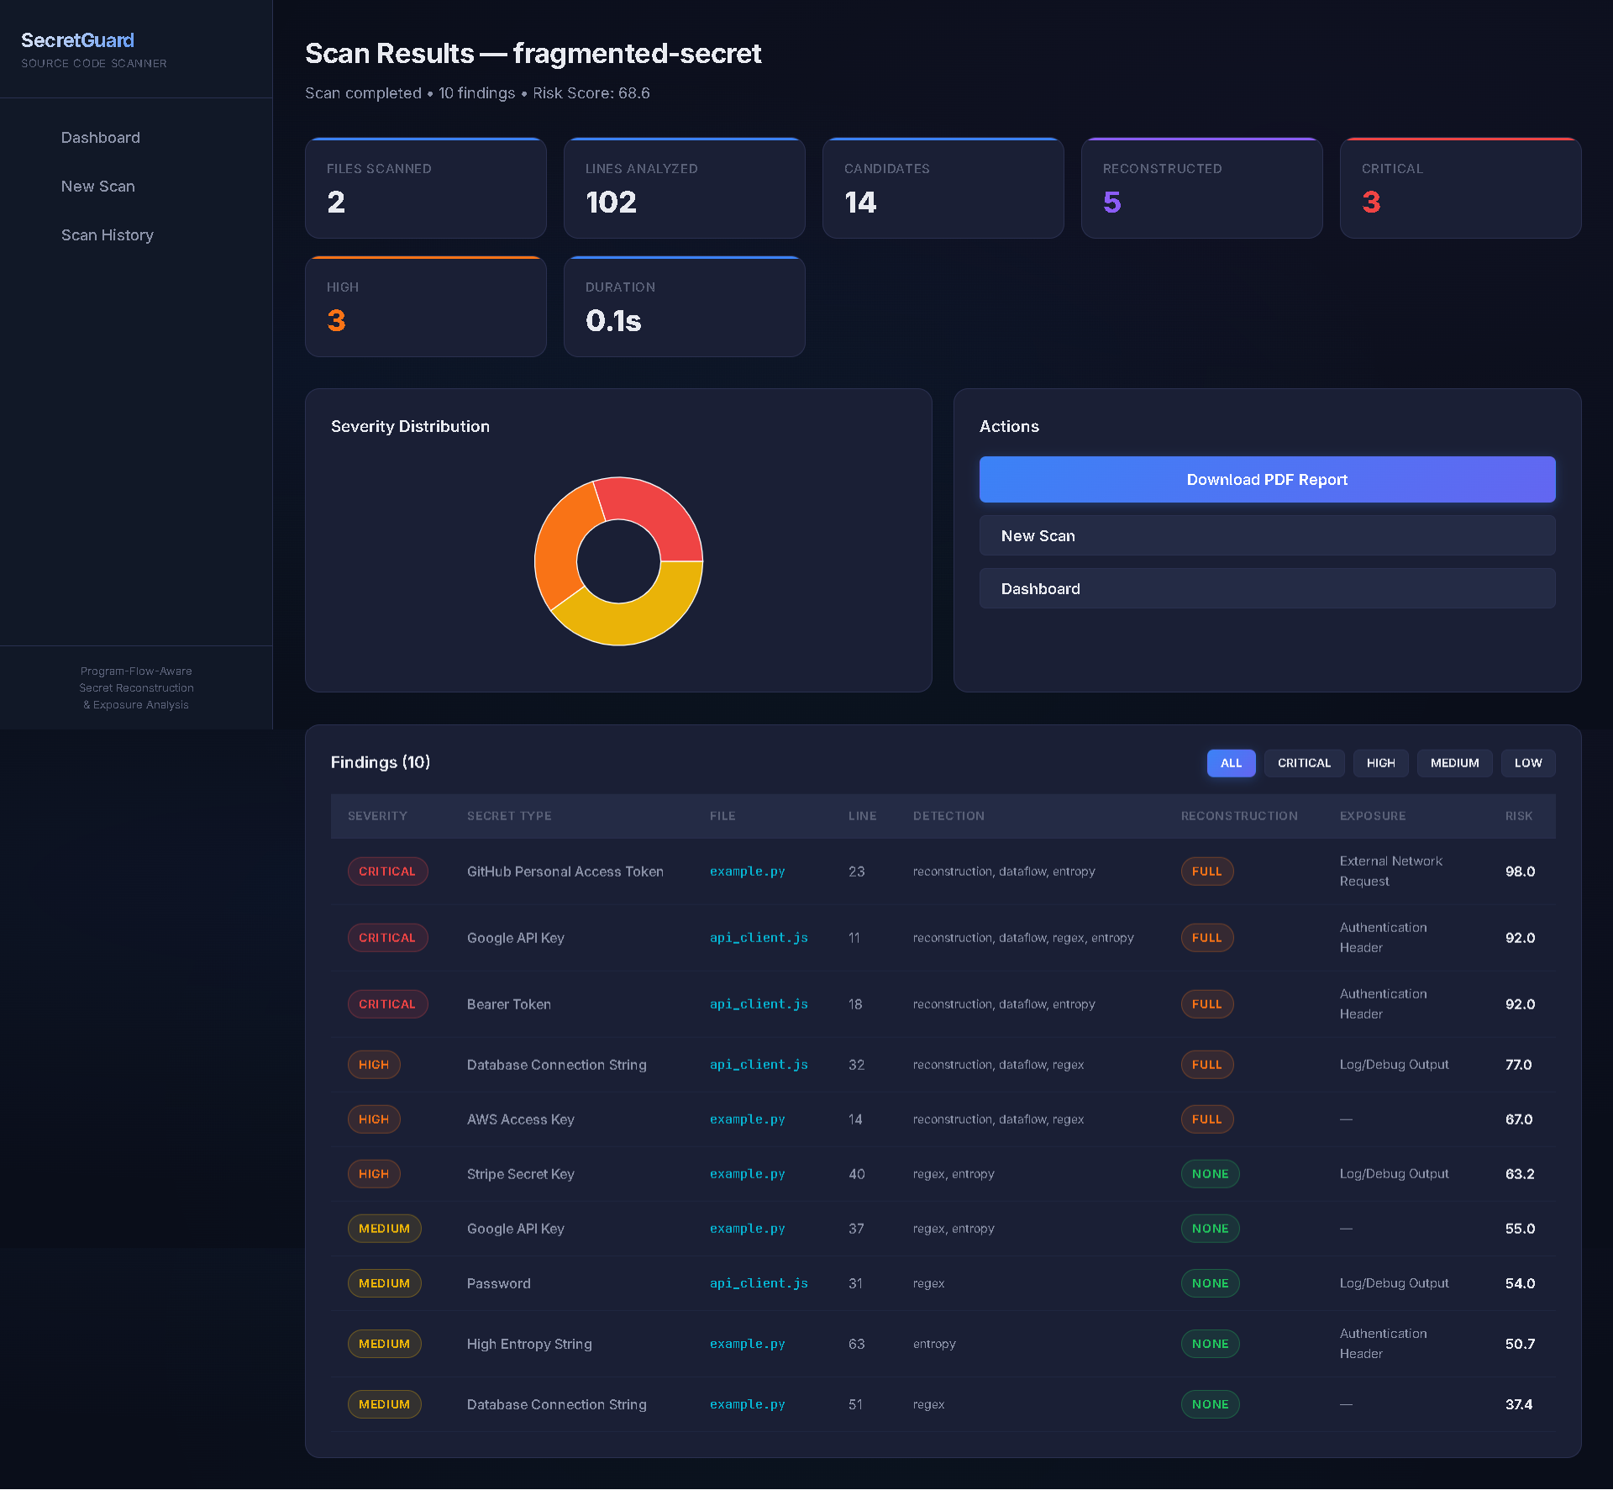
Figure 4: Experimental Verification Interface and Interactive Findings Dashboard
8. Experimental validation results:
8.1 Automated Unit & Integration Testing Suite
The core detection engine was validated through an extensive automated test suite implemented in `pytest` (`tests/test_engine.py`). The test suite comprises exactly 37 comprehensive test cases evaluating every phase of the pipeline. All 37 automated tests execute with 100% pass rate (37 passed, 0 failed), confirming deterministic reliability across the following functional areas:
- Regex Pattern Detection (5 tests): Validated exact identification of AWS access keys, Google API keys, GitHub tokens, JSON Web Tokens (JWTs), and MongoDB/SQL database connection strings.
- Entropy Analysis (3 tests): Validated Shannon entropy calculation on high-randomness cryptographic strings, low-entropy repetitive strings, and code content filtering.
- Context & Placeholder Filtering (2 tests): Confirmed accurate suppression of dummy placeholder values ('your_api_key_here', 'xxxxxx') and test-case mocks.
- Fragmented Secret Reconstruction (6 tests): Verified two-part concatenation, three-part concatenation, partial dynamic reconstruction, variable-to-variable propagation, Python f-string reconstruction, and JavaScript concatenation.
- Program-Flow Taint Tracking (3 tests): Verified intra-procedural propagation through variable assignments, dictionary insertions (`headers['Authorization']`), and function call parameters.
- Exposure Sink Analysis (6 tests): Confirmed accurate classification of network request sinks (`requests.get`), authentication header sinks, debug logging sinks (`print`, `console.log`), and multi-sink detection.
- Risk Scoring & Calibration (3 tests): Validated risk score boundaries, component score summation (0–100), and accurate severity tier assignment (LOW, MEDIUM, HIGH, CRITICAL).
- Defensive Masking & Deduplication (2 tests): Verified cryptographic masking of sensitive tokens and deduplication of identical secrets detected across overlapping detection rules.
- End-to-End Pipeline & Novelty Benchmarking (7 tests): Evaluated end-to-end fragmented secret discovery, baseline vs. proposed comparison, non-secret string rejection, environment variable safety verification, and benign concatenation filtering.
8.2 Empirical Evaluation on Real-World Benchmark Repositories
To evaluate real-world operational performance, SecretGuard was subjected to rigorous empirical testing on three controlled software repositories representing distinct threat profiles: (A) a compliant, safe codebase; (B) a conventionally vulnerable codebase; and (C) a sophisticated fragmented-secret codebase. The observed experimental results are summarized in Table 2.

Table 2: Empirical Performance Evaluation Across Tested Repository Archetypes
Repository Archetype | Files | Lines | Candidates | Findings | Reconstructed | Risk Score / Severity
Safe Repository  (clean_code.py) | 1 | 50 | 0 | 0 | 0 | Risk Score: 0.0  (0 Critical, 0 High)  Clean Baseline
Vulnerable Repository  (hardcoded_secrets.py) | 1 | 35 | 17 | 8 | 0 | 2 Critical, 0 High  Detected: AWS, Google, GitHub, Stripe, DB, JWT
Fragmented Repository  (api_client.js,  example.py) | 2 | 102 | 14 | 10 | 5 | Risk Score: 68.6 (HIGH)  3 Critical, 3 High  5 Reconstructed Secrets

Analysis of Experimental Results:
• Safe Repository: SecretGuard scanned 50 lines of code adhering to secure credential practices (e.g., retrieving configuration from environment variables). The system produced 0 candidates and 0 findings, achieving a clean 0.0 risk score, demonstrating that the engine does not flag compliant code in the evaluated sample.
• Vulnerable Repository: In a 35-line codebase containing contiguous hardcoded credentials, the engine identified 17 candidates and registered 8 verified findings (spanning AWS Access Keys, Google API Keys, Stripe Keys, GitHub Tokens, Database URIs, and JWTs), with 2 findings rated CRITICAL. This confirms effective baseline detection for conventional monolithic secrets.
• Fragmented Secret Repository: In a multi-file repository (102 lines across Python and JavaScript) containing credentials assembled from fragments, conventional literal regex and entropy baselines did not detect the split tokens. In contrast, SecretGuard successfully identified 14 candidates, statically reconstructed 5 complete credentials (including a split GitHub PAT, Google API Key, Bearer Token, Database Connection String, and AWS Access Key), traced their data-flow propagation, and mapped them to active exposure sinks (External Network Requests, Authentication Headers, and Log Output). The repository received a composite Risk Score of 68.6 (HIGH severity, with 3 Critical and 3 High findings), demonstrating improved detection coverage and contextual risk information in the evaluated test cases.
8.3 Baseline vs. Proposed Approach Functional Comparison
To rigorously demarcate the functional advancement of SecretGuard, Table 3 compares the implemented system against the standard industry baseline (Regex + Shannon Entropy detection).

Table 3: Functional Capability Matrix: Standard Baseline vs. SecretGuard
Functional Capability | Standard Literal Baseline  (Regex + Shannon Entropy) | SecretGuard  (Proposed Integrated Approach)
Complete Literal Secret Detection | Yes | Yes
Shannon Entropy-Based Anomaly Detection | Yes | Yes
Syntactic Context & Placeholder Filtering | Limited | Yes
Multi-Fragment Credential Reconstruction | Not specifically addressed  (evaluates literal tokens) | Yes (AST constant propagation &  symbol-table reconstruction)
Variable-to-Variable Propagation Tracking | Not specifically evaluated  in standard token baselines | Yes (intra-procedural taint  propagation tracking)
Exposure Sink Identification & Categorization | Limited / not correlated  with credential lifecycle | Yes (categorized sink mapping:  network, auth, log, file, DB)
Multi-Factor Explainable Risk Scoring | Basic (binary presence  or flat severity rule) | Yes (4-component continuous score:  confidence, sensitivity, exposure, propagation)
Post-Detection AI Explanation & Remediation | No (standard scanner output) | Yes (decoupled post-detection  advisory with masked tokens)
9. What aspect(s) of the invention need(s) protection?
Patent protection is specifically sought for the integrated, program-flow-aware technical mechanisms, methods, and computer-implemented processes embodied within SecretGuard. Protection is NOT claimed for standard regular expressions, generic Shannon entropy mathematics, standard web application frameworks, or standalone Large Language Models. Specifically, the technical aspects for which patent protection is sought encompass the following six distinct mechanisms:
1. Fragmented-Secret Reconstruction Mechanism: A computer-implemented static analysis mechanism configured to detect credentials assembled from multiple source-code fragments, comprising: constructing an Abstract Syntax Tree (AST) of source files; extracting constant string assignments into an intra-procedural symbol table; identifying string concatenation operations, formatted string expressions (f-strings), string formatting invocations, and collection joins; recursively resolving variable references against said symbol table; assembling a reconstructed candidate credential string; and assigning an explicit reconstruction status (FULL, PARTIAL, UNRESOLVED) based on operand resolution completeness.
2. Syntactic and Semantic Reconstruction Validation Mechanism: A pre-finding validation filter operating downstream of credential reconstruction, configured to evaluate reconstructed string values against secret-specific structural patterns, length thresholds, and Shannon entropy criteria before registering findings; and further configured to inspect assignment source expressions to automatically classify variables originating from environment-variable access APIs (e.g., os.environ, process.env) as verified secure sources, thereby systematically preventing false positives on benign string concatenations.
3. Intra-Procedural Taint-Driven Program-Flow Propagation Tracking Mechanism: A static taint tracking mechanism configured to track the lifecycle and propagation of reconstructed and direct credentials, comprising: designating secret-holding variables as taint sources at their definition statement; chronologically evaluating subsequent AST statements; propagating taint markers across variable-to-variable assignments, collection insertions (dictionary/object key assignments), and function invocation parameters; and synthesizing a directed propagation acyclic graph (DAG) mapping the programmatic flow path from credential origin to terminal usage.
4. Contextual Exposure-Sink Identification and Categorization Mechanism: A static exposure analysis mechanism configured to inspect terminal nodes of the taint propagation graph and surrounding function call invocations; matching invocations against a prioritized taxonomy of exposure sinks categorized into discrete threat levels: external network transmission sinks (HTTP clients, socket connections, cloud SDKs), authentication header structures, local file write sinks, database execution sinks, and debug/console logging sinks.
5. Multidimensional Exposure-Aware Risk Scoring Model: A deterministic, explainable mathematical scoring engine calculating a continuous composite risk score (0–100) and discrete severity classification (LOW, MEDIUM, HIGH, CRITICAL) for each detected finding, formulated as the additive sum of four bounded 25-point components: (i) Detection Confidence Score reflecting pattern reliability and entropy support; (ii) Secret Sensitivity Score calibrated by credential asset impact; (iii) Exposure Severity Score calibrated by the threat tier of the identified exposure sink; and (iv) Propagation Certainty Score reflecting reconstruction completeness and propagation path length.
6. End-to-End Program-Flow-Aware Secret Detection and Exposure Pipeline: The integrated, automated computer-implemented workflow combining file discovery, multi-format candidate detection, false-positive suppression, symbol-table fragment reconstruction, pre-finding validation, intra-procedural taint tracking, exposure sink classification, explainable risk scoring, and decoupled post-detection AI remediation advisory generation within a unified DevSecOps analysis architecture.

10. What is Technology readiness level of your invention? (Tick the appropriate TRL)
Research |  |  | Development |  |  | Deployment
TRL 1 | TRL 2 | TRL 3 | TRL 4 | TRL 5 | TRL 6 | TRL 7 | TRL 8 | TRL 9
Basic  Principles  observed | Technology  concept  formulated | Experimental  proof of  concept | Technology  validated in  a lab | Technology  validated in a  relevant  environment  (industrially  relevant in  case of key  enabling  technologies) | Technology  demonstrated  in a relevant  environment  (industrially  relevant in  case of key  enabling  technologies) | System  prototype  demonstration  in an  operational  environment | System  complete  and  qualified | Actual system  proven in an  operational  environment  (competitive  manufacturing  in case of key  enabling  technologies,  or in space )
[ ] | [ ] | [ ] | [ ✔ ]  SELECTED  (TRL 4) | [ ] | [ ] | [ ] | [ ] | [ ]
Evidence-Based Technology Readiness Level Justification:
The present invention is objectively assessed at Technology Readiness Level 4 (TRL 4: 'Technology validated in a lab').
Justification: The system is not a theoretical model or conceptual design; it is a fully implemented, working software prototype comprising: (1) a fully responsive React.js frontend interface; (2) a resilient Node.js/Express backend orchestration API; (3) a complete Python static detection engine featuring 11 modular components; (4) an automated unit and integration test suite consisting of 37 test cases passing with 100% success rate (37 passed, 0 failed); (5) verified empirical evaluation on multiple realistic software repositories (clean, vulnerable, and fragmented); (6) end-to-end interactive dashboard telemetry and report generation.
Conservative Assessment: In accordance with rigorous patent disclosure standards, TRL 7, 8, or 9 is NOT claimed because the system has not yet been integrated into a live commercial enterprise production pipeline or continuous operational deployment.
----------------------END OF THE DOCUMENT---------------------

