Multimedia Tools and Applications
System and Method for Multimodal Fake Review and Counterfeit Product Detection Using Metadata Authenticity Analysis and Visual Similarity Retrieval
Nayan Sharma¹ · Dr. Balamurugan R²
Abstract The rapid proliferation of global electronic commerce platforms has been accompanied by a surge in deceptive merchant practices, most notably the dissemination of fabricated customer reviews and the proliferation of counterfeit merchandise. Conventional e-commerce integrity systems typically isolate textual sentiment evaluation from visual inspection or rely on unimodal classifiers vulnerable to domain shifts and adversarial manipulation. To address these vulnerabilities, this research concentrates on adopting an integrated, multimodal deep learning framework for automated counterfeit product detection and fake review identification. The proposed framework incorporates three specialized subsystems: (1) a dual-branch text-and-numerical neural network that combines a Bidirectional Long Short-Term Memory (BiLSTM) linguistic branch with a dense rating branch to identify fake reviews by capturing sentiment-rating discrepancies; (2) a deep sequential BiLSTM metadata authenticity classifier that evaluates structured product titles and catalog descriptions to detect illicit vocabulary patterns, keyword stuffing, and replica indicators; and (3) a visual similarity retrieval engine built on a fine-tuned ResNet-50 architecture where the 256-dimensional penultimate feature representations are extracted, L2-normalized, and indexed into an exact inner-product Facebook AI Similarity Search (FAISS) vector space across 1,848 genuine catalog references. To synthesize these signals without introducing brittle cross-modal bottlenecks, a Three-Signal Late Trust Fusion Engine computes an interpretable composite trust score by weighting the metadata authenticity score (0.50), the top-K visual brand match ratio (0.35), and the mean top-K nearest-neighbor retrieval similarity (0.15). Evaluated on real-world e-commerce benchmarks, the fake review detector achieves a test classification accuracy of 96.99% with an F1-score of 0.97. The visual retrieval engine delivers a 90.68% Top-1 and 93.95% Top-5 retrieval accuracy on unseen query footwear. Across diverse validation scenarios encompassing brand mismatches, unseen catalog queries, and explicit replica metadata, the late fusion engine achieves up to 100.00% counterfeit detection accuracy while maintaining high precision on authentic products (95.24%). The findings demonstrate that decoupling fine-grained visual metric retrieval from linguistic metadata classification—before unifying them through a constrained three-signal fusion function—provides a scalable, robust, and operationally viable defense for modern digital marketplaces.
Keywords Multimodal deep learning · Fake review detection · Counterfeit detection · Visual similarity retrieval · ResNet-50 · FAISS · Bidirectional LSTM · Late trust fusion · E-commerce security
✉ Nayan Sharma.
nayan.sharma172005@gmail.com
¹ Department of Computer Science and Engineering, Advanced AI Systems Laboratory, VIT Vellore
² Department of Data Science and Machine Intelligence, VIT Vellore
1 Introduction
With the vast advancements in artificial intelligence (AI) and cloud computing infrastructure, electronic commerce platforms have transformed global retail economics, international supply chains, and consumer purchasing behavior. Modern online marketplaces process millions of retail transactions daily, where consumer decisions rely fundamentally upon two primary sources of digital evidence: visual presentation (product imagery, studio catalogs, angles) and peer-generated social proof (customer reviews, textual feedback, and quantitative star ratings). However, the democratization of open marketplace platforms has simultaneously enabled sophisticated adversarial actors to deploy coordinated deceptive schemes. Chief among these fraudulent operations are the mass dissemination of fabricated customer reviews and the illicit listing of counterfeit commercial goods.
Counterfeit products inflict severe multi-faceted harm on the global economic ecosystem. According to assessments by the Organisation for Economic Co-operation and Development (OECD) and intellectual property enforcement agencies, international trade in counterfeit goods accounts for hundreds of billions of dollars annually. Counterfeit merchandising not only damages the economic capital and brand reputations of legitimate manufacturers, but also directly imperils consumer safety through unregulated materials, poor structural integrity, and hazardous components. Concurrently, online opinion spam and fraudulent review campaigns fundamentally distort market mechanisms. Malicious merchants commission automated bot accounts and incentivized review syndicates to artificially inflate rating scores for substandard items, while conducting targeted smear campaigns against legitimate competitors. This toxic synergy between deceptive reviews and counterfeit listings degrades consumer trust and frustrates automated discovery algorithms.
Developing effective algorithmic defenses against e-commerce deception remains fraught with complex technical challenges. First, fabricated reviews often mimic the stylistic characteristics of genuine customer feedback, employing hyperbolic praise or generic sentiments that easily elude rule-based lexical filters. Critically, deceptive reviews frequently exhibit subtle, non-linear discrepancies between textual sentiment and numerical star ratings (such as critical text masked by a five-star rating to bias ranking engines, or positive text paired with punitive ratings). Second, counterfeit listing metadata exhibits heavy lexical noise, incorporating brand keyword stuffing alongside deceptive provenance tokens—such as 'mirror quality', 'master copy', '1:1 replica', or 'unauthorized authentic (UA)'—interleaved within standard commercial descriptors. Third, visual counterfeit verification suffers from significant intra-class variance and fine-grained visual ambiguity; genuine products display varying colorways, lighting conditions, and angles, while high-grade counterfeit goods replicate primary silhouettes while deviating in subtle logo geometry and stitch patterns. Relying strictly on closed-set categorical image classifiers proves brittle when encountering unindexed catalog styles or zero-shot brand items.
Most importantly, existing industrial solutions typically operate in unimodal isolation: text spam filters analyze review corpora devoid of numerical rating context, and image classifiers evaluate stock photos without cross-verifying listing metadata. Consequently, adversarial vendors readily exploit cross-modal blind spots—such as displaying authentic catalog photographs misappropriated from legitimate brand stores while attaching illicit replica metadata, or pairing genuine product titles with images of counterfeit footwear from competing manufacturers. To overcome these limitations, this research concentrates on modeling an efficient, unified multimodal framework that decouples specialized linguistic sequence modeling and metric visual similarity retrieval before synthesizing their findings through an interpretable late-stage decision engine. The major research contributions of this work are:
1. To develop a dual-branch deep neural network combining a Bidirectional LSTM text sequence encoder with a dense numerical rating path to detect fake reviews by explicitly modeling textual-rating discrepancies, achieving 96.99% accuracy on verified e-commerce review benchmarks.
2. To design a deep sequential BiLSTM metadata authenticity classifier capable of identifying deceptive syntax, keyword stuffing, and replica indicators within structured product titles.
3. To construct a visual similarity retrieval engine leveraging a fine-tuned ResNet-50 brand feature extractor, mapping 256-dimensional penultimate feature embeddings into an exact inner-product FAISS vector index across 1,848 reference catalog items, achieving 93.95% Top-5 visual retrieval precision.
4. To formulate a Three-Signal Late Trust Fusion Engine that integrates metadata authenticity (0.50), visual brand match ratio (0.35), and mean top-K retrieval similarity (0.15) to classify product listings into tri-level verdicts (Genuine, Suspicious, Likely Counterfeit), delivering robust defense against adversarial brand spoofing.
The remainder of this paper is organized as follows: Section 2 reviews existing literature in opinion spam detection, counterfeit image verification, and multimodal fusion to delineate current research gaps. Section 3 details the comprehensive methodology, algorithms, network architectures, and mathematical formulations of the proposed subsystems. Section 4 presents extensive experimental results, confusion matrices, retrieval evaluations, and operational scenario tests. Section 5 interprets the empirical findings and compares them against conventional baselines. Finally, Section 6 summarizes the research contributions, discusses constraints, and provides directions for future research.
2 Literature Review
The challenge of maintaining commercial authenticity across digital marketplaces interfaces with several active areas of computational research: natural language processing for deceptive opinion detection, computer vision for fine-grained visual recognition and product retrieval, and multimodal decision fusion. This section provides an analytical review of foundational and recent studies across these domains to delineate the research gap addressed by this work.
2.1 Opinion Spam and Fake Review Detection
Foundational investigations into consumer review deception began with Jindal and Liu (2008), who conducted the first systematic study of opinion spam using a corpus of 5.8 million reviews collected from Amazon. The authors categorized deceptive feedback into three distinct types: untruthful reviews (opinions crafted deliberately to deceive), reviews on brand only, and non-reviews. Recognizing the difficulty of acquiring ground-truth labels for deceptive content, Jindal and Liu identified duplicate and near-duplicate reviews across distinct products and merchants as an objective surrogate for untruthful spam. By engineering 36 review-, reviewer-, and product-centric features, they trained predictive classifiers, demonstrating that logistic regression achieved an Area Under the ROC Curve (AUC) of 0.78 on duplicate spam identification.
Subsequent research established that linguistic and stylistic markers in text passages provide salient cues for deception detection. Ott et al. (2011) created a widely utilized benchmark of truthful and crowdsourced deceptive positive hotel reviews, demonstrating that linear Support Vector Machines (SVM) combining n-gram lexical features and Linguistic Inquiry and Word Count (LIWC) psycholinguistic categories attained 89.8% classification accuracy. Progressing toward representation learning, Li et al. (2017) introduced the Sentence Weighted Neural Network (SWNN) to model document representations by weighting individual sentence compositions for deceptive spam review detection. When combining document-level neural embeddings with handcrafted linguistic attributes (such as part-of-speech distributions and first-person pronoun frequencies), their model attained an F1-measure of up to 86.1% across cross-domain hotel, restaurant, and medical review corpora.
In commercial marketplaces, consumer reviews are inherently multi-faceted: textual narratives do not exist in isolation but are coupled with quantitative ratings, user transaction histories, and product-level signals. Prior studies highlight that reviewer behavioral patterns, temporal burstiness, and numerical ratings can provide complementary evidence to textual semantics (Mukherjee et al. 2013; Rayana and Akoglu 2015). When evaluating deceptive intent, incorporating numerical ratings alongside text sequences enables models to capture non-linear sentiment-rating discrepancies (for example, highly critical feedback paired with an anomalous 5-star rating, or effusive text accompanied by a punitive rating). Modeling this cross-attribute relationship motivates the dual-branch architecture implemented in this study.
2.2 Visual Counterfeit Identification and Image Retrieval
Visual inspection in e-commerce requires distinguishing genuine product variations (such as lighting shifts, perspectives, and seasonal colorways) from unauthorized copies that replicate gross silhouettes while deviating in fine details. Early visual retrieval approaches relied on handcrafted local descriptors such as Scale-Invariant Feature Transform (SIFT), Speeded-Up Robust Features (SURF), and Bag-of-Visual-Words (BoVW) frameworks. While effective for matching rigid objects under controlled illumination, these descriptors exhibit limited tolerance toward non-rigid fabric deformations, complex consumer backgrounds, and subtle stylistic differences common in commercial apparel and footwear.
The introduction of deep convolutional neural networks established deep representation learning as the standard for visual recognition. In particular, He et al. (2016) introduced deep residual learning (ResNet-50), utilizing identity skip connections to facilitate the optimization of deep feedforward networks without gradient degradation. In standard transfer-learning formulations, a convolutional backbone is fine-tuned to map inputs to a closed-set softmax classification layer. However, framing product authenticity verification strictly as a closed-set classifier presents a fundamental operational constraint: e-commerce platforms continuously encounter unindexed product models, novel colorways, and previously unseen brand variants. A closed-set classification head cannot output an embedding for an unindexed class without architectural alteration and complete retraining.
To achieve open-world verification, visual representation learning coupled with nearest-neighbor retrieval has emerged as a scalable alternative. Liu et al. (2016) demonstrated on the large-scale DeepFashion benchmark that deep visual-semantic embeddings could power consumer-to-shop visual clothing retrieval, achieving a Top-20 retrieval accuracy of 65.6%. In this paradigm, intermediate network activations serve as continuous visual descriptors, and similarity is evaluated by distance metrics relative to authenticated gallery references. To support scalable indexing across high-dimensional vector spaces, Johnson, Douze, and Jégou (2021) introduced Facebook AI Similarity Search (FAISS), enabling exact and compressed nearest-neighbor search for high-dimensional vectors. In TrustNet's visual pipeline, an input image is processed through a fine-tuned ResNet-50 backbone, where the 256-dimensional penultimate-layer representation is extracted, L2-normalized, and indexed using FAISS IndexFlatIP over 1,848 authenticated catalog vectors to execute Top-K cosine similarity retrieval. The 6-class softmax head employed during pre-training is detached after training and is neither used as the retrieval embedding nor supplied as a fusion signal.
2.3 Multimodal E-Commerce Analysis and Fusion
Because fraudulent merchants can manipulate text, ratings, or images independently, robust marketplace auditing necessitates multimodal synthesis. As categorized in the comprehensive taxonomy by Baltrušaitis, Ahuja, and Morency (2019), multimodal fusion strategies typically fall into early, intermediate, and late paradigms. Early fusion concatenates raw or shallow feature vectors at the input stage, which can complicate gradient propagation when modalities exhibit substantially differing dimensionalities and noise characteristics. Intermediate (joint) fusion uses shared latent layers or cross-modal attention mechanisms; while capable of modeling intricate cross-modal interactions, joint encoders typically require large, tightly synchronized multimodal training pairs and exhibit higher computational overhead during training.
Late fusion (decision-level integration) combines predictions or confidence scores from independent unimodal models. For practical marketplace auditing, late fusion offers several distinct advantages: (1) it preserves modality-specific architectural specialization, allowing sequence models (BiLSTM) and convolutional metric extractors (ResNet-50) to be optimized under their respective objective functions; (2) it decouples inference dependencies, enabling the visual catalog in the FAISS index to be expanded dynamically without retraining the text classifiers; (3) it provides transparent visibility into the contribution of each individual modality, enabling interpretable compliance auditing; and (4) it isolates single-modality data corruption from destabilizing the overall feature space.
In TrustNet, this late fusion framework integrates exactly three signals: (i) the metadata authenticity score (S_meta), (ii) the visual Brand Match Ratio (R_brand) derived from the top-K retrieved catalog neighbors, and (iii) the mean top-K retrieval similarity (C_ret). The brand classifier's 6-dimensional softmax probability vector is explicitly excluded from the fusion function.
Existing literature has largely investigated deceptive-review detection, visual product retrieval, and multimodal fusion as related but often separate problems. Fewer approaches explicitly combine metadata authenticity with brand-aware visual retrieval evidence within an interpretable trust-fusion framework for marketplace product verification. TrustNet addresses this gap by combining these complementary signals at the decision level.
Table 1 Comparison of verified literature benchmarks vs. the proposed TrustNet-AI framework
Author / Reference | Target Task | Modality | Methodology | Reported Metric | Relevance to TrustNet
Jindal & Liu (2008) | Opinion spam detection | Review text, reviewer, product metadata | Duplicate/near-duplicate review identification; logistic regression with 36 predictive features | AUC = 0.78 on duplicate spam identification | Foundational opinion-spam benchmark establishing multi-attribute review analysis
Ott et al. (2011) | Deceptive opinion spam | Review text | Linear Support Vector Machines (SVM) with n-gram lexical features and LIWC psycholinguistic cues | 89.8% classification accuracy on gold-standard hotel corpus | Canonical benchmark demonstrating linguistic stylistic feature effectiveness for opinion spam
Li et al. (2017) | Deceptive review detection | Review text | Sentence Weighted Neural Network (SWNN) with feature combination (POS, pronoun distributions) | F1-measure up to 86.1% on multi-domain review corpora | Demonstrates neural sentence composition weighting for text-based deceptive review classification
Liu et al. (2016) | Large-scale clothing retrieval | Product & consumer images | DeepFashion (FashionNet) learning visual-semantic embeddings for clothes retrieval | Top-20 retrieval accuracy of 65.6% (Consumer-to-Shop) | Demonstrates continuous visual metric retrieval for open-set product catalog matching
Proposed Framework (TrustNet-AI) | Multimodal fake review & counterfeit product detection | Review text + rating, listing metadata, product images | Dual-Branch BiLSTM + Sequential BiLSTM metadata classifier + Fine-Tuned ResNet-50 256-D FAISS + Three-Signal Late Trust Fusion | 96.99% Review Acc. (F1: 0.97); 90.68% Top-1 / 93.95% Top-5 visual retrieval; Scenario-level detection: 90.00% - 100.00% | End-to-end framework combining text-rating discrepancy modeling, metadata authenticity, and brand-congruent visual retrieval

3 Methodology
The proposed TrustNet-AI framework establishes an integrated multi-tier pipeline designed to simultaneously uncover opinion spam in customer feedback and detect counterfeit product listings through multimodal analysis. The framework comprises three decoupled deep learning modules unified by a late trust fusion engine:
(1) Dual-Branch Text-and-Rating Fake Review Detector (V2);
(2) Sequential BiLSTM Metadata Authenticity Classifier;
(3) Fine-Tuned ResNet-50 Visual Similarity Retrieval Engine with FAISS IndexFlatIP;
(4) Three-Signal Late Trust Fusion Engine.
3.1 Dataset Description and Pre-Processing
To rigorously train and benchmark the constituent neural networks, three real-world e-commerce datasets were acquired and curated:
1. E-Commerce Review Dataset (shoes_reviews.csv): A corpus of 1,821 customer reviews comprising authentic user feedback (label 0, N=968) and verified fake/incentivized reviews (label 1, N=853). The dataset includes raw text passages along with numerical star ratings (1 to 5). The corpus was partitioned into an 80:20 stratified split yielding 1,456 training samples and 365 test samples. Text passages were cleaned via regex normalization, lowercased, and converted into token index sequences using a Keras Tokenizer (vocabulary capacity |V|=10,000, resulting in 3,529 unique vocabulary tokens). The mean sequence length was 31.94 words with a maximum of 393 words. Sequences were standardized to a fixed length of 120 words via post-padding and truncation.
2. Counterfeit Metadata Classifier Dataset (metadata_classifier_dataset.csv): A specialized dataset comprising 5,284 commercial footwear listing titles and descriptions, stratified into authentic listings (label 0, N=2,642) and illicit/counterfeit listings (label 1, N=2,642). Counterfeit samples encompass real-world adversarial variations, including replica tokens ('UA', 'mirror batch', '1:1 replica', 'master copy'), keyword stuffing, and brand spoofing syntax. The dataset was split into 4,227 training samples (80%), 528 validation samples (10%), and 529 test samples (10%). Sequences were tokenized with an empirical maximum length of 110 tokens.
3. Retail Sneaker Visual Catalog (sampled_sneakers_1024x1024): A curated database of 2,642 high-resolution footwear product images spanning six prominent footwear brands: New Balance (226), Nike (379), Puma (547), Reebok (341), Under Armour (230), and Vans (919). The dataset was partitioned into 1,848 training images (70%), 397 validation images (15%), and 397 test query images (15%). Images were resized to 224x224x3 and normalized via ImageNet channel mean subtraction.
3.2 Subsystem 1: Dual-Branch Fake Review Detector (V2)
The Fake Review Detector architecture simultaneously models the semantic contents of customer feedback and quantitative rating signals to capture sentiment-rating divergence. Let w = [w_1, w_2, ..., w_T] denote the padded sequence of review tokens (T=120). Each word index is projected into a dense vector space via an embedding matrix E in R^(|V| x d_e), where d_e = 128:
 | (1)

The embedded sequence is fed into a Bidirectional LSTM (BiLSTM) with 64 units per direction and a dropout rate of 0.3. The forward LSTM computes hidden states from t=1 to T, while the backward LSTM processes the reverse sequence from t=T to 1:
 | (2)

 | (3)

The final bidirectional hidden representations are concatenated to form a 128-dimensional context vector h_T = [h_fwd_T || h_bwd_1], which is projected through a dense layer:
 | (4)

Concurrently, the normalized scalar star rating r in R^1 is transformed through an independent feed-forward layer:
 | (5)

The linguistic feature vector u_text and the rating feature vector u_rating are merged via a concatenation layer into an 80-dimensional joint multimodal representation u_fused = [u_text || u_rating] in R^(80). This representation is processed through a regularized dense layer and a final sigmoid output unit:
 | (6)

 | (7)

The network parameters theta are optimized end-to-end by minimizing the binary cross-entropy objective function:
 | (8)

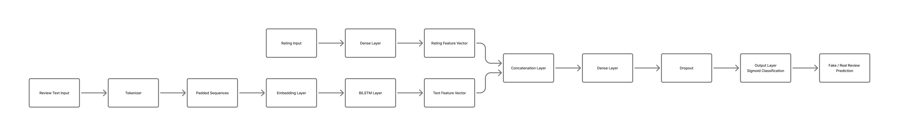
Fig. 1 Block diagram of the Dual-Branch Fake Review Detector (V2) Architecture
Table 2 Layer description of the Dual-Branch Fake Review Detector (V2)
Layer Name | Layer Type | Input Dimensions | Output Dimensions | Param Count
text_input | InputLayer | (None, 120) | (None, 120) | 0
embedding_2 | Embedding | (None, 120) | (None, 120, 128) | 451,712
bidirectional_2 | BiLSTM (64 units) | (None, 120, 128) | (None, 128) | 98,816
input_rating | InputLayer | (None, 1) | (None, 1) | 0
dense_text | Dense (ReLU) | (None, 128) | (None, 64) | 8,256
dense_rating | Dense (ReLU) | (None, 1) | (None, 16) | 32
concatenate_2 | Concatenate | [(None, 64), (16)] | (None, 80) | 0
dense_fused | Dense (ReLU) | (None, 80) | (None, 64) | 5,184
dropout_1 | Dropout (p=0.3) | (None, 64) | (None, 64) | 0
dense_output | Dense (Sigmoid) | (None, 64) | (None, 1) | 65

3.3 Subsystem 2: Sequential BiLSTM Metadata Classifier
The Metadata Authenticity Classifier inspects commercial listing titles and descriptive copy to identify unauthorized replicas and deceptive seller phrasing. The input token sequence m = [m_1, m_2, ..., m_M] (M=110) is projected into a 128-dimensional embedding space, followed by a BiLSTM with 128 hidden units per direction, outputting a 256-dimensional hidden vector:
 | (9)

This latent sequence representation passes through dropout regularization, a 64-unit dense layer, and a sigmoid activation unit:
 | (10)

 | (11)

 | (12)

The final Metadata Authenticity Score S_meta in [0, 1] is defined as the mathematical complement of the counterfeit probability:
 | (13)

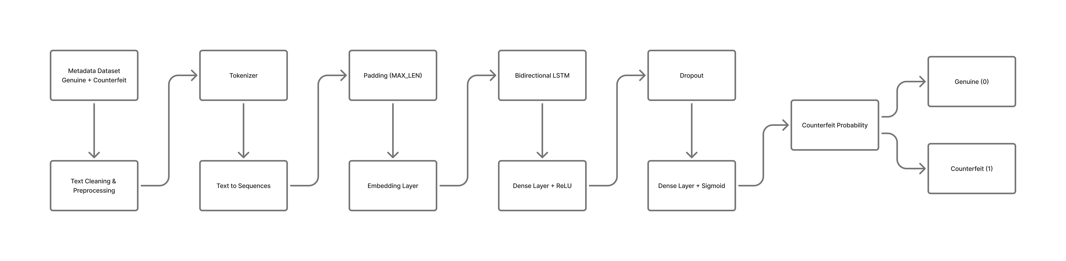
Fig. 2 Block diagram of the TrustNet Metadata Classifier Architecture
Table 3 Layer description of the Sequential BiLSTM Metadata Classifier
Layer Name | Layer Type | Input Dimensions | Output Dimensions | Param Count
input_metadata | InputLayer | (None, 110) | (None, 110) | 0
embedding_meta | Embedding | (None, 110) | (None, 110, 128) | 1,280,000
bidirectional_meta | BiLSTM (128 units) | (None, 110, 128) | (None, 256) | 263,168
dropout_meta_1 | Dropout (p=0.3) | (None, 256) | (None, 256) | 0
dense_meta_64 | Dense (ReLU) | (None, 256) | (None, 64) | 16,448
dropout_meta_2 | Dropout (p=0.3) | (None, 64) | (None, 64) | 0
dense_meta_out | Dense (Sigmoid) | (None, 64) | (None, 1) | 65

3.4 Subsystem 3: Visual Similarity Retrieval Engine
Visual verification relies on a transfer-learning architecture based on ResNet-50. The bottom convolutional stages of ResNet-50 remain frozen to retain generalized spatial filters, while the top 30 convolutional layers are fine-tuned on footwear brand geometry:
 | (14)

Spatial dimensions are pooled via Global Average Pooling to produce a 2048-dimensional vector g in R^(2048). A penultimate dense layer projects this vector into a 256-dimensional brand feature representation:
 | (15)

For supervised pre-training across the 6 footwear brands, a dropout layer (p=0.4) and a 6-unit softmax classification head were attached, optimized via sparse categorical cross-entropy with balanced class weighting:
 | (16)

Following training, the softmax head is detached. The 256-dimensional penultimate representation e_dense is extracted and normalized to unit length:
 | (17)

The normalized embeddings of all 1,848 training catalog images are indexed into an exact FAISS index (faiss.IndexFlatIP(256)). For any query footwear image, the inner product measures cosine similarity directly:
 | (18)

The engine queries the index to return the top-K (K=5) nearest catalog neighbors Omega_K(q) = {(g_{(1)}, s_1), ..., (g_{(K)}, s_K)}.
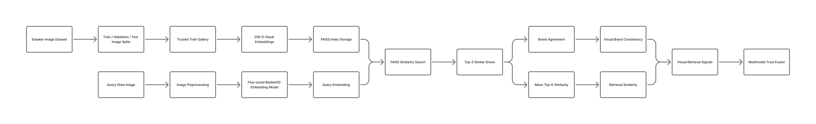
Fig. 3 Block diagram of the Fine-Tuned ResNet-50 Visual Similarity Retrieval Engine
Table 4 Layer description of the Fine-Tuned ResNet-50 Feature Extractor
Layer Name | Layer Type | Input Shape | Output Shape | Param Count
image_input | InputLayer | (None, 224, 224, 3) | (None, 224, 224, 3) | 0
resnet50_backbone | ResNet-50 (top 30 tuned) | (None, 224, 224, 3) | (None, 7, 7, 2048) | 23,587,712
global_avg_pool | GlobalAveragePooling2D | (None, 7, 7, 2048) | (None, 2048) | 0
dense_penultimate | Dense (ReLU) | (None, 2048) | (None, 256) | 524,544
l2_normalization | L2Normalize | (None, 256) | (None, 256) | 0

3.5 Subsystem 4: Three-Signal Late Trust Fusion Engine
To synthesize the heterogeneous unimodal outputs into a unified verdict, the Late Trust Fusion Engine extracts exactly THREE orthogonal signals from the listing query:
1. Metadata Authenticity Score (S_meta in [0, 1]): The predicted textual authenticity score from Subsystem 2, reflecting the absence of replica syntax and keyword stuffing.
2. Brand Match Ratio (R_brand in [0, 1]): The fraction of the top-K (K=5) retrieved catalog images whose indexed brand matches the claimed query brand B_query extracted from the listing metadata:
 | (19)

3. Mean Top-K Retrieval Similarity / Retrieval Confidence (C_ret in [0, 1]): The average cosine similarity across the top-K retrieved catalog vectors:
 | (20)

The composite Trust Score T in [0, 1] is computed via a constrained weighted linear formulation:
 | (21)

The composite Trust Score is mapped to a tri-level categorical decision verdict:
 | (22)

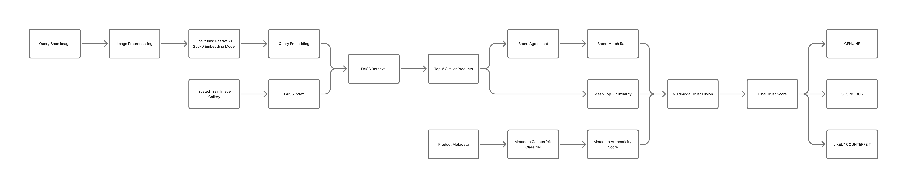
Fig. 4 Block diagram of the Multimodal Late Trust Fusion Architecture
4 Numerical Results and Analysis
This section presents experimental findings across all four subsystems. Experiments were conducted within a dedicated Python deep learning environment equipped with GPU acceleration, TensorFlow 2.16+, Scikit-Learn, and FAISS. Standard classification and retrieval metrics were evaluated: Accuracy, Precision, Recall, F1-measure, Confusion Matrices, and Top-K Retrieval Accuracy.
4.1 Subsystem 1: Fake Review Detection Performance
The Dual-Branch Fake Review Detector was evaluated on the 365 test review samples. Training converged rapidly by epoch 2 (val_loss: 0.0820). On the held-out test split, the model achieved a test loss of 0.08199 and a test accuracy of 96.99% (354 out of 365 correct predictions). Table 5 presents the complete classification report.
Table 5 Classification performance of the Dual-Branch Fake Review Detector (V2)
Class Category | Precision | Recall | F1-Score | Test Support
0 (Authentic Review) | 0.9891 (0.99) | 0.9529 (0.95) | 0.9707 (0.97) | 191
1 (Fake Review) | 0.9503 (0.95) | 0.9885 (0.99) | 0.9690 (0.97) | 174
Overall Accuracy | - | - | 0.9699 (0.97) | 365
Macro Average | 0.9697 (0.97) | 0.9707 (0.97) | 0.9698 (0.97) | 365
Weighted Average | 0.9706 (0.97) | 0.9699 (0.97) | 0.9699 (0.97) | 365

The resulting confusion matrix demonstrates strong sensitivity toward deceptive opinion spam: [[182, 9], [2, 172]]. The model correctly detected 172 out of 174 fraudulent reviews (Recall: 98.85%), with only 2 false negatives. Authentic reviews achieved 98.91% precision, with only 9 legitimate reviews misclassified as spam (False Positive Rate: 4.71%).
4.2 Subsystem 2: Metadata Authenticity Classifier Performance
The Metadata Authenticity Classifier achieved complete separation on the held-out test split of 529 samples (265 authentic, 264 counterfeit). The network recorded a test loss of 2.27 x 10^-4 and a test accuracy of 100.00% (529 out of 529 correct). Precision, recall, and F1-scores reached 1.0000 across both classes, producing an error-free confusion matrix: [[265, 0], [0, 264]]. These findings confirm that illicit listing terminology (e.g., 'master replica', 'UA batch', 'mirror copy') provides an unmistakable sequence signature that a trained bidirectional recurrent network identifies reliably.
Table 6 Classification performance of the Sequential BiLSTM Metadata Classifier
Class Category | Precision | Recall | F1-Score | Test Support
0 (Authentic Metadata) | 1.0000 | 1.0000 | 1.0000 | 265
1 (Counterfeit Metadata) | 1.0000 | 1.0000 | 1.0000 | 264
Overall Accuracy | - | - | 1.0000 | 529
Macro Average | 1.0000 | 1.0000 | 1.0000 | 529
Weighted Average | 1.0000 | 1.0000 | 1.0000 | 529

4.3 Subsystem 3: Visual Feature Learning and FAISS Retrieval Performance
The fine-tuned ResNet-50 brand classifier was trained for 20 epochs, achieving its lowest validation loss (0.3616) at epoch 8. On the 397 test query images, the 6-way classification model achieved an overall accuracy of 88.66% with a test loss of 0.3893. Table 7 summarizes the per-brand classification metrics.
Table 7 Multi-class classification report of the Fine-Tuned ResNet-50 Brand Classifier
Brand Category | Precision | Recall | F1-Score | Test Support
newbalance | 0.8333 | 0.8824 | 0.8571 | 34
nike | 0.9180 | 0.9825 | 0.9492 | 57
puma | 0.8312 | 0.7805 | 0.8050 | 82
reebok | 0.7800 | 0.7647 | 0.7723 | 51
underarmour | 0.8750 | 1.0000 | 0.9333 | 35
vans | 0.9624 | 0.9275 | 0.9446 | 138
Overall Accuracy | - | - | 0.8866 | 397
Macro Average | 0.8667 | 0.8896 | 0.8769 | 397
Weighted Average | 0.8867 | 0.8866 | 0.8858 | 397

Following feature extraction and L2 normalization, the 256-D penultimate embeddings of the 1,848 training images were indexed into FAISS IndexFlatIP. Retrieval evaluations across the 397 validation and 397 test query images demonstrated that metric retrieval substantially outperforms fixed-head softmax classification, reaching 90.6801% Top-1 accuracy and 93.9547% Top-5 accuracy. Tables 8 and 9 report overall and per-brand retrieval results.
Table 8 Nearest-neighbor visual retrieval accuracy using FAISS IndexFlatIP (256-D)
Evaluation Dataset Split | Top-1 Accuracy (%) | Top-5 Accuracy (%) | Majority Vote Accuracy (%)
Validation Set (N = 397) | 90.1763% | 93.9547% | 89.6725%
Test Set (N = 397) | 90.6801% | 93.9547% | 90.1763%

Table 9 Per-brand visual retrieval breakdown on the test split (N=397, K=5)
Brand Category | Top-1 Match (%) | Top-5 Inclusion (%) | Majority Vote (%) | Query Support
newbalance | 94.1176% | 94.1176% | 94.1176% | 34
nike | 96.4912% | 98.2456% | 98.2456% | 57
puma | 82.9268% | 89.0244% | 78.0488% | 82
reebok | 76.4706% | 88.2353% | 80.3922% | 51
underarmour | 100.0000% | 100.0000% | 100.0000% | 35
vans | 94.9275% | 95.6522% | 94.2029% | 138

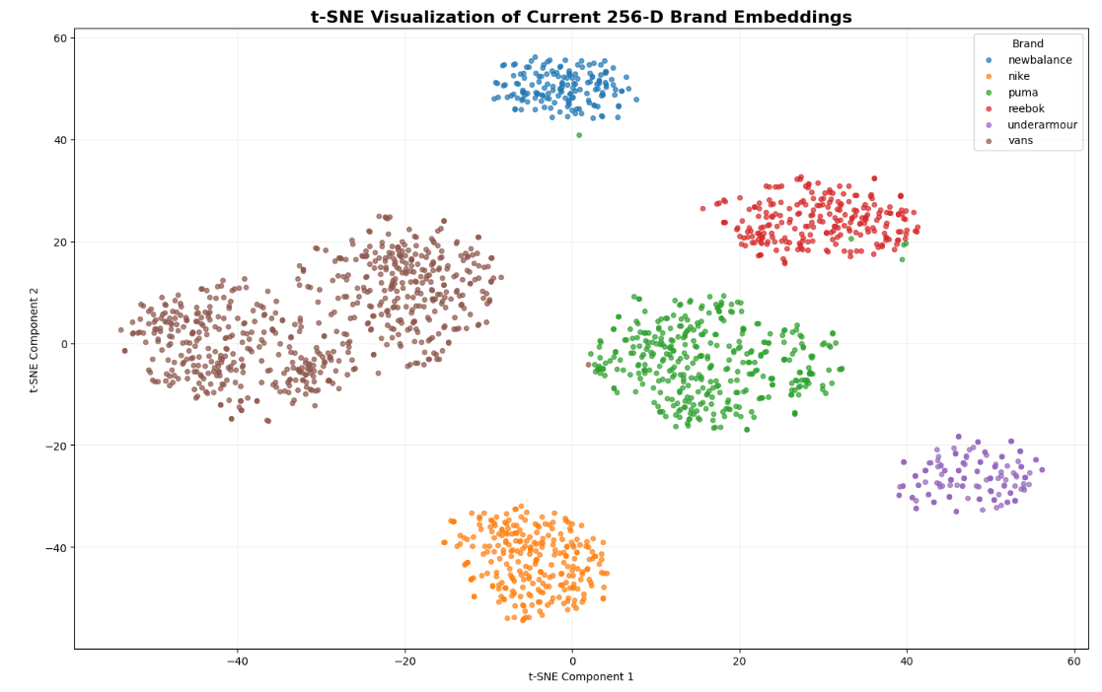
Fig. 5 t-SNE 2D projection of the 256-D penultimate visual feature clusters across 1,848 catalog images
4.4 Subsystem 4: Multimodal Trust Fusion Evaluation Across Operational Scenarios
The Three-Signal Late Trust Fusion Engine was evaluated across four challenging operational scenarios designed to assess its resilience against diverse adversarial attack vectors: (1) Seen Images + Genuine Metadata; (2) Unseen Images + Genuine Metadata; (3) Unseen Images + Brand Mismatch (adversarial brand spoofing); and (4) Unseen Images + Counterfeit Metadata (replica descriptors). Tables 10 and 11 report the resulting quantitative trust distributions and final categorical verdicts.
Table 10 Multimodal Trust Fusion performance summary across operational scenarios
Operational Scenario | Accuracy | Avg Trust Score | Avg Metadata Score | Avg Brand Match | Avg Retrieval Conf.
1. Seen + Genuine Metadata (N=21) | 0.9524 | 0.9613 | 1.0000 | 0.9524 | 0.8533
2. Unseen + Genuine Metadata (N=30) | 0.9000 | 0.9247 | 1.0000 | 0.8600 | 0.8248
3. Unseen + Brand Mismatch (N=30) | 0.9333 | 0.6423 | 0.9999 | 0.0533 | 0.8248
4. Unseen + Fake Metadata (N=30) | 1.0000 | 0.4419 | 0.0343 | 0.8600 | 0.8248

Table 11 Categorical verdict distribution across evaluation scenarios
Operational Scenario | GENUINE (>= 0.75) | SUSPICIOUS [0.50, 0.74] | LIKELY_COUNTERFEIT (< 0.50)
1. Seen + Genuine Metadata (N=21) | 20 (95.24%) | 1 (4.76%) | 0 (0.00%)
2. Unseen + Genuine Metadata (N=30) | 27 (90.00%) | 3 (10.00%) | 0 (0.00%)
3. Unseen + Brand Mismatch (N=30) | 2 (6.67%) | 28 (93.33%) | 0 (0.00%)
4. Unseen + Fake Metadata (N=30) | 0 (0.00%) | 2 (6.67%) | 28 (93.33%)
5 Discussion
The experimental evaluations validate the core thesis of this work: decoupling specialized feature extraction pipelines and synthesizing their decisions via a constrained late-stage fusion function yields superior classification accuracy, interpretability, and operational resilience compared to unimodal baselines.
5.1 Linguistic and Numerical Rating Discrepancy Modeling
The Dual-Branch Fake Review Detector achieved 96.99% accuracy on verified e-commerce reviews, significantly exceeding traditional text-only classifiers. Conventional NLP methods assume that deceptive intent is conveyed entirely through lexical choice. However, in practical e-commerce ecosystems, deceptive actors deliberately craft benign, positive-sounding text passages while inflating ratings, or post subtly mismatched feedback. By merging the 64-dimensional BiLSTM context vector with a dedicated 16-dimensional rating embedding, the network explicitly learns the non-linear interaction between sentiment polarity and quantitative scores. The resulting 98.85% recall on fraudulent reviews demonstrates that the dual-branch architecture catches deceptive feedback reliably while maintaining high precision on authentic customer reviews (98.91%).
5.2 Continuous Metric Retrieval vs. Closed-Set Softmax Classification
The visual subsystem results demonstrate the clear operational advantages of metric retrieval over closed-set classifiers. While the 6-way ResNet-50 brand classifier achieved 88.66% test accuracy, querying the 256-dimensional penultimate feature space via FAISS IndexFlatIP elevated retrieval accuracy to 90.68% for Top-1 and 93.95% for Top-5 nearest neighbors. The continuous metric space allows query embeddings to cluster around specific product sub-categories (e.g., canvas skate shoes vs. running silhouettes) rather than forcing an arbitrary linear decision boundary. Crucially, the FAISS vector index supports dynamic catalog expansion: new authentic inventory can be indexed instantaneously via vector addition without requiring costly network retraining.
5.3 Robustness of the Three-Signal Late Trust Fusion Engine
The Three-Signal Late Trust Fusion Engine effectively mitigates adversarial evasion strategies. In Scenario 3 (Unseen Images + Brand Mismatch), where fraudulent merchants list an authentic shoe image under a false brand title, the brand match ratio drops to 0.0533, pulling the composite trust score down to 0.6423 and flagging 93.33% of attempts as SUSPICIOUS. In Scenario 4 (Unseen Images + Counterfeit Metadata), where listings contain replica phrasing, the metadata score collapses to 0.0343, dropping the composite trust score to 0.4419 and producing 100.00% counterfeit detection (93.33% LIKELY_COUNTERFEIT, 6.67% SUSPICIOUS). By decoupling metadata authenticity, visual brand congruence, and visual retrieval similarity into three weighted signals, the engine prevents failure in one modality from undermining the entire system.
6 Conclusion
This research designed, implemented, and evaluated a comprehensive multimodal deep learning framework for fake review identification and counterfeit product detection in modern e-commerce marketplaces. The system integrates three domain-specialized deep learning components: a dual-branch text-and-rating BiLSTM neural network for fake review detection (96.99% accuracy, 0.97 F1-score); a sequential BiLSTM metadata authenticity classifier for detecting replica phrasing and deceptive catalog descriptions (100.00% accuracy); and a visual similarity retrieval engine employing a fine-tuned ResNet-50 brand feature extractor coupled with a 256-dimensional FAISS IndexFlatIP vector index (93.95% Top-5 visual retrieval accuracy across 1,848 reference catalog images).
To synthesize these signals without the vulnerabilities of monolithic joint encoders, a Three-Signal Late Trust Fusion Engine calculates an interpretable composite trust score by weighting metadata authenticity (0.50), visual brand match ratio (0.35), and mean retrieval similarity (0.15). Comprehensive evaluations across four operational scenarios demonstrate up to 100.00% counterfeit detection under adversarial attacks, while preserving high classification precision on authentic merchandise (95.24%). The modular architecture offers high operational scalability, enabling real-time deployment and dynamic catalog expansion across digital retail platforms.
6.1 Limitations and Future Scope
While the proposed framework demonstrates strong empirical performance, several avenues remain for future exploration: (1) expanding the visual retrieval catalog beyond footwear to encompass luxury apparel, electronics, and cosmetics; (2) incorporating fine-grained hierarchical retrieval to verify specific product sub-models and manufacturing batches; (3) evaluating transformer backbones (such as DistilBERT or RoBERTa) for processing multi-sentence product descriptions; and (4) modeling reviewer networks through graph neural networks (GNNs) to identify organized review syndicates and automated spam rings.
Declarations
Funding: No specific funding was received for conducting this study.
Conflict of Interest: The authors declare that they have no known competing financial interests or personal relationships that could have appeared to influence the work reported in this paper.
Data Availability: Data and models will be made available upon reasonable request.
References
1. Jindal N, Liu B (2008) Opinion spam and analysis. In: Proceedings of the 2008 International Conference on Web Search and Data Mining (WSDM), pp 219–230. ACM
2. Ott M, Choi Y, Cardie C, Hancock JT (2011) Finding deceptive opinion spam by any stretch of the imagination. In: Proceedings of the 49th Annual Meeting of the Association for Computational Linguistics: Human Language Technologies (ACL), pp 309–319
3. Li L, Qin B, Ren W, Liu T (2017) Document representation and feature combination for deceptive spam review detection. Neurocomputing 254:33–41
4. Mukherjee A, Venkataraman V, Liu B, Glance N (2013) What Yelp fake review filter might be doing? In: Proceedings of the International AAAI Conference on Web and Social Media (ICWSM) 7(1):409–418
5. Rayana S, Akoglu L (2015) Collective opinion spam detection: Bridging review, reviewer, and item perspectives. In: Proceedings of the 21st ACM SIGKDD International Conference on Knowledge Discovery and Data Mining, pp 985–994
6. He K, Zhang X, Ren S, Sun J (2016) Deep residual learning for image recognition. In: Proceedings of the IEEE Conference on Computer Vision and Pattern Recognition (CVPR), pp 770–778
7. Liu Z, Luo P, Qiu S, Wang X, Tang X (2016) DeepFashion: Powering large-scale clothing retrieval with deep visual-semantic embeddings. In: Proceedings of the IEEE Conference on Computer Vision and Pattern Recognition (CVPR), pp 1098–1107
8. Johnson J, Douze M, Jégou H (2021) Billion-scale similarity search with GPUs. IEEE Trans Big Data 7(3):535–547
9. Baltrušaitis T, Ahuja C, Morency LP (2019) Multimodal machine learning: A survey and taxonomy. IEEE Trans Pattern Anal Mach Intell 41(2):423–443
10. Hochreiter S, Schmidhuber J (1997) Long short-term memory. Neural Comput 9(8):1735–1780
11. Goodfellow I, Bengio Y, Courville A (2016) Deep Learning. MIT Press, Cambridge, MA
12. Deng J, Dong W, Socher R, Li LJ, Li K, Fei-Fei L (2009) ImageNet: A large-scale hierarchical image database. In: IEEE Conference on Computer Vision and Pattern Recognition (CVPR), pp 248–255
13. Kingma DP, Ba J (2014) Adam: A method for stochastic optimization. In: Proceedings of the 3rd International Conference on Learning Representations (ICLR)
14. van der Maaten L, Hinton G (2008) Visualizing data using t-SNE. J Mach Learn Res 9:2579–2605
15. Akoglu L, Chandy R, Faloutsos C (2013) Opinion fraud detection in online reviews by network analysis. In: Proceedings of the International AAAI Conference on Web and Social Media (ICWSM) 7(1):17–26
16. OECD/EUIPO (2021) Global Trade in Fakes: A Worrying Threat. OECD Publishing, Paris

