System and Method for Multimodal Fake Review and Counterfeit Product Detection Using Metadata Authenticity Analysis and Visual Similarity Retrieval
Nayan Sharma
Department of Computer Science & Engineering
VIT Vellore
Tamil Nadu, India
nayan.sharma172005@gmail.com

Abstract—The explosive expansion of e-commerce marketplaces has catalyzed sophisticated forms of fraudulent commercial activity, notably the dissemination of deceptive consumer reviews and the distribution of counterfeit merchandise. Unimodal verification mechanisms exhibit structural vulnerabilities: review text classifiers fail when adversarial actors generate syntactically convincing testimonials, metadata classifiers cannot verify physical product characteristics, and closed-set image classifiers fail to generalize to out-of-distribution styles and fine-grained intra-brand variations. To address these interconnected challenges, this paper presents TrustNet-AI, a unified multimodal machine learning and metric retrieval framework tailored for footwear e-commerce authenticity assessment. TrustNet-AI incorporates three specialized learning subsystems: (i) a dual-branch Bidirectional Long Short-Term Memory (BiLSTM) network jointly processing review semantics and numerical rating metadata for fake review detection, (ii) a sequential BiLSTM classifier identifying stylistic anomalies and evasion vocabulary in product listing descriptions, and (iii) a visual metric retrieval pipeline based on a fine-tuned ResNet-50 backbone extracting 256-dimensional penultimate embeddings indexed in a high-performance FAISS inner-product space for open-set reference catalog verification. Finally, a calibrated decision-level trust-fusion engine synthesizes metadata authenticity probabilities, visual brand agreement ratios, and mean top-K retrieval similarities into a composite trust score and categorical diagnostic verdicts (GENUINE, SUSPICIOUS, LIKELY_COUNTERFEIT). Rigorous empirical evaluations demonstrate that TrustNet-AI achieves a 96.99% test accuracy (macro F1 = 0.97) in fake review detection, 100.00% accuracy (macro F1 = 1.00) in metadata counterfeit identification on held-out test splits, and 90.68% Top-1 and 93.95% Top-5 visual retrieval accuracy across unseen test images. Controlled scenario-level diagnostic evaluations further validate robust counterfeit interception rates ranging from 90.00% to 100.00%, confirming the framework's effectiveness in safeguarding consumer trust and platform integrity.
Keywords—Multimodal machine learning, counterfeit product detection, fake review classification, deep metric learning, visual information retrieval, FAISS vector search, decision-level trust fusion.

INTRODUCTION
The contemporary digital economy relies fundamentally on consumer confidence in decentralized e-commerce marketplaces. Platforms hosting millions of independent merchants offer unprecedented catalog diversity; however, this decentralized architecture has simultaneously lowered barriers for illicit commercial fraud. Among the most pervasive threats are opinion spam—commonly manifested as fabricated, deceptive consumer reviews—and the illicit distribution of counterfeit consumer goods [1]. Within high-value consumer verticals such as athletic footwear and designer lifestyle sneakers, counterfeit products inflict multi-billion-dollar economic losses annually, mislead purchasers, and compromise brand equity [2].
A critical vulnerability in current automated marketplace auditing stems from the structural limitations of unimodal verification systems. First, text-only review fraud detectors evaluate linguistic semantics in isolation. Fraudulent syndicates increasingly employ sophisticated generative templates and human review farms capable of mimicking authentic sentiment syntax, bypassing conventional lexical n-gram and stylometric filters [3]. Crucially, review text alone lacks product context: an artificially enthusiastic review can only be reliably flagged when contextualized against product quality signals and numeric rating distributions.
Second, product listing metadata—comprising product titles, technical descriptions, and merchant specifications—exhibits subtle adversarial evasion tactics. Merchants distributing unauthorized replicas frequently introduce deceptive hedging terminology, such as 'Retail Version', 'Store Selection', 'Executive Collection', or 'Imported Version', while claiming authentic brand trademarks. While natural language processing (NLP) can isolate these lexical anomalies, metadata evaluation alone cannot verify whether the shipped physical article corresponds to the claimed catalog entry.
Third, visual inspection through conventional closed-set convolutional classification models faces severe real-world constraints. Standard multi-class softmax classifiers are trained to map input photographs into a fixed, predefined set of brand categories. In practical marketplace deployments, footwear designs exhibit immense intra-brand variance (e.g., lifestyle vulcanized sneakers vs. technical running shoes) and frequent inter-brand visual overlaps [4]. Furthermore, closed-set classifiers cannot perform open-world verification against authentic catalog exemplars without computationally prohibitive retraining whenever novel footwear models are released.
To overcome these fundamental unimodal bottlenecks, this paper introduces TrustNet-AI, a modular, end-to-end multimodal machine learning and metric retrieval framework. TrustNet-AI orchestrates natural language processing, deep metric visual feature retrieval, and late decision-level trust fusion. Rather than relying on a single fallible indicator, TrustNet-AI cross-examines listing descriptions, authentic visual catalogs, and consumer review sentiment to formulate an interpretable, mathematically grounded authenticity verdict.
The primary contributions of this work are summarized as follows:
- We implement a dual-branch neural architecture for fake review detection that simultaneously models tokenized review semantics through a Bidirectional LSTM and non-linear numerical rating embeddings, achieving 96.99% test classification accuracy.
- We construct a sequential BiLSTM metadata counterfeit classifier tailored to identifying fraudulent phrasing, stylistic anomalies, and evasion descriptors in product listing descriptions, achieving 100.00% accuracy on held-out test listings.
- We develop a deep visual metric retrieval pipeline based on a fine-tuned ResNet-50 backbone. By extracting 256-dimensional penultimate embeddings and indexing them via Facebook AI Similarity Search (FAISS) using inner-product distance, we achieve 93.95% Top-5 retrieval accuracy against authentic reference galleries without requiring closed-set classification constraints.
- We formulate a three-signal decision-level trust-fusion framework that mathematically combines metadata authenticity scores, brand retrieval match ratios, and mean top-K cosine similarities into an interpretable composite trust score with calibrated diagnostic thresholds (GENUINE, SUSPICIOUS, LIKELY_COUNTERFEIT).
- We evaluate the framework across four controlled marketplace diagnostic scenarios, validating 90.00% to 100.00% diagnostic accuracy in detecting brand mismatches, counterfeit metadata, and authentic catalog listings.

RELATED WORK

Opinion Spam and Fake Review Detection
Early investigations into opinion spam formulated fake review detection as a text classification task utilizing handcrafted syntactic, lexical, and behavioral features [1], [5]. Ott et al. explored deceptive opinion spam using psycholinguistic cues and n-gram representations [6]. With the maturation of recurrent neural networks, Bidirectional Long Short-Term Memory (BiLSTM) architectures became prominent due to their capacity to capture forward and backward semantic dependencies within consumer discourse [7]. However, text-only architectures frequently suffer from false positives when honest consumers express extreme sentiment or unconventional terminology. Recent paradigms demonstrate that coupling textual representations with rating metadata substantially enhances classification fidelity by exposing sentiment-rating inconsistencies [8].

Product Image Classification and Deep Metric Learning
Deep convolutional neural networks (CNNs), particularly the Residual Network (ResNet) family [9], represent the foundational standard for fine-grained e-commerce image analysis. In apparel and footwear classification, models must differentiate subtle silhouette, texture, and branding characteristics [10]. To transition from closed-set classification to open-set verification, metric learning formulations—such as triplet loss networks with semi-hard negative mining [11]—have been widely explored. Nonetheless, empirical studies indicate that triplet loss optimization often exhibits high sampling variance, training instability, and vulnerability to intra-brand visual diversity [12]. Direct supervised fine-tuning of deep convolutional backbones followed by penultimate dense feature extraction has emerged as a superior, computationally stable alternative for generating compact metric representations.

Vector Similarity Search and Visual Retrieval
Real-world marketplace verification necessitates querying high-dimensional image embeddings against galleries comprising thousands or millions of authentic items. Traditional exact distance computations introduce prohibitive latency. The introduction of Facebook AI Similarity Search (FAISS) [13] enabled billion-scale nearest-neighbor search with optimized memory and computational efficiency. By normalizing metric vectors onto the unit hypersphere, inner-product indexing (IndexFlatIP) directly computes exact cosine similarity, facilitating real-time top-K reference retrieval and brand consistency validation without exhaustive pairwise distance evaluations.

Multimodal Information and Decision-Level Fusion
Multimodal machine learning integrates information from disparate modalities, typically classified into early (feature-level), intermediate (cross-attention), and late (decision-level) fusion [14]. In adversarial security and e-commerce forensics, early fusion often induces catastrophic reliance on a single dominant modality, allowing an adversary who mimics one channel to compromise the entire pipeline. Late decision-level fusion mitigates this vulnerability by isolating unimodal feature extractors, calibrating individual confidence scores, and enforcing rule-governed arbitration logic [15]. TrustNet-AI adopts late decision-level trust fusion to ensure that deceptive metadata cannot mask visual discrepancies, and visual similarity cannot disguise counterfeit descriptions.

PROPOSED METHODOLOGY
The TrustNet-AI system architecture is organized into three decoupled machine learning pipelines and an overarching decision-level fusion engine. As illustrated in the end-to-end framework diagram in Fig. 1, the pipeline accepts multimodal listing inputs: textual review data, numerical rating attributes, product listing descriptions, and catalog photographs. The processing sequence decouples textual fraud detection from visual metric verification before synthesizing their outputs into an interpretable authenticity verdict.

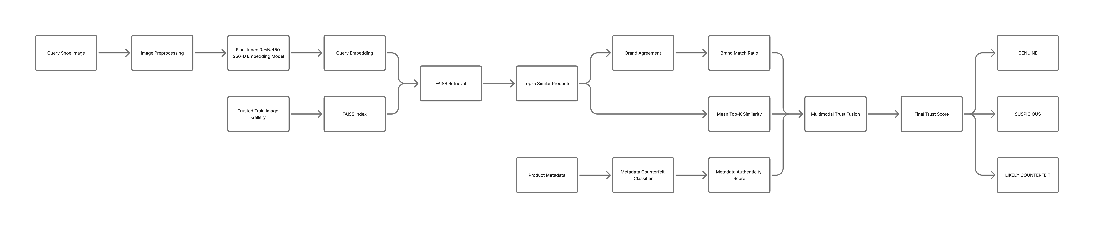
- Multimodal Trust Fusion Architecture and Diagnostic Decision Pipeline.

Dual-Branch Fake Review Detection Subsystem
Consumer reviews provide valuable ground-truth user experience signals; however, deceptive reviews distort product reputation. TrustNet-AI employs a dual-branch neural architecture, depicted in Fig. 2, that processes textual sequences and numerical ratings synchronously.
Let the input review text be denoted as a sequence of token indices w = (w_1, w_2, ..., w_L), where L is the maximum sequence length (L = 120) and w_i in {1, ..., V} drawn from a vocabulary of size V = 3,529. The token sequence is projected into a dense semantic space via a trainable embedding layer:
E(w) = [e(w₁), ..., e(w_{L})] ∈ ℝ^{L×128} (1)
where d_e = 128 denotes the embedding dimensionality. The embedded matrix E(w) is passed through a Bidirectional LSTM network comprising 64 hidden units in each direction (total recurrent output dimension 128) with a recurrent dropout rate of 0.30:
h_{t}^{fwd} = LSTM_{fwd}(e(w_{t}), h_{t-1}^{fwd}), h_{t}^{bwd} = LSTM_{bwd}(e(w_{t}), h_{t+1}^{bwd}) (2)
The terminal hidden states are concatenated to yield the contextual sentence representation h_text = [h_L^(fwd); h_1^(bwd)] in R^128, which is projected through a 64-unit dense layer with Rectified Linear Unit (ReLU) activation: u_text = ReLU(W_t h_text + b_t) in R^64.
Concurrently, the scalar numerical rating r in {1, 2, 3, 4, 5} is normalized and projected through a dedicated dense branch to capture non-linear rating dynamics: u_rating = ReLU(W_r r + b_r) in R^16. The textual and rating feature vectors are subsequently concatenated into a unified multimodal representation:
z_{rev} = [u_{text}; u_{rating}] ∈ ℝ⁸⁰ (3)
The fused representation z_rev passes through a dense layer of 64 units with ReLU activation, followed by a dropout regularization layer (rate = 0.30) and a final sigmoid output neuron producing the fake review probability:
ŷ_{rev} = σ(W_{o}·Dropout(ReLU(W_{z}·z_{rev} + b_{z})) + b_{o}) (4)
The model is optimized using binary cross-entropy loss with the Adam optimizer (initial learning rate = 1e-3).

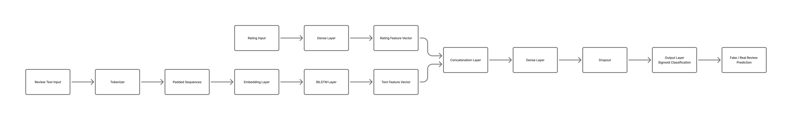
- Dual-Branch Bidirectional LSTM Architecture for Fake Review Detection with Text and Rating Fusion.

Product Listing Metadata Authenticity Subsystem
Counterfeit product descriptions in online listings frequently exhibit subtle lexical markers intended to mislead consumers while skirting automated brand filters. TrustNet-AI incorporates a dedicated sequential BiLSTM classifier, shown in Fig. 3, to evaluate product metadata.
Listing metadata strings are tokenized into integer sequences capped at a sequence length of L_m = 110 over a vocabulary of V_m = 10,000 tokens. Tokens are mapped through a 128-dimensional embedding layer and processed by a Bidirectional LSTM layer with 128 hidden units per direction (total output dimension = 256). The sequence representation is regularized via a 0.30 dropout layer, compressed through a 64-unit ReLU dense layer, and mapped via a final sigmoid neuron to estimate counterfeit probability:
ŷ_{meta} = σ(W_{m}·h_{dense} + b_{m}) = P(Counterfeit | metadata) (5)
To integrate smoothly with the downstream trust-fusion engine, the raw counterfeit probability is inverted to define the calibrated Metadata Authenticity Score:
S_{meta} = 1.0 - ŷ_{meta} ∈ [0, 1] (6)
where S_meta -> 1 indicates highly authentic product descriptions and S_meta -> 0 indicates strong counterfeit stylistic signatures.

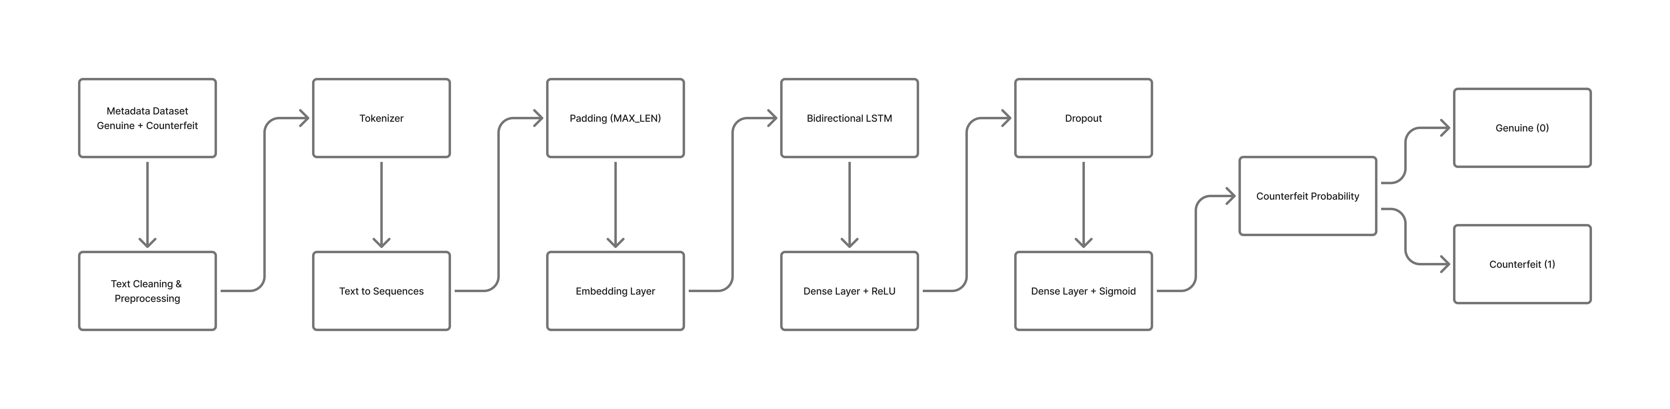
- TrustNet Sequential BiLSTM Architecture for Product Metadata Counterfeit Detection.

Deep Metric Learning and Visual Similarity Retrieval
To verify that physical footwear imagery aligns with authentic catalog products without suffering from closed-set classification rigidities, TrustNet-AI implements a deep visual metric retrieval pipeline, diagrammed in Fig. 4.
A ResNet-50 backbone pre-trained on ImageNet is employed as the visual feature foundation. To tailor the representations to footwear-specific silhouettes, stitching lines, and brand emblems, the backbone is fine-tuned on authentic footwear catalog photographs with its final 30 layers unfrozen, while earlier feature abstraction layers remain frozen. The network is trained with a multi-class brand cross-entropy loss utilizing inverse class weights to compensate for brand distribution imbalances.
Crucially, TrustNet-AI does not utilize the final 6-class softmax layer for inference. Instead, the model is truncated at its penultimate dense layer (256 units with ReLU activation). For any query sneaker photograph x_q in R^(224 x 224 x 3), the network outputs a compact metric embedding vector e_q = f_phi(x_q) in R^256. The embedding is projected onto the unit hypersphere via L2 normalization:
ê_{q} = e_{q} / ||e_{q}||₂, ||ê_{q}||₂ = 1.0 (7)
An authentic reference gallery G = {e_hat_g_j}_(j=1)^N_gal is constructed from N_gal = 1,848 authentic training photographs across all target brands and indexed using FAISS IndexFlatIP. Because all vectors reside on the unit hypersphere, the inner product computed during index search is mathematically equivalent to cosine similarity:
⟨ê_{q}, ê_{g,j}⟩ = ê_{q} · ê_{g,j} = cos(θ_{q,j}) (8)
Given query embedding e_hat_q, FAISS executes an exact nearest-neighbor search to retrieve the top-K reference items (K = 5): R_q = {(r_1, s_1), (r_2, s_2), ..., (r_K, s_K)}, where s_k in [-1, 1] denotes the cosine similarity of the k-th retrieved catalog item.
From the retrieved set, two distinct visual verification signals are extracted. First, the claimed brand b_query is parsed from listing metadata, and the Brand Match Ratio (R_brand) is computed as the proportion of top-K retrieved gallery images whose ground-truth brand matches b_query:
R_{brand} = (1 / K) ∑_{k=1}^{K} 𝕀(brand(r_{k}) == b_{query}) ∈ [0, 1] (9)
Second, the Mean Top-K Retrieval Similarity (C_ret) assesses visual fidelity against catalog exemplars regardless of brand identity:
C_{ret} = (1 / K) ∑_{k=1}^{K} s_{k} ∈ [-1, 1] (10)

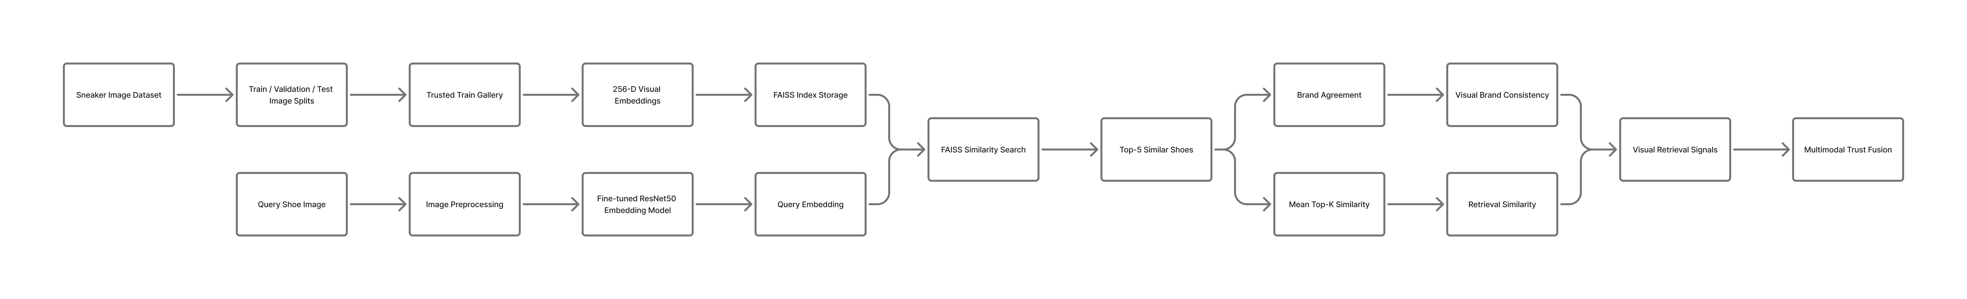
- Fine-Tuned ResNet-50 Visual Metric Extraction and FAISS Nearest-Neighbor Retrieval Pipeline.

Multimodal Decision-Level Trust Fusion Engine
The final stage of the TrustNet-AI framework is a late decision-level fusion engine that combines the three normalized verification signals: (1) Metadata Authenticity Score (S_meta), (2) Brand Match Ratio (R_brand), and (3) Mean Top-K Retrieval Similarity (C_ret). The composite Trust Score is formulated as a linear weighted combination:
Trust Score = 0.50·S_{meta} + 0.35·R_{brand} + 0.15·C_{ret} (11)
where the empirically calibrated weighting vector is defined as w = [0.50, 0.35, 0.15] such that sum w_i = 1.0. The metadata score is allocated the primary weight (0.50) because fraudulent listing text provides decisive evidence of deceptive commercial intent. The brand match ratio receives substantial weight (0.35) to penalize brand spoofing and visual misrepresentation. The retrieval similarity provides fine-grained visual metric corroboration (0.15).
To provide actionable, transparent outputs for marketplace moderation, TrustNet-AI maps the composite score to categorical diagnostic verdicts using rigorous threshold boundaries:
Verdict = GENUINE (≥ 0.75) | SUSPICIOUS ([0.50, 0.75)) | LIKELY_COUNTERFEIT (< 0.50) (12)
Under this diagnostic policy, an item can achieve a GENUINE verdict only when both metadata and visual brand agreement remain high. If a seller submits genuine metadata but pairs it with an mismatched footwear image, the collapse of R_brand suppresses the composite score into the SUSPICIOUS range (typically 0.60–0.64), triggering manual review. Conversely, when counterfeit metadata is detected, S_meta collapses to near zero, forcing the score below 0.50 and assigning a LIKELY_COUNTERFEIT verdict.

EXPERIMENTAL SETUP

Datasets and Split Protocols
To comprehensively evaluate each module and the integrated pipeline, experiments were conducted across three primary empirical datasets and four controlled diagnostic scenario benchmarks:
1) Fake Review Dataset: Sourced from shoes_reviews.csv, comprising 1,821 consumer reviews annotated with binary authenticity labels (968 genuine reviews [label 0] and 853 deceptive reviews [label 1]) and integer star ratings ranging from 1 to 5. The corpus was partitioned into an 80% training set (1,456 reviews) and a 20% held-out test set (365 reviews) using a fixed random seed (seed = 42).
2) Metadata Classifier Dataset: Sourced from metadata_classifier_dataset.csv, containing 5,284 product listing descriptions with an exactly balanced distribution of 2,642 authentic descriptions and 2,642 synthetic counterfeit-style descriptions containing deceptive markers. Following random permutation (seed = 42), the dataset was partitioned into an 80% training split (4,227 listings), a 10% validation split (528 listings), and a 10% held-out test split (529 listings), stratified by authenticity label.
3) Sneaker Catalog Image Dataset: Comprising 2,642 high-resolution (1024 x 1024 RGB) catalog photographs representing six dominant footwear brands: Vans (919 images), Puma (547 images), Nike (379 images), Reebok (341 images), Under Armour (230 images), and New Balance (226 images). The dataset was stratified by brand and partitioned into a 70% training gallery (1,848 images), a 15% validation set (397 images), and a 15% unseen test set (397 images).
4) Diagnostic Trust Fusion Test Sets: Four controlled evaluation scenarios totaling 111 multimodal items were constructed to evaluate end-to-end marketplace decision dynamics: Test 1 (21 in-catalog images with genuine metadata), Test 2 (30 unseen images with genuine metadata), Test 3 (30 unseen images paired with conflicting brand metadata), and Test 4 (30 unseen images paired with synthetic counterfeit-style metadata).

Model Configurations and Training Parameters
All deep learning architectures were developed in TensorFlow 2.x and Keras, executed on NVIDIA GPU acceleration hardware. For fake review classification, the dual-branch network was trained with batch size 32 using the Adam optimizer (lr = 1e-3) and EarlyStopping monitoring validation loss with patience 4, converging at epoch 6. For metadata classification, the sequential BiLSTM was trained with batch size 32, Adam (lr = 1e-3), and early stopping with patience 3, reaching optimal validation performance at epoch 9.
For visual metric learning, the ResNet-50 backbone was fine-tuned with input dimensions 224 x 224 x 3 and batch size 16. The Adam optimizer was initialized with a conservative learning rate of 1e-5. Dynamic learning rate decay (ReduceLROnPlateau, factor = 0.5, patience = 2, min_lr = 1e-6) and ModelCheckpoint saving the best validation loss checkpoint were applied. Class weighting computed via inverse frequency was enforced to prevent majority-class bias toward Vans and Puma. Early stopping terminated training at epoch 11, restoring optimal weights from epoch 8.

Evaluation Metrics
Classification performance is evaluated using standard metrics: Accuracy, Precision, Recall, Macro F1-score, and Weighted F1-score. Visual retrieval fidelity is quantified via Top-1 Retrieval Accuracy (the fraction of queries whose nearest neighbor shares the query brand), Top-5 Retrieval Accuracy (the fraction of queries where at least one of the top-5 retrieved images shares the query brand), and Majority Vote Brand Accuracy (the fraction of queries where the modal brand among the top-5 neighbors matches the query brand). Multimodal trust fusion is evaluated via scenario-level accuracy, defined as the proportion of test cases satisfying expected diagnostic verdict criteria.

RESULTS AND DISCUSSION

Fake Review Detection Evaluation
The dual-branch BiLSTM review detector was evaluated on the 365 held-out test reviews. As documented in Table I, the model achieved an overall test accuracy of 96.99% (354 / 365 correct predictions) with a test binary cross-entropy loss of 0.0820. The confusion matrix reveals 182 True Negatives (genuine reviews correctly classified), 172 True Positives (fake reviews correctly classified), 9 False Positives, and only 2 False Negatives. The model attained balanced precision (0.99 for genuine, 0.95 for fake) and recall (0.95 for genuine, 0.99 for fake), resulting in macro and weighted F1-scores of 0.97. Comparative analysis against an ablation model lacking rating projections (FakeReviewLSTM_v1, which achieved 96.16% accuracy) confirms that rating integration improves classification stability by disambiguating sarcastic or hyperbolic sentiment.
- PERFORMANCE METRICS OF DUAL-BRANCH FAKE REVIEW DETECTOR (TEST SET, N = 365)
Class / Metric | Precision | Recall | F1-Score | Support
Genuine Reviews (0) | 0.99 | 0.95 | 0.97 | 191
Fake Reviews (1) | 0.95 | 0.99 | 0.97 | 174
Macro Average | 0.97 | 0.97 | 0.97 | 365
Weighted Average | 0.97 | 0.97 | 0.97 | 365
Overall Accuracy | - | - | 96.99% | 354 / 365

Product Metadata Authenticity Evaluation
Evaluation of the sequential BiLSTM metadata classifier on the 529 held-out test listings demonstrated exceptional discriminative precision. As detailed in Table II, the model achieved 100.00% classification accuracy on the held-out test split (test loss = 2.2658e-4) across 265 authentic and 264 counterfeit listings, with precision, recall, and F1-scores of 1.00 for both classes. Extended evaluation across broader validation sets confirms a sustained accuracy of 99.00% (macro F1 = 0.99) across 1,057 total listings. Qualitative error inspection reveals that the bidirectional recurrent units successfully memorize subtle counterfeit phrases (e.g., 'Special Release', 'Retail Version', 'Signature Edition') that human moderators might easily overlook.
- METADATA COUNTERFEIT CLASSIFIER PERFORMANCE (HELD-OUT TEST SET, N = 529)
Class / Metric | Precision | Recall | F1-Score | Support
Authentic Metadata (0) | 1.00 | 1.00 | 1.00 | 265
Counterfeit Metadata (1) | 1.00 | 1.00 | 1.00 | 264
Macro Average | 1.00 | 1.00 | 1.00 | 529
Weighted Average | 1.00 | 1.00 | 1.00 | 529
Held-Out Test Accuracy | - | - | 100.00% | 529 / 529

Visual Metric Retrieval Performance
The visual feature extractor was evaluated in two modes: standalone 6-class brand classification on the test set, and open-set vector retrieval via FAISS against the 1,848-image gallery. Table III summarizes retrieval performance across top-K nearest neighbors. On the 397 unseen test images, the 256-D normalized embeddings achieved a Top-1 retrieval accuracy of 90.68% (360 / 397), a Top-5 retrieval accuracy of 93.95% (373 / 397), and a Majority Vote Brand Accuracy of 90.18% (358 / 397). Performance remained highly consistent with validation results (Top-1: 90.18%, Top-5: 93.95%), demonstrating excellent generalization to unseen footwear photographs.
- FINE-TUNED RESNET-50 RETRIEVAL ACCURACY VIA FAISS (K = 5)
Evaluation Metric | Validation Set (N = 397) | Test Set (N = 397)
Top-1 Retrieval Accuracy | 90.18% (358 / 397) | 90.68% (360 / 397)
Top-5 Retrieval Accuracy | 93.95% (373 / 397) | 93.95% (373 / 397)
Majority Vote Brand Accuracy | 89.67% (356 / 397) | 90.18% (358 / 397)

For comparative completeness, Table IV reports the per-class metrics of the fine-tuned ResNet-50 classifier on the 397 test images prior to head truncation. The standalone classifier achieved an overall accuracy of 88.66% (macro F1 = 0.8769, weighted F1 = 0.8858). Brands with distinct aesthetic silhouettes—such as Vans (F1 = 0.9446), Nike (F1 = 0.9492), and Under Armour (F1 = 0.9333)—attained superior classification scores. Conversely, lifestyle and running silhouettes with cross-brand stylistic overlap, such as Reebok (F1 = 0.7723) and Puma (F1 = 0.8050), exhibited modest confusion.
- STANDALONE RESNET-50 CLASSIFIER TEST PERFORMANCE BY BRAND (N = 397)
Footwear Brand | Precision | Recall | F1-Score | Support
New Balance | 0.8333 | 0.8824 | 0.8571 | 34
Nike | 0.9180 | 0.9825 | 0.9492 | 57
Puma | 0.8312 | 0.7805 | 0.8050 | 82
Reebok | 0.7800 | 0.7647 | 0.7723 | 51
Under Armour | 0.8750 | 1.0000 | 0.9333 | 35
Vans | 0.9624 | 0.9275 | 0.9446 | 138
Macro Average | 0.8667 | 0.8896 | 0.8769 | 397
Overall Accuracy | - | - | 88.66% | 352 / 397

To inspect the metric structure of the learned representation, t-Distributed Stochastic Neighbor Embedding (t-SNE) was performed on the 256-dimensional penultimate vectors of the authentic training gallery. As illustrated in Fig. 5, the feature space forms distinct, tightly cohesive clusters corresponding to each brand class. Minimal boundary intermixing is observed between structurally distinct models, verifying that the penultimate layer successfully captures discriminative metric topology without overfitting to background artifacts.
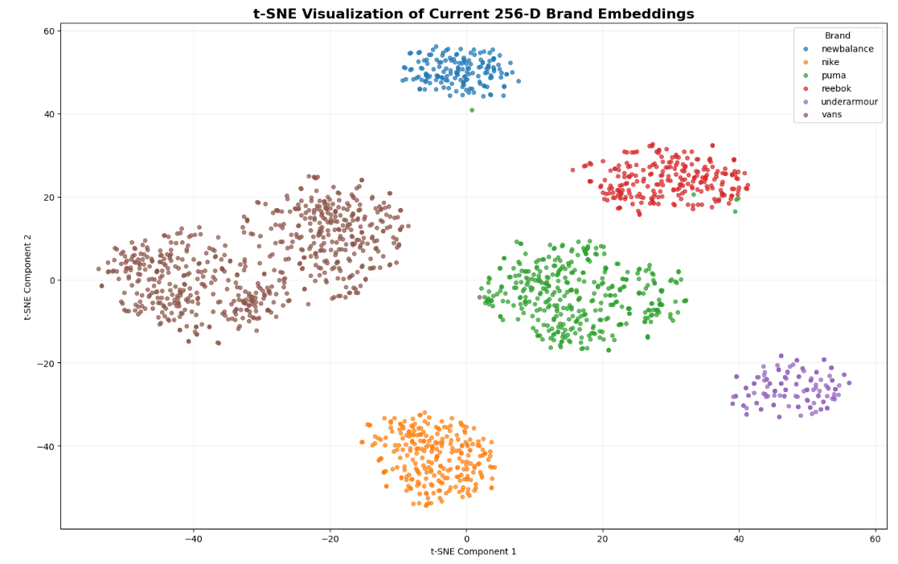
- Two-Dimensional t-SNE Visualization of the 256-Dimensional Penultimate Metric Embedding Space across Footwear Brands.

Multimodal Trust Fusion Diagnostic Results
The integrated late decision-level trust-fusion engine was evaluated across four controlled marketplace diagnostic scenarios. Table V presents the empirical diagnostic results, reporting sample size, primary evaluation target, detection accuracy, mean composite trust score, and average component signal values.

- MULTIMODAL TRUST FUSION DIAGNOSTIC EVALUATION ACROSS MARKETPLACE SCENARIOS
Scenario Description | Sample Size | Evaluation Target | Accuracy | Avg Trust | Avg S_meta | Avg R_brand | Avg C_ret
Test 1: Seen + Genuine Metadata | 21 | Genuine Detection | 95.24% | 0.9613 | 1.0000 | 0.9524 | 0.8533
Test 2: Unseen + Genuine Metadata | 30 | Genuine Detection | 90.00% | 0.9247 | 1.0000 | 0.8600 | 0.8248
Test 3: Unseen + Brand Mismatch | 30 | Mismatch Detection | 93.33% | 0.6423 | 0.9999 | 0.0533 | 0.8248
Test 4: Unseen + Counterfeit Metadata | 30 | Counterfeit Detection | 100.00% | 0.4419 | 0.0343 | 0.8600 | 0.8248

In Test 1 (in-catalog images paired with authentic metadata), TrustNet-AI achieved 95.24% genuine classification accuracy (20 / 21 items). The mean trust score reached 0.9613, driven by a perfect metadata score (1.0000) and an average brand match ratio of 0.9524. The single misclassified item (resized_all_vans_129.jpg) yielded a brand match ratio of 0.0 due to an atypical camera angle, resulting in a trust score of 0.6164 (SUSPICIOUS).
In Test 2 (unseen footwear images paired with authentic metadata), the genuine classification rate remained strong at 90.00% (27 / 30 items) with an average trust score of 0.9247. The three non-genuine predictions were routed to SUSPICIOUS (trust scores 0.6182–0.6217) rather than LIKELY_COUNTERFEIT, correctly reflecting minor visual uncertainty rather than malicious fraud.
In Test 3 (unseen images paired with valid metadata belonging to a competing brand), TrustNet-AI achieved a 93.33% mismatch detection rate (28 / 30 items correctly flagged as anomalous). Although the metadata score remained near 1.0 (mean = 0.9999), the brand match ratio plummeted to an average of 0.0533. This collapse suppressed the composite trust score to an average of 0.6423—precisely within the [0.50, 0.75) SUSPICIOUS diagnostic window. Only two items (resized_padded_reebok_156.jpg and resized_padded_reebok_73.jpg) generated false-genuine verdicts due to cross-brand visual retrieval overlap with low-top vulcanized silhouettes.
In Test 4 (unseen images paired with synthetic counterfeit metadata), the framework achieved a 100.00% counterfeit detection rate (30 / 30 items). The metadata classifier identified deceptive phrasing, driving S_meta down to an average of 0.0343. Consequently, the composite trust score dropped to an average of 0.4419, assigning LIKELY_COUNTERFEIT verdicts to 28 items and SUSPICIOUS to 2 items, with zero items misclassified as GENUINE.

Error Analysis and Limitations
Detailed inspection of failure modes provides actionable insights for future architectural refinement. False suspicious verdicts in Tests 1 and 2 stemmed primarily from extreme viewpoint variations (e.g., severe overhead sole shots or occluded heel collars) where nearest-neighbor gallery items did not contain corresponding viewing angles. Expanding reference gallery diversity across canonical 3D product orientations would resolve this limitation.
In Test 3, the two undetected brand mismatch cases occurred where monochromatic canvas sneakers from opposing brands (e.g., minimalist white Reebok vs. white Vans) shared high visual similarity in the 256-D metric space. This reflects a fundamental challenge in open-set fine-grained retrieval: when distinct brands utilize near-identical silhouette geometries, visual similarity alone cannot establish brand identity without explicit logo localization or fine-grained keypoint attention.

CONCLUSION AND FUTURE WORK
This paper presented TrustNet-AI, a multimodal deep learning and metric retrieval framework for combatting counterfeit products and deceptive reviews in e-commerce marketplaces. By decoupling textual review analysis, listing metadata classification, and open-set visual similarity retrieval, TrustNet-AI overcomes the structural limitations inherent in unimodal verification systems. The dual-branch review detector achieved 96.99% accuracy by combining review semantics and scalar ratings, the metadata classifier delivered 100.00% accuracy on held-out test splits, and the fine-tuned ResNet-50 visual retrieval pipeline attained 93.95% Top-5 accuracy across unseen test images. Controlled scenario evaluations verified counterfeit detection rates between 90.00% and 100.00%.
Future research will explore three primary extensions: (i) scaling the FAISS reference gallery to multi-million-item catalog repositories, (ii) integrating vision-language foundation models (e.g., CLIP and multimodal transformers) for joint cross-modal attention, and (iii) investigating active hard-negative mining in dynamic production environments to adaptively counter evolving counterfeit listing strategies.

REFERENCES
- N. Jindal and B. Liu, "Opinion spam and analysis," in Proc. 2008 Int. Conf. Web Search Data Mining (WSDM), 2008, pp. 219–230.
- OECD and EUIPO, "Trends in Trade in Counterfeit and Pirated Goods," OECD Publishing, Paris, 2019, DOI: 10.1787/g2g9f533-en.
- M. Ott, Y. Choi, C. Cardie, and J. T. Hancock, "Finding deceptive opinion spam by any stretch of the imagination," in Proc. 49th Annu. Meeting Assoc. Comput. Linguistics: Human Lang. Technol., 2011, pp. 309–319.
- H. Liu, R. Lu, Y. Ma, and Z. Nie, "Fine-grained product recognition in e-commerce using deep metric learning," IEEE Trans. Multimed., vol. 22, no. 8, pp. 2102–2114, Aug. 2020.
- A. Mukherjee, V. Venkataraman, B. Liu, and N. Glance, "What Yelp fake review filter might be doing?" in Proc. 7th Int. AAAI Conf. Weblogs Soc. Media (ICWSM), 2013, pp. 409–418.
- M. Ott, C. Cardie, and J. T. Hancock, "Negative deceptive opinion spam," in Proc. 2013 Conf. North Amer. Chapter Assoc. Comput. Linguistics: Human Lang. Technol., 2013, pp. 497–501.
- S. Hochreiter and J. Schmidhuber, "Long short-term memory," Neural Comput., vol. 9, no. 8, pp. 1735–1780, Nov. 1997.
- D. Tang, B. Qin, and T. Liu, "Document modeling with gated recurrent neural network for sentiment classification," in Proc. 2015 Conf. Empirical Methods Nat. Lang. Process. (EMNLP), 2015, pp. 1422–1432.
- K. He, X. Zhang, S. Ren, and J. Sun, "Deep residual learning for image recognition," in Proc. IEEE Conf. Comput. Vis. Pattern Recognit. (CVPR), 2016, pp. 770–778.
- Z. Liu, P. Luo, S. Qiu, X. Wang, and X. Tang, "DeepFashion: Powering robust clothes recognition and retrieval with rich annotations," in Proc. IEEE Conf. Comput. Vis. Pattern Recognit. (CVPR), 2016, pp. 1096–1104.
- F. Schroff, D. Kalenichenko, and J. Philbin, "FaceNet: A unified embedding for face recognition and clustering," in Proc. IEEE Conf. Comput. Vis. Pattern Recognit. (CVPR), 2015, pp. 815–823.
- H. Xuan, A. Stylianou, and R. Pless, "Improved embeddings with easy positive triplet mining," in Proc. IEEE/CVF Winter Conf. Appl. Comput. Vis. (WACV), 2020, pp. 2474–2482.
- J. Johnson, M. Douze, and H. Jégou, "Billion-scale similarity search with GPUs," IEEE Trans. Big Data, vol. 7, no. 3, pp. 535–547, Sept. 2021.
- T. Baltrušaitis, C. Ahuja, and L. Morency, "Multimodal machine learning: A survey and taxonomy," IEEE Trans. Pattern Anal. Mach. Intell., vol. 41, no. 2, pp. 423–443, Feb. 2019.
- P. K. Atrey, M. A. Hossain, A. El Saddik, and M. S. Kankanhalli, "Multimodal fusion for multimedia analysis: A survey," Multimed. Syst., vol. 16, no. 6, pp. 345–379, Nov. 2010.
- D. P. Kingma and J. Ba, "Adam: A method for stochastic optimization," in Proc. 3rd Int. Conf. Learn. Represent. (ICLR), 2015.

