Adult Income Data Cleaning and Exploratory Data Analysis
Descriptive analysis of the UCI Adult Income Dataset

1. Project Summary
This project downloads, cleans, and analyzes the UCI Adult Income dataset. The analysis combines the official adult.data and adult.test files and examines demographic, education, employment, and working-hour characteristics associated with annual income above USD 50K.
The analysis is descriptive. The observed relationships represent associations in the historical dataset and should not be interpreted as evidence that a particular characteristic causes a person's income.

2. Problem Statement
Main question: Which demographic, education, and work characteristics are associated with an annual income above USD 50K in this census dataset?

3. Dataset Information
The combined dataset contains 48,842 records and 20 analysis columns after cleaning and feature creation.
The dataset contains numerical and categorical variables, including age, employment type, education, occupation, working hours, capital gains/losses, and income category.
Source: UCI Machine Learning Repository — Adult dataset.

4. Data Quality Summary
Number of records: 48,842
Number of columns: 20
Exact duplicate rows retained: 29
Total remaining missing values: 0

5. Income Distribution
<=50K: 37,155 records (76.07%)
>50K: 11,687 records (23.93%)
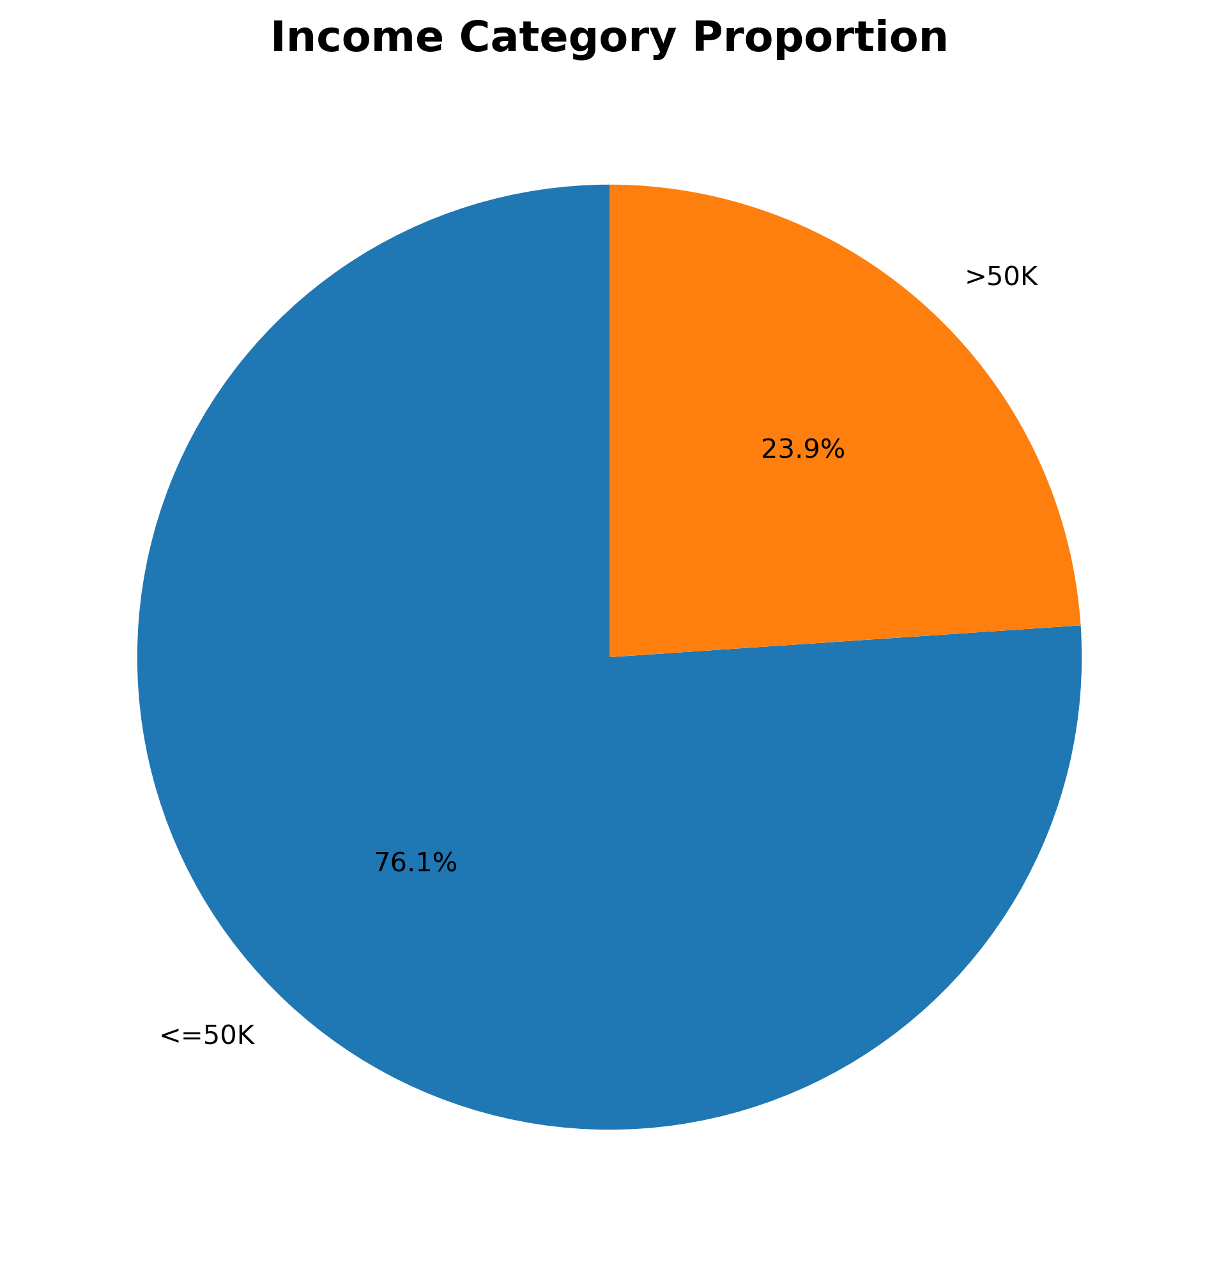

6. Education and Income
The table below summarizes the percentage of records above USD 50K for each education category.
Prof-school: 73.98% above USD 50K
Doctorate: 72.56% above USD 50K
Masters: 54.91% above USD 50K
Bachelors: 41.28% above USD 50K
Assoc-acdm: 25.80% above USD 50K
Assoc-voc: 25.33% above USD 50K
Some-college: 18.96% above USD 50K
HS-grad: 15.86% above USD 50K
12th: 7.31% above USD 50K
7th-8th: 6.49% above USD 50K
10th: 6.26% above USD 50K
9th: 5.42% above USD 50K
5th-6th: 5.30% above USD 50K
11th: 5.08% above USD 50K
1st-4th: 3.24% above USD 50K
Preschool: 1.20% above USD 50K
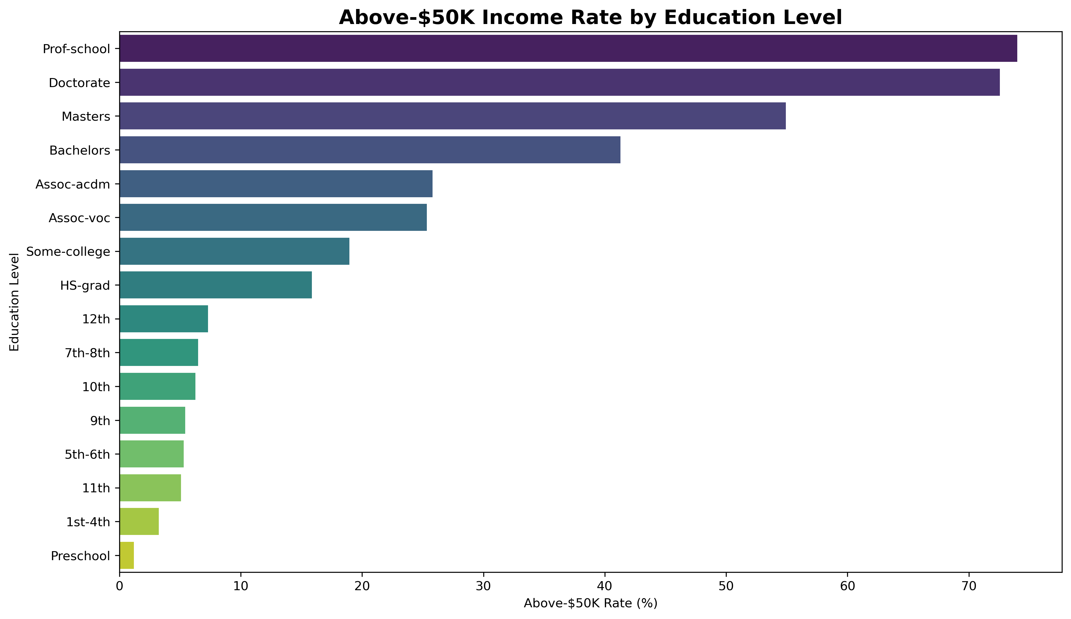

7. Age Group and Income
25-34: 16.82% above USD 50K
35-44: 33.29% above USD 50K
45-54: 39.39% above USD 50K
55-64: 32.16% above USD 50K
65+: 20.46% above USD 50K
<=24: 1.10% above USD 50K
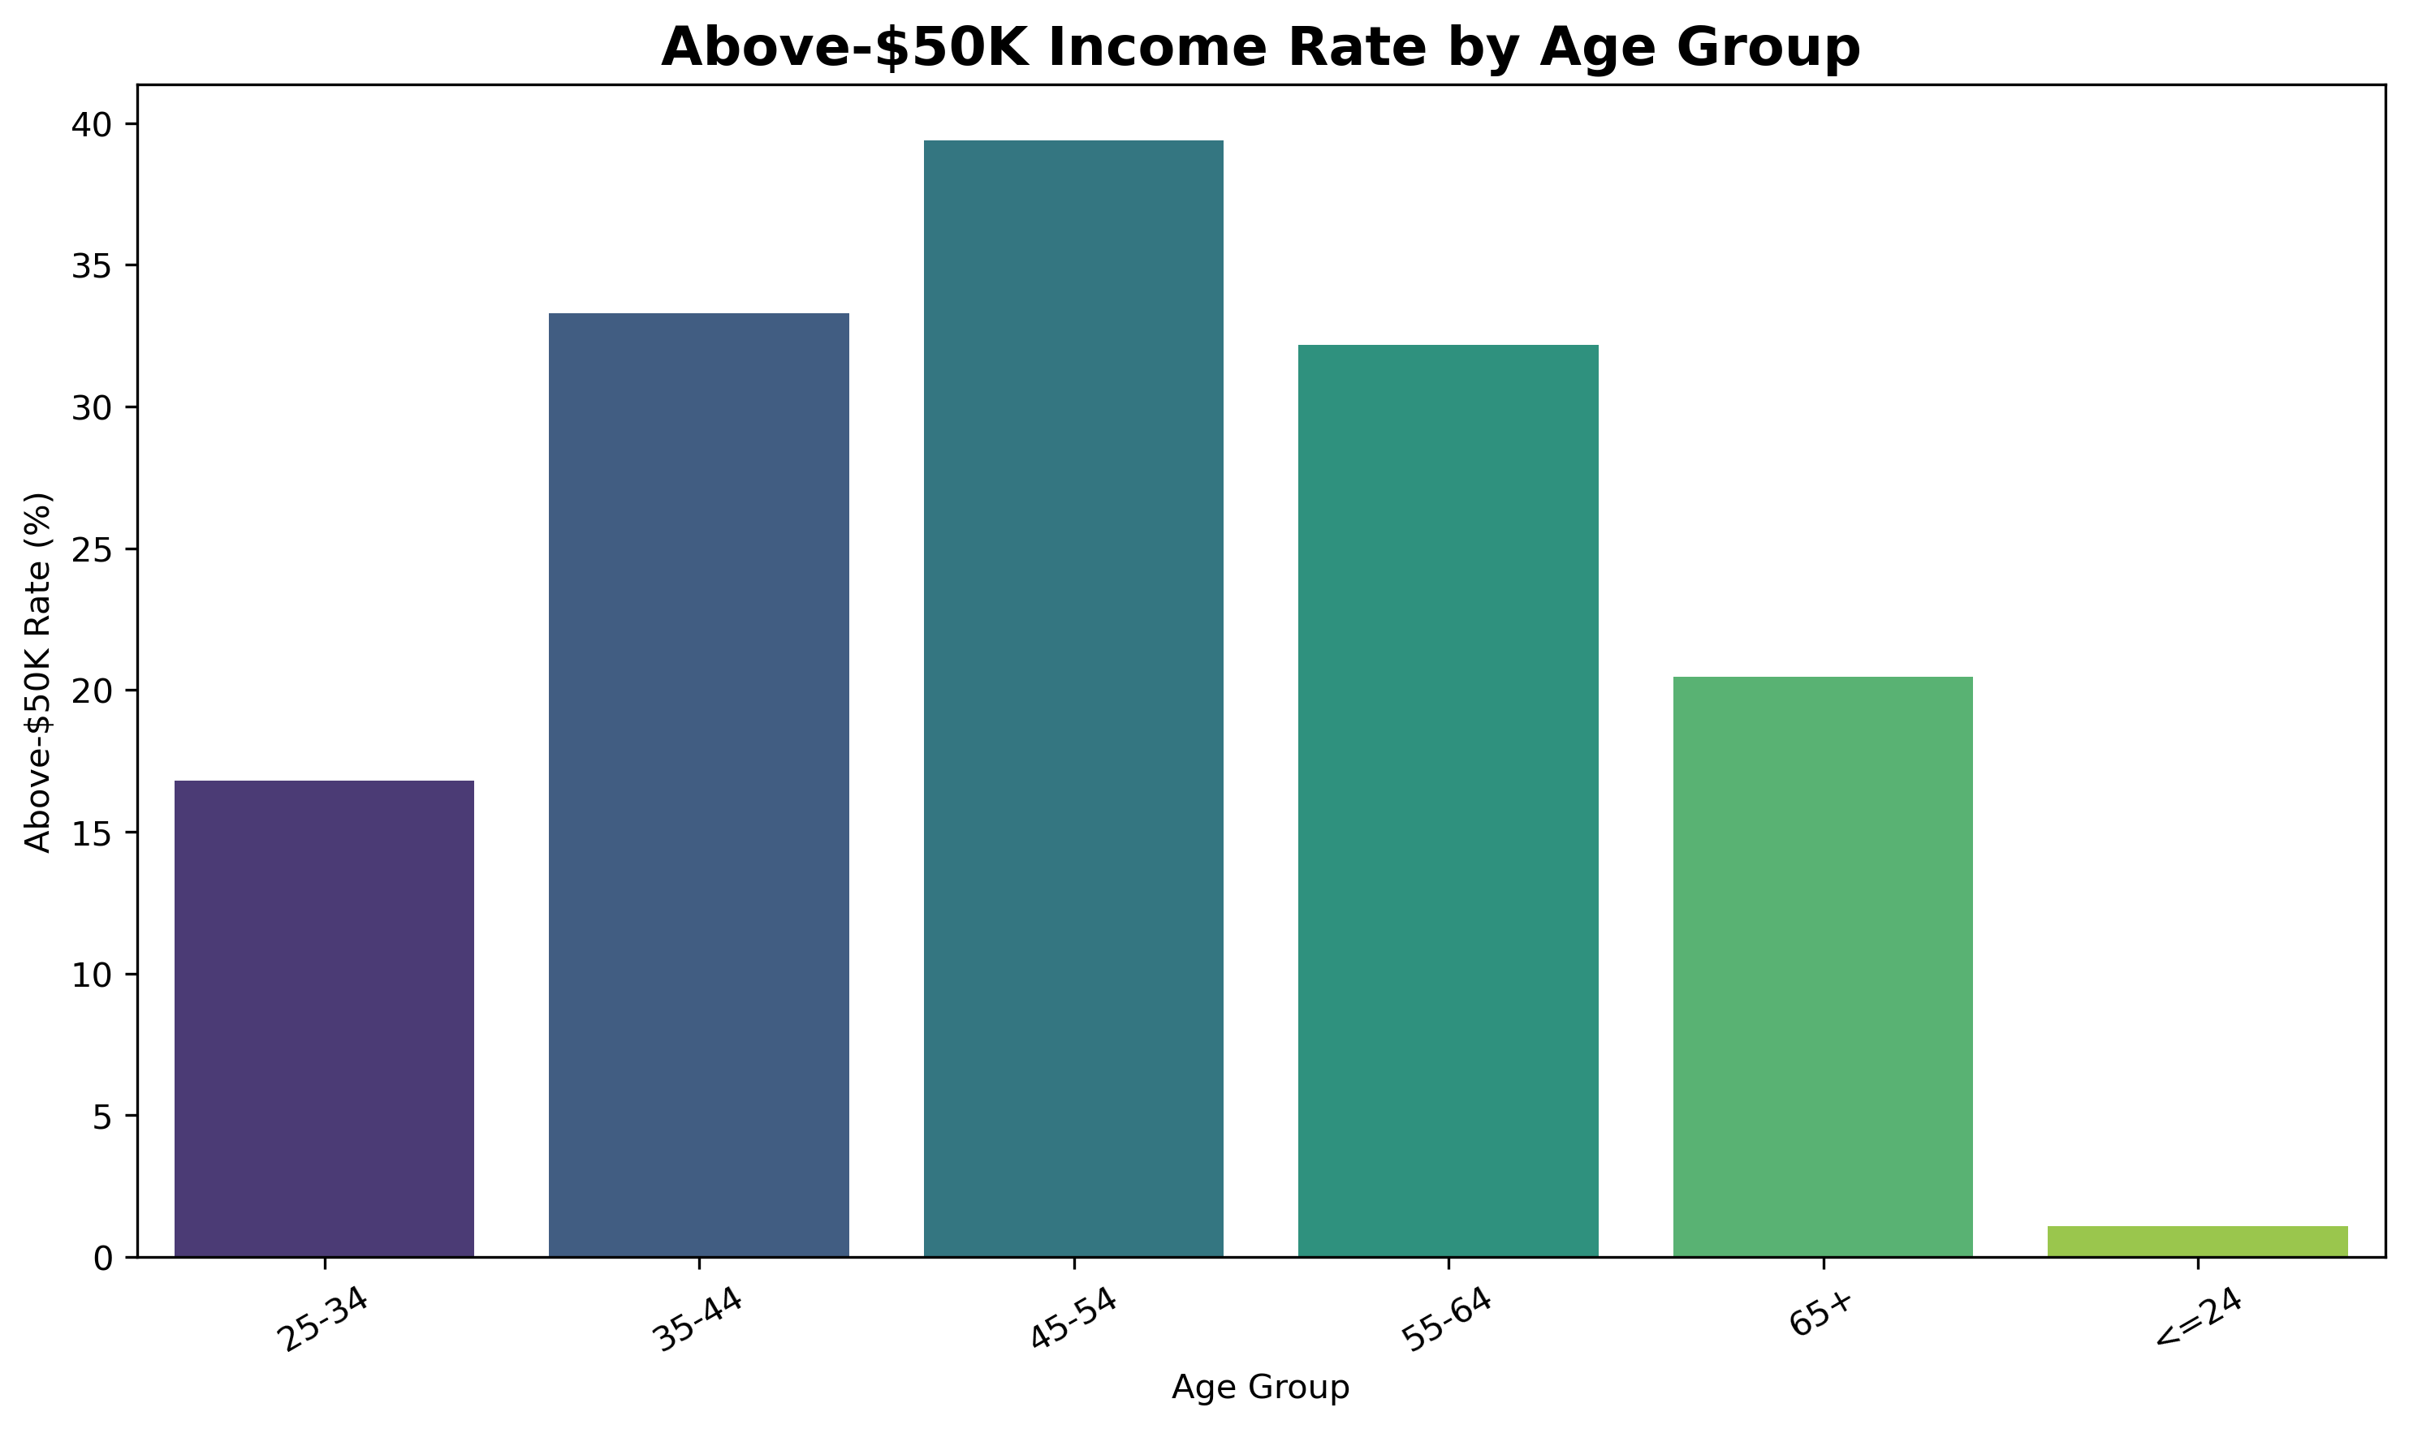

8. Employment Type and Income
Self-emp-inc: 55.34% above USD 50K
Federal-gov: 39.18% above USD 50K
Local-gov: 29.56% above USD 50K
Self-emp-not-inc: 27.89% above USD 50K
State-gov: 26.75% above USD 50K
Private: 21.79% above USD 50K
Without-pay: 9.52% above USD 50K
Unknown: 9.47% above USD 50K
Never-worked: 0.00% above USD 50K
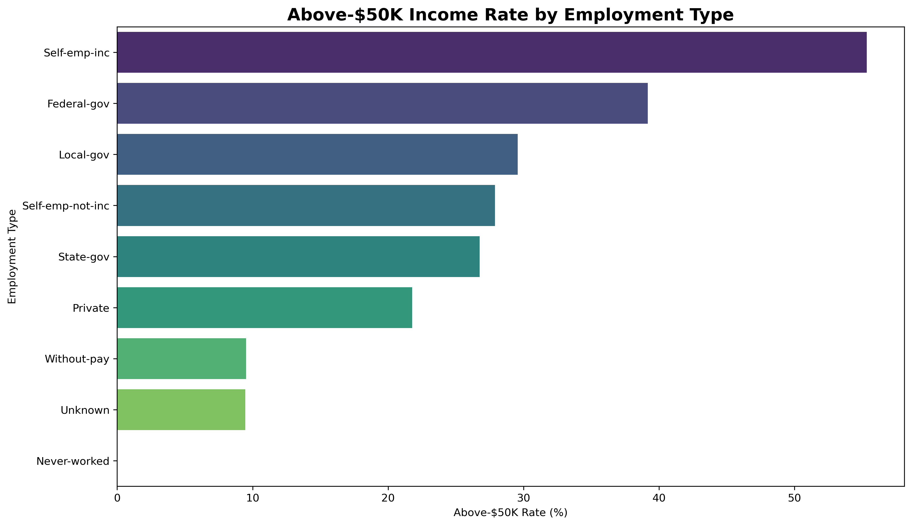

9. Occupation and Income
Exec-managerial: 47.78% above USD 50K
Prof-specialty: 45.11% above USD 50K
Armed-Forces: 33.33% above USD 50K
Protective-serv: 31.33% above USD 50K
Tech-support: 29.05% above USD 50K
Sales: 26.80% above USD 50K
Craft-repair: 22.63% above USD 50K
Transport-moving: 20.42% above USD 50K
Adm-clerical: 13.69% above USD 50K
Machine-op-inspct: 12.31% above USD 50K
Farming-fishing: 11.61% above USD 50K
Unknown: 9.43% above USD 50K
Handlers-cleaners: 6.66% above USD 50K
Other-service: 4.14% above USD 50K
Priv-house-serv: 1.24% above USD 50K
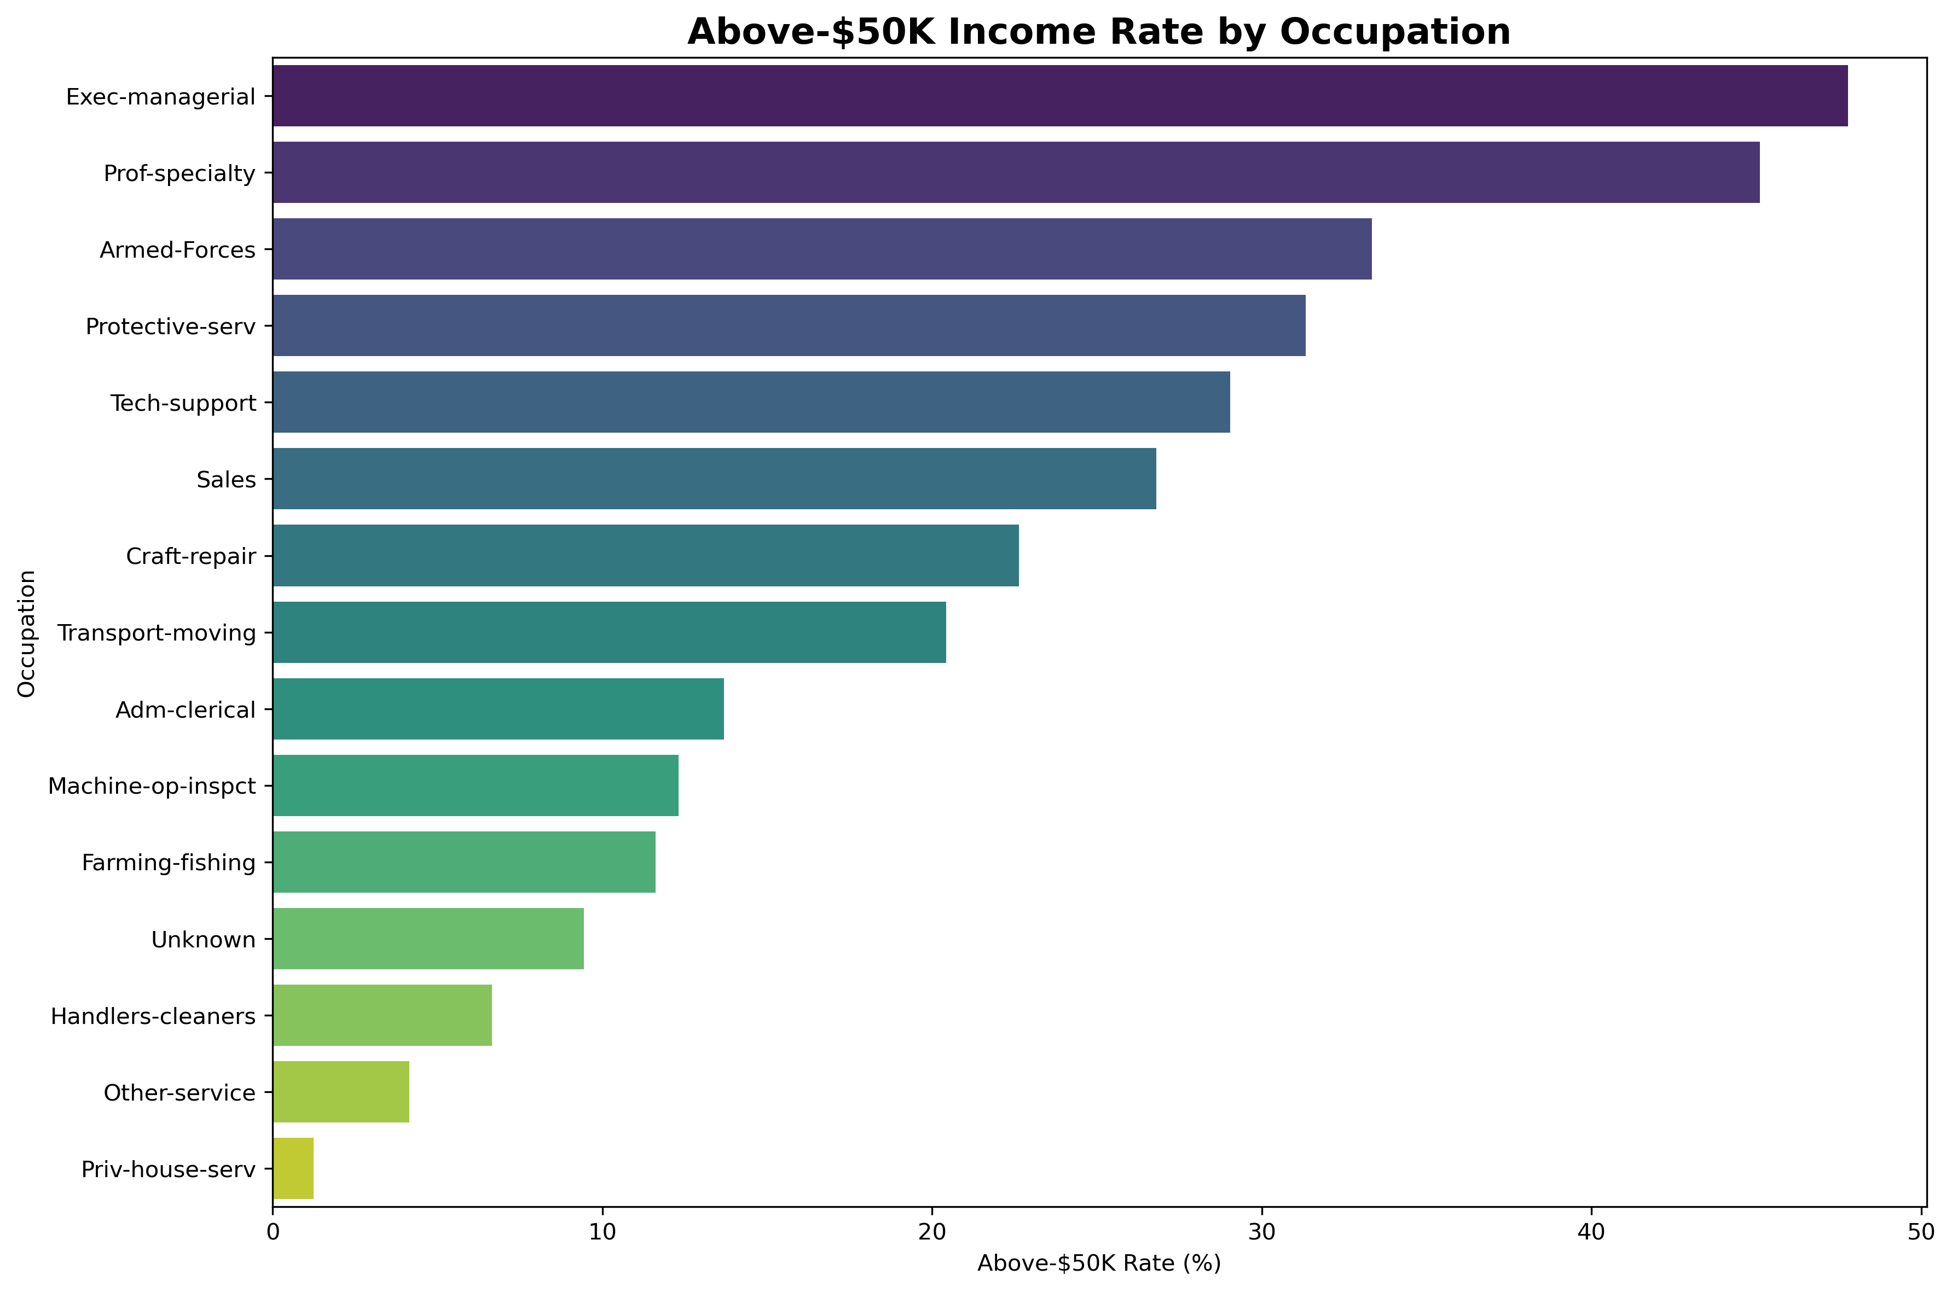

10. Sex and Income
Female: 10.93% above USD 50K
Male: 30.38% above USD 50K
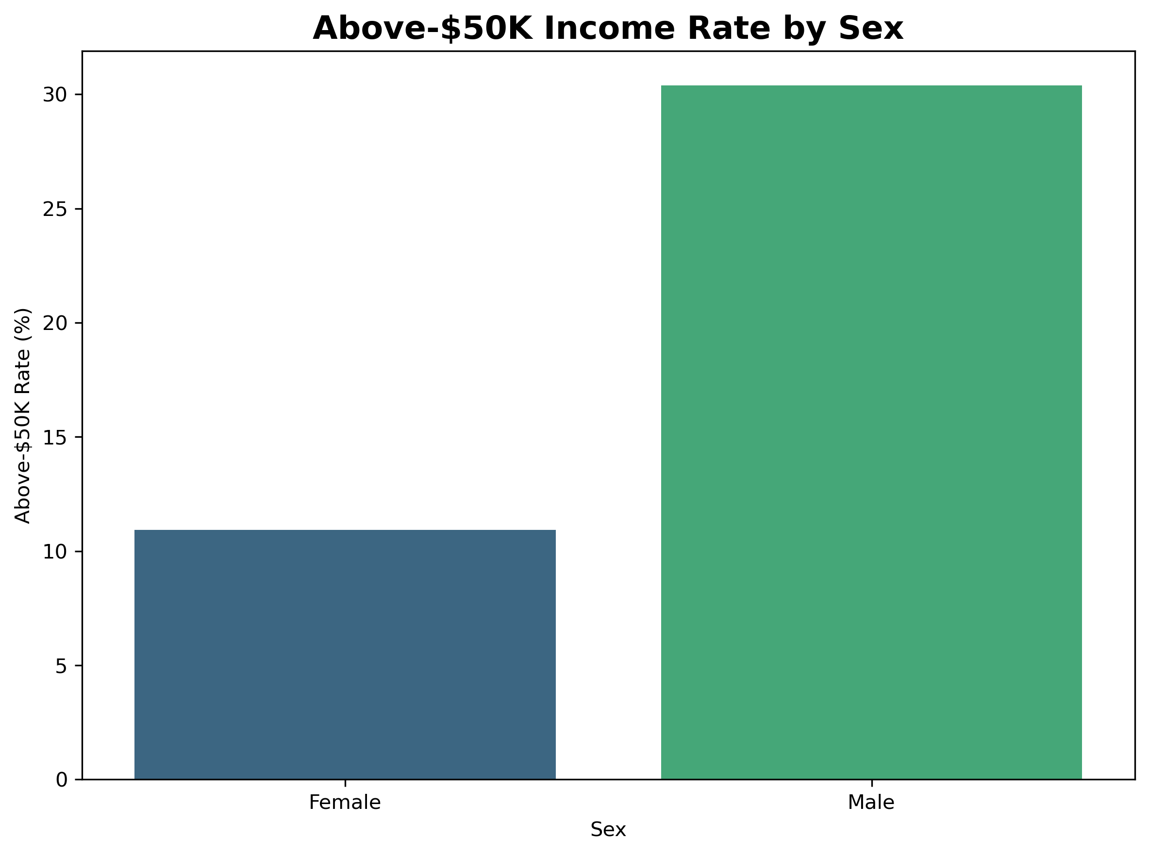

11. Weekly Working Hours and Income
21-34 hours: 7.08% above USD 50K
35-40 hours: 20.56% above USD 50K
41-49 hours: 34.64% above USD 50K
50-59 hours: 44.11% above USD 50K
60+ hours: 40.31% above USD 50K
<=20 hours: 6.76% above USD 50K
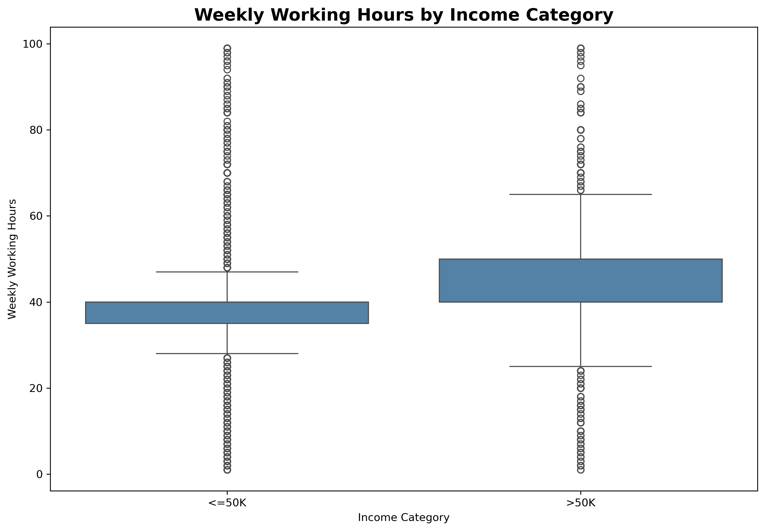

12. Numeric Relationships
A correlation matrix was examined for selected numerical variables. Correlation measures the strength of a linear association and does not establish causation.
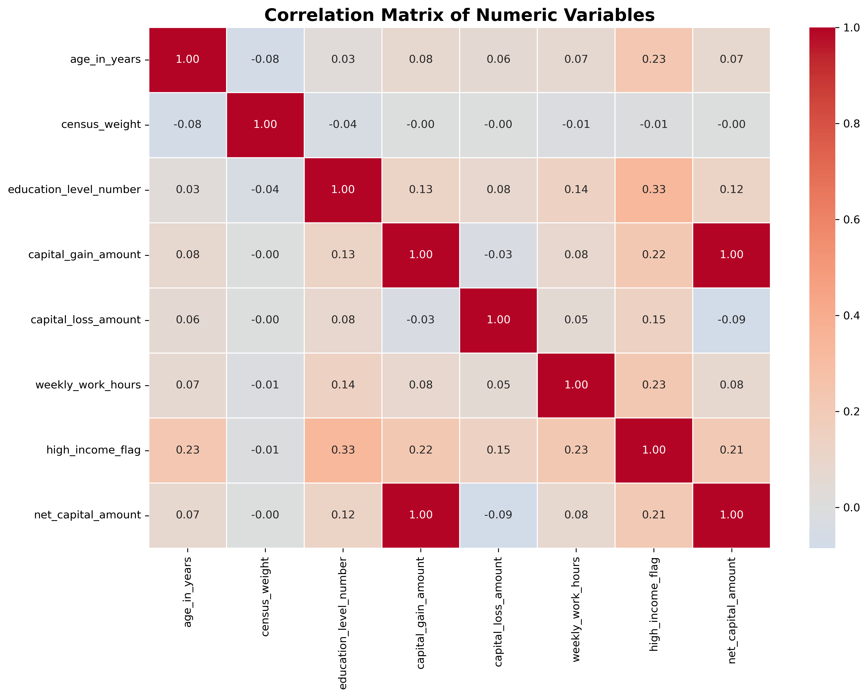

13. Limitations
- The dataset is historical and may not represent current income patterns.
- The analysis is observational and identifies associations rather than causation.
- The dataset contains demographic variables that require careful interpretation.
- The analysis uses descriptive summaries and does not establish predictive performance.
- The census weight variable is not used as a survey-weighted adjustment in the visual summaries.
- Missing categorical values are represented as Unknown rather than being deleted.

14. Conclusion
The exploratory analysis provides a descriptive view of how income categories vary across education, occupation, age groups, employment types, sex, and weekly working hours in the UCI Adult dataset. These patterns can be used as a foundation for further statistical analysis or predictive modeling.

