**NAYAN MUKHERJEE**

**CA_BOOTCAMP2020: TASK1**

Question01: What is Cache Memory?

Answer:

Cache Memory is a special very high-speed memory. It is used to speed up and synchronizing with high-speed CPU. Cache memory is costlier than the main memory or disk memory but economical than CPU registers. Cache memory is an extremely fast memory type that acts as a buffer between RAM and the CPU. It holds frequently requested data and instructions so that they are immediately available to the CPU when needed.

Cache memory is used to reduce the average time to access data from the Main memory. The cache is a smaller and faster memory which stores copies of the data from frequently used main memory locations. There are various different independent caches in a CPU, which store instructions and data.

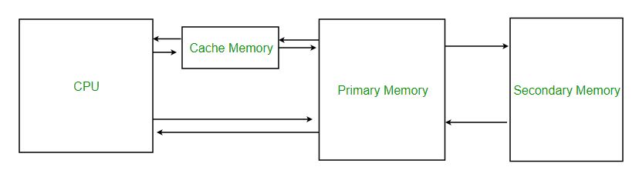

Question02: What is Disk Management?

Answer:

Disk management is a utility built into different operating systems that can be used to create, delete, format partitions, assign drive letters, and much more. Disk management can also be used to view partitions and their formatted file systems on the hard drive.

Question03: Cache vs RAM?

Answer:

## Key Differences: RAM vs Cache Memory

1. Definition - Cache is an element in the computer that collects data so that future requests for that data can be completed faster. RAM is a kind of computer data storage that stores data and computer code currently being used.

2. Speed - RAM is faster than secondary storage mediums, but it is not as fast as the cache.

3. Cost - Although RAM is expensive, it is not as valuable as a cache.

4. Capacity - The capacity of cache memory is smaller than RAM, which has a higher capacity.

5. Usage - The cache holds commonly used data by the CPU. RAM contains programs and data that are currently executed by the CPU.

Question04: HDD vs SSD?

Answer:

|  |  |
| --- | --- |
| Hard Disk Drive | Solid State Drive |
| More power draw, averages 6 – 7 watts and therefore uses more battery | Less power draw, averages 2 – 3 watts, resulting in 30+ minute battery boost |
| HDD use magnetic tapes to store and retrieve data | SSDs are a non-volatile storage solution that stores data persistently |
| Maximum storage capacity is 2 TB for notebook and 10 TB fr desktop computers | Not more than 1TB for notebooks and 4 TB for desktop computers |
| It produces more heat due to the mechanical parts | It produces little or no heat as there is no moving part involved |
| Only around $0.03 per gigabyte, very cheap (buying a 4TB model) | Expensive, roughly $0.20 per gigabyte (based on buying a 1TB drive) |
| HDDs are slower than SSD | IT is up to 30% faster than HDD |
| Less durable than SSD and less lifespan | More durable than HDD with a longer lifespan |