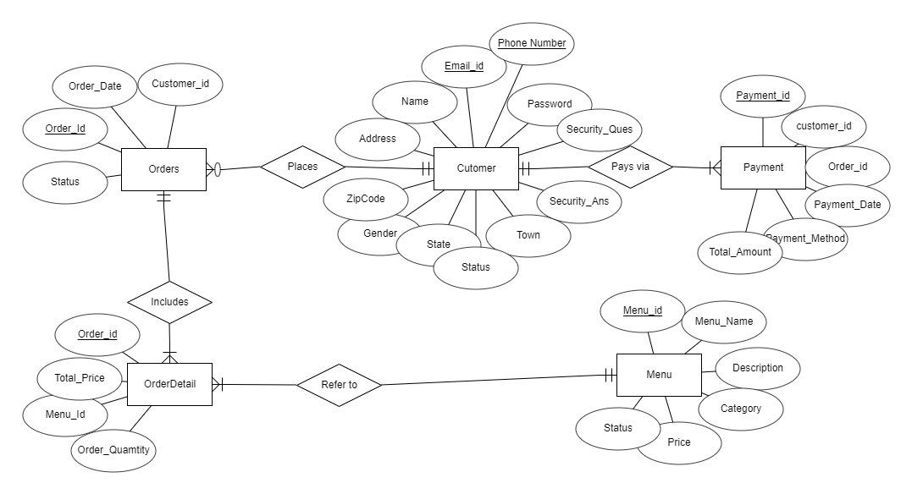

This is a demo ER diagram of how the database for food ordering system might look like.