1. Develop nodejs application with following requirements:
- Develop a route "/gethello" with GET method. It displays "Hello NodeJS!!" as response.
- Make an HTML page and display.
- Call "/gethello" route from HTML page using AJAX call. (Any frontend AJAX call API can be used.)
Output :-
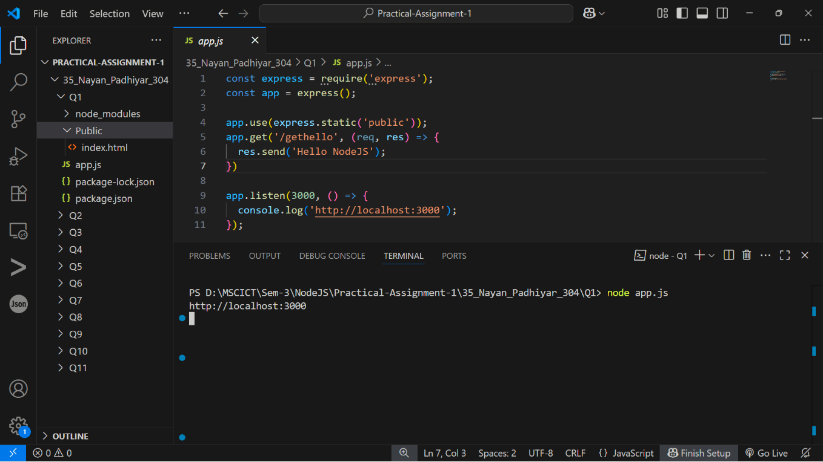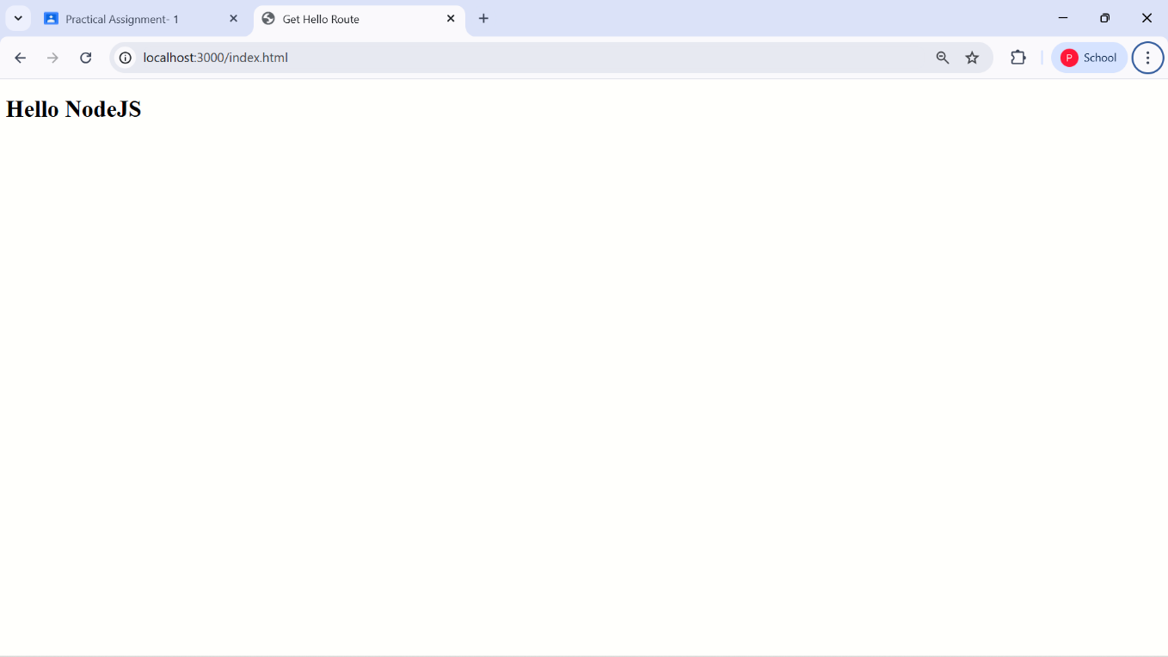

2. Develop a web server which serves static resources.
Output :-
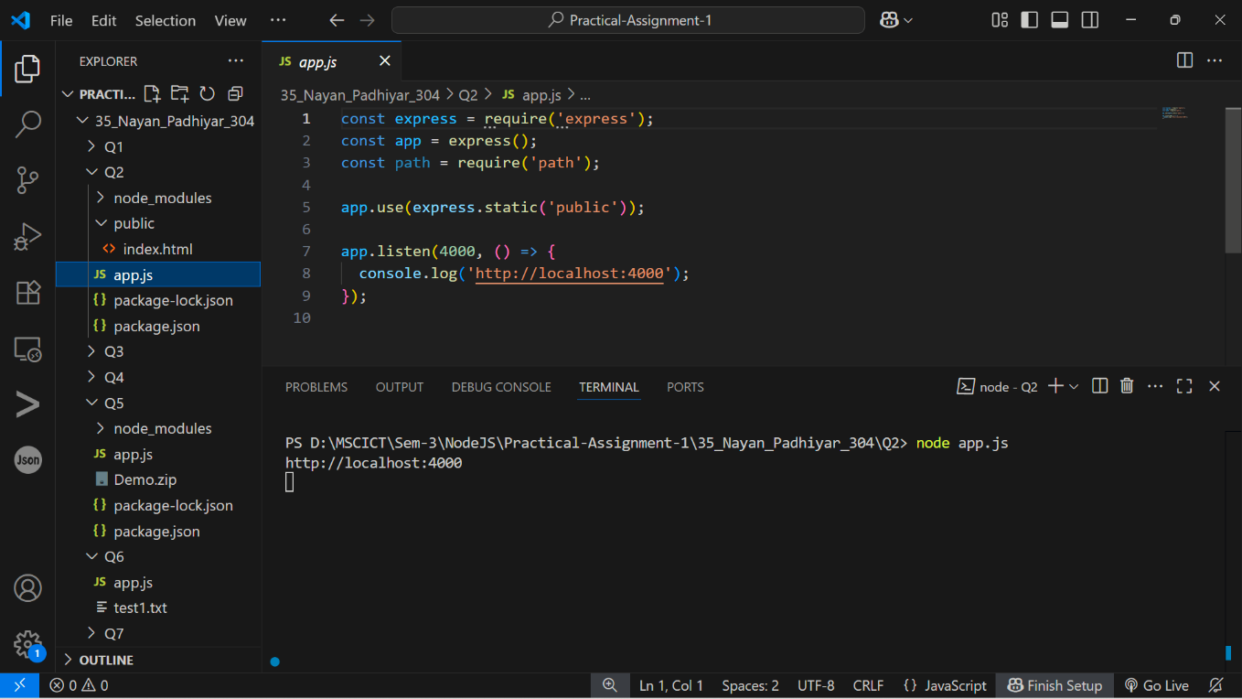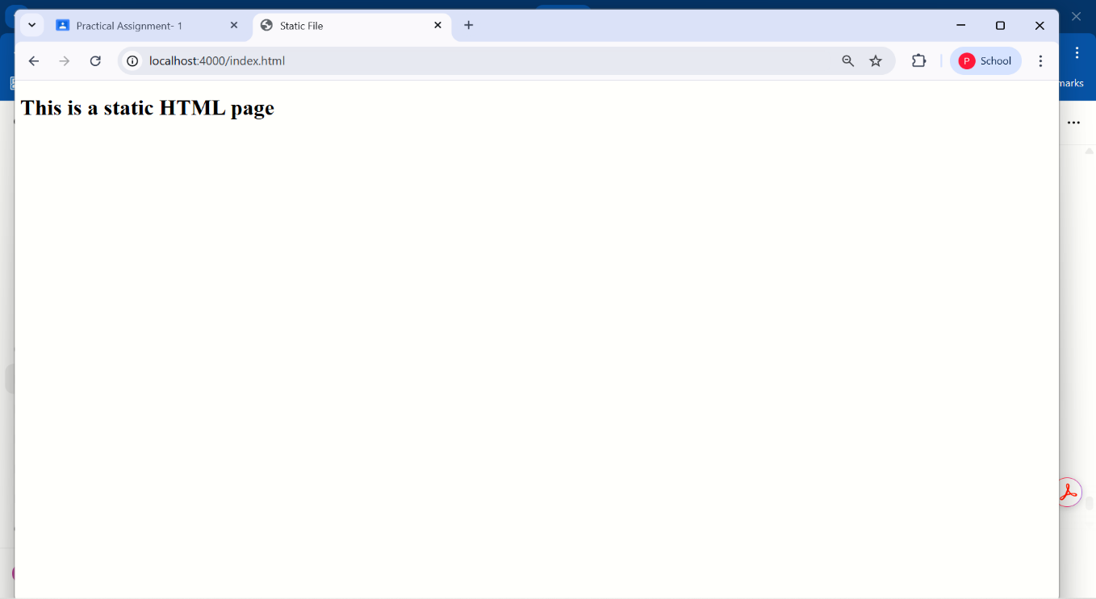
3. Develop a module for domain specific chatbot and use it in a command line application.
Output :-
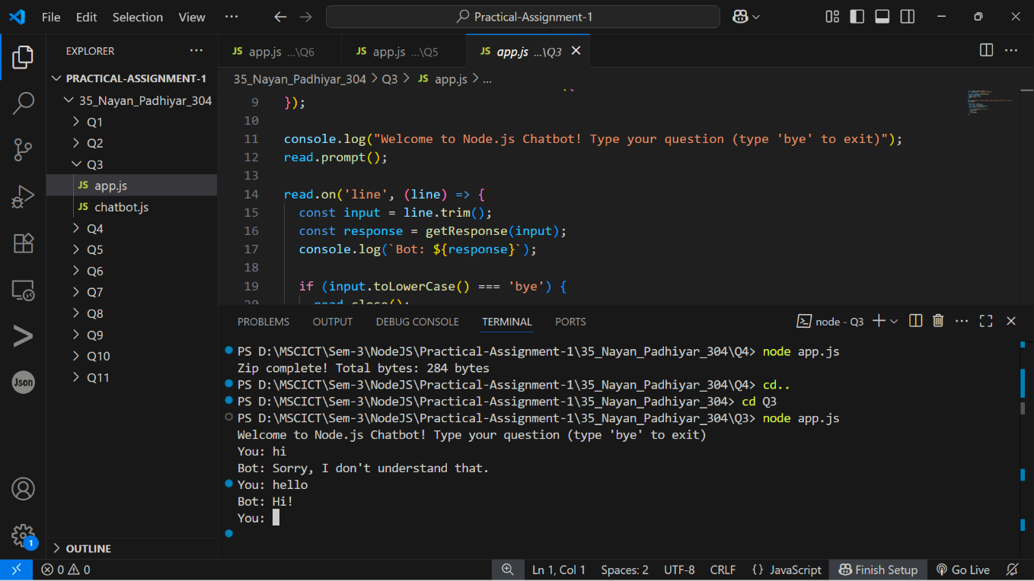

4. Write a program to create a compressed zip file for a folder.
Output :-
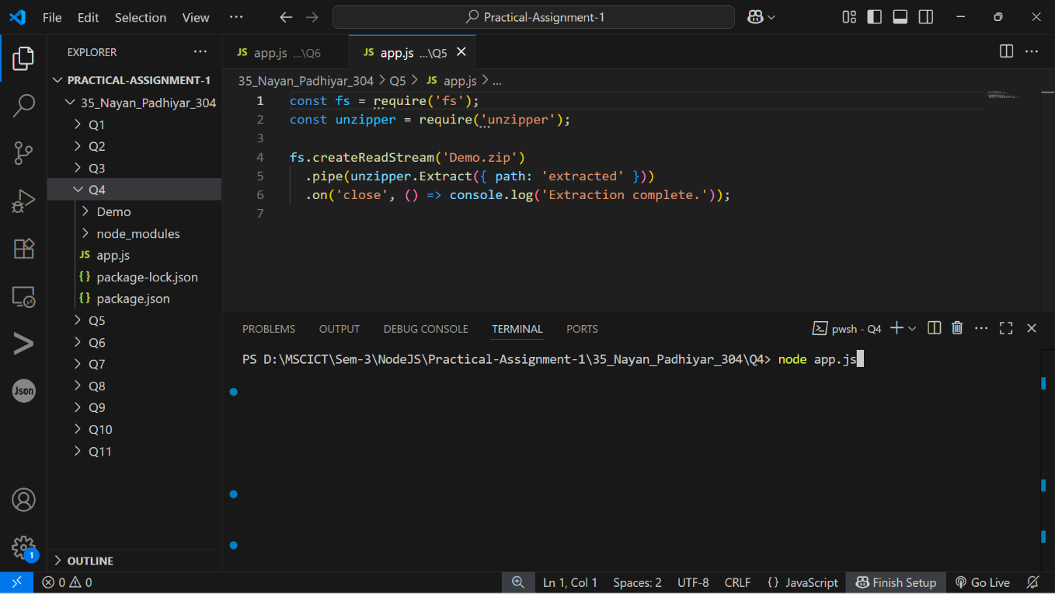

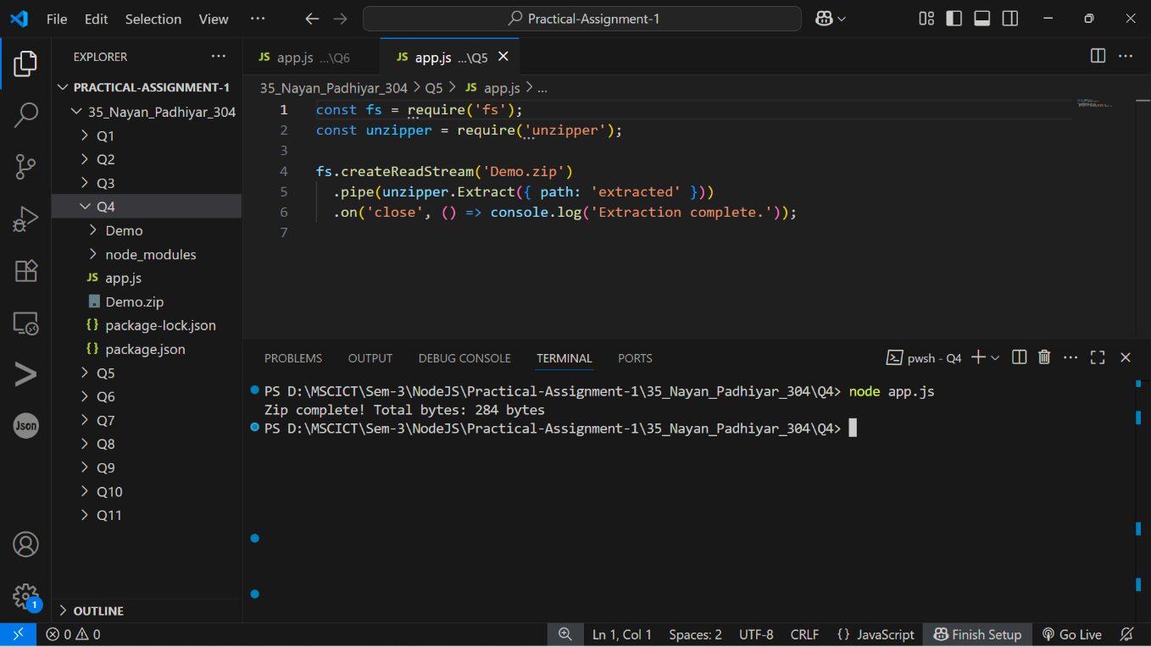

5. Write a program to extract a zip file.
Output :-
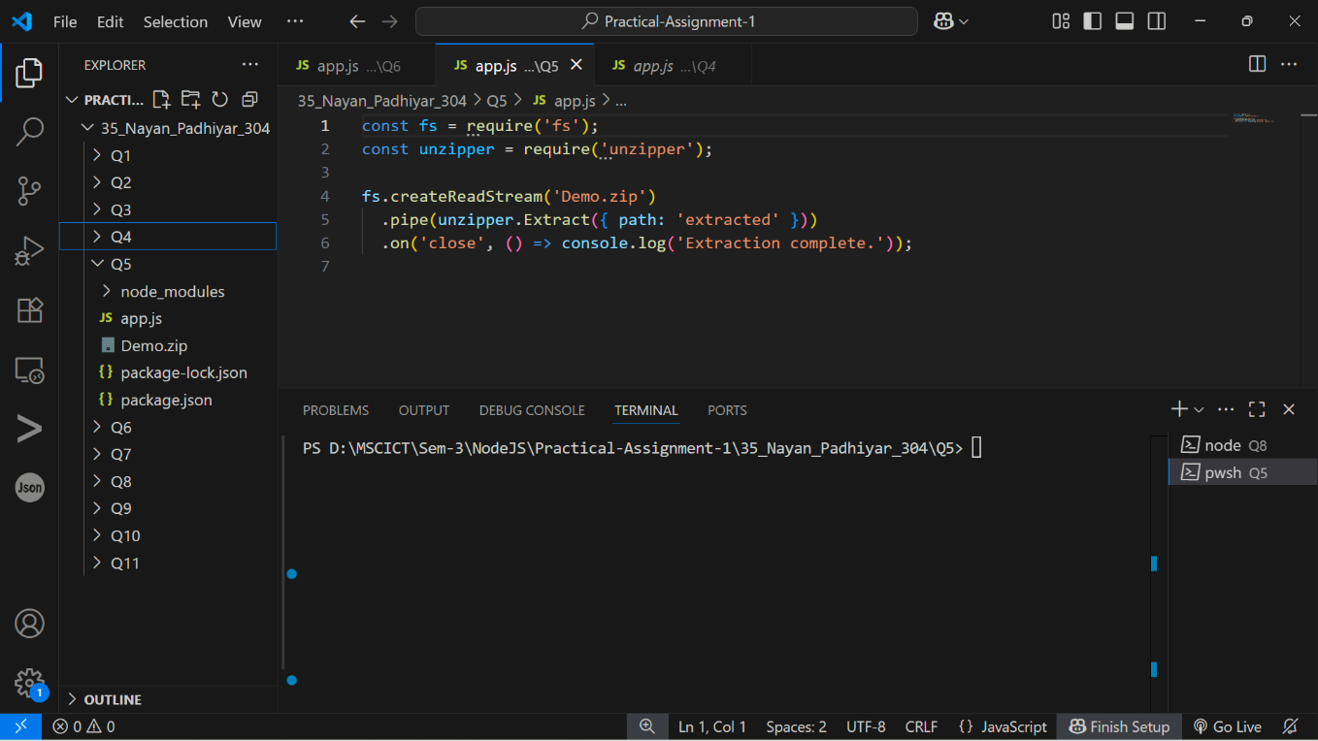

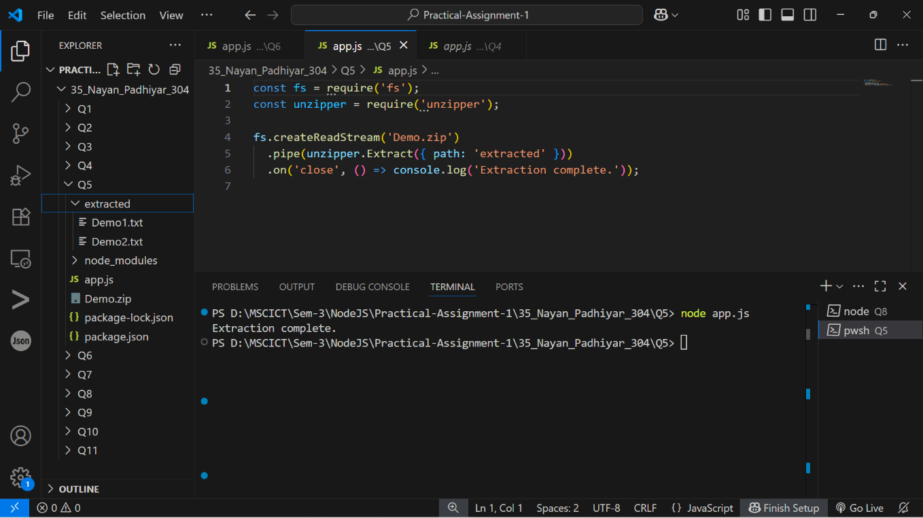

6. Write a program to promisify fs.unlink function and call it.
Output :-
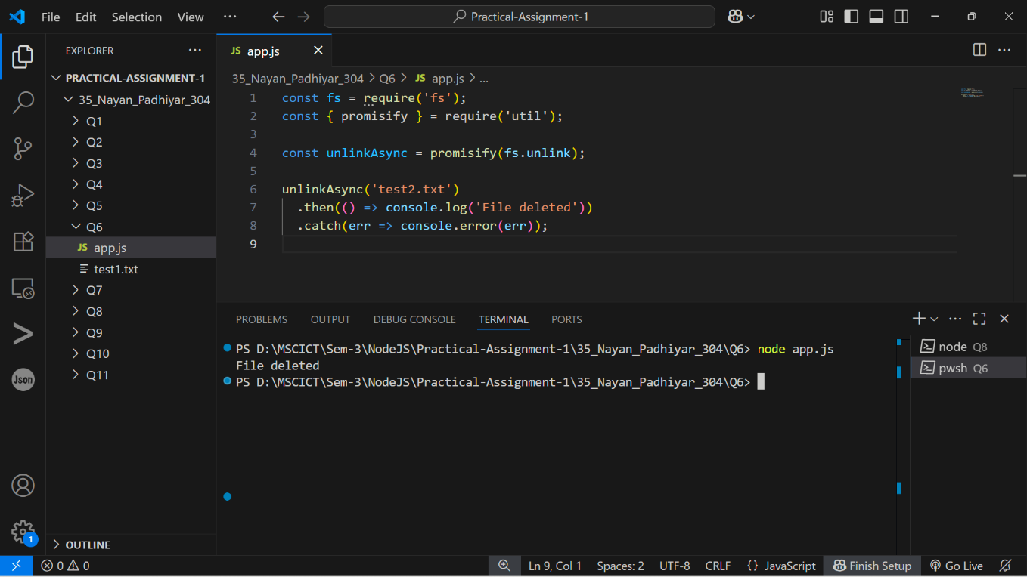

7. Fetch data of google page using note-fetch using async-await model.
Output :-
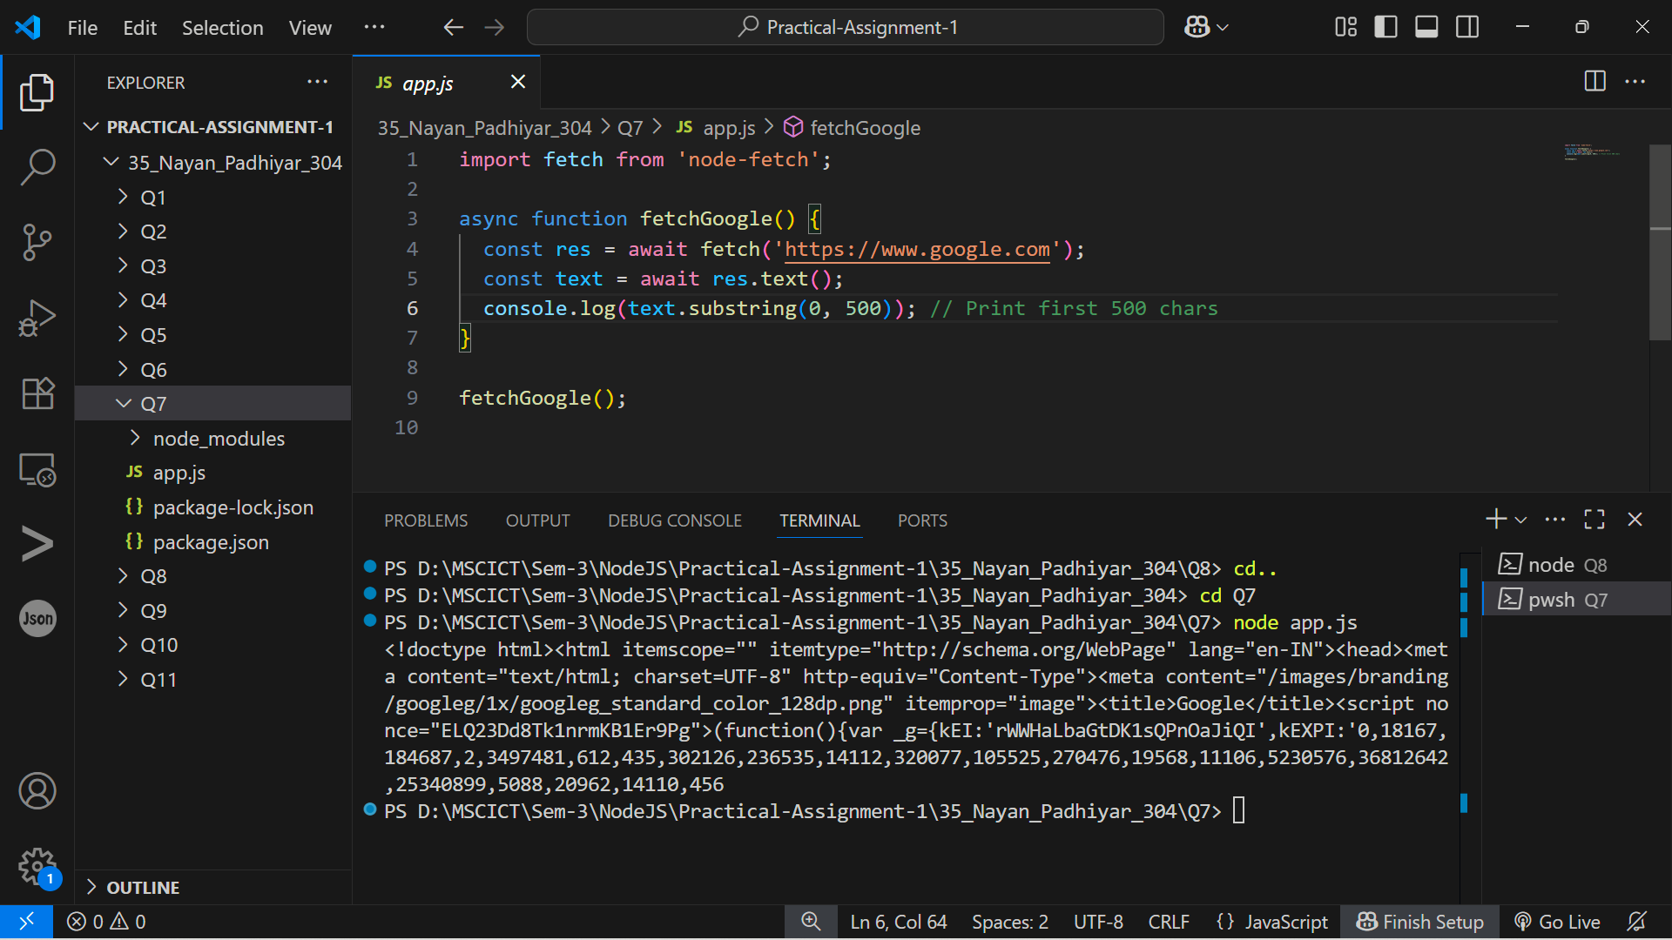

8. Set a server script, a test script and 3 user defined scripts in package.json file in your nodejs
application.
Output :-
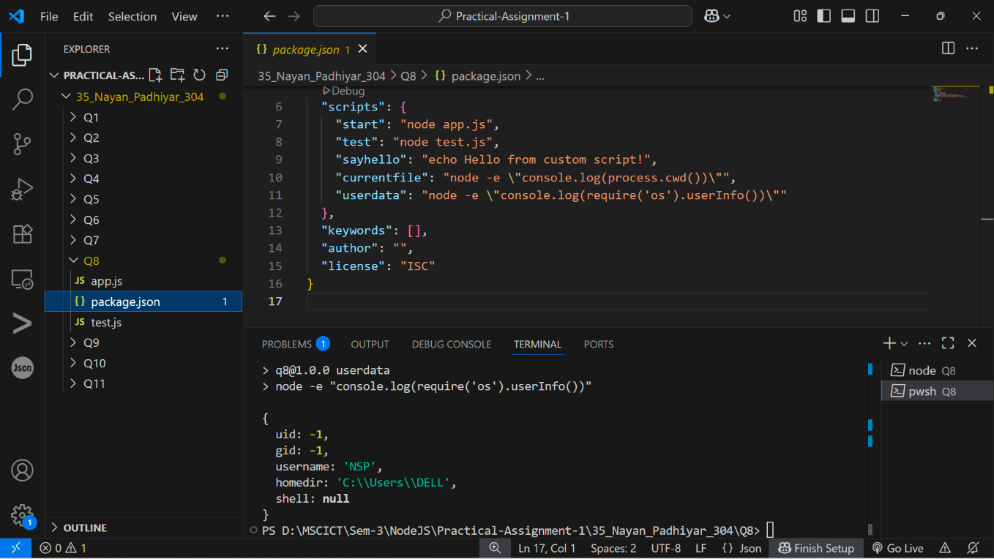

9. A program which calls useful functions in fs modile.
Output :-
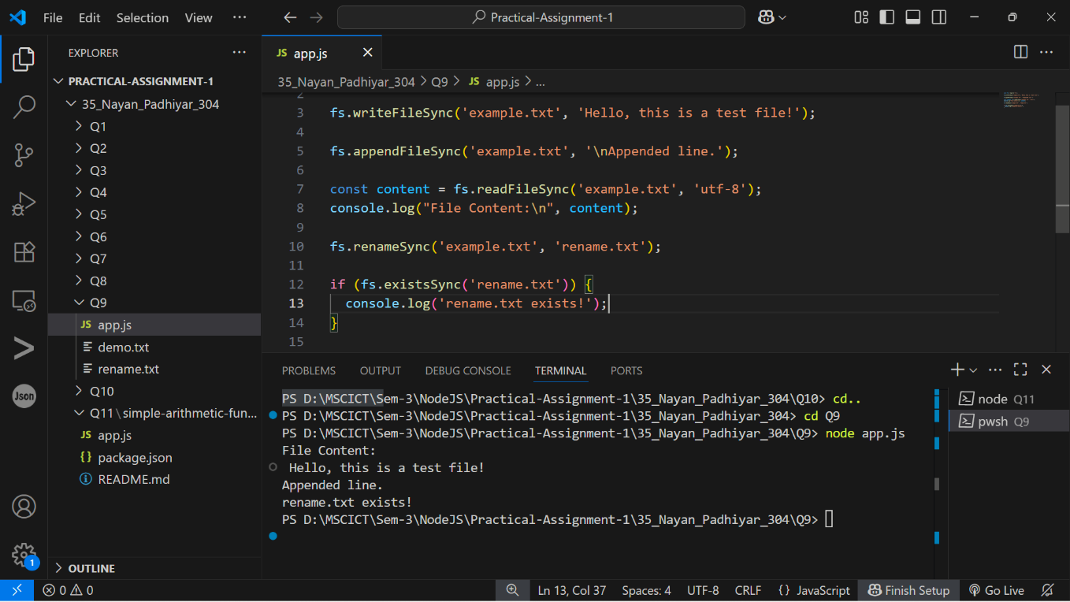

10. A program which uses global objects in nodejs.
Output :-
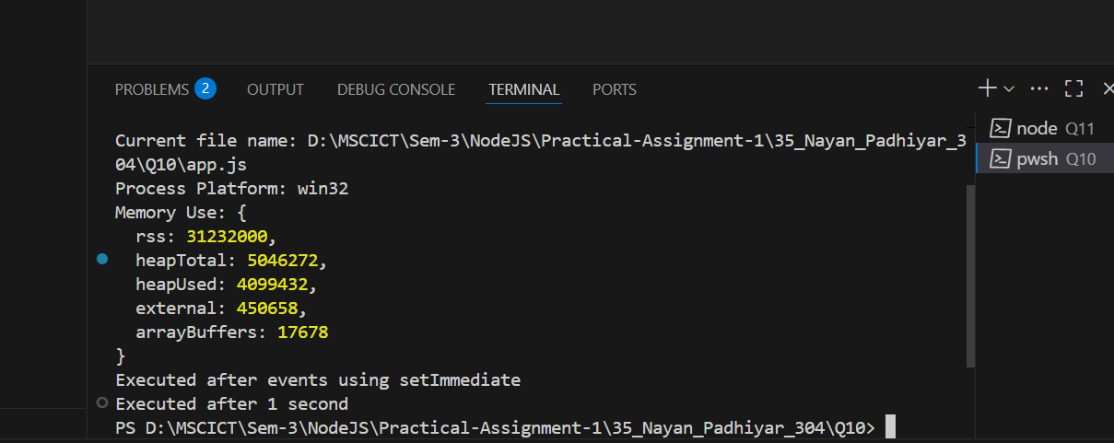

11. Develop a useful package and publish it on npmjs.com
Output :-
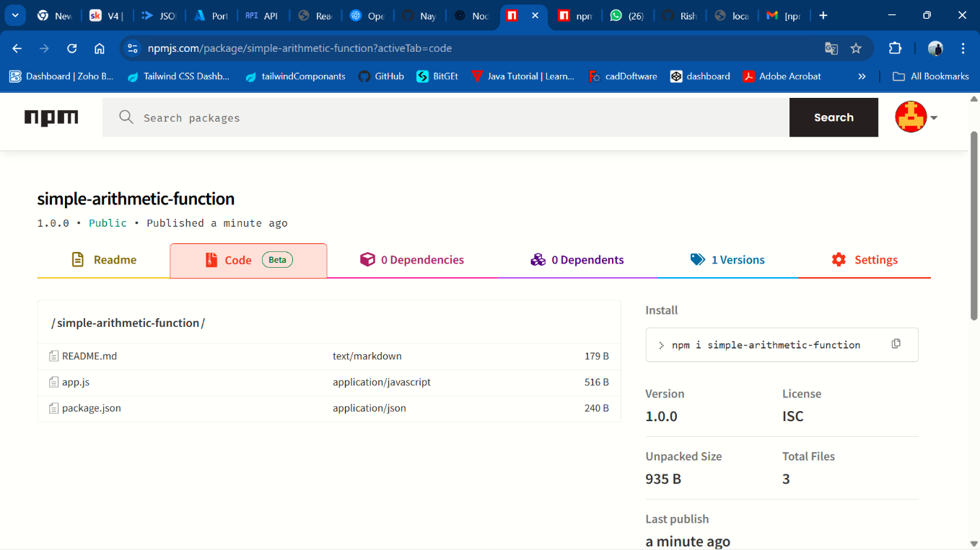

[GitHub Link: https://github.com/Nayan8319/OSWD/tree/main/35_Nayan_Padhiyar_304_A1 ]

