1. Develop nodejs application with following requirements:

* Develop a route "/gethello" with GET method. It displays "Hello NodeJS!!" as response.
* Make an HTML page and display.
* Call "/gethello" route from HTML page using AJAX call. (Any frontend AJAX call API can be used.)

Output :-

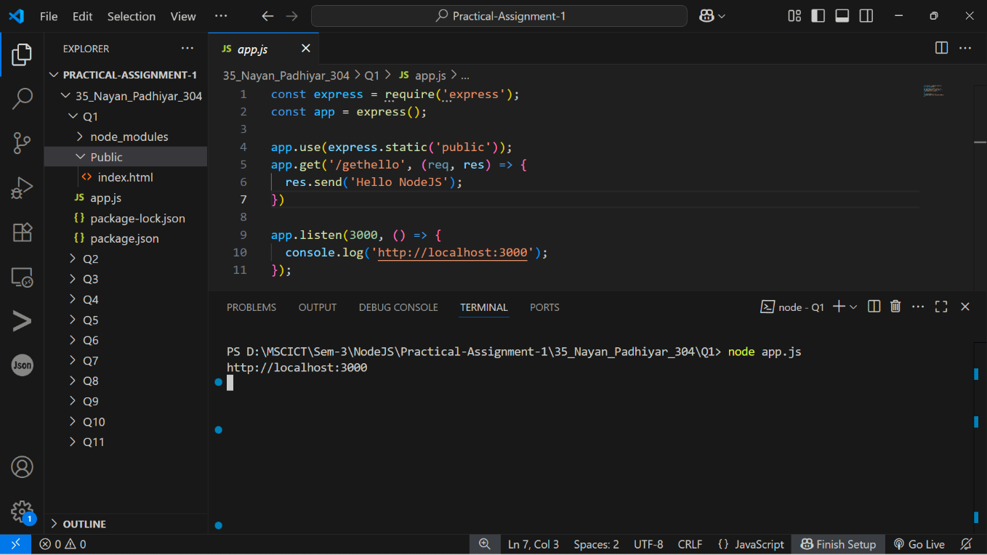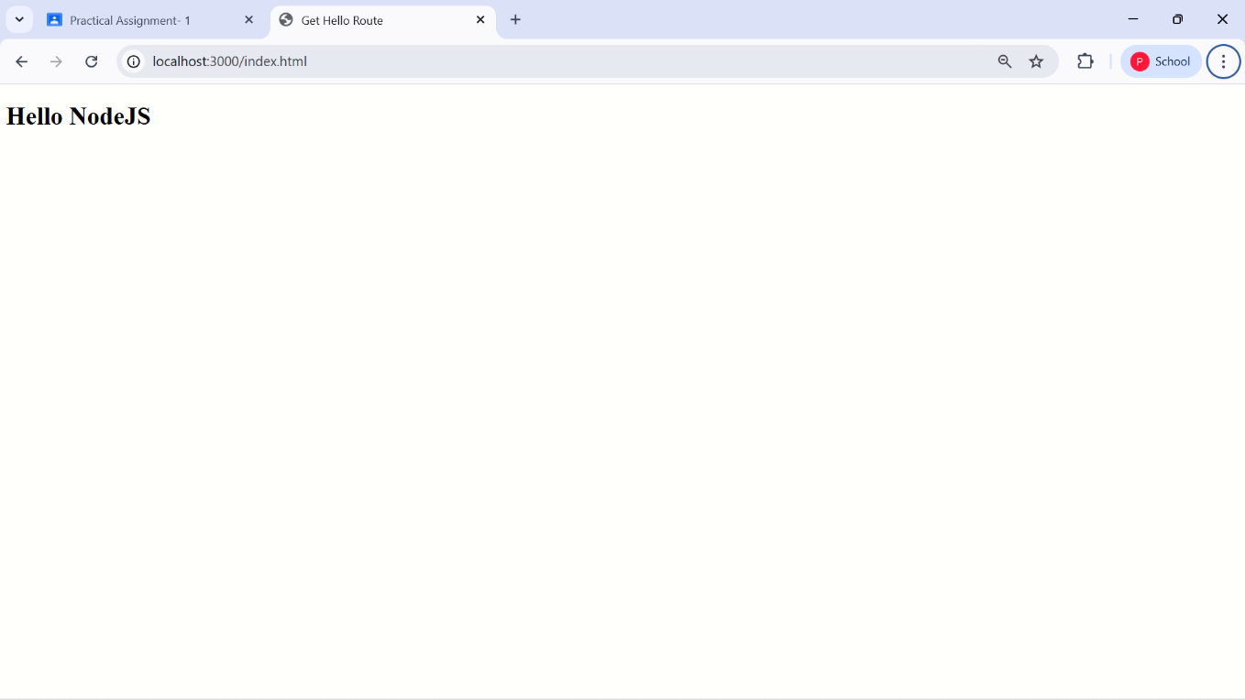

2. Develop a web server which serves static resources.  
Output :-

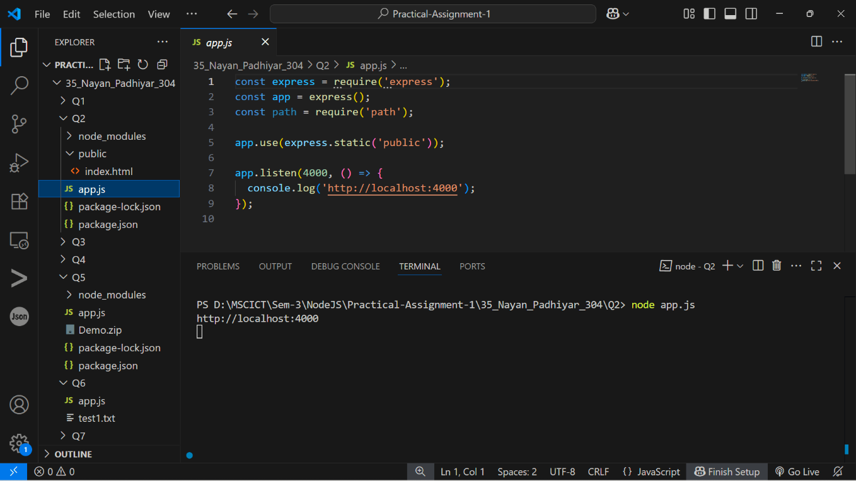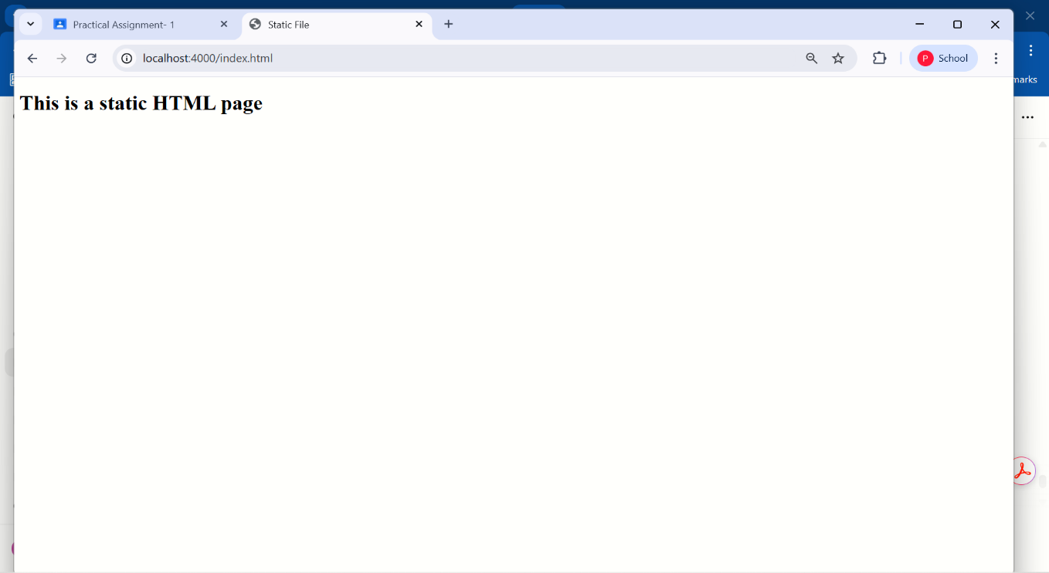

3. Develop a module for domain specific chatbot and use it in a command line application.  
Output :-

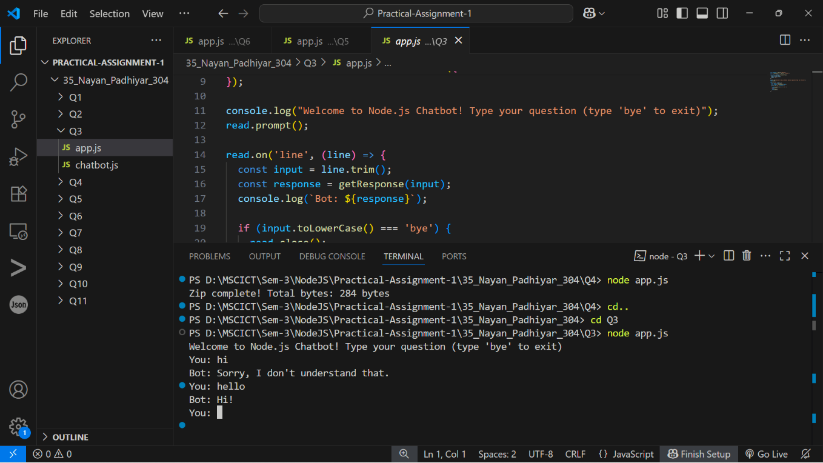

4. Write a program to create a compressed zip file for a folder.  
Output :-

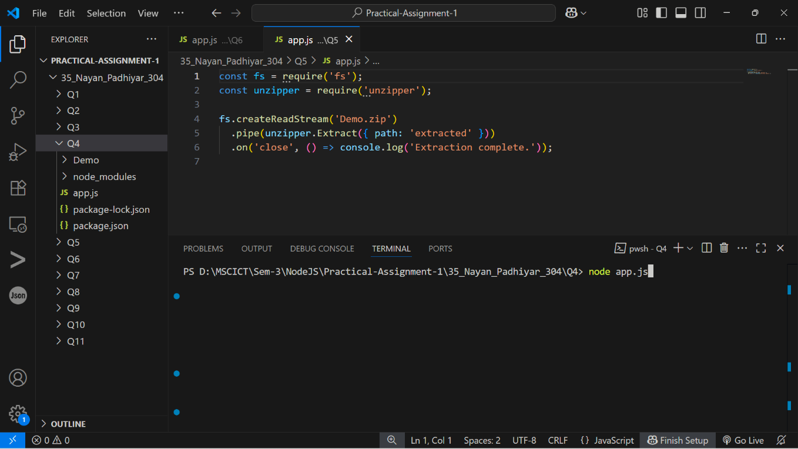

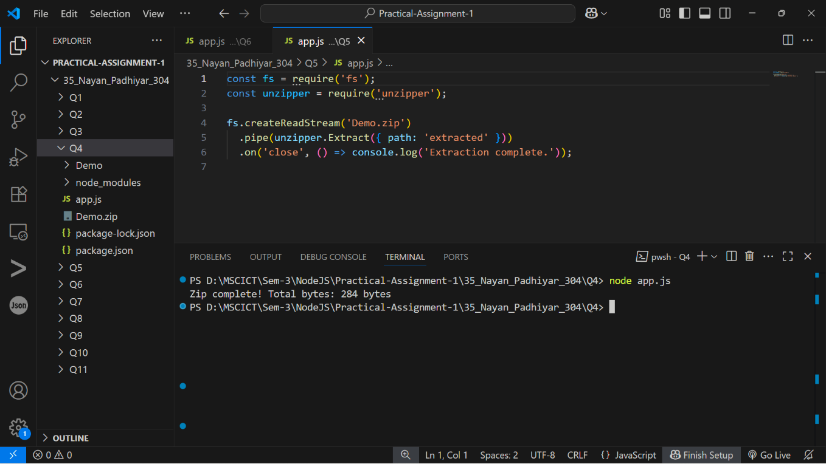

5. Write a program to extract a zip file.  
Output :-

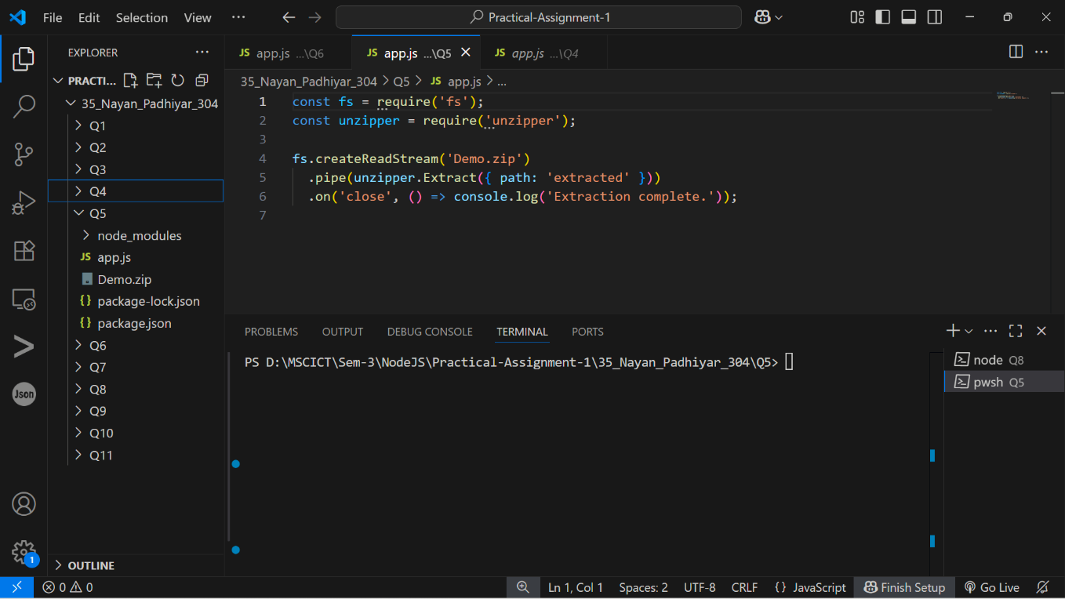

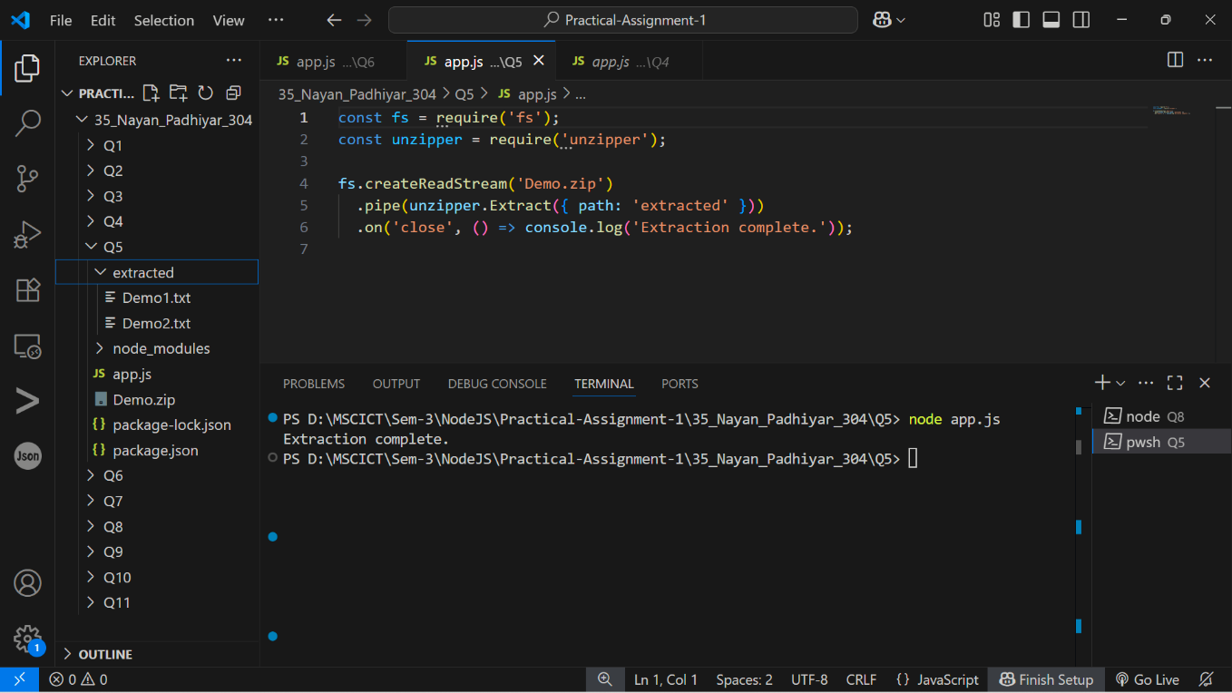

6. Write a program to promisify fs.unlink function and call it.  
Output :-

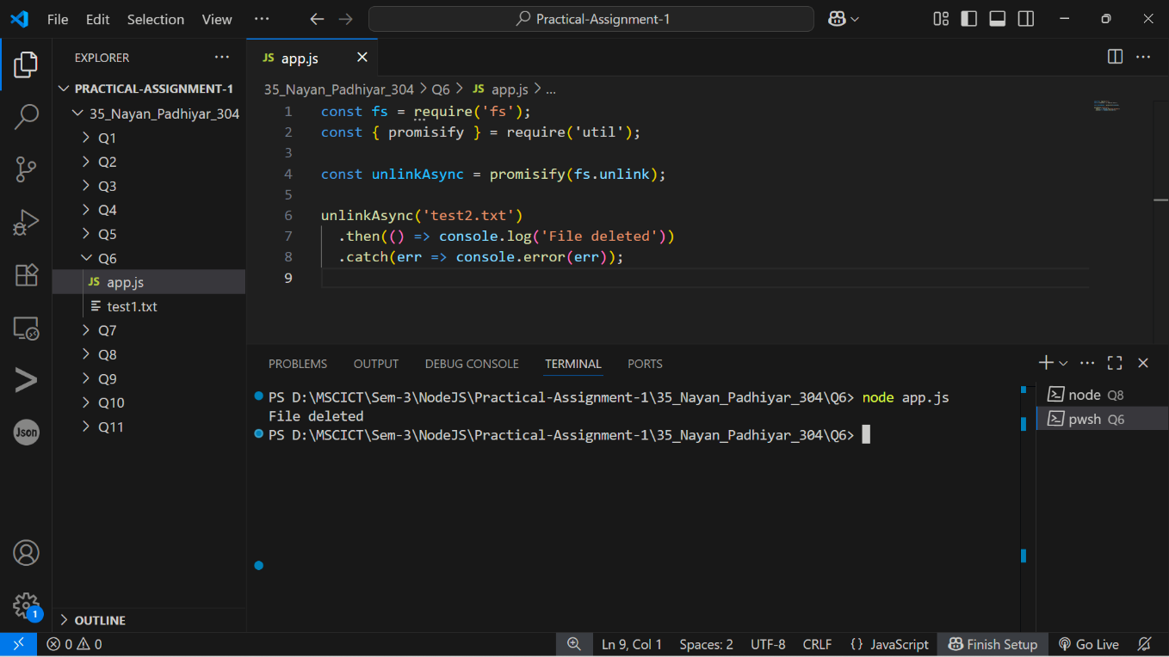

7. Fetch data of google page using note-fetch using async-await model.  
Output :-

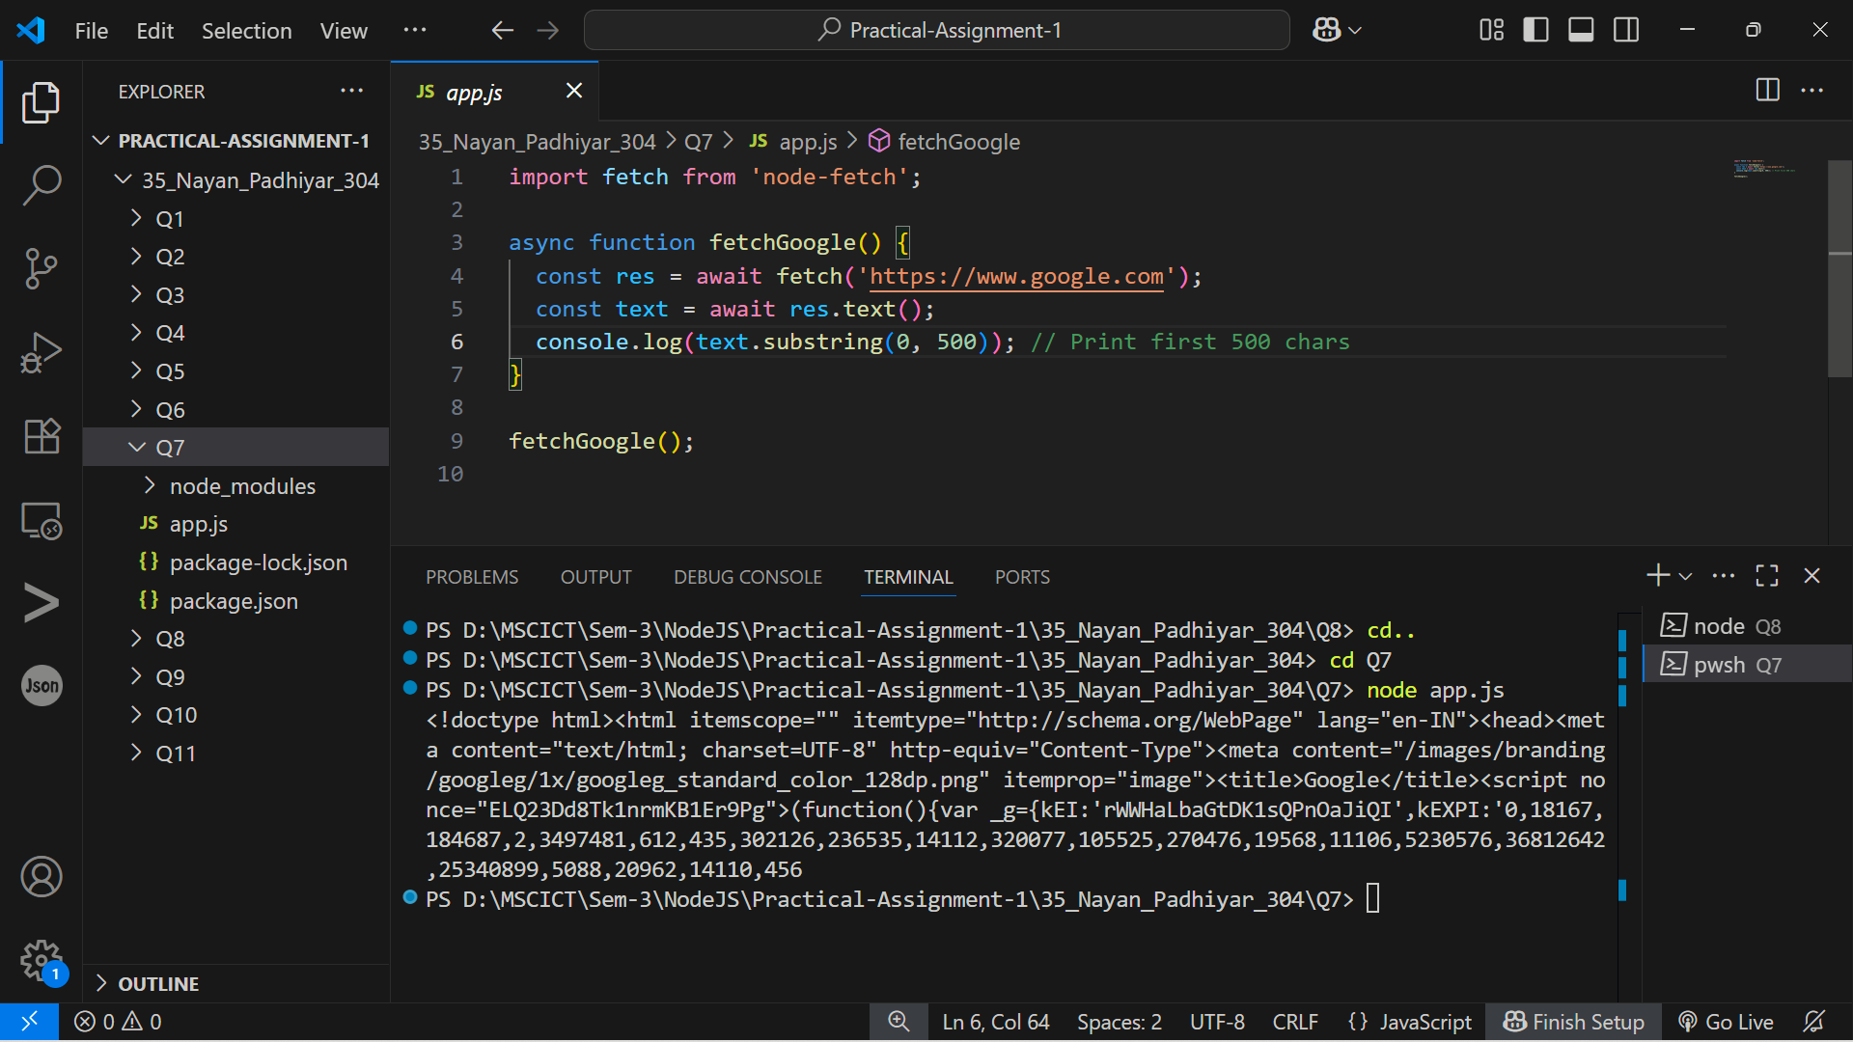

8. Set a server script, a test script and 3 user defined scripts in package.json file in your nodejs  
application.  
Output :-

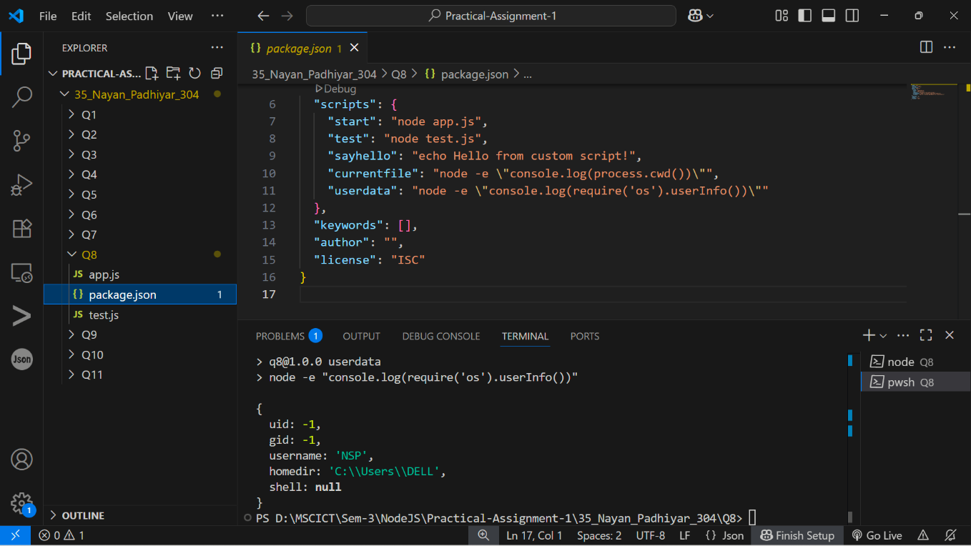

9. A program which calls useful functions in fs modile.  
Output :-

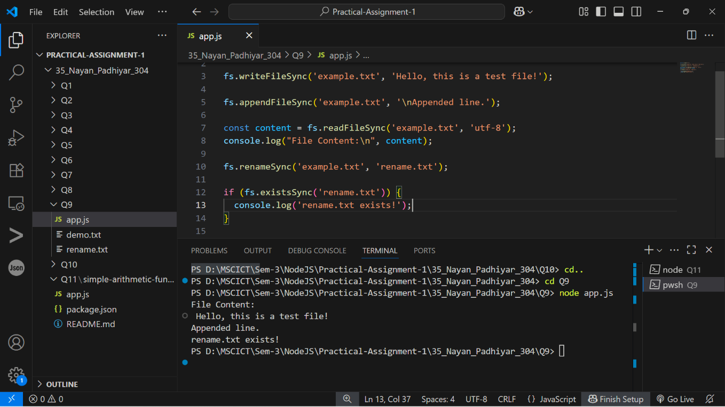

10. A program which uses global objects in nodejs.  
Output :-

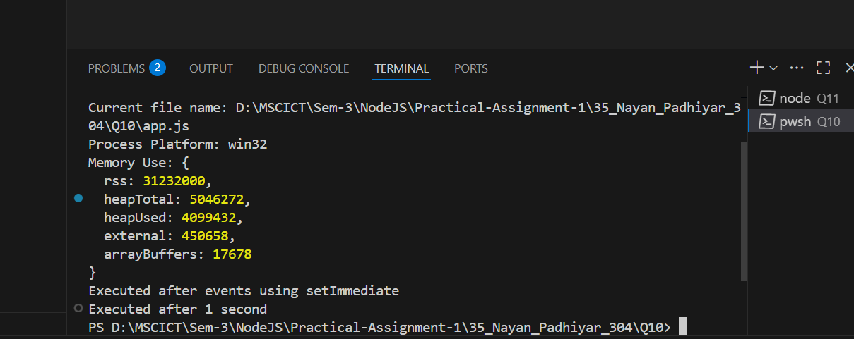

11. Develop a useful package and publish it on npmjs.com

Output :-

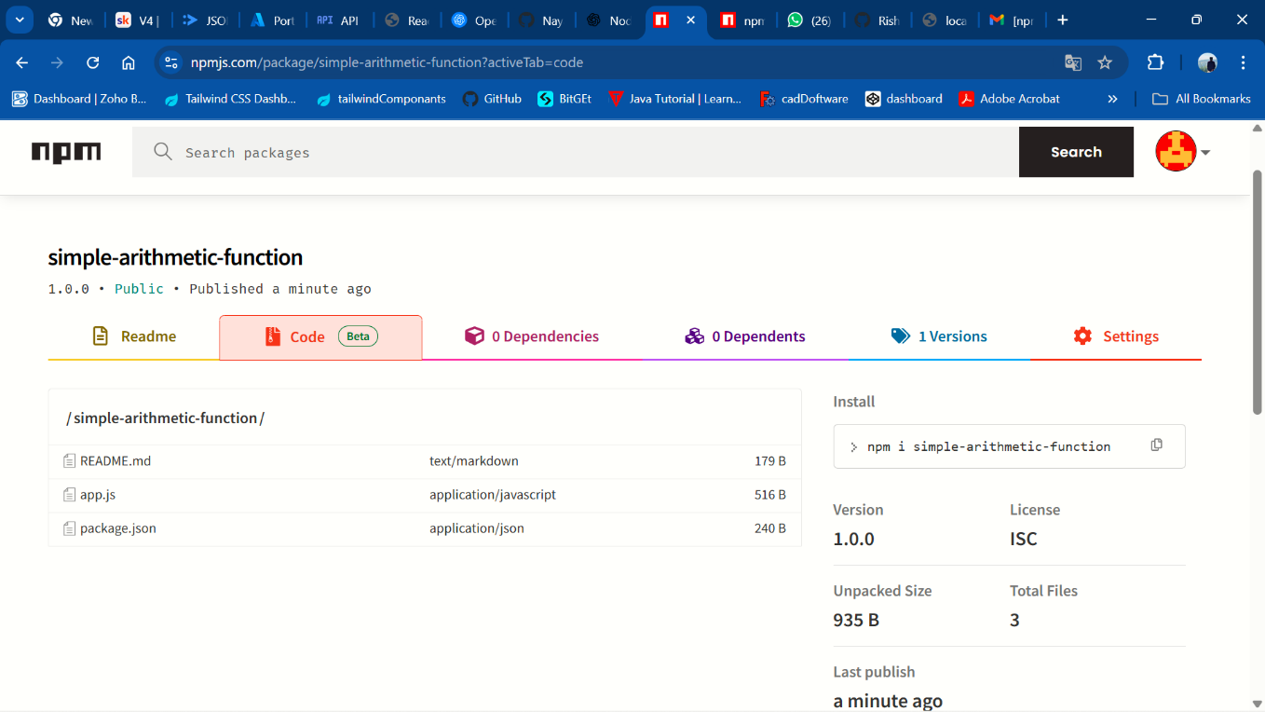

[GitHub Link: <https://github.com/Nayan8319/OSWD/tree/main/35_Nayan_Padhiyar_304_A1> ]