Assignment 2

1. Develop a user registration form (fields: username, password, confirm password, email, gender, hobbies, upload profile pic, upload other pics) (use text box, radio, checkboxes, file upload) using Express.  Form should also contain file upload (single, multiple) with validations.  
    - In case of invalid data, display errors along with all previous field values.  
    - In case of all valid fields, display all data and images in a well formatted tabular form. and allow the user to download that file using Express. Develop route for file download.   (Use express, ejs, express-validator)

Output :-

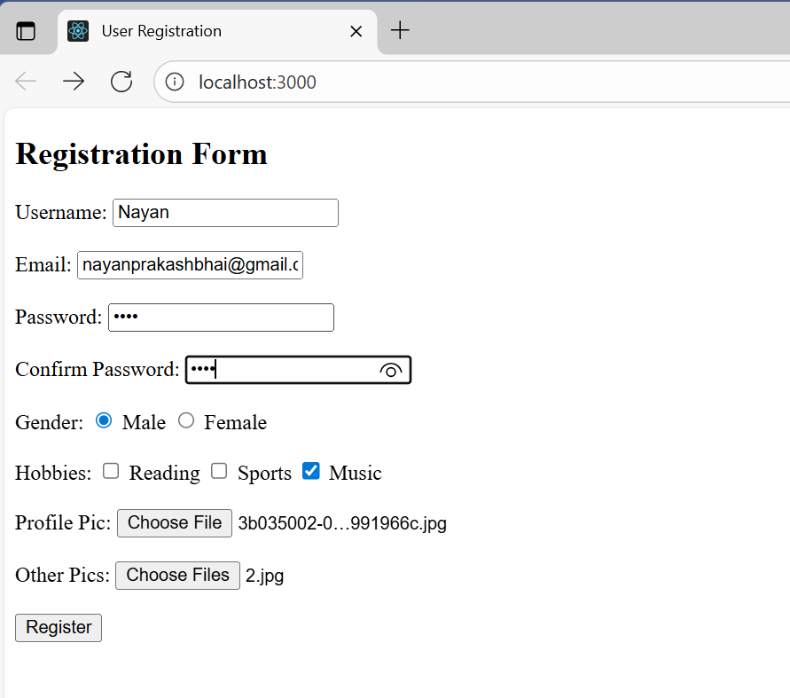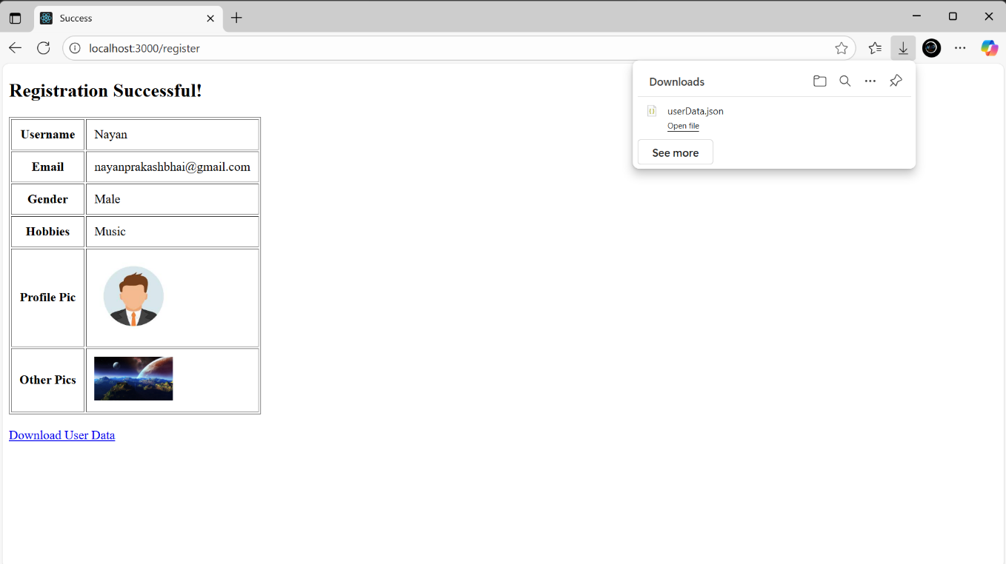

2. Express Login application with file session store.  
Output :-



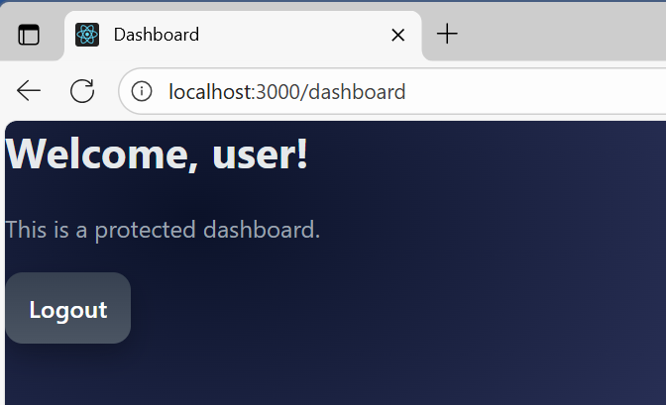

33) Express Login application with redis session store.  
Output :-

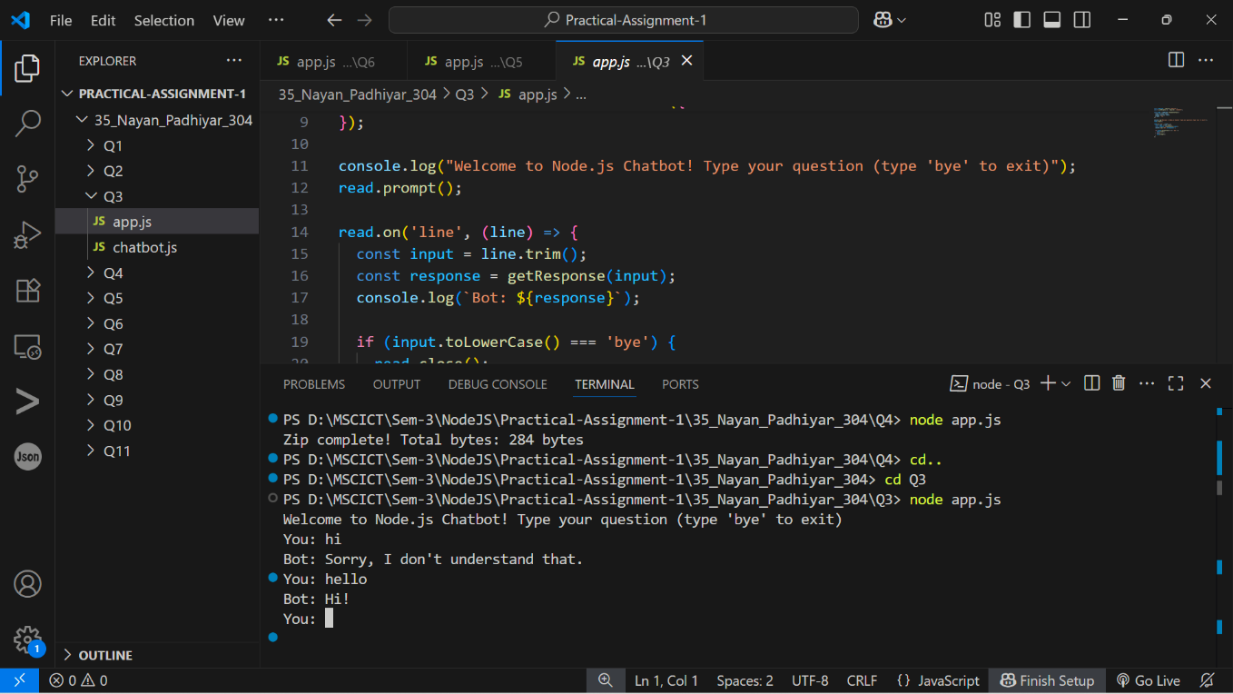

4. Write a program to create a compressed zip file for a folder.  
Output :-

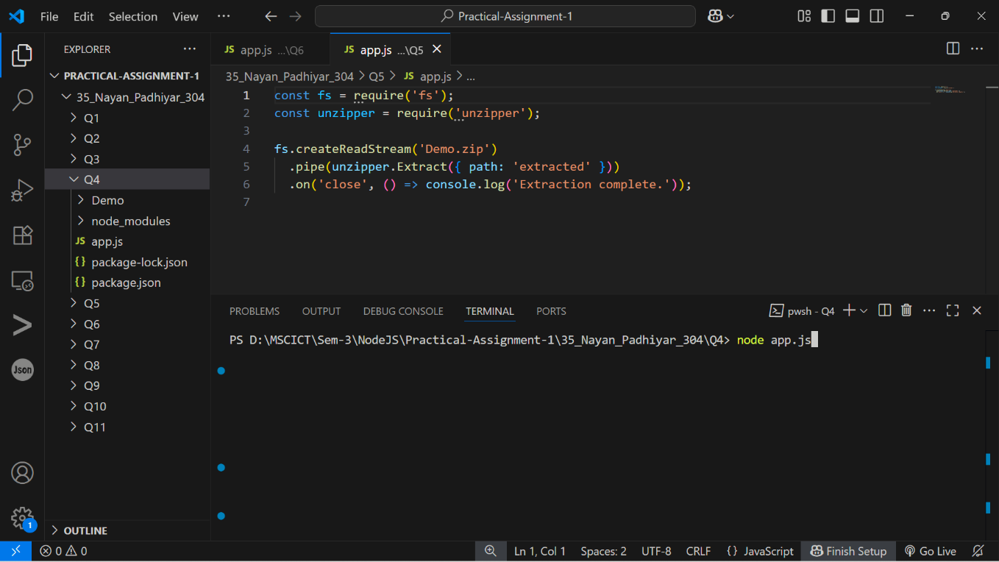

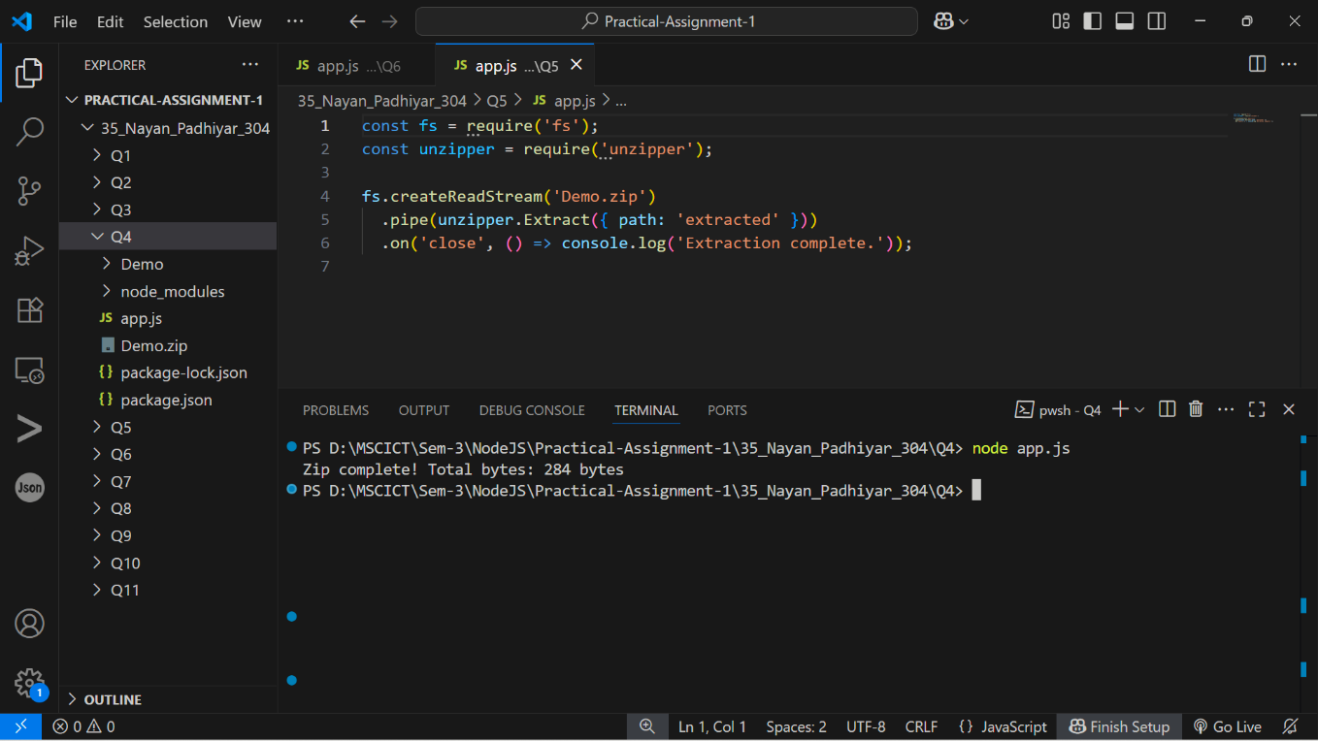

5. Write a program to extract a zip file.  
Output :-

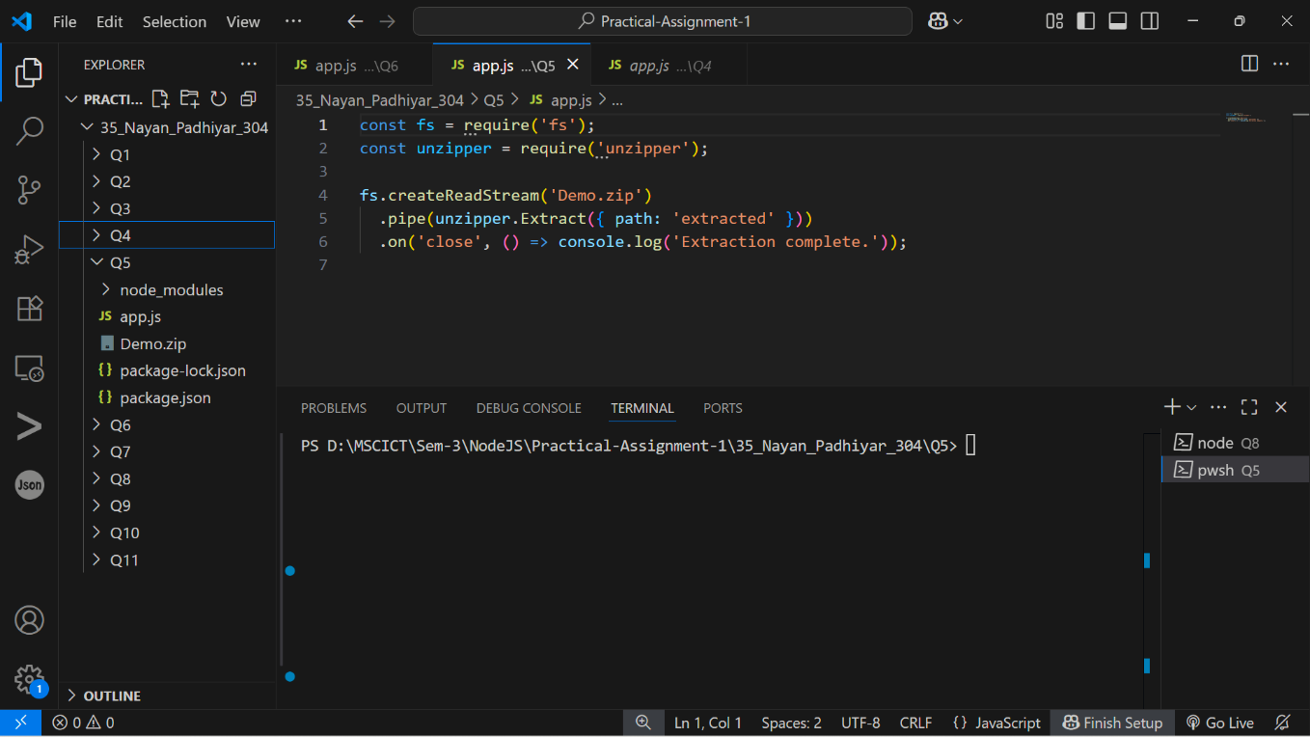

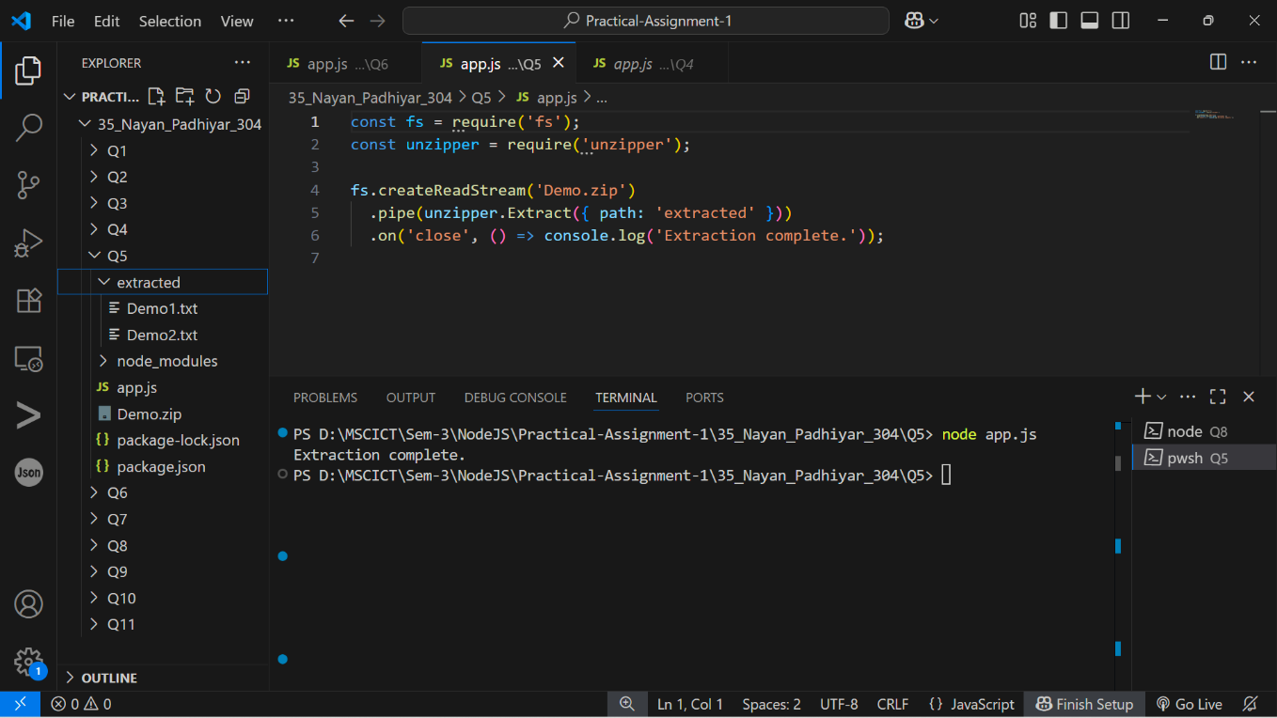

6. Write a program to promisify fs.unlink function and call it.  
Output :-

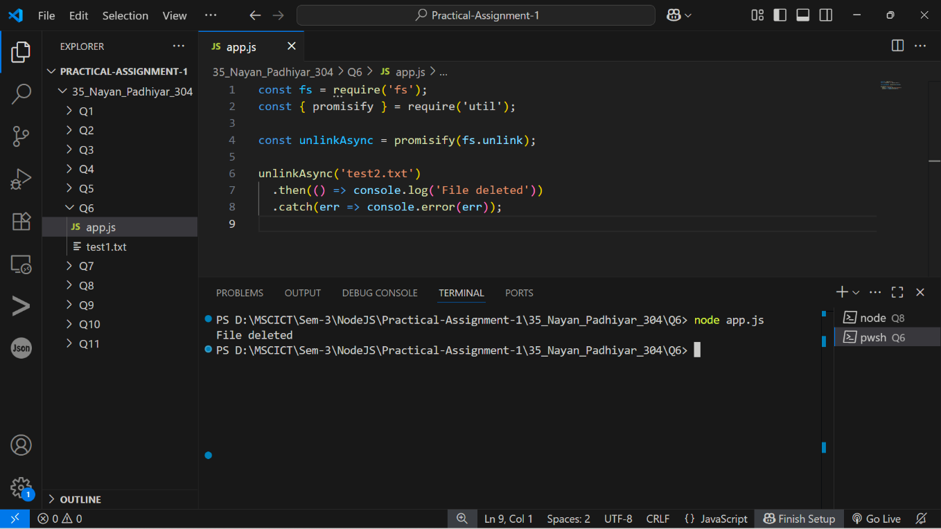

7. Fetch data of google page using note-fetch using async-await model.  
Output :-

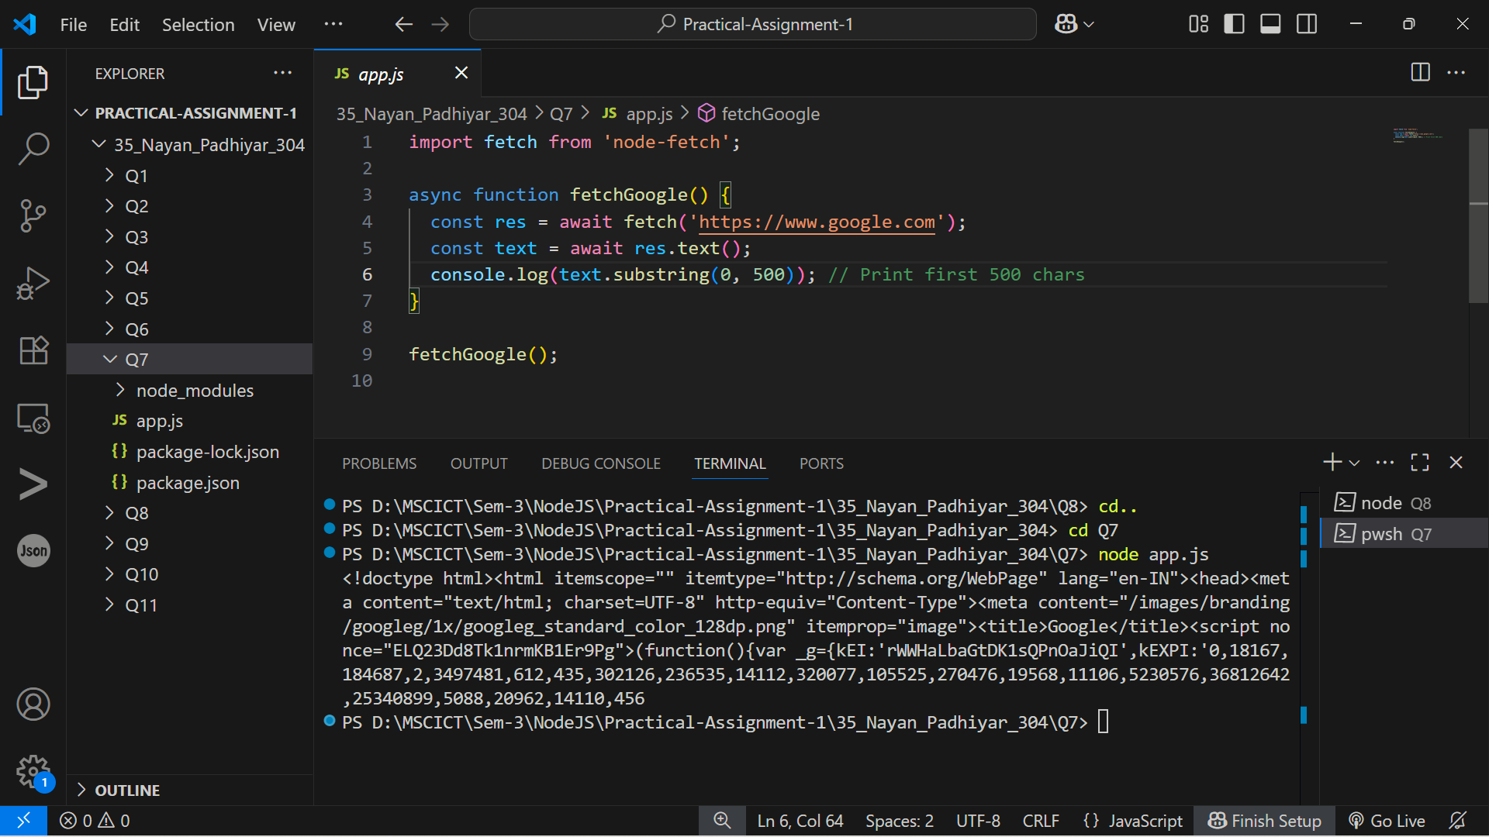

8. Set a server script, a test script and 3 user defined scripts in package.json file in your nodejs  
application.  
Output :-

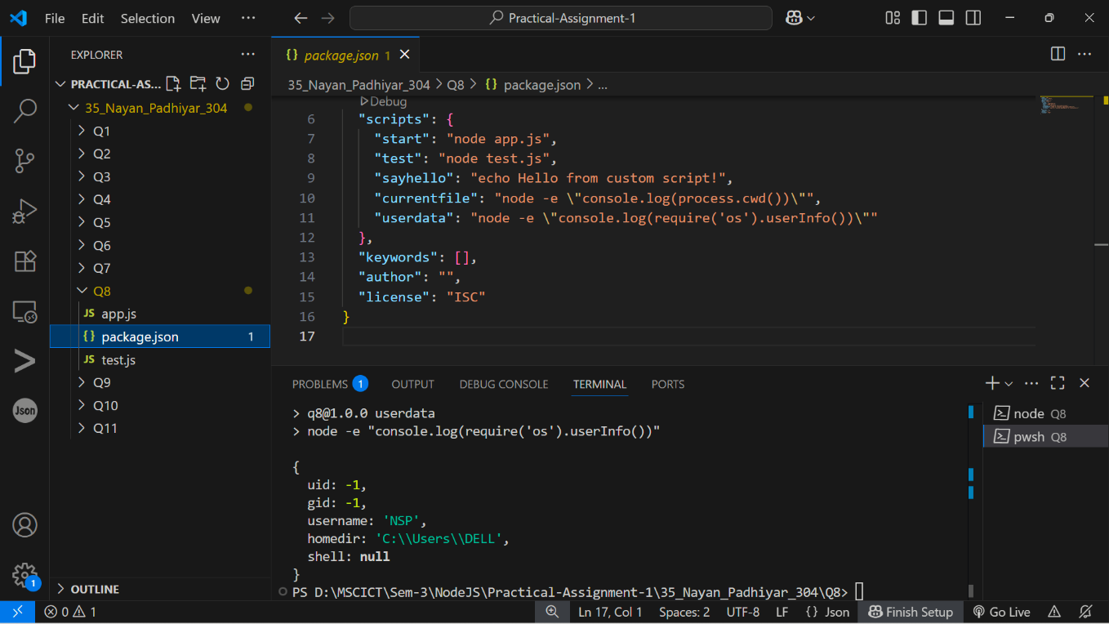

9. A program which calls useful functions in fs modile.  
Output :-

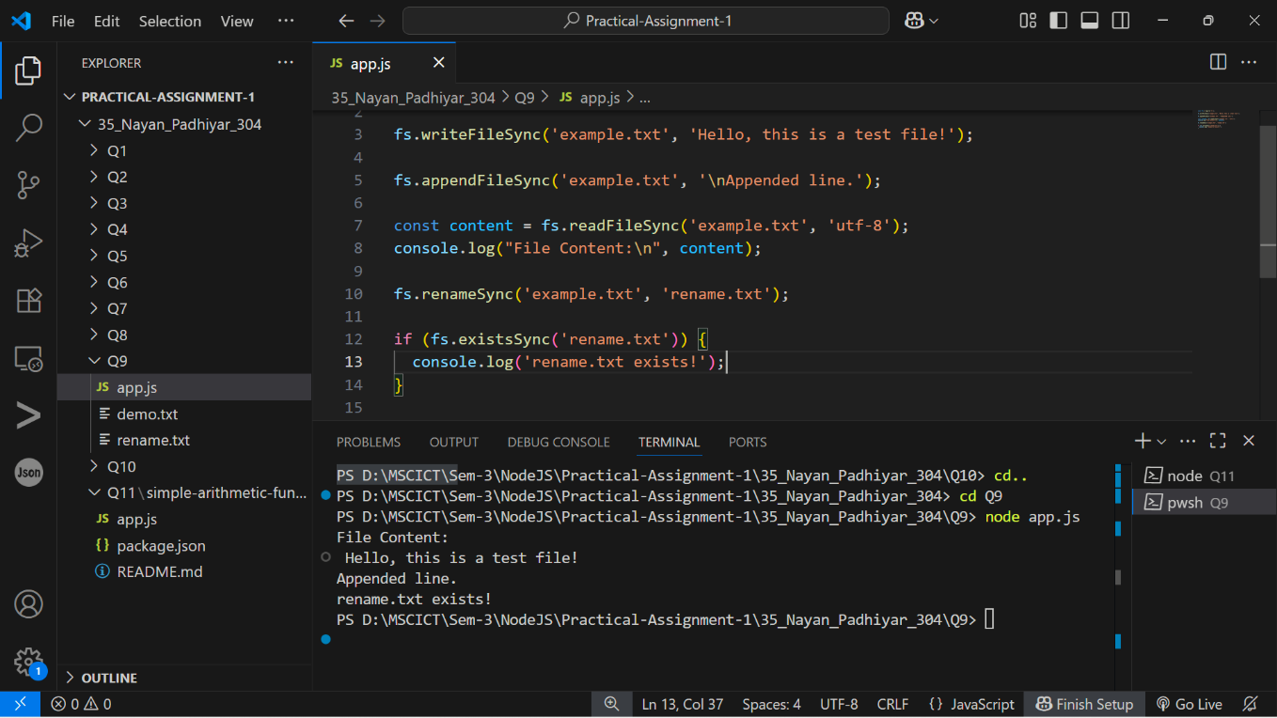

10. A program which uses global objects in nodejs.  
Output :-

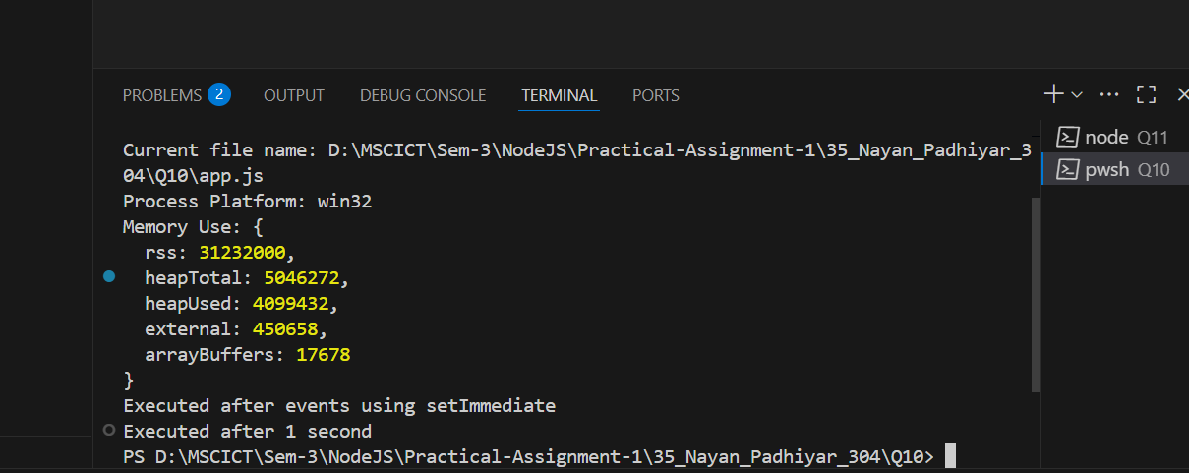

11. Develop a useful package and publish it on npmjs.com

Output :-

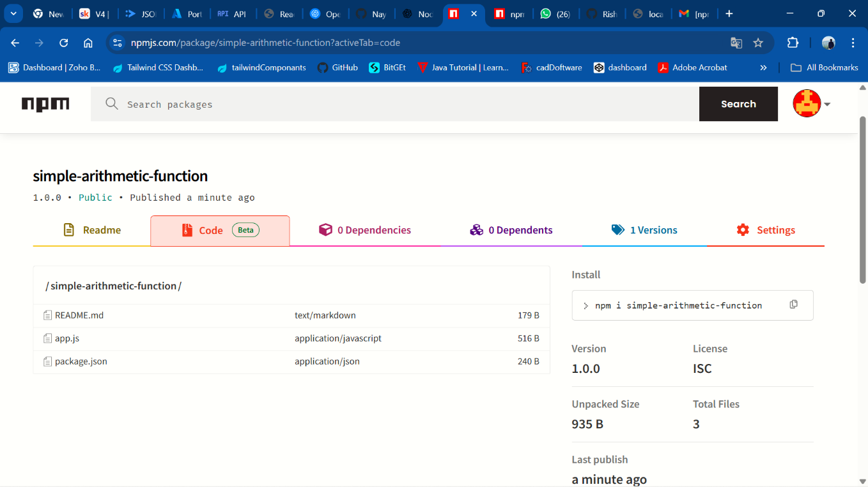

[GitHub Link: <https://github.com/Nayan8319/OSWD/tree/main/35_Nayan_Padhiyar_304_A1> ]