Bug Report
Field | Detail
Bug ID | BUG-1
Title | The button ‘@’ was not being identified as @ button but as 2, after pressing shift+2 button
Project | the-internet.herokuapp.com/key_presses
Reporter | Nayan Raj Pokharel
Assignee | Backend Team – Input Module
Date Reported | 2026-08-01
Environment | Edge 151.0.4129.59
Severity | Mid
Priority | P2
Status | Open
Component | Key press
Sprint | Sprint 2

Summary
After entering shift+2 button instead of registering as @ button, It registers as 2 button.

Steps to Reproduce
- Open the-internet.herokuapp.com on browser.
- Tap "Key Presses."
- Press the shift and 2 key to verify if they are working.
- Press the Shift + 2 key to get @ symbol.

Expected Result
The @ symbol is obtained but the website reads it as @ key.
Actual Result
The @ symbol is obtained but the website reads it as 2 key.

Frequency
100% reproducible.
Workaround
No workaround.

Additional Context
- Issue appeared on The Internet.

Attachments
- Screenshot on edge — wrong key registered.
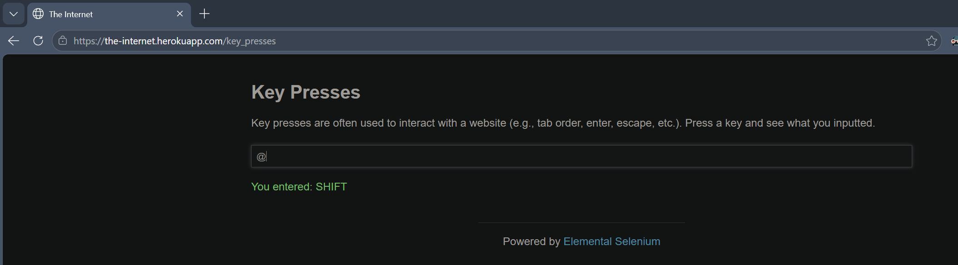

Bug Report
Bug Report
Field | Detail
Bug ID | BUG-2
Title | The number field was not rejecting 'e' button but accepting it as a valid number
Project | the-internet.herokuapp.com/inputs
Reporter | Nayan Raj Pokharel
Assignee | Backend Team – Input Module
Date Reported | 2026-08-01
Environment | Edge 151.0.4129.59
Severity | Low
Priority | P3
Status | Open
Component | Input field
Sprint | Sprint 2

Summary
After entering 'e' button in the number field instead of getting rejected, It gets accepted as a valid number.

Steps to Reproduce
- Open the-internet.herokuapp.com on browser.
- Tap "Inputs."
- Click on the number field to verify if it is working.
- Press the 'e' key to check if it is accepted or not.

Expected Result
The 'e' button is entered but the website should reject it as an invalid number.
Actual Result
The 'e' button is entered but the website accepts it as a valid number.

Frequency
100% reproducible.
Workaround
No workaround.

Additional Context
- Issue appeared on The Internet.

Attachments
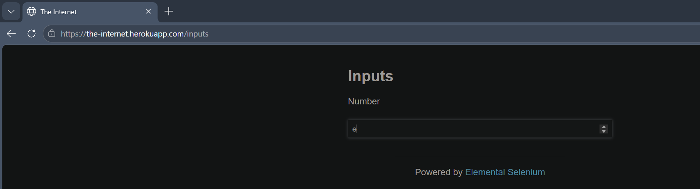

Bug Report
Field | Detail
Bug ID | BUG-4
Title | The 'Retrieve password' button was not showing the confirmation page but showing Internal Server Error, after entering email and submitting
Project | the-internet.herokuapp.com/forgot_password
Reporter | Nayan Raj Pokharel
Assignee | Backend Team – Input Module
Date Reported | 2026-08-01
Environment | Edge 151.0.4129.59
Severity | High
Priority | P1
Status | Open
Component | Forgot Password
Sprint | Sprint 2

Summary
After entering an email address and clicking the 'Retrieve password' button instead of showing the confirmation page, It shows an Internal Server Error.

Steps to Reproduce
- Open the-internet.herokuapp.com on browser.
- Tap "Forgot Password."
- Enter any valid-format email address in the email field.
- Click the 'Retrieve password' button to submit.

Expected Result
The email is submitted but the website shows a confirmation page/message that the password reset was initiated.
Actual Result
The email is submitted but the website shows an Internal Server Error page.

Frequency
100% reproducible.
Workaround
No workaround.

Additional Context
- Issue appeared on The Internet .
- Error occurs regardless of whether the email format is valid or invalid.

Attachments
