## Nehru College Of Engineering And Research Centre 3rd International Conference-NeCTAR series Vol 3 ISBN-978-93-5526-597-5 July-August 2022

GOLD PRICE PREDICTION USING MACHINE LEARNING

Nayana George, Student

Dr. Vineetha K. R, M.Phil, PhD, Associate Professor

Department of MCA, Nehru College Of Engineering And Research Centre, Thrissur, Kerala

# ABSTRACT

This article is based on a study conducted to understand the relationship between gold price and selected factors influencing it, namely stock market, crude oil price, rupee dollar exchange rate, inflation and interest rate. Monthly price data for the period January 2000 to December 2018 was used for the study. The data was further split into two periods, period I from January 2000 to October 2011 during which the gold price exhibits a raising trend and period II from November 2011 to December 2018 where the gold price is showing a horizontal trend. Three machine learning algorithms, linear regression, random forest regression and gradient boosting regression were used in analyzing these data. It is found that the correlation between the variables is strong during the period I and weak during period II. While these models show good fit with data during period I, the fitness is not good during the period II. While random forest regression is found to have better prediction accuracy for the entire period, gradient boosting regression is found to give better accuracy for the two periods taken separately

# INTRODUCTION

# In finance, an investment is purchase of a monetary asset with the idea that the asset will provide income in the future or will later be sold at a higher price for a profit. The Indian economy being one of the fastest growing in the world has resulted in higher disposable income level and a plethora of investment avenues. There are a number of investment avenues available for investors, which includes stocks, deposits, commodities and real estate. Gold is another asset which is being considered as an attractive investment avenue by many investors due to its increasing value and the area of usage. Investor’s preference for gold as a protective asset increases due to their negative expectations concerning the situation in the developed foreign exchange markets and the capital markets, they take in to consideration major world events which may have affected US dollar rates. Thus, this project is aimed at studying the relationship between gold price and selected economic and market variable. Understanding such relationship will be helpful not only to monetary policymakers but also to investors, fund managers and portfolio managers to take better investment decisions in the market. Further this study uses machine learning algorithms, linear regression, random forest regression in analyzing these data.

# LITERATURE SURVEY

Gold is the only asset that retains its worth even through the political and economic downturn. The gold values are often directly linked to other resources. Future gold price forecast is the investors' alert mechanism because of unpredictable market risk. Therefore, precise forecasting of gold prices is needed to predict the market patterns.

The research topic of Xiaohui Yang was "The Prediction of Gold Price Using ARIMA Model", and author use text mining and artificial neural networks (ANN) to forecast the gold prices and compare their results with the autoregressive-moving average (ARMA) model. ARMA model is the most frequently used statistical model for analyzing time series data. They forecast actual gold prices and achieve an accuracy of 66.67%. author use ARMA model but compare their results with ANN and show that ANN performs better than ARMA.

Manjula K. A., Karthikeyan P, has a remarkable note in "Gold Price Prediction using Ensemble based Machine Learning Techniques", and their findings on an investigation led to comprehend the connection between gold cost and chose factors affecting it, to be specific financial exchange, unrefined petroleum value, rupee dollar conversion scale, swelling and loan cost. Three AI calculations, direct relapse, arbitrary woodland relapse and inclination boosting reap were utilized in examining this information

Mrs. B. Kishori 1, V. Preethi made research on “Gold Price forecasting using ARIMA model” and says that gold is metal which is significant as fiscal resource, adornments, Investment choice. As venture choice it snatches the fascination of financial specialists by its high heightening costs.

R. Hafezi, A. N. Akhavan has done research on the “Forecasting Gold Price Changes” The figure of vacillations of costs is the significant worry in money related markets. This paper endeavors to propose a shrewd model established by counterfeit neural systems (ANNs) to extend future costs of gold. The proposed clever system is furnished with a meta-heuristic calculation called BAT calculation to make ANN fit for following variances. The structured model is contrasted with that of a distributed logical paper and other serious models, for example, Autoregressive Integrated Moving Average (ARIMA), ANN, Adaptive NeuroFuzzy Inference System (ANFIS), Multilayer Perceptron (MLP) Neural Network.

# METHODOLOGY

We can understand that the system will predict future gold prices for twenty-four hours with references to the present rates and us dollar rates, so that we can overcome the financial crisis in stock market

Admin

* View user and update delete them
* view prediction by user
* view gold shop owner

User module

* Current gold price
* View prediction

# RESULT ANALYSIS:

The Daily gold price values are taken from period 2010-2022.Monthly Gold Price values are taken from Period 2015-2022. Six Months Gold Price values are taken from Period 2010-2022. Yearly Gold Price values are taken from Period 2010-2022.Actual vs Predicted prices Bar Graph Plotted below for daily Prices during the period 2010-2022

The bar graph for actual predicted for linear regression is taken and the pic is taken.

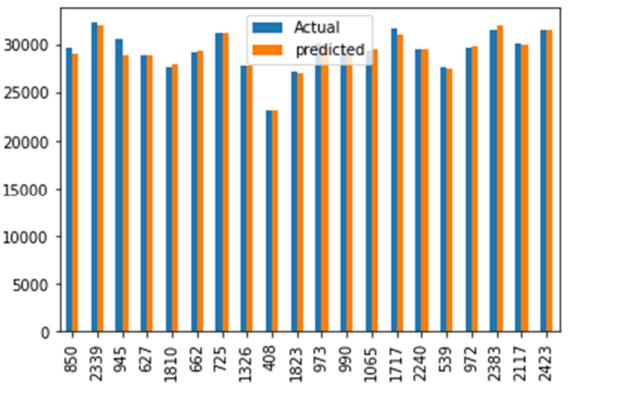

Figure.1: Bar graph of linear regression

**CONCLUSION**

Gold has been one of history's most significant commodities. Maintaining central banks' gold reserves is essential to maintaining the world's existing economic system. Some big firms and investors are now spending large amounts of money in gold. While forecasting the rate of gold is not very easy, it will allow investors and central banks to determine better when to sell and buy them and thus maximize their income. Furthermore, an attempt has been made in this study by using machine learning algorithms to accurately predict the gold prices and when to sell them and purchase them. This research was done in order to clarify the gold price predictions using machine learning using Python. It is concluded that machine learning algorithms with linear regression analysis are very useful in gold price prediction.

# REFERENCE

**BOOKS AND ARTICLES**

1. Xiaohui Yang, "The Prediction of Gold Price Using ARIMA Model", 2nd International Conference on Social Science, Public Health and Education 2019.
2. Manjula K. A., Karthikeyan P, "Gold Price Prediction using Ensemble based Machine Learning Techniques", Third International Conference on Trends in Electronics and Informatics, 2019.
3. Mrs. B. Kishori 1, V. Preethi, "Gold Price forecasting using ARIMA Model", International Journal of Research, 2018
4. R. Hafezi* , A. N. Akhavan, "Forecasting Gold Price Changes: Application of an Equipped Artificial Neural Network", AUT Journal of Modeling and Simulation, 2018.
5. Xiaohui Yang, "The Prediction of Gold Price Using ARIMA Model", 2nd International Conference on Social Science, Public Health and Education (SSPHE 2018).
6. Shian-Chang Huang and Cheng-Feng Wu, Energy Commodity Price Forecasting with Deep Multiple Kernel Learning, MDPI Journal, 2018.
7. Wedad Ahmed Al-Dhuraibi and Jauhar Ali, "Using Classification Techniques to Predict Gold Price Movement", 4th International Conference on Computer and Technology Applications, 2018.
8. Iftikharul Sami and KhurumNazirJunejo, "Predicting Future Gold Rates using Machine

Learning Approach", International Journal of Advanced Computer Science and Applications,