E-COMMERCE SALES
& CUSTOMER ANALYTICS
Data Cleaning • Exploratory Analysis • SQL • Power BI
Project Report
Prepared from the supplied e-commerce dataset and project workflow

1. Executive Summary
This project develops an end-to-end e-commerce analytics workflow. The source data was inspected and cleaned with Python/Pandas, prepared for relational analysis in MySQL, queried using SQL, and presented through an interactive Power BI dashboard. The objective is to turn raw order-level data into clear business insights on sales, products, categories, locations, payment methods, and order status.
Final analysis rows | Total sales | Net amount | Estimated profit*
343 | ₹3,808,557 | ₹3,515,432 | ₹703,086
Total quantity | Unique orders | Customers | Avg. order record value
1,143 | 343 | 7 | ₹11,104

*Profit is an illustrative project calculation using the 20% margin defined in the notebook; it should not be interpreted as audited business profit.

Headline Findings
- Electronics is the largest category with ₹1,411,589 in sales, representing 37.1% of total sales.
- Laptop is the top product by sales at ₹729,099.
- Pune is the leading city by sales at ₹894,272, followed closely by Bengaluru.
- May is the strongest month at ₹875,578; March is the weakest among the six months shown.
- Wallet has the highest number of orders (80); COD is also a major payment channel.
- Returned orders are the largest status group in the cleaned analysis dataset (90 records), highlighting a key operational area for improvement.

2. Data Overview & Business Objective
The original working dataset contained 414 records and 15 columns. The notebook identifies fields covering order details, customer information, geography, products, pricing, discounts, payment mode, order status, and delivery dates. After applying the documented cleaning rules, the analysis frame contains 343 records and 22 columns after feature engineering.

Business Questions
- How much sales value is generated across the order dataset?
- Which products and categories contribute the most sales?
- Which cities are the strongest markets?
- How does sales performance change month by month?
- Which payment modes are most frequently used?
- How are orders distributed across Delivered, Pending, Returned, and Cancelled statuses?

Key Dataset Fields
Field | Purpose
Order_ID | Order identifier
Order_Date / Delivery_Date | Order and delivery dates
Customer_Name | Customer label
City / State | Geographic dimensions
Product / Category | Product hierarchy
Qty / Unit_Price | Quantity and price
Discount | Discount percentage
Payment_Mode | Payment channel
Order_Status | Order lifecycle status

Analytical Scope
The project focuses on descriptive analytics rather than predictive modeling. The output is designed to support business reporting, performance monitoring, and management-level decision making.

3. Data Cleaning & Preparation
The notebook follows a structured cleaning workflow before analysis. This improves consistency and prevents obvious data-quality issues from distorting the dashboard and SQL results.
Cleaning step | Treatment
Duplicate records | 8 duplicates removed
Text standardization | Trim spaces; title-case customer/city/state
Email validation | Keep records containing '@'
Date conversion | Convert order and delivery dates to datetime
Numeric conversion | Convert Qty, Unit_Price and Discount to numeric
Invalid quantity | Remove Qty ≤ 0 records
Missing Qty/Price | Remove rows missing Qty or Unit_Price
Missing discount | Fill with 0
Missing phone | Fill with 'Unknown'
Missing delivery date | Fill from Order_Date

Feature Engineering
Three main financial fields were derived in the notebook:
- Sales = Qty × Unit_Price
- Net Amount = Sales − (Sales × Discount / 100)
- Profit = Net Amount × 20% (illustrative project assumption)
Additional time dimensions were created for Month, Year, and Weekday to support trend analysis and dashboard filtering.

Data Quality Note
The supplied CSV file is a project output file but still contains some raw-style values such as blank discounts and negative quantities. The report therefore uses the notebook's documented cleaning rules to reproduce the 343-row analysis dataset for the business metrics. This keeps the reported insights aligned with the demonstrated cleaning workflow.

4. Exploratory Data Analysis

Sales by Product
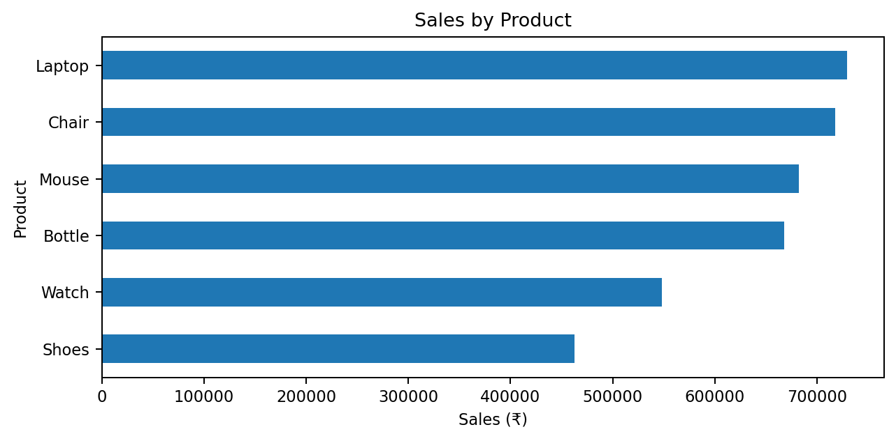
Laptop leads product sales at ₹729,099, followed by Chair (₹718,109) and Mouse (₹682,490). Shoes contributes the lowest sales among the six products.

Sales by Category
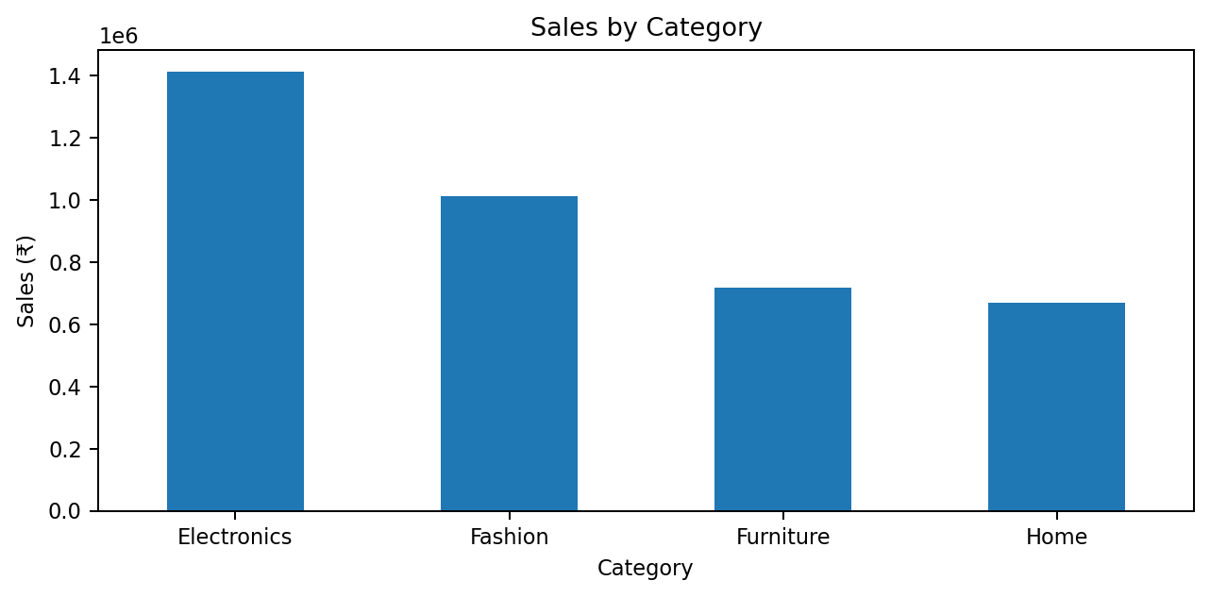
Electronics is the strongest category at ₹1,411,589; Fashion is second at ₹1,010,968. Together, these two categories contribute 63.6% of total sales.

5. Trends, Geography & Order Behavior

Monthly Sales Trend
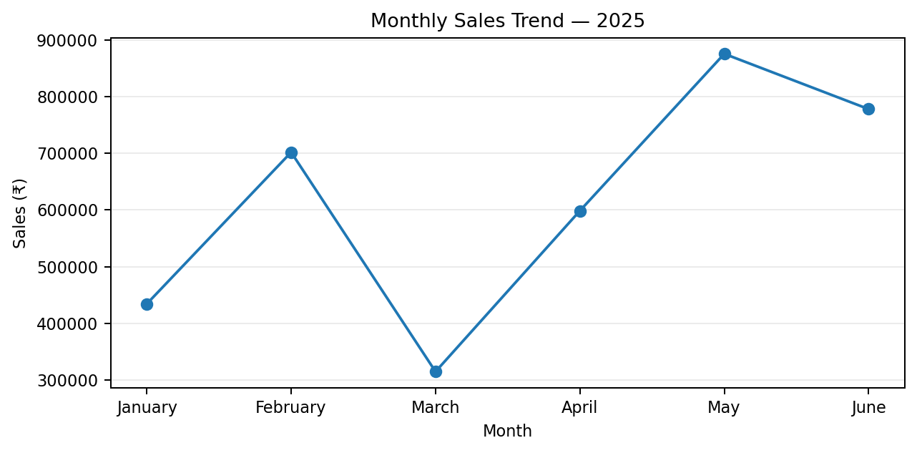
Sales peak in May at ₹875,578. June remains strong at ₹777,983, while March records the lowest monthly sales at ₹314,559.

Top Markets
City | Sales | Share
Pune | ₹894,272 | 23.5%
Bengaluru | ₹827,695 | 21.7%
Delhi | ₹579,814 | 15.2%
Lucknow | ₹573,937 | 15.1%
Mumbai | ₹520,995 | 13.7%
Jaipur | ₹411,844 | 10.8%

Payment Mode
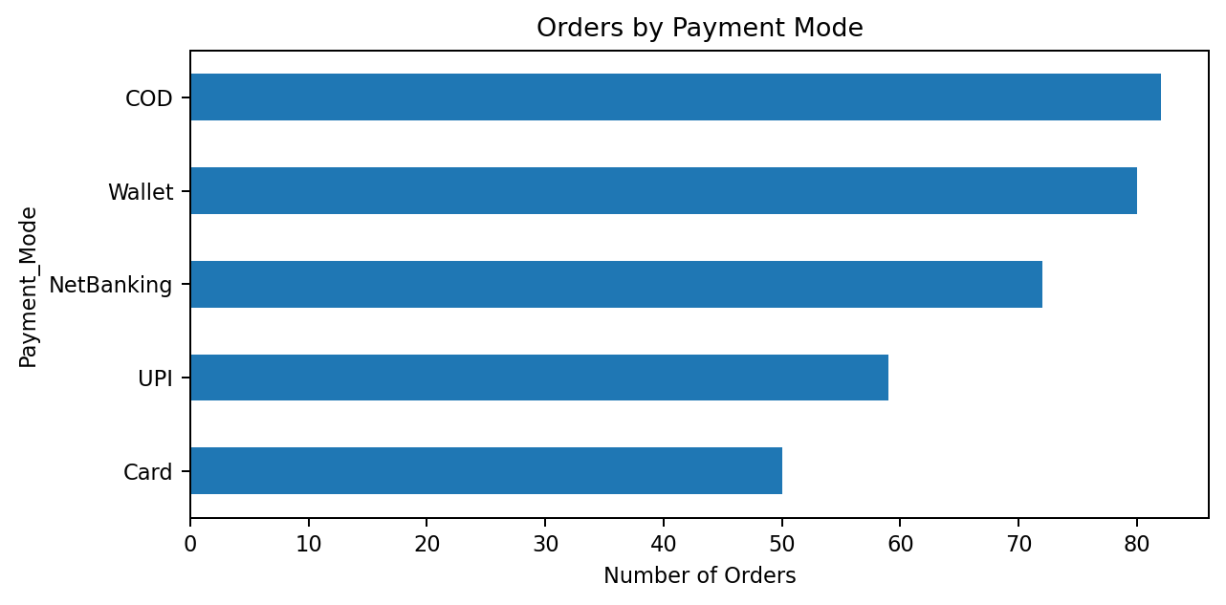
Wallet has the highest order count, while COD is also heavily used. This suggests that payment-channel analysis can be useful for customer experience and conversion optimization.

6. SQL & Power BI Implementation

MySQL / SQL Analysis
The SQL script creates and selects the ecommerce database, inspects the orders table, calculates total sales, ranks products and cities by sales, analyzes monthly sales, counts orders by payment mode, and filters cancelled orders. The core sales logic is based on Qty × Unit_Price.
Analysis | SQL approach
Total sales | SUM(Qty * Unit_Price)
Product ranking | GROUP BY Product + ORDER BY Total_Sales DESC
City ranking | GROUP BY City + ORDER BY Total_Sales DESC
Monthly trend | MONTH(STR_TO_DATE(Order_Date, '%d/%m/%Y'))
Payment analysis | GROUP BY Payment_Mode
Cancelled orders | WHERE Order_Status = 'Cancelled'

The supplied SQL file explicitly includes these analysis queries, demonstrating the transition from cleaned order data to relational business reporting.

Power BI Dashboard
The Power BI dashboard is the presentation layer of the project. Recommended dashboard interactions include date/year-month, category, city, and payment-mode filters, allowing users to move from high-level KPIs to specific segments. The dashboard is intended to provide a single view of sales performance, product contribution, geography, payment behavior, and order status.

End-to-End Flow
Raw Excel → Python/Pandas cleaning → Feature engineering → Clean dataset → MySQL orders table → SQL analysis → Power BI dashboard → Business insights

7. Key Findings & Recommendations
Area | Evidence | Recommendation
Category strength | Electronics leads with ₹1,411,589 sales. | Protect inventory availability and promote high-performing electronics products.
Product performance | Laptop is #1 at ₹729,099. | Use laptop performance as a benchmark for pricing, promotion and stock planning.
Geographic performance | Pune leads at ₹894,272; Bengaluru is second. | Prioritize marketing and fulfillment optimization in the strongest cities.
Monthly seasonality | May is the strongest month at ₹875,578. | Investigate May drivers and replicate successful campaigns or demand patterns.
Returns | Returned orders are the largest status group (90). | Review product quality, descriptions, sizing/specification clarity and delivery experience.
Cancellations | Cancelled orders total 86. | Identify cancellation reasons and improve payment, inventory and delivery communication.
Payment behavior | Wallet records 80 orders. | Keep wallet experience strong while monitoring COD and other payment channels.

Management Dashboard KPIs
- Total Sales
- Net Amount
- Estimated Profit
- Total Orders
- Total Quantity
- Delivered / Pending / Returned / Cancelled
- Sales by Product and Category
- Sales by City
- Monthly Sales Trend
- Orders by Payment Mode

8. Conclusion
This e-commerce analytics project demonstrates a complete data-analysis lifecycle from raw data preparation to business reporting. Python/Pandas was used to identify and address duplicates, invalid values, missing values, formatting inconsistencies and data types. Feature engineering added sales, net amount, profit and time-based fields for analysis.
SQL provided a structured way to query sales, products, cities, monthly performance, payment methods and cancelled orders. Power BI then converts these analyses into an interactive dashboard suitable for management review and business exploration.
Based on the cleaned 343-row analysis dataset, the project reports ₹3,808,557 in gross sales, ₹3,515,432 in net amount, ₹703,086 in illustrative profit, and 1,143 units across 343 unique order IDs. The strongest category is Electronics, the leading product is Laptop, and Pune is the strongest city by sales.

Final Takeaway
The main business opportunity is not only to grow sales but also to improve order quality. The high share of returned and cancelled orders indicates that operational improvements—such as better product information, inventory accuracy, payment experience and delivery communication—could strengthen the value generated from existing demand.

Tools Used
Python • Pandas • NumPy • MySQL • SQL • Power BI • Excel

Source Files Reviewed
- Ecommerce_Unclean_Project.xlsx — source dataset
- ecommerce.ipynb — cleaning, feature engineering and MySQL workflow
- ecommerce sql.sql — SQL analysis queries
- Clean_Ecommerce_Finall.csv — supplied project data output
- Ecommerce dashboard.pbix — Power BI dashboard

