**INTRODUCTION :**

A hotel is an establishment that provides lodging paid on a short-term basis. Facilities provided may range from a basic bed and storage for clothing, to luxury features like en-suite bathrooms. Larger hotels may provide additional guest facilities such as a swimming pool, business centre, childcare, conference facilities and social function services. Hotel rooms are usually numbered (or named in some smaller hotels and B&Bs) to allow guests to identify their room. Some hotels offer meals as part of a room and board arrangement. In the United Kingdom, a hotel is required by law to serve food and drinks to all guests within certain stated hours. In Japan, capsule hotels provide a minimized amount of room space and shared facilities.

The precursor to the modern hotel was the inn of medieval Europe. For a period of about 200 years from the mid-17th century, coaching inns served as a place for lodging for coach travelers. Inns began to cater for richer clients in the mid-18th century. One of the first hotels in a modern sense was opened in Exeter in 1768. Hotels proliferated throughout Western Europe and North America in the 19th century, and luxury hotels began to spring up in the later part of the century.

Hotel operations vary in size, function, and cost. Most hotels and major hospitality companies have set industry standards to classify hotel types. An upscale full-service hotel facility offers luxury amenities, full service accommodations, on-site full service restaurant(s), and the highest level of personalized service. Full service hotels often contain upscale full-service facilities with a large volume of full service accommodations, on-site full service restaurant(s), and a variety of on-site amenities. Boutique hotels are smaller independent non-branded hotels that often contain upscale facilities. Small to medium-sized hotel establishments offer a limited amount of on-site amenities. Economy hotels are small to medium-sized hotel establishments that offer basic accommodations with little to no services. Extended stay hotels are small to medium-sized hotels that offer longer term full service accommodations compared to a traditional hotel.

**HTML CODDING:**

**HOTEL FIVE STAR**

**Snapshot 1:**

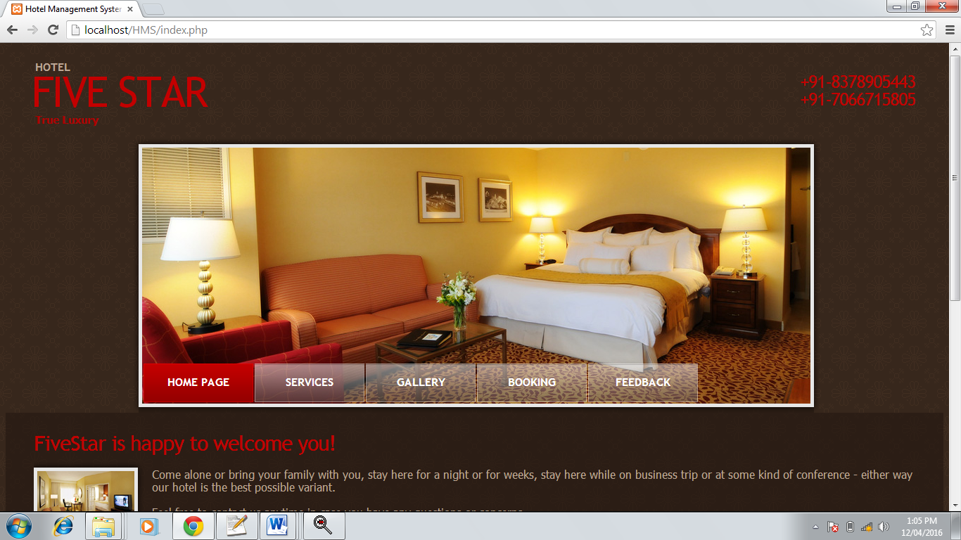

**Codding**

<html><head>

<title>Hotel Management System</title>

<meta http-equiv="Content-Type" content="text/html; charset=utf-8" />

<link href="style.css" rel="stylesheet" type="text/css" />

<link href="layout.css" rel="stylesheet" type="text/css" />

<script src="maxheight.js" type="text/javascript"></script>

</head>

<body id="page1" onload="new ElementMaxHeight();">

<div id="main">

<!-- header -->

<div id="header">

<div class="row-1">

<div class="wrapper">

<div class="logo">

<h1><a href="#">Five Star</a></h1>

<em>Hotel</em> <strong>True Luxury</strong> </div>

<div class="phones"> +91-8378905443<br />

+91-7066715805 </div>

</div>

</div>

<div class="row-2">

<div class="indent">

<!-- header-box begin -->

<div class="header-box">

<div class="inner">

<ul class="nav">

<li><a href="index.php" class="current">Home page</a></li>

<li><a href="services.php">Services</a></li>

<li><a href="gallery.php">Gallery</a></li>

<li><a href="booking.php">Booking</a></li>

<li><a href="feedback.php">Feedback</a></li>

</ul>

</div>

</div>

<!-- header-box end -->

</div>

</div>

</div>

<!-- content -->

<div id="content">

<div class="wrapper">

<div class="content">

<div class="indent">

<h2>FiveStar is happy to welcome you!</h2>

<img class="img-indent png" alt="" src="images/1page-img1.png" />

<p class="alt-top">Come alone or bring your family with you, stay here for a night or for weeks, stay here while on business trip or at some kind of conference - either way our hotel is the best possible variant.</p>

Feel free to contact us anytime in case you have any questions or concerns.

<div class="clear"></div>

<div class="line-hor"></div>

<div class="wrapper line-ver">

<div class="col-1">

<h3>Special Offers</h3>

<ul>

<li>FREE wide-screen TV</li>

<li>50% Discount for Restaraunt service</li>

<li>30% Discount for 3 days+ orders</li>

<li>FREE drinks and beverages in rooms</li>

<li>Exclusive souvenirs</li>

</ul>

</div>

<div class="col-2">

<h3>Location</h3>

<p>We are located in the center of Amravati surrounded by malls and boutiques.</p>

<dl class="contacts-list">

<dt>Rajkamal Square,Amravati</dt>

<dd>+91-8378905443</dd>

<dd>+91-7066715805</dd>

</dl>

</div>

</div>

</div>

</div>

</div>

</div>

<!-- footer -->

<div id="footer">

<ul class="nav">

<li><a href="index.php">Home</a>|</li>

<li><a href="services.php">Services</a>|</li>

<li><a href="gallery.php">Gallery</a>|</li>

<li><a href="booking.php">Booking</a>|</li>

</ul>

<div class="wrapper">

</div>

</div>

</div>

<marquee behavior=alternate bgcolor="#7e0000"><b><i><a href=contectus.php><font color="white">Designed By:-Vaibhav Munde</a></i></b></font></marquee>

</body>

<link rel="stylesheet" href="js/owl.carousel.css">

<script src="js/vendor/jquery-1.11.1.min.js"></script>

<script src="js/owl.carousel.min.js"></script>

<script>

$(document).ready(function (){

$(".owl-carousels").owlCarousel({loop:true,items:1,autoPlay:3000});

});

</script></html>

**Snapshot 2** :

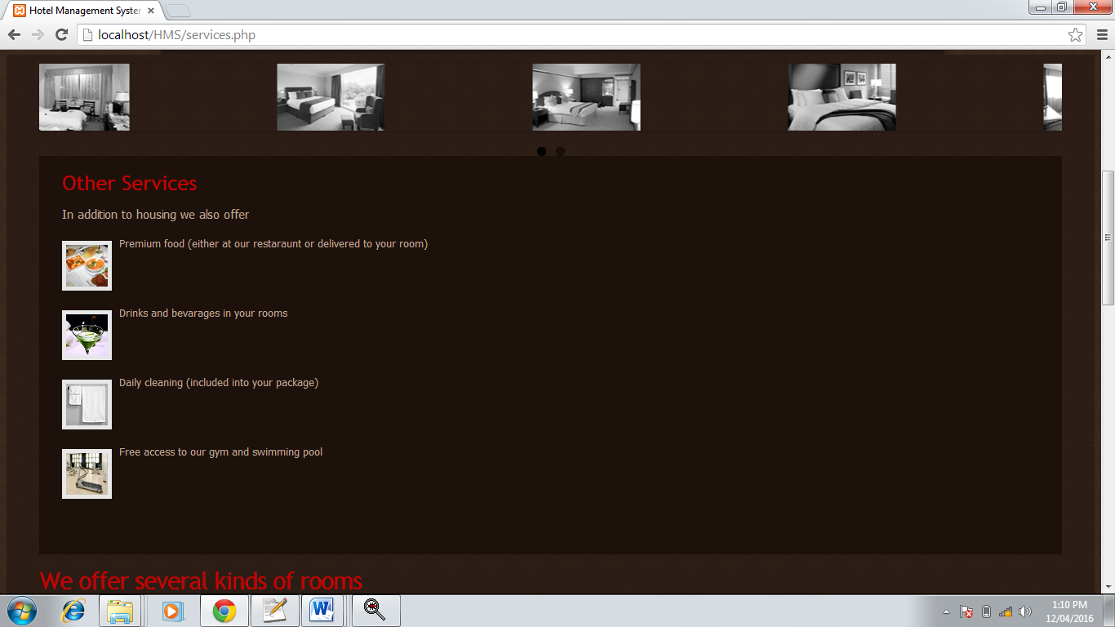

**Codding :**

<html>

<head>

<title>Hotel Management System | Services</title>

<meta http-equiv="Content-Type" content="text/html; charset=utf-8" />

<link href="style.css" rel="stylesheet" type="text/css" />

<link href="layout.css" rel="stylesheet" type="text/css" />

<script src="maxheight.js" type="text/javascript"></script>

</head>

<body id="page2" onload="new ElementMaxHeight();">

<div id="main">

<!-- header -->

<div id="header" class="small">

<div class="row-1">

<div class="wrapper">

<div class="logo">

<h1><a href="#">Five Star</a></h1>

<em>Hotel</em> <strong>True Luxury</strong> </div>

<div class="phones"> +91-8378905443<br />

+91-7066715805 </div>

</div>

</div>

<div class="row-2">

<div class="indent">

<!-- header-box-small begin -->

<div class="header-box">

<div class="inner">

<ul class="nav">

<li><a href="index.php">Home page</a></li>

<li><a href="services.php" class="current">Services</a></li>

<li><a href="gallery.php">Gallery</a></li>

<li><a href="booking.php">Booking</a></li>

<li><a href="Feedback.php">feedback</a></li>

</ul>

</div>

</div>

<!-- header-box-small end -->

</div>

</div>

</div>

<!-- content -->

<div id="content">

<div class="gallery owl-carousels">

<a href="#"><img class="item" alt="" src="images/2page-img1.jpg" /></a>

<a href="#"><img class="item" alt="" src="images/2page-img2.jpg" /></a>

<a href="#"><img class="item" alt="" src="images/2page-img3.jpg" /></a>

<a href="#"><img class="item" alt="" src="images/2page-img4.jpg" /></a>

<a href="#"><img class="item" alt="" src="images/2page-img5.jpg" /></a>

<a href="#"><img class="item" alt="" src="images/2page-img6.jpg" /></a>

</div>

<div class="wrapper">

<div class="aside maxheight">

<!-- box begin -->

<div class="box maxheight">

<div class="inner">

<h3>Other Services</h3>

<div class="txt1">

<p>In addition to housing we also offer</p>

<ul class="img-list">

<li> <img alt="" src="images/2page-img7.jpg" /> Premium food (either at our restaraunt or delivered to your room) </li>

<li> <img alt="" src="images/2page-img8.jpg" /> Drinks and bevarages in your rooms </li>

<li> <img alt="" src="images/2page-img9.jpg" /> Daily cleaning (included into your package) </li>

<li> <img alt="" src="images/2page-img10.jpg" /> Free access to our gym and swimming pool </li>

</ul>

</div>

</div>

</div>

<!-- box end -->

</div>

<div class="content">

<div class="indent">

<h2>We offer several kinds of rooms</h2>

<div class="container">

<div class="col-1"> <img alt="" src="images/2page-img11.png" class="extra-img png"/>

<dl class="list1">

<dt>Discounted Rooms</dt>

<dd>Omnis iste natus error sit volupta- tem accusantium doloremque laudantium, totam rem aperiam, eaque ipsa quae ab illo inventore veritatis et quasi.</dd>

<dd><span>6-10</span>Floor</dd>

<dd><span>1</span>Rooms</dd>

<dd><span>1</span>Beds</dd>

<dd class="alt"><span>1</span>Baths</dd>

<dd class="last"><span>Rs. 449</span>Price:</dd>

</dl>

<div class="button"><span><span><a href="#">Order Now!</a></span></span></div>

</div>

<div class="col-2"> <img alt="" src="images/2page-img12.png" class="extra-img png"/>

<dl class="list1">

<dt>Business Class Rooms</dt>

<dd>Omnis iste natus error sit volupta- tem accusantium doloremque laudantium, totam rem aperiam, eaque ipsa quae ab illo inventore veritatis et quasi.</dd>

<dd><span>3-5</span>Floor</dd>

<dd><span>2</span>Rooms</dd>

<dd><span>2</span>Beds</dd>

<dd class="alt"><span>1</span>Baths</dd>

<dd class="last"><span>Rs. 699</span>Price:</dd>

</dl>

</div>

<div class="col-3"> <img alt="" src="images/2page-img13.png" class="extra-img png"/>

<dl class="list1">

<dt>Premium Rooms</dt>

<dd>Omnis iste natus error sit volupta- tem accusantium doloremque laudantium, totam rem aperiam, eaque ipsa quae ab illo inventore veritatis et quasi.</dd>

<dd><span>1-2</span>Floor</dd>

<dd><span>3</span>Rooms</dd>

<dd><span>3</span>Beds</dd>

<dd class="alt"><span>2</span>Baths</dd>

<dd class="last"><span>Rs. 599</span>Price:</dd>

</dl>

</div>

<div class="clear"></div>

</div>

</div>

</div>

</div>

</div>

<!-- footer -->

<div id="footer">

<ul class="nav">

<li><a href="index.php">Home</a>|</li>

<li><a href="services.php">Services</a>|</li>

<li><a href="gallery.php">Gallery</a>|</li>

<li><a href="booking.php">Booking</a>|</li>

</ul>

<div class="wrapper">

</div>

</div>

</div>

<marquee behavior=alternate bgcolor="#7e0000"><b><i><a href=contectus.php><font color="white">Designed By:-Vaibhav Munde</a></i></b></font></marquee>

</body>

<link rel="stylesheet" href="js/owl.carousel.css">

<script src="js/vendor/jquery-1.11.1.min.js"></script>

<script src="js/owl.carousel.min.js"></script>

<script>

$(document).ready(function (){

$(".owl-carousels").owlCarousel({loop:true,items:4,autoPlay:3000});

});

</script></html>

**Snapshot 3:**

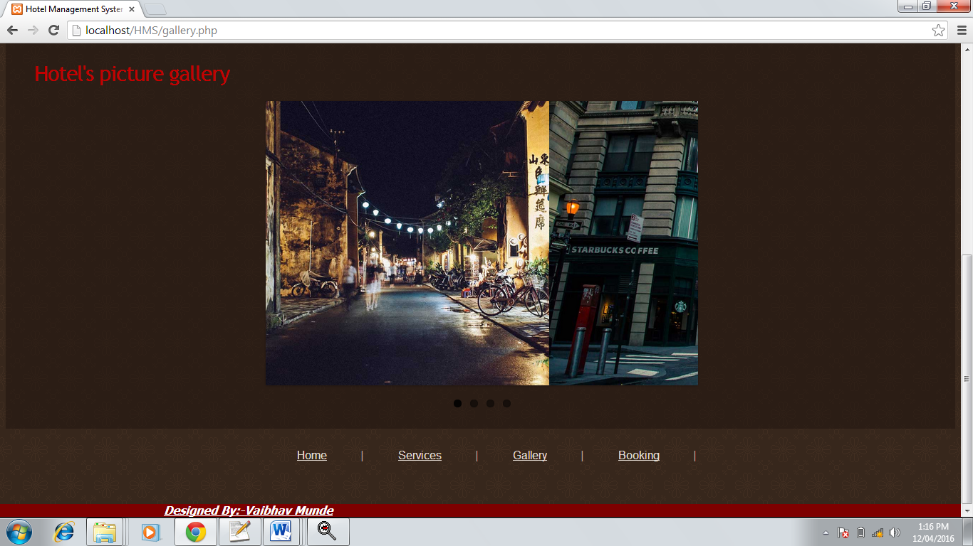

**Codding:**

<html>

<head>

<title>Hotel Management System | Gallery</title>

<meta http-equiv="Content-Type" content="text/html; charset=utf-8" />

<link href="style.css" rel="stylesheet" type="text/css" />

<link href="layout.css" rel="stylesheet" type="text/css" />

</head>

<body id="page3" onload="new ElementMaxHeight();">

<div id="main">

<!-- header -->

<div id="header" class="small">

<div class="row-1">

<div class="wrapper">

<div class="logo">

<h1><a href="#">Five Star</a></h1>

<em>Hotel</em> <strong>True Luxury</strong> </div>

<div class="phones"> +91-8378905443<br />

+91-7066715805 </div>

</div>

</div>

<div class="row-2">

<div class="indent">

<!-- header-box-small begin -->

<div class="header-box">

<div class="inner">

<ul class="nav">

<li><a href="index.php">Home page</a></li>

<li><a href="services.php">Services</a></li>

<li><a href="gallery.php" class="current">Gallery</a></li>

<li><a href="booking.php">Booking</a></li>

<li><a href="Feedback.php">feedback</a></li>

</ul>

</div>

</div>

<!-- header-box-small end -->

</div>

</div>

</div>

<!-- content -->

<div id="content">

<div class="container">

<div class="content">

<div class="indent">

<h2>Hotel's picture gallery</h2>

<div class="gallery-main png" style="margin-left:25%;">

<div class="inner owl-carousels">

<img class="item" alt="" src="images/bg1.jpg" style="height:400px" />

<img class="item" alt="" src="images/bg2.jpg" style="height:400px" />

<img class="item" alt="" src="images/bg3.jpg" style="height:400px" />

<img class="item" alt="" src="images/3page-img13.jpg" style="height:400px" />

</div>

</div>

</div>

</div>

<div class="clear"></div>

</div>

</div>

<!-- footer -->

<div id="footer">

<ul class="nav">

<li><a href="index.php">Home</a>|</li>

<li><a href="services.php">Services</a>|</li>

<li><a href="gallery.php">Gallery</a>|</li>

<li><a href="booking.php">Booking</a>|</li>

</ul>

<div class="wrapper">

</div>

</div>

</div>

<marquee behavior=alternate bgcolor="#7e0000"><b><i><a href=contectus.php><font color="white">Designed By:Nayana Lokhande</a></i></b></font></marquee>

</body>

<!-- owl carousel -->

<link rel="stylesheet" href="js/owl.carousel.css">

<script src="js/vendor/jquery-1.11.1.min.js"></script>

</script></html>

**Snapshot 4** :

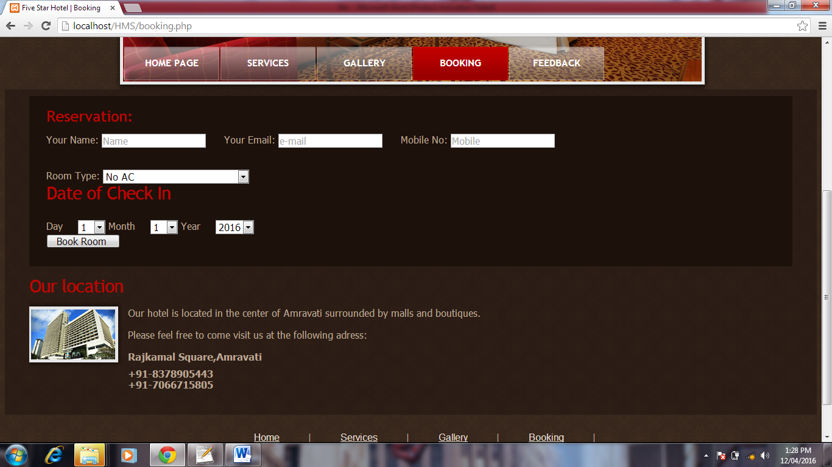

**Codding :**

<html>

<head>

<title>Five Star Hotel | Booking</title>

<meta http-equiv="Content-Type" content="text/html; charset=utf-8" />

<link href="style.css" rel="stylesheet" type="text/css" />

<link href="layout.css" rel="stylesheet" type="text/css" />

<script src="maxheight.js" type="text/javascript"></script>

</head>

<body id="page5" onload="new ElementMaxHeight();">

<div id="main">

<!-- header -->

<div id="header">

<div class="row-1">

<div class="wrapper">

<div class="logo">

<h1><a href="#">Five Star</a></h1>

<em>Hotel</em> <strong>True Luxury</strong> </div>

<div class="phones"> +91-8378905443<br />

+91-7066715805 </div>

</div>

</div>

<div class="row-2">

<div class="indent">

<!-- header-box begin -->

<div class="header-box">

<div class="inner">

<ul class="nav">

<li><a href="index.php">Home page</a></li>

<li><a href="services.php">Services</a></li>

<li><a href="gallery.php">Gallery</a></li>

<li><a href="booking.php" class="current">Booking</a></li>

<li><a href="feedback.php">Feedback</a></li>

</ul>

</div>

</div>

<!-- header-box end -->

</div>

</div>

</div>

<!-- content -->

<div id="content">

<div class="wrapper">

<div class="aside maxheight">

<!-- box begin -->

<div class="box maxheight">

<div class="inner">

<h3>Reservation:</h3>

<form method="post" action="book.php">

Your Name: <input type="text" class="input" placeholder="Name" name="name"/>

&nbsp;&nbsp;&nbsp;&nbsp;&nbsp;Your Email: <input type="text" class="input" name="email" placeholder="e-mail" />

&nbsp;&nbsp;&nbsp;&nbsp; Mobile No: <input type="text" class="input" placeholder="Mobile" name="mobile" />

<br><br><br>

Room Type: <select name="type">

<option value="No AC">No AC</option>

<option value="With 1 Ac">With 1 AC</option>

<option value="With More Than one Bedroom">With More Than one Bedroom</option>

</select>

<h2>Date of Check In</h2><br>

Day &nbsp;&nbsp;&nbsp;&nbsp;<select name="day">

<?php for ($i=1;$i<=31;$i++) { ?>

<option value="<?php echo $i;?>"><?php echo $i;?></option>

<?php }?>

</select>

Month &nbsp;&nbsp;&nbsp;&nbsp;<select name="month">

<?php for ($i=1;$i<=12;$i++) { ?>

<option value="<?php echo $i;?>"><?php echo $i;?></option>

<?php }?>

</select>

Year &nbsp;&nbsp;&nbsp;&nbsp;<select name="year">

<?php for ($i=2016;$i<=2020;$i++) { ?>

<option value="<?php echo $i;?>"><?php echo $i;?></option>

<?php }?>

</select>

<br> <input type="submit" value=" Book Room " />

</form>

</div>

</div>

<!-- box end -->

</div>

<div class="content">

<div class="indent">

<h2>Our location</h2>

<img class="img-indent png" alt="" src="images/5page-img1.png" />

<div class="extra-wrap">

<p class="alt-top">Our hotel is located in the center of Amravati surrounded by malls and boutiques.</p>

<p>Please feel free to come visit us at the following adress:</p>

<dl class="contacts-list">

<dt>Rajkamal Square,Amravati</dt>

<dd>+91-8378905443</dd>

<dd>+91-7066715805</dd>

</dl>

</div>

<div class="clear"></div>

</div>

</div>

</div>

</div>

<!-- footer -->

<div id="footer">

<ul class="nav">

<li><a href="index.php">Home</a>|</li>

<li><a href="services.php">Services</a>|</li>

<li><a href="gallery.php">Gallery</a>|</li>

<li><a href="booking.php">Booking</a>|</li>

</ul>

<div class="wrapper">

</div>

</div>

</div>

<marquee behavior=alternate bgcolor="#7e0000"><b><i><a href=contectus.php><font color="white">Designed By:- Nayana Lokhande </a></i></b></font></marquee>

</body>

</html>

**Snapshot 5** :

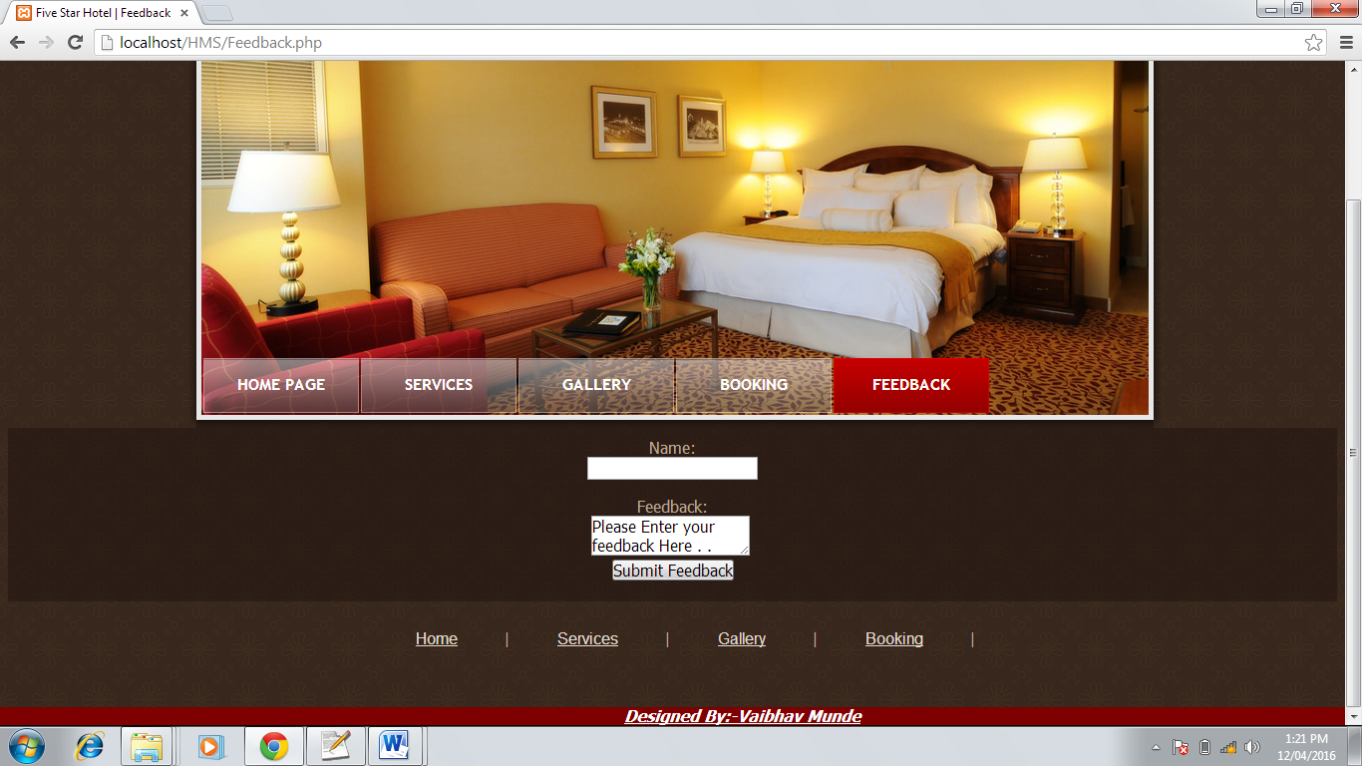

**Codding :**

<html>

<head>

<title>Five Star Hotel | Feedback</title>

<meta http-equiv="Content-Type" content="text/html; charset=utf-8" />

<link href="style.css" rel="stylesheet" type="text/css" />

<link href="layout.css" rel="stylesheet" type="text/css" />

<script src="maxheight.js" type="text/javascript"></script>

</head>

<body id="page6" onload="new ElementMaxHeight();">

<div id="main">

<!-- header -->

<div id="header" class="small">

<div class="row-1">

<div class="wrapper">

<div class="logo">

<h1><a href="#">Five Star</a></h1>

<em>Hotel</em> <strong>True Luxury</strong> </div>

<div class="phones"> +91-8378905443<br />

+91-7066715805 </div>

</div>

</div>

<div class="row-2">

<div class="indent">

<!-- header-box-small begin -->

<div class="header-box">

<div class="inner">

<ul class="nav">

<li><a href="index.php">Home page</a></li>

<li><a href="services.php">Services</a></li>

<li><a href="gallery.php">Gallery</a></li>

<li><a href="booking.php">Booking</a></li>

<li><a href="feedback.php" class="current">Feedback</a></li>

</ul>

</div>

</div>

<!-- header-box-small end -->

</div>

</div>

</div>

<!-- content --><center>

<div id="content">

<form action="feed.php" method="post">

Name:<br><input type="text" name="name"><br><br>

Feedback:<br><textarea name="comment">Please Enter your feedback Here . .</textarea>

<br> <input type="submit" value="Submit Feedback" />

</form>

</div><c//]enter>

<!-- footer -->

<div id="footer">

<ul class="nav">

<li><a href="index.php">Home</a>|</li>

<li><a href="services.php">Services</a>|</li>

<li><a href="gallery.php">Gallery</a>|</li>

<li><a href="booking.php">Booking</a>|</li>

</ul>

<div class="wrapper">

</div>

</div>

</div>

<marquee behavior=alternate bgcolor="#7e0000"><b><i><a href=contectus.php><font color="white">Designed By:- Nayana Lokhande </a></i></b></font></marquee>

</body>

</html>

**REFERENCES:**

*[1]* [*http://www.netscapeworld.com/nw-03-1997/nw-03-watermark.html*](http://www.netscapeworld.com/nw-03-1997/nw-03-watermark.html)

*[2] http://www.w3school.com/css.html*

*[3] http://www.w3school.com/html.html*

*[4]* *www.tutorialspoint.com*

*[5]* *ww.heromotocorp.com*