HTML

Introduction

* HTML is an acronym which stands for Hyper Text Markup Language.
* Tim Berners-Lee is known as father of HTML.
* HTML is used to create static web pages.
* Markup tags tell web browsers how to display the page (page formatting and layout).
* An HTML file has an extension .html

eg: new.html

Hyper Text:

* text has a link within it, is a hypertext.

Markup language:

* A markup language is a programming language that is used make text more interactive and dynamic. It can turn a text into images, tables, links etc.

Structure of HTML Document

<html>

<head>

Document header related tags

</head>

<body>

Document body related tags

</body>

</html>

Basically an HTML document contains two parts

1.head section

2.body section

1. head section

In head section contains all the invisible details of that documents. Such as file,styles,scripts.

2. body section

It contains elements that is to be visible to users.

HTML Tags

HTML tags are used to markup HTML elements.

eg: <p> </p> ->tag for paragraphs

<p> start tag

</p> end tag

<br> break tag

HTML Attribute

* HTML attributes are special words which provide additional information about the elements or attributes are the modifier of the HTML element.
* Each element or tag can have attributes, which defines the behaviour of that element.
* Attributes should always be applied with start tag.
* You can add multiple attributes in one HTML element but need to give space between two attributes.
* Syntax

**<element** attribute_name="value"**>**content**</element>**

Example

<h1 title="This is heading tag">Example of title attribute</h1>

HTML Anchor

The **HTML anchor tag** defines *a hyperlink that links one page to another page*. It can create hyperlink to other web page as well as files, location, or any URL. The "href" attribute is the most important attribute of the HTML a tag. and which links to destination page or URL.

href attribute of HTML anchor tag

The href attribute is used to define the address of the file to be linked. In other words, it points out the destination page.

Syntax

<a href = "..........."> Link Text </a>

Example

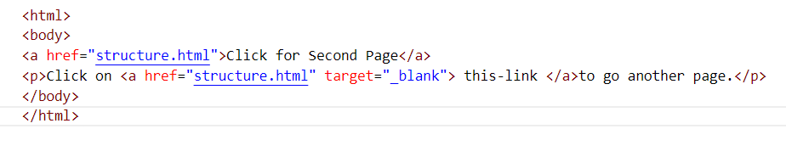

Output

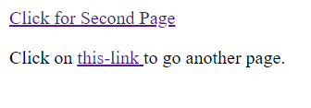

**Image**

**HTML img tag** is used to display image on the web page. **img** tag is an empty tag that contains attributes only, closing tags are not used in image element.

**Attributes**

**1) src**

It is a necessary attribute that describes the source or path of the image. The location of image may be on the same directory or another server.

**2) alt**

The alt attribute defines an alternate text for the image, if it can't be displayed.

**3) width**

It is an optional attribute which is used to specify the width to display the image.

**4) height**

It is an optional attribute which is used to specify the height to display the image.

Example

<html>

<head>

    <title>Image tag</title>

</head>

<body>

<h2>HTML image example with height and width</h2>

<img src="xmas.jfif" height="180" width="300" alt="xmas image">

</body>

</html>

**Use <img> tag as a link**

We can also link an image with other page or we can use an image as a link. To do this, put <img> tag inside the <a> tag.

Example

<html>

  <head>

    <title>Image tag</title>

  </head>

<body>

    <h2>Use image as a link</h2>

   <p>Click on the image to know about Details</p>

  <a href="structure.html"><img src="xmas.jfif" height="100" width="100" title="Click Here"></a>

  </body>

</html>

HTML tag classification

1. Text tags

2. Multimedia

3. Container elements

4. Links

5. form elements

1. Text tags

a. headings

b. paragraphs

c. lists

a. headings

* There are six different HTML headings which are defined with the <h1> to <h6> tags.
* <h1> is the largest heading tag and <h6> is the smallest heading tag.

Example

<h1>Heading no. 1</h1>

<h2>Heading no. 2</h2>

<h3>Heading no. 3</h3>

<h4>Heading no. 4</h4>

<h5>Heading no. 5</h5>

<h6>Heading no. 6</h6>

b. paragraphs

* HTML paragraph or HTML <p> tag is used to define a paragraph within a webpage.

Example

<p>My First Paragraph</p>

<p>My Second Paragraph</p>

c. lists

* Unordered List
* Ordered List
* Description List (Definition List)

Unordered List

An unordered list starts with <ul> tags and each item will be marked with bullets. (small black circles).  We can use unordered list where we do not need to display items in any particular order. There can be 4 types of bulleted list:

* disc
* circle
* square
* none
* To represent different ordered lists, there are 4 types of attributes in <ul> tag. (Default is disc)

|  |  |
| --- | --- |
| **Type** | **Description** |
| Type "disc" | This is the default style. In this style, the list items are marked with bullets. |
| Type "circle" | In this style, the list items are marked with circles. |
| Type "square" | In this style, the list items are marked with squares. |
| Type "none" | In this style, the list items are not marked. |

Example

<html>

<body>

<ul type="circle">

 <li>Computer Science</li>

 <li>Civil</li>

 <li>Mechanical</li>

 <li>Electronics</li>

</ul>

</body>

</html>

OUTPUT

* Computer Science
* Civil
* Mechanical
* Electronics

Ordered List

Ordered List or Numbered List displays elements in numbered format. The HTML ol tag is used for ordered list.

To represent different ordered lists, there are 5 types of attributes in <ol> tag.(Default is 1,2,3,4)

|  |  |
| --- | --- |
| **Type** | **Description** |
| Type "1" | This is the default type. In this type, the list items are numbered with numbers. |
| Type "I" | In this type, the list items are numbered with upper case roman numbers. |
| Type "i" | In this type, the list items are numbered with lower case roman numbers. |
| Type "A" | In this type, the list items are numbered with upper case letters. |
| Type "a" | In this type, the list items are numbered with lower case letters. |

Example

<html>

<body>

<ol type="I">

 <li>Ordered List</li>

 <li>Unordered List</li>

 <li>Description List</li>

 <li>Definition List</li>

</ol>

</body>

</html>

OUTPUT

1. Ordered List
2. Unordered List
3. Description List
4. Definition List

Description List (Definition List)

**Description List** or Definition List displays elements in definition form like in dictionary. The <dl>, <dt> and <dd> tags are used to define description list.

The description list tags are given below:

1. **<dl> tag** defines the description list.
2. **<dt> tag** defines data term.
3. **<dd> tag** defines data definition (description).

Example

<dl>

<dt>Coffee</dt>

<dd>Black hot drink</dd>

<dt>Milk</dt>

<dd>White cold drink</dd>

</dl>

OUTPUT

Coffee

Black hot drink

Milk

White cold drink

Text Formatting Tags

1. Bold

The HTML <b> element defines bold text, without any extra importance.

<b>Bold Text</b>

2. Italic

The HTML <i> element defines italic text, without any extra importance.

<i>Italic Text</i>

3. Underline

The HTML <u> element displays a text with an underline

<u>Underlined Text</u>

HTML Font

HTML <font> tag is used to add style, size, and color to the text on a web page. The font tag is having three attributes called size, color, and face to customize your fonts. The face attribute specifies the font family like "Times New Roman", "Verdana", etc.

Example

<font face="Times New Roman">

Font Family is Times New Roman

</font>

<font face="Verdana">

Font Family is Verdana

</font>

The font size attribute specifies the size of the text. The range of accepted values is from 1(smallest) to 7(largest). The default size of a font is 3.

Example

<font size=”1”>Font Size 1</font>

<font size=”2”>Font Size 2</font>

<font size=”3”>Font Size 3</font>

<font size=”4”>Font Size 4</font>

<font size=”5”>Font Size 5</font>

<font size=”6”>Font Size 6</font>

<font size=”7”>Font Size 7</font>

The font color attribute specifies the color of the text.

Example

<font color=” red”>This text is in red color</font>

<font color=” blue”>This text is in blue color</font>

2. Multimedia

Multimedia comes in many different formats. It can be almost anything you can hear or see.

Examples: Images, audios, videos etc.

<video width="320" height="240" controls autoplay loop>

  <source src="Tom_And_Jerry_-_Polka_Dot_Puss_Part_2-590330.mp4" type="video/mp4">

  Your browser does not support the html video tag.

</video>

<audio controls>

<source src="file_example_OOG_1MG.ogg" type="audio/ogg"></source>

</audio>

3. Container elements

They are html elements that can contain other elements.

eg: tables

Tables are defined with the <table> tag and the tables are divided into table rows with <tr> tag.

Table row are again divided into table data. <td>tag.

A table row can also divide into table heading <th> tag.

Example:- 1

<html>

<body>

<table cellspacing="20" >

<tr><th>First_Name</th><th>Last_Name</th><th>Marks</th></tr>

<tr><td>Kiran</td><td>Singh</td><td>100</td></tr>

<tr><td>Jasin</td><td>Wilson</td><td>200</td></tr>

<tr><td>Swetha</td><td>Mohan</td><td>122</td></tr>

<tr><td>Anu</td><td>Augustian</td><td>452</td></tr>

</table>

</body>

</html>

OUTPUT

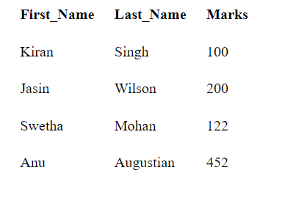

**Example: - 2** **Border attribute and caption**

* HTML caption is displayed above the table. It must be used after table tag only.

<html>

<body>

<table border="2" >

<caption>Student Records</caption>

<tr><th>First_Name</th><th>Last_Name</th><th>Marks</th></tr>

<tr><td>Kiran</td><td>Singh</td><td>100</td></tr>

<tr><td>Jasin</td><td>Wilson</td><td>200</td></tr>

<tr><td>Swetha</td><td>Mohan</td><td>122</td></tr>

<tr><td>Anu</td><td>Augustian</td><td>452</td></tr>

</table>

</body>

</html>

OUTPUT

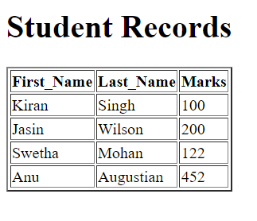

Example: - 2 **Border property using CSS**

<html>

<head>

<style>

table, th, td {

    border: 1px solid black;

}

</style>

</head>

<body>

<table>

<tr><th>First_Name</th><th>Last_Name</th><th>Marks</th></tr>

<tr><td>Sonoo</td><td>Jaiswal</td><td>60</td></tr>

<tr><td>James</td><td>William</td><td>80</td></tr>

<tr><td>Swati</td><td>Sironi</td><td>82</td></tr>

<tr><td>Chetna</td><td>Singh</td><td>72</td></tr>

</table>

</body>

</html>

**Example: - 3 Table with colspan**

If you want to make a cell span more than one column, you can use the colspan attribute.

<html>

<head>

    <h1>Table with colspan</h1>

</head>

<body>

    <table  border="1">

        <tr>

          <th>Name</th>

          <th colspan="2">Mobile No.</th>

        </tr>

        <tr>

          <td>Ajeet Maurya</td>

          <td>7503520801</td>

          <td>9555879135</td>

        </tr>

      </table>

</body>

</html>

OUTPUT

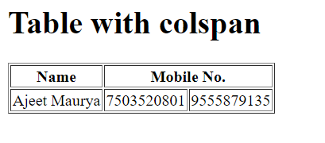

**Example: - 4** **Table with rowpan**

* If you want to make a cell span more than one row, you can use the rowspan attribute.
* It will divide a cell into multiple rows.

<html>

<head>

    <h1>Table with colspan</h1>

</head>

<body>

<table border="1">

<tr><th>Name</th><td>Ajeet Maurya</td></tr>

<tr><th rowspan="2">Mobile No.</th><td>7503520801</td></tr>

<tr><td>9555879135</td></tr>

</table>

</body>

</html>

OUTPUT

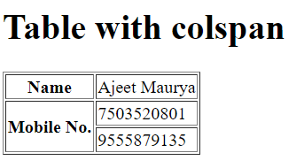

**Example work**

