--1ST QUERY

--1) Write a query to fetch the details of the books written by author whose name ends with er

SELECT * FROM BOOK WHERE AUTHOR LIKE '%ER'

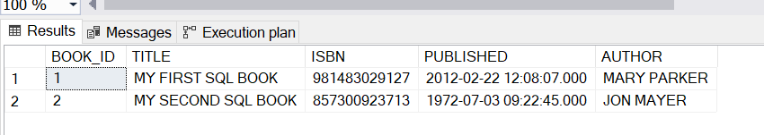

--2ND QUERY

2 )Display the Title ,Author and ReviewerName for all the books from the above table

select B.TITELE ,B.AUTHOR ,R.R_NAME

from BOOK B, REVIEW R

where R.book_id = B.BOOK_ID;

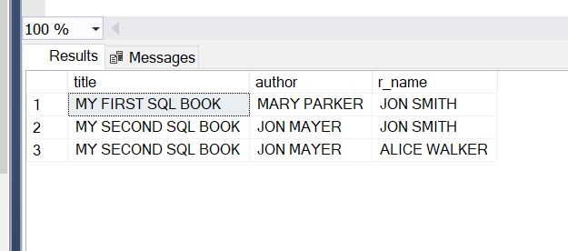

--3ND QUERY

--3)Display the reviewer name who reviewed more than one book.

SELECT R_NAME,COUNT(*) AS 'TIMES OF REVIEW'

FROM REVIEW

GROUP BY R_NAME

HAVING COUNT(*)>1

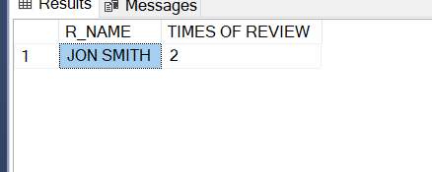

--4TH QUERY

--4)Display the Name for the customer from above customer table who live in same address which has character o anywhere in address

SELECT C_NAME,C_ADDRESS

FROM CUSTOMER

WHERE C_ADDRESS LIKE '%[O]%'

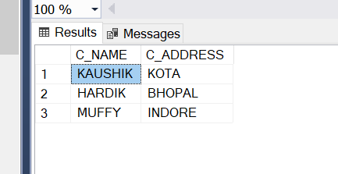

--5TH QUERY

--5)Write a query to display the Date,Total no of customer placed order on same Date

SELECT ORDER_DATE,COUNT(C_ID) AS 'NO OF CUSTOMER'

FROM ORDERS

GROUP BY ORDER_DATE;

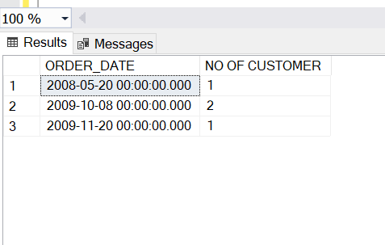

-- 6TH QUERY

--6) Display the Names of the Employee in lower case, whose salary is null

SELECT LOWER(E_NAME)

FROM EMPLOYEE

WHERE SALARY IS NULL;

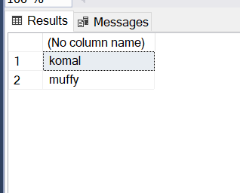

--7TH QUERY

--7)Write a sql server query to display the Gender,Total no of male and female from the above relation.

SELECT GENDER ,COUNT(GENDER)

FROM STUDENT

GROUP BY GENDER

