**Part 1 Result Format**

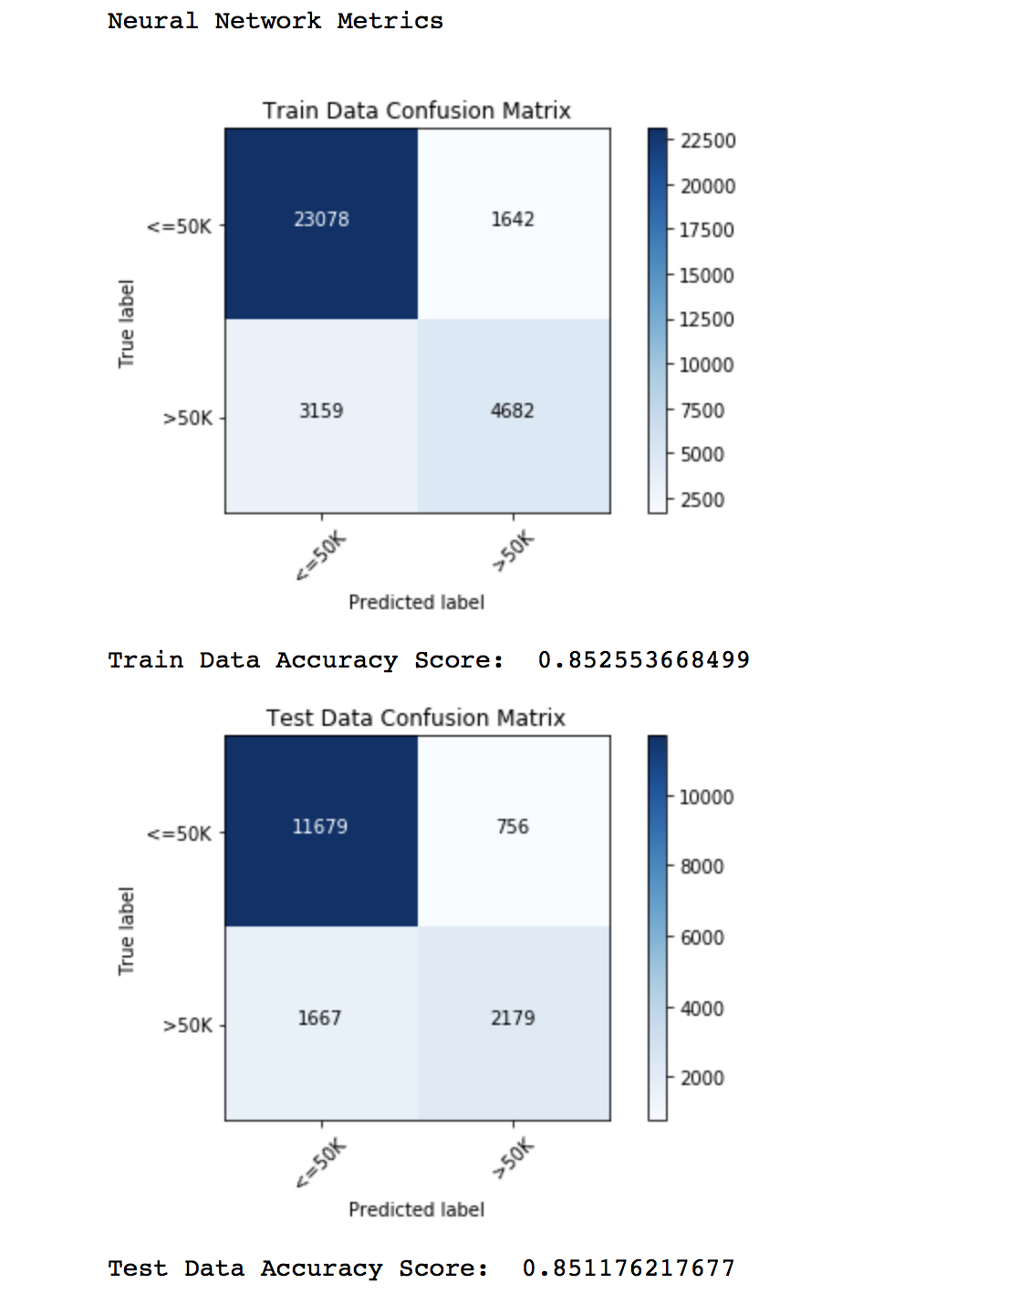

All other models in the Part 1 will print the Confusion Matrix and Accuracy Score similarly.

**Part 2 Result Format**

Neural Network Metrics

Training Mean squared error: 3181.60

Test Mean squared error: 2946.09

Metrics after 5-fold CV

Test Mean squared error: 13174.08

In [275]:

Linear Regression Metrics:

Training Mean squared error: 19411.97

Test Mean squared error: 16853.71

Metrics after 5-fold CV

Test Mean squared error: 16729.32

In [277]:

KNN with k=8 Metrics

Training Mean squared error: 8560.51

Test Mean squared error: 9234.95

Metrics after 5-fold CV

Test Mean squared error: 12913.93