**Code is written in R Language**

#install some packages required

install.packages("tidyr")

install.packages("sqldf")

library(tidyr)

#Read data from CSV file

texas_cities_data<- read.csv("texas-cities.csv", header = T)

View(texas_cities_data)

cities_to_county<-read.csv("cities-to-county.csv", header = T)

Create dataframes

#View(texas_cities_data)

dataframe1<-data.frame(texas_cities_data)

dataframe_county<-data.frame(cities_to_county)

Rename the column names of dataframe for user convinience

#View(dataframe1)

colnames(dataframe1) <- c("Name", "2010","2011","2012","2013","2014","2015","2016","2017")

View(dataframe1)

colnames(dataframe_country)[2] <- "Name"

#Texas_Cities_Country<- merge(dataframe1, dataframe_country, by = "Category", all. = TRUE)

Convert the upper case to lowercase in cities_to_county dataframe

levels(dataframe_county$Name) <- tolower(levels(dataframe_country$Name))

levels(dataframe_cities$Name) <- tolower(levels(dataframe_cities$Name))

View(dataframe_cities)

Texas_Cities_County <- merge(dataframe_cities,dataframe_country,by.dataframe_cities="Name",by.dataframe_country="Name")

View(Texas_Cities_County)

dataframe_cities_county<-data.frame(Texas_Cities_Country)

View(dataframe_cities_county)

total <- merge(dataframe_cities,dataframe_country,by="Name")

View(total)

#Separate Cities, towns and villages

dataframe2<-data.frame(separate(data = dataframe1, col = Name, into = c("City_town_village", "State"), sep = ","))

View(dataframe2)

dataframe3<-data.frame(separate(data = dataframe2, col = City_town_village, into = c("City" ,"town","village","v1"), sep = " "))

View(dataframe3)

library(sqldf)

colnames(dataframe3)[1] <- "city_name"

colnames(dataframe3)[2] <- "t_1"

colnames(dataframe3)[3] <- "v_1"

library(stringr)

library(dplyr)

dataframe4<-data.frame(dataframe3 %>%

filter(str_detect(t_1, "city")))

View(dataframe4)

dataframe4<-data.frame(dataframe3 %>%

filter(str_detect(t_1, "city")))

dataframe4[3:4] <- NULL

dataframe5[4] <- NULL

dataframe5<-data.frame(dataframe3 %>%

filter(str_detect(v_1, "city")))

View(dataframe5)

dataframe6<-data.frame(dataframe3 %>%

filter(str_detect(v1, "city")))

View(dataframe6)

dataframe_cities <- rbind(dataframe4, dataframe5, dataframe6)

View(dataframe_cities)

View(dataframe3)

dataframe7<-data.frame(dataframe3 %>%

filter(str_detect(t_1, "town")))

dataframe10<-data.frame(dataframe3 %>%

filter(str_detect(v_1, "town")))

View(dataframe7)

dataframe10[4] <- NULL

dataframe10$city_name <- paste(dataframe10$city_name," ",dataframe10$t_1)

dataframe10[2] <- NULL

colnames(dataframe10)[2] <- "t_1"

dataframe_town <- rbind(dataframe7, dataframe10)

View(dataframe_town)

View(dataframe8)

dataframe7[3:4] <- NULL

dataframe8<-data.frame(dataframe3 %>%

filter(str_detect(v_1, "village")))

dataframe8[4] <- NULL

dataframe11<-data.frame(dataframe3 %>%

filter(str_detect(t_1, "village")))

View(dataframe8)

dataframe11[3] <- NULL

View(dataframe11)

dataframe8$city_name <- paste(dataframe8$city_name," ",dataframe8$t_1)

dataframe8[2] <- NULL

colnames(dataframe8)[2] <- "t_1"

dataframe_village <- rbind(dataframe8, dataframe11)

View(dataframe_village)

dataframe9$city_name<-data.frame(within(dataframe5, city <- paste(city_name, t_1, sep=' ')))

View(dataframe9)

#dataframe5$city<-c("city_name","t_1")

dataframe5$city_name <- paste(dataframe5$city_name," ",dataframe5$t_1)

View(dataframe5)

dataframe5[2] <- NULL

dataframe5[13] <- NULL

dataframe6$city_name <- paste(dataframe6$city_name," ",dataframe6$t_1," ", dataframe6$v_1)

View(dataframe6)

dataframe6[2] <- NULL

dataframe6[2] <- NULL

colnames(dataframe4)[2] <- "v1"

colnames(dataframe5)[2] <- "v1"

#dataframe5[12] <- NULL

dataframe_cities <- rbind(dataframe4, dataframe5, dataframe6)

View(dataframe_cities)

colnames(dataframe_cities) <- c("Name","Category","State","Y_2010","Y_2011","Y_2012","Y_2013","Y_2014","Y_2015","Y_2016","Y_2017")

colnames(dataframe_town) <- c("Name","Category","State","Y_2010","Y_2011","Y_2012","Y_2013","Y_2014","Y_2015","Y_2016","Y_2017")

colnames(dataframe_village) <- c("Name","Category","State","Y_2010","Y_2011","Y_2012","Y_2013","Y_2014","Y_2015","Y_2016","Y_2017")

**1)What was the largest city, town, and village in each year?**

**ANS: City: Houston**

**Town:Flower Mound**

**Village: The Hills**

d1_cities<-data.frame(dataframe_cities[

with(dataframe_cities, order(-Y_2011)),

])

View(d1_cities)

View(head(d1_cities, n = 1L))

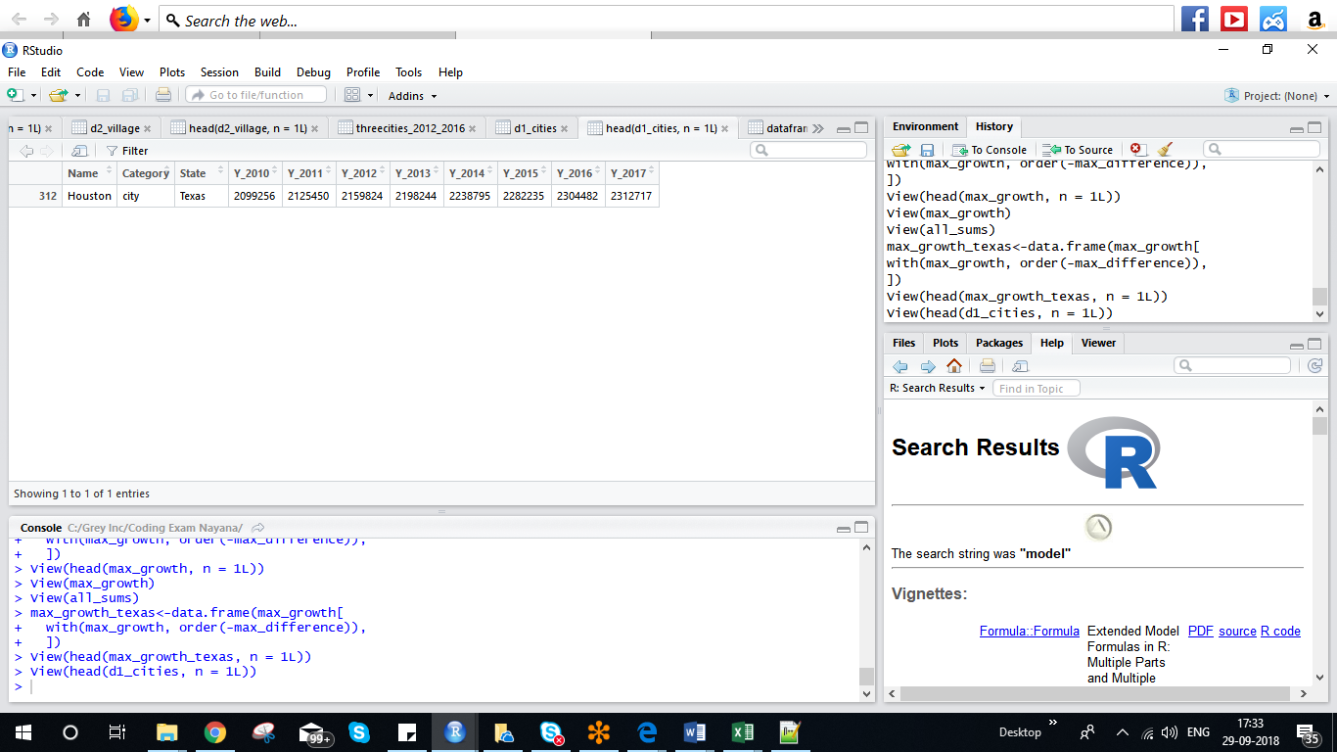

d2_town<-data.frame(dataframe_town[

with(dataframe_town, order(-Y_2011)),

])

View(d2_town)

View(head(d2_town, n = 1L))

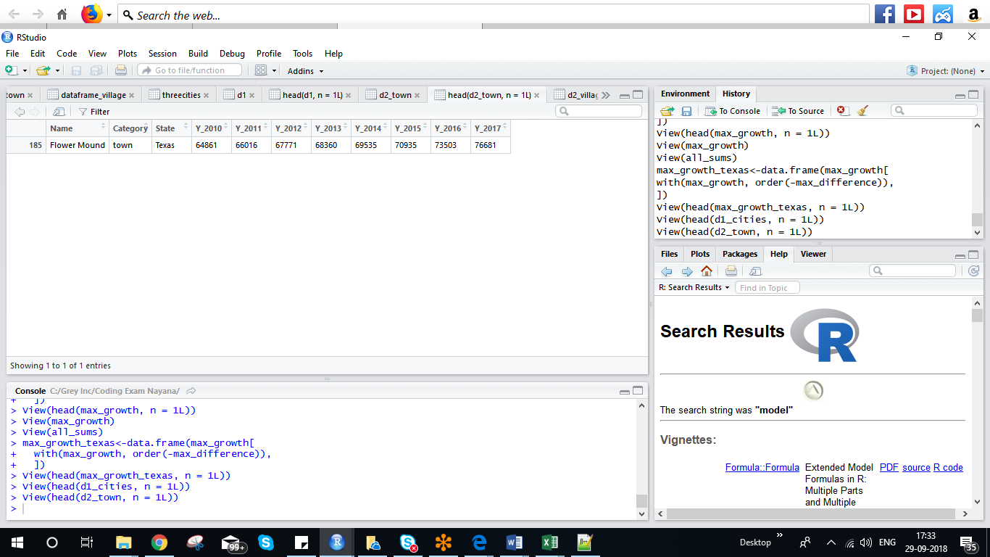

d2_village<-data.frame(dataframe_village[

with(dataframe_village, order(-Y_2011)),

])

View(d2_village)

View(head(d2_village, n = 1L))

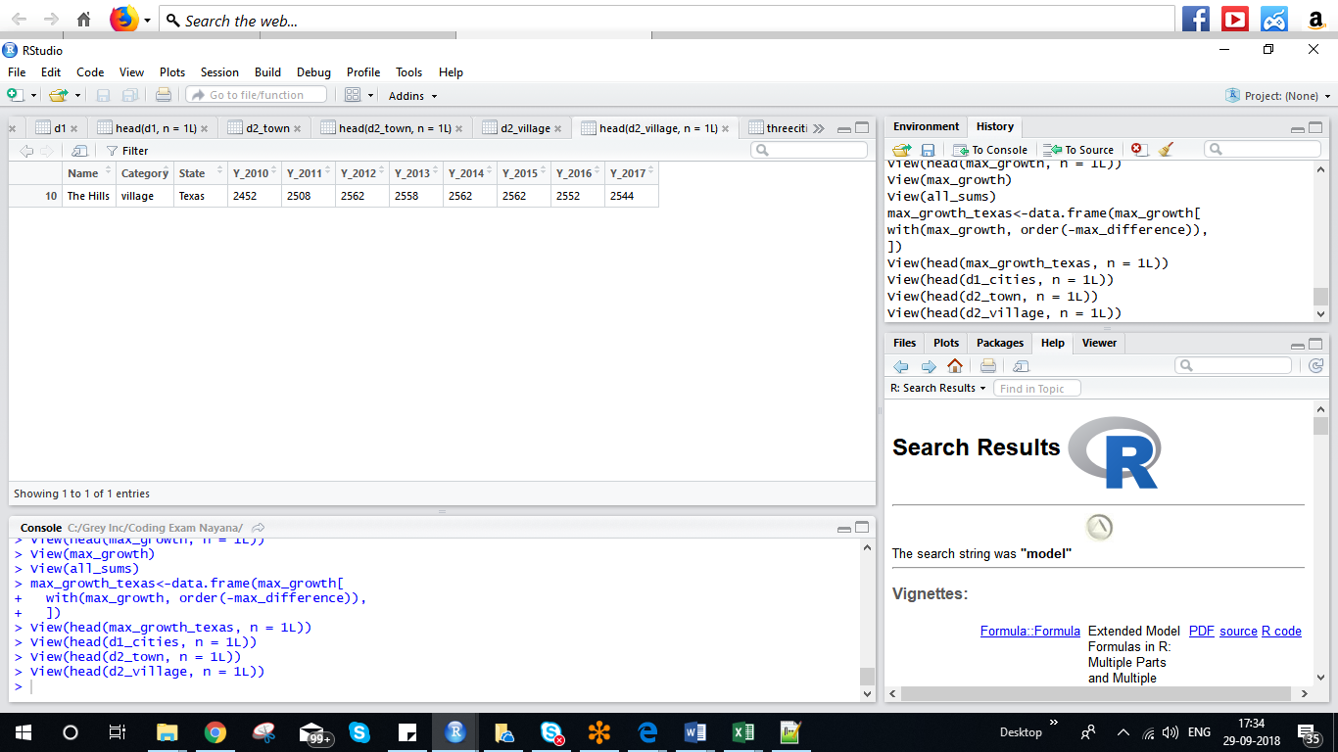

**2)What are the three fastest growing cities in Texas between 2012-2016?**

**ANS: Houston, San Antonio, Dallas**

threecities<-data.frame((head(d1_cities, n = 3L)))

View(threecities)

threecities_2012_2016 <- data.frame(threecities[c(1:3,6:10)])

View(threecities_2012_2016)

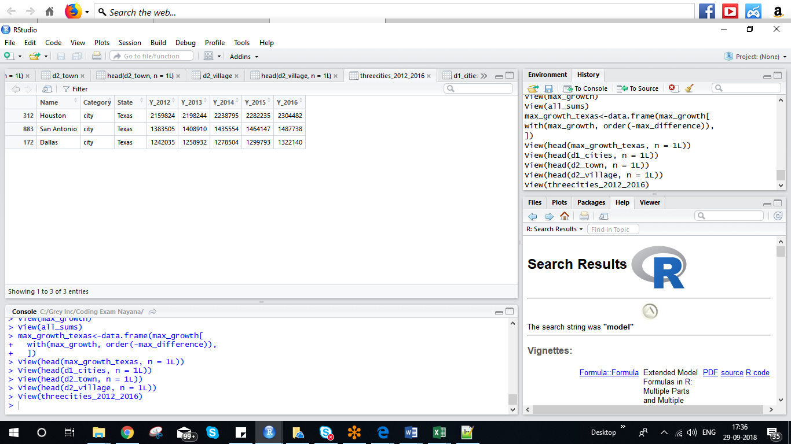

**3) Which county had the most population in each year?**

Merge Data frames based on city as a unique field

Texas_Cities_County<- merge(dataframe_cities, dataframe_county, by = "Name")

Texas_Cities_County<-data.frame(Texas_Cities_County[

with(Texas_Cities_County, order(-Y_2011)),

])

View(Texas_Cities_County)

View(head(Texas_Cities_County, n = 1L))

**5) Which county experienced the highest rate of growth from 2014-2016?**

Texas_Cities_County<-data.frame(Texas_Cities_County[

with(Texas_Cities_County, order(-Y_2011)),

])

View(Texas_Cities_County)

df<-data.frame(head(Texas_Cities_County, n = 1L))

county_2014_2016 <- data.frame(df[c(1:3,8:10)])

**6) What percentage of Texans lived in towns in 2017?**

**Ans:1.8%**

sum_2017_cities<-sum(dataframe_cities$Y_2017)

sum_2017_towns<-sum(dataframe_town$Y_2017)

sum_2017_villages<-sum(dataframe_village$Y_2017)

Total_2017_population<- sum_2017_cities+sum_2017_towns+sum_2017_villages

Percentage_of_texans_in_towns<-(sum_2017_towns/Total_2017_population)*100

View(Percentage_of_texans_in_towns)

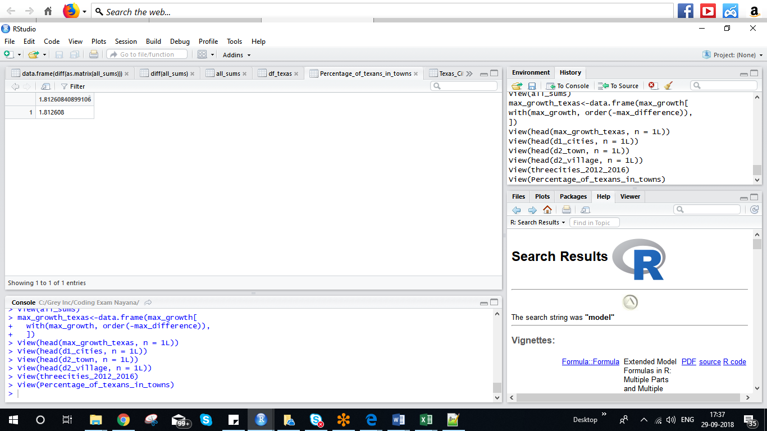

**7) Which year did Texas grow the most?**

**Ans:2015**

dataframe_village <- rbind(dataframe8, dataframe11)

Texas_total_population<-rbind(dataframe_cities,dataframe_town, dataframe_village )

df_texas<-data.frame(Texas_total_population)

View(df_texas)

all_sums<-data.frame(colSums(Filter(is.numeric, df_texas)))

View(all_sums)

colnames(all_sums)<-c("Total_population")

View(apply( all_sums , 2 , diff ))

all_sums[ , diff := value - shift(value), by = Total_population]

max_growth<-data.frame(diff(all_sums$Total_population))

colnames(max_growth)<-c("max_difference")

View(max_growth)

max_growth_texas<-data.frame(max_growth[

with(max_growth, order(-max_difference)),

])

View(head(max_growth_texas, n = 1L))

