LAB 2 ASSIGNMENT

1.
FIND IF THE NUMBER IS POSITIVE,NGATIVE OR ZERO

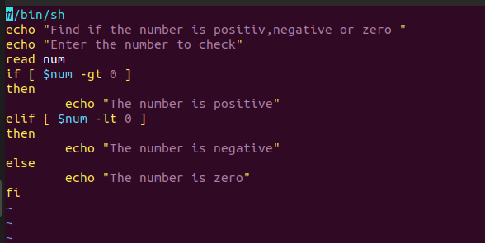

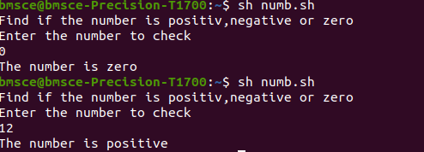

2.
FIND THE GREATEST OF THREE NUMBERS

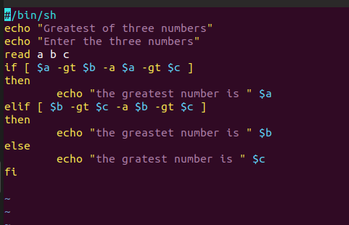

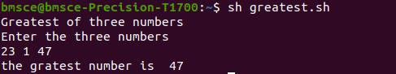

3.
FIND IF THE GIVEN YEAR IS LAEP YEAR OR NOT
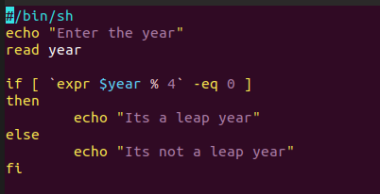

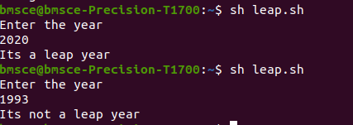

4.
FIND THE AREA OF THE CIRCLE

