***USP LAB- 1 ASSIGNMENT***

1. Find the present Directory



1. Write the / directory structure

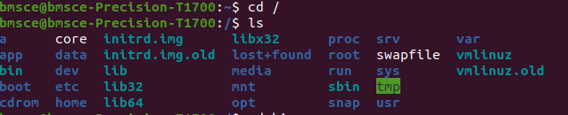

1. Write a few commands available in /bin and /sbin directory

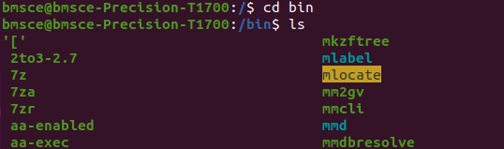

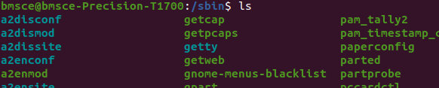

1. Create a new Directory test



1. Write the permissions of test directory

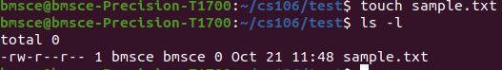

1. Copy the file /etc/resolv.conf in test directory



1. Rename the test directory to testing



1. Change the permissions of testing directory to 775



1. Change the permissions of /tmp directory to 700



1. Change the permissions of guest directory to 700

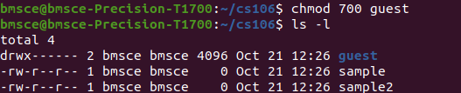

1. Delete the testing directory



1. The location of kernel files in Unix File System is /boot and by looking at the kernel file, write the kernel version you are using in your system.

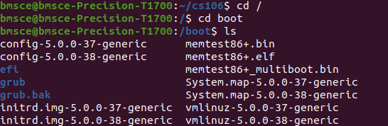

1. Change directory to /



1. List the contents of /home directory



1. Create a file sidbi in the home directory



1. Find the permissions of the file sidbi

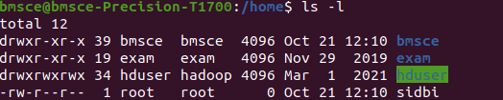

1. Find the inode number of file sidbi (hint: ls –li)

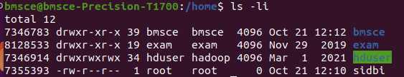

1. Copy the file sidbi to sidbi1



1. Find the inode number of file sidbi1 (hint: ls –li)

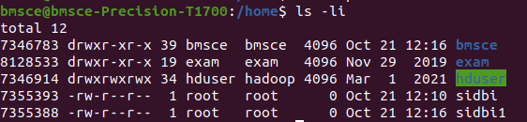’

1. Move the file sidbi to sidbi2



1. Find the inode number of file sidbi2 (hint: ls –li)

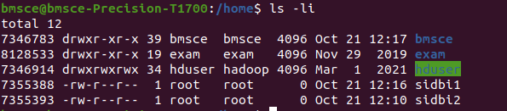

1. Move sidbi2 to sidbi

