**System API Documentation**

1. **Get details of a product**

API URL : **http://localhost/KBTec/index.php/api/product/3**

Received Result :

{

    "p_id": "3",

    "product_name": "Trousers",

    "product_categry": "1",

    "price": "2500.0000",

    "description": "Made in Sri Lanka",

    "image": "facebook.png",

    "active": "1"

}

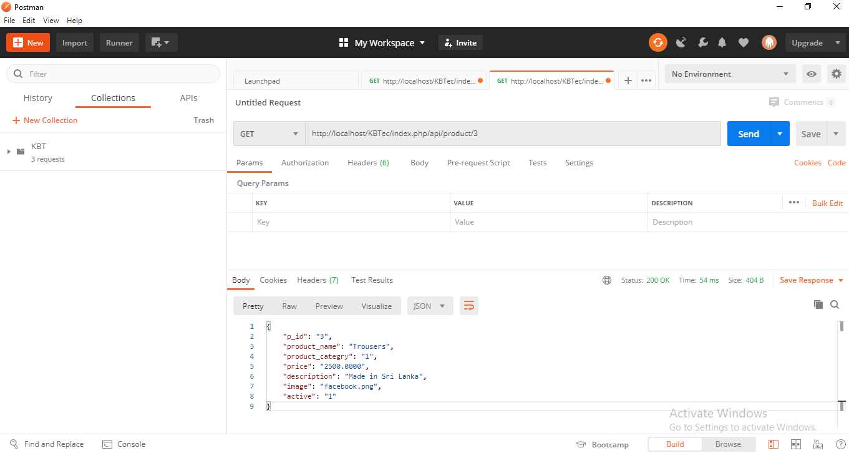

1. **Get details of all products**

API URL : [**http://localhost/KBTec/index.php/api/product/**](http://localhost/KBTec/index.php/api/product/)

Received Result :

[

    {

        "p_id": "1",

        "product_name": "Rice Cooker",

        "product_categry": "3",

        "price": "10000.0000",

        "description": "test",

        "image": "Outlook-1x4xq4qn.png",

        "active": "1"

    },

    {

        "p_id": "2",

        "product_name": "Dell Laptop",

        "product_categry": "2",

        "price": "65000.0000",

        "description": "Laptop product",

        "image": "Outlook-1x4xq4qn.png",

        "active": "1"

    }

]

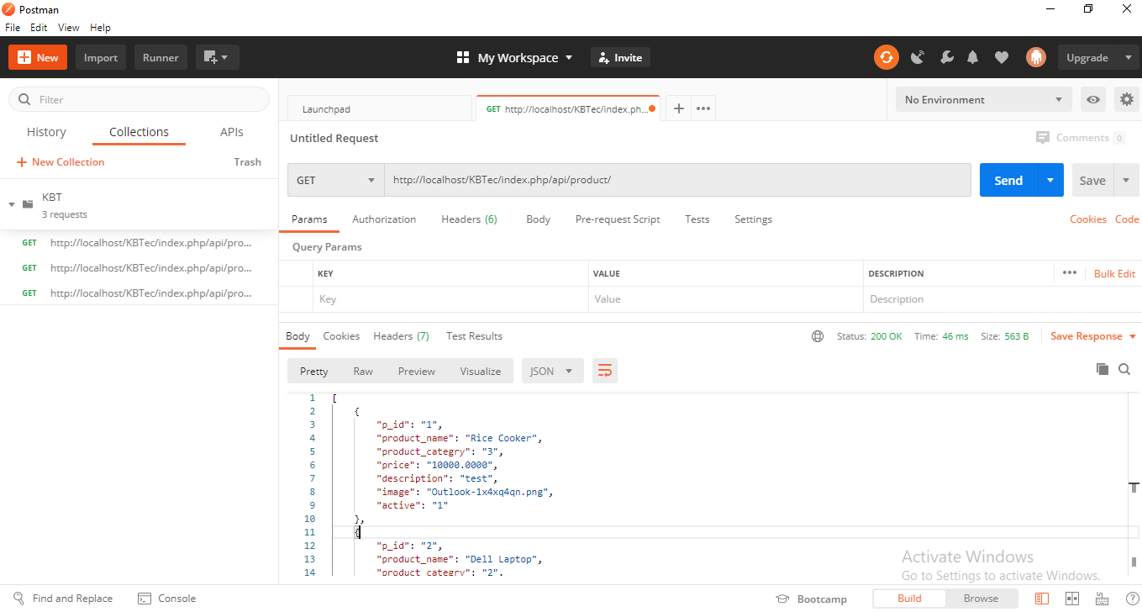

1. **Get products list by seller**

API URL : [**http://localhost/KBTec/index.php/api/product/productsBySeller/2**](http://localhost/KBTec/index.php/api/product/productsBySeller/2)

Received Result :

[

    {

        "p_id": "1",

        "product_name": "Rice Cooker",

        "product_categry": "3",

        "price": "10000.0000",

        "description": "test",

        "image": "Outlook-1x4xq4qn.png",

        "active": "1"

    },

    {

        "p_id": "2",

        "product_name": "Dell Laptop",

        "product_categry": "2",

        "price": "65000.0000",

        "description": "Laptop product",

        "image": "Outlook-1x4xq4qn.png",

        "active": "1"

    },

    {

        "p_id": "3",

        "product_name": "Trousers",

        "product_categry": "1",

        "price": "2500.0000",

        "description": "Made in Sri Lanka",

        "image": "facebook.png",

        "active": "1"

    }

]

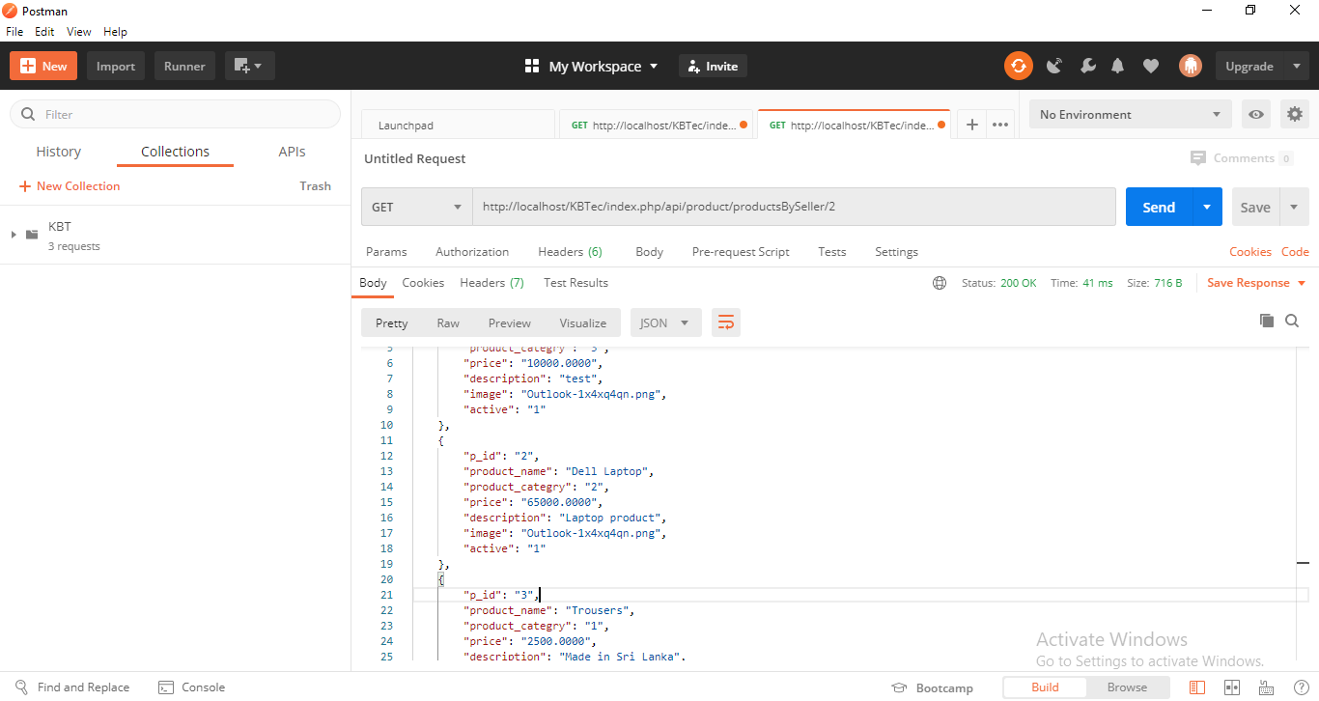

1. **Get seller details for a product**

API URL : **http://localhost/KBTec/index.php/api/product/SellerDataProduct/1**

Received Result :

[

    {

        "s_id": "1",

        "s_name": "John Mike",

        "DOB": "2018-08-18 00:00:00",

        "address": "London",

        "contact_no": "044576968",

        "NIC": "3426585878V",

        "active": "1"

    },

    {

        "s_id": "2",

        "s_name": "Garry Hobbs",

        "DOB": "2017-10-20 00:00:00",

        "address": "Australia",

        "contact_no": "09464273545",

        "NIC": "398537593",

        "active": "1"

    }

]

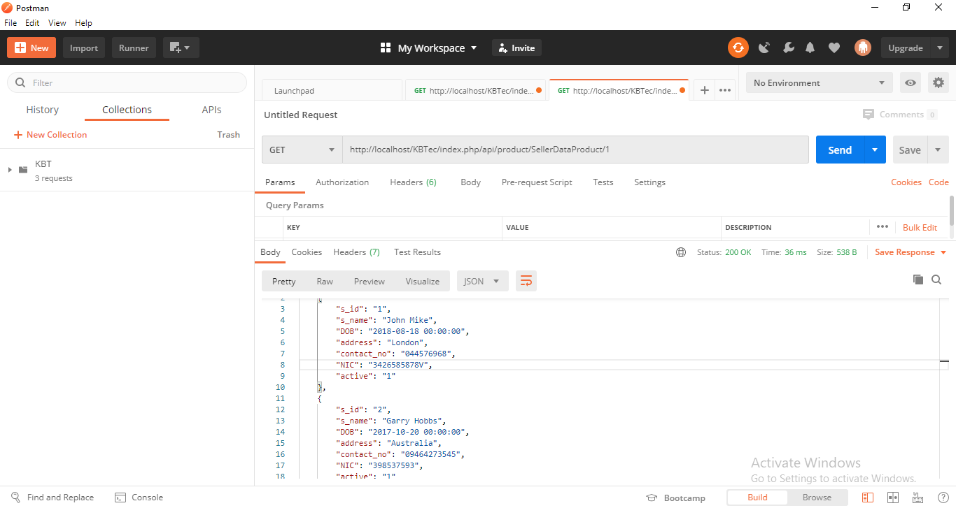

**Use below API keys and values for test the API**

