EMBEDDED SYSTEMS / SECURITY AUTOMATION

SMART LOCKER SECURITY SYSTEM
Two-Factor Dynamic OTP with Silent Duress Alarm

An Arduino-based electronic locker combining password verification, time-limited OTP, door monitoring and emergency alerting

Project Report

Team Members
A.S.K.Nayanida – CB.SC.U4CSE25601
Adwaith V – CB.SC.U4CSE25602
Agastiya JL – CB.SC.U4CSE25603
Shanjana Venkateswaran – CB.SC.U4CSE25654

1. Team Members
S.No | Name | Roll Number
1 | A.S.K.Nayanida | CB.SC.U4CSE25601
2 | Adwaith V | CB.SC.U4CSE25602
3 | AgastIya JL | CB.SC.U4CSE25603
4 | Shanjana Venkateswaran | CB.SC.U4CSE25654

GitHub Link
Project repository: [Add your GitHub repository link here]
The repository should contain the Arduino source code (.ino), the Wokwi simulation files, the circuit diagram and this report.

Contents
- Team Members and GitHub Link
- Project Scope
- Objective
- Already Existing Related Work
- Our Idea
- Implementation – Method and Architecture
- Flowchart
- Algorithm and Software Method
- Hardware and Technology Specification
- Circuit Design and Pin Mapping
- Results
- Discussion
- Conclusion
- Future Work

2. Project Scope
The Smart Locker Security System is an embedded-systems project that adds multi-factor authentication and event monitoring to a physical storage locker. The system is built on an Arduino Uno and is first validated through simulation in Wokwi, with a design that can be carried over to a physical prototype.

2.1 Problem Background
- Mechanical keys can be copied, stolen or picked.
- Static PINs can be observed or inferred by someone nearby.
- A person forced to open a safe under threat has no discreet way of asking for help.
- Users may forget to secure a locker after taking items out of it.

2.2 In Scope
- Two-factor access using a master password and a random 4-digit OTP valid for 60 seconds.
- A silent duress code (9999#) that appears to unlock normally but raises a high-priority alert.
- Brute-force protection: three failed attempts cause a 30-second lockout and an admin alert.
- Left-open warning when the door stays open for more than two minutes.
- Door-contact and motion monitoring where the sensors are installed.
- Persistent credential storage in EEPROM and a memory-optimised embedded C++ program.
- Simulation-based testing, with an outline for physical integration (servo latch, SIM800L SMS).

2.3 Out of Scope (current phase)
- Biometric and RFID authentication, cloud logging and a mobile application (listed under future work).
- Verified SMS delivery and mechanical latch torque testing on the physical build, which must be confirmed on real hardware before any deployment claim.

2.4 Target Applications
Bank and safe-deposit lockers, jewellery and retail storage, gym and campus lockers, pharmacy storage cabinets, parcel collection lockers, and personal document or equipment safes.

3. Objective
The main objective is to design and demonstrate a low-cost electronic locker that protects both the stored valuables and the person using the locker.

3.1 Specific Objectives
- Provide two-factor authentication: master password (Factor 1) plus a time-limited OTP (Factor 2).
- Generate a random 4-digit OTP that expires after 60 seconds and can be re-requested with the C key.
- Provide a silent duress mode that follows the normal unlock flow while generating a discreet alert.
- Keep the locker open while the user is accessing items, and warn if the door is left open for more than two minutes.
- Limit brute-force attempts using a three-failure limit and a 30-second lockout.
- Monitor the door contact and nearby motion where sensors are installed.
- Run on constrained hardware (2 KB SRAM) by using flash-stored strings and EEPROM.
- Keep the user workflow simple: keypad entry, LCD prompts and LED/buzzer feedback.

3.2 Design Motivation
Multi-factor authentication is common in online services but rare in everyday physical storage. This project brings the same idea to lockers while adding a duress signal, which most simple electronic locks lack.

4. Already Existing Related Work
Electronic and smart locking has been studied and sold in several forms. The table below summarises the common categories and the gap that this project addresses.
Existing approach | Description | Limitation
Mechanical key locks | Pin-tumbler or padlock mechanisms. | Keys can be copied, lost or picked; no event record.
Keypad / PIN electronic locks | Fixed numeric code opens a solenoid or servo latch. | Static PIN can be observed (shoulder-surfing) or guessed.
RFID / card-based lockers | Tag or card read by an RFID reader. | Cards can be lost, shared or cloned; single factor.
Biometric (fingerprint) locks | Fingerprint sensor authenticates the user. | Higher cost; no safe response to coercion.
GSM / OTP-based locks | OTP sent to a registered phone by SMS. | Depends on network; many designs have no duress or left-open handling.
IoT / cloud smart locks | Wi-Fi or Bluetooth locks controlled by an app. | Needs internet and accounts; larger attack surface.

4.1 Gap Identified
Most low-cost designs offer only one authentication step and none of them offer a discreet way to signal coercion. Few also consider the situation in which a user forgets to re-lock the locker. Our design combines a password, an expiring OTP, a silent duress code, a left-open guardian and a brute-force lockout on a single inexpensive Arduino platform that can work without cloud dependency.
Note: this table gives a general overview of categories of existing systems. Specific papers or products can be added in this section as references if your course requires citations.

5. Our Idea
The proposed idea is a layered approach to physical locker security. Instead of relying on one secret, access requires two independent factors, and the system is designed to behave safely under threat and under user error.
Feature | How it works
Factor 1 – Master password | Entered on a 4x4 keypad and stored in EEPROM with a validation marker (0xAA).
Factor 2 – Dynamic OTP | A random 4-digit code is generated after the password is accepted and is valid for 60 seconds. The C key requests a new code; the * key clears input.
Silent duress code | Entering 9999# unlocks through the usual flow so an observer sees nothing unusual, while a silent high-priority alert is generated.
Left-open guardian | If the door remains open for more than two minutes, the buzzer sounds and a warning alert is sent.
Brute-force limit | Three failed attempts trigger a 30-second lockout and an admin alert.
Monitoring | A reed switch tracks the door state and a PIR sensor detects nearby motion.

5.1 Why This Is Different
- The duress code protects the user, not only the contents of the locker.
- The OTP removes the risk of a static, observable code.
- The design is low-cost and can run on local logic or cellular SMS without the cloud.

6. Implementation – Method and Architecture
The system follows an Input → Control → Output architecture. The Arduino Uno coordinates user input, authentication state, timers, sensors and alerts.
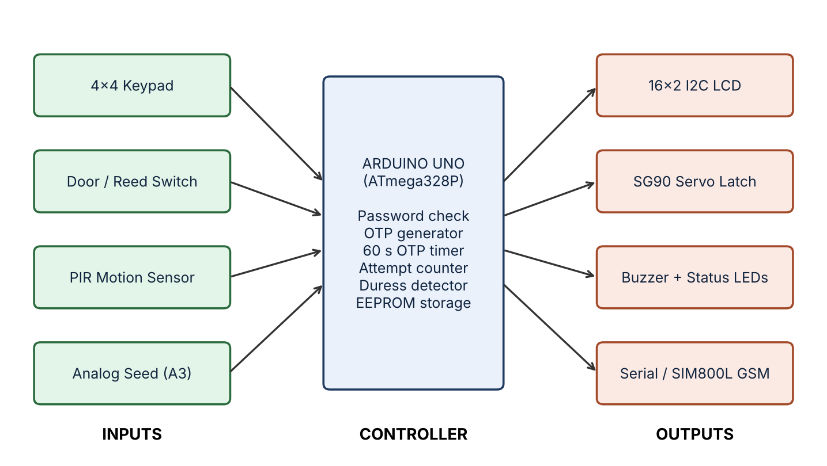
Figure 1: System block diagram

6.1 Working Principle
- Boot: initialise the hardware, LCD and EEPROM.
- Password: the user enters the master password.
- OTP: a 4-digit OTP is generated and delivered (Serial Monitor in simulation, SMS in a physical build); a 60-second timer starts.
- Verify: the code and its expiry are checked and failed attempts are counted.
- Unlock: the servo moves to 90 degrees, the green LED lights and the open-door timer starts.
- Secure: the user presses # to lock; an alert is raised if the door stays open for more than two minutes.

7. Flowchart
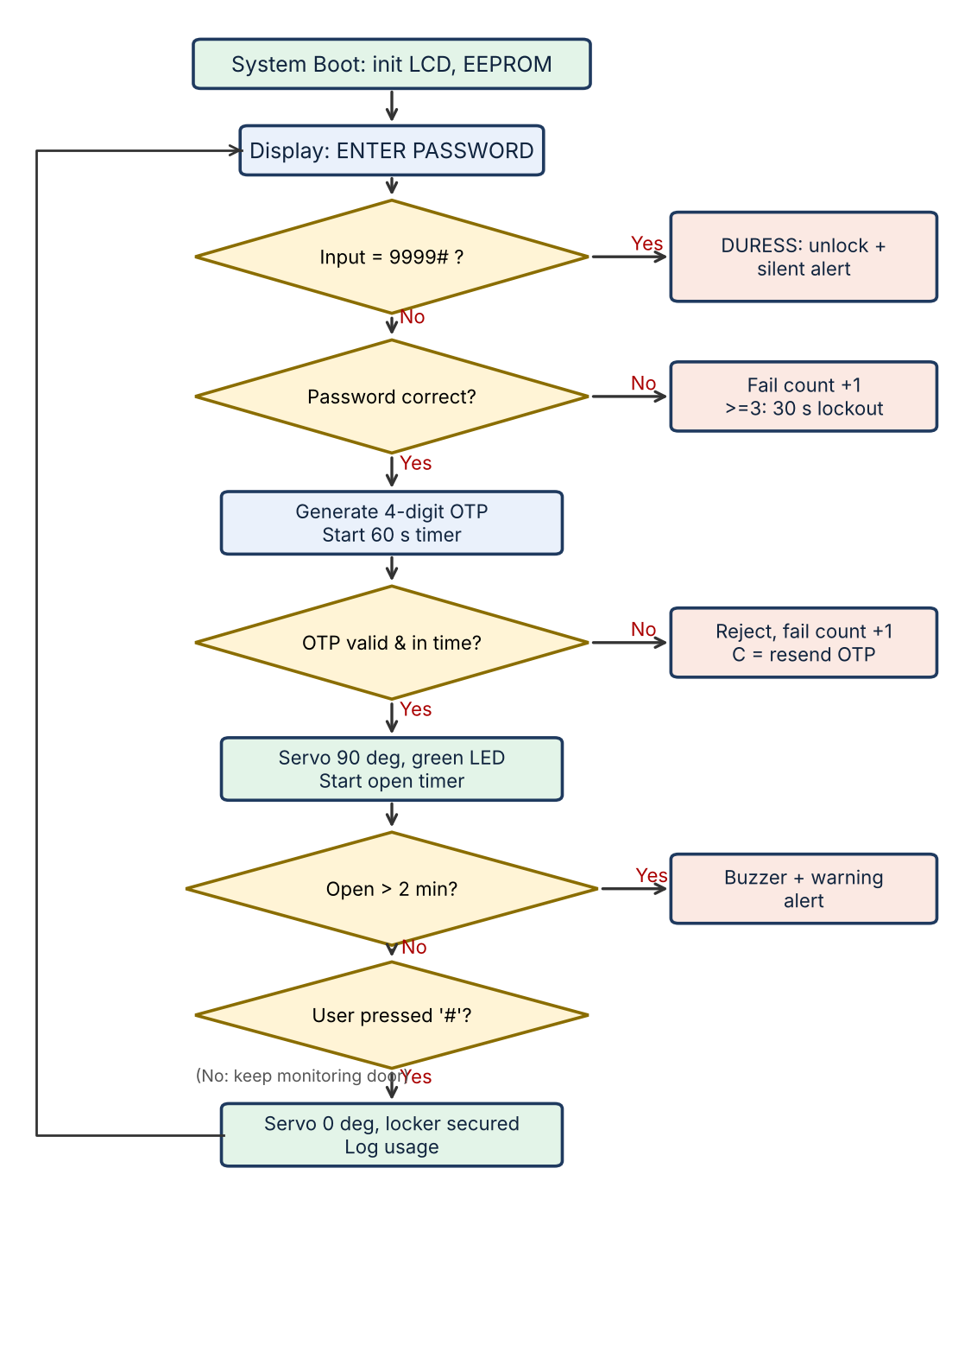
Figure 2: Security flowchart of the Smart Locker
Special keys: C resends the OTP, * clears the current input, # secures the locker. Three failed attempts trigger a 30-second lockout.

8. Algorithm and Software Method

8.1 Algorithm
- Initialise the LCD, keypad, servo, sensors and EEPROM; read stored credentials if the marker 0xAA is valid.
- Display ENTER PASSWORD and read keypad input until # is pressed.
- If the input is 9999#: unlock, send a silent duress alert and display ACCESS GRANTED.
- If the input equals the master password: generate a random 4-digit OTP, send it, start a 60-second timer and display ENTER OTP.
- Otherwise increase the fail counter; at three failures start the 30-second lockout and send an admin alert.
- Read the OTP entry. If it matches and has not expired, move the servo to 90 degrees, light the green LED and start the open timer.
- If it is wrong or expired, reject it, increase the fail counter and show the status. C requests a new OTP.
- While the locker is open, monitor the door: if open for 2 minutes or more, sound the buzzer and send a warning.
- When # is pressed, return the servo to 0 degrees, log the usage duration and return to step 2.

8.2 Software Design
- Language and platform: embedded C++ (Arduino framework).
- Structure: state-based logic – boot, password, OTP, unlock, open monitoring, lock.
- Memory optimisation: fixed UI and serial strings use F() / PROGMEM to save SRAM.
- Persistence: credentials are stored in EEPROM with a validation marker (0xAA).
- Randomness: the OTP generator is seeded from an unconnected analog input (A3).
- Tools: Arduino IDE and Wokwi simulator.

9. Hardware and Technology Specification
Machine learning, deep learning, NLP and computer vision are not used in this project. It is a rule-based embedded-systems design; the OTP uses a pseudo-random generator, not a learned model. The specification of the hardware is given below.
Component | Role / specification | Pins
Arduino Uno (ATmega328P) | Main controller, 16 MHz, 2 KB SRAM | –
4x4 membrane keypad | Password, OTP and admin input | D2–D9
1602 LCD with PCF8574 I2C | User prompts and status | A4 (SDA), A5 (SCL)
SG90 micro servo | Latch actuator, PWM | D10
Piezo buzzer | Audio alerts | D11
Red / green / yellow LEDs | Visual status | D12, D13, A0
Door (reed) switch | Door open/closed and tamper, INPUT_PULLUP | A1
PIR motion sensor | Nearby motion detection | A2
Analog seed input | Random-number seed | A3
EEPROM (on-chip) | Credential persistence | –
SIM800L GSM (optional) | SMS delivery in the physical build, AT commands | D0/D1 (UART)

10. Circuit Design and Pin Mapping
Arduino pin | Connected to
D2–D9 | 4x4 keypad rows and columns
D10 | Servo PWM signal
D11 | Buzzer
D12 / D13 | Red / green status LEDs
A0 | Yellow status LED
A1 | Door sensor (INPUT_PULLUP)
A2 | PIR motion sensor
A3 | Analog input for random seed
A4 / A5 | LCD I2C – SDA / SCL
D0 / D1 | UART for Serial / GSM (optional)

The I2C LCD reduces display wiring to two signal lines. For a physical build, use regulated supplies suited to the Arduino, servo and GSM module, because the servo and the SIM800L draw current peaks. The servo should be coupled to a sliding deadbolt and its alignment and torque tested.

10.1 Physical Integration Notes
- Simulation: the Serial Monitor emulates OTP delivery and shows telemetry.
- Cellular SMS: the SIM800L can send SMS with AT commands such as AT+CMGF=1 and AT+CMGS.
- Prototype status and SMS delivery should be verified on actual hardware before claiming deployment.

11. Results
The design was tested through a Wokwi simulation using the following flow. The Serial Monitor output showed the OTP, the access-granted alert and successful relocking.
Test | Procedure | Expected result | Observed
1. Valid access | Enter 1234#; OTP generated (example 4729); enter 4729# | ACCESS_GRANTED | Access granted; OTP and alert shown on Serial Monitor
2. OTP expiry / wrong OTP | Wait beyond 60 s or enter a wrong OTP | OTP rejected, failure counted, status shown | OTP rejected as expected
3. Duress | Enter 9999# | Unlock with silent alert | Duress alert generated
4. Left open | Leave door open for more than 2 min | Buzzer and warning | Warning raised
5. Re-lock | Press # | Servo to 0 degrees, locker secured | Locker secured successfully

11.1 Memory Optimisation
Using F() / PROGMEM for fixed strings reduced static-string RAM use from 1,502 bytes to 65 bytes, about a 95% reduction. This is the figure reported in the project notes; please confirm it against the final compiled build before submission.
Add screenshots of the Wokwi circuit and the Serial Monitor output here for the final submission.

12. Discussion – Advantages and Applications

12.1 Advantages
- Two-factor access.
- Time-limited OTP that cannot be reused after expiry.
- Discreet duress alert concept.
- Left-open warning.
- Low-cost embedded platform.
- Can operate without cloud dependency, using local logic or cellular SMS.

12.2 Limitations
- The password is a single master code, and the OTP is only 4 digits; the 3-attempt lockout limits guessing.
- In simulation, OTP delivery is through the Serial Monitor; SMS delivery has still to be verified on hardware.
- Event timestamps are not battery-backed until an RTC is added.
- Alerts depend on the GSM or serial link being available.

13. Conclusion
The Smart Locker Security System shows a layered approach to physical locker security. It combines a master password with a 60-second OTP, introduces a discreet duress code for coercion scenarios, monitors how long the door is open and limits repeated failed attempts.
The design uses embedded C++ techniques and EEPROM storage to fit constrained hardware, and the reported memory optimisation cut static-string RAM use by about 95%. Simulation tests covered valid access, OTP expiry, duress entry, left-open warning and relocking.
The project provides a practical foundation for a physical prototype. The key message is that secure access should protect both the stored valuables and the person using the locker.

14. Future Work
Enhancement | Description
Three-factor access | Add MFRC522 RFID card verification alongside the password and OTP.
Biometrics | Integrate an optical fingerprint sensor such as the R307.
Cloud / app | Use an ESP32 with Wi-Fi/MQTT, Firebase logging and mobile push notifications.
Audit timestamps | Add a DS3231 RTC for battery-backed event timestamps and audit logs.
Physical prototype | Build the full hardware with a deadbolt latch, regulated power and tested SMS delivery.

References / Tools
- Arduino Uno (ATmega328P) documentation and Arduino IDE.
- Wokwi online Arduino simulator.
- SIM800L AT command manual (AT+CMGF, AT+CMGS).
- Project presentation: Smart Locker Security System – Review 2.

