A. KPI’s
1. Total Revenue:
SELECT SUM(total_price) AS Total_Revenue
FROM pizza_sales;

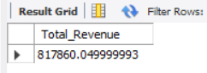

2.Average Order Value:
SELECT SUM(total_price) / COUNT(DISTINCT order_id) AS Avg_Order_Value
FROM pizza_sales;

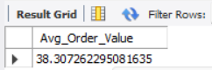

3.Total Pizzas Sold:
SELECT SUM(quantity) AS Total_Pizza_Sold
FROM pizza_sales;

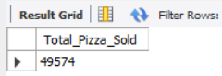

4.Total Orders Placed:
SELECT COUNT(DISTINCT order_id) AS Total_Orders
FROM pizza_sales;



5. Average Pizzas Per Orders:
SELECT sum(quantity) / count(DISTINCT order_id) AS Avg_Pizzas_per_Orders
FROM pizza_sales;

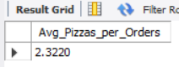

B. CHARTS REQUIERMENT

1. Daily Trends For Total Orders:

SELECT
DAYNAME(order_date) AS order_day,
COUNT(DISTINCT order_id) AS Total_orders
FROM pizza_sales
GROUP BY DAYNAME(order_date), WEEKDAY(order_date)
ORDER BY WEEKDAY(order_date);

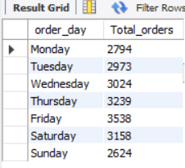

2. Monthly Trend For Total Orders:

SELECT
MONTHNAME(order_date) AS Month_Name,
COUNT(DISTINCT order_id) AS Total_Orders
FROM pizza_sales
GROUP BY MONTHNAME(order_date), MONTH(order_date)
ORDER BY MONTH(order_date);

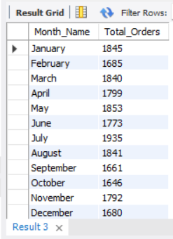

3. Hourly Trend for Total Orders:
SELECT
HOUR(order_time) AS order_hour,
COUNT(DISTINCT order_id) AS Total_Orders
FROM pizza_sales
GROUP BY HOUR(order_time)
ORDER BY order_hour;

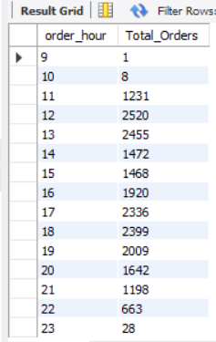

4.Percentage of Sales by Pizza Category:

SELECT pizza_category, SUM(total_price) * 100 / (SELECT SUM(total_price) FROM pizza_sales) AS PCT
FROM pizza_sales
GROUP BY pizza_category;

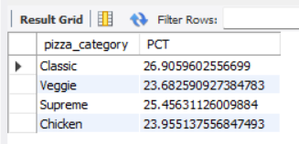

5. Percentage of Sales by Pizza Size:

SELECT pizza_size, CAST(SUM(total_price) * 100 / (SELECT SUM(total_price) FROM pizza_sales) AS DECIMAL(10,2)) AS PCT
FROM pizza_sales
GROUP BY pizza_size
ORDER BY PCT DESC;

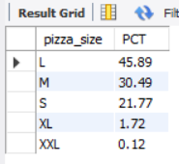

6. Top 5 Pizzas by Revenue:
SELECT pizza_name,SUM(total_price) AS Total_Revenue
FROM pizza_sales
GROUP BY pizza_name
ORDER BY Total_Revenue DESC LIMIT 5;

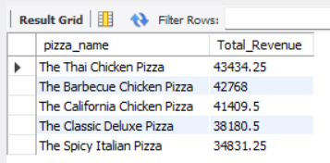

7. Bottom 5 Pizzas by Revenue:

SELECT pizza_name, SUM(total_price) AS Total_Revenue
FROM pizza_sales
GROUP BY pizza_name
ORDER BY Total_Revenue ASC LIMIT 5;
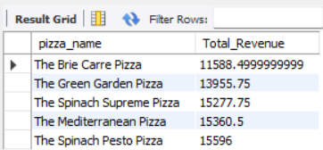

8.Top 5 Pizza by Quantity:

SELECT pizza_name,SUM(quantity) AS Total_Quantity
FROM pizza_sales
GROUP BY pizza_name
ORDER BY Total_Quantity DESC LIMIT 5;

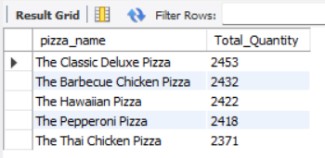

9. Bottom 5 PIZZA by Quantity:

SELECT pizza_name,SUM(quantity) AS Total_Quantity
FROM pizza_sales
GROUP BY pizza_name
ORDER BY Total_Quantity ASC LIMIT 5;

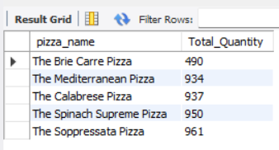

10. ToP 5 PIZZA by Orders:

SELECT pizza_name,COUNT(DISTINCT order_id) AS Total_Orders
FROM pizza_sales
GROUP BY pizza_name
ORDER BY Total_Orders DESC LIMIT 5;

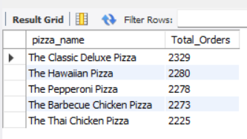

11. Bottom 5 Pizza by Orders:

SELECT pizza_name,COUNT(DISTINCT order_id) AS Total_Orders
FROM pizza_sales
GROUP BY pizza_name
ORDER BY Total_Orders ASC LIMIT 5;

