Universal-Bank-Predictive-Analytics-Python-SASviya

Nayantara Ravi Samtani
1199378
Lakehead University
BUSI-4016: Data Mining & Predictive Analytics
Dr. Aydin Farrokhi
28-09-2025

1.Data preparation (5 Points) {Use Python – Google Colab}
Using data visualization for initial variable investigation:
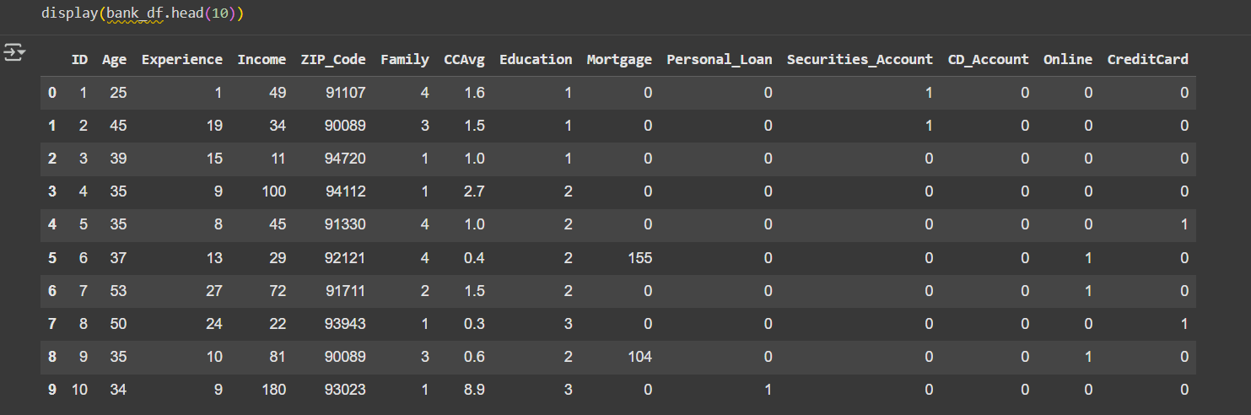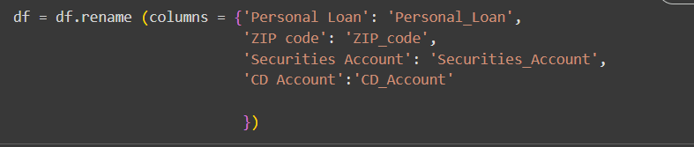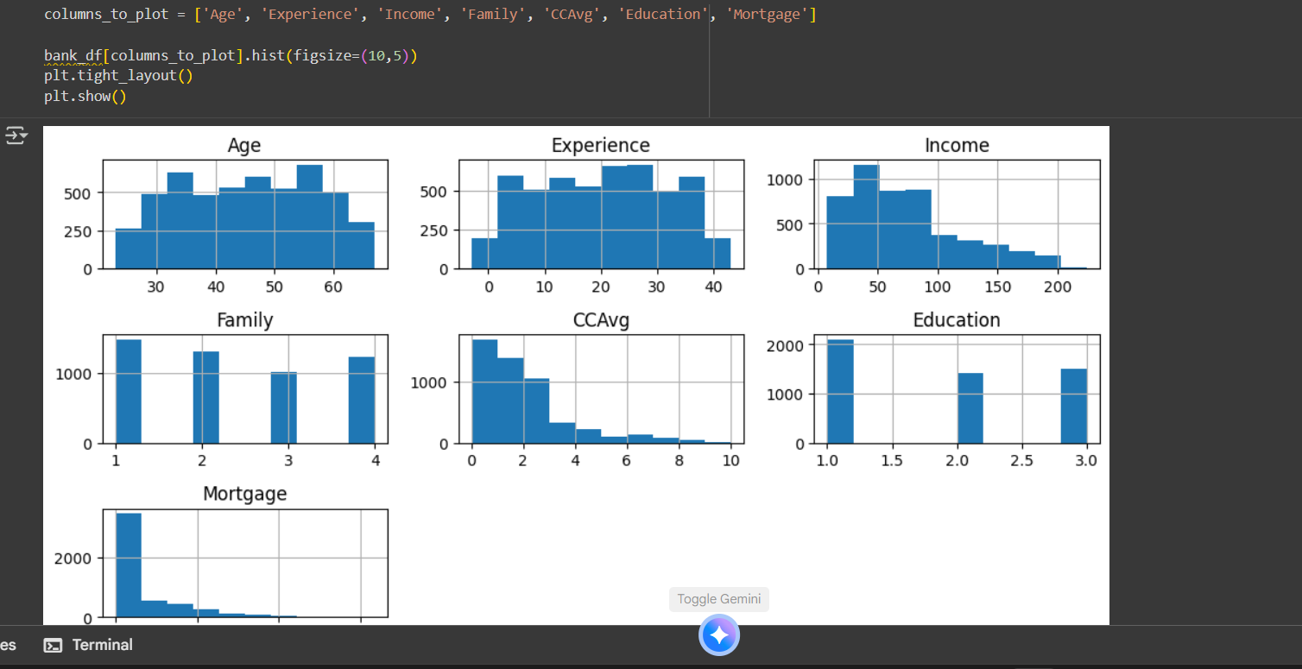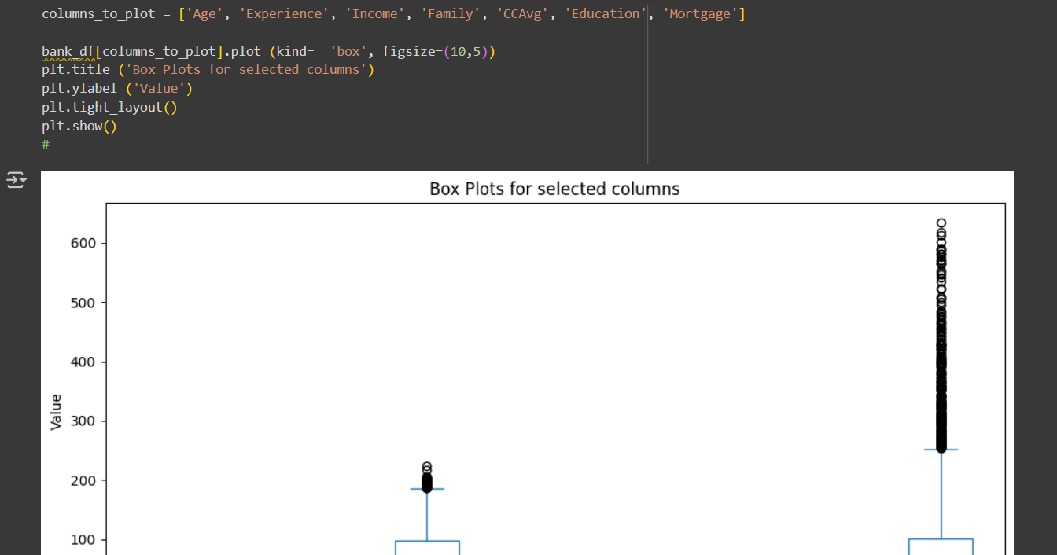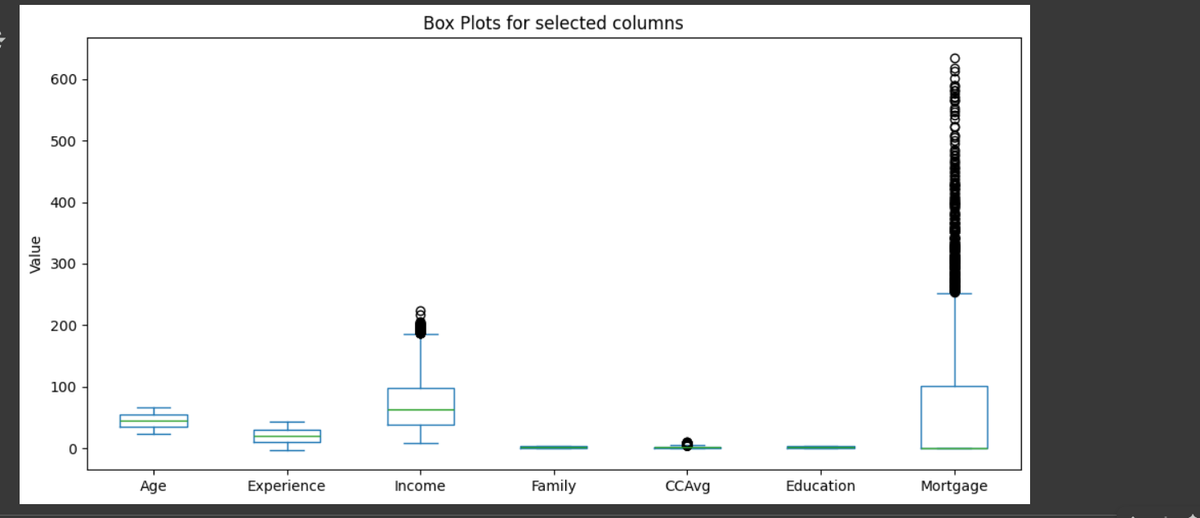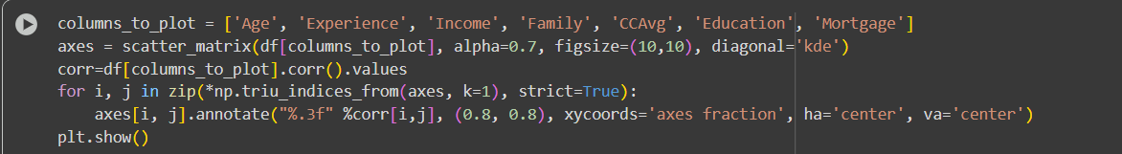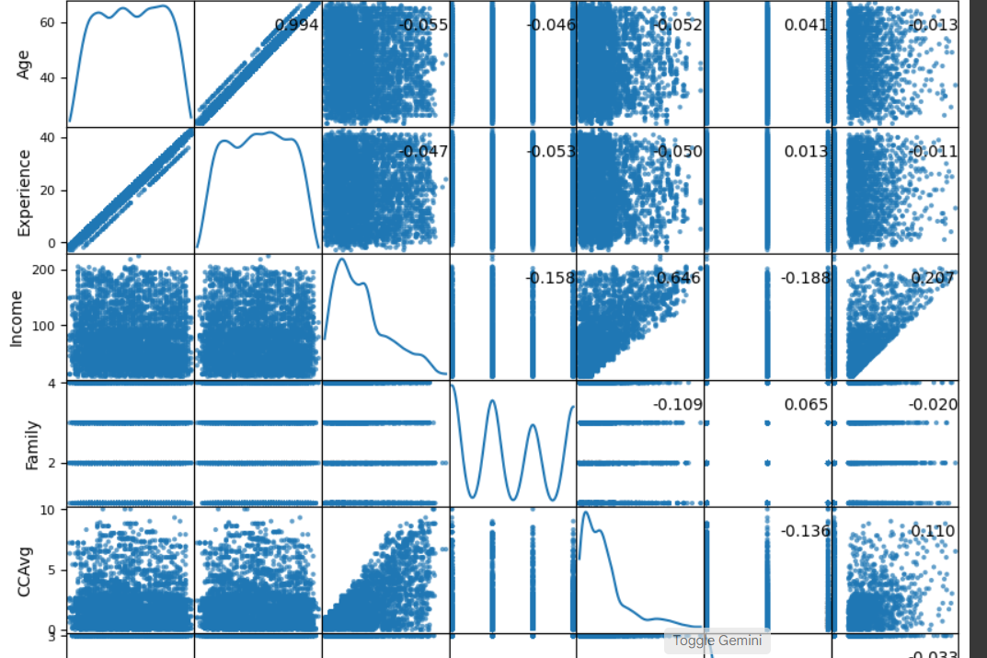

(a) What are the distributions for the dependent and independent variables? (b) Perform Descriptive Analytics.

Looking at the histograms, box plots, and scatterplot matrix, each visualization offered a different perspective on how the variables are distributed and how they relate to one another. Age and Experience being mildly similar in their meaning, showed even distribution, with most customers falling between their late 20s and early 60s, showing no significant skewness. Income, on the other hand, was heavily right skewed because most of the customers were earning under 100K, with a few high-income individuals, extending the tail to the far right. Family was a discrete variable as it showed clear peaks at 1, 2, 3, and 4, which suggested that most customers came from a smaller family unit. CCAvg (average monthly credit card spending) was also right-skewed, with majority of the customers spending less than 2K per month, whereas smaller groups were found to spend much higher amounts which created a long upper tail. Education fell into three distinct categories: undergraduate, graduate, and advanced/professional degrees, with undergraduates forming the largest group, followed by graduates, then those with advanced degrees. Mortgage was another right skewing variable, which meant many customers had little to no mortgage debt, and only a few carried large mortgage balances.
From the box plots, outliers were prominent in Income and Mortgage which showed the same skewness observed in the histograms. Meanwhile, Age, Experience, and Family show tighter ranges with fewer extreme values.
The scatterplot matrix highlighted the relationships between variables. Age and Experience were found to have a strong positive correlation. Income had a moderate positive relationship with CCAvg and Mortgage showing that higher income individuals tend to spend more on credit cards and have higher mortgage balances. This descriptive analytics shows a customer base that varies with age and experience but is concentrated in lower income, spending, and mortgage ranges, with a few outliers that stand apart from the rest.

(b) How do they relate to each other? (c ) What appears to be the most important factor for predicting the Personal loan?
Looking at the different visualizations, we can see how the variables relate to one another. Age and Experience are very closely related, showing a strong positive correlation, which makes sense because as a customer’s age increases so do their years of work experience. Income shows a moderate positive relationship with both CCAvg and Mortgage, proving that customers who earn more, tend to spend more on their credit cards, and are also more likely to have higher mortgages. However, these relationships are not perfectly linear which shows that there are other factors influencing spending and mortgage amounts beyond a customer's income. Family does not show a strong relationship with most variables but there are slight differences such as higher family sizes appearing across various income and spending levels. Education displays a slight connection with Income and CCAvg, which proves that customers with higher education levels are slightly more likely to earn and spend more. The scatterplot matrix also reveals that while most of the financial variables are right skewed, there are clusters of customers with no mortgage or low credit card spending, which contrasts with the smaller group of customers who are rather high spenders or have high mortgages. Overall, these relationships prove that even though age and experience seem consistent other factors such as income, education, and lifestyle, influence financial behavior.
2.Building classification tree and evaluating performance (8 Points) {Use SAS Viya}

(a) You may try to split and prune trees and try to find a best or desirable tree.
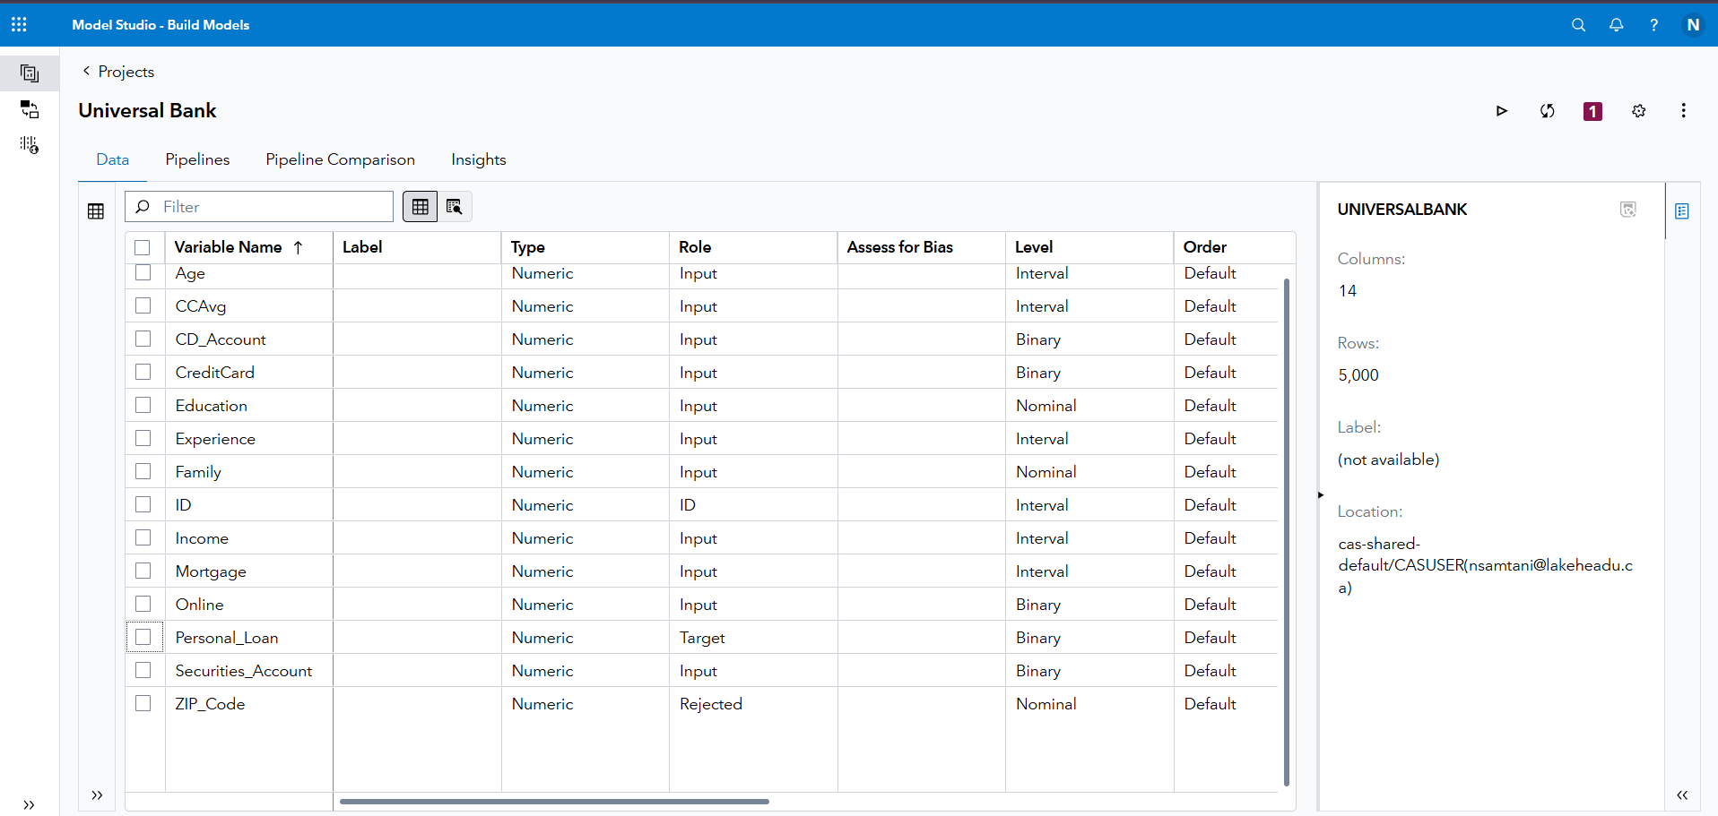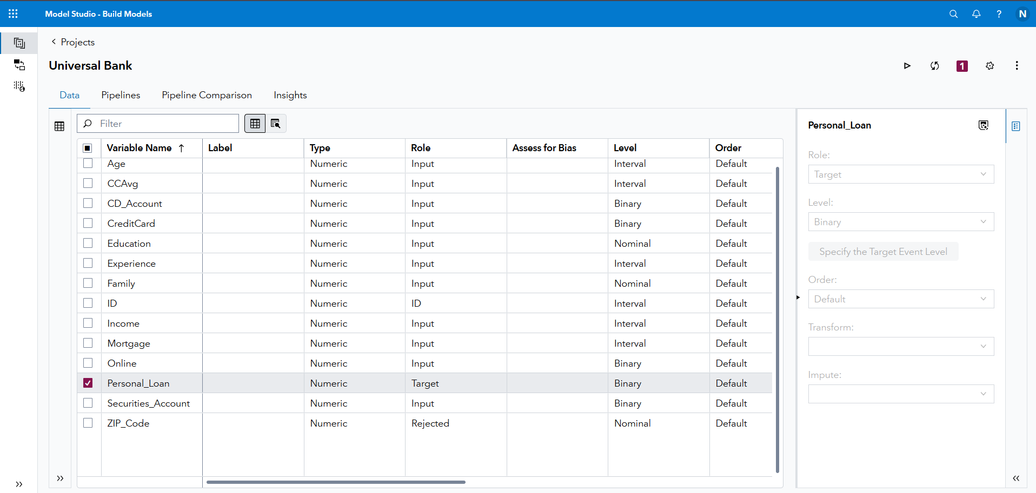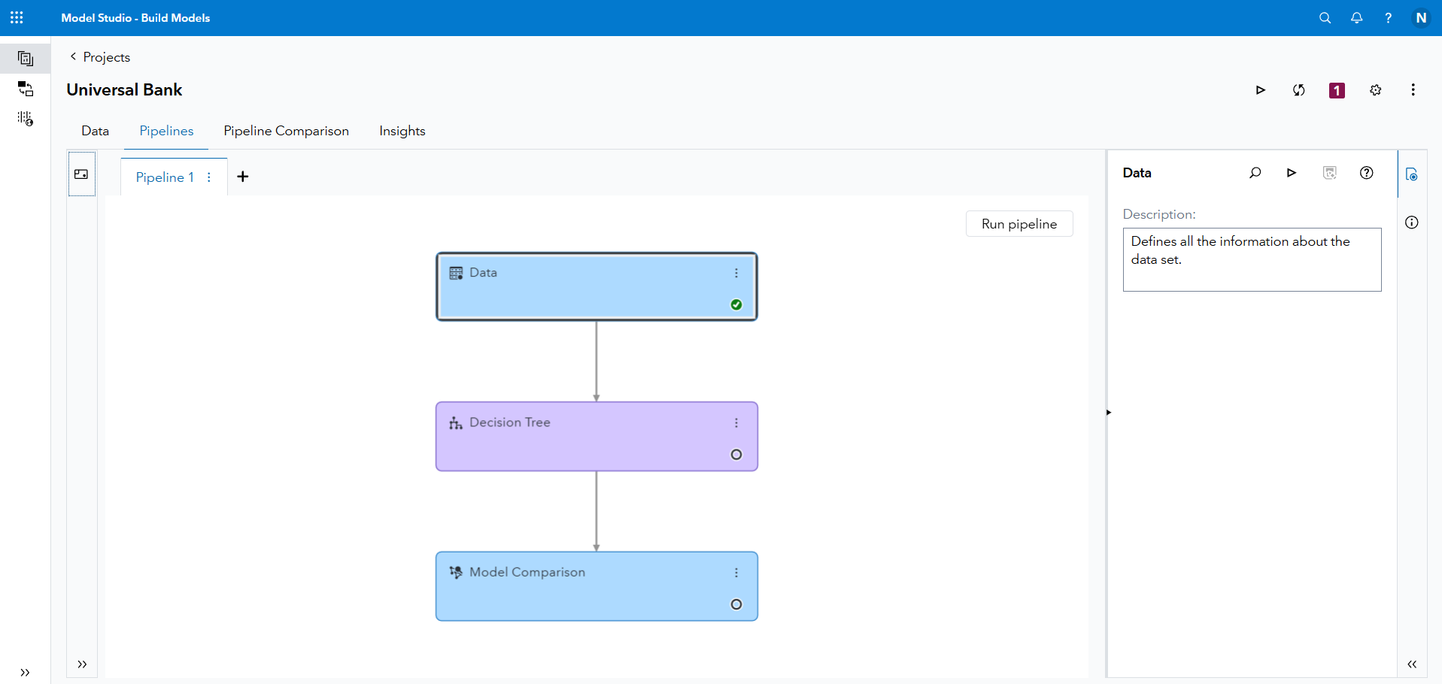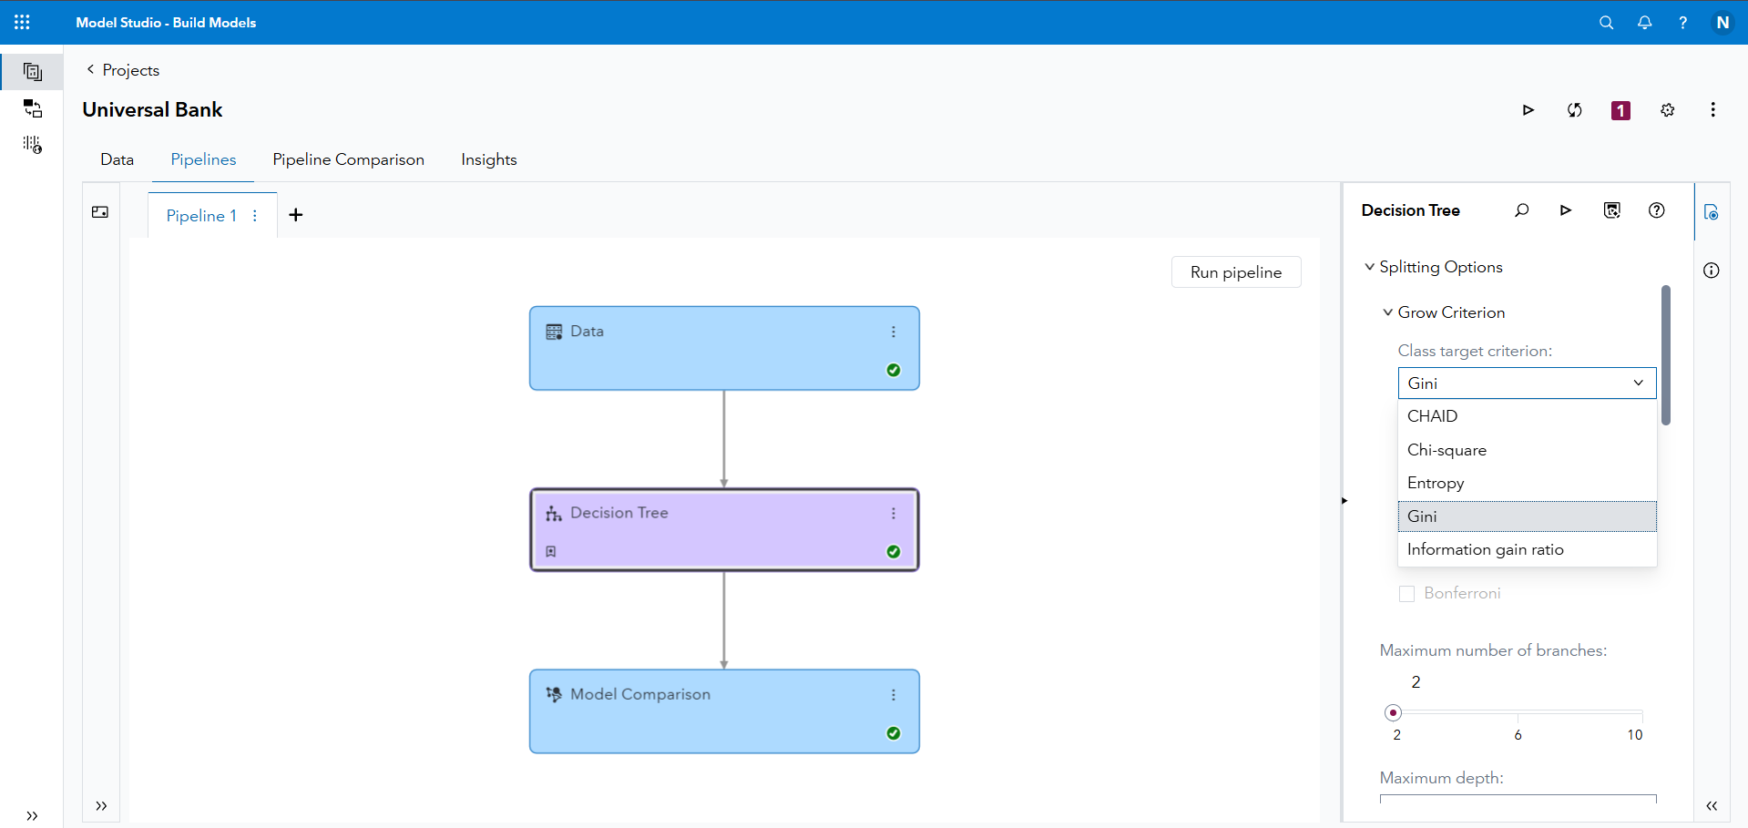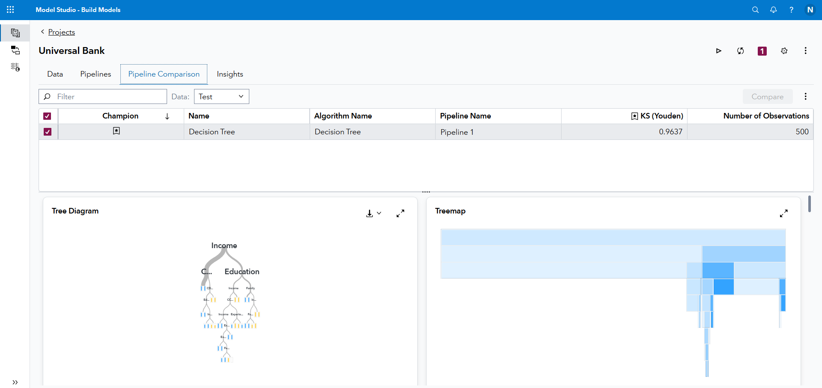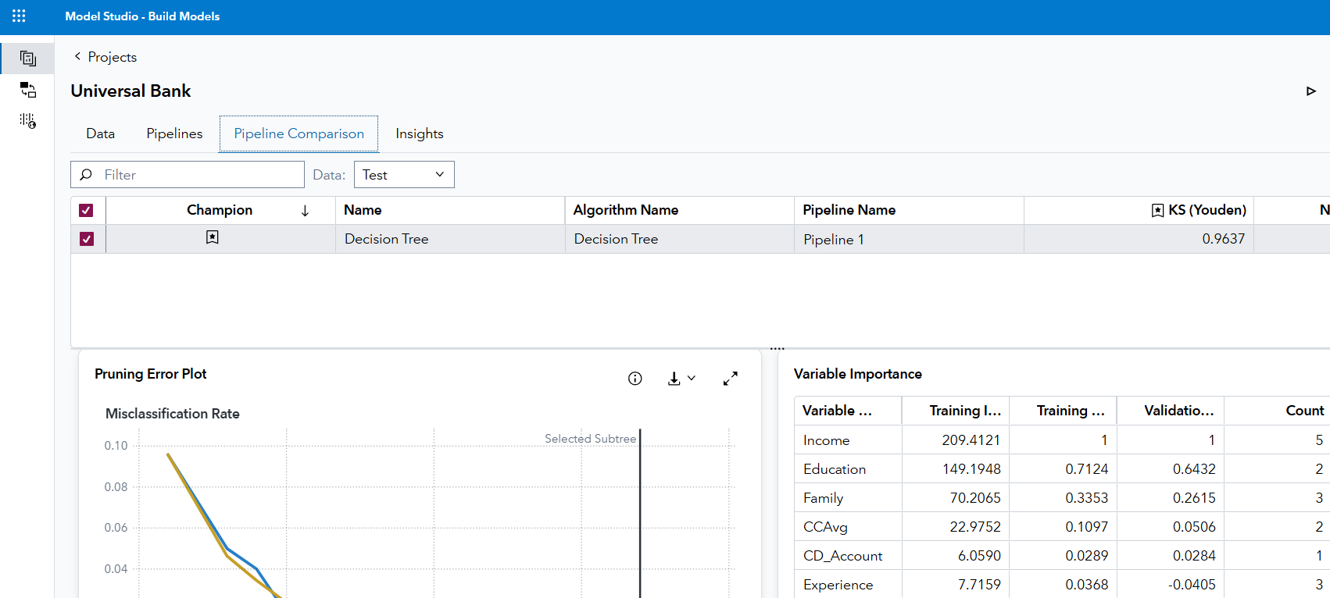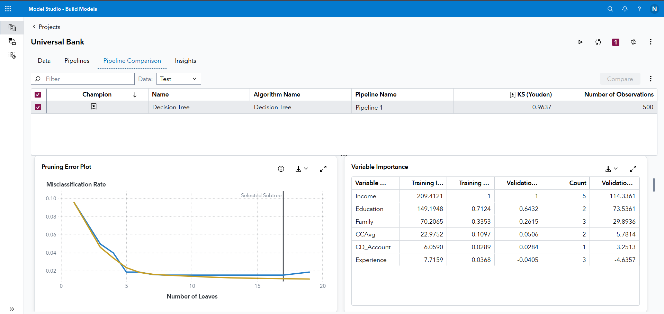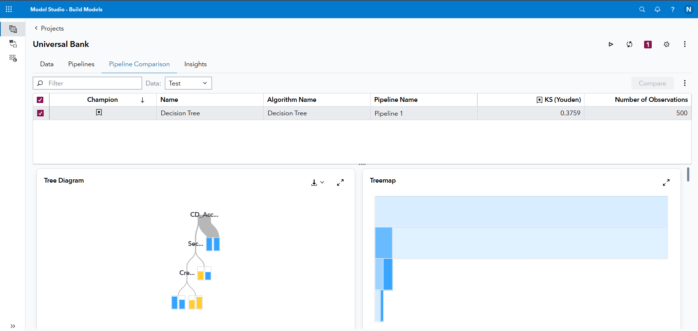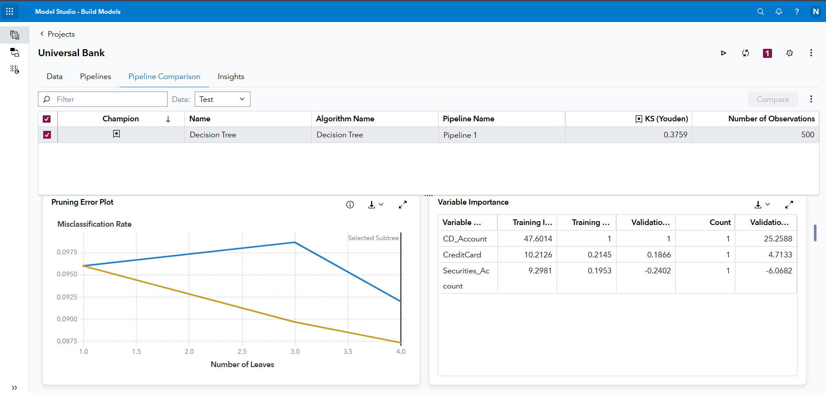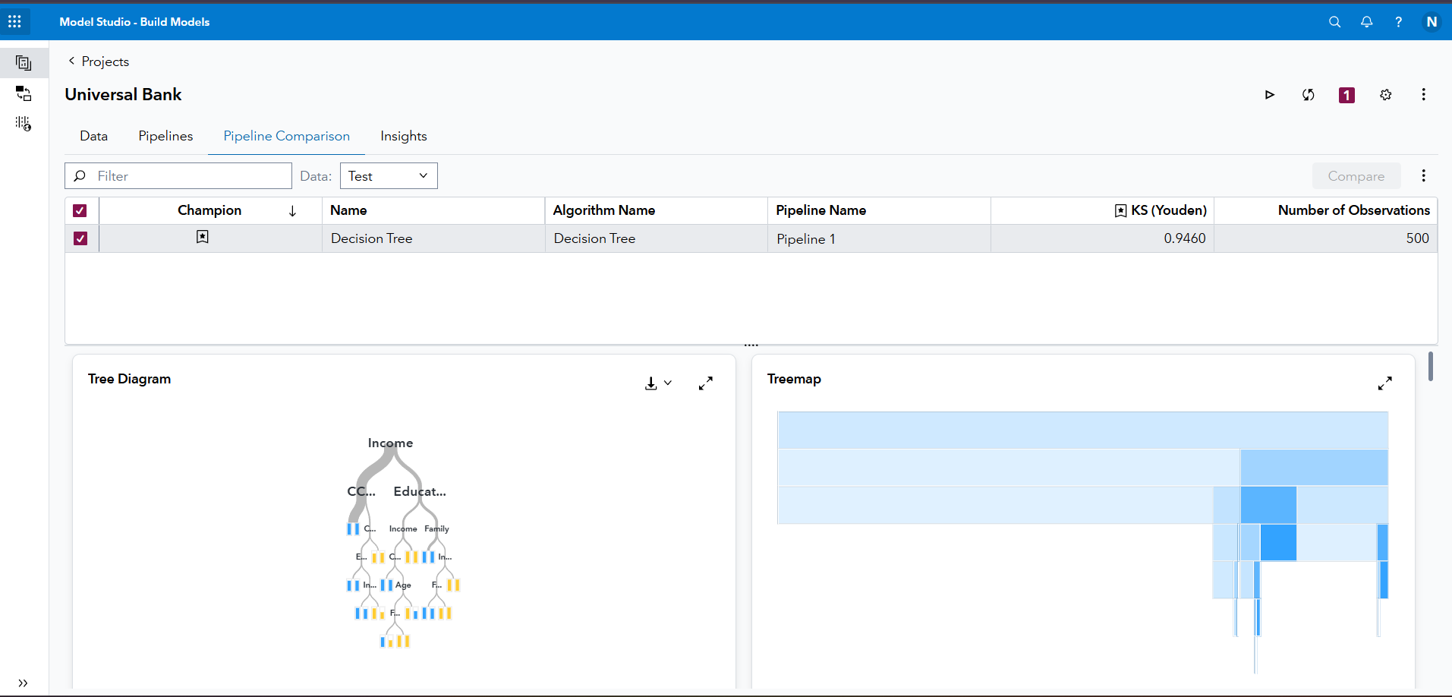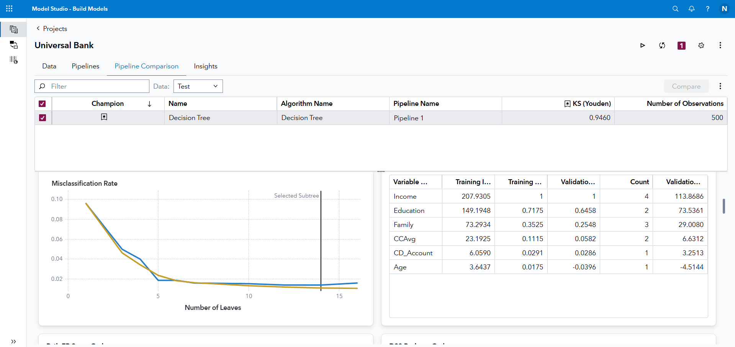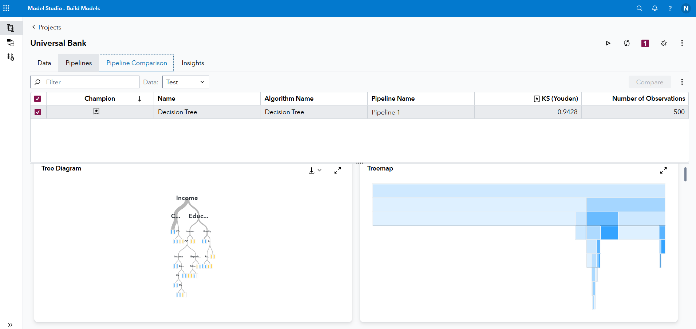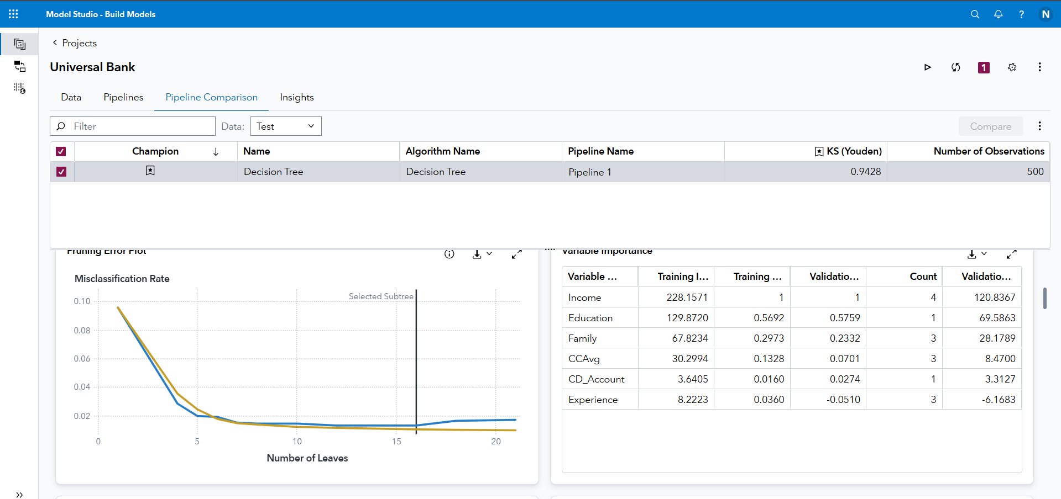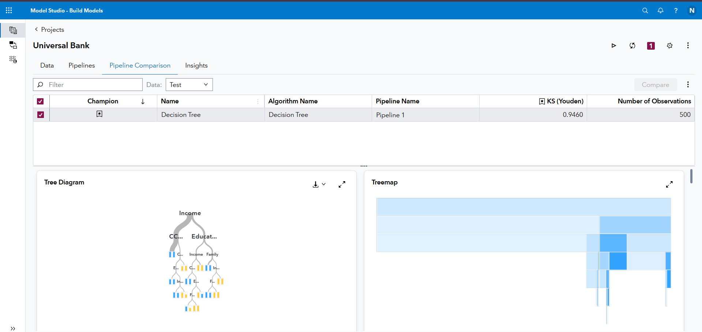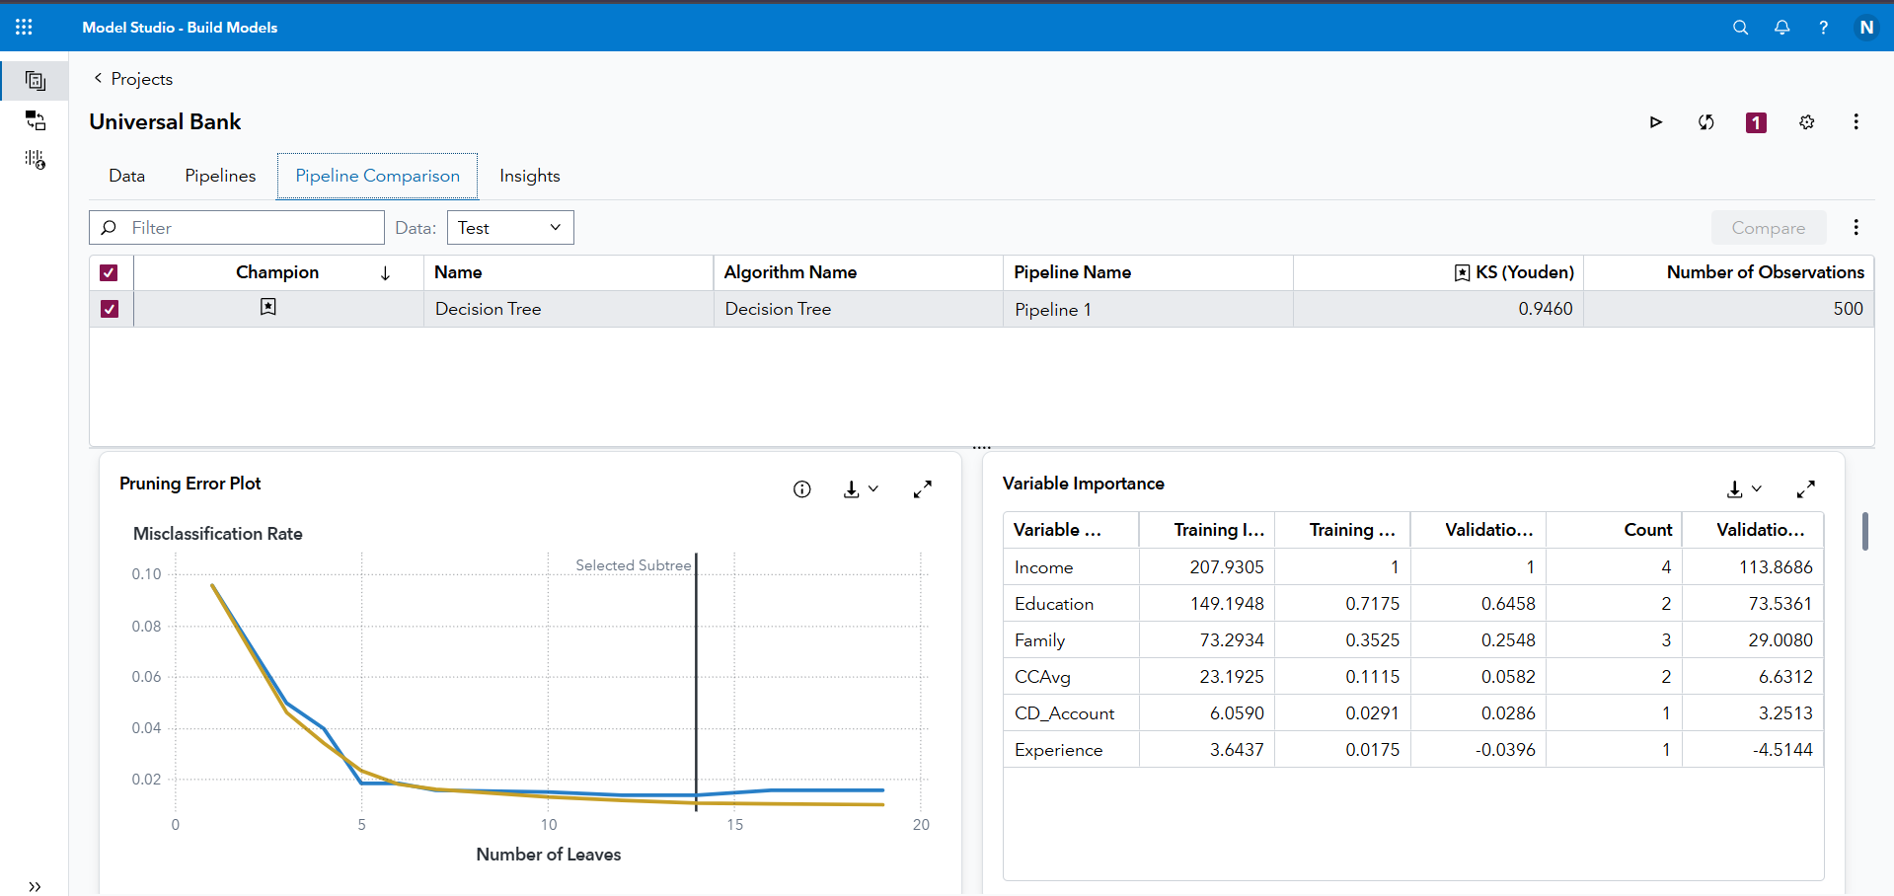

Screenshots show the set of the SAS environment and proceed to identify the decision trees and other forms or plotting.

(b) What is your criteria and approach to identify the best tree?
Gini turned out to be the best identified tree because while CHAID, Entropy, and Gain Ratio offered valuable insights, the Gini based tree provided the strongest balance between predictive accuracy and interpretability. The CHAID method created broader, generalized splits but lacked the same level of precision when predicting outcomes. Entropy and Gain Ratio,were effective at identifying informative splits with many distinct values, but they ended up producing slightly more complex trees that risked overfitting.
The Gini index created well structured splits that minimized impurity and kept the tree relatively simple. It performed particularly well with the key variables in this dataset such as Income, CCAvg, and Mortgage by well-representing high and low-risk customers.
3. Possible real word applications (1 Point)
What is the potential application of classification for mortgage approval? What data a bank may need to collect and what analytic tool the bank should consider in order to make a good
mortgage approval decision? Search web to find out the criteria for mortgage application and
approval.

Classifying mortgage approvals can assist banks with picking better suited customers that are less likely to default on their loans. Additionally, it can help banks provide better financial assistance to customers by analyzing their financial circumstances more closely, to help them work toward appropriate financial goals, leading to better financial standing of the bank and its customers.

In order to analyze mortgage applications effectively, banks collect financial data such as the customer's credit score, income, previous bank statements, employment history and verification, savings, debt-to-income ratios, and various other factors. SAS would be a great tool as it consists of a simple workflow, a user friendly interface, furthermore, it can handle a large amount of financial data along with having multiple tools for different model evaluation, and can provide assistance with managing large data sets without programming capabilities.

4. Report how much time you have spent on this assignment, what problem you have faced and what you have learned. (1 Point)

I spent about 8-10 hours completing this assignment. I found it quite simple and the documents provided to complete the assignment were structured and clear. Additionally, throughout each step of the assignment I found the steps easy to follow as well as understand. Q1 (a) and (b) I found a little confusing as I was not completely sure how to structure my answers, therefore, I formatted (a) and (b), and (c ) and (d) together. As I transitioned to SAS, the lesson I learned was that I should pay attention in class because identifying the best decision tree required me to look through our course work to understand the graphs and their breakdowns.

