**Lab Report:02**

**Name of the lab report: Basic Linux Command**

Linux Command: Linux is a Unix-Like operating system. All the Linux/Unix commands are run in the terminal provided by the Linux system. Linux/Unix commands are case-sensitive. Linux terminal is user-interactive. The terminal outputs the results of commands which are specified by the user itself. There are about fifteen important basic command in Linux command.

**Essential Linux command:**

1. pwd
2. ls
3. cd
4. mkdir & rmdir
5. rm
6. touch
7. man & --help
8. cp
9. mv
10. locate
11. Echo
12. Cat
13. nano, vi, jed
14. Sudo
15. du

**Description:**

**1. pwd** — After opening the terminal, you're within the home directory of your user. To grasp that directory you're in, you'll be able to use the ‘pwd’command.



**2. Is** –The ‘Is’command- the list command - functions in the Linux terminal to show all of the major directories filed under a given file system.

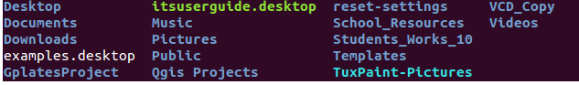

**3. cd**—‘cd’ command is using for travelling to a directory.For example you're within the home folder,and you would like to travel to the downloads folder,then you'll be able to sort in “cd Downloads”.



**4. mkdir & rmdir** — ‘mkdir’ command is using for creating a folder or a directory. For example, if you want to make a directory called “DIY”, then you can type “mkdir DIY”. Remember, as told before, if you want to create a directory named “DIY Hacking”, then you can type “mkdir DIY\ Hacking”. Use rmdir to delete a directory. But rmdir can only be used to delete an empty directory. To delete a directory containing files, use rm.  
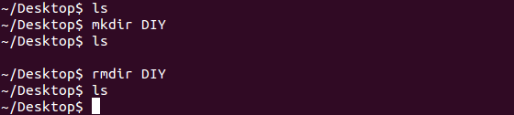

**5. rm**--‘rm’command useable for deleting files and directions.  


**6.Touch**--The ‘Touch’ command is used to create a file.  


7. **man& --help** — To know more about a command and how to use it, use the ‘man’ command. It shows the manual pages of the command.

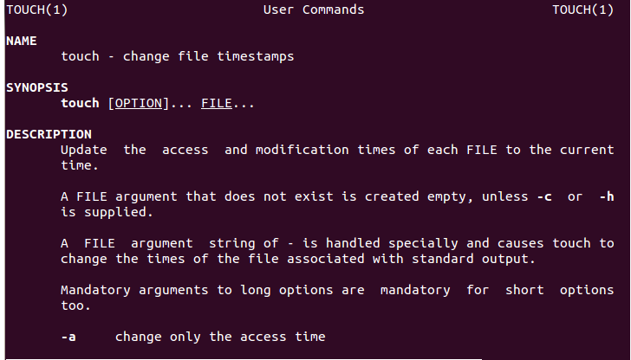

**8. cp** — ‘cp’ command is useable for copying files through the command line. It takes two arguments: The first is the location of the file to be copied, the second is where to copy.  
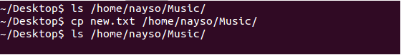

**9. mv** —‘mv’ command is used to maneuver files through the statement. we will conjointly use the mv command to rename a file. as an example, if we wish to rename the file “text” to “new”, we will use “mv text new”. It takes the 2arguments, similar to the cp command.

**10. find** — The ‘find’ command is employed to find a go into a UNIX operating system system, similar to the search command in Windows. This command is helpful after you do not know wherever a file is saved or the particularname of the file.

**11. echo** — The ‘echo’ command helps us to move

**12. Cat**-Use the ‘Cat’ command to show the contents of a file.

**13. nano, vi, jed** — nano and vi area unit already put in text editors within the UNIX operating system statement. The nano command may be a smart text editor that denotes keywords with color and may acknowledge most languages. And vi is less complicated than nano. you'll produce a brand new file or modify a file victimization this editor.

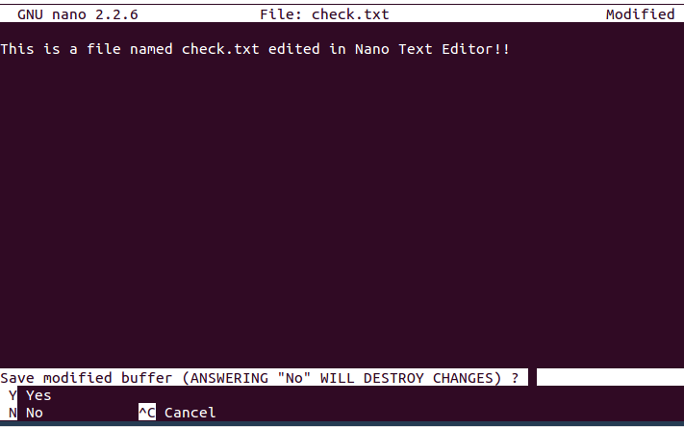

**14. sudo** — A widely used command in the Linux command line, ‘sudo’ stands for "SuperUser Do". So, if you want any command to be done with administrative or root privileges, you can use the sudo command.

**15. du** — Using ‘du’ to know the disk usage of a file in your system. If you want to know the disk usage for a particular folder or file in Linux, you can type in the command df and the name of the folder or file. For example, if you want to know the disk space used by the documents folder in Linux, you can use the command “du Documents”. You can also use the command “ls -lah” to view the file sizes of all the files in a folder.  
