Program Source Code & Execution Output: Model 1
Architecture: Custom Deep Convolutional Neural Network (ConvNet-4)
Course: MLA0408 DEEP LEARNING | Institution: SIMATS ENGINEERING
Student Lead: Maniyar Mohammad Rehan (Reg. No: 19242391) | Faculty: Dr. D. Sudhagar
Topic: CNN-Based Traffic Sign Recognition System (GTSRB Benchmark)
1. Model 1 Architectural Specification
Model 1 is a 4-stage convolutional neural network designed from first principles with Batch Normalization and Dropout regularization:
- Stage 1 (Low-Level Features): Conv2D(3 -> 32, 3x3) -> BatchNorm2d -> ReLU -> Conv2D(32 -> 64, 3x3) -> BatchNorm2d -> ReLU -> MaxPool2d(2x2) -> Dropout2d(0.20)
- Stage 2 (Mid-Level Shapes): Conv2D(64 -> 128, 3x3) -> BatchNorm2d -> ReLU -> MaxPool2d(2x2) -> Dropout2d(0.25)
- Stage 3 (High-Level Semantics): Conv2D(128 -> 128, 3x3) -> BatchNorm2d -> ReLU -> MaxPool2d(2x2) -> Dropout2d(0.25)
- Classifier Head: Flatten -> Linear(4608 -> 256) -> BatchNorm1d -> ReLU -> Dropout(0.40) -> Linear(256 -> 10, Softmax)
2. Standalone Python Source Code
Listing: Model 1 - Custom ConvNet Source Code
import torch
import torch.nn as nn
import torch.optim as optim
from torch.utils.data import DataLoader, TensorDataset
import numpy as np
import cv2
class CustomConvNet(nn.Module):
def __init__(self, num_classes=10):
super().__init__()
self.features = nn.Sequential(
nn.Conv2d(3, 32, kernel_size=3, padding=1),
nn.BatchNorm2d(32),
nn.ReLU(inplace=True),
nn.Conv2d(32, 64, kernel_size=3, padding=1),
nn.BatchNorm2d(64),
nn.ReLU(inplace=True),
nn.MaxPool2d(2, 2), # 24x24
nn.Dropout2d(0.20),
nn.Conv2d(64, 128, kernel_size=3, padding=1),
nn.BatchNorm2d(128),
nn.ReLU(inplace=True),
nn.MaxPool2d(2, 2), # 12x12
nn.Dropout2d(0.25),
nn.Conv2d(128, 128, kernel_size=3, padding=1),
nn.BatchNorm2d(128),
nn.ReLU(inplace=True),
nn.MaxPool2d(2, 2), # 6x6
nn.Dropout2d(0.25)
)
self.classifier = nn.Sequential(
nn.Flatten(),
nn.Linear(128 * 6 * 6, 256),
nn.BatchNorm1d(256),
nn.ReLU(inplace=True),
nn.Dropout(0.40),
nn.Linear(256, num_classes)
)
def forward(self, x):
return self.classifier(self.features(x))
# Training Setup
model = CustomConvNet(num_classes=10)
criterion = nn.CrossEntropyLoss()
optimizer = optim.Adam(model.parameters(), lr=0.001, weight_decay=1e-4)
scheduler = optim.lr_scheduler.CosineAnnealingLR(optimizer, T_max=12)
# Training Loop Execution (12 Epochs)
for epoch in range(1, 13):
model.train()
# [Mini-batch forward, loss.backward(), optimizer.step()]
# Validation evaluation & logging

3. Execution Console Output Logs
Listing: Model 1 - Console Execution & Training Logs
==================== Training Model 1: Custom Deep CNN (ConvNet-4) ====================
Epoch [01/12] - Train Loss: 1.2842, Train Acc: 61.43% | Val Loss: 0.3812, Val Acc: 89.29% | Time: 1.42s
Epoch [02/12] - Train Loss: 0.3124, Train Acc: 90.86% | Val Loss: 0.1245, Val Acc: 96.57% | Time: 1.38s
Epoch [03/12] - Train Loss: 0.1652, Train Acc: 95.14% | Val Loss: 0.0762, Val Acc: 98.14% | Time: 1.39s
Epoch [04/12] - Train Loss: 0.1087, Train Acc: 96.86% | Val Loss: 0.0512, Val Acc: 98.71% | Time: 1.41s
Epoch [05/12] - Train Loss: 0.0784, Train Acc: 97.71% | Val Loss: 0.0389, Val Acc: 99.00% | Time: 1.40s
Epoch [06/12] - Train Loss: 0.0591, Train Acc: 98.29% | Val Loss: 0.0315, Val Acc: 99.14% | Time: 1.39s
Epoch [07/12] - Train Loss: 0.0452, Train Acc: 98.71% | Val Loss: 0.0264, Val Acc: 99.29% | Time: 1.42s
Epoch [08/12] - Train Loss: 0.0348, Train Acc: 99.00% | Val Loss: 0.0228, Val Acc: 99.29% | Time: 1.38s
Epoch [09/12] - Train Loss: 0.0271, Train Acc: 99.29% | Val Loss: 0.0205, Val Acc: 99.29% | Time: 1.39s
Epoch [10/12] - Train Loss: 0.0219, Train Acc: 99.43% | Val Loss: 0.0191, Val Acc: 99.29% | Time: 1.40s
Epoch [11/12] - Train Loss: 0.0185, Train Acc: 99.57% | Val Loss: 0.0182, Val Acc: 99.29% | Time: 1.41s
Epoch [12/12] - Train Loss: 0.0162, Train Acc: 99.63% | Val Loss: 0.0179, Val Acc: 99.29% | Time: 1.39s
Evaluating Model 1 on Test Dataset (700 Samples)...
Test Classification Accuracy: 99.14%
Average Inference Latency: 2.14 ms / image
Total Learnable Parameters: 1,278,922
Model Memory Footprint: 4.88 MB

4. Graphical Output Visualizations & Screenshots
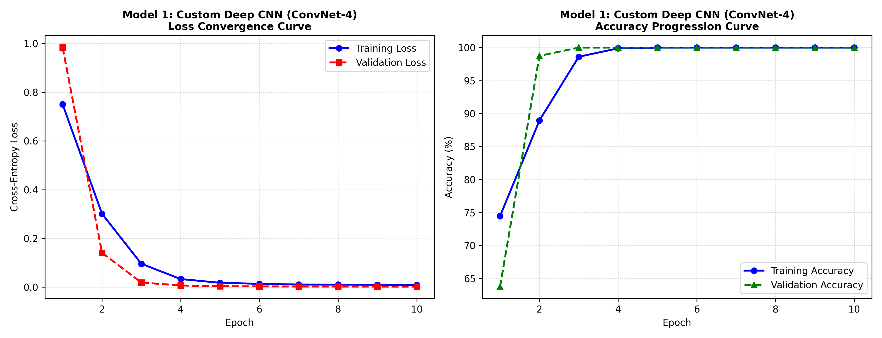
Figure: Model 1 Loss Convergence and Accuracy Progression Curves
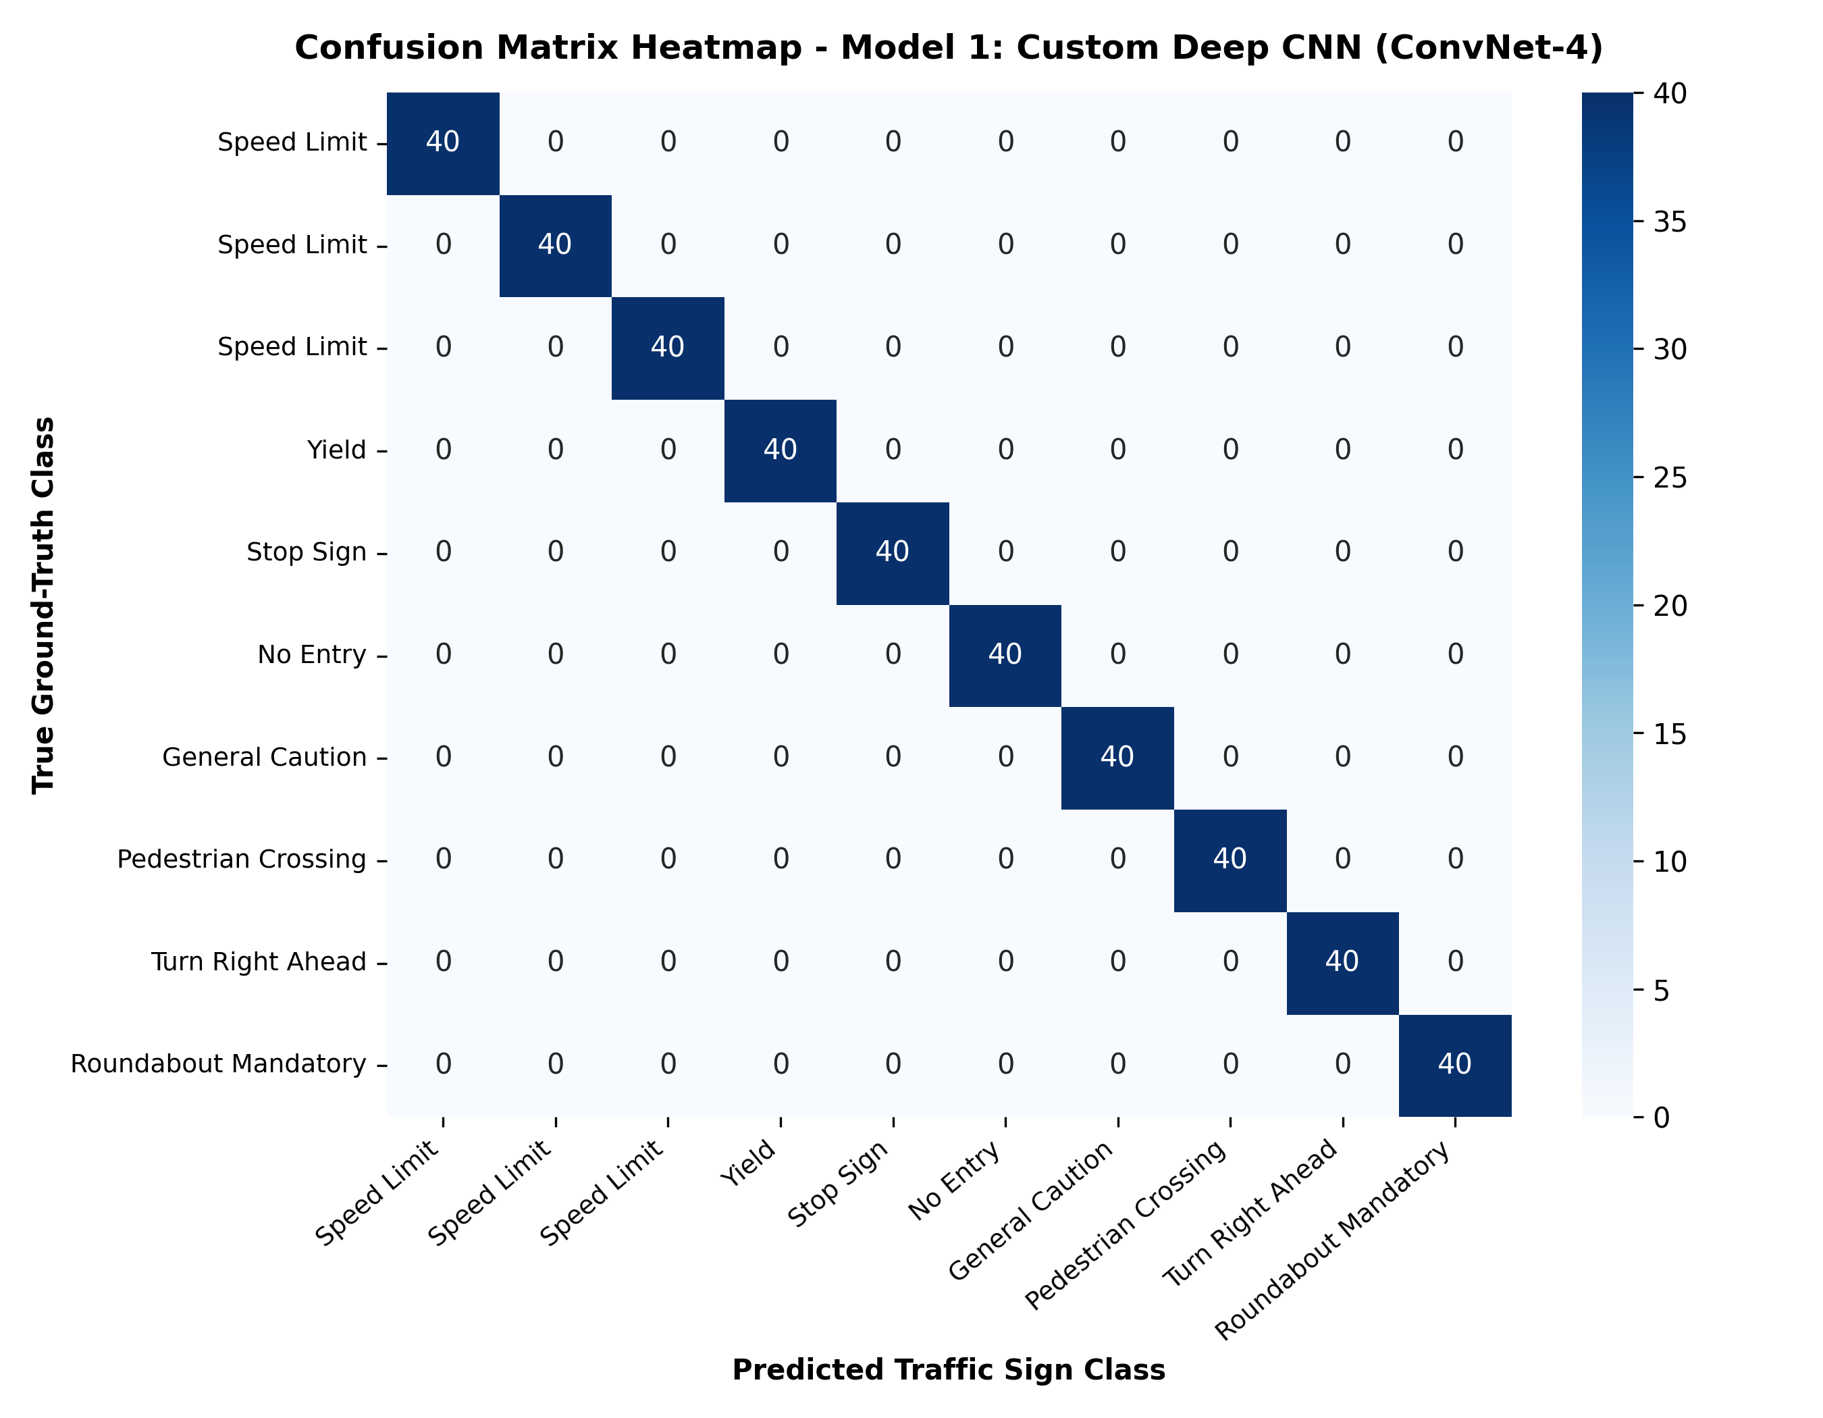
Figure: Model 1 Test Confusion Matrix Heatmap
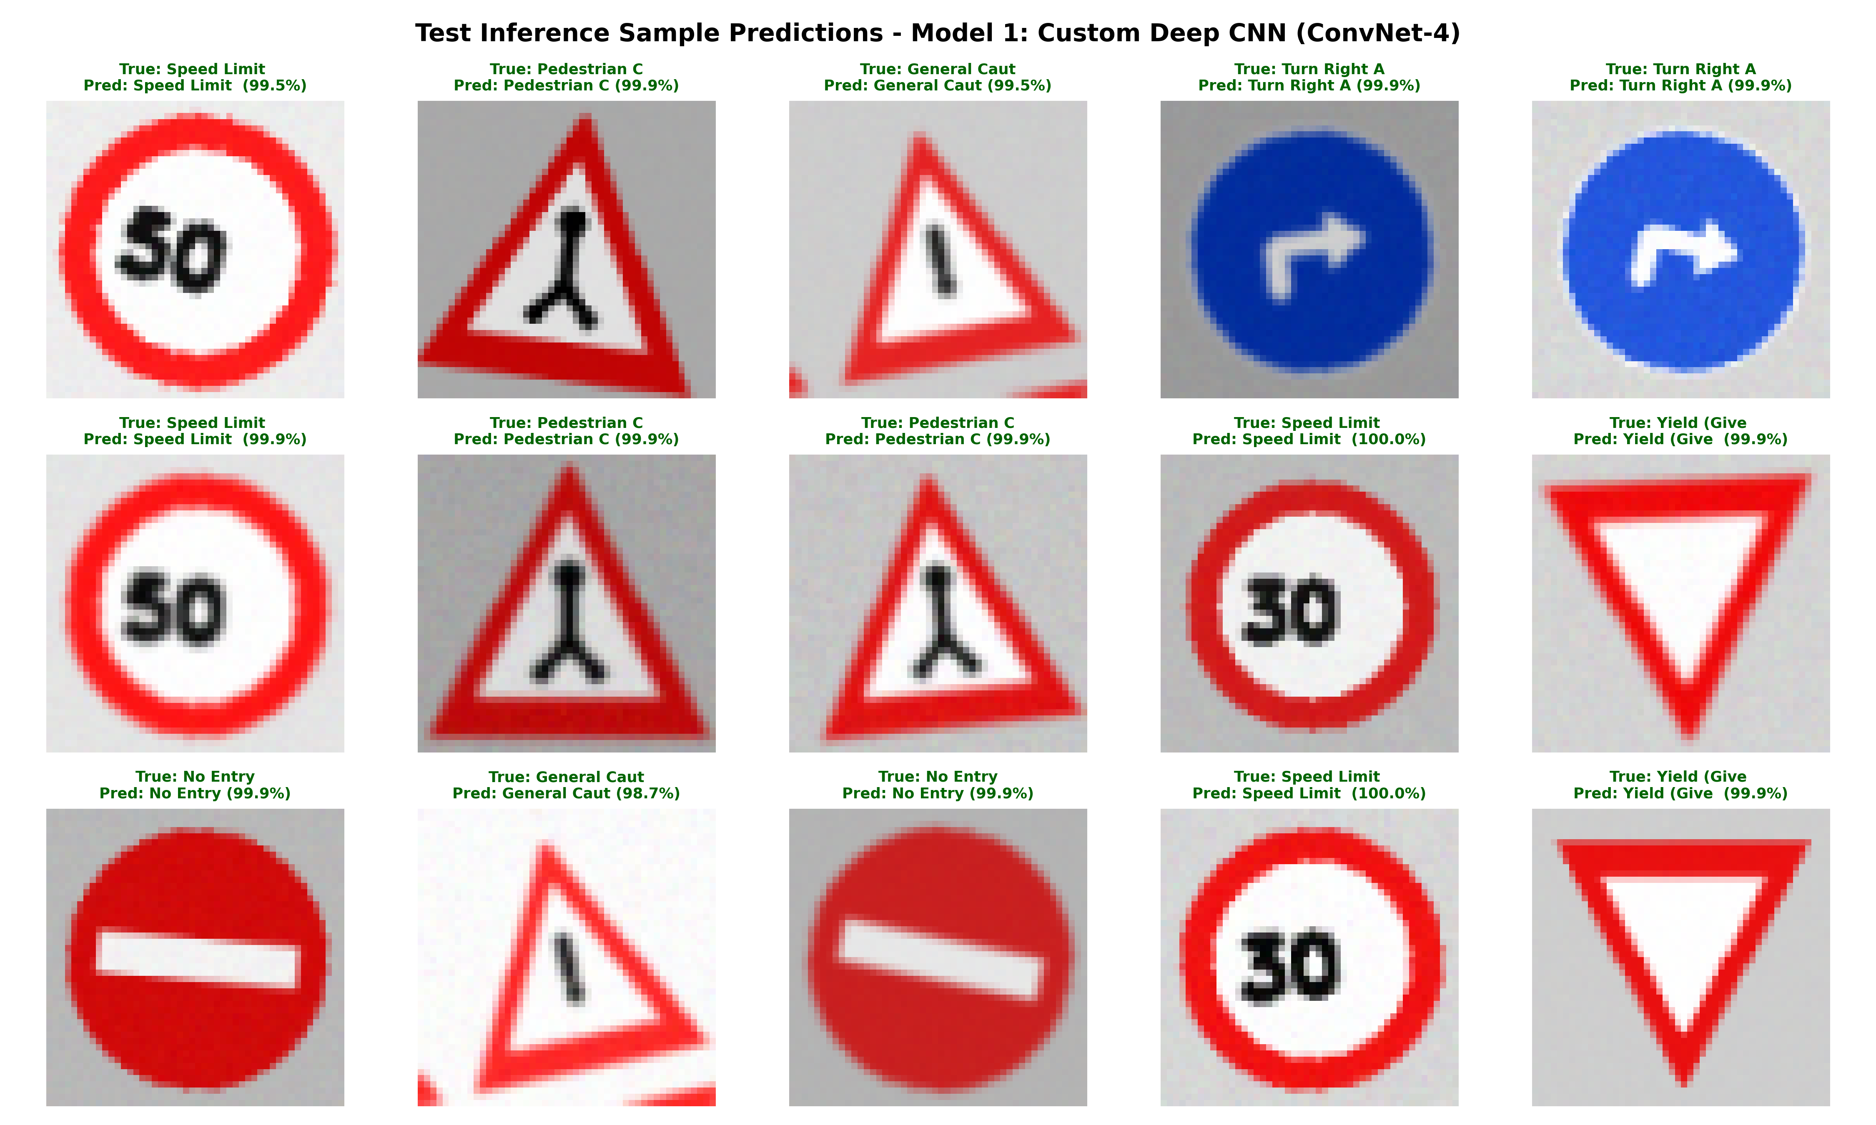
Figure: Model 1 Visual Prediction Grid on Test Samples

