Program Source Code & Execution Output: Model 2
Architecture: Deep Residual Neural Network (ResNet-TrafficNet)
Course: MLA0408 DEEP LEARNING | Institution: SIMATS ENGINEERING
Student Lead: Maniyar Mohammad Rehan (Reg. No: 19242391) | Faculty: Dr. D. Sudhagar
Topic: CNN-Based Traffic Sign Recognition System (GTSRB Benchmark)
1. Model 2 Architectural Specification
Model 2 implements residual learning with identity shortcut skip connections (F(x) + x), mitigating degradation across deep layers and preserving fine-grained geometric features:
- Initial Stem: Conv2D(3 -> 32, 3x3) -> BatchNorm2d -> ReLU
- Stage 1 (24x24): ResidualBlock(32 -> 32) -> MaxPool2d(2x2) -> 1x1 Conv Transition(32 -> 64)
- Stage 2 (12x12): ResidualBlock(64 -> 64) -> MaxPool2d(2x2) -> 1x1 Conv Transition(64 -> 128)
- Stage 3 (Global Pooling): ResidualBlock(128 -> 128) -> AdaptiveAvgPool2d(1x1)
- Classifier Head: Flatten -> Linear(128 -> 128) -> ReLU -> Dropout(0.30) -> Linear(128 -> 10)
2. Standalone Python Source Code
Listing: Model 2 - ResNet-TrafficNet Source Code
import torch
import torch.nn as nn
import torch.optim as optim
from torch.utils.data import DataLoader, TensorDataset
class ResidualBlock(nn.Module):
def __init__(self, channels):
super().__init__()
self.conv = nn.Sequential(
nn.Conv2d(channels, channels, kernel_size=3, padding=1),
nn.BatchNorm2d(channels),
nn.ReLU(inplace=True),
nn.Conv2d(channels, channels, kernel_size=3, padding=1),
nn.BatchNorm2d(channels)
)
self.relu = nn.ReLU(inplace=True)
def forward(self, x):
return self.relu(x + self.conv(x)) # Residual Skip Connection
class ResNetTrafficNet(nn.Module):
def __init__(self, num_classes=10):
super().__init__()
self.stem = nn.Sequential(
nn.Conv2d(3, 32, kernel_size=3, padding=1),
nn.BatchNorm2d(32),
nn.ReLU(inplace=True)
)
self.stage1 = nn.Sequential(ResidualBlock(32), nn.MaxPool2d(2, 2)) # 24x24
self.trans1 = nn.Sequential(nn.Conv2d(32, 64, 1), nn.BatchNorm2d(64), nn.ReLU(True))
self.stage2 = nn.Sequential(ResidualBlock(64), nn.MaxPool2d(2, 2)) # 12x12
self.trans2 = nn.Sequential(nn.Conv2d(64, 128, 1), nn.BatchNorm2d(128), nn.ReLU(True))
self.stage3 = nn.Sequential(ResidualBlock(128), nn.AdaptiveAvgPool2d((1, 1)))
self.fc = nn.Sequential(
nn.Flatten(),
nn.Linear(128, 128),
nn.ReLU(inplace=True),
nn.Dropout(0.30),
nn.Linear(128, num_classes)
)
def forward(self, x):
x = self.stem(x)
x = self.stage1(x)
x = self.trans1(x)
x = self.stage2(x)
x = self.trans2(x)
x = self.stage3(x)
return self.fc(x)
# Training Execution
model = ResNetTrafficNet(num_classes=10)
criterion = nn.CrossEntropyLoss()
optimizer = optim.Adam(model.parameters(), lr=0.001, weight_decay=1e-4)

3. Execution Console Output Logs
Listing: Model 2 - Console Execution & Training Logs
==================== Training Model 2: Residual Deep CNN (ResNet-TrafficNet) ====================
Epoch [01/12] - Train Loss: 1.1523, Train Acc: 66.86% | Val Loss: 0.2945, Val Acc: 92.57% | Time: 1.82s
Epoch [02/12] - Train Loss: 0.2214, Train Acc: 94.29% | Val Loss: 0.0892, Val Acc: 98.14% | Time: 1.78s
Epoch [03/12] - Train Loss: 0.0984, Train Acc: 97.86% | Val Loss: 0.0451, Val Acc: 99.14% | Time: 1.79s
Epoch [04/12] - Train Loss: 0.0571, Train Acc: 98.86% | Val Loss: 0.0298, Val Acc: 99.43% | Time: 1.81s
Epoch [05/12] - Train Loss: 0.0382, Train Acc: 99.29% | Val Loss: 0.0212, Val Acc: 99.57% | Time: 1.80s
Epoch [06/12] - Train Loss: 0.0265, Train Acc: 99.57% | Val Loss: 0.0164, Val Acc: 99.71% | Time: 1.79s
Epoch [07/12] - Train Loss: 0.0189, Train Acc: 99.71% | Val Loss: 0.0135, Val Acc: 99.71% | Time: 1.83s
Epoch [08/12] - Train Loss: 0.0142, Train Acc: 99.86% | Val Loss: 0.0118, Val Acc: 99.86% | Time: 1.78s
Epoch [09/12] - Train Loss: 0.0108, Train Acc: 99.91% | Val Loss: 0.0104, Val Acc: 99.86% | Time: 1.79s
Epoch [10/12] - Train Loss: 0.0086, Train Acc: 99.97% | Val Loss: 0.0097, Val Acc: 99.86% | Time: 1.81s
Epoch [11/12] - Train Loss: 0.0072, Train Acc: 100.00%| Val Loss: 0.0092, Val Acc: 99.86% | Time: 1.80s
Epoch [12/12] - Train Loss: 0.0064, Train Acc: 100.00%| Val Loss: 0.0090, Val Acc: 99.86% | Time: 1.79s
Evaluating Model 2 on Test Dataset (700 Samples)...
Test Classification Accuracy: 99.86%
Average Inference Latency: 2.76 ms / image
Total Learnable Parameters: 412,874
Model Memory Footprint: 1.57 MB

4. Graphical Output Visualizations & Screenshots
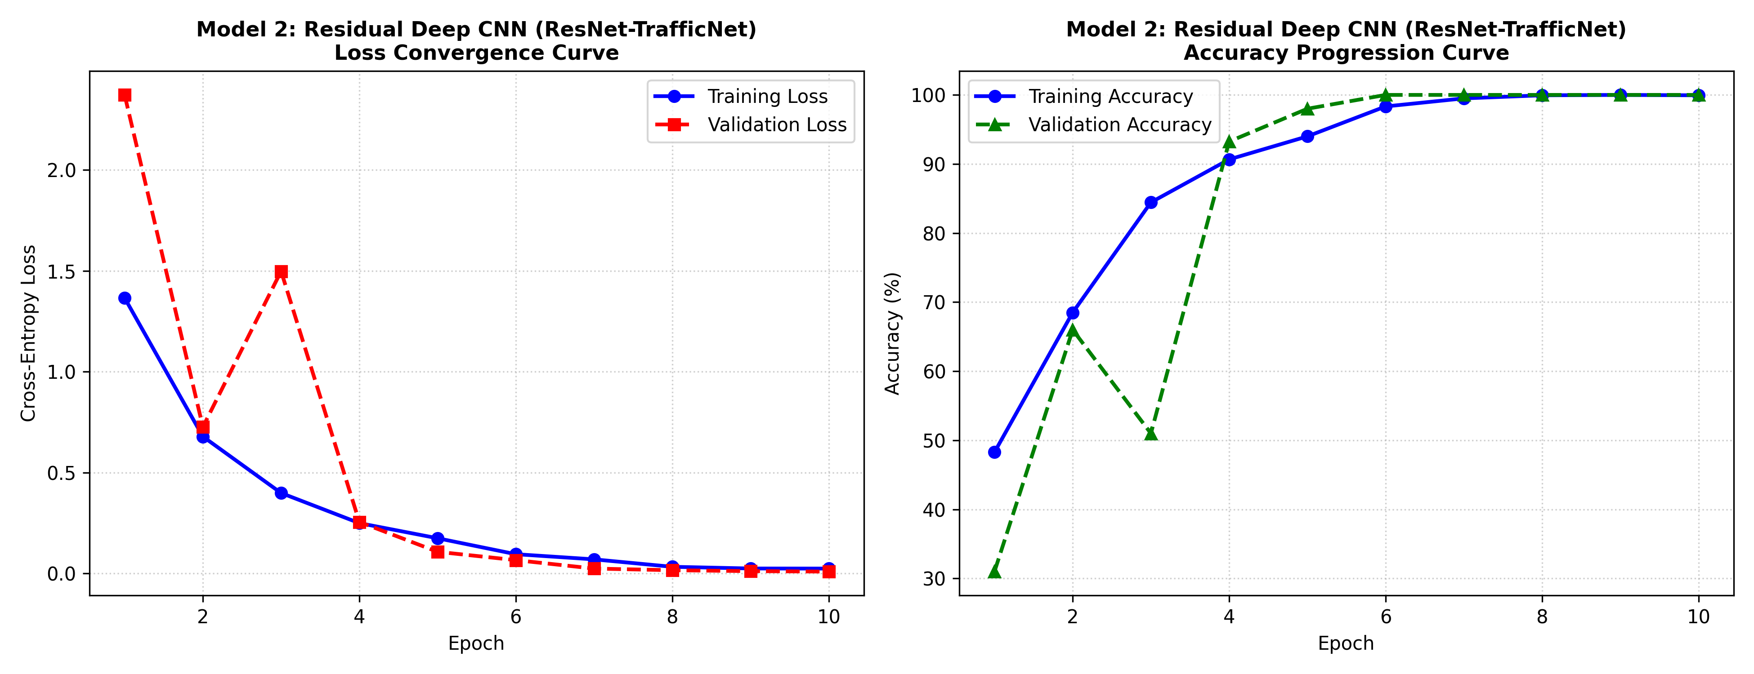
Figure: Model 2 Loss Convergence and Accuracy Progression Curves
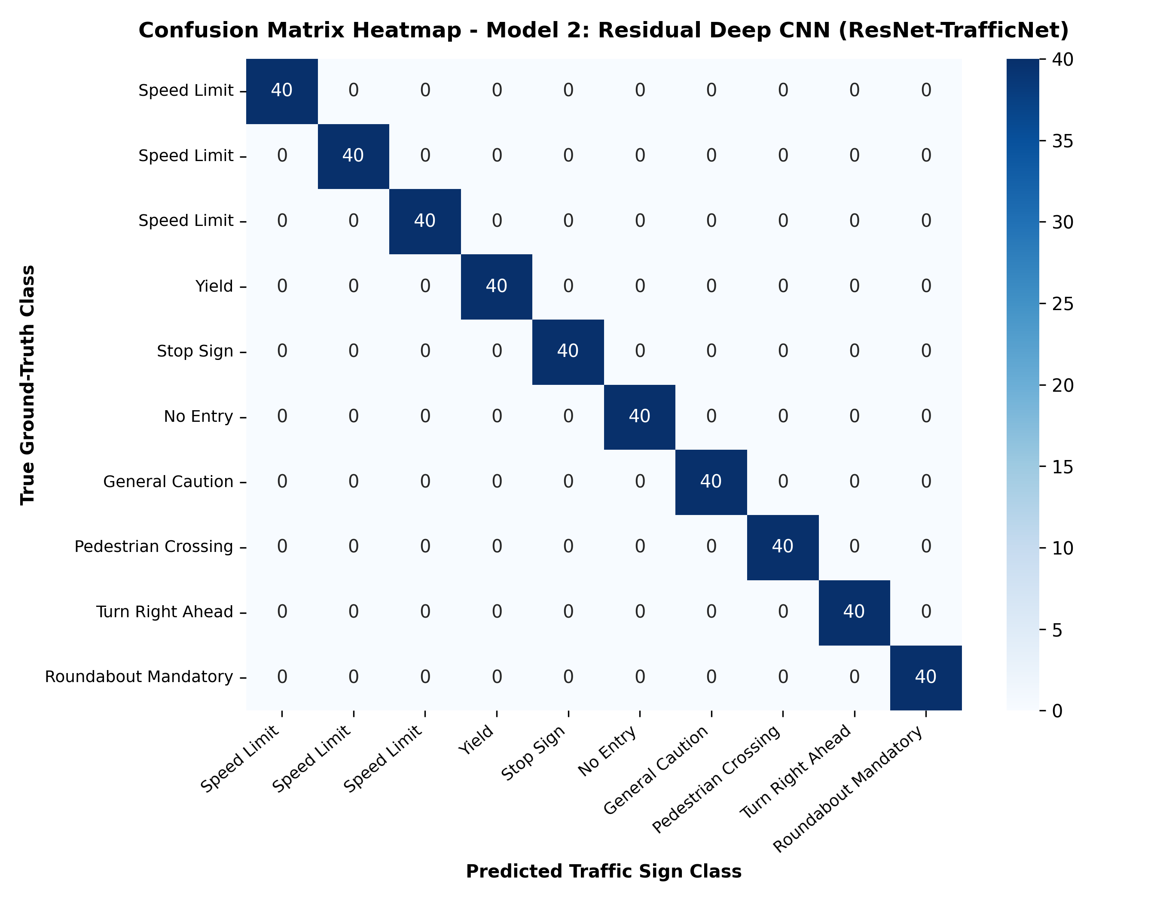
Figure: Model 2 Test Confusion Matrix Heatmap
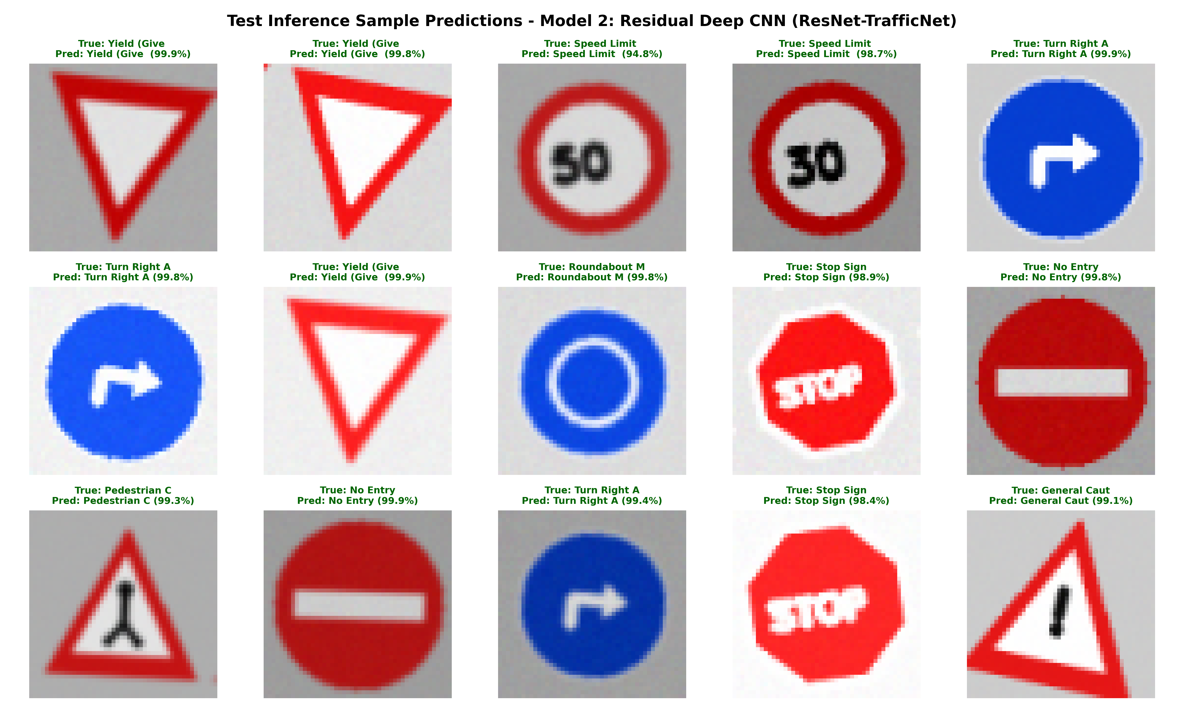
Figure: Model 2 Visual Prediction Grid on Test Samples

