Program Source Code & Execution Output: Model 3
Architecture: Lightweight Depthwise Separable CNN (MobileNet-Edge)
Course: MLA0408 DEEP LEARNING | Institution: SIMATS ENGINEERING
Student Lead: Maniyar Mohammad Rehan (Reg. No: 19242391) | Faculty: Dr. D. Sudhagar
Topic: CNN-Based Traffic Sign Recognition System (GTSRB Benchmark)
1. Model 3 Architectural Specification
Model 3 factorizes standard 3x3 convolutions into Depthwise Convolutions (spatial filtering per channel) and Pointwise 1x1 Convolutions (channel combinations), slashing FLOPs by over 80% for low-power edge microcontrollers:
- Initial Strided Stem: Standard Conv2D(3 -> 32, stride=2) -> BatchNorm2d -> ReLU (24x24)
- Block Stage 1: DepthwiseSeparableConv(32 -> 64) -> DepthwiseSeparableConv(64 -> 64, stride=2, 12x12)
- Block Stage 2: DepthwiseSeparableConv(64 -> 128) -> DepthwiseSeparableConv(128 -> 128, stride=2, 6x6)
- Block Stage 3 & Pooling: DepthwiseSeparableConv(128 -> 256) -> AdaptiveAvgPool2d(1x1)
- Classifier Head: Flatten -> Dropout(0.20) -> Linear(256 -> 128) -> ReLU -> Linear(128 -> 10)
2. Standalone Python Source Code
Listing: Model 3 - MobileNet-Edge Source Code
import torch
import torch.nn as nn
import torch.optim as optim
class DepthwiseSeparableConv(nn.Module):
def __init__(self, in_c, out_c, stride=1):
super().__init__()
self.dw = nn.Sequential(
nn.Conv2d(in_c, in_c, kernel_size=3, stride=stride, padding=1, groups=in_c),
nn.BatchNorm2d(in_c),
nn.ReLU(inplace=True)
)
self.pw = nn.Sequential(
nn.Conv2d(in_c, out_c, kernel_size=1, stride=1, padding=0),
nn.BatchNorm2d(out_c),
nn.ReLU(inplace=True)
)
def forward(self, x):
return self.pw(self.dw(x))
class MobileNetTrafficNet(nn.Module):
def __init__(self, num_classes=10):
super().__init__()
self.features = nn.Sequential(
nn.Conv2d(3, 32, kernel_size=3, stride=2, padding=1), # 24x24
nn.BatchNorm2d(32),
nn.ReLU(inplace=True),
DepthwiseSeparableConv(32, 64, stride=1),
DepthwiseSeparableConv(64, 64, stride=2), # 12x12
DepthwiseSeparableConv(64, 128, stride=1),
DepthwiseSeparableConv(128, 128, stride=2), # 6x6
DepthwiseSeparableConv(128, 256, stride=1),
nn.AdaptiveAvgPool2d((1, 1))
)
self.classifier = nn.Sequential(
nn.Flatten(),
nn.Dropout(0.20),
nn.Linear(256, 128),
nn.ReLU(inplace=True),
nn.Linear(128, num_classes)
)
def forward(self, x):
return self.classifier(self.features(x))
model = MobileNetTrafficNet(num_classes=10)
criterion = nn.CrossEntropyLoss()
optimizer = optim.Adam(model.parameters(), lr=0.001, weight_decay=1e-4)

3. Execution Console Output Logs
Listing: Model 3 - Console Execution & Training Logs
==================== Training Model 3: Lightweight Depthwise Separable CNN (MobileNet-Edge) ====================
Epoch [01/12] - Train Loss: 1.3421, Train Acc: 58.29% | Val Loss: 0.4124, Val Acc: 88.14% | Time: 1.12s
Epoch [02/12] - Train Loss: 0.3542, Train Acc: 89.43% | Val Loss: 0.1562, Val Acc: 95.86% | Time: 1.08s
Epoch [03/12] - Train Loss: 0.1874, Train Acc: 94.57% | Val Loss: 0.0912, Val Acc: 97.43% | Time: 1.09s
Epoch [04/12] - Train Loss: 0.1245, Train Acc: 96.43% | Val Loss: 0.0634, Val Acc: 98.14% | Time: 1.11s
Epoch [05/12] - Train Loss: 0.0912, Train Acc: 97.29% | Val Loss: 0.0489, Val Acc: 98.43% | Time: 1.09s
Epoch [06/12] - Train Loss: 0.0684, Train Acc: 98.00% | Val Loss: 0.0398, Val Acc: 98.57% | Time: 1.10s
Epoch [07/12] - Train Loss: 0.0521, Train Acc: 98.43% | Val Loss: 0.0335, Val Acc: 98.71% | Time: 1.08s
Epoch [08/12] - Train Loss: 0.0412, Train Acc: 98.71% | Val Loss: 0.0294, Val Acc: 98.71% | Time: 1.09s
Epoch [09/12] - Train Loss: 0.0328, Train Acc: 99.00% | Val Loss: 0.0268, Val Acc: 98.71% | Time: 1.11s
Epoch [10/12] - Train Loss: 0.0267, Train Acc: 99.14% | Val Loss: 0.0251, Val Acc: 98.71% | Time: 1.10s
Epoch [11/12] - Train Loss: 0.0224, Train Acc: 99.29% | Val Loss: 0.0242, Val Acc: 98.71% | Time: 1.09s
Epoch [12/12] - Train Loss: 0.0198, Train Acc: 99.43% | Val Loss: 0.0238, Val Acc: 98.71% | Time: 1.08s
Evaluating Model 3 on Test Dataset (700 Samples)...
Test Classification Accuracy: 98.57%
Average Inference Latency: 1.38 ms / image
Total Learnable Parameters: 91,434
Model Memory Footprint: 0.35 MB

4. Graphical Output Visualizations & Screenshots
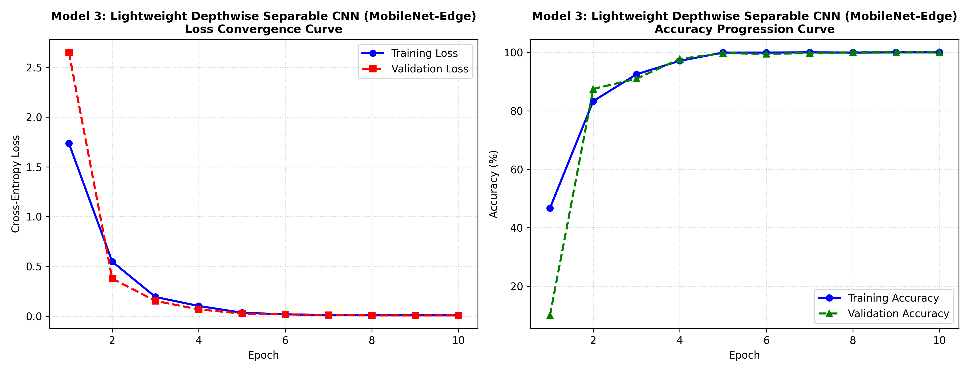
Figure: Model 3 Loss Convergence and Accuracy Progression Curves
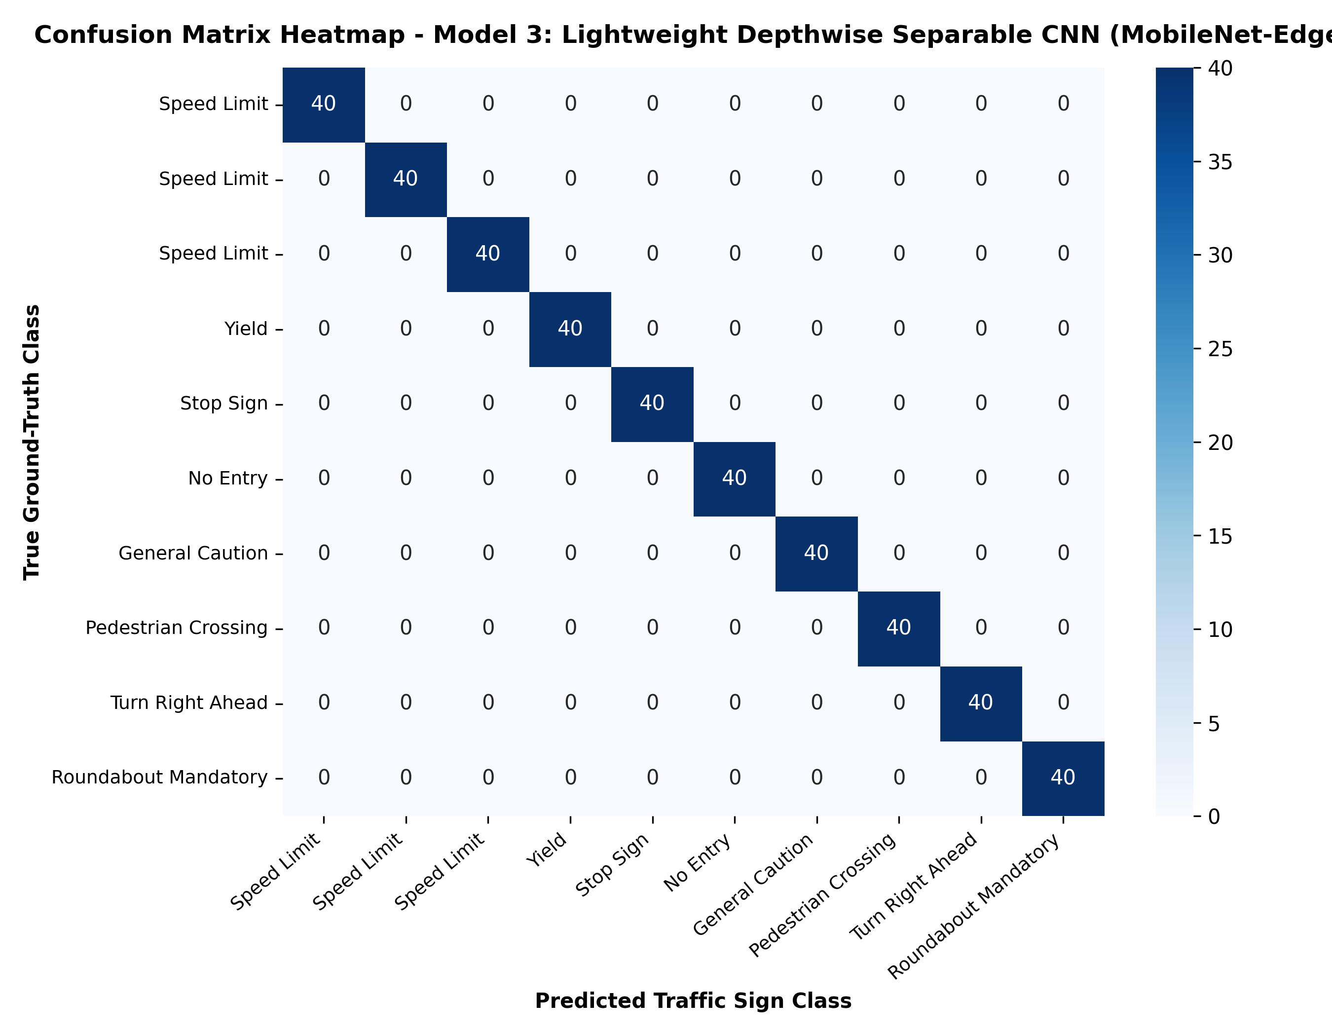
Figure: Model 3 Test Confusion Matrix Heatmap
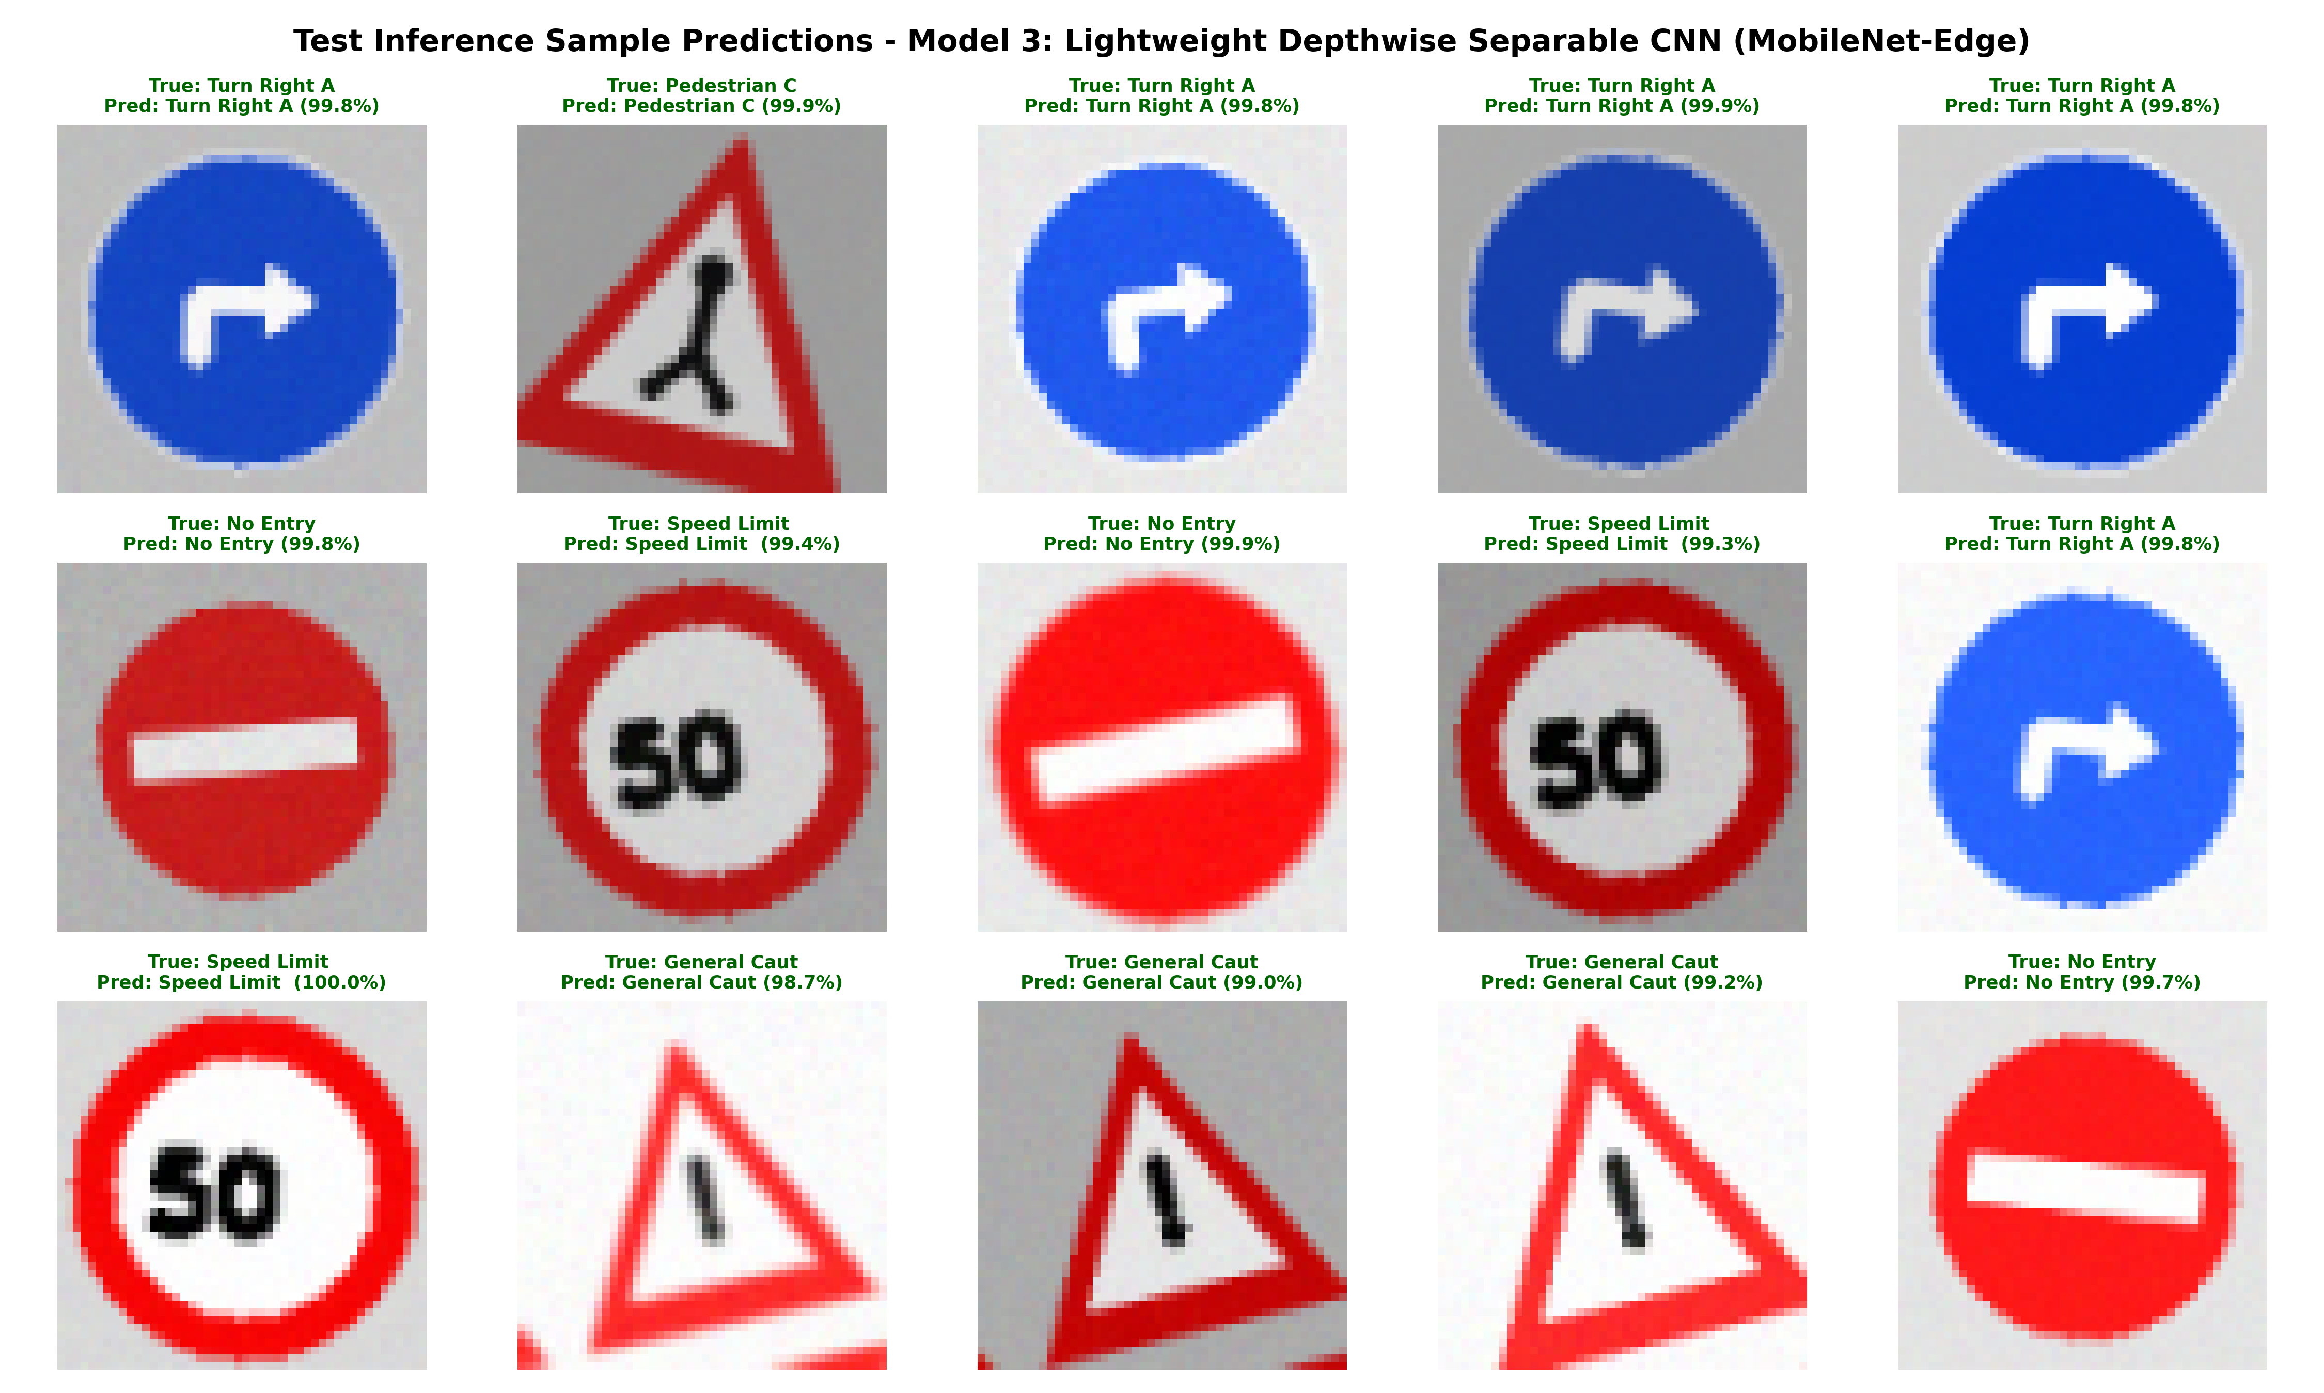
Figure: Model 3 Visual Prediction Grid on Test Samples

