**ANSWER TO THE QUESTIONS**

a) The message signal is – “Sum”.

b) My ID is 18-36546-1. So according to my ID,

B = 8; it is an even number

That is why the message will be transmitted in Synchronous form.

To find the bit stream of the message signal the following code will be applied –

Transmitted_Message= 'Sum'

%Converting Information Message to bit%

x=asc2bn(Transmitted_Message); % Binary Information

bp=1; % bit period

disp(' Binary information at Trans mitter :');

disp(x);

The function used here is a user defined function. It is –

function dn = asc2bn(txt)

dec=double(txt) %Text to ASCII (decimal)

p2=2.^(0:-1:-7) % 2^0,2^-1,.......,2^-7

B=mod(floor(p2'*dec),2) %Decimal to binary conversion

%Columns of B are bits of chars

dn=reshape(B,1,numel(B));%Bytes to serial conbversion

end

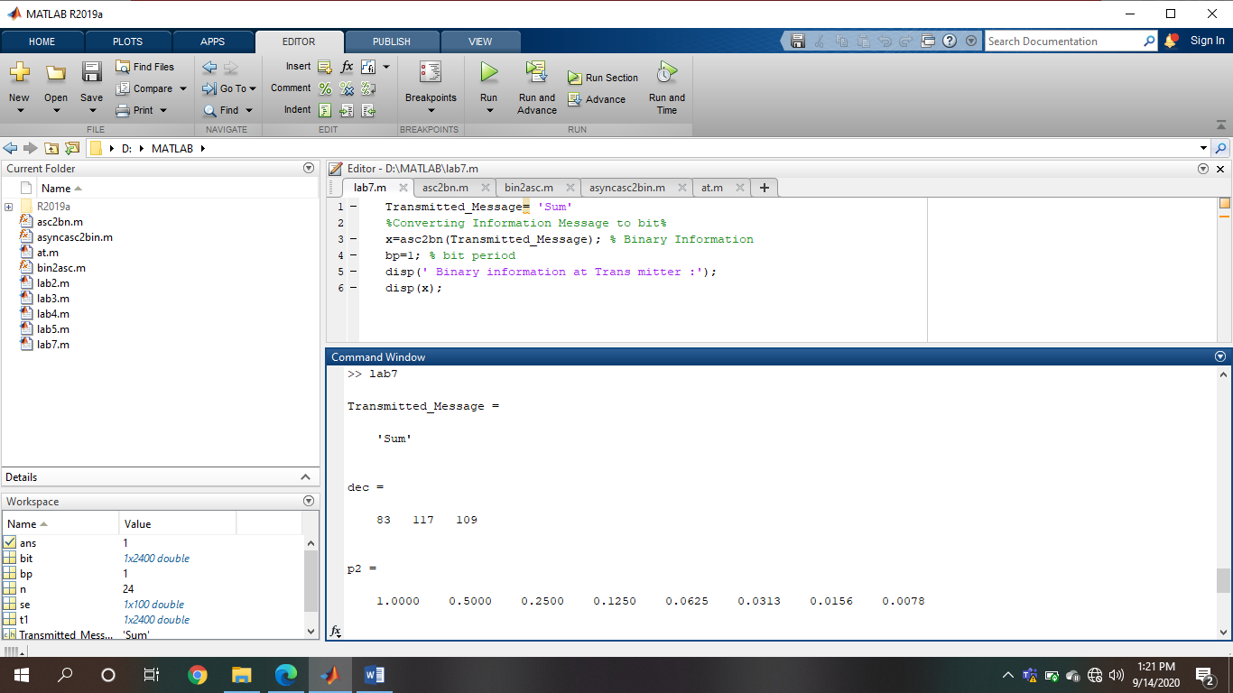

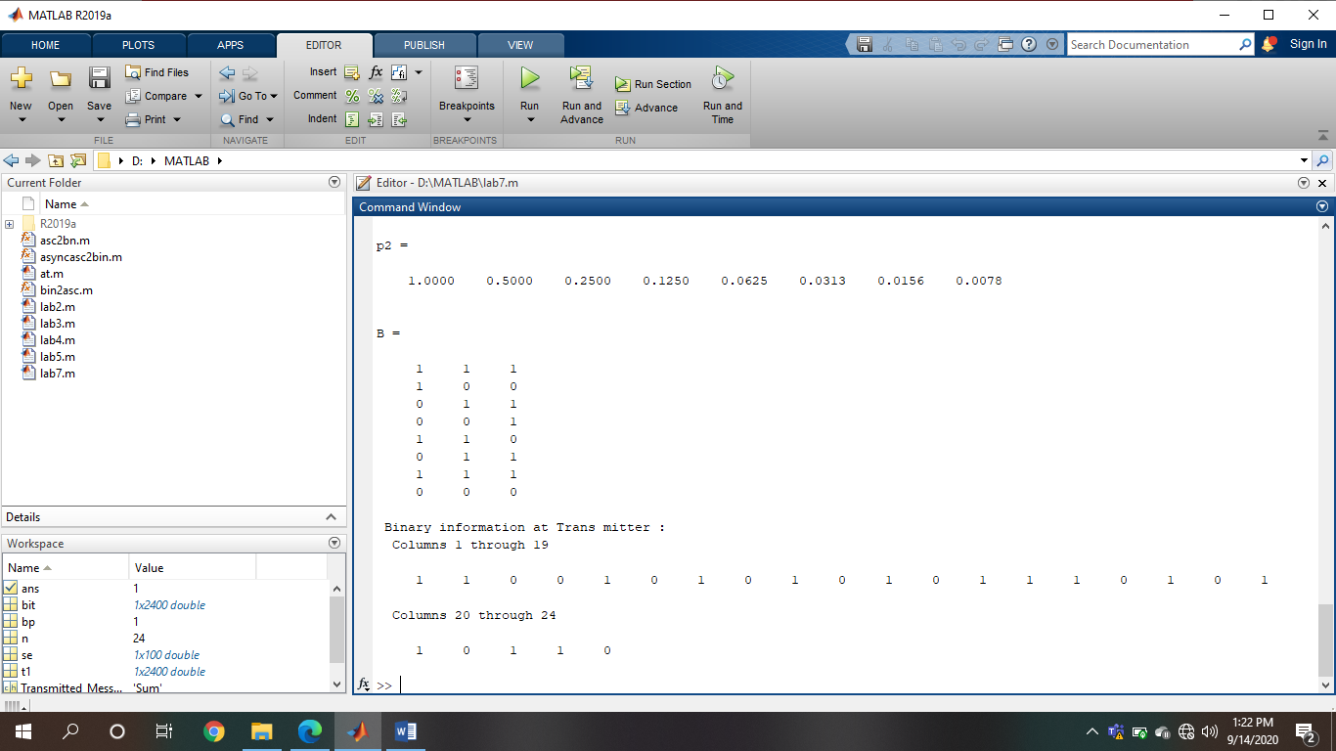

c)