**Click for Login or Registration**

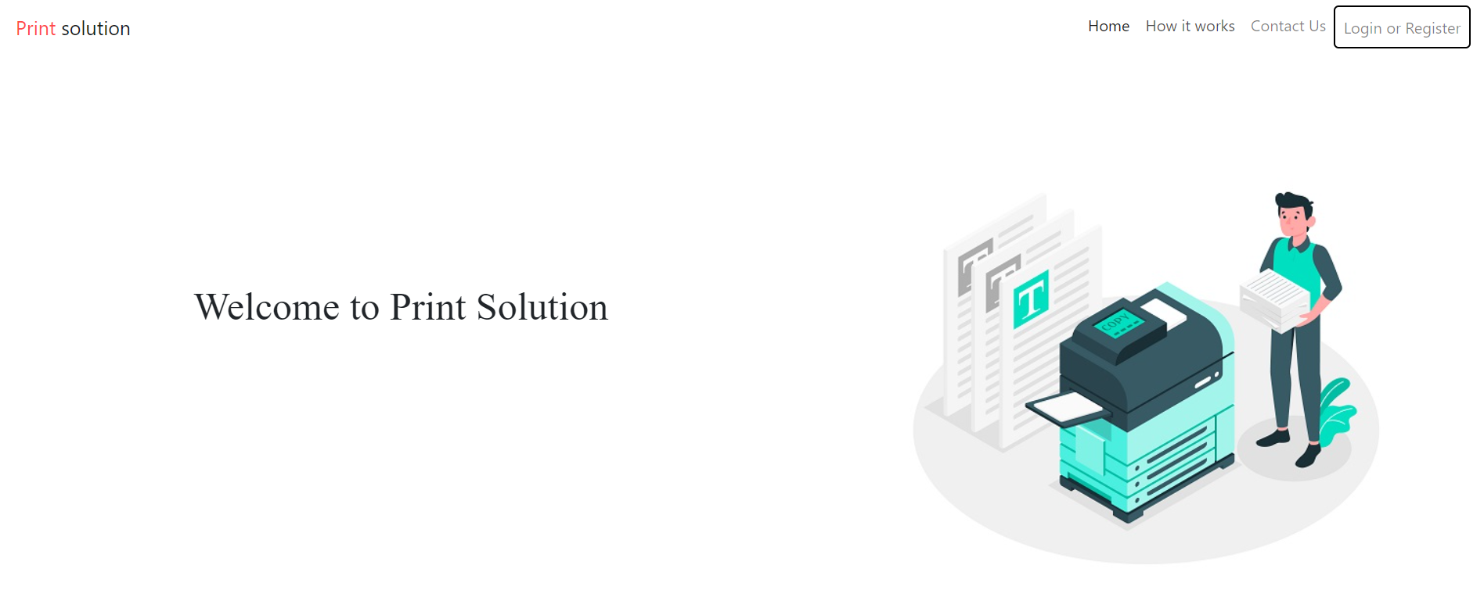

**Those who want to print their file**

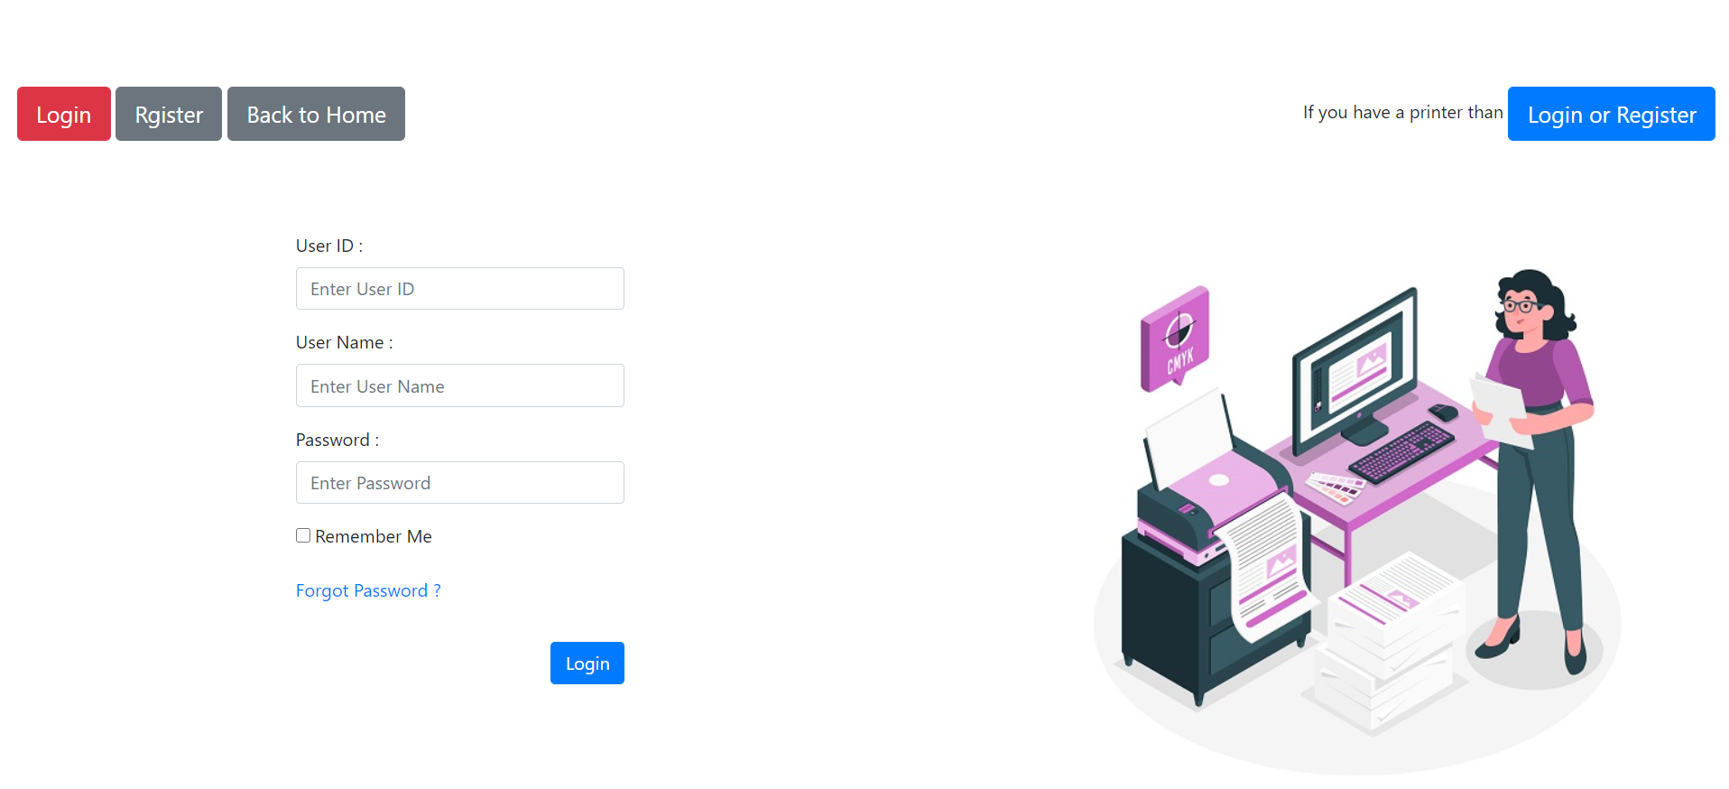

**Those who have a printer**

**Use this Those who have a printer**

