**Click Here for Logout**

**Click Here for Show information**

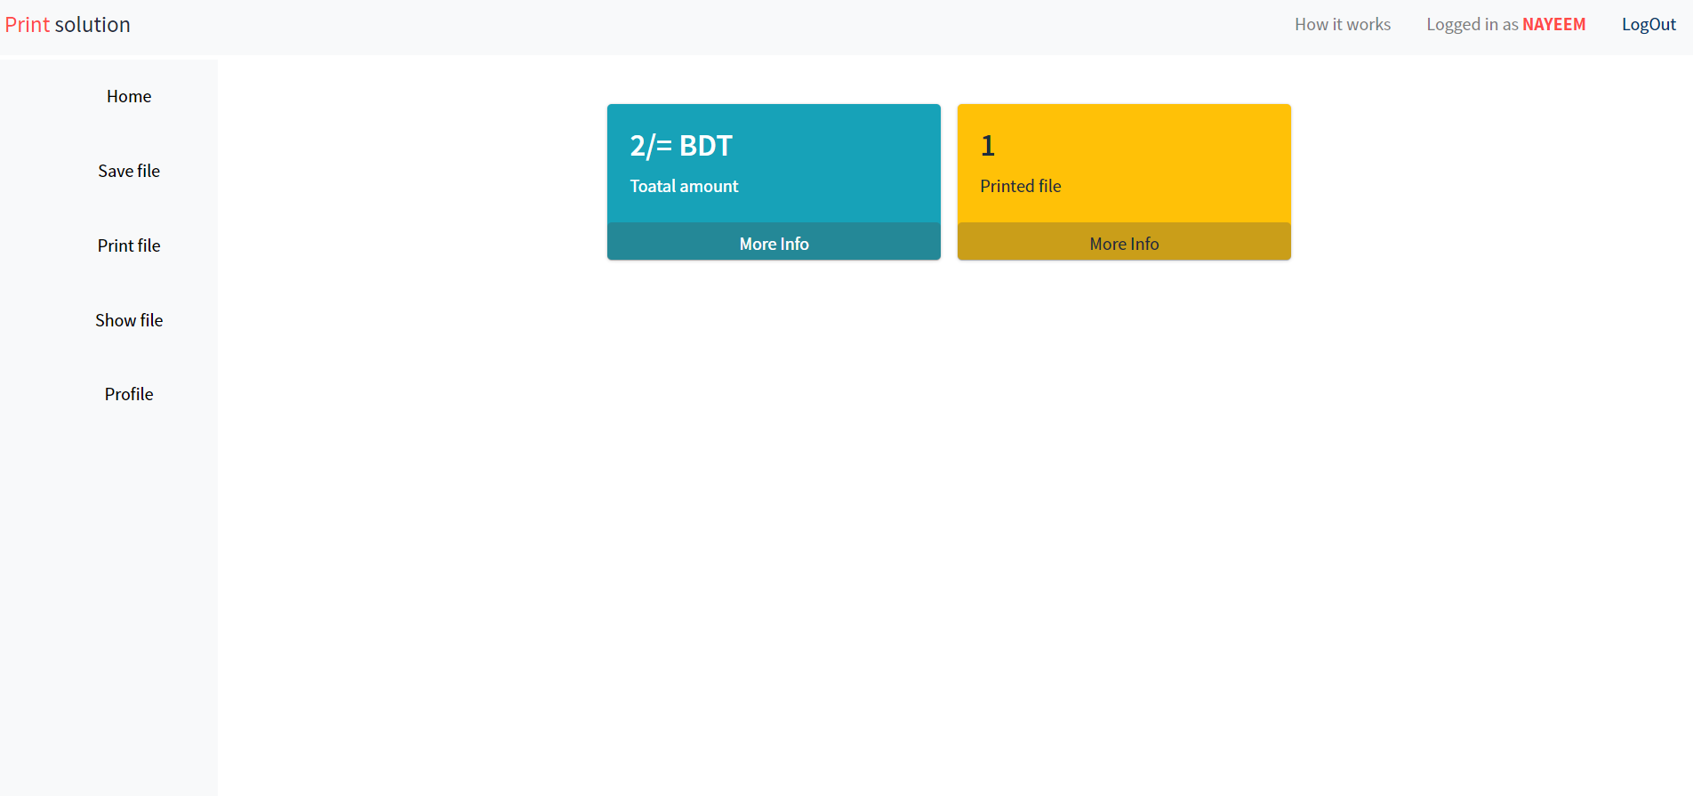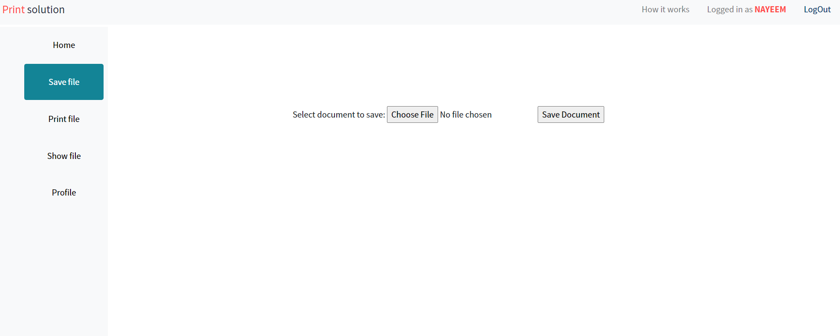

**For Saving File**

**Total Print file amount**

**Total Print file Price**

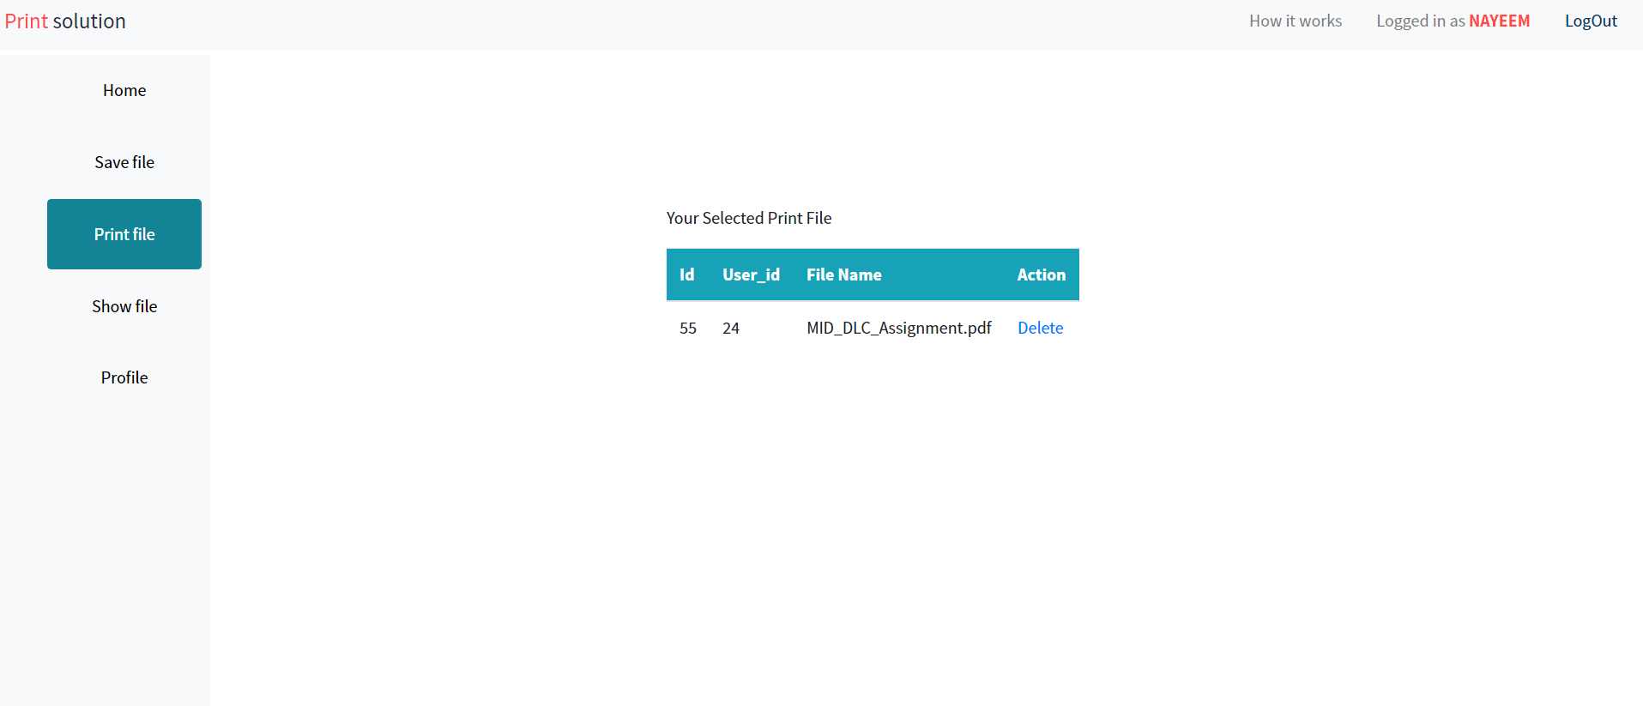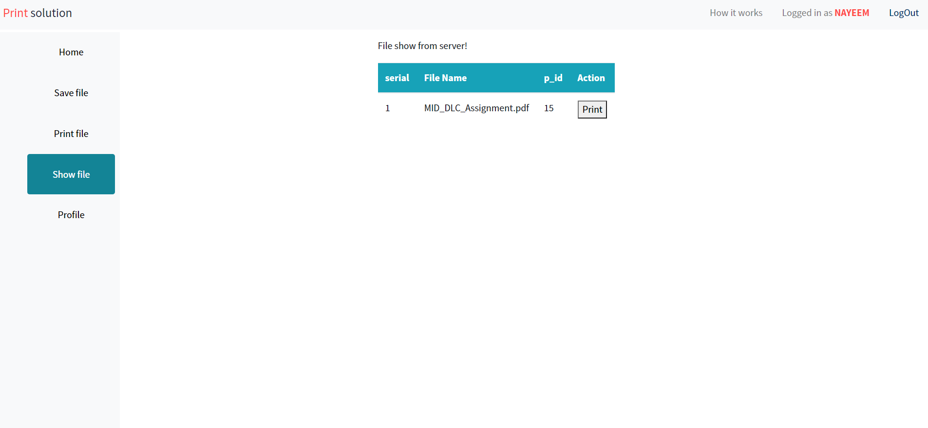

**Selecting Print File**

**For Delete Request File**

**For Request Print File**

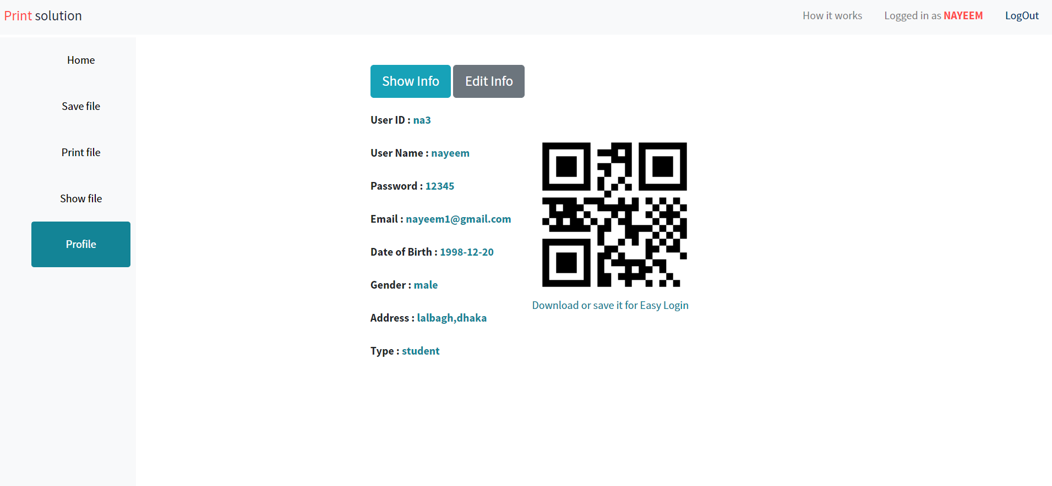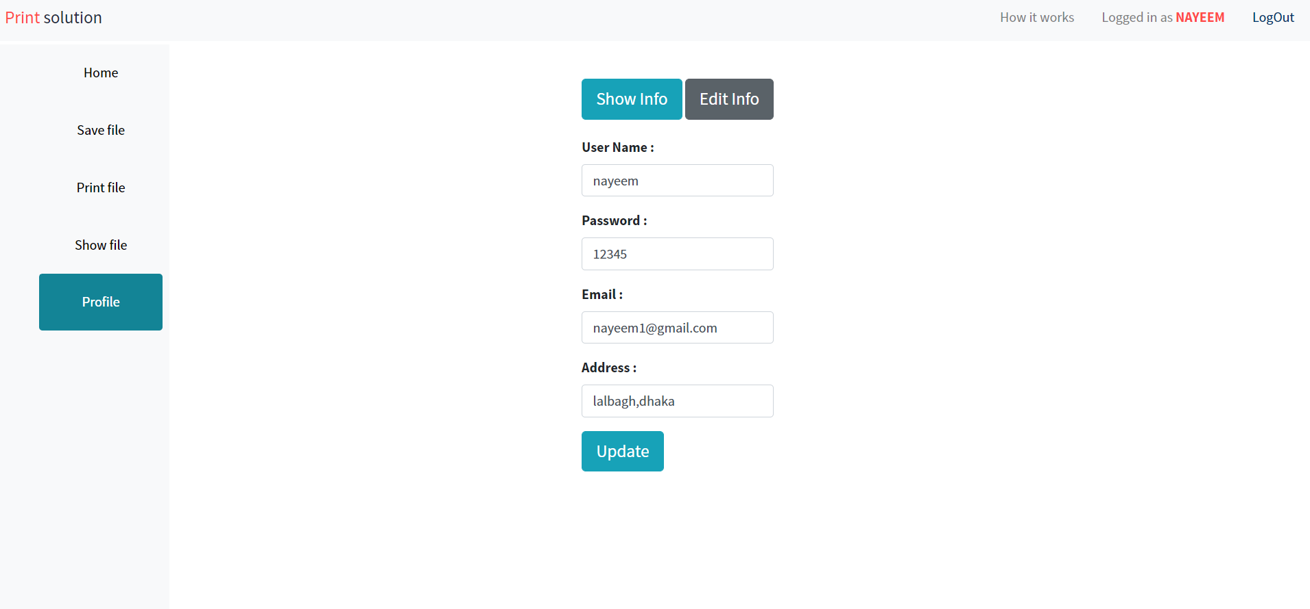

**For Edit user Information**

**Use it for Easy login**

**Show user information**