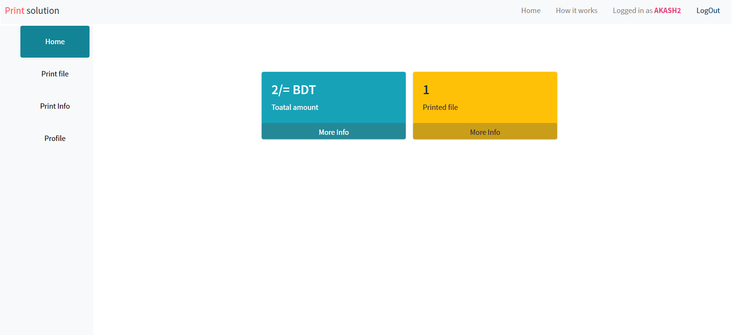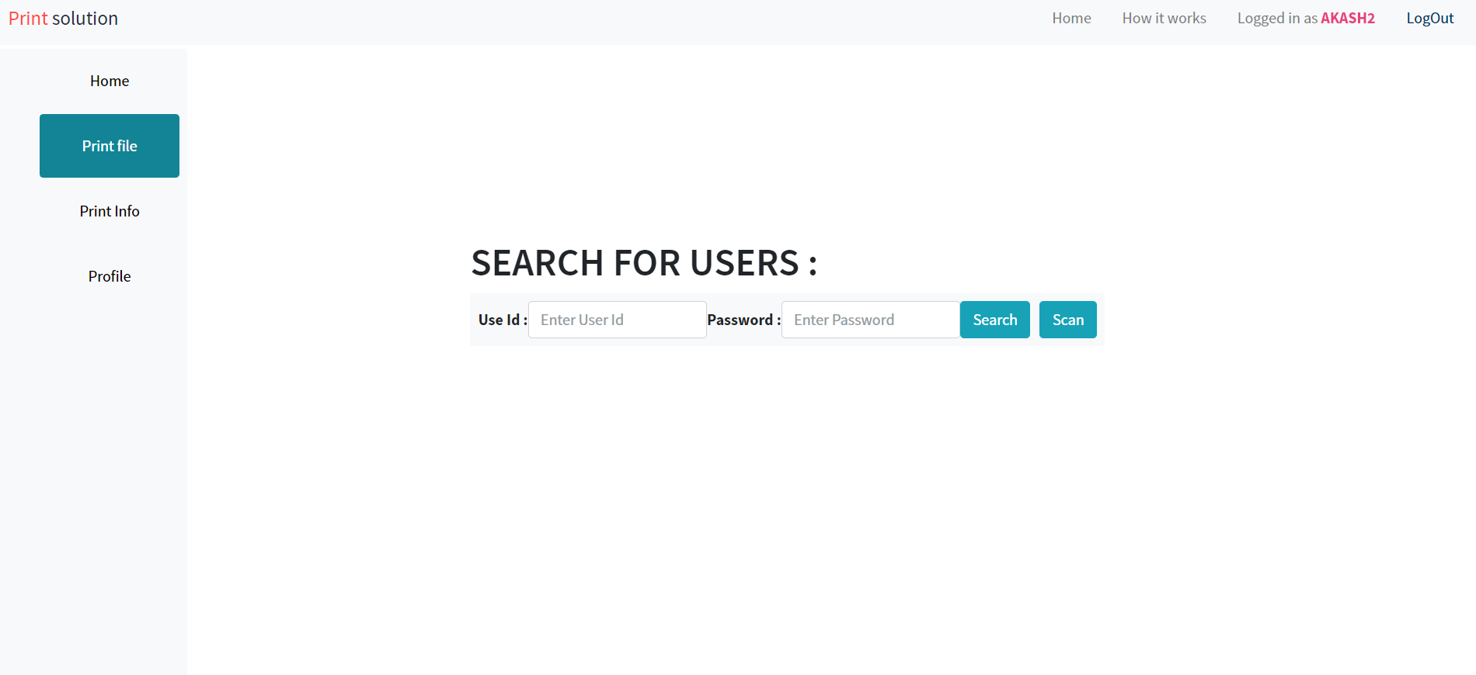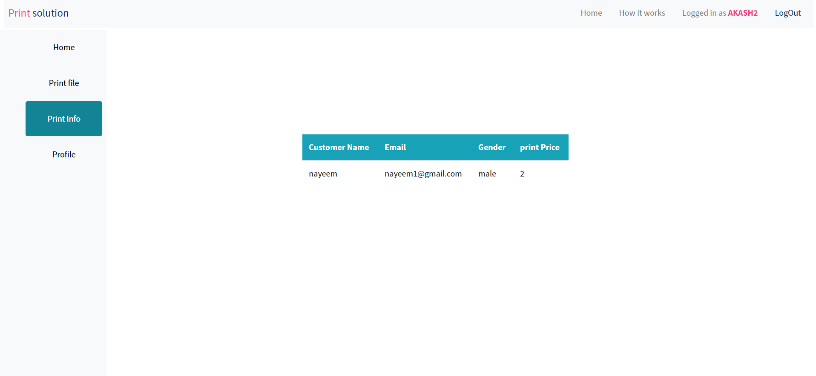

**For Login(Who want to print)**

**For scan Qr code for easy Login**

**Print file LogIn**

**Total Print file amount**

**Total Print file Price**

**Click Here for Logout**

**Those who already print their file from this user**

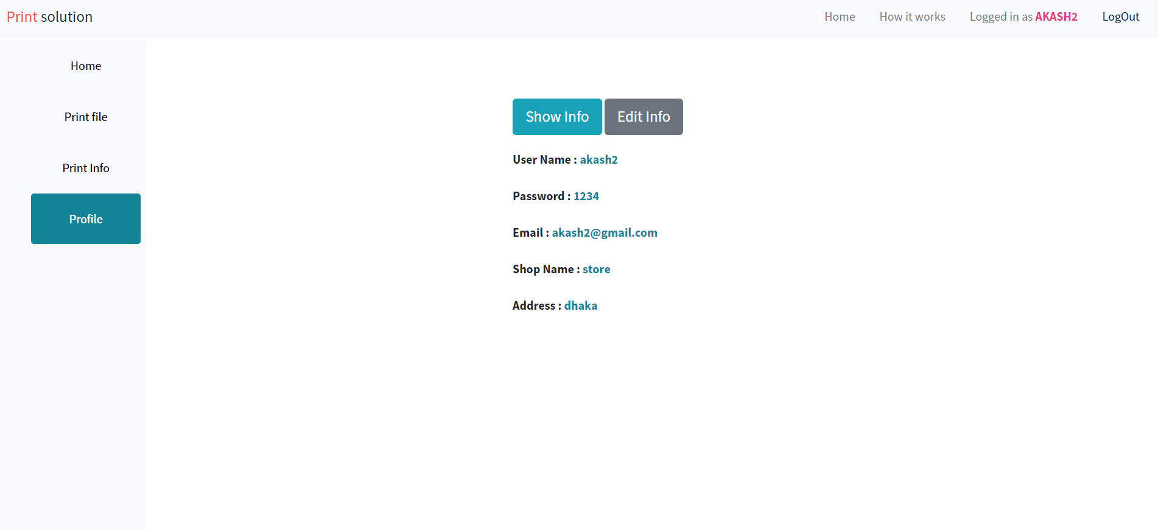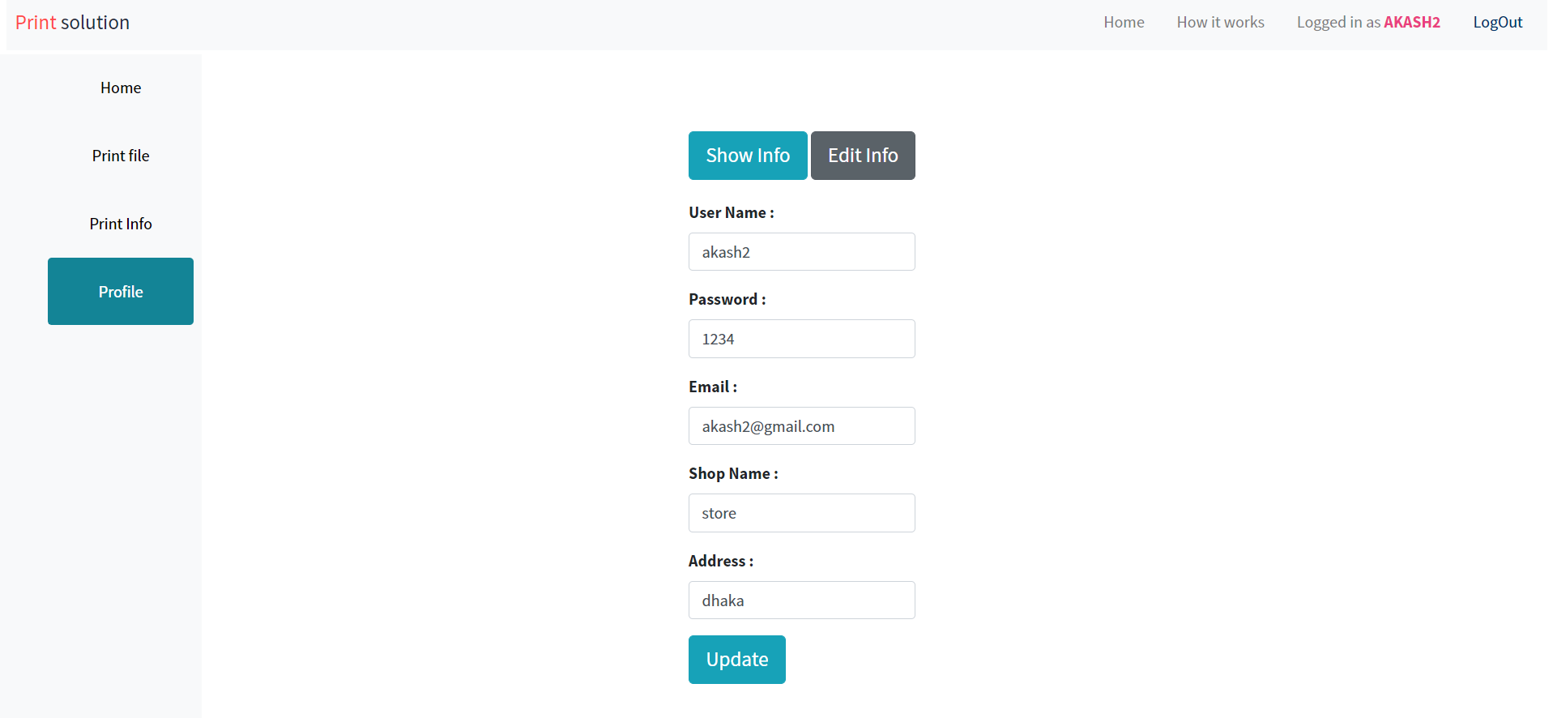

**For Edit user Information**

**Show user information**