**Nombre: Nayeli Pineda**

1.10.3 PLANT–POLLINATOR NETWORKS

* Captura de pantalla de la ejecución del archivo **netsize.sh**

**The data of Saavedra and Stouffer (2013) can be found in the directory CSB/unix/data/Saavedra2013.**

1. Write a script that takes one of these files and determines the number of rows (pollinators) and columns (plants). Note that columns are separated by spaces and that there is a space at the end of each line. Your script should return.

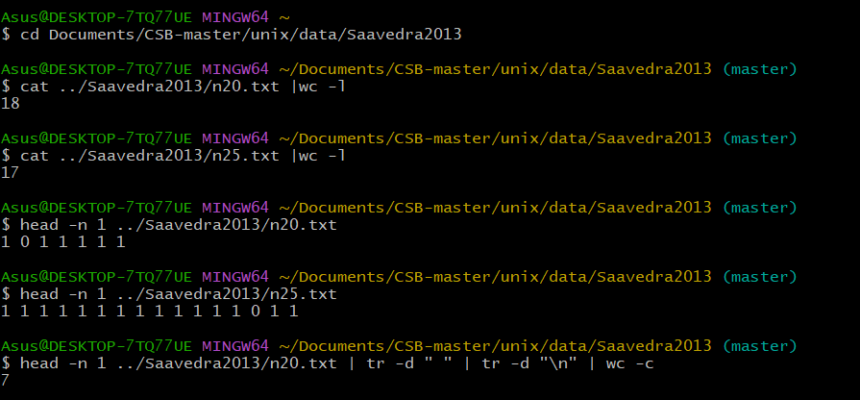

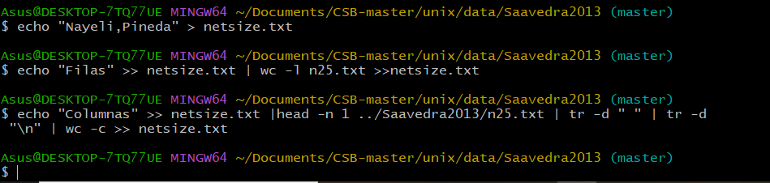

2. [Advanced]

Write a script that prints the numbers of rows and columns for each network:

